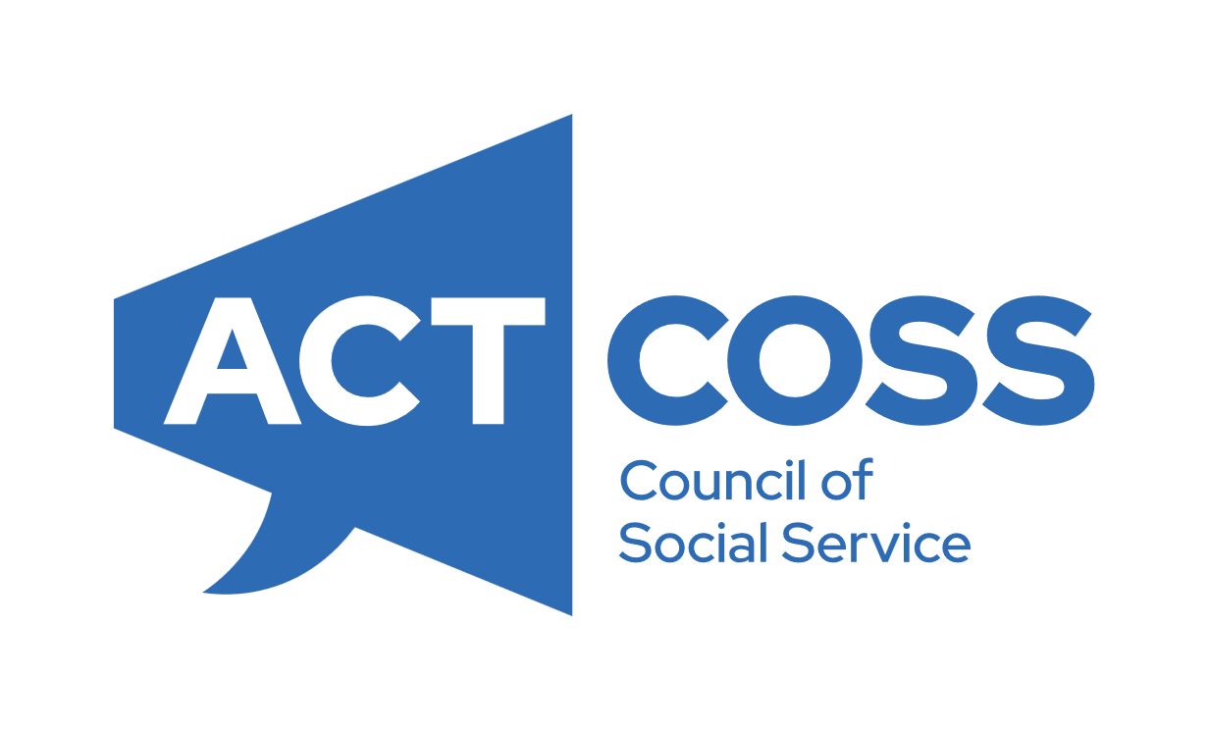
Media release
WEDNESDAY 10 JUNE 2026

2026 ACT Budget:
Responding to cost-of-living pressures
In the 2026-27 Budget, the ACT Government has recognised the importance of investing in people who most need support, and in the community sector which provides the services and programs to help them.
“This is a Budget that has responded to an environment where a growing number of Canberrans are struggling, and it takes steps to address that,” said Dr Devin Bowles, CEO of ACTCOSS.
“The ACT Government is showing national leadership in taking concrete action to help people deal with increasing financial pressures.”
“In this time of international and economic uncertainty, everyone is feeling the pressure to manage expenditure, including the ACT Government.”
“This Budget takes steps to reduce the harm these pressures are causing to Canberrans dealing with poverty and hardship.”
The Budget includes several measures that are aligned with the recommendations ACTCOSS made on behalf of people experiencing poverty and the community sector in its 2026-27 Budget Submission.
“Important measures in this budget include continued and new funding for homelessness services, the funding uplift of $23.7 million over four years for community organisations, additional funding for the ATSIEB, a focus on domestic, family and sexual violence support services, and a commitment to more public housing in the ACT,” Dr Bowles said.
“These measures build on the dialogue started between the ACT Government and the community sector ahead of last year’s Budget, and show that the Government is listening. For many of these measures, more work and investment will be required in future years.
“We look forward to continuing the productive engagement with Government, so that the perspectives of people experiencing disadvantage remain represented in a time of rapid economic change,” Dr Bowles said.
Funding for the Community Sector has increased from $252 million in 2025-26 to $327 million in 2026-27. This is an overall increase of 26% in real terms. It is significant because it signals a pivot towards high-value services that are focused on keeping people out of crises. This is a good financial investment.
“The community sector is the best cost and most approachable provider of support for people in hardship and experiencing exclusion,” said Dr Bowles
“Community organisations have unique and positive relationships with the Canberrans who need help the most. The sector has highly skilled staff and the structural capacity to respond early and quickly to changing circumstances. It is innovative and efficient in delivering services,” said Dr Bowles
The community sector is well-placed to continue working with the ACT Government to help develop policies and measures during this period of rapid economic and social change.
ACTCOSS notes some gaps in the Budget measures.
“We are concerned that there are few measures to directly benefit people with disability and carers and their organisations,” said Dr Bowles.
“In this time of uncertainty around the NDIS, stronger action from state and territory governments is required.”
It is the right of the Aboriginal and Torres Strait Islander community to assess how well this budget supports self-determination. As an ally, ACTCOSS’s first impression is that there should have been more long-term investment in ACCOs and the community, even as we acknowledge the additional investment that was provided in this Budget.
“Similarly, we appreciate the significant investments in public housing maintenance and creation, but are conscious that the undersupply of public housing was decades in the making. Further investment is required, including a clear plan to reach the Government’s targets for new residences by 2030,” said Dr Bowles. “We need to see the proportion of all housing which is social housing increase.”

ACTCOSS advocates for social justice in the ACT and represents not-for-profit community organisations. Follow us @ACTCOSS on X, Facebook and Instagram.
For more information or comment, please contact
Dr Devin Bowles, CEO, ACTCOSS, on 0413 435 080.
Authorised by Dr Devin Bowles on behalf of the ACT Council of Social Service Inc (ACTCOSS)

