OIK home > Governance & Strategic Leadership> Grants
Grants provide essential funding for services and programs that benefit communities or individuals who are unable to pay a fee for this service. This section of the OIK provides an outline of the process of applying for a grant.

Contents
Applying for a Grant 2
Identifying Funding Sources 3
Developing Projects that meet community needs 4
Logic Model 4
Sources of Quantitative Evidence 6

Applying for a Grant
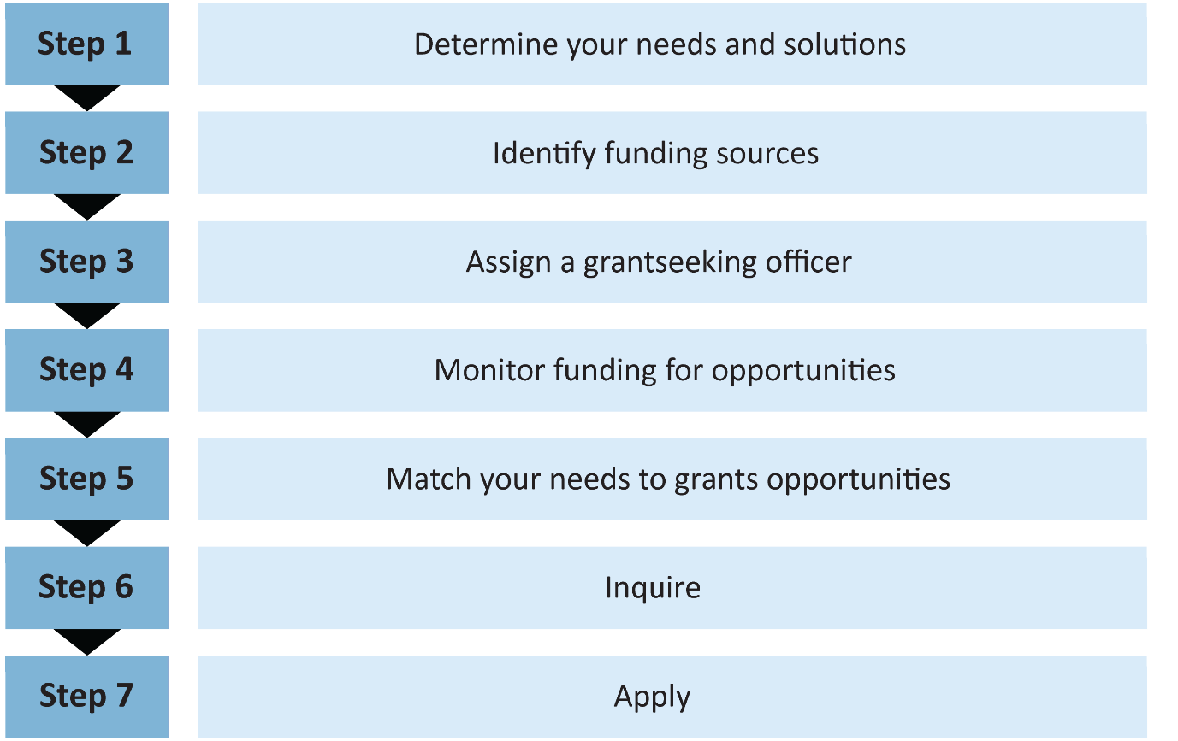

Identifying Funding Sources
Information on available grants can be found here:
- www.grants.act.gov.au
- www.business.gov.au/grantfinder
- http://www.fundingcentre.com.au/grant/home

Developing Projects that meet community needs
A Program Logic Approach provides a roadmap to reach important outcome goals, a graphic representation and a sequence of if – then relationships. This approach helps to develop a well-structured grant application and evaluate whether a particular project matches the outcomes outlined in the grant.

Logic Model
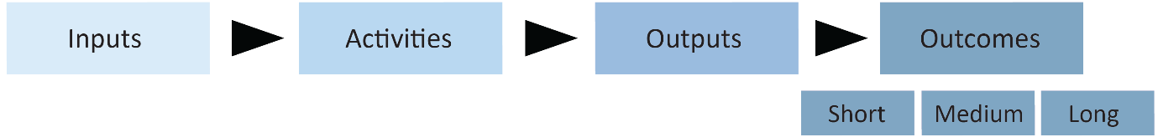

Inputs are the resources needed – what we invest to make the program happen (drives the budget). These can include:
- Money
- Staff
- Volunteers
- Equipment
- Collaborative partners
- Facilities
- Licences etc.
Activities outline the tasks that will be carried out in the project/program - What we do in the program
For example, services provided like:
- Training
- Provide shelter
- Counselling
- Support services
Outputs are the direct results achieved by the activities and are easily measured. Such as Products and Participation like:
- Numbers reached
- Clients served
- Sessions completed etc.
Outcomes are the anticipated results – the difference a program will make
- Initial Outcomes - new skills, changes in attitude and opinions
- Intermediate Outcomes - changed behaviours
- Longer Term - altered conditions or status
The purpose of the logic model is to logically connect inputs to outcomes and this provides a framework for a grant application.

Sources of Quantitative Evidence
Quantitative data can support your grant application and provide an evidence base for your program or project. The following websites are sources for such evidence:
- Australian Capital Territory at a Glance, 2007 - This resource from the Australian Bureau of Statistics provides information about the Australian Capital Territory compared with Australia.
- Canberra ... A Social Atlas, 2006 - This resource from the Australian Bureau of Statistics uses a series of ACT district maps to display statistics covering a variety of areas including population, ethnicity, education, families, income, labour force and dwellings.
- ACT Policing Crime Statistics - Each quarter ACT Policing issues crime statistics illustrating the offences reported or becoming known in suburbs across Canberra.
- National Regional Profile – Australian Capital Territory - This Australian Bureau of Statistics guide profiles the economy, population, people, industry, environment and energy of the Australian Capital Territory.

