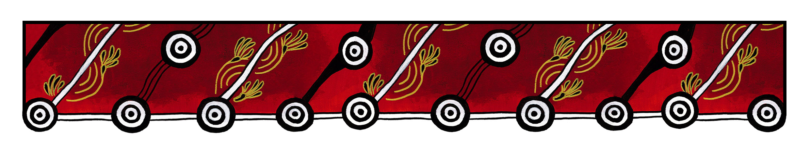

ACT Council of Social Service logo

|  |
| --- |
| Gulanga Good Practice Guides  These guides provide information on topics that aim to assist organisations implement and embed good practice when working and engaging with Aboriginal and/or Torres Strait Islander peoples, particularly within the ACT and region. Each guide provides a general overview, which we hope will generate change and discussion within a workplace. Links are provided at the end of each guide for further information and research. Feedback on the guides can be directed to [gulanga@actcoss.org.au](mailto:gulanga@actcoss.org.au) or by phone to 02 6202 7200. |

Commissioning Aboriginal or   
Torres Strait Islander artwork

Last updated December 2016

For the purpose of this guide, ‘artwork’ can refer to forms of art, artefacts, craft and instruments.

You may wish to commission Aboriginal or Torres Strait Islander artwork for design purposes such as report covers, logos, posters, clothing and merchandise, invitations or greeting cards.

Prior to commissioning any artwork, obtain information about the artist and the artwork to ensure you are commissioning an authentic piece.

Aboriginal or Torres Strait Islander artwork can depict traditional and contemporary themes. They can have important cultural and spiritual themes attached and may have restrictions. Ensure you acquire knowledge about the artwork and any restrictions. For example, if the artwork is about men’s business, can women see the painting? If purchasing a didgeridoo, can women touch or play the instrument? Are children allowed to see the artwork?

It is important to ensure the artist’s intellectual and property rights are respected and they are paid appropriately for their work. The financial value of artwork will vary for each artist. Endeavour to support local artists and their outlets.

Commissioning artwork can include purchasing the artwork or seeking permission from the artist and/or copyright holder for use of the artwork.

If you require the development of a new piece of artwork, be sure that the following criteria can by met by the artist and provide clear clarification to the artist on your expectations:

* Specify your purpose for the artwork, a theme and vision
* Specify if you would like to purchase the artwork, purchase rights to use the artwork, or both
* Specify how long you intend to use the artwork, and for what purpose
* Specify the medium and size required
* Do you require any graphic and printing requirements such as colour usage, borders and boldness of images?
* Do you require permission to adapt the artwork such as changing colours or backgrounds, using all the artwork or parts of the artwork?
* Provide and/or negotiate a budget proposal
* Provide a timeframe for completion
* Be prepared to negotiate all of the above with the artist.

If you would like to commission an existing piece of artwork, provide clear clarification to the artist on your terms of use for the painting.

Where practical, clearly acknowledge the artist and a description of the artwork each time the image is reproduced.

# Contracts/agreements for commissioning Aboriginal or Torres Strait Islander artwork

Once you have accepted the artwork, and the artist has agreed with your terms, a contract or agreement can be made. It is advisable to agree on a contract to avoid disputes. Contracts and agreements:

* Can be oral, written or both oral and written
* Can be formal or you can write your own
* Must be accessible by all staff so they can understand the agreed terms of use for the artwork.

Further information and research

Artists in the Black  
[www.aitb.com.au](http://www.aitb.com.au)

Australia Council for the Arts: Protocols for Working with Indigenous Artists  
[www.australiacouncil.gov.au/about/protocols-for-working-with-indigenous-artists/](http://www.australiacouncil.gov.au/about/protocols-for-working-with-indigenous-artists/)

Indigenous Art Code  
[www.indigenousartcode.org](http://www.indigenousartcode.org)

Viscopy: Indigenous Arts  
<https://viscopy.net.au/indigenous>

Copyright Agency: Indigenous Copyright  
[www.copyright.com.au/about-copyright/indigenous-copyright](http://www.copyright.com.au/about-copyright/indigenous-copyright)

Gulanga Program | ACT Council of Social Service Inc. | gulanga@actcoss.org.au | www.actcoss.org.au

ACTCOSS is committed to reconciliation, acknowledges the traditional custodians of the land and pays respect to elders past and present.