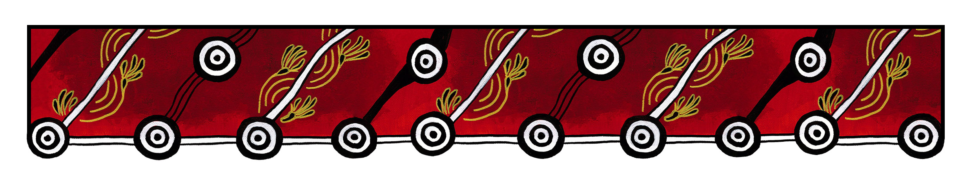

ACT Council of Social Service logo

|  |
| --- |
| Gulanga Good Practice Guides  These guides provide information on topics that aim to assist organisations implement and embed good practice when working and engaging with Aboriginal and/or Torres Strait Islander peoples, particularly within the ACT and region. Each guide provides a general overview, which we hope will generate change and discussion within a workplace. Links are provided at the end of each guide for further information and research. Feedback on the guides can be directed to [gulanga@actcoss.org.au](mailto:gulanga@actcoss.org.au) or by phone to 02 6202 7200. |

Photographing, filming and sound recording Aboriginal and/or Torres Strait Islander peoples, places, objects, sites and cultural activities

Last updated December 2016

To promote mutual respect and understanding, it is advisable to request permission before taking a photograph, film or sound recording.

It is important to acknowledge that photographing, filming and sound recording Aboriginal and/or Torres Strait Islander peoples, places, objects, sites and cultural activities do occur without consent. In some instances privacy, identity and cultural heritage are exploited, misrepresented and depicted in negative ways. In other instances cultural protocols and restrictions are breached, either accidentally or negligently.

# Aboriginal and/or Torres Strait Islander peoples

Before taking a photograph, film or sound recording of a person(s), it is advisable to:

1. Introduce yourself to the person(s)
2. Inform the person(s) why you would like to take the photograph, film or sound recording
3. Request their permission to do so
4. Respect their decision to refuse permission.

Note: If you intend to use your photograph, film or sound recording in your communications, you will need to seek written or verbal permission from the person(s). For further information refer to the Gulanga Good Practice Guide: Reproducing photographs, images, film and sound recording of Aboriginal and/or Torres Strait Islander peoples, places, objects, sites and cultural activities.

# Aboriginal and/or Torres Strait Islander places, objects, sites and cultural activities

Traditional owners may prohibit photographing and filming places, objects, sites and cultural activities, such as paintings, artefacts, rock art and ceremonies. Ensure you observe the protocols.

Further information and research

Australia Council for the Arts: Protocols for Working with Indigenous Artists  
[www.australiacouncil.gov.au/about/protocols-for-working-with-indigenous-artists/](http://www.australiacouncil.gov.au/about/protocols-for-working-with-indigenous-artists/)

SBS: The Greater Perspective - Protocol and Guidelines for the Production of Film and Television on Aboriginal and Torres Strait Islander Communities.  
[www.sbs.com.au/aboutus/corporate/view/id/106/h/The-Greater-Perspective](http://www.sbs.com.au/aboutus/corporate/view/id/106/h/The-Greater-Perspective)

Screen Australia: Indigenous Content - Pathways & Protocols, a filmmaker’s guide to working with Indigenous people, culture and concept  
[www.screenaustralia.gov.au/about-us/doing-business-with-us/indigenous-content/indigenous-protocols](http://www.screenaustralia.gov.au/about-us/doing-business-with-us/indigenous-content/indigenous-protocols)

Arts Law Centre of Australia: Information Sheet – Street Photographer’s Rights  
[www.artslaw.com.au/info-sheets/info-sheet/street-photographers-rights/](http://www.artslaw.com.au/info-sheets/info-sheet/street-photographers-rights/)

Gulanga Program | ACT Council of Social Service Inc. | gulanga@actcoss.org.au | www.actcoss.org.au

ACTCOSS is committed to reconciliation, acknowledges the traditional custodians of the land and pays respect to elders past and present.