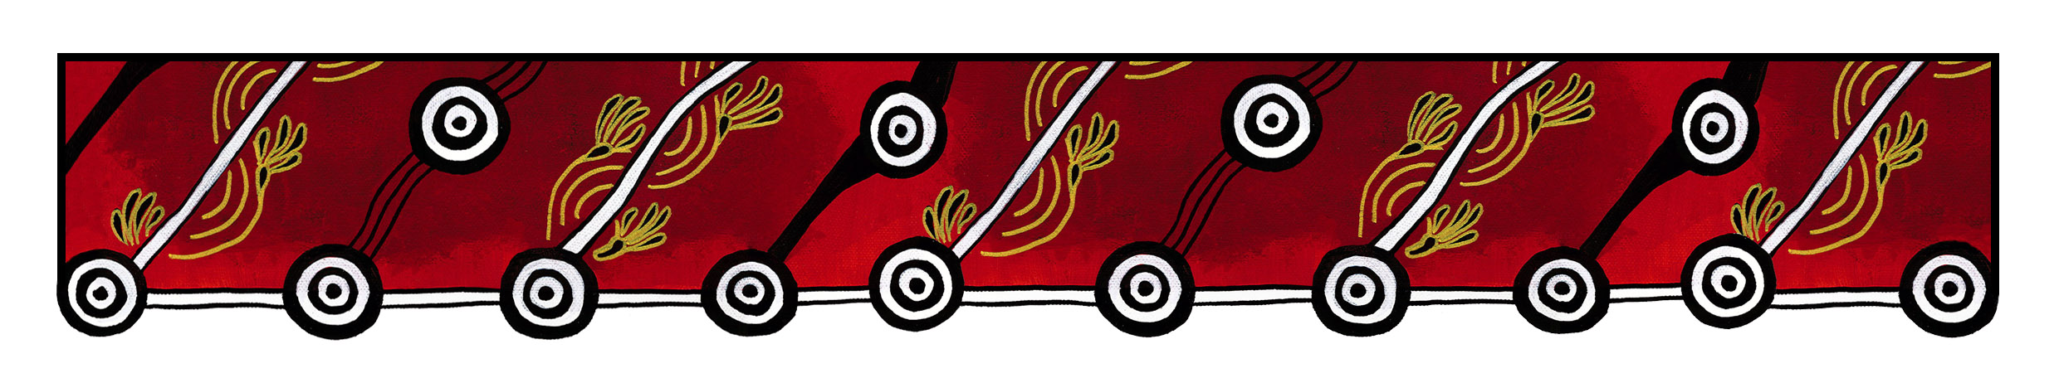

ACT Council of Social Service logo

|  |
| --- |
| Gulanga Good Practice Guides  These guides provide information on topics that aim to assist organisations implement and embed good practice when working and engaging with Aboriginal and/or Torres Strait Islander peoples, particularly within the ACT and region. Each guide provides a general overview, which we hope will generate change and discussion within a workplace. Links are provided at the end of each guide for further information and research. Feedback on the guides can be directed to [gulanga@actcoss.org.au](mailto:gulanga@actcoss.org.au) or by phone to 02 6202 7200. |

Purchasing Aboriginal or   
Torres Strait Islander artwork

Last updated December 2016

For the purpose of this information sheet, ‘artwork’ can refer to forms of art, artefacts, craft and instruments.

You may wish to purchase artwork for your workplace, home or as a gift.

Prior to purchasing any artwork, obtain information about the artist and the artwork to ensure you are purchasing an authentic piece.

Aboriginal or Torres Strait Islander artwork can depict traditional and contemporary themes. They can have important cultural and spiritual themes attached and may have restrictions. Ensure you acquire knowledge about the artwork and any restrictions. For example, if the artwork is about men’s business, can women see the painting? If purchasing a didgeridoo, can women touch or play the instrument? Are children allowed to see the artwork?

It is important to ensure the artist’s intellectual and property rights are respected and they are paid appropriately for their work. The financial value of artwork will vary for each artist.

Endeavour to support local artists and their outlets in the ACT, such as the Burrunju Aboriginal Art Gallery and Kemarre Arts. Other outlets can include markets, festivals, expos and exhibitions at various art galleries.

Do not assume that because you have purchased an artwork, you can reproduce all or parts of it for any purpose. You will need to seek the appropriate permission from the artist and/or copyright holder.

When you have purchased art for your workplace, ensure you acknowledge the artist by displaying information about the artist and the artwork.

Further information and research

Aboriginal Art Directory  
[www.aboriginalartdirectory.com](http://www.aboriginalartdirectory.com)

Aboriginal Art & Fashion  
[www.aboriginalartresource.com](http://www.aboriginalartresource.com)

Indigenous Art Code  
[www.indigenousartcode.org](http://www.indigenousartcode.org)

Australia Council for the Arts: Protocols for Working with Indigenous Artists  
[www.australiacouncil.gov.au/about/protocols-for-working-with-indigenous-artists/](http://www.australiacouncil.gov.au/about/protocols-for-working-with-indigenous-artists/)

Arts Law Centre of Australia: Respect and Protect Indigenous Art and Culture  
[www.artslaw.com.au/case-studies/entry/respect-and-protect-indigenous-art-and-culture/](http://www.artslaw.com.au/case-studies/entry/respect-and-protect-indigenous-art-and-culture/)

Viscopy  
<https://viscopy.net.au>

Copyright Agency: Indigenous Copyright  
[www.copyright.com.au/about-copyright/indigenous-copyright](http://www.copyright.com.au/about-copyright/indigenous-copyright)

Gulanga Program | ACT Council of Social Service Inc. | gulanga@actcoss.org.au | www.actcoss.org.au

ACTCOSS is committed to reconciliation, acknowledges the traditional custodians of the land and pays respect to elders past and present.