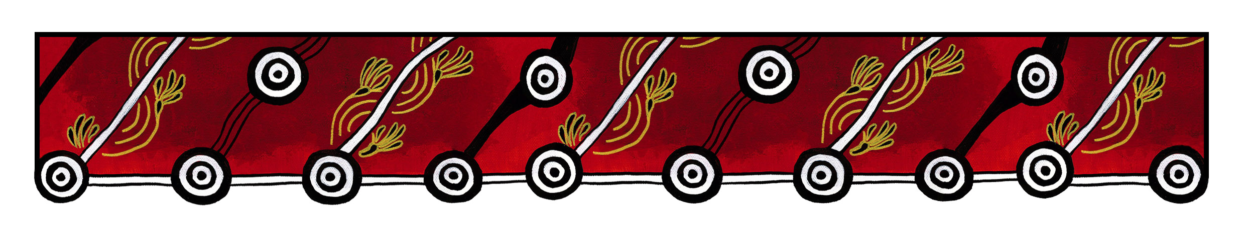

ACT Council of Social Service logo

|  |
| --- |
| Gulanga Good Practice Guides  These guides provide information on topics that aim to assist organisations implement and embed good practice when working and engaging with Aboriginal and/or Torres Strait Islander peoples, particularly within the ACT and region. Each guide provides a general overview, which we hope will generate change and discussion within a workplace. Links are provided at the end of each guide for further information and research. Feedback on the guides can be directed to [gulanga@actcoss.org.au](mailto:gulanga@actcoss.org.au) or by phone to 02 6202 7200. |

Reconciliation

Last updated December 2016

In 1991, the Australian Government established the Council for Aboriginal Reconciliation to promote reconciliation between Aboriginal and/or Torres Strait Islander peoples and the wider community. The Council ended in 2000, and Reconciliation Australia is the current peak national organisation.

National Reconciliation Week began in 1993 as the Week of Prayer for Reconciliation. In 1996 it became National Reconciliation Week. The week begins on 25 May, the anniversary of the 1967 Referendum. The week ends on 3 June, the anniversary of the Mabo decision. You can register an event or view events in your area by visiting the Reconciliation Australia website: [www.reconciliation.org.au](http://www.reconciliation.org.au).

Here are some ideas on how you can build relationships and positive change within your workplace:

* Develop a Reconciliation Action Plan (RAP)
* Encourage and support staff to participate in National Reconciliation Week activities in your area
* Host an event such as a morning tea
* Support staff to attend cultural awareness training
* Have regular discussions on reconciliation at your staff meetings
* Develop ways to improve upon current good practice in reconciliation
* Develop a reconciliation statement or acknowledgement for your publications.

Further information and research

Reconciliation Australia  
[www.reconciliation.org.au](http://www.reconciliation.org.au)

ANTaR  
<https://antar.org.au>

ACTCOSS: Reconciliation Peer Network  
[www.actcoss.org.au/services-resources/networks-working-groups/reconciliation-peer-network](http://www.actcoss.org.au/services-resources/networks-working-groups/reconciliation-peer-network)

Australian Human Rights Commission - Face the facts: Aboriginal and Torres Strait Islander Peoples  
[www.humanrights.gov.au/education/face-facts/face-facts-aboriginal-and-torres-strait-islander-peoples](http://www.humanrights.gov.au/education/face-facts/face-facts-aboriginal-and-torres-strait-islander-peoples)

Gulanga Program | ACT Council of Social Service Inc. | gulanga@actcoss.org.au | www.actcoss.org.au

ACTCOSS is committed to reconciliation, acknowledges the traditional custodians of the land and pays respect to elders past and present.