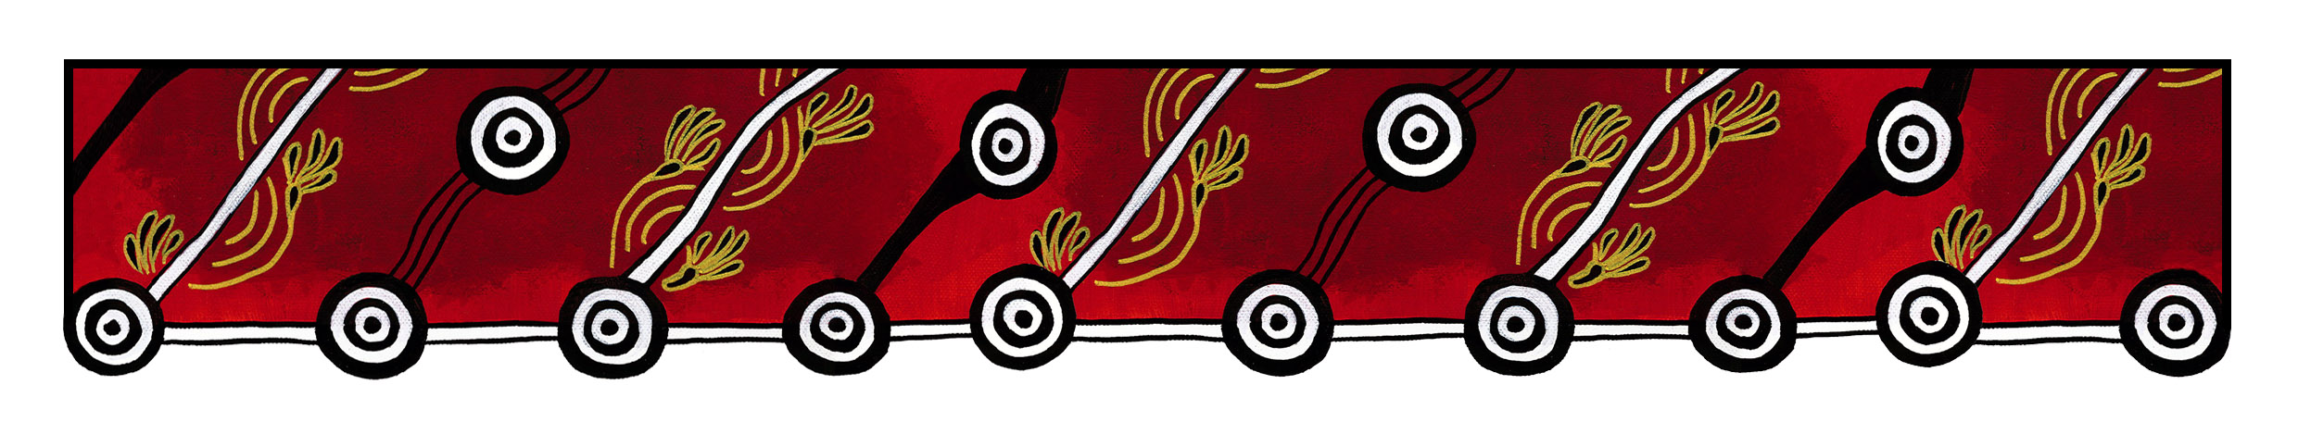

ACT Council of Social Service logo

|  |
| --- |
| Gulanga Good Practice Guides  These guides provide information on topics that aim to assist organisations implement and embed good practice when working and engaging with Aboriginal and/or Torres Strait Islander peoples, particularly within the ACT and region. Each guide provides a general overview, which we hope will generate change and discussion within a workplace. Links are provided at the end of each guide for further information and research. Feedback on the guides can be directed to [gulanga@actcoss.org.au](mailto:gulanga@actcoss.org.au) or by phone to 02 6202 7200. |

Reproducing photographs, images, film and sounding recordings of Aboriginal and/or Torres Strait Islander peoples, places, objects, sites and cultural activities in your communications

Last updated December 2016

For the purpose of this guide, communications can include various mediums used for internal and public distribution such as: promotional materials, flyers, posters and products, website content, video and sound recordings, slide presentations, publications, reports and newsletters.

It is important to know that the reproduction of photographs, images, film and sound recordings of Aboriginal and/or Torres Strait Islander peoples, places, objects, sites and cultural activities has occurred without their consent. In some instances their privacy, identity and cultural heritage were exploited, misrepresented and depicted in negative ways. In other instances cultural protocols and restrictions were breached, either accidentally or negligently.

To promote mutual respect and understanding, it is advisable to obtain written and/or verbal permission before reproducing a photograph, film or sound recording of Aboriginal and/or Torres Strait peoples, places, objects, sites and cultural activities for your internal and external communications.

When requesting permission, follow these guidelines:

* Specify why you would like to use this in your communications and how it will be used
* Request permission to do so, either written, verbal or both
* If no permission is obtained, do not use
* If permission is obtained, record how this occurred
* Ensure you have obtained the correct name and spelling for the person(s)
* If possible, include a warning in your communications (see the Gulanga Good Practice Guide: Aboriginal and/or Torres Strait Islander warning)
* If possible, send the person(s) a copy of the communications.

# Aboriginal and/or Torres Strait Islander places, objects, sites and cultural activities

Traditional owners may allow photographing, filming and sound recording places, objects, sites and cultural activities, such as paintings, artefacts, rock art and ceremonies. This can involve permission or copyright to reproduce.

Further information and research

Australia Council for the Arts: Protocols for Working with Indigenous Artists  
[www.australiacouncil.gov.au/about/protocols-for-working-with-indigenous-artists/](http://www.australiacouncil.gov.au/about/protocols-for-working-with-indigenous-artists/)

SBS: The Greater Perspective - Protocol and Guidelines for the Production of Film and Television on Aboriginal and Torres Strait Islander Communities.  
[www.sbs.com.au/aboutus/corporate/view/id/106/h/The-Greater-Perspective](http://www.sbs.com.au/aboutus/corporate/view/id/106/h/The-Greater-Perspective)

Screen Australia: Indigenous Content - Pathways & Protocols, a filmmaker’s guide to working with Indigenous people, culture and concept  
[www.screenaustralia.gov.au/about-us/doing-business-with-us/indigenous-content/indigenous-protocols](http://www.screenaustralia.gov.au/about-us/doing-business-with-us/indigenous-content/indigenous-protocols)

Arts Law Centre of Australia: Information Sheet – Street Photographer’s Rights  
[www.artslaw.com.au/info-sheets/info-sheet/street-photographers-rights/](http://www.artslaw.com.au/info-sheets/info-sheet/street-photographers-rights/)

Australian Human Rights Commission: Aboriginal and Torres Strait Islander Peoples Engagement Toolkit  
[www.humanrights.gov.au/publications/reconciliation-action-plan-2012-book](http://www.humanrights.gov.au/publications/reconciliation-action-plan-2012-book)

Copyright Agency: Indigenous Copyright  
[www.copyright.com.au/about-copyright/indigenous-copyright](http://www.copyright.com.au/about-copyright/indigenous-copyright)

Gulanga Program | ACT Council of Social Service Inc. | gulanga@actcoss.org.au | www.actcoss.org.au

ACTCOSS is committed to reconciliation, acknowledges the traditional custodians of the land and pays respect to elders past and present.