ACT Council of Social Service Inc. (ACTCOSS) logo.

ACT Decides:   
a community conversation

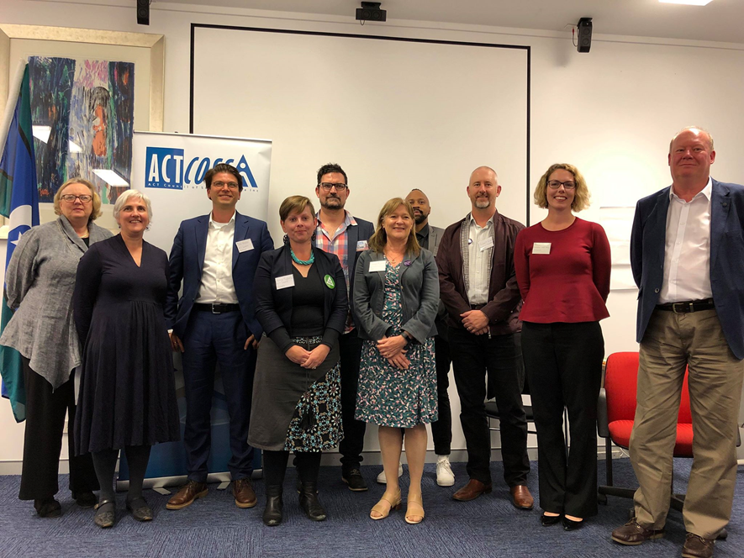

From left: Glenda Stevens, Susan Helyar, Tim Hollo, Penny Kyburz, Tim Bohm, Therese Faulkner, Kagiso Ratlhagane, Robert Knight, Alicia Payne and Dr James Christie.

Reflections from the ACTCOSS 2019   
Federal Election Forum

May 2019

Introduction

A federal election is being held on 18 May 2019. Together with an ACT election due in 2020, these are critical elections that will significantly influence the future wellbeing of people living in our city and region; and determine policy, services, supports, safety net and funding outcomes for many years to come.

The ACT is invested in federal matters, not just as the home of major national institutions and a concentration of public administration for the federal government, but also as a municipality with local needs and concerns. Local, municipal and service user level implications of federal policy debates are sometimes not highly visible. Our Chief Minister has suggested the ACT as a place is considered neither a regional centre nor a major capital city.

On 29 April 2019, the ACT Council of Social Service (ACTCOSS) hosted a forum with eight local candidates for the Senate and the House of Representatives in the seats of Bean, Fenner and Canberra. We designed the forum to stimulate local dialogue on federal issues looked at through a sharp local lens. We were especially pleased to be able to facilitate discussions around the three new electorate boundaries in the Territory.

Rather than a traditional debate, ACTCOSS provided a space for candidates to reflect on community sector priorities, have conversations with community sector workers and leaders and reflect on the concerns raised.

This local focus recognises that the ACT isn’t just the seat of government, it’s a growing Territory where over 420,000 people live, work and depend on services, transfer payments, tax arrangements and infrastructure arranged in whole or part by the federal government.

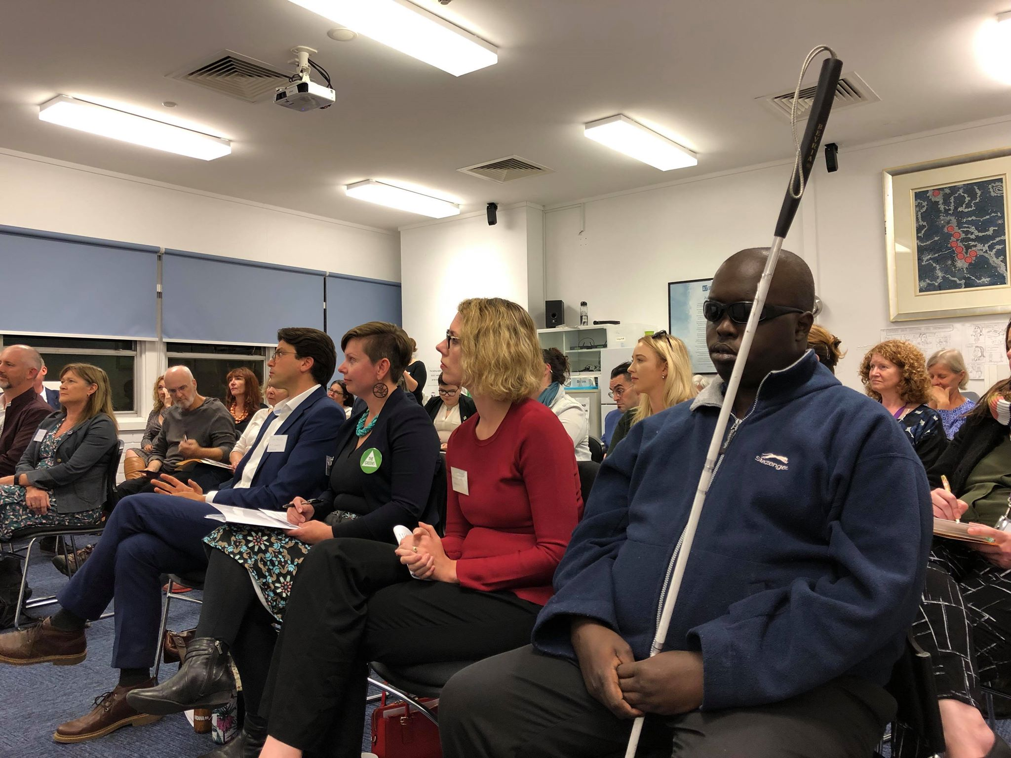

|  |
| --- |
| At a glance  Members of the ACT community sector attending the 2019 ACT election dialogue want federal representatives who are sharply attendant to local and regional issues outside the ‘Canberra bubble’:  For instance, they expect federal representatives to recognise the existence of poverty and disadvantage in the ACT driven in part by cost of living pressures. They asked candidates to commit to promptly fix a broken safety net as well as commit to act for a better deal on housing and homelessness. They want elected representatives to work to set right faltering human services systems like the NDIS, and address and fund service gaps in health and homelessness. Action of these big picture national concerns should be achieved alongside recognising and responding to municipal level service and infrastructure gaps in a growing Territory, mindful of specific needs in terms of gender, age and disability.  In the words of one participant – but resonating through many conversations from audience *and* candidates alike – there is a ‘need and a hunger’ for better public administration and a more honest political conversation that sets out choices and clearly articulates trade-offs considered by decision makers. The need for just action on climate change and more sustainable sources of adequate revenue for future services were consistent themes in these conversations.  There was active discussion and reflection on specific service gaps, lagging investments and intersectional disadvantage, such as that experienced by women.  ACTCOSS saw a strong alignment between national surveys of key concerns of voters, Australian Council of Social Service (ACOSS) priorities for the next federal government and specific issues raised by ACTCOSS members. |

## Acknowledgments

We would like to thank the [Australian Futures Project](http://australianfutures.org/) for permission to use information from [The Perfect Candidate](https://theperfectcandidate.org.au/) to spur discussions. We hope that taken together with attendee feedback they provide both a broad and granular set of insights into some community priorities in the minds of ACT residents as we enter the final days of the 2019 federal election campaign.

We also thank and acknowledge the candidates and members who contributed to the forum.

Setting the scene

## Community Priorities

### The ACT frame for national issues

In the lead up to the forum, candidates received a copy of the ACOSS federal election priorities, which relate to adequate income support, employment, affordable homes, affordable clean energy and action on climate change, and quality health and community services.

To ensure these priorities can be enacted, ACOSS has also called for the next federal government to guarantee enough funding for the services we all need, a strong community voice and a thriving democracy.

ACTCOSS in turn provided localised background, ACT data, personal stories and a question relating to each priority and invited candidates to choose two of them to respond to. You can find these here:

[**Social security (pdf)**](https://www.actcoss.org.au/sites/default/files/public/documents/2019-act-federal-election-brief-social-security-priorities.pdf) **|** [**(docx)**](https://www.actcoss.org.au/sites/default/files/public/documents/2019-act-federal-election-brief-social-security-priorities.docx)**:** The single rate of Newstart is less than $40 a day and this rate hasn’t increased in real terms in 25 years. Instead, it has declined in relation to the increase in living costs. Over 10,000 ACT people on various allowances are in this situation. As a federal candidate, what will you do to strengthen the income support system?

[**Public revenue for essential services (pdf)**](https://www.actcoss.org.au/sites/default/files/public/documents/2019-act-federal-election-brief-revenue-priorities.pdf) **|** [**(docx)**](https://www.actcoss.org.au/sites/default/files/public/documents/2019-act-federal-election-brief-revenue-priorities.docx)**:** The ACT is reliant on a sound revenue stream to generate both local economic activity and appropriate streams of revenue for essential services to support the 420,000 people who live here. What is your position on maintaining a sustainable revenue stream for the ACT?

[**Employment (pdf)**](https://www.actcoss.org.au/sites/default/files/public/documents/2019-act-federal-election-brief-employment-priorities.pdf) **|** [**(docx)**](https://www.actcoss.org.au/sites/default/files/public/documents/2019-act-federal-election-brief-employment-priorities.docx)**:** More Canberrans are experiencing casualised, precarious employment and a lack of job security. The federal government has key responsibilities as an employer, a driver of economic settings, a funder of Job Network providers and steward of the income support safety net. How will you ensure more ACT people have secure well-paid jobs and a safety net when they can’t find them?

[**Climate and clean energy (pdf)**](https://www.actcoss.org.au/sites/default/files/public/documents/2019-act-federal-election-brief-climate-energy-priorities.pdf) **|** [**(docx)**](https://www.actcoss.org.au/sites/default/files/public/documents/2019-act-federal-election-brief-climate-energy-priorities.docx)**:** The ACT experiences climate extremes of both heat and cold across most average years. These periods are getting longer, with many people experiencing hardship from energy bills. As a federal candidate, what are you proposing to do to respond to climate change and ensure a just response?

[**Housing and homelessness (pdf)**](https://www.actcoss.org.au/sites/default/files/public/documents/2019-act-federal-election-brief-housing-homelessness-priorities.pdf) **|** [**(docx)**](https://www.actcoss.org.au/sites/default/files/public/documents/2019-act-federal-election-brief-housing-homelessness-priorities.docx)**:** What do you think the federal government needs to be doing to ensure adequate federal funding, provisioning and co-operation for affordable housing, including via COAG? Will you work to urge action on Universal Design Housing? What is your view on secure and adequate funding for specialist homelessness services?

[**Health (pdf)**](https://www.actcoss.org.au/sites/default/files/public/documents/2019-act-federal-election-brief-health-priorities.pdf) **|** [**(docx)**](https://www.actcoss.org.au/sites/default/files/public/documents/2019-act-federal-election-brief-health-priorities.docx)**:** As a federal candidate, what are you proposing to do to respond to the ACT’s health needs, particularly the high cost of GPs – the most expensive in the country, with the fewest bulk billing doctors -- and inadequate access to preventative health services?

[**Community services (pdf)**](https://www.actcoss.org.au/sites/default/files/public/documents/2019-act-federal-election-brief-community-services-priorities.pdf) **|** [**(docx)**](https://www.actcoss.org.au/sites/default/files/public/documents/2019-act-federal-election-brief-community-services-priorities.docx)**:** What will you do to support viable and sustainable community services for everyone and improve the experience of ACT services with the Commonwealth Government?

[**Reform to government advisory structures (pdf)**](https://www.actcoss.org.au/sites/default/files/public/documents/2019-act-federal-election-brief-whole-of-government-advisory-structures.pdf) **|** [**(docx)**](https://www.actcoss.org.au/sites/default/files/public/documents/2019-act-federal-election-brief-whole-of-government-advisory-structures.docx)**:** What are your reflections on ACOSS priorities to sustain and ensure community-controlled ACT peak bodies, including self-determination for Aboriginal and/or Torres Strait Islander people? As a candidate, do you feel the community needs a greater local voice in Commonwealth policy and program initiatives and how might you work to achieve that?

### Electorate level priorities

In the 2019 federal election, the electorate boundaries for the ACT have been redrawn and the new seat of Bean created.

The eastern seat of Canberra comprises the city centre as well as the geographic centre of the ACT in Woden while stretching up into the Belconnen district including Bruce. The seat of Bean covers a large geographic area from Stromlo and Weston Creek down to Tuggeranong and Calwell. It includes new suburbs in the Molongolo Valley and also encompasses the Norfolk Island Territory. The seat of Fenner reaches across the north of the ACT including most of Belconnen and Gungahlin with some semi-rural districts including Hall. It also includes the Jervis Bay territory on the South Coast.

To facilitate discussion of electorate level needs, priorities and demographics, three A3 diorama maps were produced which included:

* Australian Electoral Commission (AEC) maps of the electorate boundaries and a list of suburbs in the new electorates
* A list of the top five priorities for that seat identified by a national survey of 125,000 voters from a website called *The Perfect Candidate* which used survey research from Roy Morgan
* Spotlights on the experience of poverty, housing stress and information on the diversity profile of the electorate
* Scene-setting facts from each division, focussing on population, age profile, family structures, housing type, engagement in work or study, occupation and education. These tables were reproduced from the Australian Electoral Commission Commonwealth Electoral Division Profile.

# About the Forum

## Who was there?

ACTCOSS invited candidates from all party affiliations and independents to the forum and attendees (in order of acceptance) included:

* Dr Jamie Christie – Independent for Bean
* Therese Faulkner – Australian Progressive for Bean
* Tim Hollo – ACT Greens for Canberra
* Robert Knight – Australian Progressives for Canberra
* Tim Bohm – Independent for Canberra
* Kagiso Ratlhagane – Australian Progressives for Fenner
* Alicia Payne – Australian Labor Party for Canberra
* Penny Kyburz – ACT Greens for the Senate.

Apologies were received from the Canberra Liberals and some independents. ACTCOSS invited political parties and independent candidates unable to attend the forum to provide written responses that could be included in this report.

The forum was well attended by the community sector with around forty people in the audience including ACTCOSS members, other local community organisation representatives and individual voters seeking an opportunity to get to know the candidates.

## How did it work?

*Meet and mingle*: The forum included an informal meet and mingle period enabling people to meet and connect with their local candidates

*The candidate pitch*: Candidates were given two minutes each to discuss two of the policy priorities for the next Australian Government chosen from the ACOSS priorities outlined above. They were asked to speak about why they chose the priorities and how they would respond to them if elected.

*Electorate tables*: Candidates and guests then split into three electorate-based groups with information and tools on the tables to enable an electorate-specific conversation. House of Representatives or Senate candidates were invited to join the table for the electorate that they were either contesting or residing in. They then struck up a conversation with ACTCOSS members and guests about their responses to national and local policy priorities through a local lens.

*Reflection*: To conclude the forum and share highlights from the electorate tables with everyone attending, ACTCOSS invited each candidate to briefly tell us one thing that they learnt or heard that surprised them or is likely make a lasting impression if they are elected. This part of the forum was [livestreamed](https://www.facebook.com/actcoss/videos/414672352645743/) on Facebook as part of our ongoing social media outreach via #ACTCOSSlive.

*Follow through*: This report is being made available publicly and sent to candidates who were either invited to, accepted or apologised for the forum. After the federal election has been held and the successful representatives declared by the Electoral Commission, a communication will be sent to people elected to represent the people of the ACT in the House of Representatives and the Senate, inviting them to act on the priorities articulated in our forum.

What they said

## Candidate priorities

At the start of the forum, candidates were invited to make brief statements[1].

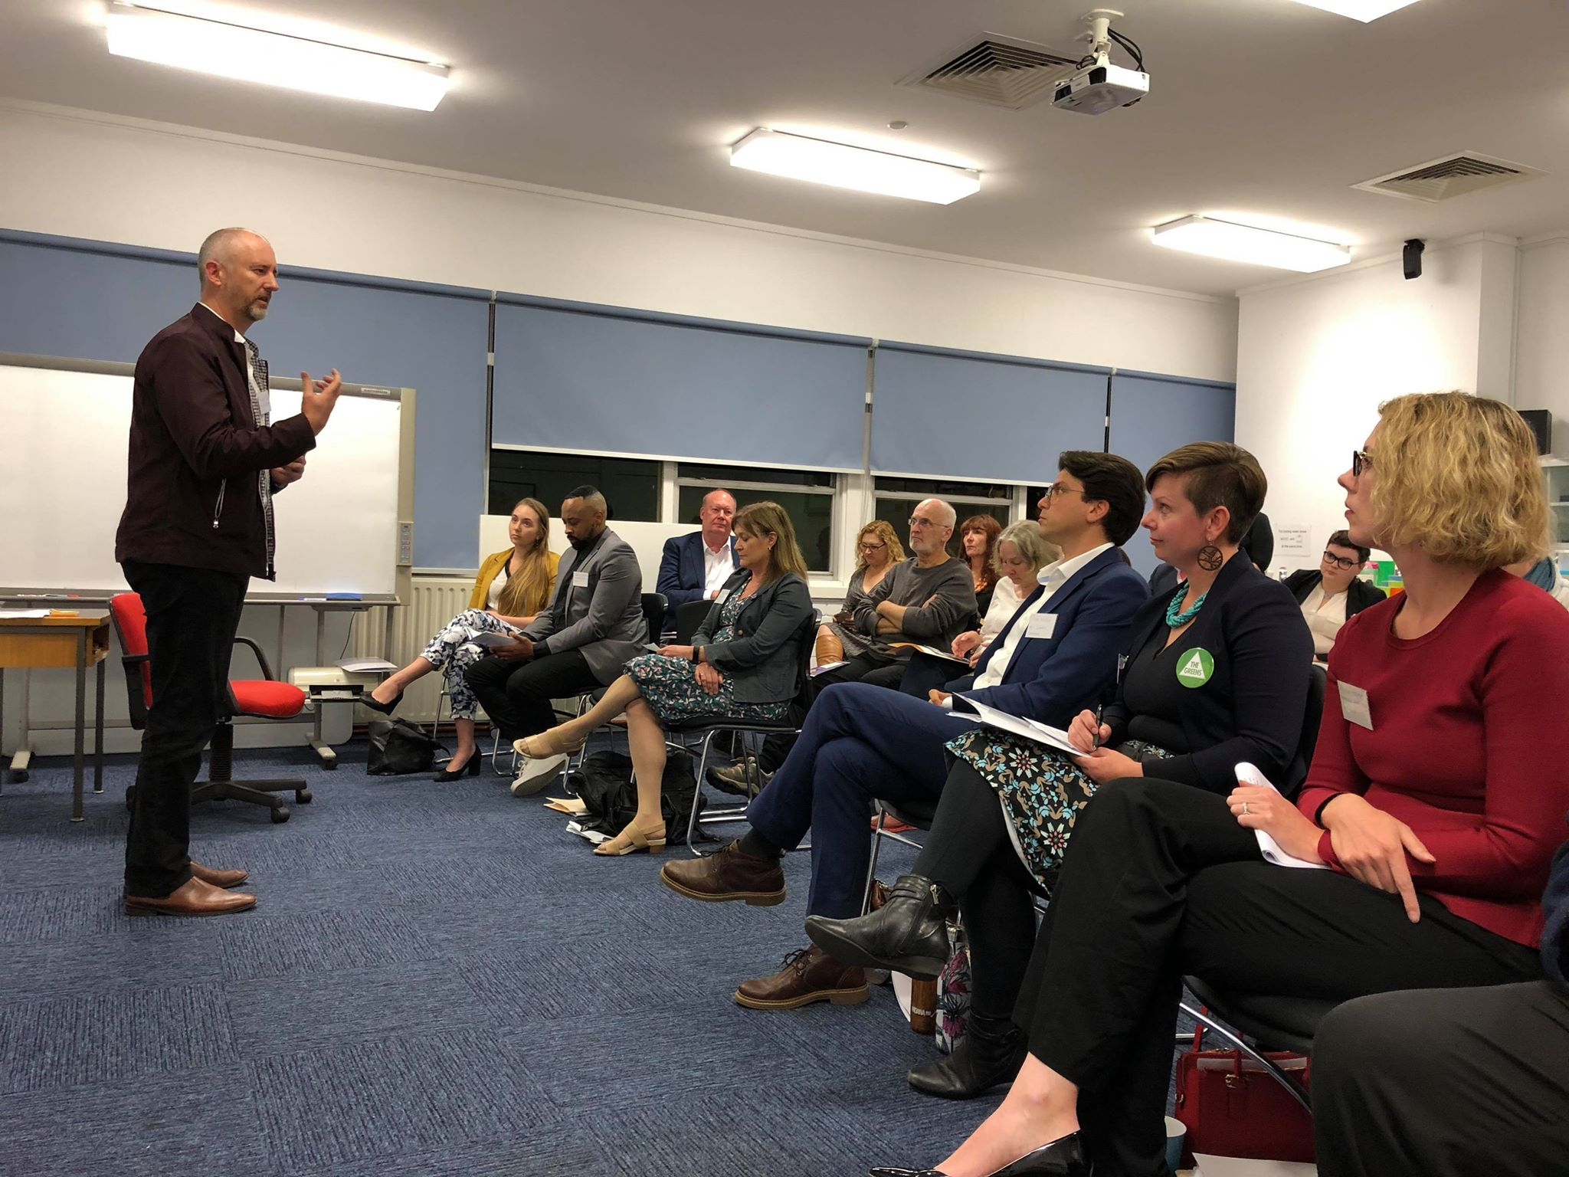

### Robert Knight – Australian Progressives for Canberra

Points raised:

* The need to address housing and homelessness and recognise these were linked to a thriving economy and society
* Housing needs to be affordable, close to amenities and infrastructure, accessible and available in quantum
* Needs to be more social housing through a National Housing Strategy.

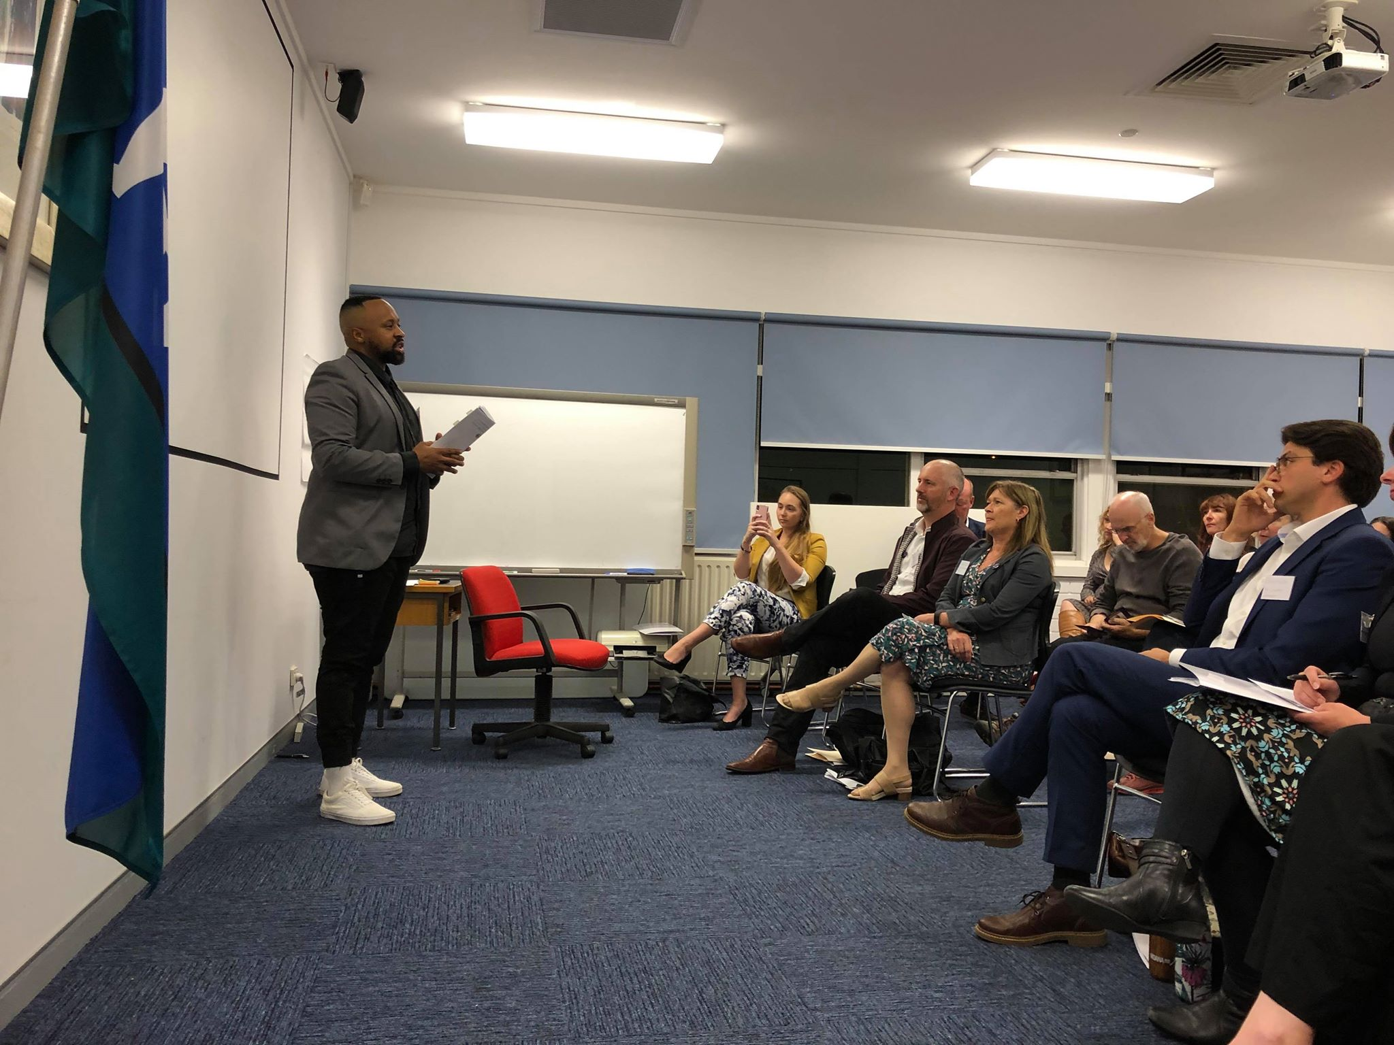

### Kagiso Ratlhagane – Australian Progressives for Fenner

Points raised:

* More positive conversations about young people
* Adequate income support – reducing pressure and dealing with demotivation
* Breaking cycles of poverty and funding community services.

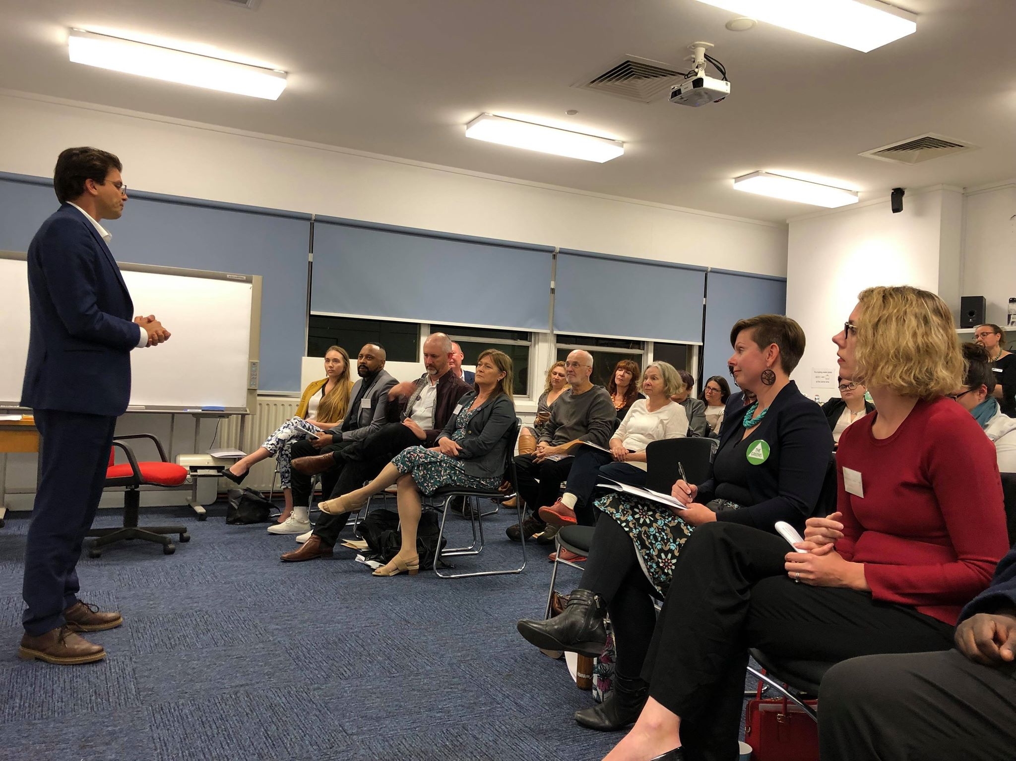

### Tim Hollo – ACT Greens for Canberra

Points raised:

* Climate change as an overarching issue with the need for a just transition
* The importance of social justice advocacy as a valuable resource and the need to retain independence
* Emphasised need for an NFP energy supplier, to improve access to affordable energy across the nation and support improved energy efficiency.

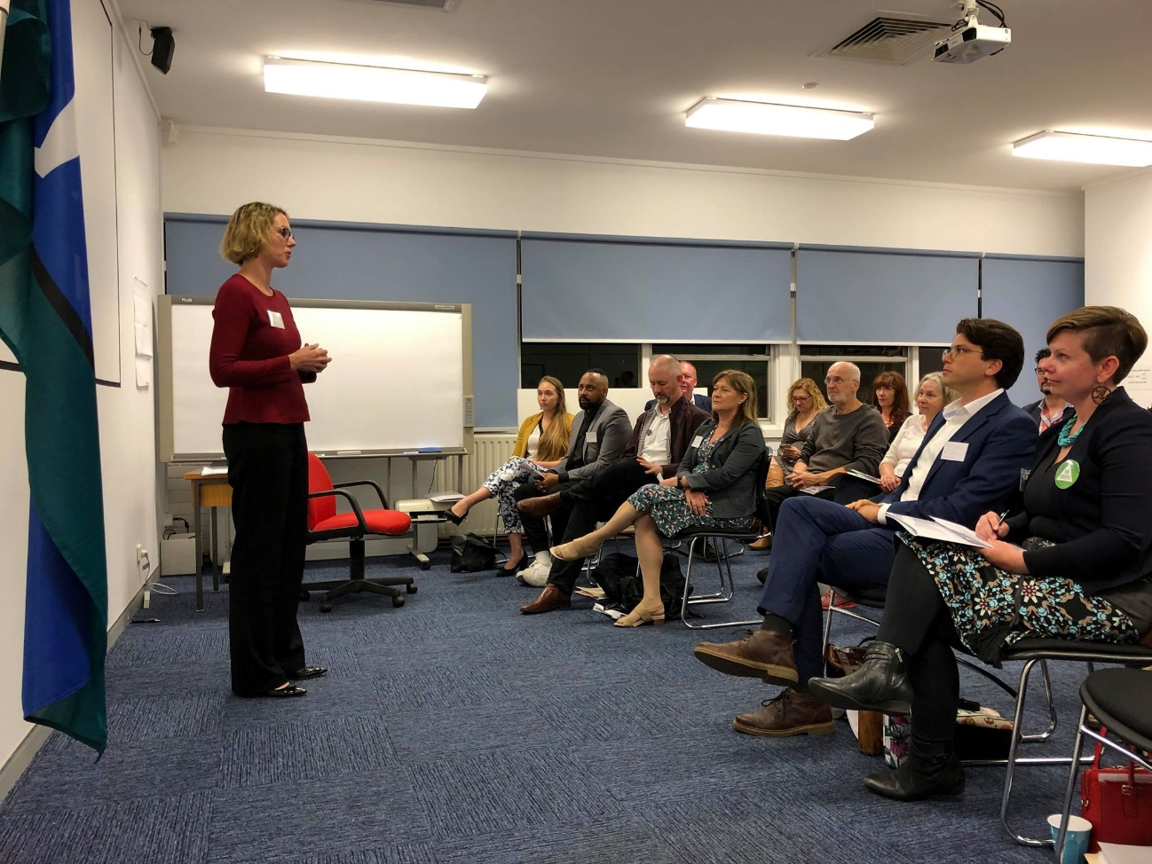

### Alicia Payne – Australian Labor Party for Canberra

Points raised:

* Social justice advocacy is a valuable tool/resource
* Social housing is a way to improve lives and make society fairer
* Social security is a tool to address poverty and disadvantage and Labor would look at Newstart via a ‘prompt’ review ‘as soon as we get into government’.

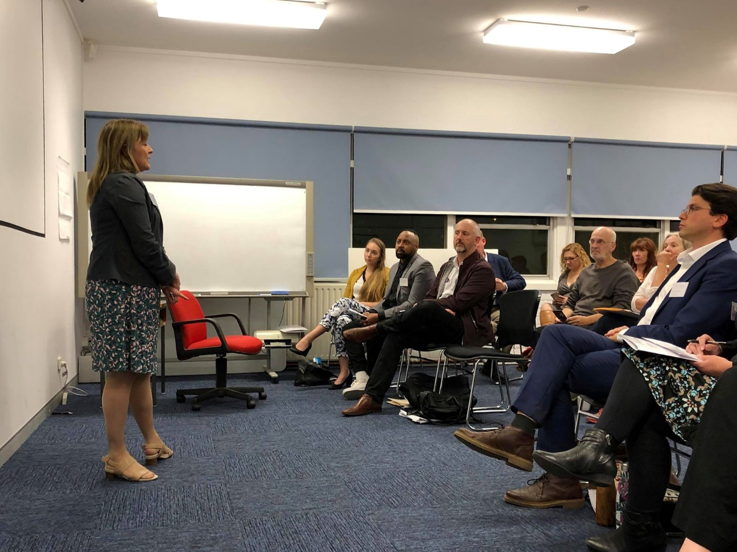

### Therese Faulkner – Australian Progressive for Bean

Points raised included:

* Need to address social security including raising Newstart and Pensions and more fairly taxing wealth
* Employment – addressing casualisation and lifting the amount of full-time work
* Tools to enable the society we want to live in include equality, empathy and empowerment.

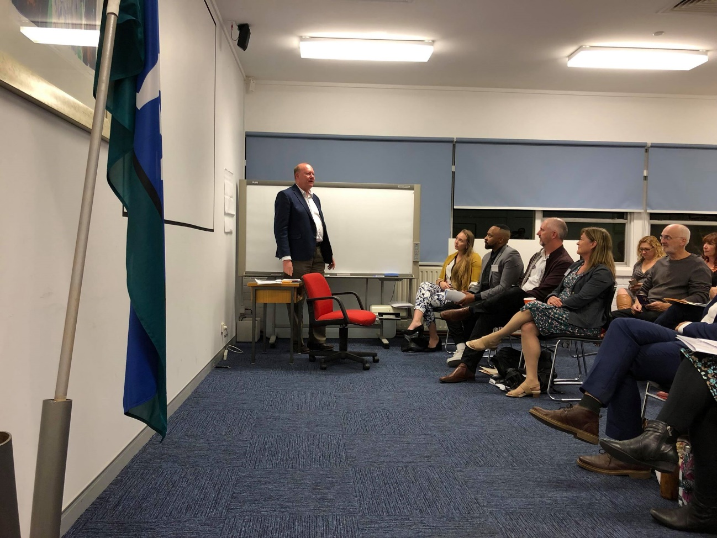

### Dr Jamie Christie – Independent for Bean

Points raised:

* Value of independents as a direct, honest voice
* Needing to sort out addressing climate change
* Need to pay more attention to health and infrastructure.

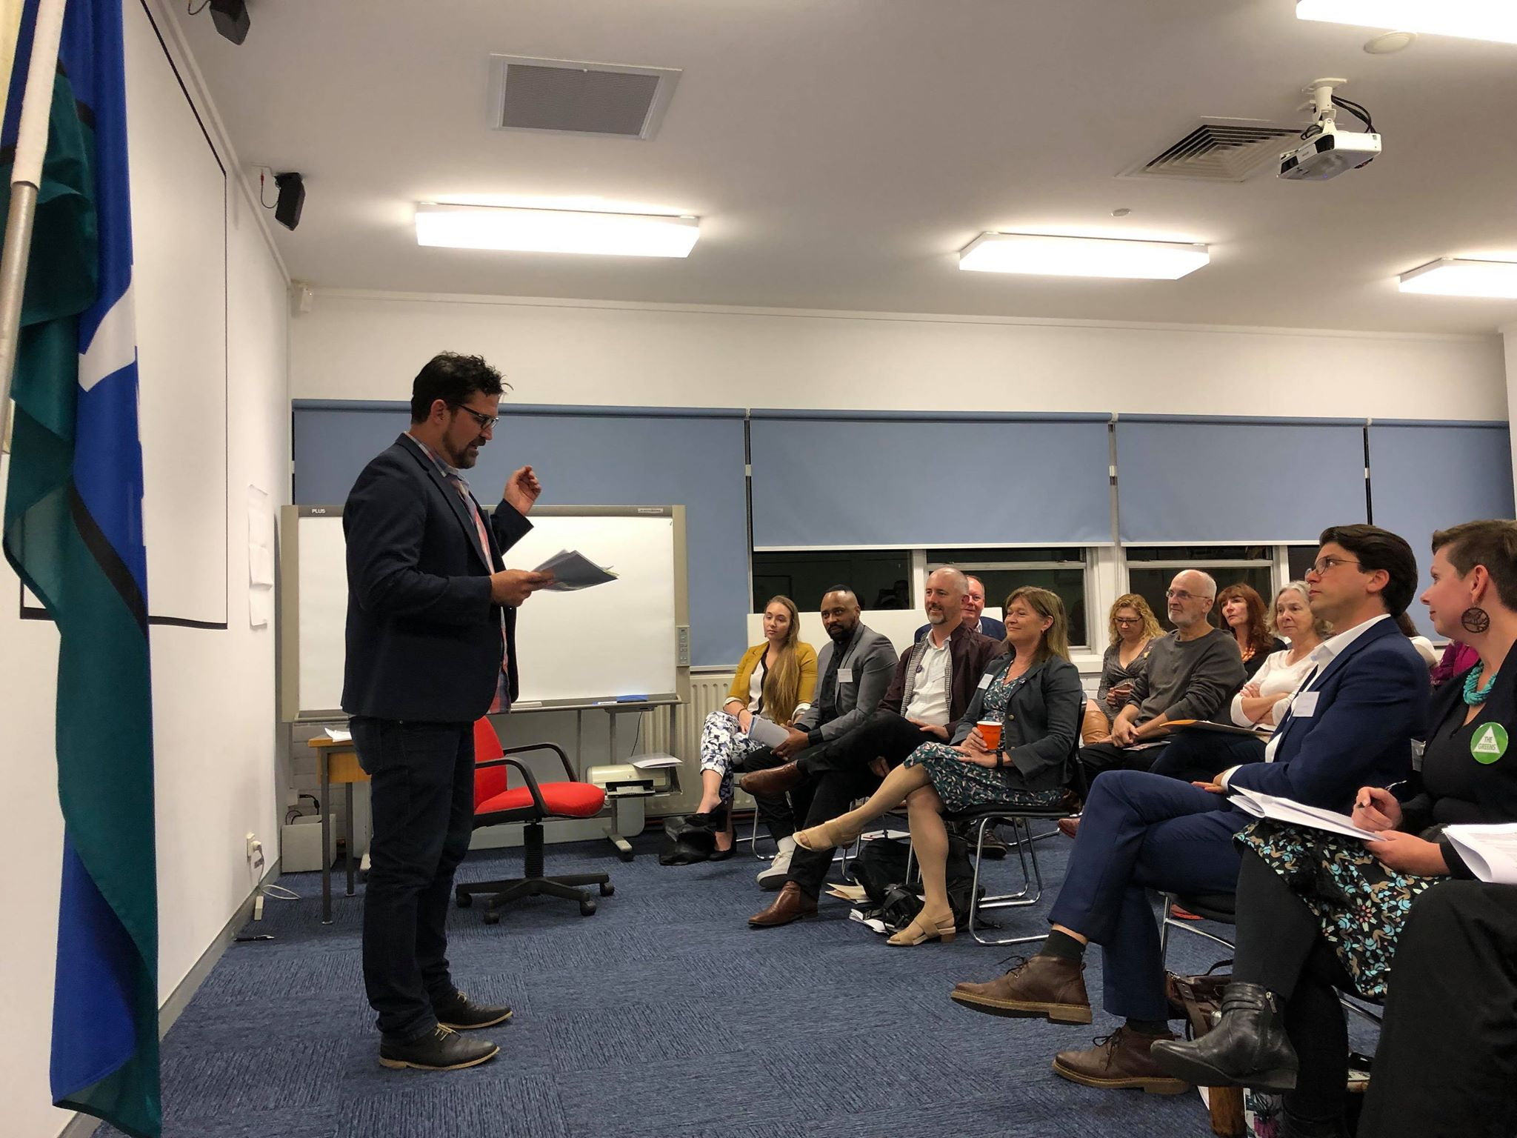

### Tim Bohm – Independent for Canberra

Points raised:

* Detailed connections and passions via arts, community sector, Parents and Citizens Council and as a sports coach
* Adequate and fair funding for the ACT
* Social security adequacy
* Direct democracy
* Housing and homelessness including funding for Safe Shelter.

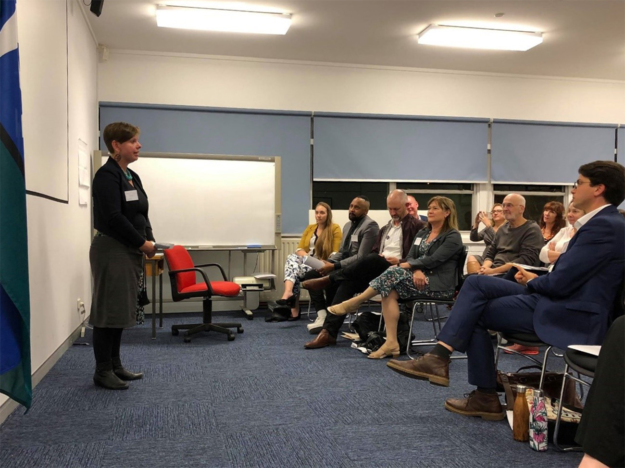

### Penny Kyburz – ACT Greens for the Senate

Points raised:

* Income support – immediate rise to Newstart and abolish punitive compliance programs
* Free TAFE and universities to lift job opportunities
* Affordable housing – part of universal human rights; need to grow social housing; back with tax reform and a housing first policy framework.

What the community said

During this session, candidates and members engaged in a dialogue centred around the electorate information including priorities from some ACT voters identified as part of an online project called ‘[The Perfect Candidate](https://theperfectcandidate.org.au/)’.

The Perfect Candidate is powered by the Australian Futures Project, who describe themselves as a nonpartisan, non-profit organisation dedicated to ending short-termism in Australia. The Australian Futures Project envisions a nation where all parts of society demand and work constructively toward decisions and actions that balance the immediate and long-term needs of the country.

The Perfect Candidate was developed from a survey of 125,000 Australians as an initiative of the Australian Futures Project with collaboration from Isobar, Cox Inall Change, Roy Morgan market research and The Centre for Data Analytics and Cognition at the La Trobe University Business School.

ACTCOSS presented these priorities as a catalyst for discussion at the electorate table groups. We asked our forum participants to discuss where their views differed, converged or matched those identified by The Futures Project survey, and to identify other priorities.

What follows is a summary of the electorate table group discussions. We also look at where hot topics discussed on electorate tables matched, sharpened or contrasted with the kinds of issues highlighted in The Futures Project survey.

We hope that presented together both the survey priorities and the brief discussions at the conversation tables provide an interesting and complimentary window into broad community concerns and some more granular issues.

## FENNER

|  |
| --- |
| **HOT TOPICS around the Fenner table included local experiences of service and funding gaps, concerns around costs of living, social security adequacy and compliance, employment opportunities, a lack of access to social and community infrastructure, worries about the quality of government, service and reform implementation and a belief that the quality and honesty of political conversation needed to improve and focus on real choices, especially in terms of revenue and climate change.**  **Conversation mostly aligned to The Perfect Candidate priorities, especially cost of living pressures, but there was a greater focus on service gaps and the quality of government administration and delivery, including healthy political conversation.** |

### The Perfect Candidate priorities

1. Keeping day to day living costs down (2 in 5 people agree)
2. Improving health services and hospitals (2 in 5 people agree)
3. Global warming and climate change (1 in 3 people agree)
4. Open and honest government (1 in 4 people agree)
5. Improving education (1 in 4 people agree).

### Table discussions

Specific issues and priorities for the incoming federal government discussed were as follows:

#### Service and funding gaps

* Improving education
* Gaps in the aged care system
* Funding for counselling
* Access to health care
* Lack of access to health services like Headspace. Also a need for investment in multiple programs (not just one preferred model to support improved mental health)
* Lack of locally based supports
* People in hospitals too long.

#### Concerns around costs of living, social security and employment

* Day to day living costs
* ‘Have a go to get a go’ isn’t an honest reflection of people’s experiences of casualised employment and social security
* Youth Allowance adequacy
* Criteria for Disability Support Pension is ever tightening
* Issues for women needing to get traction – even women in ‘good jobs’ are experiencing issues with living costs here in Canberra
* Struggles with homelessness and poverty by people in the electorate.

#### Access to planned social and community infrastructure

* Lack of physical, sensory and digital access to city infrastructure for older people and people with disabilities
* Governments need to prioritise investments for young people who don’t have access to local amenities
* Fenner has new suburbs and places with a lack of local infrastructure and commerce.

#### Quality of government, service and reform implementation

* Host of issues around the NDIS implementation and criteria – the criteria are not ‘nutted out’ sufficiently for people to access supports in a timely way
* Failures in services and honest government – one person observed in respect of human services that ‘systems are failing and we don’t know why’.

#### Political culture and conversations

* Need for voters to have and make real choices around investment priorities
* Need and hunger for honest political conversations – we need to tell truth around the consequences of self interest in policy (speaking of revenue and issues like climate)

#### Climate

* Global warming and climate change – just transition and mitigation especially in rural areas (also above).

## BEAN

|  |
| --- |
| **HOT TOPICS around the Bean table were poverty, employment and disadvantage (especially un/under/employment and concentrations of disadvantage); access to well-planned social and community infrastructure; local service gaps and the quality of focus on ACT needs as opposed to Canberra as the national capital.**  **Conversation mostly aligned to The Perfect Candidate priorities, especially cost of living pressures, but the discussion also saw a sharp focus on a number of community infrastructure and service gaps.** |

### The Perfect Candidate priorities

1. Keeping day to day living costs down (2 in 5 people agree)
2. Global warming and climate change (2 in 5 people agree)
3. Improving health services and hospitals (1 in 3 people agree)
4. Open and honest government (1 in 3 people agree)
5. Managing the economy (1 in 4 people agree).

### Table discussions

Specific issues and priorities for the incoming federal government discussed were as follows:

#### Poverty, employment and disadvantage

* Daily cost of living is important
* Free transport access
* Concentration of economic disadvantage
* Employment in Tuggeranong
* Employment for people with disabilities
* Need for focus on workplace inclusion.

#### Access to planned social and community infrastructure

* Infrastructure and planning
* Physical improvement in local amenities and the ‘public realm’
* Community planning in multiple places
* Healthcare and education in the community.

#### Local service gaps and access

* Needs of single mothers
* Ageing population – importance of health investments
* Homelessness.

#### Quality of focus on local needs

* ACT is a regional centre and we should talk about it like this instead of the ‘Canberra bubble’.

## CANBERRA

|  |
| --- |
| **HOT TOPICS at the Canberra table were housing, improving health services and service gaps in the National Disability Insurance Scheme.**  **In some contrast to the broader Perfect Candidate priorities, but consistent with a focus on improved health services, the discussion saw a sharp focus on housing, health and disability.** |

### The Perfect Candidate priorities

1. Global warming and climate change (1 in 2 people agree)
2. Improving education (1 in 3 people agree)
3. Open and honest government (1 in 3 people agree)
4. Improving health services and hospitals (1 in 3 people agree)
5. Keeping day to day living costs down (1 in 4 people agree).

### Table discussions

Specific issues and priorities for the incoming Federal Government discussed were as follows:

#### Housing

* Absence of housing from the health discourse is a problem and there was a need to see housing as a social determinant of health
* Need for action on the National Affordable Housing Agreement – currently is a per capita funding model. ACT would get fairer funding via a per dwelling funding model
* Housing is priority issue – need for more accessible and affordable housing
* Options in housing as a human right, not an investment.
* Security of tenure
* Engagement in community and in the people that will use the housing
* Comment – ‘the design and build people aren’t the people who live in or use the housing’.

#### Improving health services

* Improving health services, especially addressing a lack of bulk billing GPs, a lack of supply for people with limited mobility and the need for home visiting and responses by a stretched community transport system.

#### National Disability Insurance Scheme

* NDIS gaps including cuts to transport allowances and eligibility limits which particularly disadvantage women entrants.

# What candidates heard

In the time remaining, we briefly invited each candidate to tell us *one thing* that they learnt or heard that surprised them or was likely to sustain a lasting impression if they were elected. This was [livestreamed](https://www.facebook.com/actcoss/videos/414672352645743/) via Facebook. Here is a recap of what they said:

Therese Faulkner – Australian Progressive for Bean

Issues for women and accessibility of services for a wide range of women, single mothers and people living alone.

Dr Jamie Christie – Independent for Bean

Level of disadvantage that was clustered in the electorate and need to address in multiple ways.

Tim Bohm – Independent for Canberra

Level of housing stress in the electorate and the need for more safe housing including women’s refugees.

Kagiso Ratlhagane – Australian Progressives for Fenner

Open, honest and ethical government, having preventative mental health practices and fixing NDIS to better serve community.

Robert Knight – Australian Progressives for Canberra

Ongoing lack of recognition and action on housing and its relation to health and mental health.

Alicia Payne – Australian Labor Party for Canberra

Need for accessible emergency accommodation and idea of housing as a social determinant of health, and need for budgets to look at effects and benefits of investment in social programs and prevention.

Penny Kyburz– ACT Greens for the Senate

Affordable housing, access to services and its intersectional impacts on young people, women and disabled people. Need for a community conversation about how much poverty and homelessness is acceptable and need to invest in all people so that people have basic needs met.

Tim Hollo – ACT Greens for Canberra

Access to health services and housing as a social determinant of health. Gendered access to NDIS – many women with disabilities have less visible disabilities. Because housing is so expensive in Canberra, can be in housing stress even if you have quite a reasonable income.

# What next?

ACTCOSS is working closely with ACOSS to advance national community priorities during the election campaign. You can follow progress here including via the [ACOSS policy tracker here](https://www.acoss.org.au/2019-election-policy-tracker/).

We are releasing the reflections in this report publicly and disseminating them to candidates who attended the forum and those that were unable to attend. Going forward, we will engage with and present these community reflections and priorities to each of the incoming members of the House of Representatives and senators for the Australian Capital Territory.

ACT Council of Social Service Inc. | Weston Community Hub, 1/6 Gritten St, Weston ACT 2611  
Ph: 02 6202 7200 | actcoss@actcoss.org.au | www.actcoss.org.au

ACTCOSS is committed to reconciliation, acknowledges the traditional custodians of the land and pays respect to elders past and present.

ACTCOSS represents not-for-profit community organisations and advocates for social justice in the ACT.

1. Candidates in the order they appeared via random draw.