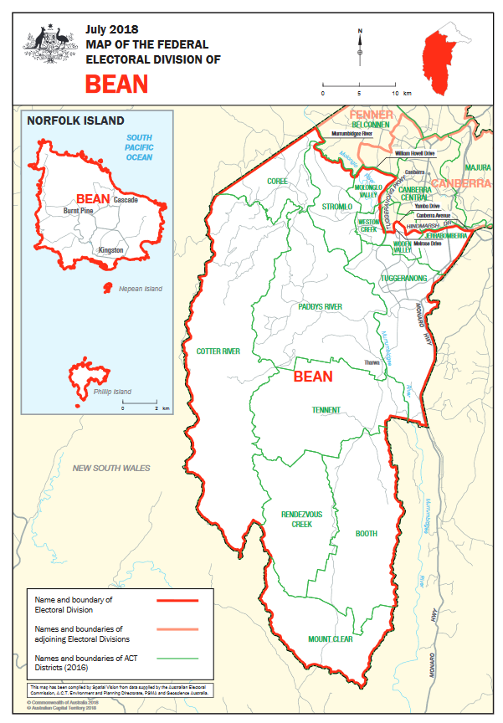 SEAT OF BEAN

Top Five Bean priorities?

Which suburbs are in Bean?

1. **Keeping day to day living costs down**(2 in 5 people agree)
2. **Global warming and climate change**(2 in 5 people agree)
3. **Improving health services and hospitals** (1 in 3 people agree)
4. **Open and honest government**(1 in 3 people agree)
5. **Managing the economy**(1 in 4 people agree)

**WHAT TO DO?**

These are the top priorities for the seat of Bean identified from a survey of 125,000 voters by the Australian Futures Foundation (with Roy Morgan Research).

🡺 In your groups you might want to **discuss whether these align with your priorities** with candidates and what you’d like done about them.

🡺If you agree, disagree or identify other specific **Bean priorities, please write them down** and **place these on this map** using your sticky notes.

We’ll collect, collate and include this information in our summary from today which will be made public and also help shape our advice to the next member for Bean.

See <https://theperfectcandidate.org.au/about> for more information on ‘The Perfect Candidate’.

Banks, Belconnen District, Bonython, Booth District, Calwell, Chapman, Chifley, Chisholm, Conder, Coombs, Coree District, Corin Dam, Cotter Dam, Cotter River District, Denman Prospect, Duffy, Fadden, Farrer, Fisher, Gilmore, Gordon, Gowrie, Greenway, HMAS Harman, Holder, Hume, Isaacs, Isabella Plains, Jerrabomberra District, Kambah, Macarthur, Mawson, Molonglo Valley District, Monash, Mount Stromlo, Norfolk Island, O'Malley, Oxley, Paddys River District, Pearce, Phillip, Pierces Creek, Rendezvous Creek District, Richardson, Rivett, Royalla, Stirling, Stromlo, Stromlo District, Swinger Hill, Symonston, Tennent District, Tharwa, Theodore, Torrens, Tuggeranong District, Uriarra, Wanniassa, Waramanga, Weston, Weston Creek District, Williamsdale and Wright

BEAN FACTS

|  |  |  |
| --- | --- | --- |
| **POVERTY** | **HOUSING STRESS** | **SPOTLIGHT** |
| **7.1% of people in Bean live in poverty** and 11% of children live in poverty.  *Source: NATSEM Policy Note 2019/2 data file.* | **6.1% of citizens in Bean live in housing stress**; 9.1% of children are in housing stress; 15.4% of renter households in housing stress and 4.6% of mortgage households in housing stress.    *Source: NATSEM Policy Note 2019/2 data file.* | Bean has the **highest proportion of Aboriginal and/or Torres Strait Islander people** of any Canberra electorate.  The electorate of Bean includes Norfolk Island  *Source: AEC.* |

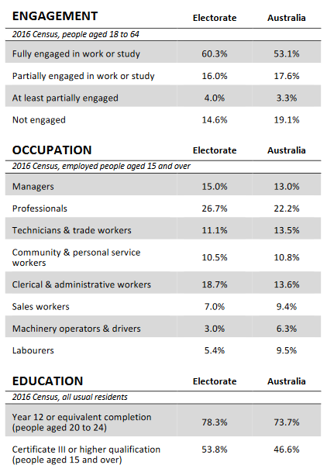

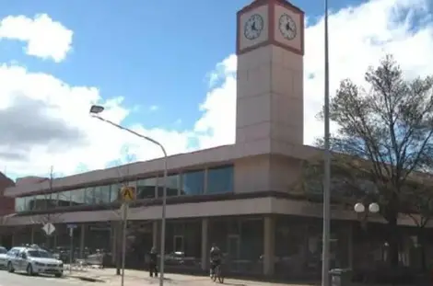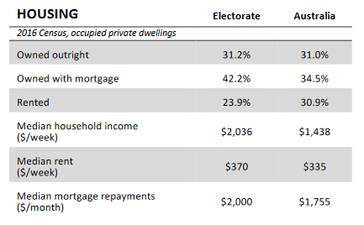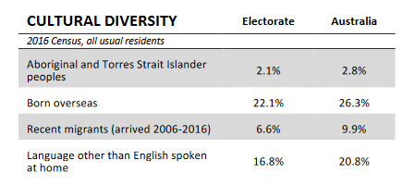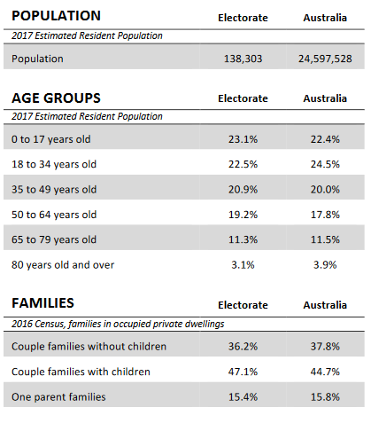

Tables from Australian Electoral Commission Commonwealth Electoral Division profile produced using information from the 2017 Estimated Resident Population and the 2016 Census of Population and Housing. Image from, Skatermaps.