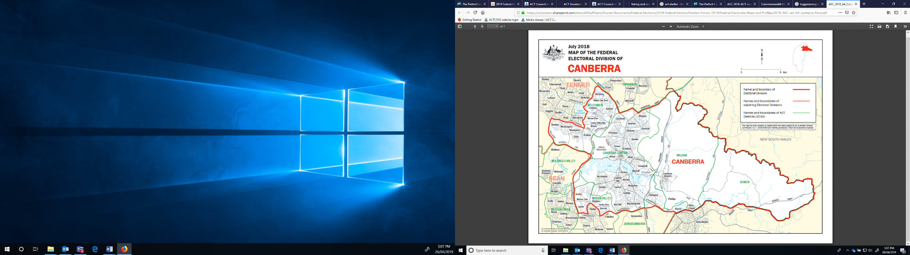 SEAT OF CANBERRA

Top Five Canberra priorities?

1. **Global warming and climate change**(1 in 2 people agree)
2. **Improving education**(1 in 3 people agree)
3. **Open and honest government**(1 in 3 people agree)
4. **Improving health services and hospitals**(1 in 3 people agree)
5. **Keeping day to day living costs down**(1 in 4 people agree)

**WHAT TO DO?**

These are the top priorities for the seat of Canberra identified from a survey of 125,000 voters by the Australian Futures Foundation (with Roy Morgan Research).

🡺 In your groups you might want to **discuss whether these align with your priorities** with candidates and what you’d like done about them.

🡺If you agree, disagree or identify other specific **Canberra** **priorities please write them down** and **place these on this map** using your sticky notes.

We’ll collect, collate and include this information in our summary from today which will be made public and also help shape our advice to the next member for Canberra.

See <https://theperfectcandidate.org.au/about> for more information on ‘The Perfect Candidate’.

Which suburbs are in Canberra?

Acton, Ainslie, Aranda, Barton, Beard, Belconnen District, Braddon, Bruce, Campbell, Canberra Airport, Canberra Central, Canberra City, Cook, Curtin, Deakin, Dickson, Downer, Forrest, Fyshwick, Garran, Giralang, Griffith, Hackett, Hawker, Hughes, Kaleen, Kingston, Kowen District, Kowen Forest, Lawson, Lyneham, Lyons , Macquarie, Majura District, Molonglo Valley District, Narrabundah, Oaks Estate, O'connor, Parkes, Pialligo, Red Hill, Reid, Symonston, Turner, Watson, Weetangera,   
Weston Creek District, Yarralumla

CANBERRA FACTS

|  |  |  |
| --- | --- | --- |
| **POVERTY** | **HOUSING STRESS** | **SPOTLIGHT** |
| Canberra has the second highest poverty rate of all three divisions at 8.9% and the highest **child poverty rate** at 13.9%.  *Source: NATSEM Policy Note 2019/2 data file.* | There are 7.1% of people in housing stress in the seat of Canberra with 9.7% of children in housing stress; 15.8% of renter households in housing stress (level pegging with Fenner) and 3.2% of mortgage households in housing stress.  *Source: NATSEM Policy Note 2019/2 data file.* | The division of Canberra is the ACT seat with the **highest number of rented households**  It also has the **lowest proportion of children but the highest of people between 18-14.**  *Source: AEC.* |

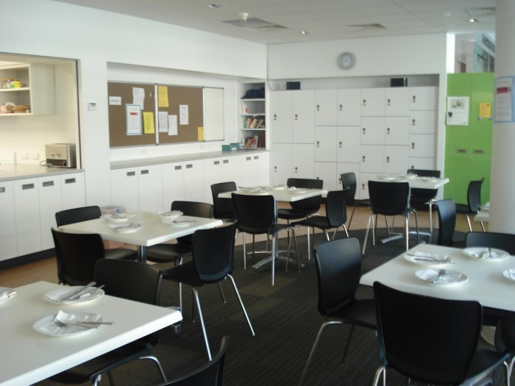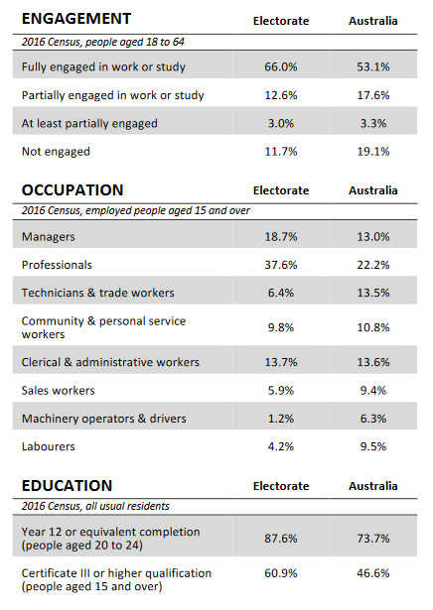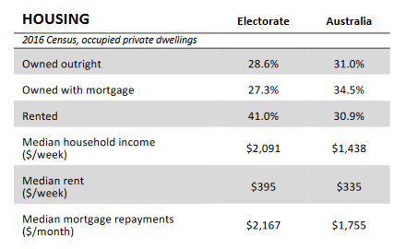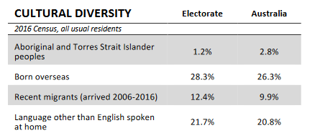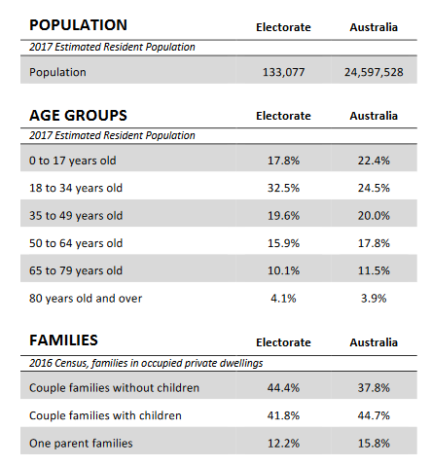

Tables from Australian Electoral Commission Commonwealth Electoral Division profile produced using information from the 2017 Estimated Resident Population and the 2016 Census of Population and Housing. Image of Early Morning Centre via Volunteering and Contact ACT.