Logo: ACT Council of Social Service Inc. (ACTCOSS).Factsheet

June 2019

Energy affordability and hardship in the ACT

Energy prices in the ACT have increased significantly in the last decade. Households living with low incomes or experiencing disadvantage pay disproportionately more of their income on energy than the average household. Low-income households face poverty premiums especially in terms of not being able to make modifications or purchase technologies to make their dwellings more energy efficient. There needs to be a just transition to adapt to climate change that reduces the disproportionate burden on low-income households. The development of appropriate policy solutions needs to be informed by a better understanding of those households most impacted by high energy prices.

# Energy affordability

According to the Australian Energy Regulator (AER), the ACT had the most affordable electricity in terms of percentage of income spent on energy ($1,501, 4.7%) in 2017-18. At the same time, the ACT recorded the highest market contract price rises for both electricity (22.6%) and gas (16.8%). The ACT also has high levels of energy use. The Energy Security Board has classified the current status of electricity affordability as ‘critical’, with ‘household electricity costs [having] increased by 56% in real terms over the past 10 years, much faster than wages growth or inflation’.[1]

Changes in electricity, gas and All Groups CPI, Canberra, December 2008 to   
December 2018

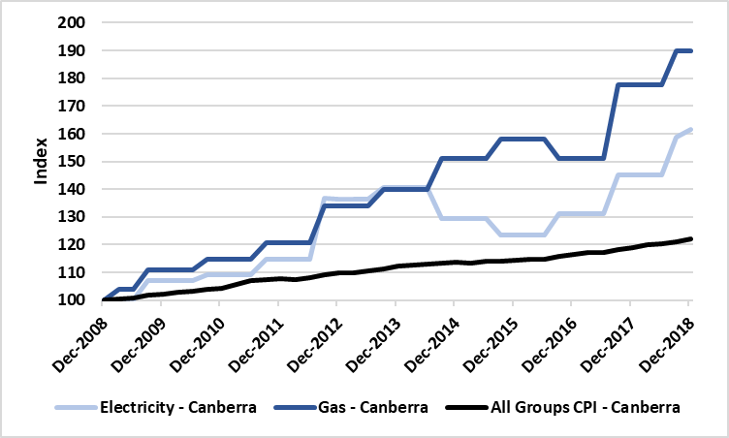

The 2019 *ACT Cost of Living Report* published by ACTCOSS found that electricity and gas prices rose by 11.2% and 6.8% respectively from December 2017 to December 2018 – this was above the national rates of 1.8% and 3.2%.[2] Over the past decade both electricity and gas prices have risen well above the overall CPI in Canberra, with gas prices rising more than electricity.

Increases in energy prices impact disproportionately on low-income households as a greater proportion of their income and expenditure is spent on energy. These households are more likely to experience energy stress which can result in households ‘going without heating and cooling, meals, and other basic essentials in order to afford their energy bills’.[3] A quarter of people receiving Newstart and similar allowances spend more than 9.7% of their income on energy.[4] On average, people in the lowest 20% of the income distribution spend 6.4% of their income on energy, a quarter spend more than 8.8% on energy.[5]

Energy expenditure by equivalised disposable income quintiles

|  | Lowest | Second | Third | Fourth | Highest |
| --- | --- | --- | --- | --- | --- |
| Average Weekly Expenditure – ACT | $42.22 | $51.78 | $44.37 | $41.00 | $56.21 |
| Proportion of Total Goods and Services Expenditure – ACT | 4.0% | *4.4% | 3.0% | 2.2% | 2.4% |
| Proportion of income – Australia | 6.4% | 3.8% | 2.8% | 2.3% | 1.5% |

* estimate has a relative standard error of 25% to 50% and should be used with caution.  
Sources: ABS*, Household expenditure survey, Australia, Summary of results, 2015-16*, ABS, Canberra, 2017, Table 21.1 Household expenditure, Broad expenditure groups, Equivalised disposable household income quintiles, ACT; ACOSS, Brotherhood of St Laurence & ANU Centre for Social Research and Methods, *Energy stressed in Australia*, ACOSS, Sydney, 2018, p. 4.

AER data from 2015-16 to 2017-28 shows that the proportion of income spent on electricity and gas by low-income households in the ACT has increased, and is higher than the proportion spent by middle-income households.[6] In 2017-18, low-income households in the ACT spent 4.7% of their income on electricity and 4.3% on gas compared to 2.0% and 2.5% in middle-income households.[7]

Annual electricity bills for low income households (with concession) on a median market offer 2015-16 to 2017-18, ACT

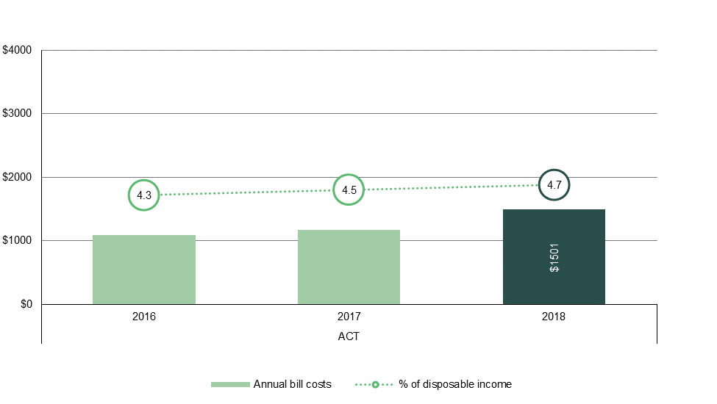

Annual gas bills for low income households (with concession) on a median market offer 2015-16 to 2017-18, ACT

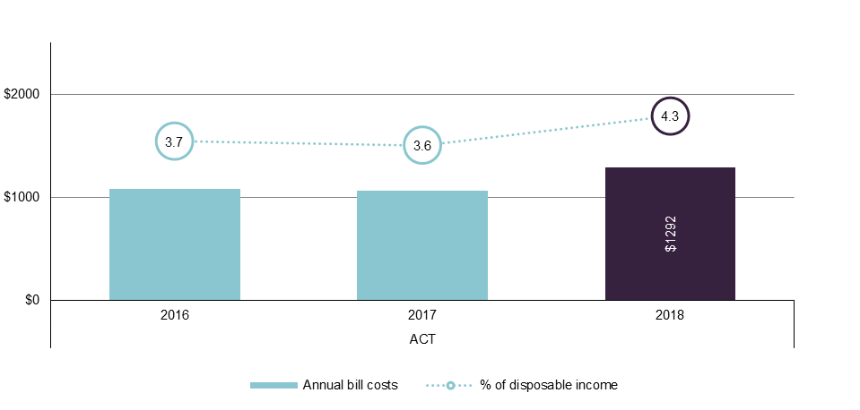

Source: adapted from AER, *Annual report on compliance and performance of the retail energy market 2017-18 - Chapter 1 2 3 5 and 6 tables and charts*, AER, Melbourne, 2018, Figs 5.10 & 5.14, viewed 19 June 2019, <<https://www.aer.gov.au/retail-markets/performance-reporting/annual-report-on-compliance-and-performance-of-the-retail-energy-market-2017-18>>.

# Poverty premiums and energy efficiency

Being poor can cost extra money as people on low incomes have costs that others with more money and resources can buy their way out of, avoid or minimise – this is referred to as a poverty premium.[8]

Disadvantage in the ACT tends to be hidden behind high averages across indicators such as income, education, and employment. Closer analysis reveals that a sizeable number of people in the ACT do experience poverty and disadvantage, with many experiencing multiple disadvantage.[9] It is estimated that 25,800 people are living below the poverty line in the ACT (representing 7.7% of the population).[10] The number of people who struggle with energy stress is likely to be much higher than the poverty figures.[11] An estimated 37,000 people in the ACT live in households with an income below $500 per week.[12]

One poverty premium that low-income households face is not being able to access discounts for paying on time or by direct debit. Digital exclusion (including not having the internet at home) may also prevent people from accessing online-only discounts. Additional costs may also be incurred if they are unable to pay their bill on time.

Another poverty premium arises where they are unable to save and often live in housing that has poor energy efficiency. Low- and fixed-income renters or homeowners tend not to be able to afford investments in their housing to reduce energy usage. Renters are reliant on property owners’ willingness and ability to approve or invest in such improvements. The ACT Government and ACTCOSS have produced a factsheet for landlords and property managers on reducing energy and water costs in rental properties.[13]

A 2018 report from Better Renting estimated the cost of poor energy efficiency in rental housing in the ACT:

For an average-sized property with an EER of 0, it would cost $2,800 to produce the same amount of heat that would be free in a property with an EER of 5. To put it another way, renters in such a property are being frozen out of free heat equivalent to running two 2000W electric heaters 24/7 from mid-May to September. We estimate that the ACT has roughly 24,000 rental properties that would attain an EER lower than 5. With an average household burden of just over $1,600, the total burden borne by all ACT renters living in energy-deficient properties is equivalent to over $39,000,000.[14]

The Energy Efficiency Improvement Scheme (EEIS) is an ACT Government initiative that places a requirement on electricity retailers to achieve energy savings in households and small-to-medium businesses.[15] A target has been placed on these retailers to ensure a proportion of the savings are delivered to low-income households.[16] To ensure that low-income households can benefit, Tier 1 retailers (ActewAGL) are obliged to deliver a proportion of their energy saving obligations from eligible activities in priority households. The priority household target was set at 20% from 2017 to 2019. This has been increased to 30% for 2020 to encourage retailers to provide more opportunity for low-income households to participate in the scheme. An eligible priority household is defined in the dictionaries of the Energy Efficiency (Cost of Living) Improvement Act 2012 (ACT).[17] A total of 19,381 priority households received EEIS activities from 2013 to 2016.[18] Commentary in advance of the ACT Budget 2016-17 stated that ‘concessions play an important role in supporting around 30,000 Canberra households, and the need for support is increasing’.[19] With approximately 156,000 households in the ACT in 2017, over 19% of Canberra households fit the definition of EEIS priority households. This suggests that about two-thirds of ACT priority households had received EEIS benefits by 2017.[20] The 2014 review of the EEIS confirmed average savings through the EEIS of $318 per year with total savings of $1,614 per household.[21]

# Energy hardship

Households that are struggling to pay their bills will often pay late and/or enter into debt if they do not have money available when their bills fall due. The AER monitors figures on the energy-related debt that results from customers not paying their bills on time. The AER reported that in the ACT in 2017-18, 3.2% of non-hardship residential electricity customers were in debt, with an average debt of $886.09. The proportion of non-hardship residential gas customers in debt was 3.8%, with an average debt of $628.75.[22]

The AER data as at June 2018 shows that 987 (0.6%) residential electricity customers and 636 (0.5%) residential gas customers were accessing hardship programs.[23] The ACT rate of hardship assistance for electricity is the lowest in the National Electricity Market.[24] In 2017-18, the average debt on entry to hardship schemes was $1,617.33 for electricity and $1,448.53 for gas.[25] The hardship programs being referred to in these statistics are delivered by the three energy retailers in the ACT: ActewAGL, Energy Australia and Origin Energy.

The AER data does not take account of those being assisted through the ACT Civil and Administrative Tribunal (ACAT) Energy and Water Hardship Program.[26] As at 30 April 2018, the program had the following number of households registered:

* Electricity: 571 households (this is a ***decrease*** in numbers since December 2016 when 622 households were accessing the program)
* Gas: 279 households (this is an ***increase*** in numbers since December 2016 when 128 households were accessing the program).[27]

ACAT new applications in the 2017-18 financial year to 30 April 2018:

* Electricity: 267 households
* Gas: 199 households.[28]

When people are unable to pay their energy bills, one of the more serious outcomes is disconnection. The Australian Energy Regulator (AER) reports that in 2017-18 there were 501 (0.29%) residential electricity and 433 (0.36%) gas customers in the ACT disconnected for non-payment.[29] A study of electricity disconnections in South Australia, Victoria, New South Wales and South East Queensland found that low-to-median income families and small households experiencing housing stress or greater transport costs were particularly vulnerable to being disconnected.[30]

# Hardship programs, payment plans and concessions

Hardship programs are an important means of avoiding disconnection for those struggling to pay their energy bills. Under the Retail Law, authorised retailers must develop, maintain and implement customer hardship policies for their residential customers – these must be in accordance with the AER’s *Customer Hardship Policy Guideline*.[31] Energy retailers must publish their customer hardship policies on their websites.

Payment plans are one of the main ways that energy retailers can help customers who are experiencing financial difficulties to better manage their energy bills. Under the National Energy Retail Law and Rules, energy retailers must establish payment plans by having regard to a customer’s capacity to pay, any amount they owe, and how much energy they expect to use over the next year. ACT energy retailers have adopted the AER’s *Sustainable Payment Plans Framework* which is designed to help residential customers and retailers agree to payment plans that are sustainable and affordable.[32]

Your retailer cannot disconnect you if you are actively participating in their hardship program or if you are sticking to your agreed payment plan. Disconnection of your energy supply should be a last resort option for your energy retailer.[33] There are rules around what a retailer must do before it takes this action, including providing you with reminders and a disconnection warning notice.

Concessions and efficiency-improvement measures help improve energy affordability for low-income households and avoid hardship and possible disconnection. The ACT Government offers a Utilities Concession for concession card holders which is applied for through your energy provider. For 2018-19, the annual concession was $654 – this will increase to $700 (from 1 July 2019).[34] Actsmart is a one-stop-shop for ACT Government programs and assistance developed to help save energy and water, reduce waste and cut greenhouse gas emissions. Actsmart offers a Low Income Household Program as a free in-home service to identify ways to reduce energy bills and a Solar for Low Income Program to assist eligible households to invest in rooftop solar panels.[35]

As mentioned above, the ACT Government’s Energy Efficiency Improvement Scheme places a requirement on electricity retailers to achieve energy savings in households and small-to-medium businesses.[36]

Better Renting is an ACT not-for-profit organisation that advocates for stable, affordable and liveable homes for renters. Similar to Actsmart’s Low Income Household Program, Better Renting’s *Home Truths* initiative includes home visits to rental households to identify ways to reduce energy bills, improve home comfort, and reduce climate pollution.[37]

ACT Council of Social Service Inc. | Weston Community Hub, 1/6 Gritten St, Weston ACT 2611  
Ph: 02 6202 7200 | actcoss@actcoss.org.au | www.actcoss.org.au

ACTCOSS is committed to reconciliation, acknowledges the traditional custodians of the land and pays respect to elders past and present.

ACTCOSS represents not-for-profit community organisations and advocates for social justice in the ACT.

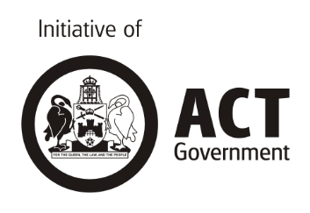

1. Energy Security Board, *The Health of the National Electricity Market, 2018*, COAG Energy Council, Canberra, 2018, p. 7, viewed 19 June 2019, <<http://www.coagenergycouncil.gov.au/sites/prod.energycouncil/files/publications/documents/the%20health%20of%20the%20national%20electricity%20market%20-%202018.pdf>>.
2. ACTCOSS, *ACT Cost of Living Report*, ACTCOSS, Canberra, May 2019, p.9, viewed 18 June 2019, <<https://www.actcoss.org.au/publications/advocacy-publications/act-cost-living-report-2019>>.
3. ACOSS, Brotherhood of St Laurence & ANU Centre for Social Research and Methods, *Energy stressed in Australia*, ACOSS, Sydney, 2018, p. 4, viewed 1 May 2019, <<https://www.acoss.org.au/wp-content/uploads/2018/10/Energy-Stressed-in-Australia.pdf>>.
4. ibid.
5. ibid.
6. AER, *AER Retail Report Jurisdictional Dashboards 2017-18*, AER, Melbourne, 2018, viewed 19 June 2019, <<https://www.aer.gov.au/retail-markets/performance-reporting/annual-report-on-compliance-and-performance-of-the-retail-energy-market-2017-18>>.
7. ibid.
8. SACOSS, *Poverty premiums (infographic)*, SACOSS, Adelaide, 2017, viewed 19 June 2019, <<https://www.sacoss.org.au/sites/default/files/public/documents/Reports/APW%20Statements/APW_Fact_Sheet_A4_FINAL.pdf>>.
9. R Tanton, R Miranti & Y Vidyattama, *Hidden disadvantage in the ACT: report for ACT Anti-Poverty Week*, NATSEM, Institute for Governance and Policy Analysis (IGPA), University of Canberra, Canberra, October 2017, accessed 13 April 2018, <<http://www.actcoss.org.au/publications/advocacy-publications/hidden-disadvantage-act-report-anti-poverty-week-2017>>.
10. P Davidson, P Saunders, B Bradbury & M Wong, *Poverty in Australia, 2018*, ACOSS/UNSW Poverty and Inequality Partnership Report No. 2, ACOSS, Sydney, 2018, p. 12, viewed 1 April 2019, <<https://www.acoss.org.au/wp-content/uploads/2018/10/ACOSS_Poverty-in-Australia-Report_Web-Final.pdf>>; B Bradbury, email, 16 October 2018.
11. ACOSS, Brotherhood of St Laurence & The Climate Institute, *Empowering disadvantaged households to access affordable, clean energy*, ACOSS, Brotherhood of St Laurence & The Climate Institute, 2017, <<http://www.acoss.org.au/wp-content/uploads/2017/07/ACOSS_BSL_TCI_Empowering-households.pdf>>.
12. R Tanton, R Miranti & Y Vidyattama, *Hidden disadvantage in the ACT: report for ACT Anti-Poverty Week*, NATSEM, University of Canberra, Canberra, October 2017, viewed 1 April 2019, <<https://www.actcoss.org.au/publications/advocacy-publications/hidden-disadvantage-act-report-anti-poverty-week-2017>>.
13. ACT Government & ACTCOSS, *Reducing energy and water costs in rental properties*, ACT Government, Canberra, 2013, viewed 19 June 2019, <<https://www.actsmart.act.gov.au/__data/assets/pdf_file/0018/503109/201301010-Landlord-factsheet-updated.pdf>>.
14. Better Renting, Frozen out: The Burden of Energy Deficiency on People who Rent, Better Renting, n.d. <<https://d3n8a8pro7vhmx.cloudfront.net/betterrenting/pages/112/attachments/original/1530085206/Frozen_out_The_Burden_of_Energy_Deficiency_on_People_who_Rent_Better_Renting.pdf?1530085206>>.
15. ACT Government, *Energy Efficiency Improvement Scheme* (website), viewed 19 June 2019, <<https://www.environment.act.gov.au/energy/smarter-use-of-energy/energy-efficiency-improvement-scheme>>.
16. For the definition of priority households visit: <<https://www.environment.act.gov.au/energy/smarter-use-of-energy/energy-efficiency-improvement-scheme/how-the-scheme-works/priority-household-target>>.
17. This legislation is available at: <<https://www.legislation.act.gov.au/a/2012-17/default.asp>>.
18. ACT Government, Energy Efficiency (Cost of Living) Improvement (Priority Household Target) Determination 2017, *Regulatory Impact Statement to set 2018 Priority Household Target*, ACT Government, 2017, p. 8, viewed 19 June 2019, <<http://www.legislation.act.gov.au/di/2017-251/default.asp>>.
19. ibid, pp. 8-9.
20. ibid, p. 9.
21. ibid, p. 8.
22. AER, op. cit., pp. 53 & 55.
23. ibid, p. 61; Australian Energy Regulator, *AER Retail Report Appendices2017-18 (excel version)*, AER, 2018, Appendix 3: Hardship, Tables 7.9 & 7.10, viewed 18 June 2019, <<https://www.aer.gov.au/retail-markets/performance-reporting/annual-report-on-compliance-and-performance-of-the-retail-energy-market-2017-18>>.
24. AER, op. cit.
25. ibid, p. 63.
26. ACAT, website, viewed 19 June 2019, <<http://acat.act.gov.au/application-type/energy_water>>.
27. Data provided by ACAT to ACTCOSS, May 2018.
28. ibid.
29. Australian Energy Regulator (AER), *Annual report on compliance performance of the retail energy market 2017-2018,* AER, Melbourne, 2018, pp. 65 & 66, viewed 22 May 2019, <<https://www.aer.gov.au/retail-markets/performance-reporting/annual-report-on-compliance-and-performance-of-the-retail-energy-market-2017-18>>.
30. St Vincent de Paul Society and Alviss Consulting, *Households in the Dark: mapping electricity disconnections in South Australia, Victoria, New South Wales and South East Queensland*, St Vincent de Paul Society, 2016.
31. AER, *AER Customer Hardship Policy Guideline*, Version 1, AER, Melbourne, March 2019, viewed 20 June 2019, <<https://www.aer.gov.au/retail-markets/retail-guidelines-reviews/customer-hardship-policy-guideline>>.
32. AER, *Sustainable Payment Plans Framework*, Version 1, AER, Melbourne, July 2016, viewed 20 June 2019, <[https://www.aer.gov.au/consumers/my-energy-bill/experiencing-trouble-paying-your-energy-bills#sustainable-payment-plans-framework](https://www.aer.gov.au/consumers/my-energy-bill/experiencing-trouble-paying-your-energy-bills%23sustainable-payment-plans-framework)>.
33. AER, *Energy disconnections* (website), viewed 20 June 2019, <<https://www.aer.gov.au/consumers/my-energy-service/energy-disconnections>>.
34. ACT Government, *Utilities concession* (website), visited 19 June 2019, <<https://www.revenue.act.gov.au/community-assistance/utilities-concession>>.
35. ACT Government, *Actsmart Low Income Household Program* (website) and *Actsmart Solar for Low Income Program* (website), viewed 20 June 2019, <<https://www.actsmart.act.gov.au/what-can-i-do/homes/Actsmart-household-energy-efficiency-program>>.
36. ACT Government, *Energy Efficiency Improvement Scheme* (website), viewed 19 June 2019, <<https://www.environment.act.gov.au/energy/smarter-use-of-energy/energy-efficiency-improvement-scheme>>.
37. Better Renting, *Home Truths* (website), viewed 20 June 2019, <<https://www.betterrenting.org.au/home_truths>>.