

ACT Council of Social Service Inc. (ACTCOSS) logo. Gulanga Program logo.

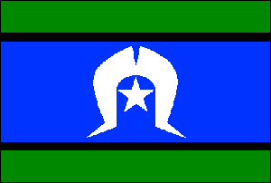

Canberra & District

NAIDOC Awards 2019

Canberra & District Aboriginal &/or Torres Strait Islander Community Sector Worker of the Year

Since 2006, the ACT Council of Social Service (ACTCOSS) has coordinated the Canberra & District Aboriginal and/or Torres Strait Islander Community Sector Worker of the Year Award (please turn over for the Nomination Form). This award recognises Aboriginal and Torres Strait Islander volunteers and workers at the forefront of this vital work. The award will be presented to the recipient at the ACT NAIDOC Ball at the Canberra Arboretum on 29th June 2019.

**Eligibility Guidelines:**

1. Nominees must be of Aboriginal and/or Torres Strait Islander descent.
2. Nominees must volunteer or be employed in the ACT & region, in the community sector or within a non-government agency that works with the local community.

Please include as much information and detail to demonstrate:

* How the nominee is providing links between their organisations and their Aboriginal and/or Torres Strait Islander communities.
* How they have supported Aboriginal and Torres Strait Islander communities through their work.
* Any achievements such as further education, training, and leadership. (optional)
* Any information on maintaining connections with their community and culture. (optional)  
  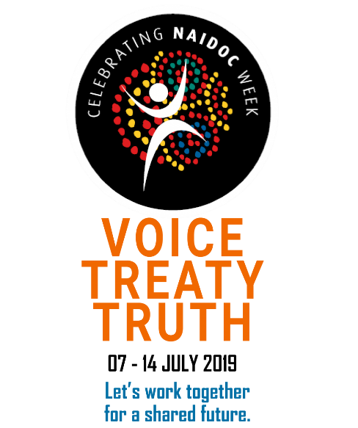

2019 NAIDOC Week celebrations are an opportunity for all Australians to come together to celebrate the history, culture and achievements of Aboriginal and Torres Strait peoples.

The 2019 NAIDOC Week theme - ***VOICE. TREATY. TRUTH.***

This theme acknowledges that Aboriginal and Torres Strait Islander peoples have always wanted an enhanced role in decision making in Australian democracy.

For more information visit the NAIDOC website: [www.naidoc.org.au](http://www.naidoc.org.au)

2019 Canberra & District Aboriginal and/or Torres Strait Islander Community Sector Worker of the Year

Nomination Form

Nominee: ___________________________________________________________

Organisation they work for: _____________________________________________

Nominator(s): ________________________________________________________

Contact phone for Nominator(s): _________________________________________

Please include as much information and detail as possible and a photo of the nominee. The photo will be used in a PowerPoint presentation during the awards ceremony to showcase the nominees and their achievements. **The awards panel will evaluate each nomination in a fair and democratic process.**

You may include additional pages if needed.

|  |
| --- |
|  |

Nominations must be received at ACTCOSS by Friday 17th May 2019

Please email your nomination to [gulanga@actcoss.org.au](mailto:gulanga@actcoss.org.au)

If you require further information, please call ACTCOSS on 02 6202 7200.