

ACT Council of Social Service Inc. (ACTCOSS) logo.

ACT Cost of Living Report

Tracking changes in the cost of living for   
low-income households in the   
Australian Capital Territory

May 2019

About ACTCOSS

ACTCOSS acknowledges Canberra has been built on the land of the Ngunnawal people. We pay respects to their Elders and recognise the strength and resilience of Aboriginal and Torres Strait Islander peoples. We celebrate Aboriginal and Torres Strait Islander cultures and ongoing contribution to the ACT community.

The ACT Council of Social Service Inc. (ACTCOSS) represents not-for-profit community organisations and advocates for social justice in the ACT.

ACTCOSS is a member of the nationwide COSS network, made up of each of the state and territory Councils and the national body, the Australian Council of Social Service (ACOSS).

ACTCOSS’ vision is to live in a fair and equitable community that respects and values diversity, human rights and sustainability and promotes justice, equity, reconciliation and social inclusion.

The membership of the Council includes the majority of community-based service providers in the social welfare area, a range of community associations and networks, self-help and consumer groups and interested individuals.

ACTCOSS advises that this document may be publicly distributed, including by placing a copy on our website.

Contact Details

Phone: 02 6202 7200  
Address: Weston Community Hub, 1/6 Gritten St, Weston ACT 2611  
Email: [actcoss@actcoss.org.au](mailto:actcoss@actcoss.org.au)   
Web: [www.actcoss.org.au](http://www.actcoss.org.au)

Director: Susan Helyar  
Policy Officer: Geoff Buchanan

May 2019

ISBN 978-1-876632-70-0 (electronic version)  
© Copyright ACT Council of Social Service Incorporated

This publication is copyright, apart from use by those agencies for which it has been produced. Non-profit associations and groups have permission to reproduce parts of this publication as long as the original meaning is retained and proper credit is given to the ACT Council of Social Service Inc (ACTCOSS). All other individuals and Agencies seeking to reproduce material from this publication should obtain the permission of the Director of ACTCOSS.

An ACT Government funded initiative.



**ACTCOSS acknowledges the work of SACOSS and NTCOSS whose Cost of Living Reports have informed the development of this ACTCOSS Cost of Living Report.**

Table of contents

Acronyms 4

Overview 5

Recommendations 6

Introduction 8

Tracking changes in the price of key goods and services: CPI 9

Fuel prices 11

Energy prices 13

[Tracking changes in the cost of living for   
low-income households: SLCI 15](#_Toc7787735)

Appendix: Explanatory Notes 20

Consumer Price Index and Selected Living Cost Indexes 20

Limitations of the Selected Living Cost Indexes 20

[Income support payment calculations –   
December 2017 to December 2018 21](#_Toc7787739)

How Pension rates are adjusted 22

Acronyms

ABS Australian Bureau of Statistics

ACOSS Australian Council of Social Service

ACT Australian Capital Territory

ACTCOSS ACT Council of Social Service Inc.

AMC Alexander Maconochie Centre

CPI Consumer Price Index

LCI Living Cost Index

SACOSS South Australian Council of Social Service

SLCI Selected Living Cost Indexes

Overview

Canberra’s overall CPI has continued to increase above the national rate over the past year. Across most essential goods and services, prices in the ACT rose above the national rate. Fuel prices in Canberra rose by 15% over the past year and have risen by 30% over the past decade – the highest rate of any Australian capital city. Energy prices in the ACT also continued to increase well above the national rate. The rising and relatively high cost of essential goods and services in the ACT continues to hit low-income households hardest as they account for a greater proportion of these households’ disposable income.

There are almost 26,000 people living below the poverty line the ACT. While people living in households whose sole source of income is Newstart, Youth Allowance or related payments face the greatest risk of living in poverty, almost 40% of people living in poverty live in households whose main source of income is from employment. Our analysis highlights yet again that these working-age allowances are inadequate to meet essential living costs in the ACT. This report provides further evidence of the urgent need to raise the rate of these allowances and to index them to wages so that they can catch up to and keep up with the cost of living. With over 10,000 people living on these allowances in the ACT, this is the single most effective policy to immediately reduce poverty and inequality in the Canberra and across Australia today.

This report outlines a range of measures the ACT Government should take to address the disproportionate cost of essential goods and services for Canberra’s low-income households. This includes improving the concessions scheme operated by the ACT Government along with other fee and charging regimes by expanding access according to need, not age or source of income. ACTCOSS is also calling for the introduction of income-based fines as well as increases to financial counselling services to keep pace with demand. These and other measures outlined in this report are critical if we are to improve the wellbeing of almost 37,000 people – including around 8,000 children – living in low-income households in the ACT. By reducing hardship and inequality these measures would improve the wellbeing of the entire Canberra community.

Recommendations

ACTCOSS calls on the **ACT Government** to prioritise investments and policy settings that will lift the financial wellbeing of households in the bottom 40% income groups at a rate higher than the average. These households include many whose main source of income is Newstart or similar allowances and pensions as well as a significant number of low-income households whose main source of income is wages.

Related ACTCOSS priorities outlined in our ACT Budget Priorities 2019-2020 include:

* Improving the concessions scheme operated by the ACT Government, and other fee and charging regimes, to expand access according to need, not age or source of income, in view of persistent and widening cost of living pressures for low-income households in the ACT
* Improving the fairness and adequacy of transport related concessions. This should include concessions for learner, probationary and restricted driver’s licenses and aligning the discount on license fees for Health Care Card holders (currently 50% of costs) with Pension Card Holders (100%)
* Introduction of income-based fines
* Increases to financial counselling services to keep pace with demand
* Investment in counselling services for middle-income earners – the ‘missing middle’ who are often unable to pay for services but are missed by current funding targeted at low-income earners
* Increasing investment to allow financial counselling services to offer services to detainees while they are in the Alexander Maconochie Centre (AMC)
* An in-depth, finely grained community needs assessment which would account for demographic characteristics including levels of disadvantage and the current availability and distribution of services
* Undertaking a study of transport costs to examine how individuals on low and fixed incomes meet costs of vehicle operation and maintenance, and if and to what extent this involves reliance on sub-prime loans. Measures should then be developed to address findings on the broader relationship between transport costs, indebtedness and infringements (e.g. driving unregistered) for people on low and moderate incomes
* Continued investment in community legal services to improve access to justice and timely intervention in the ACT, particularly for low-socio economic Canberrans, those from marginalised backgrounds and people living in public housing
* A ‘Budgeting for Life Work Development Program’ to provide regular financial literacy sessions for people in the community as part of the ACT Government’s Work Development Order offering
* The ACT Government legislating a minimum 5-star energy rating as a requirement for all private rental housing, and balancing this increased obligation on private landlords with creation of a Zero Emissions housing support fund that supports private rental housing owners to install energy supply and efficiency infrastructure. The legislation should also include a requirement that rents charged cannot be increased above CPI after those houses have been upgraded using the fund to support private rental housing owners to install energy supply and efficiency infrastructure
* Reducing energy poverty through targeted expansion of household energy efficiency measures
* Ensuring a just transition to adapt to climate change by developing further responses in consultation with climate affected communities and workers.[1]

ACTCOSS calls on the **Australian Government** to reduce poverty and inequality by supporting changes to income support payments so that they can catch up to and keep up with increases in the cost of living. ACOSS’ social security priorities for the 2019 federal election include:

* Raise the rate of Newstart, Youth Allowance and related payments by a minimum of $75 per week
* Establish a Single Parent Payment Supplement to help single parents with the cost of raising children
* Establish a Social Security Commission to guide the Parliament on payment settings
* Index income support and family payments to wage movements.[2]

ACTCOSS invites the **ACT community** to support the increase and proper indexation of Newstart, Youth Allowance and related payments so that Canberrans living on low incomes – many living below the poverty line – can afford the basics required for health and wellbeing. We encourage individuals and organisations to join the Raise the Rate campaign to increase Newstart, Youth Allowance and related payments by a minimum of $75 per week via: <https://raisetherate.org.au/>

Introduction

The ACT Cost of Living Report series tracks changes in the cost of living for low-income households in the ACT. Low-income households tend to be hidden behind our high average income and within a purposeful social mix of housing across Canberra’s suburbs. Closer analysis reveals that a sizeable number of people in the ACT are living in low-income households with many living below the poverty line.

Approximately 37,000 people live in low-income households in the ACT, representing 11% of the total population.[3] This includes almost 8,000 children, representing 12% of those aged 0-14.[4] Aboriginal and/or Torres Strait Islander people, people from culturally and linguistically diverse backgrounds, people with disability, and women are over-represented in Canberra’s low-income households.[5] Around 70% of people living in low-income households in the ACT are likely to be living below the poverty line. In Australia, the poverty line is defined as a single adult living on less than $433 a week, or $909 for a couple with two children.[6] It is estimated that there are almost 26,000 people living below the poverty line in the ACT, representing 7.7% of the total population.[7]

The Australian Council of Social Service (ACOSS) notes that the biggest risk to living in poverty in Australia is to receive Newstart, Youth Allowance or another allowance as your sole source of income.[8] These payments have not increased in real terms in 25 years and they trap people in poverty. As at December 2018, there were over 10,000 people living on such payments in the ACT and thus at greatest risk of living in poverty.[9] This included 6,044 recipients of Newstart Allowance and 3,239 recipients of Youth Allowance.[10] ACOSS also notes that a significant proportion of people experiencing poverty (38%) live in households whose main source of income is wages.[11]

This report adopts the methodology used by Councils of Social Service in South Australia and the Northern Territory. It draws on the latest Consumer Price Index (CPI) and Selected Living Cost Indexes (SLCI) data released by the Australian Bureau of Statistics (ABS) to show changes in the cost of living over the past 12 months. Explanatory notes about these indexes, their limitations and income support payment calculations are provided in the Appendix. This report highlights changes in the cost of living for those in receipt of income support. Tracking changes in the cost of living for these households is important as they have the least financial capacity to cope with rises in the cost of essential goods and services.

The following sections of the report track changes in the CPI and SLCI over the past year, with a focus on the impact of these changes for people living in low-income households in the ACT. Consistent with last year’s report, we find that the rising cost of living continues to hit Canberra’s low-income households the hardest. Canberra’s overall CPI has continued to increase above the national rate. Across most essential goods and services, prices in the ACT rose above the national rate, with fuel prices rising at the highest rate of any Australian capital city at almost 15%. Energy prices in the ACT also continued to increase well above the national rate. Our analysis of changes in the SLCI alongside changes in income support payments over the past year highlights yet again that Newstart, Youth Allowance and related payments are inadequate to meet essential living costs in the ACT. This provides further evidence of the urgent need to raise the rate of these allowances and to index them to wages.

# Tracking changes in the price of key goods and services: CPI

The overall (or All Groups) CPI figure covers a large number of goods and services. Eleven major categories with over 100 individual goods and services make up the CPI basket. There can be wide variations in the CPI for specific goods and services, which may impact particular population groups differently. The overall CPI figure can be separated into its component parts, allowing us to track changes in the price of key basic goods and services in the ACT and nationally. Table 1 shows the upward and downward trends in prices across key areas of household expenditure over the past year.

In the year from December 2017 to December 2018, the overall CPI for Canberra increased by 2.5% – this was above the national CPI increase of 1.8% (see Table 1). The Canberra CPI for most essential goods and services rose above the national rate – including for food (1.7% vs 1.5%), clothing (0.3% vs -0.7%), housing (4.2% vs 1.5%), transport (4.8% vs 2.8%), and education (3.2% vs 2.7%). The increase in the CPI for housing included increases in rents (3.0% vs 0.5%) and utilities (5.9% vs 2.0%). The increase in the CPI for utilities was driven by significant price increases for electricity (11.2% vs 1.8%) and gas (6.8% vs 3.2%). Increases in the prices of essential goods and services hit Canberra’s low-income households hardest as expenditure on these items accounts for a greater proportion of weekly household income than in average- and high-income households.

Table 1 CPI changes for key household expenditure areas, Canberra and Australia, Dec 2017 – Dec 2018

| **Cost of Living area** | **Canberra CPI**  **Dec 2017 –**  **Dec 2018**  **% change** | **National CPI**  **Dec 2017 –**  **Dec 2018**  **% change** |
| --- | --- | --- |
| **Food & Non-Alcoholic Beverages** | **1.7%** | **1.5%** |
| * **Bread and cereal products** | **0.2%** | **0.5%** |
| * **Meat and seafoods** | **2.6%** | **2.4%** |
| * **Dairy & related products** | **0.9%** | **1.1%** |
| * **Fruit and vegetables** | **1.5%** | **1.6%** |
| * **Food products n.e.c.** | **-0.6%** | **-0.5%** |
| * **Non-alcoholic beverages** | **3.9%** | **1.2%** |
| * **Meals out and takeaway foods** | **2.6%** | **2.1%** |
| **Alcohol & Tobacco** | **7.3%** | **6.8%** |
| * **Alcohol** | **4.0%** | **1.8%** |
| * **Tobacco** | **14.8%** | **15.0%** |
| **Clothing & Footwear** | **0.3%** | **-0.7%** |
| **Housing (includes utilities)** | **4.2%** | **1.5%** |
| * **Rents** | **3.0%** | **0.5%** |
| * **New dwelling purchase** | **3.6%** | **1.8%** |
| * **Utilities** | **5.9%** | **2.0%** |
| * *Water & sewerage* | **-5.0%** | **1.3%** |
| * *Electricity* | **11.2%** | **1.8%** |
| * *Gas and other household fuels* | **6.8%** | **3.2%** |
| **Furnishings, household equipment/ services** | **-2.3%** | **-0.8%** |
| **Health** | **2.8%** | **3.3%** |
| **Transport** | **4.8%** | **2.8%** |
| * **Automotive Fuel** | **14.8%** | **6.7%** |
| * **Public Transport** | **0.9%** | **2.5%** |
| **Communication** | **-4.0%** | **-4.3%** |
| * **Telecommunication Equipment & Services** | **-4.8%** | **-4.7%** |
| **Recreation & culture** | **2.7%** | **1.7%** |
| * **Audio, visual and computing equipment** | **-7.8%** | **-8.8%** |
| * **Audio, visual and computing media & services** | **1.2%** | **-0.2%** |
| **Education** | **3.2%** | **2.7%** |
| **Insurance & financial services** | **-0.1%** | **1.5%** |
| * **Insurance** | **4.0%** | **2.9%** |
| **CPI All Groups** | **2.5%** | **1.8%** |

Source: ABS, *Consumer Price Index, Australia, Dec 2018*, cat. no. 6401.0, ABS, Canberra, 2019, Table 10: CPI: Group, Sub-group and Expenditure Class, Percentage change from corresponding quarter of previous year by Capital City, viewed 12 Feb 2019, <<http://www.abs.gov.au/AUSSTATS/abs@.nsf/DetailsPage/6401.0Dec%202018?OpenDocument>>.

The CPI for health in Canberra increased, but this increase was below the national rate (2.8% vs 3.3%). The Canberra CPI for telecommunications equipment and services decreased (-4.8%) as did the CPI for audio, visual and computing equipment (-7.8%).

The largest price increases in Canberra over the year were for the sub-categories of automotive fuel (up 14.8% in ACT vs 6.7% nationally) and tobacco (up 14.8% in ACT vs 15.0% nationally). The ABS notes that ‘the rise in tobacco is due to the effects of the 12.5% increase in the federal excise tax and the further increase based on Average Weekly Ordinary Time Earnings (AWOTE), effective from 1 September 2018’.[12] Explaining the increase in Canberra fuel prices over the past year is more challenging, but some insights from an analysis of CPI data is provided below.

## Fuel prices

Fuel prices in the ACT have been the subject of much public concern and media commentary in recent months.[13] In February 2019, the ACT Legislative Assembly referred matters related to fuel prices in the ACT to a Select Committee on Fuel Pricing. ACTCOSS’ submission to the Inquiry into Fuel Pricing noted that Canberra fuel prices increased at a higher rate than any other Australian capital city over the past year and decade (see Figure 1).[14] Fuel prices increased by almost 30% between December 2008 and December 2018, but there was significant fluctuation in prices over this period (see Figure 2).

The ABS noted that domestic fuel prices dropped by 2.5% nationally between September and December 2018 due to a fall in world oil prices.[15] Over the same period, fuel prices in the ACT went against the national trend, rising by 2.9%. While it is unclear whether this trend will continue, the data indicates that the cost of fuel has generally tended to be higher in the ACT than in other jurisdictions and that fuel prices are the highest we’ve seen in the past ten years.

Relatively high and fluctuating fuel prices hit Canberra’s low-income households hardest. For households in the bottom 40% of the income distribution, fuel costs account for a similar proportion of income (4.0% to 6.1%) as that spent on other essentials such as energy and telecommunications (see Figure 3). Price fluctuations present a budgeting challenge for people living on low incomes who may be on fixed incomes and may not have adequate income and/or savings to cover sudden and substantial price increases. As we have previously noted, ‘people on Newstart and Youth Allowance would be particularly impacted by future price rises’.[16]

Figure 1 Percentage change in CPI for automotive fuel by capital city, past year (Dec 2017-Dec 2018) and decade (Dec 2008-Dec 2018)

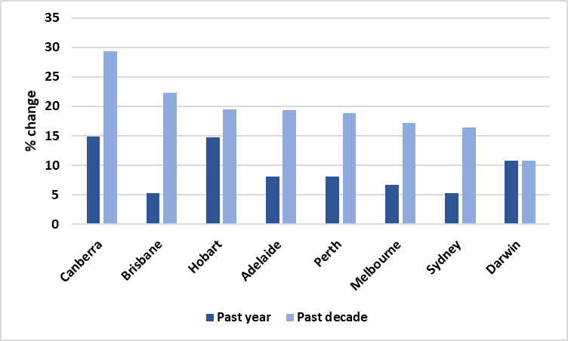

Source: G Jericho, ‘Inflation growth remains lower than Reserve Bank wants. How will it act?’, *The Guardian*, 31 January 2019, using ABS, Consumer Price Index, Australia, Dec 2018, cat. no. 6401.0.

Figure 2 Changes in CPI for automotive fuel and All Groups CPI, Canberra and Australia, December 2008 to December 2018

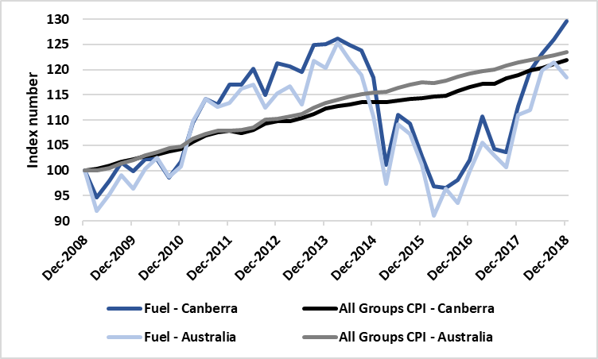

Source: ACTCOSS analysis derived from ABS, *Consumer Price Index, Australia, Dec 2018*, cat. no. 6401.0, ABS, Canberra, January 2019, Table 11, Data 5 & 6.

Figure 3 Fuel expenditure as a proportion of weekly disposable household income, by income quintile, Australia, 2015-16

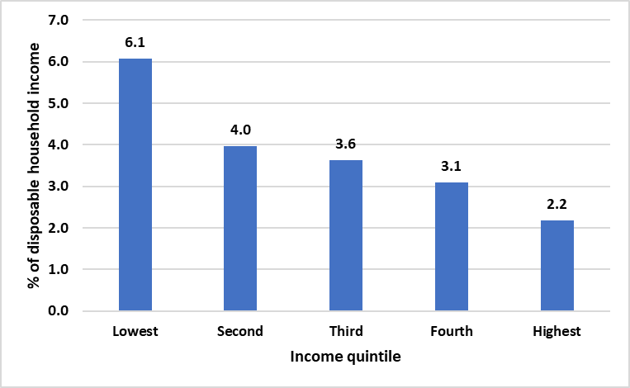

Source: ACTCOSS analysis derived from ABS, *Household expenditure survey, Australia, Summary of results, 2015-16*, ABS, Canberra, 2017, Tables 3.2 & 3.3A.

Fuel pricing is both a cost of living and a transport issue. ACTCOSS supports the exploration of regulatory and legislative solutions and barriers and the consideration of best practice approaches and initiatives that would have a meaningful impact on reducing fuel prices. At the same time, we encourage the ACT Government to view fuel pricing as one element to be addressed as part of a comprehensive response to transport disadvantage in the ACT. Transport is a social determinant of health and transport disadvantage can exacerbate food insecurity and impede access to health services. We encourage the ACT Government to view the impact of fuel prices within the context of addressing transport disadvantage as a social determinant of health in Canberra.

## Energy prices

Energy is another essential household expenditure item that has seen significant price increases over the past year and decade (see Figure 4). Over the past decade both electricity and gas prices have risen well above the overall CPI in Canberra. The higher price increase for gas is of particular concern for duel fuel households, ‘especially for renters and those on low incomes who can’t replace gas appliances with cheaper solar technology’.[17] Energy prices are expected to continue to increase. A recent determination by the Australian Energy Regulator for the ACT’s electricity distribution network operator estimates that the average ACT residential electricity bill increase by 2.5% by 30 June 2024 – ‘by the end of the 2019-24 regulatory period the average annual electricity bill will be $64 higher for a residential customer’.[18]

Figure 4 Changes in CPI for electricity, gas and All Groups CPI, Canberra, December 2008 to December 2018

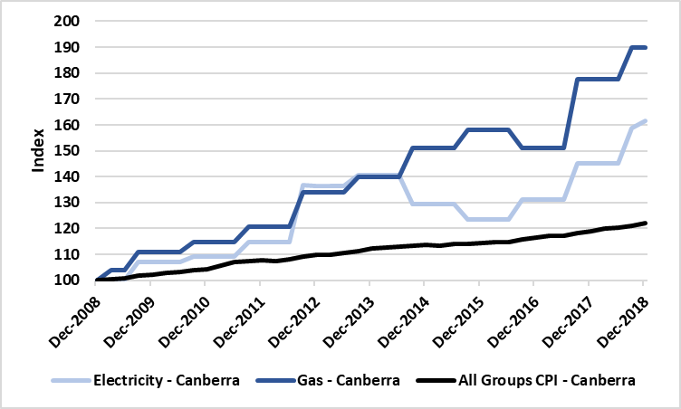

Source: ACTCOSS analysis derived from ABS, *Consumer Price Index, Australia, Dec 2018*, cat. no. 6401.0, ABS, Canberra, January 2019, Table 11, Data 5.

As with fuel, energy price increases hit low-income households hardest. As noted in a recent analysis of energy stress in Australia:

Some groups are paying disproportionately more of their income on energy bills, and this has risen since 2008, contributing to an increase in inequality and poverty… On average, low-income households spend 6.4% of their income on energy, while high-income households [spend] an average of 1.5%. This is despite the fact that low-income households appear to use less energy, spending less in dollar terms per year… One in four [low-income households] are now paying over 8.8% of their income on energy (electricity or gas). This is up from 7.6% in 2008... Those households dependent on income support payments such as Newstart and similar allowances are hit hardest by high prices, with one in four of these households spending more than 9.7% of their incomes on energy.[19]

Table 2 indicates how increases in energy prices impact disproportionately on low-income households due to a greater proportion of income and expenditure being spent on energy. These households are more likely to experience energy stress which can result in households ‘going without heating and cooling, meals, and other basic essentials in order to afford their energy bills’.[20]

Table 2 Energy expenditure by equivalised disposable income quintiles

|  | Lowest | Second | Third | Fourth | Highest |
| --- | --- | --- | --- | --- | --- |
| Average Weekly Expenditure – ACT ($) | 42.22 | 51.78 | 44.37 | 41.00 | 56.21 |
| Proportion of Total Goods and Services Expenditure – ACT (%) | 4.0 | *4.4 | 3.0 | 2.2 | 2.4 |
| Proportion of income- Australia (%) | 6.4 | 3.8 | 2.8 | 2.3 | 1.5 |

* estimate has a relative standard error of 25% to 50% and should be used with caution

Sources: ABS*, Household expenditure survey, Australia, Summary of results, 2015-16*, ABS, Canberra, 2017, Table 21.1 Household expenditure, Broad expenditure groups, Equivalised disposable household income quintiles, ACT; ACOSS, Brotherhood of St Laurence & ANU Centre for Social Research and Methods, *Energy stressed in Australia*, ACOSS, Sydney, 2018, p. 4.

Low-income renters are particularly vulnerable as they ‘have less choice and less control in the reduction of their energy bills … [these households] face a double whammy of high costs and the inability to introduce energy efficiency measures to reduce [energy costs]’.[21] The energy efficiency of rental properties can have a significant impact on tenants’ cost of living. Better Renting’s recent analysis of the energy efficiency of ACT rental properties found that over two in five rental properties in the ACT (43%) with Energy Efficiency Ratings (EERs) had an EER of 0, compared with only 4% of properties for sale.[22] Renters of these energy inefficient properties face higher energy costs – it is estimated that in a property with an EER of 0 it would cost approximately $1,800 a year to achieve the same thermal comfort as an equivalent property with an EER of 2.[23]

# Tracking changes in the cost of living for low-income households: SLCI

The Selected Living Cost Indexes (SLCI) measure the cost of various baskets of goods which are specific to a number of different household types – including ‘Age pensioner’ and ‘Other government transfer recipients’ (e.g. Newstart and Youth Allowance recipients), ‘Employee’, and ‘Self-funded retiree’ households. An examination of changes in the SLCI is important for determining how well Australia’s income support system is doing in terms of helping people to keep up with rising living costs. Our analysis focuses on age pensioner and other government transfer recipient households as these are more likely to represent low-income and disadvantaged households in the ACT.

Each Living Cost Index (LCI) is measured at the national level – unlike the CPI, the SLCI are not produced for each capital city so this analysis is not specific to Canberra or the ACT. In the past year, the LCI for all household types rose at a higher rate than the national CPI (see Figure 5). The LCI for both age pensioner and other government transfer recipient households increased by 2.1% while the national overall CPI rose by 1.8%.

Figure 5 Percentage change in CPI and Selected Living Cost Indexes, Dec 2017 – Dec 2018, Australia

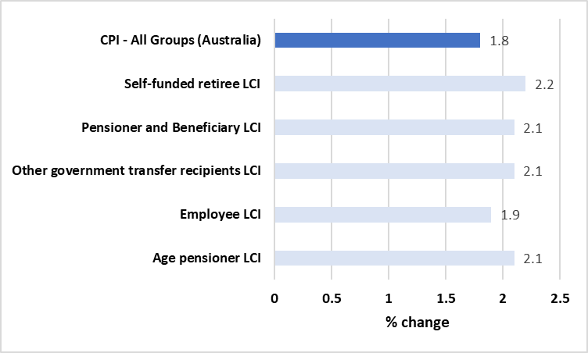

Source: ABS, *Selected Living Cost Indexes, Australia, Dec 2018*, cat. no. 6467.0, ABS, Canberra, 2019, viewed 12 Feb 2019, <<http://www.abs.gov.au/AUSSTATS/abs@.nsf/Lookup/6467.0Main+Features1Dec%202018?OpenDocument>>.

The single rate of Newstart is less than $40 a day – for Youth Allowance the single rate is just over $32 a day (see Figure 6). Newstart and other working-age allowances are not adequate to meet the basic costs of living.[24] While there has been much discussion in recent times around the slow growth in wages in Australia, Newstart has not increased at all in real terms in 25 years (see Figure 7). Further analysis indicates that these allowances have fallen well behind increases in the cost of living.

Figure 6 Change in weekly income by income source, December 2017 to December 2018

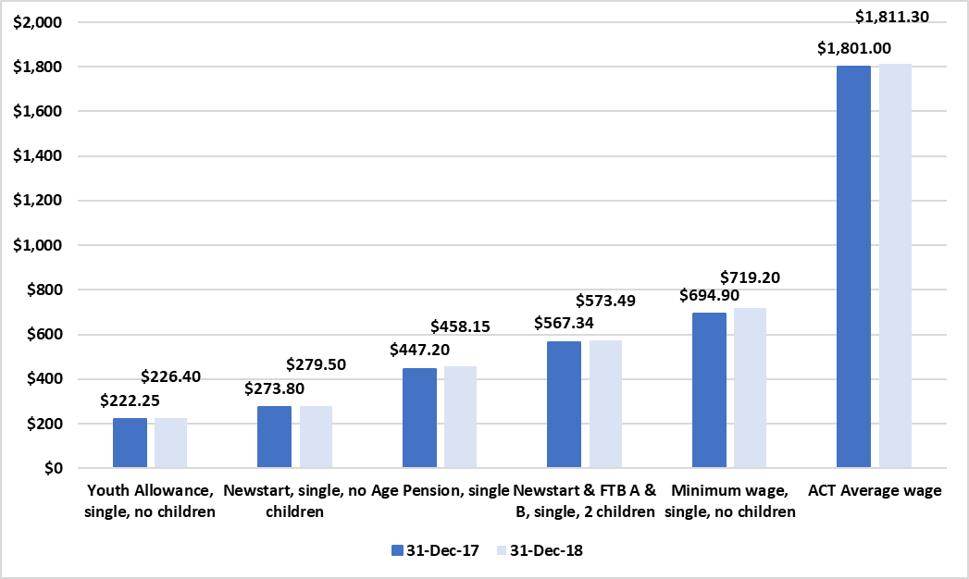

Source: Centrelink, A guide to Australian Government payments 20 September-31 December 2017, Centrelink, Canberra, 2017; Centrelink, A guide to Australian Government payments 20 September-31 December 2018, Canberra, 2018; Fair Work Ombudsman, Get set for a new minimum wage rate from 1 July, media release, Fair Work Ombudsman, Melbourne, 16 June 2017; Fair Work Ombudsman, New minimum wage takes effect from Sunday, media release, Fair Work Ombudsman, Melbourne; ABS, Average weekly earnings, Australia, Nov 2017, cat. no. 6302.0, ABS, Canberra, Table 12H; ABS, Average weekly earnings, Australia, Nov 2018, cat. no. 6303.0, ABS, Canberra, Table 12H.

Figure 7 Newstart vs pensions and wages ($2018)

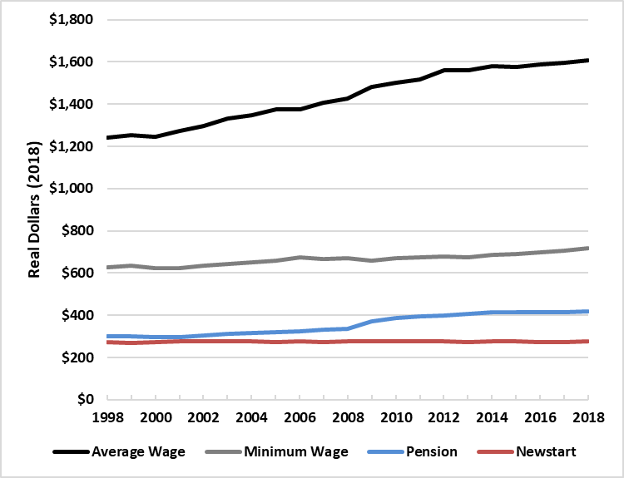

Source: ACOSS, *Raise the Rate Briefing Note*, ACOSS, Sydney, 2018; G Ogle, email, 7 March 2019.

Analysis of changes in living costs for households in receipt of government transfer payments such as Newstart and Youth Allowance over the past two decades shows that these payments have failed to keep up with increases in the cost of living – especially over the past 10 years (see Figure 8). Over the past year these payments have yet again failed to keep up with increasing living costs (see Figure 9). For a single parent of two children receiving Newstart plus Family Tax Benefit A and B, the cost of living increased over the past year by $11.91 per week while their income only rose by $6.15 leaving them $5.76 worse off per week than they were a year ago.

Figure 8 Relative change in living cost for Newstart recipients, December 1998-December 2018

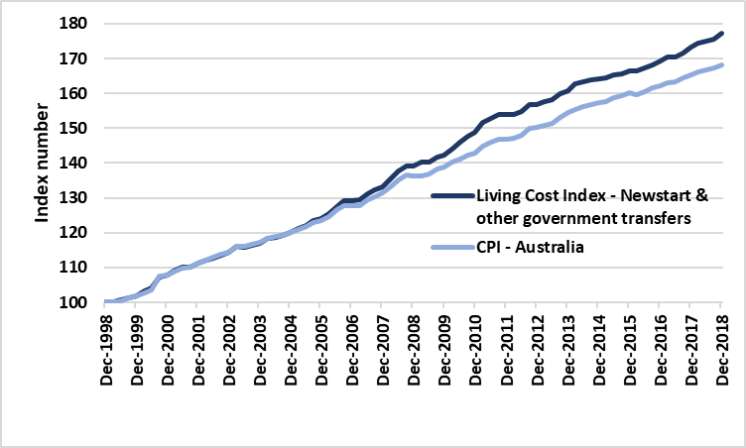

Source: ACTCOSS’ own analysis, derived from ABS, *Consumer Price Index, Australia, Dec 2018*, cat. no. 6401.0, ABS, Canberra, 2019, Table 11, Data 6; and ABS, *Selected Living Cost Indexes, Australia, Dec 2018*, cat. no. 6467.0, ABS, Canberra, 2019, Table 2, Data 1.

This highlights the inadequacy of indexing Newstart, Youth Allowance and related payments solely to the CPI. Figure 9 indicates that over the past year the Age Pension increased slightly above the rise in cost of living – by $1.56 per week. Age Pension indexation is designed ‘to reflect growth in the Consumer Price Index and the Pensioner and Beneficiary Living Cost Index, whichever is higher. When wages grow more quickly than prices, the pension is increased to the wages benchmark’.[25] A more detailed explanation of how Age Pension rates are adjusted is provided in the Appendix below. Our ACT Cost of Living Reports – from 2015 to 2019 – show that the LCI for other government transfer recipient households has increased above the CPI in four out of the past five years.

Figure 9 Change in weekly income vs change in cost of living, December 2017 to December 2018

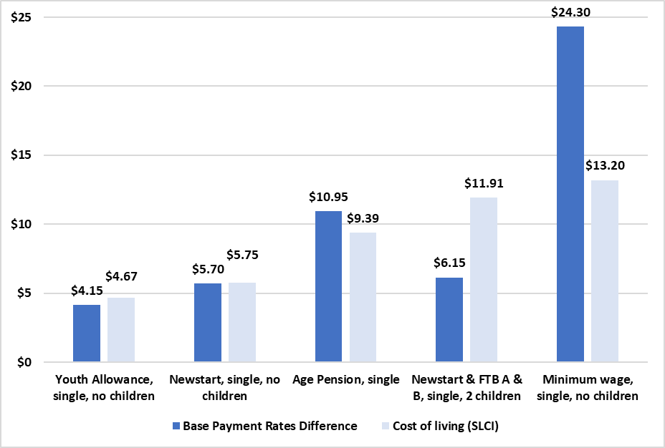

Source: Centrelink, A guide to Australian Government payments 20 September-31 December 2017, Centrelink, Canberra, 2017; Centrelink, A guide to Australian Government payments 20 September-31 December 2018, Canberra, 2018; Fair Work Ombudsman, Get set for a new minimum wage rate from 1 July, media release, Fair Work Ombudsman, Melbourne, 16 June 2017; Fair Work Ombudsman, New minimum wage takes effect from Sunday, media release, Fair Work Ombudsman, Melbourne; ABS, *Selected Living Cost Indexes, Australia, Dec 2018*, cat. no. 6467.0, ABS, Canberra, 2019, Table 2, Data 1.

This ACT Cost of Living Report – and the series as a whole – highlights the need for measures that address the gap that has grown between these allowances and cost of living and that ensure that these allowances continue to keep up with rising living costs into the future. Through the ACOSS Raise the Rate campaign, ACTCOSS is calling for Newstart, Youth Allowance and related payments for single people to be increased by a minimum of $75 per week, and to be indexed to wages.

Appendix: Explanatory Notes

ACTCOSS uses the cost of living methodology developed by SACOSS and the following explanatory notes have been adapted from SACOSS.[26]

## Consumer Price Index and Selected Living Cost Indexes

The ABS Selected Living Cost Indexes uses a different methodology to the CPI in that the CPI is based on acquisition (i.e. the price at the time of acquisition of a product), while the living cost index is based on actual expenditure. This is particularly relevant in relation to housing costs where CPI traces changes in house prices, while the SLCI traces changes in the amount expended each week on housing (e.g. mortgage repayments). Further information is available in the Explanatory Notes to the Selected Living Cost Indexes.[27] In that sense, the Selected Living Cost Indexes are not a simple disaggregation of CPI and the two are not strictly comparable. However, both indexes are used to measure changes in the cost of living over time (although that is not what CPI was designed for), and given the general usage of the CPI measure and its powerful political and economic status, it is useful to compare the two and highlight the differences for different household types.

## Limitations of the Selected Living Cost Indexes

The Selected Living Cost Indexes are more nuanced than the generic CPI in that they measure changes for different household types, but there are still a number of problems with using those indexes to show cost of living changes faced by the most vulnerable and disadvantaged in the ACT. While it is safe to assume that social security recipients are among the most vulnerable and disadvantaged, any household-based data for multi-person households says nothing about distribution of power, money and expenditure within a household and may therefore hide particular (and often gendered) structures of vulnerability and disadvantage. Further, the living cost indexes are not state based, so particular ACT trends or circumstances may not show up.

At the more technical level, the Selected Living Cost Indexes are for households whose predominant income is from the described source (e.g. Age Pension or government transfers). However, the expenditures that formed the base data and weighting (from the 2015-16 Household Expenditure Survey) add up to well over the actual social security payments available (even including other government payments like rent assistance, utilities allowance and family tax benefits). Clearly many households in these categories have other sources of income, or more than one social security recipient in the same household. Like the CPI, the Living Cost Index figures reflect broad averages (even if more nuanced), but do not reflect the experience of the poorest in those categories.

Another example of this ‘averaging problem’ is that expenditures on some items, like housing, are too low to reflect the real expenditures and changes for the most vulnerable in the housing market – again, because the worst-case scenarios are ‘averaged out’ by those in the category with other resources. For instance, if one pensioner owned their own home outright they would generally be in a better financial position than a pensioner who has to pay market rents – but if the market rent were $300 per week, the average expenditure on rent between the two would be $150 per week, much less than what the renting pensioner was actually paying.

The weightings in the Selected Living Cost Indexes are also based on a set point in time (from the Household Expenditure Survey), but over time the price of some necessities may increase rapidly, forcing people to change expenditure patterns to cover the increased cost. There is some adjustment of weightings for this, but these can’t be checked without a new survey. Alternatively, or additionally, expenditure patterns may change for a variety of other reasons. However, the weighting in the indexes does not change and so does not track the expenditure substitutions and the impact that has on cost of living and lifestyle.

Finally, the Selected Living Cost Indexes’ household income figures are based on households that are the average size for that household type: 1.51 people for aged pensioners, and 2.46 for other social security recipients.[28] This makes comparison with allowances difficult. This report focuses on single person households or a single person with two children (to align to the other social security recipient household average of 2.46 persons). However, this is a proxy rather than statistical correlation.

It is inevitable that any summary measure will have limitations, and as noted in the main text, the Selected Living Cost Indexes provide a robust statistical base, a long time series, and quarterly tracking of changes in the cost of living which is somewhat sensitive to low income earners.

## Income support payment calculations – December 2017 to December 2018

Even using the base rate of benefits, the calculation of the relevant weekly incomes is difficult because of the complexity of the income support system which means that payment eligibility and rates change depending on the exact circumstances of the household (e.g. age of children, assets). The calculation is also complex because of changes over time in eligibility and available benefits. However, based on an assumption of a single Age Pensioner and a single Newstart recipient with two children (aged 10 and 14) – with neither receiving Commonwealth Rent Assistance, the basic income supports payments have been calculated as follows:

Rates at 31 December 2017

|  | Base rate | Pension support | Energy supplement | FTB A Child u13 | FTB A Child 13-15 | FTB B | Pharmaceutical Benefit | Total |
| --- | --- | --- | --- | --- | --- | --- | --- | --- |
| Age pension, single | $407.00 | $33.15 | $7.05 | - | - | - | - | $447.20 |
| Newstart, single, no children | $269.40 | - | $4.40 | - | - | - | - | $273.80 |
| Newstart, single, 2 children | $291.40 | - | $9.72 | $91.42 | $118.93 | $54.32 | $1.55 | $567.34 |
| Youth Allowance, single, no children | $218.75 | - | $3.50 | - | - | - | - | $222.25 |

Source: Centrelink, A guide to Australian Government payments 20 September-31 December 2017, Centrelink, Canberra, 2017.

Rates at 31 December 2018

|  | Base rate | Pension support | Energy supplement | FTB A Child u13 | FTB A Child 13-15 | FTB B | Pharmaceutical Benefit | Total |
| --- | --- | --- | --- | --- | --- | --- | --- | --- |
| Age pension, single | $417.20 | $33.90 | $7.05 | - | - | - | - | $458.15 |
| Newstart, single, no children | $275.10 | - | $4.40 | - | - | - | - | $279.50 |
| Newstart, single, 2 children | $297.55 | - | $9.72 | $91.42 | $118.93 | $54.32 | $1.55 | $573.49 |
| Youth Allowance, single, no children | $222.90 | - | $3.50 | - | - | - | - | $226.40 |

Source: Centrelink, A guide to Australian Government payments 20 September-31 December 2018, Canberra, 2018.

## How Pension rates are adjusted

The following explanation of pension indexation has been extracted from a guide produced by the Parliamentary Library:

Currently, pensions (including the Age Pension, Service Pension, Disability Support Pension and Carer Payment) are [indexed twice each year](http://guides.dss.gov.au/guide-social-security-law/5/1/8/50) by the greater of the movement in the [Consumer Price Index](http://www.abs.gov.au/ausstats/abs@.nsf/mf/6401.0?opendocument) (CPI) or the [Pensioner and Beneficiary Living Cost Index](http://www.abs.gov.au/AUSSTATS/abs@.nsf/allprimarymainfeatures/E592A3A56EBC2B31CA257C130017D2FA?opendocument) (PBLCI). They are then ‘benchmarked’ against a percentage of [Male Total Average Weekly Earnings](http://www.abs.gov.au/ausstats/abs@.nsf/mf/6302.0) (MTAWE). The combined couple rate is benchmarked to 41.76% of MTAWE; the single rate of pension is set at 66.33% of the combined couple rate (which is equal to around 27.7% of MTAWE). ‘Benchmarked’ means that after it has been indexed, the combined couple rate is checked to see whether it is equal to or higher than 41.76% of MTAWE. If the rate is lower than this percentage, the rates are increased to the appropriate benchmark level.

The CPI is a measure of changes in the prices paid by households for a fixed basket of goods and services. Indexing pension rates to CPI maintains the real value of pensions over time. The PBLCI measures the effect of changes in prices of the out-of-pocket living expenses experienced by age pensioner and other households whose main source of income is a government payment. The PBLCI is designed to check whether their disposable incomes have kept pace with price changes. The MTAWE benchmark is not intended to maintain the value of the pension relative to costs; it is seen as ensuring pensioners maintain a certain standard of living, relative to the rest of the population.[29]

1. ACTCOSS, *ACT Budget Priorities 2019-2020: Community sector priorities*, ACTCOSS, Canberra, 2018, viewed 1 May 2019, <<https://www.actcoss.org.au/budgetsub2019-20>>.
2. ACOSS, *Social security priorities for the 2019 Federal Election*, ACOSS, Sydney, 2019, viewed 1 May 2019, <<https://www.acoss.org.au/social-security-priorities-for-the-2019-federal-election/>>.
3. R Tanton, R Miranti & Y Vidyattama, *Hidden disadvantage in the ACT: report for ACT Anti-Poverty Week*, NATSEM, University of Canberra, Canberra, October 2017, viewed 1 April 2019, <<https://www.actcoss.org.au/publications/advocacy-publications/hidden-disadvantage-act-report-anti-poverty-week-2017>>.
4. ibid.
5. E Davidson, *Hidden disadvantage among women in the ACT*, Women’s Centre for Health Matters, Canberra, June 2018, viewed 1 April 2019, <<http://www.wchm.org.au/wp-content/uploads/2018/06/Hidden-disadvantage-among-women-in-the-ACT-final.pdf>>; ACTCOSS unpublished analysis of ABS 2016 Census of Population and Housing using TableBuilder.
6. P Davidson, P Saunders, B Bradbury & M Wong, *Poverty in Australia, 2018*, ACOSS/UNSW Poverty and Inequality Partnership Report No. 2, ACOSS, Sydney, 2018, p. 12, viewed 1 April 2019, <<https://www.acoss.org.au/wp-content/uploads/2018/10/ACOSS_Poverty-in-Australia-Report_Web-Final.pdf>>.
7. ibid, p. 65; B Bradbury, email, 16 October 2018.
8. ACOSS, *Policy priorities for the next Australian government: social security*, ACOSS, Sydney, March 2019, viewed 1 April 2019, <<https://www.acoss.org.au/wp-content/uploads/2019/03/ACOSS-Pre-election-priorities-social-security.pdf>>.
9. Department of Social Services, *DSS Demographics December 2018*, DSS, Canberra, 2019, viewed 1 April 2019, <<https://data.gov.au/dataset/ds-dga-cff2ae8a-55e4-47db-a66d-e177fe0ac6a0/details?q=dss>>.
10. ibid.
11. P Davidson et al., op. cit.
12. ABS, *Consumer Price Index, Australia, Dec 2018*, cat. no. 6401.0, ABS, Canberra, 2019.
13. See, for example, ‘Petrol prices an outrage and Canberrans deserve better’, *The Canberra Times*, 20 January 2019, viewed 10 April 2019, <<https://www.canberratimes.com.au/story/5996600/petrol-prices-an-outrage-and-canberrans-deserve-better/>>.
14. ACTCOSS, *Submission: Select Committee on Fuel Pricing Inquiry into Fuel Pricing*, ACTCOSS, Canberra, February 2019, viewed 1 April 2019, <<https://www.actcoss.org.au/publications/advocacy-publications/submission-inquiry-fuel-pricing>>.
15. ABS, *Consumer Price Index, Australia, Dec 2018*, cat. no. 6401.0, ABS, Canberra, 2019, viewed 12 Feb 2019, <<http://www.abs.gov.au/AUSSTATS/abs@.nsf/DetailsPage/6401.0Dec%202018?OpenDocument>>.
16. ACTCOSS, *Full data report: ACT cost of living report: transport*, ACTCOSS, Canberra, April 2016, viewed 6 March 2019, p. 48, <<https://www.actcoss.org.au/publications/advocacy-publications/act-cost-living-report-transport-2016>>.
17. SACOSS, *Cost of Living Update No. 30, March Quarter 2017*, SACOSS, Adelaide, 2017, p. 3, viewed 1 May 2019, <<https://www.sacoss.org.au/no-30-march-qtr-2017-energy-snapshot>>.
18. Australian Energy Regulator, *Final decision: Evoenergy 2019-2024 – Fact Sheet*, AER, Melbourne, 2019, viewed 1 May 2019, <<https://www.aer.gov.au/networks-pipelines/determinations-access-arrangements/evoenergy-actewagl-determination-2019-24>>.
19. ACOSS, Brotherhood of St Laurence & ANU Centre for Social Research and Methods, *Energy stressed in Australia*, ACOSS, Sydney, 2018, pp. 4-6, viewed 1 May 2019, <<https://www.acoss.org.au/wp-content/uploads/2018/10/Energy-Stressed-in-Australia.pdf>>.
20. ibid, p. 4.
21. ibid, p. 6.
22. Better Renting, *The energy efficiency of rental properties in the ACT*, Better Renting, Canberra, 2018, viewed 1 May 2018, <<https://d3n8a8pro7vhmx.cloudfront.net/betterrenting/pages/42/attachments/original/1523488292/The_energy_efficiency_of_rental_properties_in_the_ACT.pdf?1523488292>>.
23. ibid.
24. P Saunders & M Bedford, *New minimum income for healthy living budget standards for low-paid and unemployed Australians*, SPRC Report 11/17, Social Policy Research Centre, UNSW Sydney, Sydney, 2017, viewed 10 April 2019, <<https://www.sprc.unsw.edu.au/research/projects/a-new-healthy-living-minimum-income-standard-for-low-paid-and-unemployed-australians/>>.
25. Department of Social Services, *Pension Rates*, Department of Social Services, Canberra, 2019, viewed 12 April 2019, <<https://www.dss.gov.au/our-responsibilities/seniors/benefits-payments/pension-rates>>.
26. SACOSS, *SACOSS Cost of Living Update No. 37, December Qtr 2018*, SACOSS, Adelaide, 2019, viewed 12 April 2019, <<https://www.sacoss.org.au/sites/default/files/public/documents/Reports/Cost%20of%20Living%20Reports/190130%20Cost%20of%20Living%20Update37.pdf>>.
27. ABS, *Selected Living Cost Indexes, Australia, December 2018: Explanatory Notes*, Australian Bureau of Statistics, Canberra, 2019, viewed 12 April 2019, <<https://www.abs.gov.au/AUSSTATS/abs@.nsf/Lookup/6467.0Explanatory%20Notes1Dec%202018?OpenDocument>>.
28. ibid.
29. M Klapdor, *Pension indexation: a brief history*, FlagPost blog, Parliamentary Library, Canberra, posted 16 April 2014, viewed 13 April 2018, <<https://www.aph.gov.au/About_Parliament/Parliamentary_Departments/Parliamentary_Library/FlagPost/2014/April/Pension-indexation>>. NOTE: Allowance payments, such as Newstart and Youth Allowance are indexed to the CPI only, and are adjusted 6 monthly - every March and September.