

Logo: ACT Council of Social Service Inc. (ACTCOSS).

Food security, food assistance and the affordability of healthy food in Canberra



May 2019

About ACTCOSS

ACTCOSS acknowledges Canberra has been built on the land of the Ngunnawal people. We pay respects to their Elders and recognise the strength and resilience of Aboriginal and Torres Strait Islander peoples. We celebrate Aboriginal and Torres Strait Islander cultures and ongoing contribution to the ACT community.

The ACT Council of Social Service Inc. (ACTCOSS) represents not-for-profit community organisations and advocates for social justice in the ACT.

ACTCOSS is a member of the nationwide COSS Network, made up of each of the state and territory Councils and the national body, the Australian Council of Social Service (ACOSS).

ACTCOSS’ vision is for Canberra to be a just, safe and sustainable community in which everyone has the opportunity for self-determination and a fair share of resources and services.

The membership of the Council includes the majority of community-based service providers in the social welfare area, a range of community associations and networks, self-help and consumer groups and interested individuals.

ACTCOSS advises that this document may be publicly distributed, including by placing a copy on our website.

Contact Details

Phone: 02 6202 7200  
Address: Weston Community Hub, 1/6 Gritten St, Weston ACT 2611  
Email: [actcoss@actcoss.org.au](mailto:actcoss@actcoss.org.au)  
Web: [www.actcoss.org.au](https://www.actcoss.org.au)

Director: Susan Helyar  
Policy Officer: Geoff Buchanan  
Data Consultant: Jonathan Pilbrow

May 2019

ISBN 978-1-876632-65-6 (electronic version)  
© Copyright ACT Council of Social Service Incorporated

This publication is copyright, apart from use by those agencies for which it has been produced. Non-profit associations and groups have permission to reproduce parts of this publication as long as the original meaning is retained and proper credit is given to the ACT Council of Social Service Inc (ACTCOSS). All other individuals and Agencies seeking to reproduce material from this publication should obtain the permission of the Director of ACTCOSS.

An ACT Government funded initiative.

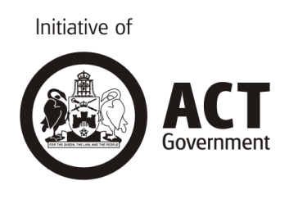

Cover images from [Vecteezy.com](https://www.vecteezy.com).

**ACTCOSS acknowledges the work of SACOSS and NTCOSS whose Cost of Living Reports have informed the analysis of Cost of Living data included in this report.**

Table of contents

Acronyms 5

Overview 6

Research methods and materials 7

Key findings 8

Further work recommended 9

What is food security? 10

What are the impacts of food insecurity? 11

What predicts increasing food insecurity? 12

Food security in the ACT 13

[Why is food security an issue in the ACT when we have a   
relatively high average income? 13](#_Toc10030843)

[Cost of living in the ACT is a risk factor for food insecurity in   
low-income households 15](#_Toc10030844)

Food affordability in the ACT 17

Tracking changes in food prices: 2007-2017 17

Australian Dietary Guidelines Price Index changes 19

[2015 Canberra Australian Standardised Affordability and   
Pricing Survey 20](#_Toc10030848)

Food stress 22

Household food expenditure in the ACT and food stress 22

A picture of food insecurity in the ACT 25

Risk factors related to food insecurity 26

People on low income and government transfer payments 27

People who are unemployed or underemployed 29

[People experiencing homelessness, inadequate housing,   
and rental stress 30](#_Toc10030855)

Women 32

Aboriginal and/or Torres Strait Islander people 34

Older people 35

People with a disability 36

Migrants, refugees and asylum seekers 37

[People experiencing gambling harm and people with an   
addiction to alcohol or other drugs 39](#_Toc10030861)

Tertiary students 39

Protective factors related to food security 40

Food assistance services facilitate access to healthy food 40

Access to transport makes a difference 41

[Social connectedness is critical to the health of people   
experiencing food insecurity 42](#_Toc10030866)

Looking at food insecurity through the lens of the social determinants of health and applying a public health approach 43

[Better data needed to more fully understand and address food   
insecurity and its impacts on healthy living in the ACT 45](#_Toc10030868)

Food insecurity 45

Food stress 45

Affordability of Healthy Food 46

Acknowledgements 47

Acronyms

ABS Australian Bureau of Statistics

ACT Australian Capital Territory

ACTCOSS ACT Council of Social Service Inc.

ADG Australian Dietary Guidelines

ADGPI Australian Dietary Guidelines Price Index

ANU Australian National University

ANUSA Australian National University Students’ Association

ASAP Australian Standardised Affordability and Pricing

CPI Consumer Price Index

DEX Data Exchange

FAO Food and Agriculture Organization of the United Nations

FIES Food Insecurity Experience Scale

HE2 Healthy and Equitable Eating

HES Household Expenditure Survey

LGBTIQ Lesbian, Gay, Bisexual, Transgender, Intersex and Questioning

NATSEM National Centre for Social and Economic Modelling

NHMRC National Health and Medical Research Council

NSW New South Wales

SEIFA Socio-Economic Indexes for Areas

SEIFI Socio-Economic Index for Individuals

SLCI Selected Living Cost Index

SRSS Status Resolution Support Services

USDA United States Department of Agriculture

Overview

Food security is an important social determinant of health and a significant public health issue in Australia.[1] Food security is defined as:

when all people, at all times, have physical, social and economic access to sufficient, safe and nutritious food to meet their dietary needs and food preferences for an active and healthy life. The four pillars of food security are availability, access, utilisation and stability. The nutritional dimension is integral to the concept of food security.[2]

With costs of living increasing while wages and income support have remained stagnant, and insecure work and underemployment have grown, concern around food security and the affordability of healthy food in Australia has grown. The 2018 Foodbank Hunger Report found that, in the previous 12 months, more than four million Australians (18% of the population) had experienced food insecurity, with many experiencing very low food security.[3] For low-income households faced with increasing costs for essentials such as rent and utility bills, food can become a discretionary expense. This can lead to food insecurity and poor nutrition due to not being able to afford a healthy diet.

This paper provides an introduction to the concept of food security and a picture of food insecurity in the ACT. It contextualises food insecurity by providing an overview of recent data on the number people living in low-income households in the ACT and the cost of living. It builds on the work of others including Anglicare NSW South, NSW West & ACT.[4]

The ACTCOSS food security project aims to contribute to understanding the extent of the problem of food insecurity in the ACT, identifying relevant risk and protective factors and suggesting ways the ACT Government could invest to improve food security for people living in low income households. The report analyses quantitative and qualitative data on food security, food assistance, and the affordability of healthy food in the ACT. The aim of this research is to synthesise information and analysis from diverse sources to improve the visibility of people and households in the ACT at risk of or experiencing food insecurity.

It is important to acknowledge the existing policies and programs under way in the ACT that promote food security and that aim to either prevent or address food insecurity. This includes work done directly and collaboratively by the government, community, researchers, philanthropy and business sectors.

This research has been commissioned to inform further ACT Government work on improving food security through promoting healthy and active living.

## Research methods and materials

Data has been gathered from a range of sources, including:

* A review of the recent literature on food security, food assistance and the affordability of healthy food in Australia
* ABS data sets, including the Consumer Price Index (CPI); Australian Dietary Guidelines Price Index (ADGPI); Selected Living Cost Index (SLCI) data for pensioners, other government transfer payment recipients for Australia, and other household types; the 2015-16 Household Expenditure Survey; and 2011-12 Australian Health Survey
* Selected findings from the 2015 ACT Australian Standardised Affordability and Pricing (ASAP) survey released to date by ACT Health
* Data reports provided by food assistance distributors and providers, especially Rotary (Foodbank NSW/ACT) and OzHarvest
* Semi-structured interviews with food assistance stakeholders, including food assistance providers, their suppliers and their clients as well as financial counsellors.

Written informed consent was obtained from all interview participants. Interview participants who were food assistance clients were offered a $75 supermarket or shopping centre voucher as a thank you at the completion of the interview. Their names are not used in this report to protect the identity of people who have shared their lived experience of food insecurity.

Key findings

**The key finding from this research is there are 25,800 people in the ACT living below the poverty line, with a similar number estimated to be experiencing food stress. These people are spending 30% or more of their disposable household income on food as compared to the average household that spends 13.9%. The households below the poverty line spend less on food despite spending a greater proportion of their income.**

This research has generated data and insights that should inform further work to address food insecurity in the ACT. These include:

* There is no current, reliable estimate of the prevalence of food insecurity in the ACT, but Foodbank’s most recent national estimate is that 18% of Australians experienced food insecurity in the previous year[5]
* While the common perception is that healthy food is more expensive than unhealthy food, recent research indicates that in the ACT a healthy diet may be more affordable than people’s current (unhealthy) diet
* While food affordability is an important element of food security, low-income households in the ACT are put at risk of food insecurity because incomes are not adequate to cover all essential costs of living, including housing, transport, energy and health care
* A range of social determinants increase the risk of household food insecurity and that these factors impact hardest on a number of different demographic groups within our community
* As long as systemic barriers to food security remain, food assistance services provide an important yet insufficient protection against food insecurity being experienced by people in low-income households
* Food insecurity impacts on people’s health, both physical and mentally
* Programs to improve food security that are designed around improving the social determinants of health would increase the positive impact on the health and wellbeing of people living in low-income households in the ACT
* People with lived experience have valuable insights to share in the development and evaluation of programs to improve household food security in the ACT.

Programs in community service settings could be framed around three themes:

* Enhancing existing good practice: such as extending eligibility for ACT provided concessions and ACT Government fee relief to people without access to a health care card as per the access card provided by the ACT Government to people on Humanitarian Settlement Visas; extending access to healthy meals provided by food assistance services that maximise access to daily nutritional requirements; extending access to no interest loans that support people to purchase food storage and cooking appliances; and increasing access to community transport services to people so they can access food assistance services and transport food to their home
* Addressing food scarcity: expanding supply of emergency food assistance services to increase availability of services across more locations and across days of the week; increasing access at food assistance services to healthy non-perishable foods
* Building an ACT-specific data set to improve the breadth and regularity of data collection that can inform decision makers’ understanding of the prevalence of food insecurity and any changes over time in food security: working with Foodbank to produce ACT-specific data; working with providers to contribute to the Commonwealth Data Exchange (DEX) data set to reduce the need for duplicate data collection and surveillance of service users; conducting regular market basket surveys and adopting or adapting a reliable, multi-item measure for quantitative data collection such as the Food and Agriculture Organization of the United Nations (FAO) Food Insecurity Experience Scale (FIES) or the USDA Food Security Core Survey Module.

## Further work recommended

Further work is needed to inform incorporation of food security interventions into work across government and the broader community to reduce preventable chronic conditions through addressing the social determinants of health. This should include:

* Consulting with health services (such as Aboriginal community-controlled services, rehabilitation, post-hospital care, chronic illness management, women’s health, mental health and maternal and child health services) about the visibility of food insecurity as an issue facing consumers who access their services, their provision of and/or referrals to food assistance services
* Improved data collection and better disaggregation of food insecurity data by gender, age, income source, household structure, identifying as Aboriginal, Torres Strait Islander, LGBTIQ, or culturally and linguistically diverse
* Engagement of decision makers and actors who can impact on the social determinants of healthy eating and its distribution in the community including in housing, income support, employment, education, transport, urban planning, food production and distribution systems.

# What is food security?

The Food and Agriculture Organization (FAO) of the United Nations defines food security as:

Food security exists when all people, at all times, have physical, social and economic access to sufficient, safe and nutritious food to meet their dietary needs and food preferences for an active and healthy life. The four pillars of food security are availability, access, utilization and stability. The nutritional dimension is integral to the concept of food security.[6]

The four dimensions of food security are: availability, access, utilisation, and stability. All four dimensions need to be fulfilled simultaneously for food security to be realised.

Four main dimensions of food security[7]

|  |  |
| --- | --- |
| Physical AVAILABILITY of food | Food availability addresses the supply side of food security and is determined by the level of food production, stock levels and net trade. |
| Economic and physical ACCESS to food | An adequate supply of food at the national or international level does not in itself guarantee household level food security. Concerns about insufficient food access have resulted in a greater policy focus on incomes, expenditure, markets and prices in achieving food security objectives. |
| Food UTILISATION | Utilisation is commonly understood as the way the body makes the most of various nutrients in the food. Sufficient energy and nutrient intake by individuals is the result of good care and feeding practices, food preparation, diversity of the diet and intra-household distribution of food. Combined with good biological utilisation of food consumed, this determines the nutritional status of individuals. |
| STABILITY of the other three dimensions over time | Even if your food intake is adequate today, you are still considered to be food insecure if you have inadequate access to food on a periodic basis, risking a deterioration of your nutritional status. Adverse weather conditions, political instability, or economic factors (unemployment, rising food prices) may have an impact on your food security status. |

The FAO has developed the Food Insecurity Experience Scale (FIES) for international use.[8] The FIES forms a quantitative tool to measure the prevalence of food insecurity and its severity. Food insecurity is measured along a continuous scale of severity.

FAO scale of food insecurity severity[9]

|  |  |  |  |
| --- | --- | --- | --- |
| **Mild food insecurity** | **Moderate food insecurity** | | **Severe food insecurity** |
| Worrying about running out of food | Compromising on quality and variety | Reducing quantities, skipping meals | Experiencing hunger |

The FIES aligns with Sustainable Development Goal 2 ‘Zero Hunger’ – ‘To end hunger, achieve food security and improved nutrition and promote sustainable agriculture’. It aligns specifically with Target 2.1:

By 2030, end hunger and ensure access by all people, in particular the poor and people in vulnerable situations, including infants, to safe, nutritious and sufficient food all year round.[10]

Australian governments are required to report on progress towards the Sustainable Development Goals so action on food insecurity in the ACT will contribute to demonstrating ACT Government commitment to and action on these.

## What are the impacts of food insecurity?

Understanding the impacts of food insecurity is critical to policy and program design and the targeting of initiatives across many portfolios but especially in health.

Being unable to afford food can be both physically and emotionally detrimental. Based on a national study of food insecurity among emergency relief clients, Anglicare identified the following impacts of being food insecure:

* Stress, anger and anxiety
* Depression and [low] self esteem
* Shame and embarrassment
* Compromised health
* Parenting pressures (including anxiety, pain and shame).[11]

Foodbank found that food insecurity often resulted in:

* Feeling stressed (57%)
* Feeling depressed (52%)
* Feeling tired or lethargic (52%)
* Feeling hopeless (44%)
* Feeling embarrassed (43%)
* Feeling sad (47%)
* A decline in mental health (44%)
* A loss of confidence (38%).[12]

## What predicts increasing food insecurity?

Food insecurity can be experienced either as chronic (long-term or persistent), transitory (short-term and temporary), or seasonal (recurrent yet transitory).[13]

Based on a national study of food insecurity among emergency relief clients, Anglicare found the following correlates of increasing food insecurity:

* Household income inadequacy
* Source of income
* The costs of fresh and special foods
* Food quality
* Location and transport costs
* Lack of appliances in the home.[14]

These factors are often interrelated and interact with other social determinants of health and nutritional status.

# Food security in the ACT

## Why is food security an issue in the ACT when we have a relatively high average income?

The average household income in the ACT is relatively high, but so too is our cost of living.[15] This has a significant impact on costs of living for those households in the ACT whose income is below the average – especially those in the bottom 40% of the income distribution. It is important that when we talk about ‘Canberrans’ based on statistical averages,[16] we do not exclude or forget about the significant number of people in the ACT who are living on low incomes in a high cost of living environment.

Disadvantage in the ACT tends to be hidden behind high averages across socioeconomic indicators such as income, education and employment. This hidden disadvantage results in part from the intentional creation of ‘mixed-tenure’ neighbourhoods through the distribution of public housing across Canberra. Hidden disadvantage in the ACT also applies to health inequality. A recent study found that disadvantage increases the risk of cardiovascular disease in the ACT.[17] This relationship was evident when data was aggregated at the smaller (SA1) level, but it was hidden at the larger (SA2) level.

Research commissioned by ACTCOSS in 2017 explored disadvantage in the ACT at the SA1 level based on 2016 Census data.[18] This research found that there were 37,213 people living in low income households in the ACT, representing 11% of the population.[19] This included 7,867 children, representing 12% of children aged 0-14 years in the ACT.[20] Additional ACTCOSS analysis of 2016 Census data found that those over-represented in low-income households in the ACT included Aboriginal and/or Torres Strait Islander people (24.9%), people with disability (29.0%), and people born overseas (16.1%).[21] It has since been estimated that there are approximately 25,800 people living in poverty in the ACT, representing 7.7% of the total population.[22]

While poverty rates and indicators of disadvantage in the ACT are generally lower than the national average, small area level data analysis reveals pockets of disadvantage where outcomes for households across key indicators (income, education and rental affordability) are below the Australian capital city average.[23] While revealing hidden disadvantage, such analysis also reveals one of the ACT community’s strengths by showing the diversity that exists within our neighbourhoods – in part reflecting the spread of smaller-scale social housing across Canberra.[24] Research published by the ACT Government has highlighted that:

the ACT has one of the highest proportions of ‘diverse’ suburbs/collection districts (CDs), where diverse suburbs/CDs have high numbers of both the most and the least advantaged individuals living side by side. This is highly unique to the ACT and, as a result, the averaging effects of [area-level statistics] chronically under-reports disadvantage.[25]

Based on the 2006 Census, a Socio-Economic Index for Individuals (SEIFI) was produced for the ACT and provided a powerful tool with which to reveal and examine hidden disadvantage. The SEIFI measured disadvantage at the level of the individual and not geographic area, revealing disadvantage masked by the Socio-Economic Indexes for Areas (SEIFA). For example, the SEIFI showed that in 2006 there were 28,639 ACT residents in the most disadvantaged 20% of Australians, which was 12.6% of all ACT residents.[26] Many of these people were living in areas that were not classified as disadvantaged within SEIFA figures.

The high average indicators of advantage in the ACT effectively conceal individual disadvantage when measured at the area level – according to the SEIFI, the most disadvantaged people didn’t live in disadvantaged areas.[27] ACTCOSS has welcomed the ACT Government’s commitment to work with the ABS on the production of a socio-economic index for households/families based on the 2016 Census so we have a more contemporary data set on which to build policy and service delivery responses to poverty and deprivation.

Food relief plays an important part in supporting people living in low-income households who experience food insecurity. Nationally, the proportion of food-insecure people seeking food relief increased by an estimated 384,000 people in that past year.[28]

I would say that at least 70% of the food we get is through the food pantries, and coming here for lunch, and going to the Roadhouse for dinner, and that sort of thing. We go to the Roadhouse for dinner, say, maybe three nights a week. (Female, aged 42, on Newstart and experiencing homelessness)

As this demand increases, it is becoming more critical to take measures to prevent food insecurity and improve food security. Better understanding of who is experiencing food insecurity and why this is happening is a fundamental step towards taking preventive action alongside continued resourcing of vital food assistance services.

## Cost of living in the ACT is a risk factor for food insecurity in low-income households

ACTCOSS regularly tracks changes in the cost of living for low-income households in the ACT. The key findings from our 2018 ACT Cost of Living Report were that:

* **Rising cost of living continues to hit Canberra’s low-income households hardest.** Four years in a row (in 2015, 2016, 2017 and 2018), ACTCOSS cost of living analysis showed that living costs in the ACT have increased disproportionately for those households that can least afford it – particularly those receiving a government transfer payment such as Newstart or Youth Allowance.
* **Canberra’s CPI continues to increase above the national rate.** Over the past year the CPI in Canberra rose 2.2% – the second highest rate of rise in the country, along with Sydney and Melbourne, behind only Adelaide (2.3%). This was above the national rise of 1.9%.
* **Utilities prices in Canberra rose the most and well above the national rate.** There were significant rises in utilities prices over the year. The most significant rise in utilities costs was gas and other household fuels which rose by 17.8% in the past year (with the whole of the rise occurring in the September quarter), which was markedly above the national rise (+7.8%). This was the largest single increase in one quarter since CPI records started being kept for this item in December 1989. Water and sewerage prices increased by 8.3% – this was well above the national rise of 3.2%. Electricity prices increased by 10.6%, which was below the rise seen across the country (+12.4%).
* **Other essential service prices in the ACT rose above the national rate.** The CPI for transport rose by 4.2%, above the national rise of 3.3%. Automotive fuel prices increased by 10.5% over the past year, just below the rate of increase at the national level (+11.1%). Public transport prices rose by 1.5%, above the national level (+0.6%). Health prices rose by 5.4%, above the national rise (+4.0%), with the price rise largely driven by the rise in medical and hospital services (+7.3% vs national rise of 5.4%). In addition, education costs rose (+3.1%) which was similar to the national rise (+3.2%), while housing (which includes utilities) rose by 5.3%, above the national rise (+3.4%). Rents rose by 2.3%, which was above the national rise (+0.7%).
* **Income support is inadequate to meet essential living costs in Canberra.** These significant increases in essential living costs impact disproportionately on low-income households who spend a higher proportion of their income on these expenses than other households. All households whose income is derived from income support payments or from minimum wage work struggle to cope with the cost of living in Canberra. Households whose income is derived from a minimum wage do not have access to most of the concessions offered by ACT Government and other sources, so their relatively higher income can fail to translate into a better capacity to cope with the cost of living in Canberra.[29]

These overall cost of living increases reduce the capacity of people in low income households to spend sufficient money on purchasing food, even if food is not increasing in price.

## Food affordability in the ACT

Affordability is a critical element in terms of the economic dimension of food security – without which people are unable to access sufficient, safe and nutritious food to meet their dietary needs and to respond to food preferences that support an active and healthy life. In the absence of regular market basket research tracking the cost of store-bought food in the ACT, this report examines some of the available data sets to contribute to a clearer picture of affordability of food in the ACT, focusing where possible on the relative affordability of healthy food.

The most common view expressed in the literature is that healthy (low energy density, high nutrient density) foods are more expensive than unhealthy (higher energy density, lower nutrient density) foods.[30] Australian research on the role of expendable income and food choice by low-income families has found ‘satiating of hunger to be the most common “value” relative to price’, with these foods tending to be ‘carbohydrate-rich staples’.[31]

### Tracking changes in food prices: 2007-2017

Analysis of change in the CPI over the decade from 2007 to 2017 shows that while the rise in Canberra’s overall CPI was lower than the national rate, food and alcohol prices in Canberra have risen above the national rate (Figure 1). While food prices in Canberra fluctuated – and rose significantly in the first half of the decade – the rise in the CPI for Food over the decade (20.2%) was below the change in the overall CPI (23.5%). Over this period, the price of some key healthy foods (fruit and vegetables, 21.2%) increased at a rate slightly above the overall CPI for Food (20.2%) (Figure 2 & Table 1). Figure 2 shows that the price of fruit and vegetables in the ACT fluctuated significantly, often rising at a much higher rate than the CPI for Food. This suggests that affordability of healthy foods may be quite variable over relatively short periods of time.

It seems to be getting more expensive, the sort of – the fruit and vegie side of it. It’s been getting – like bananas at the moment can get up to $4, $4.50 a kilo which is quite expensive, so you just cut down on those. (Male, aged 68)

Over the same period, key unhealthy foods (takeaway and fast foods, 36.6%) and beverages (alcohol, 28.1%) increased steadily and at a significantly higher rate than the CPI for Food and above all other sub-categories. This provides some indication that healthy foods may have become relatively more affordable over time than unhealthy foods in Canberra.

Figure 1 Food and non-alcoholic beverages, Alcohol, and All Groups CPI, Canberra and Australia, 2007-2017

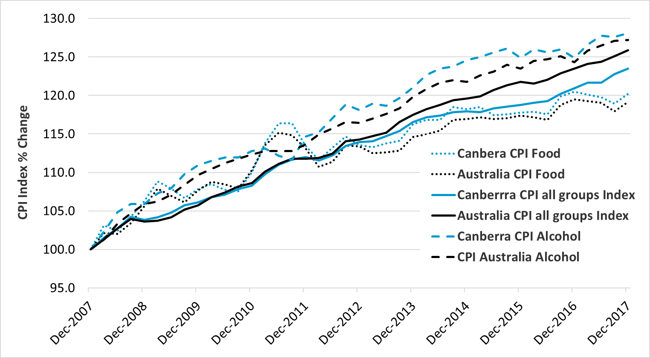

Source: ABS, *Consumer Price Index, Australia, December 2017*, cat. no. 6401.0, Table 11, CPI: Group, Sub-group and Expenditure Class, Percentage change from previous quarter by Capital City, ABS, Canberra, 2018, Data 5,6.

Figure 2 Food, Fruit & Vegetables, and All Groups CPI, Canberra, 2007-2017

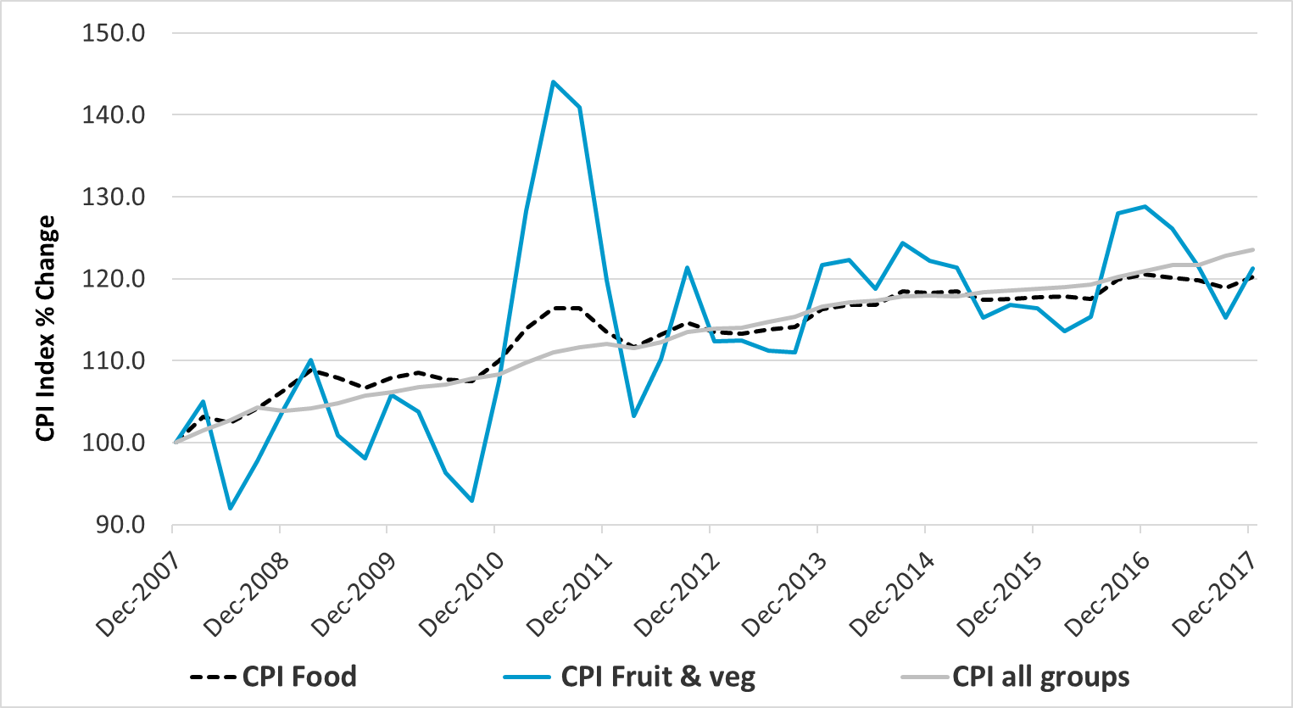

Source: ABS, *Consumer Price Index, Australia, December 2017*, cat. no. 6401.0, Table 11, CPI: Group, Sub-group and Expenditure Class, Percentage change from previous quarter by Capital City, ABS, Canberra, 2018, Data 5,6.

Table 1 Food and non-alcoholic beverage sub-categories, Alcohol, and All Groups CPI, percentage change, Canberra, 2007-2017

|  |  |
| --- | --- |
| CPI Category/Sub-category | Percentage Change (2007-2017) |
| Dairy and related | -0.3% |
| Breads and cereals | 5.4% |
| Eggs | 7.9% |
| Meat and seafood | 12.7% |
| Non-alcoholic beverages | 17.4% |
| CPI Food | 20.2% |
| Fruit and vegetables | 21.2% |
| CPI All Groups | 23.5% |
| Alcohol | 28.1% |
| Takeaway and fast foods | 36.6% |

Source: ABS, *Consumer Price Index, Australia, December 2017*, cat. no. 6401.0, Table 11, CPI: Group, Sub-group and Expenditure Class, Percentage change from previous quarter by Capital City, ABS, Canberra, 2018, Data 5,6.

### Australian Dietary Guidelines Price Index changes

In 2015, the ABS produced the Australian Dietary Guidelines Price Indexes (ADGPI) utilising historical Consumer Price Index (CPI) data with reference to the 2013 Australian Dietary Guidelines (ADG). ACTCOSS analysis of ADGPI data for the ACT found that prices for ADG Vegetables and legumes/beans (3.9%) and ADG Fruit (3.2%) had the highest average annual growth rates over the period from 2001 to 2014 (see Figure 3). These rates were higher than the average annual growth the ADG Discretionary food items (3.0%) over the same period. Our analysis also tracked the change in the CPI over this period for Food (3.0%), Restaurant meals (3.4%), and Takeaway and fast foods (3.6%).

Figure 3 Australian Dietary Guidelines Price Index, Percentage change, Canberra,   
2001-2014

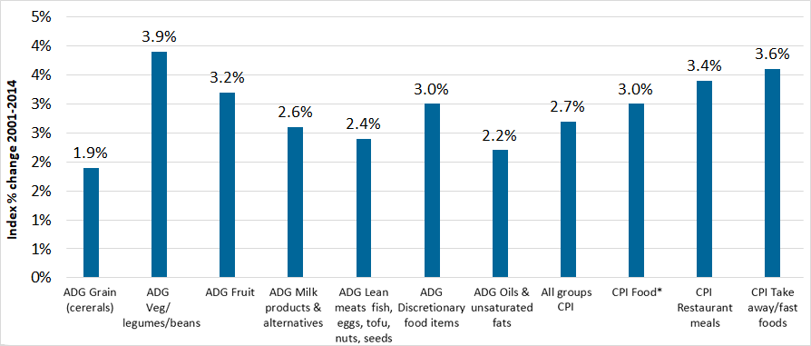

Source: ABS, *Consumer Price Index, Australia, Dec 2015*, cat. no. 6401.0, ABS, Canberra, 2016, Table 15: Australian Dietary Guidelines Price Indexes; email correspondence with ABS 9 March 2018.

The ADGPI and CPI data both show that the cost of fruit and vegetables in the ACT has increased at a higher rate than other store foods, including discretionary foods. At the same time, the cost of takeaway and fast food and alcoholic beverages have also risen at a higher rate. These ABS measures fail to provide a clear answer to the question of whether healthy food is, or has become, more affordable than unhealthy food.

This highlights the value of regular market basket surveys in being able to answer this question. Such a survey was used in the 2015 Canberra Australian Standardised Affordability and Pricing (ASAP) survey discussed below.

### 2015 Canberra Australian Standardised Affordability and Pricing Survey

Much of the Australian literature reports that a healthy diet is more expensive than an unhealthy diet.[32] The results of the 2015 Canberra ASAP survey challenge this predominant view.

The final report from the 2015 Canberra ASAP survey has not been released, but some selected findings have been published by ACT Health. The 2015 Canberra ASAP survey found that a healthy diet cost between 65 to 90% of the cost of an unhealthy diet across the range of reference household structures, meaning that a healthy diet was more affordable for all household types.[33] The key finding, ‘that households spend more on the current (unhealthy) diet than is needed to support healthy eating’ was seen to suggest that ‘efforts to support healthier food choices should address the assumption that a healthy diet is more expensive than an unhealthy diet’.[34]

The ASAP survey found ‘that low income households with children spent between 31 and 39 percent of their disposable income on the current (unhealthy) diet… Shifting to a healthy diet would reduce the total amount spent on food to between 28 and 33 percent of disposable income’.[35] The cost of a healthy diet as a proportion of disposable incomes for low-income households was 21% for the reference household of two elderly adults, 28% for the household of two adults and two children, and 33% for a household of six.

For the household of two adults and two children (one teenage boy and one primary school-aged girl), it was estimated that the shift to a healthy diet would see food costs reduce from $753 to $626 – a saving of $127 (almost 17%).[36]

The ASAP survey findings suggest that low-income households in Canberra are generally experiencing food stress and that shifting to a healthy diet would see a reduction in food stress in the ACT for at least some of these households.

It is important to note that food insecurity among low-income households is heavily influenced by the affordability of other essential goods and services such as housing, energy, health and transport. As noted by Care Inc. financial counsellors working with clients in the ACT, when people are faced with multiple cost of living pressures, food often becomes regarded as a discretionary item:

… food is a significant pressure on household budgets. Most clients express concerns about having enough money to purchase food. It is not usually the main presenting issue but is generally one of people’s concerns. People often pay rent, utilities and debts and regard food as a discretionary cost – which usually means they don’t have enough left over to cover an appropriate amount/type of food. (Financial Counsellors, Care Financial Counselling Service)

## Food stress

Food stress has been used as a measure of affordability within the context of overall household income and expenditure. This measure relates to that used to determine housing stress. The widely accepted measure of housing stress is the 30:40 indicator – that is, housing stress exists when a household in the bottom 40% of the income distribution spends 30% or more of its income on housing costs.[37] It has been argued that when a household in the bottom 40% of the income distribution spends 30% or more of their disposable household income on food, they are experiencing food stress.[38] Food stress has also been measured at the lower threshold of 25% or more of disposable household income being spent on food.[39]

## Household food expenditure in the ACT and food stress

Housing (including utilities), food, transport and health are essential goods and services and make up over half of expenditure in ACT households (see Tables 2 & 3 and Figure 4). Analysis of 2015-16 Household Expenditure Survey (HES) data shows that food is the second largest area of household expenditure in Canberra after housing.[40] On average, food accounts for 16.2% of total household expenditure and 13.9% of disposable household income.[41] ACTCOSS analysis of 2015-16 HES data produced an estimate of almost 25,500 people in the bottom 40% of the income distribution who are spending 30% or more of their disposable household income on food.[42] This figure is comparable with the ACT poverty rate reported above of around 25,800 people living below the 50% poverty line.

Figures 5 and 6 show that ACT households in the lowest income quintiles spend significantly less per week on food but that this represents a significantly higher proportion of their household income.

Table 2 Weekly expenditure as a proportion of total household expenditure for the three highest expenditure areas – capital cities and Australia, 2015-16

|  |  |  |  |  |  |  |  |  |  |
| --- | --- | --- | --- | --- | --- | --- | --- | --- | --- |
|  | **Syd** | **Melb** | **Bris** | **Adel** | **Perth** | **Hob** | **Darw** | **Canb** | **Aust** |
| **Housing** | 21.3% | 18.6% | 18.8% | 18.8% | 21.0% | 17.2% | 22.9% | 17.7% | 19.9% |
| **Food** | 16.1% | 17.0% | 16.3% | 17.3% | 16.5% | 17.4% | 15.5% | 16.2% | 16.6% |
| **Transport** | 13.5% | 14.6% | 14.2% | 12.7% | 12.8% | 15.0% | 11.8% | 13.5% | 13.8% |

Source: ABS, Household Expenditure Survey, Australia: Detailed Expenditure Items, 2015-16, cat. no. 6535.0, ABS, Canberra, 2017, Tables 13.2 & 13.3A.

Table 3 Weekly expenditure as a proportion of weekly mean disposable income for the three highest expenditure areas – capital cities and Australia, 2015-16

|  |  |  |  |  |  |  |  |  |  |
| --- | --- | --- | --- | --- | --- | --- | --- | --- | --- |
|  | **Syd** | **Melb** | **Bris** | **Adel** | **Perth** | **Hob** | **Darw** | **Canb** | **Aust** |
| **Housing** | 18.0% | 15.9% | 15.4% | 15.5% | 16.6% | 14.7% | 18.6% | 15.2% | 16.6% |
| **Food** | 13.6% | 14.5% | 13.3% | 14.3% | 13.1% | 14.8% | 12.6% | 13.9% | 13.8% |
| **Transport** | 11.4% | 12.5% | 11.6% | 10.5% | 10.1% | 12.8% | 9.5% | 11.6% | 11.5% |

Source: ABS, Household Expenditure Survey, Australia: Detailed Expenditure Items, 2015-16, cat. no. 6535.0, ABS, Canberra, 2017, Tables 13.2 & 13.3A.

Figure 4 Weekly expenditure as a proportion of total household expenditure, Canberra, 2015-16

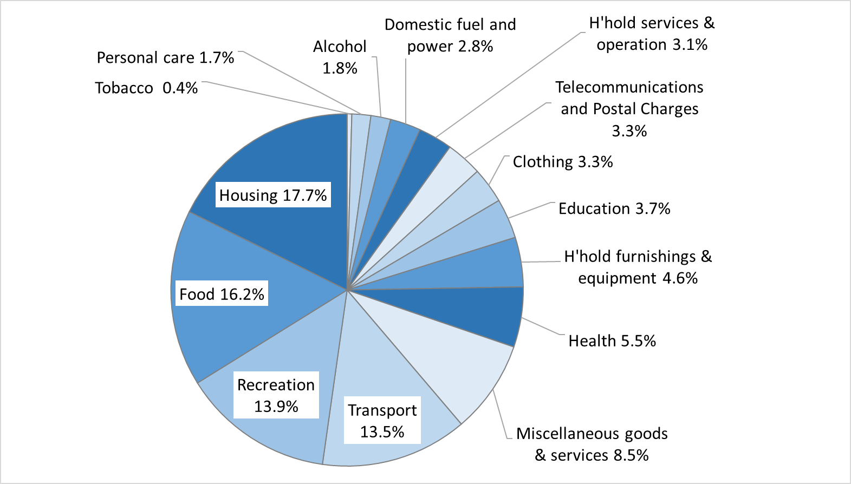

Source: ABS, Household Expenditure Survey, Australia: Detailed Expenditure Items, 2015-16, cat. no. 6535.0, ABS, Canberra, 2017, Tables 13.2 & 13.3A.

Figure 5 Average weekly household expenditure on food and alcohol by income quintile, ACT, 2015-16

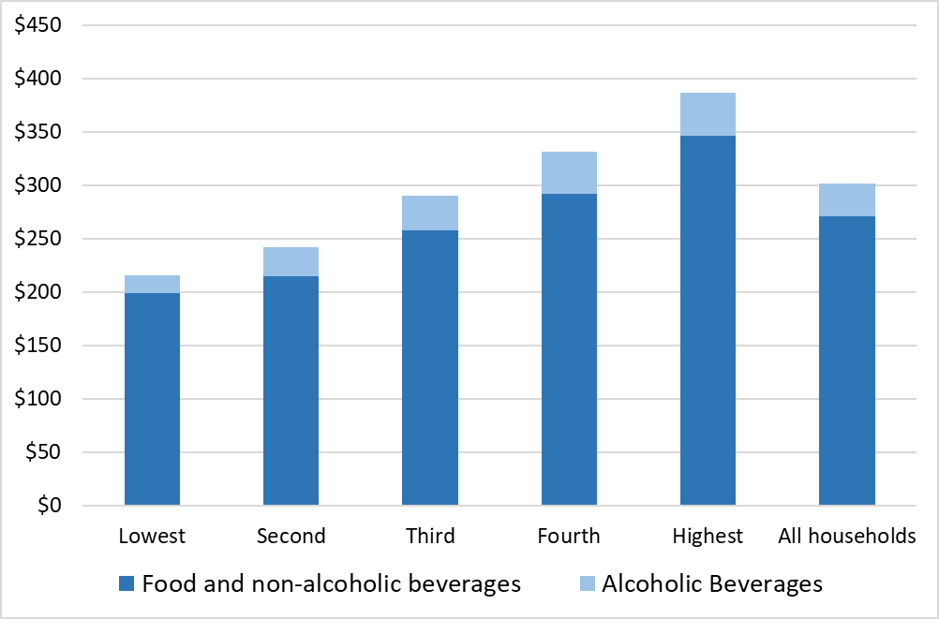

Source: ABS, Household Expenditure Survey, Australia: Detailed Expenditure Items, 2015-16, cat. no. 6535.0, ABS, Canberra, 2017, Table 21.1.

Figure 6 Average weekly household expenditure on food and alcohol as a proportion of weekly mean household disposable income, by income quintile, ACT, 2015-16

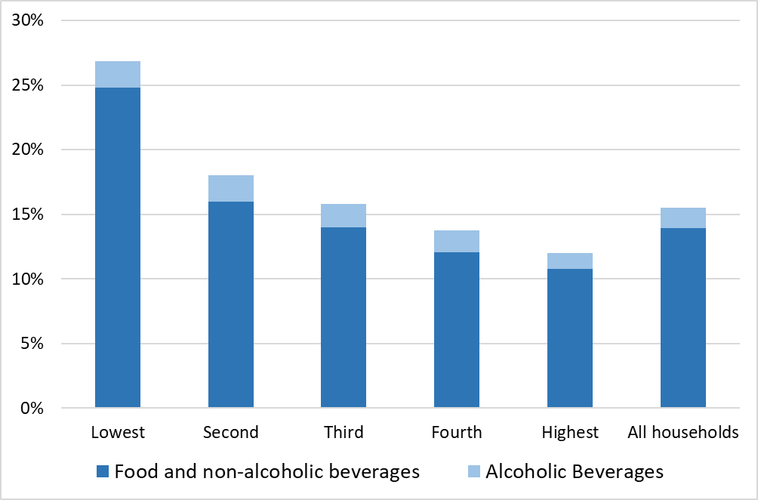

Source: ABS, Household Expenditure Survey, Australia: Detailed Expenditure Items, 2015-16, cat. no. 6535.0, ABS, Canberra, 2017, Table 21.1, 21.2.

# A picture of food insecurity in the ACT

There is no comprehensive, up-to-date data on the prevalence of food insecurity in the ACT. Food insecurity in Australia has been measured primarily through the National Health Survey (formerly Australian Health Survey) administered by the Australian Bureau of Statistics (ABS). This was last measured through the 2011-12 Australian Health Survey which found that around 3.6% (approximately 12,568 people) were living in a household in the ACT that, in the previous 12 months, had run out of food and had not been able to afford to buy more – this was lower than the national figure of 4%.[43] In the ACT and nationally, 1.5% (approximately 5,237 people in the ACT) went without food when they couldn’t afford to buy any more.[44]

The use of a single-item measure of food insecurity in Australia is seen as likely to underestimate the prevalence of food insecurity compared with more comprehensive multi-item measures.[45] The most recent Foodbank Hunger Report applied the United States Department of Agriculture (USDA) Food Security Core Survey Module to determine the scale of food insecurity in Australia. The survey found that over four million Australians (18% of the population) had experienced food insecurity in the last year.[46] Of these, 76% had experienced very low food security – reducing food intake and disrupting eating patterns due to a lack of money and other resources to obtain food.[47] In the previous year, Foodbank found that more than one in five children (22%) live in a food insecure household.[48] Data on food insecurity is not reported at the state or territory level in the Foodbank report.

Food assistance itself is both an indicator of the prevalence of food insecurity, as well as being a key way for people to achieve food security. The majority of food that is utilised by food assistance services in the ACT is sourced from Foodbank NSW/ACT and OzHarvest. In 2017-18, Foodbank (401,145kg, over 720,000 meals) and OzHarvest (383,705 kg, over 690,000 meals) delivered a combined 784,859 kilograms of food to food assistance providers in the ACT region, equivalent to almost 1.5 million meals (see Table 4).

Foodbank NSW/ACT and OzHarvest data from 2010-11 to 2017-18 shows that the supply of food to ACT food assistance providers has increased significantly over the period (see Table 4). While there are gaps in the data, 2014-15 is the only year in which a reduction in the supply of food was recorded – down by almost 4% on the previous year. This data shows that a reduction in the supply from one provider has mostly been covered by an increase in supply by the other provider (e.g. 2014-15 and 2017-18). Over the full period, the total supply of food from Foodbank NSW/ACT and OzHarvest to ACT food assistance providers has more than doubled.

Table 4 Foodbank NSW/ACT and OZHarvest food delivered to ACT region

|  |  |  |  |  |  |  |
| --- | --- | --- | --- | --- | --- | --- |
| Year | Foodbank (kg) | Foodbank (% change) | OzHarvest (kg) | OzHarvest (% change) | Total (kg) | Total  (% change) |
| 2010-2011 | 218,344 | - | 151,747 |  | 370,091 | - |
| 2011-2012 | 295,540 | 35% | 211,277 | 39.2% | 506,817 | 36.9% |
| 2012-2013 | 338,467 | 15% | 225,000 | 6.5% | 563,467 | 11.2% |
| 2013-2014 | 366,526 | 8% | 250,000 | 11.1% | 616,526 | 9.4% |
| 2014-2015 | 410,720 | 12% | 182,734 | -26.9% | 593,454 | -3.7% |
| 2015-2016 | 424,311 | 3% | NA | NA | NA | NA |
| 2016-2017 | 431,114 | 2% | 125,307 | NA | 556,421 | NA |
| 2017-2018 | 401,154 | -6.9% | 383,705 | 206.2 | 784,859 | 41.1% |

Source: Rotary Club of Canberra, Report for period 1 July 2017 to 30 June 2018, Funding for Transport of Foodbank Frozen and Dry Goods to ACT, report to ACT Community Services Directorate, 30 August 2018; D Burnet, OzHarvest ACT and Territories Manager, email, 8 May 2019.

## Risk factors related to food insecurity

In the absence of current, detailed, local data, we reviewed the Australian literature to try to identify those most likely to be at risk of food insecurity in the ACT. The literature identifies a number of demographic groups that experience higher rates of food insecurity in Australia.[49] We have complemented findings from the literature review with insights sourced from local financial counsellors, food assistance providers, and people with lived experience of food insecurity.

### People on low income and government transfer payments

Foodbank found that 43% of people experiencing food insecurity were living on a low income or pension, with 30% identifying this as the main reason for not having enough food.[50]

For people on low incomes, living with food insecurity means that food becomes a discretionary item. As noted above, there are over 37,000 people living in low-income households in the ACT, representing 11% of the population. This included almost 8,000 children, representing 12% of children aged 0-14 years in the ACT.[51] Approximately 25,800 people in the ACT are living below the poverty line.[52]

Around 3.5% of working age people in the ACT receive an unemployment or student payment – this includes 6,271 recipients of Newstart Allowance, 850 recipients of Youth Allowance (Other – unemployment payment for young people aged 16-21), and 2,631 recipients of Youth Allowance (student and apprentice).[53] Of those receiving Newstart, 57% are long-term unemployed and 85% are paid at the single rate of the allowance of just $278 per week. Nationally, more than half (55%) of people receiving Newstart live below the poverty line.[54] Even if they received Newstart plus every other entitlement for which they were eligible (e.g. rent assistance, telephone allowance), a single unemployed adult’s income ($338 per week) would fall almost $100 short of the budget standard for healthy living ($434 per week).[55]

When I went onto Newstart, which was a while ago, I graduated, then I couldn’t get a job for quite a long time. One of the things I realised – my rent at that stage was $125. Even with that relatively low rent, it became obvious that on normal Newstart the ends weren’t going to meet together. At that stage, I was buying most of my own food… On normal Newstart, even with rent assistance, and even without any expensive substance habits, and with what should be some good spending habits, to feed oneself can be hard. (Male, single, aged 40, on Newstart)

I’m on Newstart… if Blue Door wasn’t here – or, other food services around here – you wouldn’t be able to survive. Nope. Not at all. A lot of people wouldn’t be able to. But, like I say, you’ve got to put yourself on a budget. That’s the way you’ve got to go. (Male, single, aged 45-64, on Newstart)

A number of people that we spoke to told of how income support payments were inadequate to last a full fortnight.

Somewhere in the second week of my fortnight, I literally don’t have any money anymore, and I have to just go to free food services … And if any expenses come up, you just can’t pay them (Male, single, aged 40, on Newstart).

We get by, it’s a struggle sometimes to get by, but me and my partner we manage. Some days when we don't have food for a day or two days, but that’s all good, we can last till payday. Or we come here (Female, aged 55, partner with significant health condition).

Some weeks are really good. By the second week things are quite tight, but there’s one week that’s not too bad and the second week they seem to be very – I try to stretch it out as much as possible (Female, aged 51, mother of two school-age children who left a violent relationship).

ACT Government cost of living analysis undertaken as part of the 2012 ACT Targeted Assistance Strategy identified low income households and those whose main income was government pension/allowances were among those most at risk in relation to food stress in the ACT.[56] The ACT Targeted Assistance Strategy report identified a unique cohort in the ACT among low-middle income families and individuals who saw themselves as ‘normal families doing it tough’.

There’s one woman in particular. We had a training workshop for people who are interested in a particular thing. She used to come from work to do this training workshop. One day she snuck out that door and [signalled to] me, and so I went – and she said she needed to access the pantry after everyone went, could we do it after everyone had left? Making it very clear that she didn’t want anyone to know that – anyone at the workshop, that she needed to do this. Yes – there are people who work, in public service across the road, who come here. (ACT food pantry manager, de-identified)

### People who are unemployed or underemployed

Foodbank found that over a third (36%) of people who were unemployed or looking for work had experienced food insecurity in the previous year.[57] In addition to those who were unemployed, a fifth (20%) of people who were employed part time or casually had experienced food insecurity in the previous 12 months.[58]

In discussions with food assistance providers, job loss was identified as a reason for people accessing services for the first time and often on a short-term basis. The loss or reduction of income resulting from job loss can present a challenge for people not used to living on a significantly constrained budget.

I think the people that we see that have been on Centrelink for a while are very skilled at managing their money, and perhaps it’s people who all of a sudden have got a change in circumstances. They probably find it really hard to deal with, and they really can’t imagine how they’re going to survive on a lower income, or how it’s possible to, I guess, spend less money on food if they’ve never had to. That’s a daunting task for some people. (Financial Counsellor, Care Financial Counselling Service)

I’m only on Newstart allowance. I shouldn’t say only. But, it’s quite a challenge for somebody who used to be an APS-6. (Woman, aged 42, on Newstart and experiencing homelessness)

For people who are underemployed on low and/or irregular income in insecure employment, food assistance can provide an important means to address shortfalls.

So, for example, the lady who knocked on the door earlier, she is actually – I think it's a really good story of why we're here – she is a regular user, she got employment, she had a housemate and they were working, so she didn't need to come down anymore, so wasn't accessing the service. Last fortnight she came down because she's not getting hours anymore, so her income level has decreased, so now she needs to access the service again before Christmas. She had a few other supports that she needed that we don't actually provide, so I can only really – the funding only gives us money to provide food, so I gave her referrals to St Vincent de Paul's emergency relief, because they can sometimes help with household items and bills, and Smith Family and their Saver Program as well. So, we do a bit of that referral, and now she's probably going to come back for a little while, and then she'll stop coming again… it's a friendly place with faces that she's familiar with that she comes back for services. (Katherine Higgins, YWCA Lanyon Food Hub)

I've got quite a few clients who are disability support workers and they work casually and they’re not much better off than on Centrelink at all, and in fact a lot of them are being supplemented by Centrelink even though they are employed. (Financial Counsellor, Care Financial Counselling Service)

### People experiencing homelessness, inadequate housing, and rental stress

Foodbank found that 29% of households that are renting experienced food insecurity in the previous 12 months.[59]

The 2016 Census recorded almost 1,600 people experiencing homelessness in the ACT, while in 2016-17 over 4,500 clients were assisted by specialist homelessness services.[60] Accessible, affordable, safe and secure housing provides the necessary foundation from which people can actively meet their social, physical and emotional needs. There were almost 1,600 people experiencing homelessness in Canberra on census night in 2016.[61] Housing crisis and stress are major drivers of homelessness in the ACT.[62]

Negotiating with Centrelink while couch-surfing was awful. It took me eight weeks to get on Centrelink because I didn’t have a fixed address. I was battling and my friends were feeding me and I was going to the soup kitchen down the road as well as the church on the corner where you can get cheap food. I had eight weeks with no income at all. It was really hard and I lost a lot of weight. (Gary, *Stories of Home*)[63]

In 2015-16, 33.8% (8,672) of low-income rental households in the ACT were in rental stress, with most of these (7,960) living in private rental.[64] The rate was much higher for private rental households (47.8%), while just under half of Canberra households receiving Commonwealth Rent Assistance were still experiencing rental stress (48.0%).[65]

National surveys of rental affordability highlight that low-income households in the ACT face particularly unaffordable rents.[66] The latest Rental Affordability Index found that low-income households in the ACT face particularly unaffordable rents – for most low-income household types, Canberra was the second least affordable metropolitan area behind Greater Sydney.[67] Anglicare Australia’s 2018 *Rental Affordability Snapshot* found that out of 1,176 rental properties advertised in the ACT and Queanbeyan region, only 41 were affordable for households living on income support payments and only 84 were affordable for households living on the minimum wage.[68] There were no rental properties that were affordable and appropriate for people living on Newstart or Youth Allowance, or for a lone parent living on the minimum wage in the ACT.

Housing plays a critical part in food security and healthy eating in terms of having facilities to easily and safely store and prepare food. Homelessness presents significant barriers in relation to this, as highlighted by one of the people we spoke to.

Interviewer: And so, you’re camping. So, does that make it a bit hard, cooking?

Interviewee: Yeah. It does. We did have a microwave, but the microwave blew up, unfortunately. So, they’ve only got barbeque facilities at [our campground]. Basically, that’s why we come here [to the Early Morning Centre] to get our hot food, or to the [Red Cross] Roadhouse, when we want some hot food. There’s only a barbeque out there. For example, last week, we especially bought sausages, and the boys had some cheap steaks to cook up on the barbeque, and the barbeque was broken for three nights. So, we wasted money, basically, because we don’t have an Esky, or anything for storage. So, basically, they got spoiled because we couldn’t cook it … I miss the kitchen … I miss not having a house and having the advantages. I mean, we're sleeping in a tent. (Female, aged 42, on Newstart and experiencing homelessness)

The quality of housing that is affordable and available to people living on low income was also identified as a critical issue in terms of food security.

We’re living in a very small cabin. It was through friends, so it’s affordable, I get some rent assistance, but the stove doesn’t work and some of the cupboards, like I've tried to fix with screws and that, but it’s actually the chipboard is starting to rot away. What I've done, I've bought at ALDI an electric cooker that I put on top of the stove, and then I put a pan on that. But you can’t, it’s complicated to get meals and then I don’t want to say anything to the people that I'm renting the house from, I don’t want to be trouble because I'm scared, that if I say too much about what needs repairing, they might change their mind about letting me use their, they've retired elsewhere. I just deal with that. (Female, single mother of two dependent children who left a violent relationship)

Housing costs also include the cost of utilities. Recent analysis of the energy efficiency of ACT rental properties found that over two in five (43%) had a ‘0’ Energy Efficiency Rating[69] – this suggests that for low-income households, rental stress often combines with high energy bills to restrict the ability to afford adequate food.

It’s expensive just to keep the house warmed. Sometimes I have to live off two minute noodles just to pay rent, bills and expenses. We have shared care with my ex-partner so I always try and make sure my son has good food on his week and then on my week I skimp on food. (Trish, *Stories of Home*)[70]

To cut back the electricity bill we don’t use a hot water system or a refrigerator, which in some ways is good in that it means you just go out and get fresh stuff more. And I don’t, you know, in terms of putting something on bread, I use olive oil… So yeah, sometimes it’d be nice if you see something that is cheap, like salmon on special, I wouldn’t buy that because I wouldn’t have – I wouldn’t eat the whole lot. (Male, aged 68)

### Women

Foodbank found that females (49%) were 31% more likely than males (38%) to experience food insecurity as a result of living on a low income or pension.[71] Analysis of 2016 Census data found that there are more women and girls (20,093) than men and boys (17,109) living in low-income households in the ACT.[72]

Domestic and family violence was often mentioned as a reason why women accessed food assistance. A recent study of challenges to food access faced by vulnerable women living in the ACT and surrounds found that ‘low income as a result of marriage breakdown, escaping domestic violence, disability and extreme debt’ were key reasons for requiring food assistance.[73]

It gets tiring, because at the end of the day I don't want the kids to see the face that I live or the interface that I live. I want them when they open the fridge, as far as they know, to think that I still shop at Woollies and Coles like I used to, a while ago. That gets tiring and sometimes when they have something to eat, they might go this tastes funny mum this meat, and where did you get this from. Sometimes other food pantries, the meat does have that old taste, because they've been frozen on the day it’s out of date, or the day after it’s out of date. But I try and be creative, and add things to that food, so it tastes like it used to taste, but it’s tiring. (Female, single mother of two dependent children who left a violent relationship)

The Women’s Centre for Health Matters has recently published research into barriers to physical activity and healthy eating for women in the ACT.[74] This research provides valuable insights into the difficulties women living in the ACT face in terms of eating well – including the affordability of healthy food – and the vital role played by food assistance providers in overcoming barriers.

I think if there could be more support for the food banks and for making the services accessible to other people in the community, because it changed the way we eat at home. With the help of going to the food banks, particularly this one – and there’s one other one that’s quite good – the fruit, vegetables and meat we now have every meal, or we’ll have meat four times a week now. We have vegetables at every meal, they have vegetables in their lunchboxes, and fruit, and that was something we didn’t have before we found this food bank. (Research participant, *Physical activity and healthy eating promotion to ACT Women*)[75]

#### Single parent households

Foodbank found that two in five single parent households (39%) had experienced food insecurity in the previous year – a much higher proportion than in other household types.[76] Analysis of 2016 Census data revealed that there were 8,751 people living in a sole parent family in a low income household in the ACT, representing around 3% of the total population.[77] Research from Women’s Centre for Health Matters found ‘that in the ACT there are two and a half times more women than men who are sole parents on a low income’ and that ‘there are many more suburbs in the ACT where there is a high proportion of disadvantage for women compared to men’.[78]

Recent research has highlighted the impact on single mothers of the reduction of income under the Welfare to Work policy reforms introduced by the Howard Government in 2006.[79]

We were already struggling and then it was like a whole new extra bonus level of struggling. There’s things that I’ve done in the last few years that I never thought I’d have to do in my life. And you just think “how much further can rock bottom be?” when I had to actually access a food bank. (Freda, *Outside systems control my life*)[80]

I'm on New – well, I was on sole parent pension but when my youngest turned eight they moved me from the sole parent pension to the Newstart which is about $150 less. So that was a huge chunk of – because I mean when you get to teenagers they eat a lot, so that was a big huge jump from managing, to sort of like battling, to sort of manage again, so yeah that was quite hard. (Female, aged 51, single mother of two school-age children who left a violent relationship)

### Aboriginal and/or Torres Strait Islander people

In both remote and urban areas Aboriginal and/or Torres Strait Islander people tend to be over-represented as experiencing food insecurity and diet-related health inequality.[81] In urban areas this has been linked to social determinants of health including ‘poor income, household infrastructure and overcrowding, access to transport, storage and cooking facilities’.[82]

As noted above, around a quarter (24.9%) of Aboriginal and/or Torres Strait Islander people in the ACT are living in low-income households compared to 11% for the total ACT population.[83]

It is important that initiatives to address food insecurity be developed with or by Aboriginal and/or Torres Strait Islander communities based on their own perspective of what food security and food sovereignty means.

Discussions with food assistance providers did not provide significant insights into food insecurity among Aboriginal and/or Torres Strait Islander people in the ACT. Further work would usefully engage with other Aboriginal and/or Torres Strait Islander community-controlled organisations such as Winnunga Nimmityjah Aboriginal Health and Community Services and Gugan Gulwan Youth Aboriginal Corporation, as well as other Aboriginal and/or Torres Strait Islander services within other community service organisations in the ACT.

### Older people

Older people – especially those living on fixed incomes with rising costs of living associated with housing, utilities and health care – are at significant risk of food insecurity. These cost of living factors when coupled with reduced mobility, confidence and cognitive capability can lead to significant risk of inadequate access to nutritious food.

Discussions with food assistance providers in the ACT indicated that older people living on fixed incomes were more likely to be regular, long-term users of these services.

We know that a lot of people, especially with seniors with fixed incomes, will come and use us on a regular basis. So we encourage them to shop with us first, see what we’ve got, and then go over to Woolies, Coles or Aldi. (Ruth Zanker, Communities@Work Tuggeranong and Gungahlin Community Pantries)

The main group that we would have continuously using [the food pantry] would be our aged pensioners. They will come in year after year after year because it just helps them manage on a low income – that's never going to go away. They're going to be on that pension for the rest of their life. They're not going to get jobs or inherit money from parents or anything like that. They're the group that stay consistent. Some of them have been here for years, have good relationships with our volunteers, because they're a consistent group that will always need that help or support. (Danielle Bate, Canberra City Life HandUp Food Care)

One older person we spoke to regularly utilised free meal services and low-cost meals as a means of achieving food security and as a pathway out of their current circumstances.

With respect to food, I have never gone hungry in Canberra. The Blue Door at Ainslie Village provides a breakfast, Monday to Friday, which I avail myself of. There is also a lunch, Monday to Friday, but I normally have lunch in town. There is, in the Blue Door, often vegetables and other foods that people can take away… I have been, when in town, early of a morning, to the Early Morning Centre that provides a reasonable, light breakfast. I do budget to buy myself a meal in town. I do that at [a club], which provides a good senior meal, which is a full sirloin steak, veggies, chips, gravy, et cetera. And, that is about $12… It is because I manage my money and I don’t spend on alcohol or drugs that I am able to supplement what is provided at the Blue Door, the Early Morning Centre, or the Griffin Centre – the Red Cross [Roadhouse]… I hope that by using what food security and things are provided in Canberra I will be able to give myself a sufficient background to get out of these circumstances. But, whilst there is a good base here to utilise I’m going to use it. (Male, aged 65, community housing resident)

As health issues increase with age, access to appropriate, healthy food can present a particular challenge.

Norm is 68 years of age and presents for his diabetic care plan. He is having difficulty controlling his blood sugar and is not accessing the food his diabetes educator has recommended. Norm finds fast food more accessible and much cheaper. He is on a disability pension and lives alone.[84]

Those [older people] at risk can be identified as more likely to report poorer health, limited financial resources, not owning their own home and living alone. Gender and age differences were also evident… While only a minority of older Australians reported experiencing food insecurity attributable to inadequate finances, such people are at higher risk of malnutrition and associated morbidity. [85]

### People with a disability

People with a disability are also over-represented among those living in low-income households in the ACT – at 29% compared to 11% for the total ACT population.[86]

Alongside affordability, transport and access are key barriers to food security for people with a disability. This includes barriers to access to food relief services themselves.

A client on Disability Support Pension with numerous financial issues was provided with St Johns details for a food hamper which she received. She was standing up on the bus going home and accidently fell back into another person. She was then asked to leave the bus. She had no money and so couldn’t get a taxi or another bus, and so she had to leave the food as it was too heavy for her to carry home. She ended up walking several kilometres home and had no food until next pension day.[87]

As with older people living on the age pension, people with disability living on the disability support pension were also identified as being more likely to be regular, long-term users of food assistance services.

### Migrants, refugees and asylum seekers

People from culturally and linguistically diverse backgrounds are over-represented among low-income households in the ACT. As noted above, 16.1% of people in the ACT who were born overseas live in low-income households.[88]

Refugees and people seeking asylum in Australia supported by the Status Resolution Support Services (SRSS) program appear to be particularly vulnerable to food insecurity. The Australian Government has recently made significant changes to the eligibility criteria for the program. Alongside casework support, access to torture and trauma services and possibly subsidised medication, ‘the SRSS provides people with 89% of Newstart Allowance (as little as $35 a day)’.[89] The changes to SRSS eligibility criteria will see many lose access to both income and services. As at 27 February 2018, there were 85 recipients of SRSS in the ACT – the estimated additional costs for the ACT Government due to changes to the SRSS are between $500,000 and $800,000 per year.[90]

It is really hard to find a house, especially in Canberra if you don’t have any references, which I didn’t at that time. With a low Centrelink income that you get 75% of your income goes on housing just to get a room. When you take into account food you come up short at the end of the month. I’ve been looking for housing for the three to four years I’ve been in Canberra. (Jacob, Kurdish refugee, *Stories of Home*)[91]

While in the community awaiting the outcome of their protection claim, people are often coping with culture shock, language and cultural barriers, finances are often tight, anxiety is high and they are highly vulnerable to food insecurity. They face episodes of limited food availability, and turn to emergency food relief. They also experience health issues compounded by poorer eating habits within an unfamiliar food landscape. (Red Cross Food Security Team Leader, *Falling through the gaps*)[92]

Those with working rights are still often employed in low-wage and/or insecure jobs.

But, even people who are not asylum seekers, who are part of our client base, are faced with enormous pressures. They’re in low income jobs, in many instances, because of the barriers that they face, in terms of breaking into the employment market. Language, education, sometimes health… often in lesser-paid jobs, often casual, often terminated with short notice, et cetera. Job insecurity... So, many people are working multiple jobs to try and afford – it might be several part-time jobs. And, again, looking at supporting extended family. (Jeannie McLellan, Companion House)

The high cost of living in the ACT, especially compared to their previous experience, can be particularly challenging.

[In the ACT] rents are high. Heating is extremely expensive. And, we have a long cold season… And so, the houses that they can afford to rent are often poorly insulated, poorly heated, and they have sometimes arrived with next to nothing, in terms of bedding and clothing and all sorts of other things. All of those issues make their outgoing expenses high. And so, as you know, people make choices about what they can spend their money on. And, sometimes, food is the loser. So, that’s why we progressed towards the emergency pantry, and why we progressed to food vouchers to supermarkets, in the first place, and then to Foodbank vouchers. We’ve been doing Foodbank vouchers for four years. (Jeannie McLellan, Companion House)

A key support provided to asylum seekers by the ACT Government is the ACT Services Access Card. Companion House is authorised by the ACT Government to issue the care which provides:

* Concession rates for bus transport
* Access to the ACT Taxi Subsidy Scheme
* Education and library services
* Public housing
* Legal assistance from the Public Trustee and Guardian
* Public health services.[93]

But for many, the affordability and physical access to healthy food remains an issue.

The challenges around food security for our clients are no different to those faced by other Australians accessing Centrelink payments and renting privately. For families, this often impacts on their ability to access healthy and affordable culturally appropriate food options on a limited budget. This is made more difficult for families during the winter due to high utility costs. Clients are supported to access Care Financial Services for Money Management support which includes budgeting and financial counselling. Unfortunately, it is often challenging to budget on an already low income. Consequently, Clients will often request assistance from Emergency Relief providers. (Staff member, CALD Service Provider operating in ACT)

### People experiencing gambling harm and people with an addiction to alcohol or other drugs

Food insecurity is a concern amongst people experiencing gambling harm or with an addiction to alcohol, tobacco and/or other drugs. This can impact not only on the individual, but on their family or household.

Over the years, I would try to pay rent first but there were times I’d have to ring my parents or try and borrow money. You’re always trying to calculate when you’re going to get some more money and how much you’ve got… The other thing you compromise is food. You work out how to spend $20 on food for the week. And you just live very basically. (Janine, ‘The cost of gambling’, Stories of Chance)[94]

### Tertiary students

The latest Universities Australia survey of student finances found that ‘15 per cent of domestic undergraduate students regularly go without food or necessities because they can’t afford them’ – with this figure rising to 18% for low socioeconomic status students and 27% for Aboriginal and/or Torres Strait Islander students.[95]

At the Australian National University, the ANU Students’ Association (ANUSA) provides a range of food assistance options, including grocery vouchers, meal (lunch and dinner) vouchers, and free breakfast. The ANUSA Student Assistance Unit provides further assistance for students struggling financially.

If we see a student number coming up regularly, it's not for us to stop them from accessing [food assistance], but it's more for us to tap their shoulder and be like, “hey, we notice that you're accessing our meals a lot, is there something else that we can help you with long term that would be more beneficial for you than for you to come and access our meals every day”. (Student Assistance Officer, ANUSA)

## Protective factors related to food security

Discussions with food assistance providers and their clients highlighted a number of protective factors related to food security in the ACT.

### Food assistance services facilitate access to healthy food

Food assistance providers in the ACT are clearly focused on ensuring that the food they provide is both affordable and healthy. In a number of instances providers noted that they had worked with nutritionists to help ensure that this was the case in terms of providing free cooked meals or food parcels.

So the menu was actually put together with the advice of a nutritionist and the green salad usually goes each morning. Like, there’s not usually green salad left, so sort of I was surprised that people would eat green salad for breakfast… and a lot of people will also then get – we have take-away cups. They’ll get a take-away green salad and a fruit salad. So yeah, people are really conscious of getting a good nutritious breakfast or getting sort of nutritious food for the day. (Nicole Wiggins, Early Morning Centre)

At the [Red Cross Road House at the] Griffin Centre, every evening now, they have chopped salad as well, some sort of lettucey thing. You’re getting greens. I actually sometimes go there just to make sure I have greens once a day. They also pretty regularly give out free fruit as well. So that means people are getting some fruit options as well. At the early morning centre with the breakfast, they actually have a chopped up green vegetable – a salad option in the breakfast, as well. Which is great. If people actually eat the salad, obviously their nutrition is pretty good. (Male, aged 40, on Newstart)

A key challenge for many providers was being able to provide fresh fruit and vegetables, as well as fulfilling people’s dietary needs in terms of both health needs and cultural appropriateness.

### Access to transport makes a difference

Transport costs are considerable in the ACT.[96] When people are unable to meet these costs it can result in hardship including going without food.[97] Access to transport has been found to impact on access to affordable, healthy food in the ACT. A detailed analysis of the data and research related to food insecurity in the ACT was published by Anglicare ACT and the Australian Red Cross in 2013. The report stated that:

Transport accessibility is a crucial part of food security, particularly in a car-oriented city like Canberra. Two thirds of respondents to our client survey listed bus, foot or bike as the form of transport they used. A current proposition by ACTION to increase the average walking distance to access a bus could have unintended consequences negatively affecting people who depend on public transport to do grocery shopping, as well as older people or those with disabilities.[98]

Local research reinforces the very real costs to individuals and families in our community when they are experiencing financial stress yet are precluded from accessing transport concessions:

Clients from St John’s Care were most likely to have needed and been unable to access food assistance at some point in the past 3 months. 2 respondents said that they were unable to get help because they didn’t have petrol to drive there. A number of clients of other services mentioned transport or being unable to access a service as an impediment, though some stated that they were able to contact their local church or another organisation in the end. St Benedict’s clients who had been unable to access food assistance tended to just go without, or in one unfortunate case, the respondent’s children went hungry.[99]

Transport concessions need to align with need in our community. Where they do not, they cause unnecessary hardship.

The ACT has a strong community transport network of providers who offer a valued service to those who are eligible. Extending eligibility to community transport to a wider range of people who are living on low incomes would contribute to improved access to food retailers and food assistance services.

Interviewer: So, is it easy to get to those food assistance services using public transport?

Interviewee: Yeah, it is, because they’re based in the town centres. The Communities@Work one, the St John’s ones – on the 200 bus route. So, that’s fairly okay. It’s just, you usually have to take a couple of us, just to carry the bags back with you. (Female, aged 42, on Newstart and experiencing homelessness)

### Social connectedness is critical to the health of people experiencing food insecurity

In the ACT there is an increasing emphasis on food assistance and emergency relief as not being merely transactional but being relational – for example, providing not just food but also referrals to, or information about, other services.

Food pantries and free meal venues were also seen to be valued as places of social interaction. In many of our interviews with people experiencing food insecurity, social connectedness was identified as vital to emotional wellbeing, alongside improving access to food:

Well Woden and Communities@Work, it’s like you go there for the food hub but also go there to talk to the people as well, sort of like a bit of both. It’s sort of like a social thing as well so – because I do spend a lot of time on my own, with the kids, so it’s sort of like the adult sort of conversation is really nice as well... Yeah, it’s quite nice. So it’s kind of like you go there for the food hub but you also go there to talk to people as well. I mean some people just go there for the food but it’s sort of a community thing, which is good. Yeah, the café at Lanyon [Food Hub] is nice, very nice. Sitting there in the sun is really nice. (Female, aged 51, single mother of two dependent children who left a violent relationship)

My biggest expense, actually, is coffee, which I buy out. I drink some instant coffee now, but… and my one thing being a normal human being is buying coffees – when I was unemployed for a year on and off, I basically was like – I need to have one thing in normal people cafes. It also gives you a licence to sit there and use their Wi-Fi, and meet other people that are normal human beings, instead of being stuck in your room in your house. (Male, aged 40, on Newstart)

# Looking at food insecurity through the lens of the social determinants of health and applying a public health approach

Research shows that food insecurity impacts on people’s physical, social and emotional wellbeing.[100] Fundamental to the aim of improving food security is the need to address the determinants of inequities in physical, economic and social access to sufficient, safe and nutritious food.

Food security is an important social determinant of health and a significant public health issue in Australia.[101] In developing the Australian Dietary Guidelines, the National Health and Medical Research Council (NHMRC) noted that it was essential to consider ‘the social determinants of health and nutrition status… to reduce the risk of adding to health inequities’.[102] It notes that ‘a greater understanding of the barriers to consuming a nutritious diet will help ensure that appropriate messages, education and public health strategies are developed’.[103]

Interviewer: So, you’ve got health issues already. But, does it also impact on your health?

Interviewee: Yeah, it does, just because stress affects me a great deal. I’ve had to learn to minimise my own stress. It releases cortisone into your body, which makes my muscles hurt more. So, I’ve had to learn to not get so stressed out. But, having to deal with that daily stress of, “Do we have enough food? Has the dog got food?” And, making sure I’m eating a lot of salads. That’s why I eat a lot of salads, and that sort of thing. Trying to make sure we’re still eating healthily – it does add a lot of stress and it does affect my physical health. I try not to let it. But, of course, it does. (Female, aged 42, on Newstart and experiencing homelessness).

Adopting a public health approach to understanding, articulating and responding to food insecurity in the ACT would be useful. A public health approach includes:

* Defining the problem scope and magnitude: who is it affecting, where is it occurring, what are the consequences and when/how is the problem able to continue?
* Identifying risk and protective factors: why does the problem occur, what are the causes, what prevents the problem occurring and what are the factors that increase/decrease risks and/or protective factors?
* Considering primary, secondary and tertiary levels of intervention that could reduce the scope and magnitude of the problem.
* Developing and evaluating interventions: What works and for whom, what interventions can be designed to target risk and protective factors, what aspects of the intervention worked, what contextual factors enabled or constrained effectiveness of interventions?
* Ensuring widespread understanding of the problem, recognition of roles and responsibilities within and outside the health system and commitment to action by all parties with the capacity to impact positively on the causes and consequences of the problem.

This report contributes to better defining the scope and magnitude of the problem of food insecurity in the ACT and identifying risk and protective factors. We have suggested some focus areas for intervention that could be considered in the development of further work to address the determinants of health that impact on food security across the ACT Government. We have identified data gaps and shortages that need to be addressed to ensure the community, governments, business and researchers can fully understand the prevalence of food insecurity and track any changes in food insecurity at household and population levels. We have also recommended further work that would inform development of interventions.

This report focuses primarily on presenting the range of cost of living pressures impacting low-income households in the ACT, and the ways in which choices about purchasing food are made in financially/budget constrained circumstances. This focus was chosen because cost of living pressures are a key issue identified in the literature. Feedback from people with lived experience and service providers is that food often becomes a discretionary item of expenditure. This impacts significantly on people’s ability to access food options and exercise food choices, and subsequently on diet-related health status.

There have definitely been days when I just didn’t have a meal, for a couple of meals in a row. Which can make you pretty upset. You just hate not having the choice. And with being lactose intolerant, it’s also a thing of – like, I can have beans, but then it will probably mess up my stomach, which then has knock-on effects, like I’ll be in a bad mood because my stomach isn’t working properly. (Male, aged 40, on Newstart).

These research findings align with the Healthy and Equitable Eating (HE2) Framework. This framework promotes a focus on ‘the social determinants of healthy eating and its social distribution, encompassing policy areas including housing, social protection, employment, education, transport, urban planning, plus the food system and environment’.[104]

## Better data needed to more fully understand and address food insecurity and its impacts on healthy living in the ACT

### Food insecurity

One of the fundamental steps in addressing food insecurity is developing a better understanding of its prevalence, and risk and protective factors, in order to develop appropriate responses. A significant gap identified through this research project is the lack of adequate, regular measurement of the key dimensions of food insecurity and its severity in the ACT. This gap could be addressed by adopting or adapting a reliable, multi-item measure such as the FAO FIES or the USDA Food Security Core Survey Module. The latter has already been applied in Australia by both Foodbank[105], Anglicare[106], and academics.[107]

In addition to quantifying the prevalence and severity of food insecurity, there is also a need for qualitative research. Such research can provide insights into both risk and protective factors based on people’s lived experience of food insecurity. For example, this type of research can provide insights into food choices in food insecure households in order to inform efforts to improve access to and consumption of healthy foods.[108]

### Food stress

This research project has undertaken some analysis of 2015-16 Household Expenditure Survey data that is readily available from the ABS. Further analysis of this data, utilising subscription-based microdata would enable more comprehensive analysis. This would provide some insights into the prevalence of food stress across different household types in the ACT based on such things as housing tenure, household composition, age, sex, and main source of household income.

### Affordability of Healthy Food

The Healthy diets ASAP survey using the Australian Standardised Affordability and Pricing methods protocol was applied in the ACT.[109] The final report (or detailed findings) from the 2015 Canberra ASAP Survey has yet to be publicly released. This data will be of significant value in itself, as well as providing a means of tracking changes in the affordability of healthy food in the ACT over time. A regularly conducted market basket survey which allows the calculation of the affordability of a healthy diet across different household structures and income levels overcomes the significant limitations faced by relying on tracking changes in the CPI, even where indexes are developed according to the Australian Dietary Guidelines.

Acknowledgements

ACTCOSS would like to acknowledge the financial counsellors, food assistance providers, and individual participants who so generously shared their time, knowledge and experiences with us. These insights have been extremely valuable in gaining a better, and very grounded, understanding of food security in the ACT. Organisations that participated in this research project include:

* Australian Red Cross
* ANU Students’ Association
* Care Inc.
* Communities@Work
* Community Services #1
* Companion House
* Early Morning Centre – Canberra City Uniting Church
* Foodbank NSW/ACT
* HandUp Food Care, Canberra City Care
* Holy Cross Tuckerbox
* OzHarvest
* Rotary Club of Canberra
* St John’s Care Reid
* St Vincent de Paul
* UnitingCare Kippax
* Woden Community Service
* Women’s Centre for Health Matters
* YWCA Lanyon Food Hub.

1. K Rosier, Food insecurity in Australia: what is it, who experiences it and how can child and family services support families experiencing it?, *Communities and Families Clearinghouse Australia Practice Sheet*, Australian Institute of Family Studies, Melbourne, July 2011, accessed 11 September 2018, <<https://aifs.gov.au/cfca/sites/default/files/publication-documents/ps9.pdf>>.
2. Food and Agriculture Organization of the United Nations, *Declaration of the World Summit on Food Security*, UN, Rome, 16-18 November 2009, accessed 11 September 2018, <<http://www.fao.org/tempref/docrep/fao/Meeting/018/k6050e.pdf>>.
3. Foodbank, *Foodbank Hunger Report 2018*, Foodbank Australia, North Ryde NSW, 2018, viewed 30 October 2018, p. 8, <<https://www.foodbank.org.au/wp-content/uploads/2018/12/2018-Foodbank-Hunger-Report.pdf>>.
4. S King, J Bellamy, B Kemp & J Mollenhauer, *Hard choices: going without in a time of plenty – study of food insecurity in NSW & the ACT*, Anglicare, Sydney, 2013, viewed 5 November 2018, <<https://www.anglicare.org.au/media/2850/anglicaresydney_hardchoicesfoodinsecurity_2013.pdf>>.
5. Foodbank, *Foodbank Hunger Report 2018*, op. cit.
6. Food and Agriculture Organization of the United Nations, *Declaration of the World Summit on Food Security*, UN, Rome, 16-18 November 2009, accessed 11 September 2018, <<http://www.fao.org/tempref/docrep/fao/Meeting/018/k6050e.pdf>>.
7. Food and Agriculture Organization of the United Nations, *An introduction to the basic concepts of food security*, Food Security Information for Action Practical Guides, FAO, Rome, 2008, viewed 1 November 2018, <<http://www.fao.org/3/al936e/al936e00.pdf>>.
8. Food and Agriculture Organization of the United Nations, *The Food Insecurity Experience Scale: measuring food insecurity through people’s experience*, FAO, Rome, 2017, viewed 1 November 2018, <<http://www.fao.org/3/a-i7835e.pdf>>.
9. ibid.
10. United Nations, *Sustainable Development Goals, Goal 2: Zero Hunger*, viewed 1 November 2018, <<https://www.un.org/sustainabledevelopment/hunger/>>.
11. S King, A Moffitt, J Bellamy, S Carter, C McDowell & J Mollenhauer, *When there’s not enough to eat: a national study of food insecurity among emergency relief clients*, State of the Family Report Volume 2, Anglicare, Sydney, 2012, viewed 5 November 2018, <<https://www.anglicare.org.au/media/2845/anglicaresydney_whentheresnotenoughtoeat_2012.pdf>>.
12. Foodbank, *Foodbank Hunger Report 2018*, op. cit., p. 21.
13. Food and Agriculture Organization of the United Nations, *An introduction to the basic concepts of food security*, Food Security Information for Action Practical Guides, FAO, Rome, 2008, viewed 1 November 2018, <<http://www.fao.org/3/al936e/al936e00.pdf>>.
14. S King, A Moffitt, J Bellamy, S Carter, C McDowell & J Mollenhauer, *When there’s not enough to eat: a national study of food insecurity among emergency relief clients*, State of the Family Report Volume 2, Anglicare, Sydney, 2012, viewed 5 November 2018, <<https://www.anglicare.org.au/media/2845/anglicaresydney_whentheresnotenoughtoeat_2012.pdf>>.
15. R Tanton, Y Vidyattama & I Mohanty, *Disadvantage in the ACT: report for ACT Anti-Poverty Week*, NATSEM, Canberra, 2013, accessed 13 April 2018, <<https://www.actcoss.org.au/publications/advocacy-publications/disadvantage-act-report-act-anti-poverty-week>>.
16. For example, see A Barr, *State of the Territory 2018*, address to the Canberra Business Chamber, 5 April 2018, accessed 13 April 2018, <<https://www.andrewbarr.com.au/news/latest-news/state-of-the-territory-2018/>>.
17. IC Hanigan, T Cochrane & R Davey, Impact of scale of aggregation on associations of cardiovascular hospitalization and socioeconomic disadvantage*, PLoS ONE*, vol. 12, no. 11, 2017, e0188161, viewed 5 November 2018, <<https://doi.org/10.1371/journal.pone.0188161>>.
18. R Tanton, R Miranti & Y Vidyattama, *Hidden disadvantage in the ACT: report for ACT Anti-Poverty Week*, NATSEM, Institute for Governance and Policy Analysis (IGPA), University of Canberra, Canberra, October 2017, accessed 13 April 2018, <<https://www.actcoss.org.au/publications/advocacy-publications/hidden-disadvantage-act-report-anti-poverty-week-2017>>.
19. ibid.
20. ibid.
21. Independent analysis by ACTCOSS of 2016 Census data.
22. P Davidson, P Saunders, B Bradbury, M Wong, *Poverty in Australia 2018*, ACOSS/UNSW Poverty and Inequality Partnership Report No. 2, ACOSS, Sydney, 2018, viewed 5 November 2018, <<https://www.acoss.org.au/wp-content/uploads/2018/10/ACOSS_Poverty-in-Australia-Report_Web-Final.pdf>>; Bruce Bradbury, email, 16 October 2018.
23. R Tanton, R Miranti & Y Vidyattama, *Hidden disadvantage in the ACT: report for ACT Anti-Poverty Week*, NATSEM, Institute for Governance and Policy Analysis (IGPA), University of Canberra, Canberra, October 2017, accessed 13 April 2018, <<https://www.actcoss.org.au/publications/advocacy-publications/hidden-disadvantage-act-report-anti-poverty-week-2017>>.
24. ibid.
25. ACT Government, *Detecting disadvantage in the ACT: report on the comparative analysis of the SEIFI and SEIFA Indexes of relative socio-economic disadvantage in the Australian Capital Territory*, Data and Research Unit, Community Services Directorate, Canberra, p.3, accessed 13 April 2018, <<http://www.cmd.act.gov.au/__data/assets/pdf_file/0006/464775/dectectdisadvantage.pdf>>.
26. R Tanton, Y Vidyattama & I Mohanty, *Disadvantage in the ACT: report for ACT Anti-Poverty Week*, NATSEM, Canberra, 2013, accessed 13 April 2018, <<https://www.actcoss.org.au/publications/advocacy-publications/disadvantage-act-report-act-anti-poverty-week>>.
27. ibid, p.14.
28. Foodbank, *Foodbank Hunger Report 2018*, op. cit., p. 8.
29. ACTCOSS, ACT cost of living report: tracking changes in the cost of living, particularly for low income households in the Australian Capital Territory, ACTCOSS, Canberra, May 2018, viewed 14 December 2018, <<https://www.actcoss.org.au/publications/advocacy-publications/act-cost-living-report-2018>>.
30. See, for example, National Health and Medical Research Council (NHMRC), *Australian Dietary Guidelines*, NHMRC, Canberra, 2013, p. 102, viewed 30 October 2018, <<https://www.eatforhealth.gov.au/sites/default/files/content/n55_australian_dietary_guidelines.pdf>>.
31. C Burns, K Cook & H Mavoa, ‘Role of expendable income and price in food choice by low income families’, *Appetite*, vol. 71, 209-17, 2013, viewed 5 November 2018, <<https://www.ncbi.nlm.nih.gov/pubmed/24008182>>.
32. See, for example, TJ Landrigan, DA Kerr, SS Dhaliwal, V Savage & CM Pollard, ‘Removing the Australian tax exemption on healthy food adds food stress to families vulnerable to poor nutrition’, *Australian and New Zealand Journal of Public Health*, vol. 41, no. 6, 2017, pp. 591-7, 2017, viewed 29 October 2018, <<https://www.ncbi.nlm.nih.gov/pubmed/28898477>>.
33. K Graham, ‘How affordable is a healthy diet in Canberra?’, *ACT Population Health Bulletin*, vol. 7, no. 1, February 2018, pp. 12-15, viewed 29 October 2018, <<https://health.act.gov.au/sites/default/files/2018-10/ACT%20Population%20Health%20Bulletin%20-%20Volume%207%20Issue%201%20-%20Healthy%20Weight.pdf>>.
34. ibid, p. 15.
35. K Graham, ‘How affordable is a healthy diet in Canberra?’, *ACT Population Health Bulletin*, vol. 7, no. 1, pp. 12-15, February 2018, viewed 29 October 2018, <<https://health.act.gov.au/sites/default/files/2018-10/ACT%20Population%20Health%20Bulletin%20-%20Volume%207%20Issue%201%20-%20Healthy%20Weight.pdf>>.
36. ACT Health, Focus on Discretionary Food, ACT Health, Canberra, 2017, viewed 1 November 2018, <[https://stats.health.act.gov.au/sites/default/files//Focus%20On_discretionary_food_2017.pdf](https://stats.health.act.gov.au/sites/default/files/Focus%20On_discretionary_food_2017.pdf)>.
37. Australian Housing and Urban Research Institute (AHURI), ‘Understanding the 30:40 indicator of housing affordability stress, *AHURI Brief*, 2016, viewed 29 October 2018, <<https://www.ahuri.edu.au/policy/ahuri-briefs/2016/3040-indicator>>.
38. PR Ward, F Verity, P Carter, G Tsourtos, J Coveney & KC Wong, ‘Food stress in Adelaide: the relationship between low income and the affordability of healthy food’, *Journal of Environmental and Public Health*, 2013, pp. 1-10, viewed 29 October 2018, <<http://dx.doi.org/10.1155/2013/968078>>.
39. TJ Landrigan, DA Kerr, SS Dhaliwal, V Savage & CM Pollard, ‘Removing the Australian tax exemption on healthy food adds food stress to families vulnerable to poor nutrition’, *Australian and New Zealand Journal of Public Health*, vol. 41, no. 6, 2017, pp. 591-7, 2017, viewed 29 October 2018, <<https://www.ncbi.nlm.nih.gov/pubmed/28898477>>; PR Ward, J Coveney, F Verity, P Carter, M Schilling, Cost and affordability of healthy food in rural South Australia, *Rural and Remote Health*, vol. 12, no. 2, 2012, pp. 1-10, viewed 1 November 2018, <<https://www.rrh.org.au/journal/article/1938>>.
40. ABS, *Household Expenditure Survey, Australia: Summary of Results, 2015-16*, cat. no. 6530.0, ABS, Canberra, 2017, viewed 5 November 2018, <<http://www.abs.gov.au/ausstats/abs@.nsf/Latestproducts/6530.0Media%20Release22015-16>>.
41. ibid, p15.
42. ACTCOSS analysis, using ABS Household Expenditure Survey 2015-16 Basic CURF.
43. Australian Bureau of Statistics, *Australian Health Survey: Nutrition State and Territory results, 2011-12*, cat. no. 4364.0.55.009), ACT Table 7.1, ABS, Canberra, 2015, viewed 29 October 2018, <<http://www.abs.gov.au/ausstats/abs@.nsf/Lookup/4364.0.55.009main+features12011-12>>.
44. ibid.
45. C Archer, D Gallegos & R McKechnie, Developing measures of food and nutrition security within an Australian context, *Public Health Nutrition*, vol. 20, no. 14, 2017, pp. 2513-2522, viewed 2 November 2018, <<https://www.cambridge.org/core/journals/public-health-nutrition/article/developing-measures-of-food-and-nutrition-security-within-an-australian-context/6752331CF2639E4F23FF2A0C75C4C296>>.
46. Foodbank, *Foodbank Hunger Report 2018*, op. cit., p. 8.
47. ibid, p. 13.
48. Foodbank, *Rumbling tummies: child hunger in Australia*, Foodbank Australia, North Ryde NSW, 2018, viewed 30 October 2018, <<https://www.foodbank.org.au/wp-content/uploads/2018/03/Rumbling-Tummies-Full-Report-2018.pdf>>.
49. See, for example, S King, J Bellamy, B Kemp & J Mollenhauer, *Hard choices: going without in a time of plenty – a study of food insecurity in NSW & the ACT*, Anglicare, Sydney, 2013; K Rosier, op cit.
50. Foodbank, *Foodbank Hunger Report 2018*, op. cit. p. 19.
51. R Tanton, R Miranti & Y Vidyattama, *Hidden disadvantage in the ACT: report for ACT Anti-Poverty Week*, NATSEM, Institute for Governance and Policy Analysis (IGPA), University of Canberra, Canberra, October 2017, accessed 13 April 2018, <<https://www.actcoss.org.au/publications/advocacy-publications/hidden-disadvantage-act-report-anti-poverty-week-2017>>.
52. P Davidson, P Saunders, B Bradbury, M Wong, *Poverty in Australia 2018*, ACOSS/UNSW Poverty and Inequality Partnership Report No. 2, ACOSS, Sydney, 2018, viewed 5 November 2018, <<https://www.acoss.org.au/wp-content/uploads/2018/10/ACOSS_Poverty-in-Australia-Report_Web-Final.pdf>>; Bruce Bradbury, email, 16 October 2018.
53. ACOSS, *Raise the rate: people receiving Newstart and Youth Allowance in the ACT*, ACOSS, Sydney, 2018, viewed 9 November 2018, <<https://www.acoss.org.au/wp-content/uploads/2018/05/1805-ACT-specific-newstart-stats.pdf>>.
54. ACOSS, *Raise the rate*, ACOSS, Sydney, 2018, viewed 9 November 2018, <<https://www.acoss.org.au/raisetherate/>>.
55. P Saunders & M Bedford, *New minimum income for healthy living budget standards for low-paid and unemployed Australians*, (SPRC Report 11/17), Social Policy Research Centre, UNSW, Sydney, 2017, Table 5.17, p. 103, viewed 9 November 2018, <<https://www.sprc.unsw.edu.au/research/projects/a-new-healthy-living-minimum-income-standard-for-low-paid-and-unemployed-australians/>>.
56. ACT Government, *2012 ACT Targeted Assistance Strategy: data analysis of cost of living in Canberra*, ACT Government, Canberra, 2012, p. 79.
57. Foodbank, *Foodbank Hunger Report 2018*, op. cit., p. 15.
58. ibid.
59. Foodbank, *Foodbank Hunger Report 2018*, op. cit., p. 15.
60. ibid.
61. ABS, *Census of Population and Housing: Estimating homelessness, 2016*, cat. no. 2049.0, ABS, Canberra, 2018, accessed 13 April 2018, <<http://www.abs.gov.au/ausstats/abs@.nsf/mf/2049.0>>.
62. ACTCOSS, *Snapshot: Housing affordability and homelessness in the ACT*, ACTCOSS, Canberra, April 2018, accessed 18 April 2018, <<https://www.actcoss.org.au/publications/advocacy-publications/snapshot-housing-affordability-and-homelessness-act>>.
63. ACTCOSS & ACT Shelter, *Stories of home: why housing and homelessness matters in the lead up to the 2016 ACT election*, ACTCOSS, Canberra, 2016, p. 8, viewed 5 November 2018, <<https://www.actcoss.org.au/publications/advocacy-publications/stories-home>>.
64. ACTCOSS, *Factsheet: housing affordability and homelessness in the ACT*, ACTCOSS, Canberra, 2018, viewed 9 November 2018, <<https://www.actcoss.org.au/publications/advocacy-publications/factsheet-housing-affordability-and-homelessness-act>>.
65. ibid.
66. ibid.
67. SGS Economics & Planning, *Rental Affordability Index: key findings*, November 2018 release, SGS Economics & Planning, Canberra, 2018, accessed 11 December 2018, <<https://www.sgsep.com.au/application/files/8015/4336/9561/RAI_Nov_2018_-_high_quality.pdf>>.
68. Anglicare Australia, ‘Anglicare ACT – ACT and Queanbeyan Anglicare Australia’, 2018 Rental Affordability Snapshot: Regional Reports and Snapshots, Canberra, 2018, accessed 30 April 2018, <<https://www.anglicare.asn.au/docs/default-source/default-document-library/rental-affordability-snapshot---regional-report.pdf>>. NOTE: This was out of 1,176 private rental properties advertised in the ACT and Queanbeyan region on 24 March 2018.
69. Better Renting, *The energy efficiency of rental properties in the ACT*, Better Renting, Canberra, 2018, viewed 9 November, <<https://www.betterrenting.org.au/energy_efficiency_report>>.
70. ACTCOSS & ACT Shelter, *Stories of home: why housing and homelessness matters in the lead up to the 2016 ACT election*, ACTCOSS, Canberra, 2016, p. 11, viewed 5 November 2018, <<https://www.actcoss.org.au/publications/advocacy-publications/stories-home>>.
71. Foodbank, *Foodbank Hunger Report 2018*, op. cit., p. 19.
72. E Davidson, *Hidden disadvantage among women in the ACT*, Women’s Centre for Health Matters, Canberra, 2018, viewed 9 November 2018, <<http://www.wchm.org.au/hidden-disadvantage-among-women-in-the-act/>>.
73. T Lawlis, A Devine & P Upton, Vulnerable, ‘Single and living in poverty: women’s challenges to accessing food in the Australian Capital Territory’, *Australian and New Zealand Journal of Public Health*, 2018, online, doi: 10.1111/1753-6405.12845, viewed 14 December 2018, <<https://onlinelibrary.wiley.com/doi/full/10.1111/1753-6405.12845>>.
74. A Hutchison, *Physical activity and healthy eating promotion to ACT women: a guide to getting it right*, Women’s Centre for Health Matters, Canberra, November 2018, viewed 14 December 2018, <<http://www.wchm.org.au/physical-activity-and-healthy-eating-promotion-to-act-women-a-guide-to-getting-it-right-2/>>.
75. ibid., pp. 79-80.
76. Foodbank, *Foodbank Hunger Report 2018*, op. cit., p. 15.
77. R Tanton, R Miranti & Y Vidyattama, *Hidden disadvantage in the ACT: report for ACT Anti-Poverty Week*, NATSEM, Institute for Governance and Policy Analysis (IGPA), University of Canberra, Canberra, October 2017, accessed 13 April 2018, <<https://www.actcoss.org.au/publications/advocacy-publications/hidden-disadvantage-act-report-anti-poverty-week-2017>>.
78. E Davidson, *Hidden disadvantage among women in the ACT*, Women’s Centre for Health Matters, Canberra, 2018, viewed 9 November 2018, <<http://www.wchm.org.au/hidden-disadvantage-among-women-in-the-act/>>.
79. J McLaren, S Maury & S Squire, *“Outside systems control my life”: the experience of single mothers on Welfare to Work*, Women’s Research, Advocacy and Policy Centre, Good Shepherd Australia and New Zealand, Melbourne, 2018, viewed 14 December 2018, <<https://goodshep.org.au/media/2188/outside-systems-control-my-life_single-mothers-stories-of-welfare-to-work.pdf>>.
80. ibid, p. 46.
81. National Health and Medical Research Council (NHMRC), *Australian Dietary Guidelines*, NHMRC, Canberra, 2013, pp. 105-107, viewed 30 October 2018, <<https://www.eatforhealth.gov.au/sites/default/files/content/n55_australian_dietary_guidelines.pdf>>; J Browne, S Laurence & S Thorpe, *Acting on food insecurity in urban Aboriginal and Torres Strait Islander communities: policy and practice interventions to improve local food access and supply of nutritious food*, Australian Indigenous HealthInfoNet, Mt Lawely WA, 2009, viewed 9 November 2018, <<https://healthinfonet.ecu.edu.au/uploads/docs/nutrition-urban-review.pdf>>.
82. K Rosier, *Food insecurity in Australia: what is it, who experiences it and how can child and family services support families experiencing it?*, CAFCA Practice Sheet, Australian Institute of Family Studies, Melbourne, 2011, p. 3, viewed 9 November 2018, <<https://aifs.gov.au/cfca/publications/food-insecurity-australia-what-it-who-experiences-it-and-how-can-child>>.
83. Independent analysis by ACTCOSS of 2016 Census data.
84. R Lindberg, M Lawrence, L Gold, S Friel & O Pegram, ‘Food insecurity in Australia: implications for general practitioners’, *Australian Family Physician*, vol. 44, no. 11, 2015, p. 861, viewed 14 December 2018, <<https://www.racgp.org.au/afp/2015/november/food-insecurity-in-australia-implications-for-general-practitioners/>>.
85. S Quine & S Morrell, ‘Food insecurity in community-dwelling older Australians’, *Public Health Nutrition,* vol. 9, no. 2, 2006, pp. 219-224, viewed 14 December 2018, <<https://www.cambridge.org/core/journals/public-health-nutrition/article/food-insecurity-in-communitydwelling-older-australians/3057A977020FD2CE3606DE0F8D78E4BA>>.
86. Independent analysis by ACTCOSS of 2016 Census data.
87. ACTCOSS, *Transport: a ‘wicked problem’ we have the strengths and assets to solve*, ACTCOSS, Canberra, 2016, p. 15, viewed 9 November 2018, <<https://www.actcoss.org.au/publications/advocacy-publications/position-paper-transport-‘wicked-problem’-we-have-strengths-and>>.
88. Independent analysis by ACTCOSS of 2016 Census data.
89. J van Kooy & T Ward, *An unnecessary penalty: economic impacts of changes to the Status Resolution Support Services (SRSS)*, Refugee Council of Australia, Surry Hills NSW, 2018, viewed 5 November 2018, <<https://www.refugeecouncil.org.au/publications/reports/srss-economic-penalty/>>. See also W Padarin, ‘Housing for migrants and refugees in the ACT’, *Parity*, vol. 31, no. 9, November 2018, pp. 46-7.
90. ibid, p. 14.
91. ACTCOSS & ACT Shelter, *Stories of home: why housing and homelessness matters in the lead up to the 2016 ACT election*, ACTCOSS, Canberra, 2016, p. 12, viewed 5 November 2018, <<https://www.actcoss.org.au/publications/advocacy-publications/stories-home>>.
92. Australian Red Cross, *Falling through the gaps report 2017: the experiences of people living in Australia on uncertain visa pathways*, Australian Red Cross, Melbourne, 2017.
93. ACT Government, ACT Services Access Card, Access Canberra website, ACT Government, viewed 14 December 2018, <<https://www.accesscanberra.act.gov.au/app/answers/detail/a_id/1310/~/act-services-access-card>>.
94. ACTCOSS & the Canberra Gambling Reform Alliance, *Stories of chance: stories about the costs of gambling to the Canberra community and the resilience of those who experience harm and come back*, ACTCOSS, Canberra, 2018, p. 24, viewed 5 November 2018, <<https://www.actcoss.org.au/publications/advocacy-publications/stories-chance>>.
95. Universities Australia, *2017 Universities Australia Student Finances Survey*, Universities Australia, Canberra, 2018, viewed 5 November 2018, <<https://www.universitiesaustralia.edu.au/Media-and-Events/submissions-and-reports/Students-Finances-Survey-2017>>.
96. ACTCOSS, *ACT cost of living report: transport*, Full data report, ACTCOSS, Canberra, 2016, viewed 9 November 2018, <<https://www.actcoss.org.au/publications/advocacy-publications/act-cost-living-report-transport-2016>>.
97. ACTCOSS, *Transport: a ‘wicked problem’ we have the strengths and assets to solve*, ACTCOSS, Canberra, 2016, viewed 9 November 2018, <<https://www.actcoss.org.au/publications/advocacy-publications/position-paper-transport-‘wicked-problem’-we-have-strengths-and>>.
98. Anglicare ACT & Red Cross, *Mapping food insecurity in the ACT*, Anglicare ACT & Red Cross, Canberra, 2013, p. 28.
99. ibid, p. 22.
100. T Lawlis, A Devine & P Upton, Vulnerable, ‘Single and living in poverty: women’s challenges to accessing food in the Australian Capital Territory’, *Australian and New Zealand Journal of Public Health*, 2018, online, doi: 10.1111/1753-6405.12845, p. 1, viewed 14 December 2018, <<https://onlinelibrary.wiley.com/doi/full/10.1111/1753-6405.12845>>.
101. K Rosier, ‘Food insecurity in Australia: what is it, who experiences it and how can child and family services support families experiencing it?’, *Communities and Families Clearinghouse Australia Practice Sheet*, Australian Institute of Family Studies, Melbourne, July 2011, accessed 11 September 2018, <<https://aifs.gov.au/cfca/sites/default/files/publication-documents/ps9.pdf>>.
102. National Health and Medical Research Council (NHMRC), *Australian Dietary Guidelines*, NHMRC, Canberra, 2013, p. 101, viewed 30 October 2018, <<https://www.eatforhealth.gov.au/sites/default/files/content/n55_australian_dietary_guidelines.pdf>>.
103. ibid.
104. M Pescud et al, ‘Extending the paradigm: a policy framework for healthy and equitable eating (HE2)’, *Public Health Nutrition*, 2018, p. 1, viewed 9 November 2018, <<https://www.cambridge.org/core/journals/public-health-nutrition/article/extending-the-paradigm-a-policy-framework-for-healthy-and-equitable-eating-he2/F8FB60F4528649F8989CA0C3B2D1452F>>.
105. Foodbank, *Foodbank Hunger Report 2018*, op. cit.
106. S King, J Bellamy, B Kemp & J Mollenhauer, *Hard choices: going without in a time of plenty – study of food insecurity in NSW & the ACT*, Anglicare, Sydney, 2013, viewed 5 November 2018, <<https://www.anglicare.org.au/media/2850/anglicaresydney_hardchoicesfoodinsecurity_2013.pdf>>.
107. LM Butcher, TA O’Sullivan, MM Ryan, J Lo & A Devine, ‘Utilising a multi-item questionnaire to assess household food security in Australia’, *Health Promotion Journal of Australia*, 2018, pp. 1-9, 2018, viewed 5 November 2018, <<https://www.ncbi.nlm.nih.gov/pubmed/29543402>>.
108. See, for example, C Burns, K Cook & H Mavoa, Role of expendable income and price in food choice by low income families, *Appetite*, vol. 71, 2013, pp. 209-17, viewed 5 November 2018, <<https://www.ncbi.nlm.nih.gov/pubmed/24008182>>.
109. A Lee, S Kane, M Lewis, E Good, CM Pollard, TJ Landrigan & M Dick, ‘Healthy diets ASAP – Australian Standardised Affordability and Pricing methods protocol’, *Nutrition Journal*, vol. 17, 2018, p. 88, 2018, viewed 5 November 2018, <<https://nutritionj.biomedcentral.com/articles/10.1186/s12937-018-0396-0>>.