

ACT Council of Social Service Inc. (ACTCOSS) logo.

Submission:

Select Committee on Fuel Pricing

Inquiry into Fuel Pricing

March 2019

About ACTCOSS

ACTCOSS acknowledges Canberra has been built on the land of the Ngunnawal people. We pay respects to their Elders and recognise the strength and resilience of Aboriginal and Torres Strait Islander peoples. We celebrate Aboriginal and Torres Strait Islander cultures and ongoing contribution to the ACT community.

The ACT Council of Social Service Inc. (ACTCOSS) is the peak representative body for not-for-profit community organisations and people living with disadvantage in the Australian Capital Territory.

ACTCOSS is a member of the nationwide COSS Network, made up of each of the state and territory Councils and the national body, the Australian Council of Social Service (ACOSS).

ACTCOSS’ vision is for Canberra to be a just, safe and sustainable community in which everyone has the opportunity for self-determination and a fair share of resources and services.

The membership of the Council includes the majority of community based service providers in the social welfare area, a range of community associations and networks, self-help and consumer groups and interested individuals.

ACTCOSS advises that this document may be publicly distributed, including by placing a copy on our website.

Contact Details

Phone: 02 6202 7200  
Address: Weston Community Hub, 1/6 Gritten St, Weston ACT 2611  
Email: [actcoss@actcoss.org.au](mailto:actcoss@actcoss.org.au)   
Web: [www.actcoss.org.au](http://www.actcoss.org.au)

Director: Susan Helyar   
Policy Officer: Geoff Buchanan

March 2019

ISBN 978-1-876632-66-3 (electronic version)  
© Copyright ACT Council of Social Service Incorporated

This publication is copyright, apart from use by those agencies for which it has been produced. Non-profit associations and groups have permission to reproduce parts of this publication as long as the original meaning is retained and proper credit is given to the ACT Council of Social Service Inc (ACTCOSS). All other individuals and Agencies seeking to reproduce material from this publication should obtain the permission of the Director of ACTCOSS.

An ACT Government funded initiative.

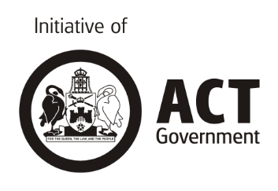

Table of contents

Acronyms 4

Recommendations 5

Introduction 6

Fuel prices and expenditure in the ACT 7

Price changes 7

Fuel expenditure for low-income households 10

Conclusion 14

Attachments 15

Acronyms

ABS Australian Bureau of Statistics

ACTCOSS ACT Council of Social Service Inc.

CPI Consumer Price Index

HES Household Expenditure Survey

|  |
| --- |
| Recommendations ACT Government   * Undertake a study of transport costs to examine how individuals on low and fixed incomes meet costs of vehicle operation and maintenance and if and to what extent this involves reliance on sub-prime loans. Measures should then be developed to address findings on the broader relationship between transport costs, indebtedness and infringements (e.g. driving unregistered) for people on low and moderate incomes * Improve the fairness and adequacy of transport related concessions. This should include: concessions for learner, probationary and restricted driver’s licenses and aligning the discount on license fees for Health Care Card holders (currently 50% of costs) with Pension Card Holders (100%) * Investigate transport gaps for people experiencing social disadvantage and funding any improvements in transport coverage and frequency required to meet the needs identified * Undertake comprehensive needs assessment, policy, design and planning work to ensure transport design, planning, integration and implementation addresses the needs of those with transport disadvantage across both on-demand and mass transit systems. This work should ensure that transport investments keep up with urban infill, growth and group centre redesign and that this is done with lived experience input from those with the greatest level of transport disadvantage. User testing by people with lived experience of transport disadvantage (related to mobility, affordability and/or accessibility) should be routine in transport re-design processes. * Identify strategies for electrification of vehicles that will prioritise growing the second-hand market for electric vehicles and considering grey fleets in the community sector as a space to test the viability and affordability of electric vehicles * Ensure the incentives for adoption of electric vehicles do not include penalties in fees and charges related to vehicle registration to low- and middle-income households who continue to drive internal combustion engine vehicles.   Australian Government   * Raise the rate of Newstart, Youth Allowance and other working age allowances for single people by a minimum of $75 a week * Increase Family Tax Benefit for older children to meet rising costs and introduce a Single Parent Supplement to reduce child poverty. |

Introduction

The ACT Council of Social Service Inc. (ACTCOSS) is the peak representative body for not-for-profit community organisations and people living with disadvantage in the Australian Capital Territory. This submission is primarily concerned with ‘the impact of fuel prices on the ACT community’ – particularly on people living in low-income households and experiencing disadvantage.

Fuel pricing is fundamentally a cost of living and transport issue. Transport is a significant and essential area of expenditure for households and automotive fuel makes up a significant component of household transport costs. Transport is also a social determinant of health. Local research has found that transport disadvantage can exacerbate food insecurity and impede access to primary health services.[1] Other research shows that when people cannot afford to cover the costs of privately-owned transport their broader social and economic outcomes are negatively affected.[2]

Over the past year, fuel prices in Canberra have increased by 15% – and by almost 30% over the past decade. This rate of price increase is higher than that experienced by any other Australian capital city. This creates a significant challenge for households without enough income to cover sudden and substantial price increases.

We urge the Select Committee on Fuel Pricing to view the impact of fuel prices on the ACT community within this broader perspective of transport as a social determinant of health.

Policies and subsidies implemented to reduce carbon emissions from internal combustion vehicles are supported by ACTCOSS, but policies and subsidies should ensure people living on low incomes and others who experience transport disadvantage can benefit from these changes. There is a risk that transition to electric vehicles (EV) will expose people living on low incomes and others who experience transport disadvantage to high costs because they are unable to afford the up-front costs of an EV.

The inquiry should prioritise the identification of measures that would improve the affordability of fuel – and transport more broadly – for low-income households in the ACT.

This submission draws on three key pieces of research and advocacy that ACTCOSS produced in relation to addressing transport disadvantage in the ACT in 2016. These documents are included as attachments to this submission:

* [ACT Cost of Living Report: Transport, April 2016 (Full data report & Snapshot)](https://www.actcoss.org.au/publications/advocacy-publications/act-cost-living-report-transport-2016)
* [Transport: a ‘wicked problem’ we have the strengths and assets to solve, September 2016](https://www.actcoss.org.au/publications/advocacy-publications/position-paper-transport-‘wicked-problem’-we-have-strengths-and)
* [2016 Election Statement – Transport, September 2016](https://www.actcoss.org.au/publications/advocacy-publications/2016-act-election-statement-transport).

In addition, we have undertaken a preliminary analysis of the latest fuel price and expenditure data produced by the Australian Bureau of Statistics (ABS).

# Fuel prices and expenditure in the ACT

## Price changes

Petrol prices in the ACT have been the subject of much public concern and media commentary in recent months. The latest Consumer Price Index (CPI) figures show that in the past year petrol prices increased by 14.8% – a higher rate than any other Australian capital city and well above the national increase of 6.7%. Analysis of changes in the CPI for fuel over a range of time periods shows that while this increase in fuel prices in Canberra appears to be a departure from the long-term trend, this trend has been characterised by significant price fluctuations over time. These price fluctuations are in themselves a potential cause of financial stress and concern – especially for people living on low incomes and who may be on fixed incomes.

|  |
| --- |
| What is of greatest concern is that rapid and significant increases in the price of an essential expenditure items impacts hardest on low-income households. The volatile nature of fuel prices has long presented a challenge in terms of household budgeting, particularly for households without enough income to cover sudden and substantial price increases. |

The CPI data shows that changes in ACT fuel prices have largely followed the national trend (see Figure 1). At the same time, fuel prices in the ACT have increased more than the national rate over a range of time periods (see Figure 2). Looking back from the Dec 2018 quarter we see that, compared to other capital cities, Canberra has experienced the highest rate of fuel price increase over the past quarter (2.9%), year (14.8%), 5 years (3.5%), and decade (29.3%). The significant variation in these rates highlights both the fluctuating nature of fuel prices and the need for caution in analysis of fuel price changes over time and across jurisdictions – the selection of a different baseline quarter and/or a different period of analysis can result in a significantly different picture of price trends. For example, while the latest CPI data shows that Canberra fuel prices rose by 14.8% between Dec 2017-Dec 2018, our 2016 ACT Cost of Living Report found that fuel prices had fallen by 13.1% from Dec 2014-Dec 2015.

At that time the ABS noted that falls in world oil prices continue to influence domestic fuel prices. Between the September 2018 and December 2018 quarters the fuel price fell nationally (-2.5%) but rose locally (2.9%). The ABS again noted that, nationally, this was ‘due to falls in world oil prices flowing through to petrol prices’.[3] This raises the question as to why Canberra fuel prices were not responsive to falls in the world oil price in the most recent quarter.

Figure 1 Changes in CPI for automative fuel and All Groups CPI, Canberra and Australia, to Dec 2018 quarter

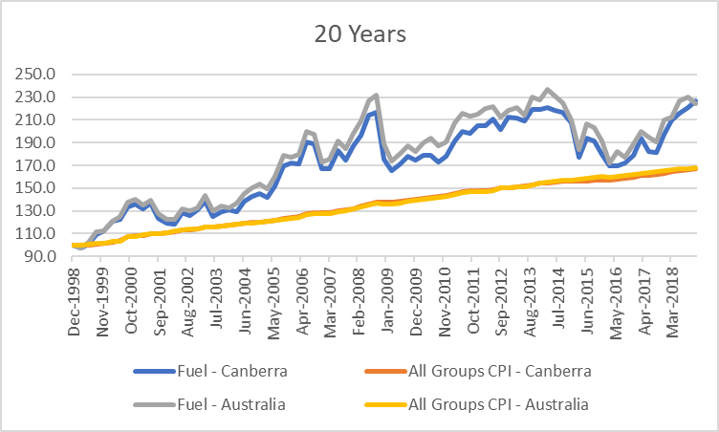

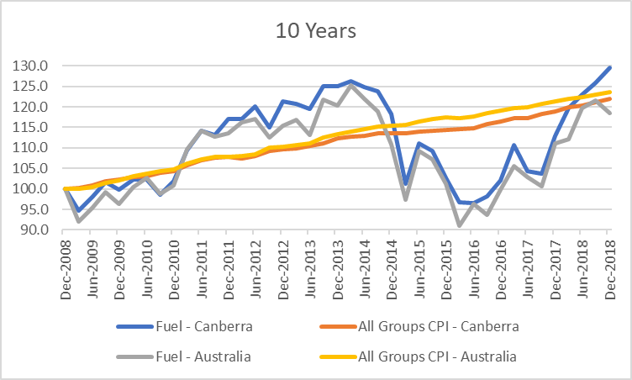

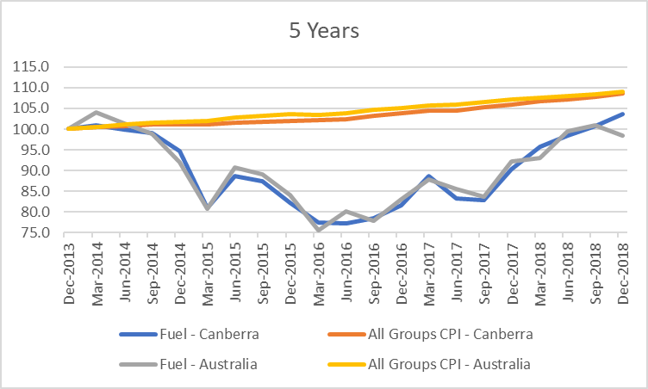

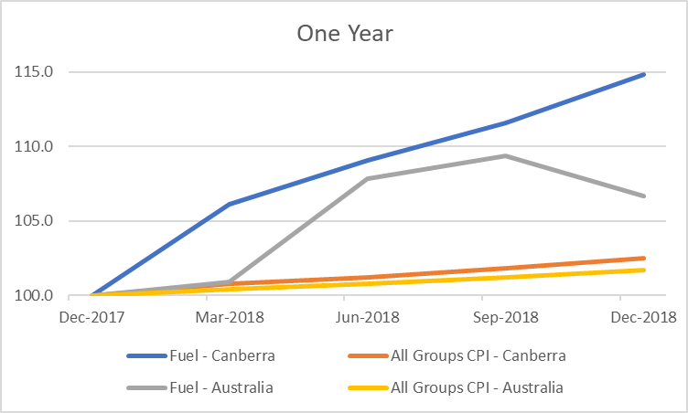

Source: ABS, *Consumer Price Index, Australia, Dec 2018*, cat. no. 6401.0, ABS, Canberra, January 2019, Table 11, Data 5 & 6.

Figure 2 Changes in CPI for automotive fuel by capital city (percent)

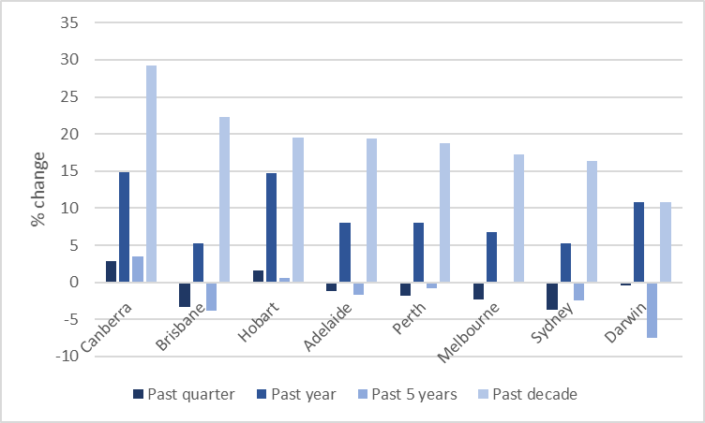

Source: G Jericho, ‘Inflation growth remains lower than Reserve Bank wants. How will it act?’, The Guardian, 31 January 2019, using ABS, Consumer Price Index, Australia, Dec 2018, cat. no. 6401.0.

## Fuel expenditure for low-income households

Based on detailed analysis of the ABS’s 2009-10 Household Expenditure Survey (HES), ACTCOSS found that:

* The proportion of household expenditure which goes to fuel is fairly standard across all categories, but it is notable that welfare recipient households spend more on fuel than other low-income households both in absolute terms and as a proportion of their total expenditure.
* Households with people receiving disability and carer payments pay above the national average as a proportion of their income on fuel (4.2% versus 4.1%). It is noteworthy also that people on unemployment and study benefits (4.6%) and family support payments (4.3%) also pay above the national average.[4]

At that time we noted:

With a single age pensioner receiving around $498 per week, a single unemployed person receiving around $330 per week and a young person receiving $260 per week, transport costs are going to be felt more keenly and, in particular, any rises in transport costs for these households will put immediate pressure on weekly budgets. Even a single person working full-time and earning the minimum wage ($656 per week) is earning around $1700 per week under the ACT average. All of these households have to pay the same bus fare and taxi fare rates (unless they are eligible for a concession or subsidy) or cost of petrol at the bowser (for which there are no concessions).[5]

This means that, when there are fuel price increases (which is not applicable currently but could again be an issue sometime in the future), people on Newstart and Youth Allowance would be particularly impacted by future price rises because of their weekly expenditure on fuel and the low incomes that they have to budget on.[6]

Newstart and other working age allowances are not adequate to meet the basic costs of living – the rate of Newstart, for example, has not been increased in real terms for 25 years (see Figure 3). At the same time, the living costs for people living on Newstart have increased at a greater rate than the CPI (see Figure 4). The current rate of $40 per day is too low to give people the support they need to meet the basic costs of living and to cope with unexpected expenses such as a car breaking down. Instead of supporting people, the current Newstart rate forces them into a cycle of debt, social isolation and humiliation that undermines their efforts to get and keep a job and exacerbates the risk of getting trapped in a cycle of inadequate income, debt and long-term poverty.

Figure 3 Newstart versus pensions and wages ($2018)

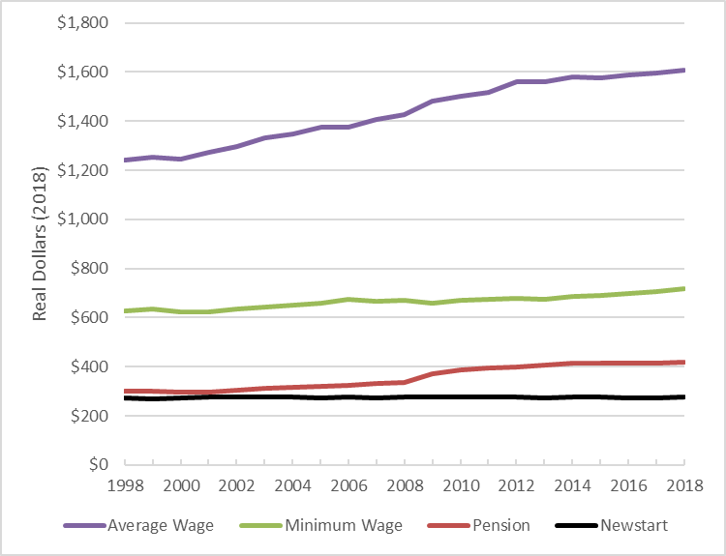

Source: ACOSS, Raise the Rate Briefing Note, ACOSS, Sydney, 2018.

Figure 4 Relative change in living cost for Newstart recipients, 1998-2018

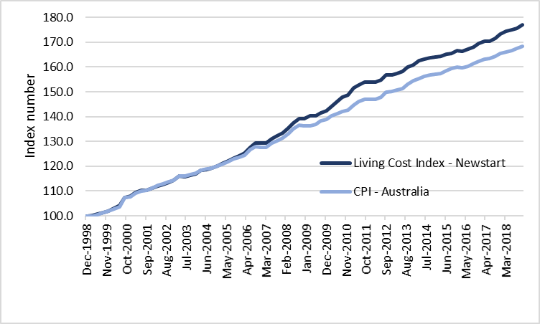

Source: ACTCOSS’ own analysis, derived from ABS, *Consumer Price Index, Australia, Dec 2018*, cat. no. 6401.0, ABS, Canberra, 2019, Table 11, Data 6; and ABS, *Selected Living Cost Indexes, Australia, Dec 2018*, ABS, Canberra, 2019, Table 2, Data 1.

In preparing this submission, we have undertaken a preliminary analysis of the 2015-16 HES data on household expenditure on automotive fuel. The 2015-16 HES found that the three largest contributors to household spending in the average Australian household are housing, food, and transport costs. In the ACT, the third largest contributor to household spending in the average household (and in higher-income households) is recreation, followed by transport – and these average and above-average income households spend more on motor vehicle purchase than fuel. However, in low-income households in the ACT, transport is the third largest component of expenditure and automotive fuel – primarily petrol – is the most significant component of household transport costs.

|  |
| --- |
| As with other essential expenditure items, fuel costs are regressive and account for a larger portion of disposable income in low-income households. |

While the average household spends more money on fuel than low-income households per week, fuel takes up a greater proportion of the household budget in low-income households (see Figures 5 & 6). In low-income households fuel accounts for a similar proportion of income spent on other essentials such as energy and telecommunications.

Figure 5 Fuel expenditure as a proportion of weekly disposable household income, by income quintile, Australia, 2015-16

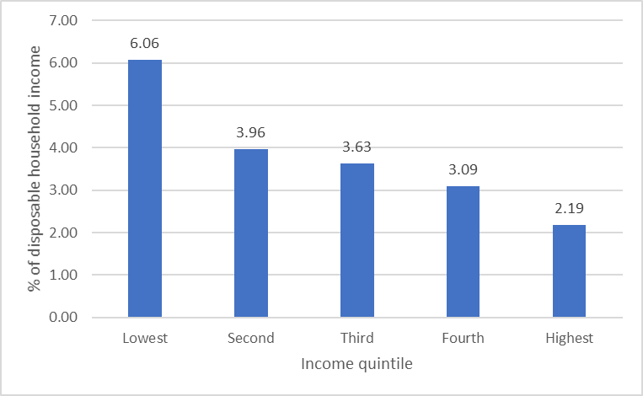

Source: ACTCOSS analysis derived from ABS, *Household expenditure survey, Australia, Summary of results, 2015-16*, ABS, Canberra, 2017, Tables 3.2 & 3.3A.

Figure 6 Weekly household expenditure on fuel by income quintile, Australia, 2015-16

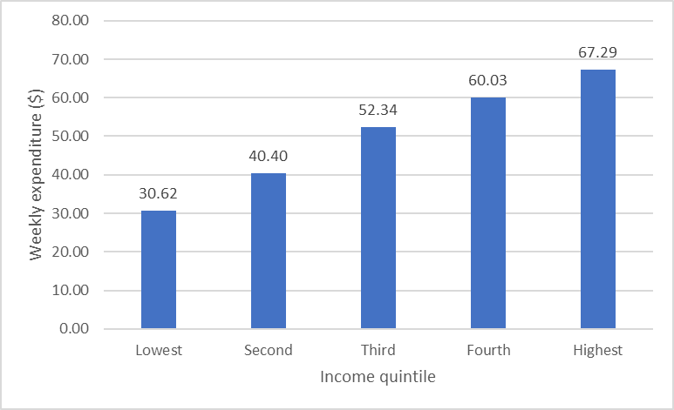

Source: ABS, Household expenditure survey, Australia, Summary of results, 2015-16, ABS, Canberra, 2017, Tables 3.3A.

Electrification of vehicles is seen to be an important component of the transition to a zero emission economy by 2045. ACTCOSS is working with the ACT Government to identify strategies for electrification of vehicles that will prioritise growing the second-hand market for electric vehicles and considering grey fleets in the community sector as a space to test the viability and affordability of electric vehicles. We are also advocating against penalties in fees and charges related to vehicle registration to low- and middle-income households who continue to drive internal combustion engine vehicles. This includes people with limited choices and capacities to upgrade to newer vehicles such as people on low incomes and people with disability access and vehicle adaption requirements not compatible with electric vehicle models.

|  |
| --- |
| Low-income households may face a poverty premium in relation to private transport if they cannot afford to purchase fuel- or energy-efficient vehicles (e.g. hybrid/electric vehicles) which provide longer-term savings in terms of fuel consumption costs.  Another poverty premium relating to private vehicle operating costs exists in relation to vehicle registration where those who can afford to pay for a full year of registration pay less annually than those who can only afford to pay for a shorter-term registration. |

# Conclusion

Over the past year, fuel prices in Canberra have increased by 15% – and by almost 30% over the past decade. This rate of price increase is higher than that experienced by any other Australian capital city. This creates a significant challenge for households without enough income to cover sudden and substantial price increases.

In assessing the impact of fuel prices on the ACT community it is necessary to prioritise the identification of measures that would improve the affordability of fuel – and transport more broadly – for low-income households in the ACT.

Fuel pricing is fundamentally a cost of living and transport issue. Transport is a significant and essential area of expenditure for households and automotive fuel makes up a significant component of household transport costs. Transport is also a social determinant of health.

ACTCOSS is supportive of the Select Committee’s exploration of regulatory and legislative solutions and barriers and its consideration of best practice approaches and initiatives that have a meaningful impact on reducing fuel prices. At the same time, we encourage the Select Committee and all members of the ACT Legislative Assembly to view fuel pricing as just one element that needs to be addressed as part of a comprehensive response to transport disadvantage in the ACT.

We recommend that the ACT Government:

* Undertake a study of transport costs to examine how individuals on low and fixed incomes meet costs of vehicle operation and maintenance and if and to what extent this involves reliance on sub-prime loans. Measures should then be developed to address findings on the broader relationship between transport costs, indebtedness and infringements (e.g. driving unregistered) for people on low and moderate incomes
* Improve the fairness and adequacy of transport related concessions. This should include: concessions for learner, probationary and restricted driver’s licenses and aligning the discount on license fees for Health Care Card holders (currently 50% of costs) with Pension Card Holders (100%)
* Investigate transport gaps for people experiencing social disadvantage and funding any improvements in transport coverage and frequency required to meet the needs identified
* Undertake comprehensive needs assessment, policy, design and planning work to ensure transport design, planning, integration and implementation addresses the needs of those with transport disadvantage across both on-demand and mass transit systems. This work should ensure that transport investments keep up with urban infill, growth and group centre redesign and that this is done with lived experience input from those with the greatest level of transport disadvantage. User testing by people with lived experience of transport disadvantage (related to mobility, affordability and/or accessibility) should be routine in transport re-design processes
* Identify strategies for electrification of vehicles that will prioritise growing the second-hand market for electric vehicles and considering grey fleets in the community sector as a space to test the viability and affordability of electric vehicles
* Ensure the incentives for adoption of electric vehicles do not include penalties in fees and charges related to vehicle registration to low- and middle-income households who continue to drive internal combustion engine vehicles.

We recommend that the ACT Government actively lobby the Australian Government to:

* Raise the rate of Newstart and Youth Allowance for single people by a minimum of $75 a week
* Increase Family Tax Benefit for older children to meet rising costs and introduce a Single Parent Supplement to reduce child poverty.

# Attachments

1. [ACTCOSS,](https://www.actcoss.org.au/publications/advocacy-publications/act-cost-living-report-transport-2016) *[Full data report: ACT cost of living report: transport](https://www.actcoss.org.au/publications/advocacy-publications/act-cost-living-report-transport-2016)*[, ACTCOSS, Canberra, April 2016, <https://www.actcoss.org.au/publications/advocacy-publications/act-cost-living-report-transport-2016>.](https://www.actcoss.org.au/publications/advocacy-publications/act-cost-living-report-transport-2016)
2. [ACTCOSS, *Snapshot: ACT cost of living report: transport*, ACTCOSS, Canberra, April 2016](https://www.actcoss.org.au/publications/advocacy-publications/act-cost-living-report-transport-2016), <<https://www.actcoss.org.au/publications/advocacy-publications/act-cost-living-report-transport-2016>>.
3. [ACTCOSS,](https://www.actcoss.org.au/publications/advocacy-publications/position-paper-transport-‘wicked-problem’-we-have-strengths-and) *[Transport: a ‘wicked problem’ we have the strengths and assets to solve](https://www.actcoss.org.au/publications/advocacy-publications/position-paper-transport-‘wicked-problem’-we-have-strengths-and)*[, ACTCOSS, Canberra, September 2016, <https://www.actcoss.org.au/publications/advocacy-publications/position-paper-transport-‘wicked-problem’-we-have-strengths-and>.](https://www.actcoss.org.au/publications/advocacy-publications/position-paper-transport-‘wicked-problem’-we-have-strengths-and)
4. [ACTCOSS, *2016 Election Statement – Transport*, September 2016](https://www.actcoss.org.au/publications/advocacy-publications/2016-act-election-statement-transport), <<https://www.actcoss.org.au/publications/advocacy-publications/2016-act-election-statement-transport>>.

1. See for example ACTCOSS, *Food security, food assistance and the affordability of healthy food in the ACT*, ACTCOSS, Canberra, forthcoming; ACTCOSS, *Transport: a ‘wicked problem’ we have the strengths and assets to solve*, ACTCOSS, Canberra, September 2016, viewed 6 March 2019, <https://www.actcoss.org.au/publications/advocacy-publications/position-paper-transport-‘wicked-problem’-we-have-strengths-and>; Anglicare ACT & Red Cross, *Mapping food insecurity in the ACT*, Anglicare ACT & Red Cross, Canberra, 2013, p.28; ACT Medicare Local, Connecting Care: A Comprehensive Needs Assessment 2014: Major Issues and Key Points, ACT Medicare Local, Canberra, 2014, viewed 16 June 2016, <https://www.chnact.org.au/sites/default/files/CNA%20Major%20Issues%20and%20Key%20Points.pdf>.
2. See for example J Dodson, N Buchanan, B Gleeson & N Sipe, ‘Investigating the Social Dimensions of Transport Disadvantage—I. Towards New Concepts and Methods’, *Urban Policy and Research*, vol. 24, 4, 2006, pp.432-453; J Hine, ‘Transport and Social Exclusion’ in R Kitchin & N Thrift (eds), *International Encyclopedia of Human Geography*, Elsevier Ltd, Oxford, 2009, pp. 429-434.
3. ABS, *Consumer Price Index, Australia, Dec 2018*, cat. no. 6401.0, ABS, Canberra, 30 January 2019, Summary – Main contributors to change.
4. ACTCOSS, *Snapshot: ACT cost of living report: transport*, ACTCOSS, Canberra, April 2016, viewed 6 March 2019, pp. 4-5, <https://www.actcoss.org.au/publications/advocacy-publications/act-cost-living-report-transport-2016>.
5. ACTCOSS, *Full data report: ACT cost of living report: transport*, ACTCOSS, Canberra, April 2016, p. 27, viewed 6 March 2019, <https://www.actcoss.org.au/publications/advocacy-publications/act-cost-living-report-transport-2016>.
6. ACTCOSS, *Full data report: ACT cost of living report: transport*, ACTCOSS, Canberra, April 2016, viewed 6 March 2019, p. 48, <https://www.actcoss.org.au/publications/advocacy-publications/act-cost-living-report-transport-2016>.