Logo: ACT Council of Social Service Inc. (ACTCOSS).Factsheet

October 2020

Poverty and COVID-19 in the ACT

Disadvantage in the ACT tends to be hidden behind high averages across indicators such as income, education, and employment. Closer analysis reveals that a sizeable number of people in the ACT do experience poverty and disadvantage.

Cost of living has a significant impact on low-income households in the ACT who spend a greater proportion of their income on essential goods and services such as housing, food, transport, and energy.

The most recent estimates for the ACT indicate that:

* Almost **40,000 Canberrans** live in households that are among Australia’s **most disadvantaged**[1]
* Since COVID-19, the number of people **living in poverty** has increased from just under 30,000 people to just over **38,000 people**[2]
* Over **25,000 people** in low-income households are experiencing **food stress**[3]
* Almost **23,000 people** are living on JobSeeker, Youth Allowance, or other working-age allowances **eligible for the Coronavirus Supplement**[4]
* Almost **9,500 low-income rental households** are in **rental stress**[5]
* Almost **8,000 children** (12%) live in **low-income households** in the ACT.[6]

The following groups face an elevated risk of experiencing poverty and/or socioeconomic disadvantage in the ACT:

* Aboriginal and/or Torres Strait Islander people
* People from culturally and linguistically diverse backgrounds
* People with disability
* Older people aged 65 years and older
* Women.[7]

|  |
| --- |
| **Quote us** ►: “For most of us, the ACT offers an excellent quality of life and supports a strong sense of wellbeing. Amidst the prosperity, significant poverty exists in the ACT. In the wake of COVID-19, there are now 38,000 Canberrans living below the poverty line.  “The ACT has the highest average weekly earnings in Australia. However, for those on low incomes, the cost of living in Canberra means many cannot afford the fundamentals of a healthy life such as food, housing, health services, and energy.  “Our [*2020 ACT Cost of Living Report*](https://www.actcoss.org.au/publications/advocacy-publications/act-cost-living-report-2020) found that over the past five years changes in the cost of living have hit Canberra’s low-income households the hardest. These households spend a greater proportion of their income on essential goods and services. Over the last five years, prices for some of these essentials grew significantly in Canberra, with medical and hospital services increasing by 28%, electricity and gas prices rose by 25% and 31% respectively, and housing costs increased by 15%.  “In August 2020, Anglicare found that out of 768 private rentals advertised in the ACT, only 17 properties could be considered affordable for people on low incomes. None were affordable for a single person on the Disability Support Pension and only one was affordable for a single person on JobSeeker receiving the $550 per fortnight Coronavirus Supplement.  “Ensuring people have adequate incomes and affordable housing is fundamental to reducing poverty and inequality in the ACT. We need the Australian Government to provide a permanent and adequate increase to JobSeeker and related income support payments to keep people out of poverty. The Australian and ACT governments must urgently work together to address the shortfall of over 3,000 social housing dwellings in Canberra.  “A just and fair Canberra requires an inclusive economy. Targeted measures that address cost of living for low-income households are an essential part of this. Targeted concessions, rebates and subsidies must be designed to relieve cost of living pressures for households with low incomes or experiencing other forms of hardship. By alleviating poverty and reducing inequality targeted measures benefit everyone.  “At the same time, tax revenue must be sufficient to fund quality services, affordable housing, and community infrastructure that address the structural causes of poverty and disadvantage while benefiting all Canberrans.”  Dr Emma Campbell, CEO, ACTCOSS |

# Poverty in the ACT during COVID-19

Prior to the COVID-19 pandemic, ACOSS and UNSW estimated that almost 30,000 people in the ACT were living below the poverty line, representing 8.6% of the total population.[8] More recent ANU analysis indicates that the number of Canberrans living in poverty has increased to approximately 38,000 people, with poverty rates varying across Canberra regions – ranging from between 8% to 12%.[9]

Poverty rates by SA3 region, ACT, March-October 2020[10]

|  |  |  |  |
| --- | --- | --- | --- |
| Region | March 2020  Poverty Rate | June 2020  Poverty Rate | October 2020  Poverty Rate |
| Belconnen | 7.5% | 5.7% | 10.5% |
| Gungahlin | 5.7% | 4.7% | 9.1% |
| North Canberra | 8.9% | 8.5% | 11.9% |
| South Canberra | 5.3% | 4.4% | 7.5% |
| Tuggeranong | 6.4% | 5.1% | 10.1% |
| Weston Creek | 5.6% | 4.2% | 8.3% |
| Woden | 5.1% | 4.0% | 7.6% |

This data indicates that the increase in the rate of JobSeeker and related working-age payments through the Coronavirus Supplement of $550 per fortnight and the introduction of the JobKeeper payment of $1,500 per fortnight per eligible employee saw a significant reduction in poverty rates across the ACT. The reduction of the Coronavirus Supplement and JobKeeper payments from late September 2020 have seen a significant increase in ACT poverty rates above pre-COVID levels. Removing these supports completely would likely see poverty rates in the ACT increase even more.

Analysis undertaken by ACTCOSS for our 2020 *ACT Cost of Living Report* shows how the introduction, reduction, and pending removal of the Coronavirus Supplement has seen income support payments rise above and fall back below the poverty line. As at June 2020, 22,676 people in the ACT were receiving income support payments boosted by the Coronavirus Supplement. Of these, almost 15,000 were looking for work while on JobSeeker or Youth Allowance (other) – this figure had more than doubled in the first six months of 2020.

# The rise and fall of income support during COVID-19

Changes in income support payments due to the introduction, reduction, and removal of the Coronavirus Supplement (in relation to the poverty line)[11]

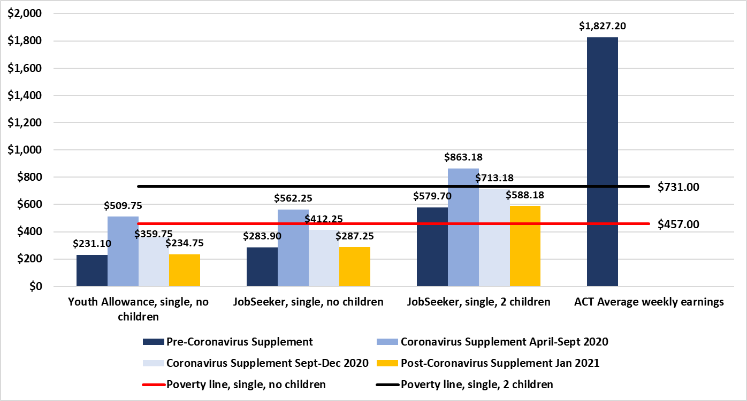

Poverty gap for JobSeeker and Youth Allowance recipients with the introduction, reduction, and removal of the Coronavirus Supplement[12]

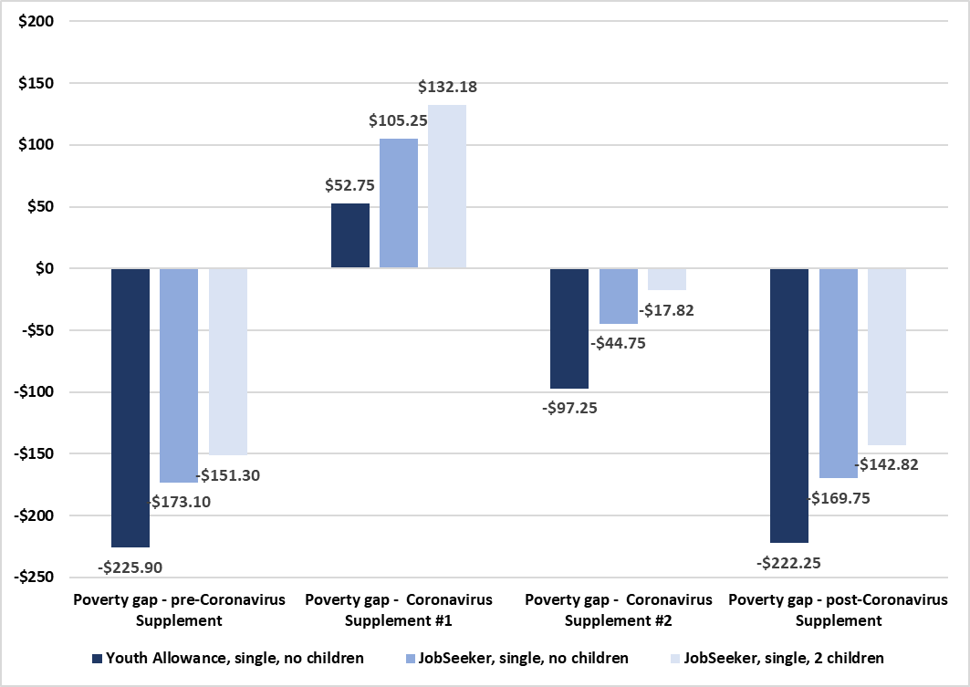

# Poverty in Australia, 2020: Who is affected?

Some groups of people are more at risk of poverty than others. Factors such as age, gender, family relationships, paid work and sources of income, disability and other characteristics can all have an impact on poverty risks.[13]

**UNEMPLOYMENT: People who are unemployed** are at most risk of poverty. **66%** of people in households where the main income earner is unemployed live in poverty.

**INCOME SUPPORT: People relying on income support payments** rather than a wage are approximately **5 times more likely** to live in poverty.

**HOUSING: People who rent** their home are almost twice as likely to live in poverty (**19%**) as those who own their home (9%).

**PARENTAL STATUS & GENDER: Sole parent families** are more likely to be in poverty (**35%**) than couple families (11%). **Families with children with a female main earner** are more likely to be in poverty (**23%**) than families with children with a male main earner (10%).

**AGE: Children** are more likely to live in poverty (**18%**) when compared with the whole population (14%). The risk of poverty for children in sole parent families is much higher, at 44%. The poverty rate for people aged over 65 is somewhat lower, at 10%, except for people aged 65+ who are renting (39%).

**LOW-PAID WORK: 38% of people in poverty are in wage-earning households**. The vast majority of these households (72%) are families with children, and a significant proportion are relying on part-time work (36%).

# Solutions to Poverty

* Set a serious goal of full employment.
* Commit to a flexible employment and training guarantee to improve the employment prospects of people unemployed long-term.
* Permanently lift social security payments above the poverty line.
* Increase Rent Assistance so that everyone around the country receives enough rental support.
* Build more social housing to improve the supply of secure and affordable homes.

# Raise the Rate campaign

ACOSS is running the **Raise the Rate** campaign which is calling on the Australian Government to permanently and adequately raise the rate of the unemployment and related payments allowances so that they keep people out of poverty.

Raise the Rate website: [raisetherate.org.au](https://raisetherate.org.au/) | #RaiseTheRateForGood

# Everybody’s Home campaign

The **Everybody’s Home** campaign is calling for a better, fairer housing system for everyone.

Everybody’s Home website: [everybodyshome.com.au](https://everybodyshome.com.au/)

# Further reading

**ACT Cost of Living Report, 2020**<https://www.actcoss.org.au/publications/advocacy-publications/act-cost-living-report-2020>

**2020 ACT Election Issue Brief: Poverty, inequality, and the cost of living**<https://www.actcoss.org.au/publications/election-platform/cost-living-financial-hardship-and-poverty>

**Hidden disadvantage in the ACT: Report for ACT Anti-Poverty Week 2017**<https://www.actcoss.org.au/publications/advocacy-publications/hidden-disadvantage-act-report-anti-poverty-week-2017>

**ACOSS Briefing: Next steps for income support, July 2020**<https://www.acoss.org.au/wp-content/uploads/2020/09/Social-security-next-steps-JUL-UPDATED-2-9_.pdf>

**ACOSS & UNSW Poverty and Inequality in Australia website**  
[http://povertyandinequality.acoss.org.au](http://povertyandinequality.acoss.org.au/)

**Poverty in Australia 2020**[http://povertyandinequality.acoss.org.au/publication/poverty-in-australia-2020-part-1-overview](http://povertyandinequality.acoss.org.au/publication/poverty-in-australia-2020-part-1-overview/)

**Inequality in Australia 2020**[http://povertyandinequality.acoss.org.au/inequality/inequality-in-australia-2020-part-1-overview](http://povertyandinequality.acoss.org.au/inequality/inequality-in-australia-2020-part-1-overview/)

# Connect

ACTCOSS website: [www.actcoss.org.au](http://www.actcoss.org.au) | Twitter: [@ACTCOSS](https://twitter.com/actcoss)

ACOSS website: [www.acoss.org.au](http://www.acoss.org.au) | Twitter: [@ACOSS](https://twitter.com/acoss)

1. ABS, *Experimental Index of Household Advantage and Disadvantage, 2016*, cat. no. 4198.0, ABS, Canberra, 2019, State and territory, percentage of persons, IHAD, 2016, Table 6, viewed 25 June 2019, <<https://www.abs.gov.au/AUSSTATS/abs@.nsf/Lookup/4198.0Main+Features12016?OpenDocument>>.
2. ACOSS & UNSW, *Poverty and Inequality website*, Data and figures, Rate of poverty by state/territory of residence, 2020, <http://povertyandinequality.acoss.org.au/poverty/rate-of-poverty-by-state-territory-of-residence-of-people/>; P Davidson, email, 18 May 2020; B Phillips, unpublished data, ANU Centre for Social Research and Methods, Canberra, October 2020.
3. ACTCOSS*, Food security, food assistance and the affordability of healthy food in Canberra*, ACTCOSS, Canberra, May 2019, p. 22, viewed 25 June 2019, <<https://www.actcoss.org.au/publications/advocacy-publications/report-food-security-food-assistance-and-affordability-healthy>>.
4. Department of Social Services*, DSS Payment Demographic Data June 2020*, DSS, Canberra, 2020, viewed 12 October 2020, < <https://data.gov.au/data/dataset/dss-payment-demographic-data>>.
5. ABS, *4130.0 - Housing Occupancy and Costs, 2017-18*, ABS, Canberra, 2019, Table 21.1, viewed 5 September 2020, <https://www.abs.gov.au/ausstats/abs@.nsf/mf/4130.0>.>.
6. R Tanton, R Miranti & Y Vidyattama, *Hidden disadvantage in the ACT: Report for ACT Anti-Poverty Week*, NATSEM, Canberra, October 2017, viewed 25 June 2019, <<https://www.actcoss.org.au/publications/advocacy-publications/hidden-disadvantage-act-report-anti-poverty-week-2017>>.
7. ABS, op. cit.; E Davidson, *Hidden disadvantage among women in the ACT*, Women’s Centre for Health Matters, Canberra, June 2018, viewed 1 April 2019, <<http://www.wchm.org.au/wp-content/uploads/2018/06/Hidden-disadvantage-among-women-in-the-ACT-final.pdf>>; ACTCOSS unpublished analysis of ABS 2016 Census of Population and Housing using TableBuilder.
8. ACOSS & UNSW, op. cit.
9. B Phillips, unpublished data, ANU Centre for Social Research and Methods, Canberra, October 2020.
10. B Phillips, unpublished data, ANU Centre for Social Research and Methods, Canberra, October 2020.
11. ACTCOSS, *ACT Cost of Living Report, 2020*, ACTCOSS, Canberra, 2020, p. 37, viewed 13 October 2020, <<https://www.actcoss.org.au/publications/advocacy-publications/act-cost-living-report-2020>>.
12. ibid, p. 38.
13. ACOSS & UNSW, *Poverty in Australia 2020: Who is affected?*, Factsheet, ACOSS, Sydney, 2020, viewed 13 October 2020, <<http://povertyandinequality.acoss.org.au/wp-content/uploads/2020/05/Poverty-in-Australia-2020-Part-2-–-Who-is-affected-factsheet-v6.pdf>>.