

Logo: ACT Council of Social Service Inc. (ACTCOSS).

ACT Cost of Living Report

Tracking changes in the cost of living for low-income households in the Australian Capital Territory

September 2020

About ACTCOSS

ACTCOSS acknowledges Canberra has been built on the land of the Ngunnawal people. We pay respects to their Elders and recognise the strength and resilience of Aboriginal and/or Torres Strait Islander peoples. We celebrate Aboriginal and/or Torres Strait Islander cultures and ongoing contributions to the ACT community.

The ACT Council of Social Service Inc. (ACTCOSS) advocates for social justice in the ACT and represents not-for-profit community organisations.

ACTCOSS is a member of the nationwide COSS Network, made up of each of the state and territory Councils and the national body, the Australian Council of Social Service (ACOSS).

ACTCOSS’s vision is for Canberra to be a just, safe and sustainable community in which everyone has the opportunity for self-determination and a fair share of resources and services.

The membership of the Council includes the majority of community-based service providers in the social welfare area, a range of community associations and networks, self-help and consumer groups and interested individuals.

ACTCOSS advises that this document may be publicly distributed, including by placing a copy on our website.

Contact Details

Phone: 02 6202 7200  
Address: Weston Community Hub, 1/6 Gritten St, Weston ACT 2611  
Email: [actcoss@actcoss.org.au](mailto:actcoss@actcoss.org.au)   
Web: [actcoss.org.au](https://www.actcoss.org.au)

CEO: Dr Emma Campbell   
Policy Officer: Geoff Buchanan

September 2020

ISBN 978-1-876632-87-8   
© Copyright ACT Council of Social Service Incorporated

This publication is copyright, apart from use by those agencies for which it has been produced. Non-profit associations and groups have permission to reproduce parts of this publication as long as the original meaning is retained and proper credit is given to the ACT Council of Social Service Inc (ACTCOSS). All other individuals and Agencies seeking to reproduce material from this publication should obtain the permission of the CEO of ACTCOSS.

An ACT Government funded initiative.

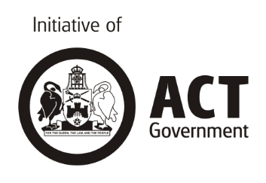

Table of contents

Acronyms 4

Key findings 5

Recommendations 7

Action on income support by the Australian Government 7

Action on cost of living by the next ACT Government 7

Introduction 10

Tracking changes in the price of key goods and services: CPI 13

Housing 19

Rental affordability 20

Low-income homeowners 27

Health 31

[Tracking changes in the cost of living for low-income   
households: SLCI 32](#_Toc51050145)

Taking action on cost of living in the ACT 42

Conclusion 45

Appendix: Explanatory notes 46

Consumer Price Index and Selected Living Cost Indexes 46

Limitations of the Selected Living Cost Indexes 46

[Income support payment calculations – December 2018 to   
December 2019 47](#_Toc51050151)

How Pension rates are adjusted 48

Acronyms

ABS Australian Bureau of Statistics

ACOSS Australian Council of Social Service

ACT Australian Capital Territory

ACTCOSS ACT Council of Social Service Inc.

CPI Consumer Price Index

CRA Commonwealth Rent Assistance

GDP Gross Domestic Product

GP General Practitioner

ICRC Independent Competition and Regulatory Commission

LCI Living Cost Index

NATSEM National Centre for Social and Economic Modelling (University of Canberra)

RAI Rental Affordability Index

SACOSS South Australian Council of Social Service

SLCI Selected Living Cost Indexes

TTPI Tax and Transfer Policy Institute (The Australian National University)

Key findings

Approximately 30,000 people live below the poverty line in the ACT

* The latest estimate of the national poverty line for a single person is a minimum income of $457 per week
* Before the COVID-19 health emergency, it had been estimated that 8.6% of the total ACT population were living below the poverty line, equating to approximately 30,000 people.

The rate of Newstart was well below the poverty line and failed to keep up with cost of living

* As at December 2019, the weekly Newstart (now JobSeeker) payment for a single person without children was $173 below the poverty line
* In the year from December 2018 to December 2019, Newstart recipients effectively experienced a reduction in income due to the payment failing to keep up with changes in the cost of living.

The Coronavirus Supplement increased JobSeeker above the poverty line

* The introduction of the $550 per fortnight Coronavirus Supplement from 27 April to 24 September 2020 saw JobSeeker (formerly Newstart) rise above the poverty line by $105 per week – finally becoming adequate to meet basic living costs for many recipients.

When the Coronavirus Supplement is reduced, JobSeeker will return below the poverty line and see over 1,000 jobs lost in the ACT

* The reduction of the Coronavirus Supplement by $300 per fortnight from 25 September 2020 will see these payments drop below the poverty line again by around $45 per week. The complete removal of the supplement at the end of the year would see this poverty gap increase to $170 per week
* The economic impact of the removal of the Coronavirus Supplement would be a loss of 1,120 full-time equivalent jobs in the ACT in 2021-22.

The number of people in the ACT looking for work while on JobSeeker and Youth Allowance has more than doubled during the COVID-19 pandemic

* From December 2019 and July 2020, the number of people in the ACT who were looking for employment while in receipt of JobSeeker and Youth Allowance more than doubled from just over 6,500 to just under 15,000.

Without the Coronavirus Supplement, the number of people in the ACT living below the poverty line could increase to around 40,000

* Without the Coronavirus Supplement, the number of people in the ACT living below the poverty line could increase by around 25%, approaching 40,000 due to there being additional 8,500 JobSeeker and Youth Allowance recipients than before the COVID-19 pandemic.

Changes in the cost of living have hit Canberra’s low-income households hardest, with significant increases in housing, health, and energy costs

* Consistent with previous ACT Cost of Living Reports, changes in the cost of living over the past 12 months and five years have hit Canberra’s low-income households the hardest
* Over the past five years, housing, health, and energy prices in Canberra have risen at rates that were higher than the national rate and above the overall Consumer Price Index (CPI)
* Over the past five years, the CPI for housing in Canberra has increased by 15%
* Housing is the most significant cost for low-income households, the majority of whom rent – around 9,500 out of 22,000 low-income rental households in the ACT (43%) are experiencing rental stress, paying over 30% of their household income on rent
* Over the year from June 2019 to June 2020, the ACT was the only state or territory where rental affordability declined
* The latest Anglicare Australia Rental Affordability Snapshot undertaken in August 2020 found that out of 768 private rentals advertised in the ACT, only 17 properties could be considered affordable for people on low incomes – only one of these was affordable for a JobSeeker recipient with the Coronavirus Supplement. None would have been affordable without the supplement
* Over the last five years, the CPI for health in Canberra increased by 22% with medical and hospital services prices increasing by almost 28% and dental services increasing by over 11%
* Over the last five years, electricity and gas prices in Canberra have risen by 25% and 31% respectively.

Recommendations

## Action on income support by the Australian Government

Raise the Rate for Good

In line with the Australian Council of Social Service (ACOSS) and the Raise the Rate for Good campaign, we call on the Australian Government to keep the $550 per fortnight Coronavirus Supplement in place until our social security system is fixed for good so that it keeps people out of poverty.

## Action on cost of living by the next ACT Government

Action on fundamentals, including:

* Publicly call for a permanent and adequate increase to JobSeeker and related income support payments to enable people to cover all basic costs, including keeping a roof over their heads
* Incorporate all economic, social, and cultural rights in the *Human Rights Act 2004* (ACT) including: the right to housing; the right to an adequate standard of living; the right to physical and mental health; and the right to a healthy environment
* Conduct a full needs analysis to understand Canberra’s demographic changes, increasing complexity of needs (including an aging population; growing number of births; greater diversity) and the changed Canberra geography
* Adequately fund community services that play a vital role in preventing, reducing, and alleviating the impacts of poverty and disadvantage in the ACT
* Ensure that revenue is collected in a way that is progressive, equitable, efficient, and sufficient to fund quality services and infrastructure that benefit the whole Canberra community in a just and fair way. This must include targeted concessions that ease cost of living pressures for low-income households and targeted investment that addresses the structural causes of poverty and disadvantage.

Action on financial assistance, including:

* Review the ACT Targeted Assistance Strategy to ensure concessions and rebates are targeted to need
* Recognise the contribution of older Canberrans to our community through a range of targeted supports and assistance points across the city
* Extend financial and other support for all young people transitioning from care
* Increase funding to financial counselling services.

Action on housing affordability, including:

* Commit to implementation of ACTCOSS’s housing affordability policy recommendations, including:
  + Achieve the target of 15% of the Land Release Program for the supply of public, community, and affordable homes
  + Provide further investment in additional public housing and renewal of current stock
  + Increase effective land transfers to ACT community housing providers and empower them to build more community and affordable housing
  + Develop an Indigenous Housing Strategy for the ACT including a pathway to a community-controlled Aboriginal housing organisation.

Action on health costs, including:

* Improve access to the public health system for Canberrans on low incomes and facing other health disadvantage
* Design and implement a Disability Health Strategy that addresses the poor health outcomes for people with disability that arise from economic disadvantage
* Increase funding for sexual and reproductive health services to improve their affordability and availability.

Action on energy affordability, including:

* Ensure the Utilities Concession and Utilities Hardship Fund eligibility are targeted toward need (including to asylum seekers through the ACT Services Access Card) and continue the Energy Support Voucher program by maintaining the Utilities Hardship Fund
* Implement the Independent Competition and Regulatory Commission’s recommendation that ACT energy retailers provide their customers with regular ‘better offer notifications’ by mid-2021 at the latest
* Expand energy efficiency and productivity programs for low-income households (including private rental) and support the introduction of a National Low-income Energy Productivity Program in National Cabinet
* Introduce minimum energy performance requirements for rental properties before the end of 2021.

Action on transport costs, including:

* Carry out a comprehensive community needs assessment to ensure transport design, planning, integration, and implementation address the needs of those with transport disadvantage
* Invest in community transport at sustainable levels with long-term commitments so that providers can renew vehicle stock and plan across a multi-year timeframe. There should be a specific community needs analysis for community transport
* Improve other on-demand transport provision including lifting the cap on the ACT Taxi Subsidy Scheme for people with disabilities, as well as delivering full compliance with the Disability Discrimination Act Transport Standards across the bus network
* Improve the fairness and adequacy of transport-related concessions by extending concessions to learner, probationary and restricted driver’s licences, aligning the discount on licence fees for Health Care Card holders (currently 50% of costs) with Pension Card Holders (100%)
* Investigate the costs and benefits of making all public transport free through a cost benefit analysis.

Action on equal access to justice, including:

* Increase funding to community legal centres, mediation and individual advocacy supports to ensure equal access to justice for all ACT residents, including women and children, Aboriginal and/or Torres Strait Islander people and other Canberrans facing legal and financial disadvantage
* Introduce an income-based approach to ACT Government fines, fees, and other charges to ensure that penalties are not regressive.

Introduction

The ACT Cost of Living Report series tracks changes in the cost of living for low-income households in the ACT. Low-income households tend to be hidden behind the ACT’s high average income and through the purposeful social mix of housing across Canberra’s suburbs. Closer analysis reveals that a significant number of people in the ACT are living in low-income households with many living below the poverty line. To analyse the way that income and wealth are shared across households in Australia, households are ranked from lowest to highest income or wealth and then divided into five equal groups with 20% of the population in each group (quintiles). In this report we focus on cost of living pressures for those households whose income is in the bottom 40% – or the first two quintiles – of the income distribution.

Approximately 37,000 people live in low-income households in the ACT, representing 11% of the total population.[1] This includes almost 8,000 children, representing 12% of those aged 0-14.[2] Aboriginal and/or Torres Strait Islander people, people from culturally and linguistically diverse backgrounds, people with disability, single parent families, and women are over-represented in Canberra’s low-income households.[3] It is estimated that there are almost 30,000 people living below the poverty line in the ACT, representing 8.6% of the total population.[4]

In Australia, the poverty line has most recently been defined as a single adult living on less than $457 a week, $731 for a single parent with two children, or $960 for a couple with two children.[5] This poverty line is set nationally at 50% of the median income. Compared to other states and territories, the ACT has the highest average weekly earnings.[6] If we were to calculate an ACT-specific poverty line it would be likely to be higher than the national poverty line, resulting in a higher ACT-specific poverty rate.

Groups that have poverty rates well above the Australian average include:

* People in households whose main income earner is unemployed (66%)
* Public housing tenants (58%) (reflecting the highly targeted nature of public housing and its scarcity)
* People in households whose main income earner is of working age and out of the labour force (45%)
* Children in sole parent households (44%)
* People in households whose main income earner receives Youth Allowance (43%), Newstart Allowance (57%), Parenting Payment (54%), or Disability Support Pension (41%)
* People aged 65 years and over who are not homeowners (39%).[7]

Unemployment and reliance on income support payments are major drivers of poverty in Australia. Before the Australian Government’s introduction of the Coronavirus Supplement in April 2020, income support payments for people seeking employment were well below the poverty line and had not increased in real terms in over 25 years. As at December 2019, there were just over 6,500 people in the ACT receiving Newstart (now JobSeeker) or Youth Allowance payments while seeking employment and were thus at greatest risk of living in poverty.[8] By July 2020, this number had more than doubled to almost 15,000 people.[9]

This report adopts the methodology used by Councils of Social Service in South Australia and the Northern Territory. It draws on the latest Consumer Price Index (CPI) and Selected Living Cost Indexes (SLCI) data released by the Australian Bureau of Statistics (ABS) to show changes in the cost of living over the past 12 months. This year’s report also looks back at changes in the cost of living over the past five years. Explanatory notes about these indexes, their limitations and income support payment calculations are provided in the Appendix. This report highlights changes in the cost of living for those people who are in receipt of income support. Tracking changes in the cost of living for these households is important as they have the least financial capacity to cope with rises in the cost of essential goods and services.

The following sections of the report track changes in the CPI and SLCI, with a focus on the impact of these changes for people living in low-income households in the ACT. Consistent with previous reports, we find that changes in the cost of living have continued to hit Canberra’s low-income households the hardest. Over the past year, and over the past five years, Canberra’s overall CPI has been largely in line with the national rate. However, there are three key categories of essential goods and services where prices in Canberra have increased at a rate above both the overall CPI and the national rate for the same category. These categories are health, housing, and energy. Our 2019 ACT Cost of Living Report included additional discussion on energy affordability.[10] In this report we provide additional discussion of housing affordability and cost barriers to health services in the ACT.

Consistent with the rest of the ACT Cost of Living Report series, our primary analysis of is based on the change in the CPI and SLCI over a 12-month period, from one December quarter to the next. This report tracks change from December 2018 to December 2019. Since December 2019, the COVID-19 health emergency has had a major impact on prices and on the rates of income support payments. This report also includes analysis of changes to incomes following the introduction of the Coronavirus Supplement by the Australian Government on 27 April 2020, its reduction after 24 September 2020, and its removal after 31 December 2020.

Our analysis of changes in the SLCI alongside changes in income support payments from December 2018 to December 2019 highlights yet again that Newstart (now JobSeeker) had failed to keep up with changes in the cost of living for recipients, resulting in an effective reduction of income over the 12-month period. The introduction of the $550 per fortnight Coronavirus Supplement in April 2020 saw these payments rise to a level above the poverty line and more in line with living costs. The pending reduction in the Coronavirus Supplement from 25 September 2020 will see incomes drop back below the poverty line and its complete withdrawal after 31 December 2020 would see weekly incomes drop to as much as $222 below the poverty line.

This report supports the recommendations of the Australian Council of Social Service (ACOSS) and the Raise the Rate for Good campaign by calling for the Australian Government to:

* Keep the $550 per fortnight Coronavirus Supplement in place until our social security system is fixed for good so that it keeps people out of poverty
* Set a minimum income floor across the working age payments system set at the current pension rate (including the Pension Supplement). This is currently $472 per week for a single person.

In the lead up to the 2020 ACT Election, this report also sets out key actions that will need to be undertaken by the next ACT Government to address cost of living pressures faced by low-income households to achieve a just and fair Canberra. The recommended actions in this report include measures to improve the affordability of housing, health, transport, and energy and to ensure equal access to justice for people on low incomes.

# Tracking changes in the price of key goods and services: CPI

The overall (or All Groups) CPI figure covers many goods and services. Eleven major categories with over 100 individual goods and services make up the CPI basket. There can be wide variations in the CPI for specific goods and services, which may impact different households differently. The overall CPI figure can be separated into its component parts, allowing us to track changes in the price of key basic goods and services in the ACT and nationally.

It is useful to view the changes in CPI in relation to the proportion of expenditure on different goods and services by low-income households. Table 1 shows the proportion of expenditure against different categories of goods and services by households across the income distribution in the ACT. This shows that housing, food, and transport account for around half of household expenditure. It also shows the variation in expenditure by higher and lower income households – for example, it shows that energy costs account for a larger proportion of expenditure for low-income households than for average- and high-income households in the ACT.

Table 1 Proportion of household expenditure, broad expenditure groups, equivalised disposable household income quintiles, ACT, 2015-16 (%)[11]

| Goods and services | Q1 - low | Q2 | Q3 | Q4 | Q5 - high | All |
| --- | --- | --- | --- | --- | --- | --- |
| Current housing costs (selected dwelling) | 23.2 | 18.4 | 22.3 | 13.6 | 14.0 | 17.7 |
| Food and non-alcoholic beverages | 20.5 | 17.1 | 17.2 | 15.1 | 14.2 | 16.1 |
| Transport | 11.4 | 12.4 | 12.7 | 16.5 | 14.4 | 13.4 |
| Recreation | 9.5 | 10.7 | 12.9 | 13.8 | 22.1 | 14.4 |
| Household furnishings and equipment | 9.0 | 3.3 | 5.2 | 3.9 | 3.4 | 4.5 |
| Domestic fuel and power | 4.0 | 4.4 | 3.0 | 2.2 | 2.4 | 2.8 |
| Miscellaneous goods and services | 3.9 | 4.2 | 9.2 | 7.9 | 12.4 | 8.5 |
| Communication | 3.8 | 3.1 | 2.9 | 2.8 | 2.4 | 2.8 |
| Medical care and health expenses | 3.4 | 5.7 | 4.5 | 7.1 | 5.4 | 5.5 |
| Clothing and footwear | 3.3 | 3.0 | 4.6 | 3.6 | 2.5 | 3.2 |
| Household services and operation | 2.6 | 5.2 | 3.5 | 3.7 | 2.4 | 3.1 |
| Alcoholic beverages | 1.6 | 2.3 | 2.2 | 2.1 | 1.6 | 1.8 |
| Education | 1.6 | 6.3 | 3.4 | 3.2 | 4.6 | 3.6 |
| Personal care | 1.3 | 2.7 | 2.0 | 1.6 | 1.5 | 1.7 |
| Tobacco products | 0.3 | 1.1 | 0.8 | 0.2 | 0.1 | 0.4 |
| Total | 100.0 | 100.0 | 100.0 | 100.0 | 100.0 | 100.0 |

Table 2 and Figures 1 and 2 show the upward and downward trends in prices across key areas of household expenditure in Canberra and nationally over the past 12 months and five years.

Table 2 CPI changes for key household expenditure areas, Canberra and Australia, Dec 2018 – Dec 2019 & Dec 2014 – Dec 2019[12]

| Cost of Living area | Canberra CPI Change - 1yr  Dec18-Dec19  (%) | Australia CPI Change - 1yr  Dec18-Dec19  (%) | Canberra CPI change - 5yrs  Dec14-Dec19  (%) | Australia CPI Change - 5yrs  Dec14-Dec19  (%) |
| --- | --- | --- | --- | --- |
| **Food & Non-Alcoholic Beverages** | **2.7** | **2.6** | **6.2** | **6.1** |
| * Bread and cereal products | **3.5** | **3.6** | **0.3** | **0.5** |
| * Meat and seafoods | **5.2** | **5.5** | **11.3** | **14.6** |
| * Dairy & related products | **4.4** | **4.9** | **0.4** | **2.9** |
| * Fruit and vegetables | **2.9** | **2.4** | **3.6** | **5.5** |
| * Food products n.e.c. | **0.8** | **1.0** | **-1.6** | **-0.9** |
| * Non-alcoholic beverages | **-0.6** | **-0.3** | **1.2** | **-1.3** |
| * Meals out and takeaway foods | **2.3** | **2.1** | **12.4** | **10.4** |
| **Alcohol & Tobacco** | **5.2** | **6.5** | **32.4** | **37.7** |
| * **Alcohol** | **1.0** | **1.4** | **8.2** | **7.9** |
| * **Tobacco** | **14.0** | **14.0** | **94.3** | **93.6** |
| **Clothing & Footwear** | **0.2** | **1.4** | **-3.9** | **-2.6** |
| **Housing** | **2.4** | **0.2** | **14.9** | **9.6** |
| * Rents | **2.7** | **0.2** | **7.1** | **3.7** |
| * New dwelling purchase | **1.2** | **-0.1** | **9.3** | **10.6** |
| * Property rates & charges | **7.9** | **2.5** | **51.7** | **17.0** |
| * Utilities | **2.0** | **-1.0** | **22.1** | **13.7** |
| * + *Water & sewerage* | **1.6** | **2.9** | **5.4** | **8.1** |
| * + *Electricity* | **0.4** | **-3.5** | **25.1** | **15.3** |
| * + *Gas* | **4.0** | **1.4** | **30.7** | **16.2** |
| **Furnishings, household equipment/ services** | **1.4** | **1.1** | **4.2** | **2.0** |
| **Childcare** | **8.3** | **7.2** | **13.1** | **21.3** |
| **Health** | **3.2** | **3.2** | **22.0** | **21.0** |
| **Transport** | **-0.3** | **2.8** | **6.9** | **7.3** |
| * Automotive Fuel | **-6.1** | **2.9** | **2.7** | **10.0** |
| * Public Transport | **2.7** | **2.2** | **9.1** | **4.2** |
| **Communication** | **-3.6** | **-3.8** | **-21.3** | **-21.6** |
| * Telecommunication Equipment & Services | **-3.7** | **-3.9** | **-22.9** | **-22.8** |
| **Recreation & culture** | **1.7** | **1.5** | **7.0** | **4.9** |
| * Audio, visual and computing equipment | **-5.6** | **-4.9** | **-28.3** | **-31.1** |
| * Audio, visual and computing media & services | **2.5** | **1.7** | **6.7** | **6.3** |
| **Education** | **3.5** | **2.9** | **17.7** | **19.0** |
| **Insurance & financial services** | **-4.0** | **0.7** | **-3.6** | **8.2** |
| * Insurance | **-0.2** | **0.7** | **9.4** | **20.1** |
| **CPI All Groups** | **1.7** | **1.8** | **9.2** | **9.0** |

Figure 1 Change in CPI Groups and CPI All Groups, Canberra and Australia, Dec 2014 – Dec 2019[13]

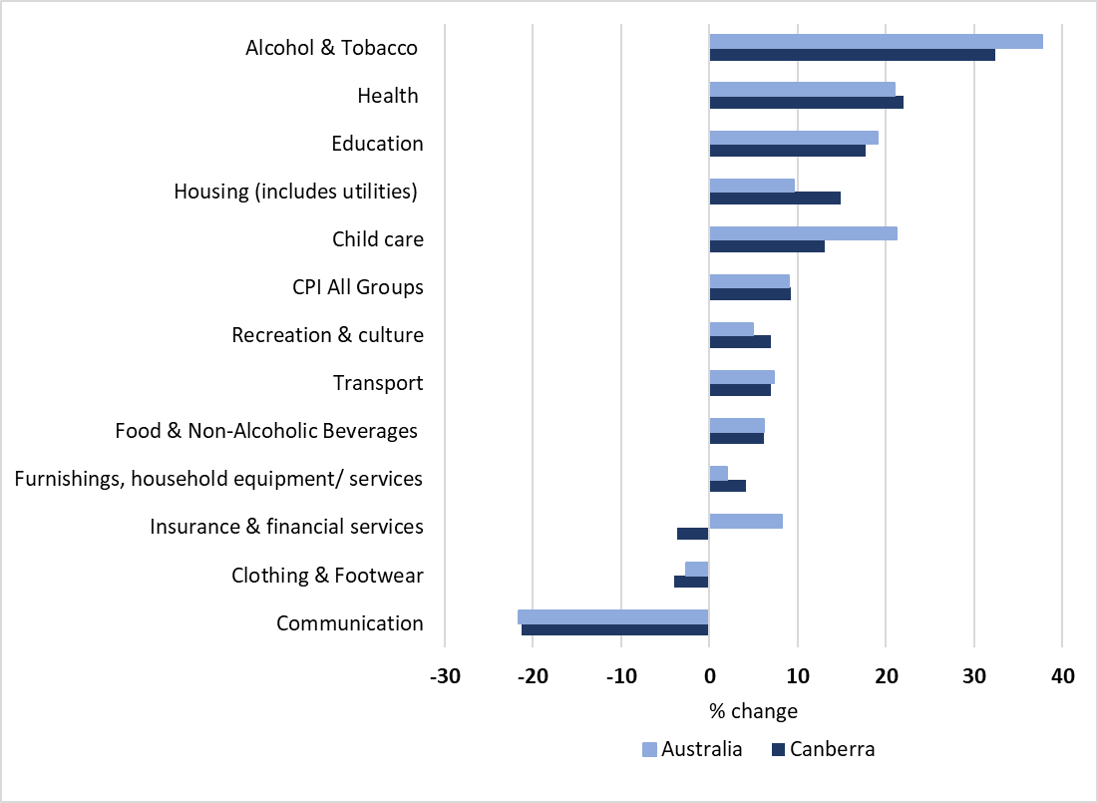

Figure 2 Change in CPI sub-groups and expenditure classes and CPI All Groups, Canberra and Australia, Dec 2014 – Dec 2019[14]

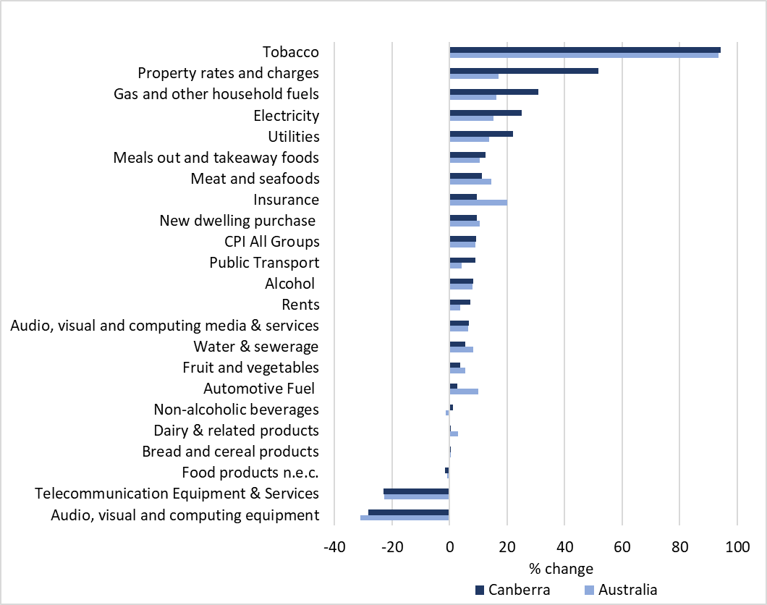

In the year from December 2018 to December 2019, the overall CPI for Canberra increased by 1.7% – slightly below the national rate of 1.8%. A key area where Canberra prices increased above the national rate was housing (including utilities), with a 2.4% increase compared to 0.2% nationally. This included a higher rate of increase in the Canberra CPI for rent (2.7% vs 0.2%) and utilities (2.0% vs -1.0%) – the latter was driven largely by the increase in the CPI for gas in Canberra (4.0% vs 1.4%).

When we look at changes in the CPI for essential goods and services over the past five years across the broad expenditure categories, we see that health (22.0% vs 21.0%), education (17.7% vs 19.0%), housing (14.9% vs 9.6%), and childcare (13.1% vs 21.3%) have all increased above the overall CPI in Canberra (9.2%) and nationally (9.0%). Recreation and culture (7.0% vs 4.9%), transport (6.9% vs 7.3%), food (6.2% vs 6.1%), and furnishings (4.2% vs 2.0%) all increased but below the overall CPI. In Canberra, insurance and financial services prices fell while they increased nationally (-3.6% vs 8.2%). Clothing and footwear prices fell slightly (-3.9% vs -2.6%) while communications prices fell significantly (-21.3% vs -21.6%).

When we look at expenditure sub-categories of essential goods and services, property rates and charges and energy prices in Canberra stand out as having risen well above the overall CPI and the national rate. The 51.7% increase in the CPI for property rates and charges in Canberra largely reflects the impact of the ACT Government’s tax reform program which commenced in 2012. Under this tax reform an increase in general rates is intended to be offset by reductions in stamp duty. The impact of this tax reform is discussed in more detail below in relation to low-income homeowners.

Over the past five years, electricity and gas prices in Canberra have increased by 25.1% and 30.7% respectively. As is the case with other essential goods and services, low-income households tend to spend a greater proportion of their income on energy meaning that these significant price increases have had a disproportionate impact:

Some groups are paying disproportionately more of their income on energy bills, and this has risen since 2008, contributing to an increase in inequality and poverty… On average, low-income households spend 6.4% of their income on energy, while high-income households [spend] an average of 1.5%. This is despite the fact that low-income households appear to use less energy, spending less in dollar terms per year… One in four [low-income households] are now paying over 8.8% of their income on energy (electricity or gas). This is up from 7.6% in 2008... Those households dependent on income support payments such as Newstart and similar allowances are hit hardest by high prices, with one in four of these households spending more than 9.7% of their incomes on energy.[15]

There are some mixed signs regarding the trend for energy prices in the ACT. A recent analysis found that from July 2019 to July 2020:

* The annual bill for households on ActewAGL’s regulated rate (single/flat rate tariff) has typically decreased by $75, or 3%
* Households’ annual gas costs have remained unchanged
* When combining ActewAGL’s regulated electricity rate and gas standing offer, the total cost of energy, for average consumption households, has decreased by 2% (or $70)
* On average, a market offer bill (inclusive of discounts) is $2,120 for households using 8,000 kWh – a rise of $45, or 2%.[16]

In June 2020, the Independent Competition and Regulatory Commission (ICRC) made its final determination on ActewAGL’s regulated electricity rate in the ACT. This will mean that a typical customer on ActewAGL’s standing offer contracts will see a 2.56% reduction in retail electricity prices in 2020-21 equating to a reduction of $43 in their annual bill.[17] While this is welcome news for ACT energy consumers, the level of this decrease appears miniscule in comparison to the significant increases in energy prices experienced in the ACT over the past five to ten years. One way to support households to further reduce their energy costs will be through the implementation of the ICRC’s recommendation that the ACT Government require electricity retailers to tell their customers if they have a plan that could reduce a customer’s bills.[18]

“It’s expensive just to keep the house warmed. Sometimes I have to live off two-minute noodles just to pay rent, bills and expenses. We have shared care with my ex-partner, so I always try and make sure my son has good food on his week and then on my week I skimp on food.”

– Trish, *Stories of Home[19]*

## Housing

As shown in Table 2, housing is the largest expense for low- and middle-income households in the ACT. Low-income households spend a significantly higher proportion of their income on housing (see Figure 3). Accessible, affordable, safe, and secure housing provides the necessary foundation from which people can actively meet their social, physical, and emotional needs. We need to ensure that everyone has access to healthy and affordable housing in the ACT. The lack of affordable rental properties for low-income households in the ACT is a critical issue that needs to be addressed.

Figure 3 Housing costs as a proportion of gross household income, ACT, 2017-18[20]

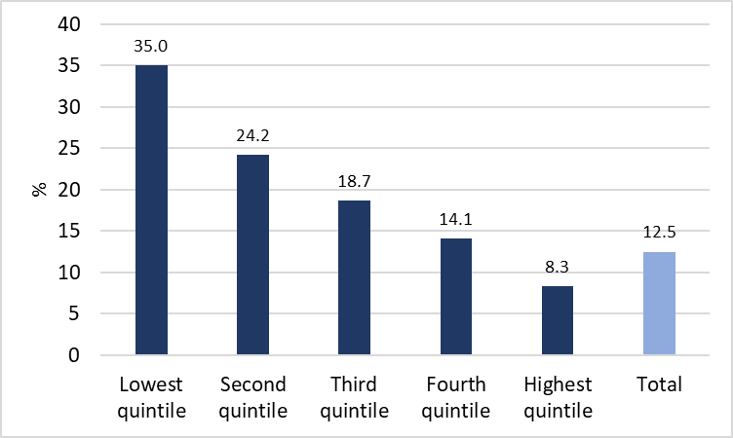

### Rental affordability

Over the past five years, the Canberra CPI for rent has increased by 7.1% which is below Canberra’s overall CPI increase (9.2%), but well above the increase in the national CPI for rent (3.7%). Real estate industry data shows that over the past five years, rents for houses and units in Canberra have increased by 28% and 22% respectively – the second highest increase across Australian capital cities during this time.[21] Over the past year, the ACT has consistently had the highest median house rent price and the second highest median unit rent price (see Figure 4). Over the year from June 2019 to June 2020, the ACT was the only state or territory where rental affordability declined.[22]

Figure 4 Median house and unit rents by capital city, June 2020[23]

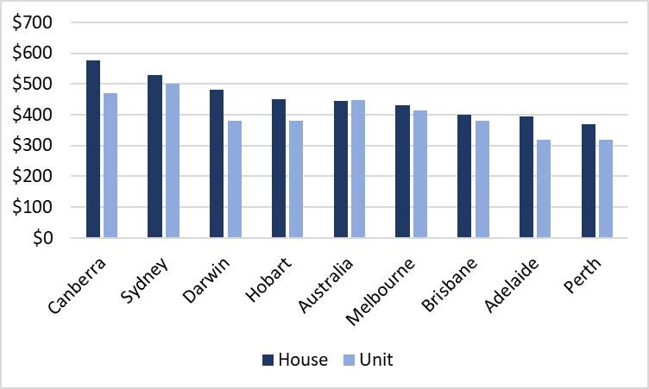

Nationally, there is a shortfall in supply of affordable private rental dwellings for low-income renters as many affordable dwellings are rented by people on higher incomes. The significance of this shortfall is highlighted in the Rental Affordability Index (RAI) and Anglicare Australia’s Rental Affordability Snapshot.

While the overall RAI for the ACT is ‘Acceptable’, ‘income growth has not kept pace with increasing rents, leading to a declining RAI score (see Table 3). Low-income households in the ACT face particularly unaffordable rents, as rents are pushed up by the overall high-income earning workforce’.[24] The RAI has consistently found that low-income households in the ACT face particularly unaffordable rents – Canberra was second least affordable area for almost all lower income household types behind Greater Sydney. Canberra was the least affordable city for student share houses.

Table 3 Rental affordability for low-income households in the ACT, Nov 2019[25]

| Household income type | RAI score | Rent as share of income | Relative unaffordability |
| --- | --- | --- | --- |
| Single person on Newstart Allowance | 26 | 115% | Extremely unaffordable |
| Single pensioner | 40 | 75% | Extremely unaffordable |
| Single part-time worker parent on benefits | 48 | 62% | Extremely unaffordable |
| Pensioner couple | 59 | 51% | Severely unaffordable |
| Hospitality worker | 77 | 39% | Severely unaffordable |
| Student share house | 85 | 35% | Unaffordable |
| Minimum wage couple | 89 | 34% | Unaffordable |
| Single income couple with children | 112 | 27% | Moderately unaffordable |
| Single full-time working parent | 124 | 24% | Acceptable |
| ACT (overall) | 129 | 23% | Acceptable |
| Dual income couple with children | 223 | 13% | Affordable |

Anglicare Australia’s Rental Affordability Snapshot in April 2020 found that out of 1,021 private rentals advertised for rent in the ACT and Queanbeyan on the weekend of 21 March 2020:

* No rentals are affordable for a person on the Disability Support Pension
* No rentals are affordable for a couple where one person is on minimum wage and the other is a stay-at-home parent
* No rentals are affordable for a person on Parenting Payment
* Even with the $550 per fortnight Coronavirus Supplement introduced in April 2020, only 30 rentals (2.5%) would have been affordable for a single person on the JobSeeker payment (formerly Newstart). Without the supplement, not a single rental would have been affordable for people receiving JobSeeker payment
* Just 1% of rentals (16 out of 1,021) were affordable for a person on the Age Pension.[26]

A more recent snapshot taken by Anglicare Australia on the weekend of 1 August 2020 found that out of 768 private rentals advertised in the ACT there were only 17 properties that could be considered affordable for people on low incomes.[27] These included:

* Four rentals for a couple on the age pension
* 10 rentals for a couple with two children on the minimum wage
* Two rentals for a single person on the minimum wage, and
* One property for a single person on the doubled JobSeeker payment.

The updated Rental Affordability Snapshot found that when the Coronavirus Supplement is reduced by $300 per fortnight from 24 September 2020, and if removed entirely from 31 December 2020, we will return to there being no affordable rentals for ACT JobSeeker recipients.[28]

The Productivity Commission has noted that population growth, rising house prices, a decline in owner-occupier households, and a decline in the availability of social housing since the mid-1980s has led to a rise in the proportion of people renting privately.[29] The proportion of low-income households renting privately in Australia has more than doubled in the past two decades.[30] According to the Productivity Commission, ‘the increase in the proportion of vulnerable people renting privately means that the number of households in rental stress in the private rental market has increased much faster than population growth’.[31] In 2017-18, 9,414 out of 22,069 low-income rental households in the ACT (42.7%) were in rental stress, where rental stress is defined as spending more than 30% of gross household income on housing costs.[32] This rate of rental stress in the ACT had increased from 5,876 out of 16,104 (36.5%) in 2013-14.[33]

The Productivity Commission argues that ‘Commonwealth Rent Assistance (CRA) is the clearest path to improving affordability’.[34] CRA is an Australian Government payment to income support recipients or people who receive more than the base rate of the Family Tax Benefit Part A, and who rent in the private market. The Productivity Commission found that ‘CRA’s ability to cushion vulnerable private renter households from rental price increases has diminished over time as the CPI — against which the CRA is indexed — has grown slower than rents’.[35] ACOSS has proposed that maximum rates of CRA be increased by 50% so that they better reflect minimum rents paid by people on low incomes.[36] ACOSS note that ‘while this would secure a more adequate payment rate, future reforms are needed to improve the effectiveness and adequacy of CRA, including eligibility and indexation’.[37]

A longer-term and more structural approach to addressing rental affordability is through investment in social housing. Recent commitments by the ACT Government will see 260 new public housing dwellings built between 2019 and 2025.[38] However, the evidence suggests that far greater investment in social housing is needed. As at 30 June 2019, there were 11,862 social housing dwellings in the ACT accommodating 23,208 tenants across 11,274 households – 99.2% of which were low-income households (see Table 4). Base on this, we can see that the ACT has the second highest rate of social housing per person and per household behind the Northern Territory (Table 4). The data also shows that over the past four years, the number of social housing dwellings in the ACT has failed to keep up with population growth and community need (see Figure 5 and Tables 5 & 6). In the period between 2016 and 2019, the number of social housing dwellings in the ACT increased by 2.0% while our population grew by 7.7%.

Table 4 Number of social housing dwellings, households, and tenants, ACT, at 30 June 2019[39]

| **Social Housing** | **Dwellings** | **Households** | **Low-income households (%)** | **Tenants** |
| --- | --- | --- | --- | --- |
| Public Housing | 10,955 | 10,529 | 99.2% | 22,093 |
| Community Housing | 907 | 745 | 99.3% | 1,115 |
| Total | 11,862 | 11,274 | 99.2% | 23,208 |

Figure 5 Number of social housing dwellings, ACT, 2009-2019[40]

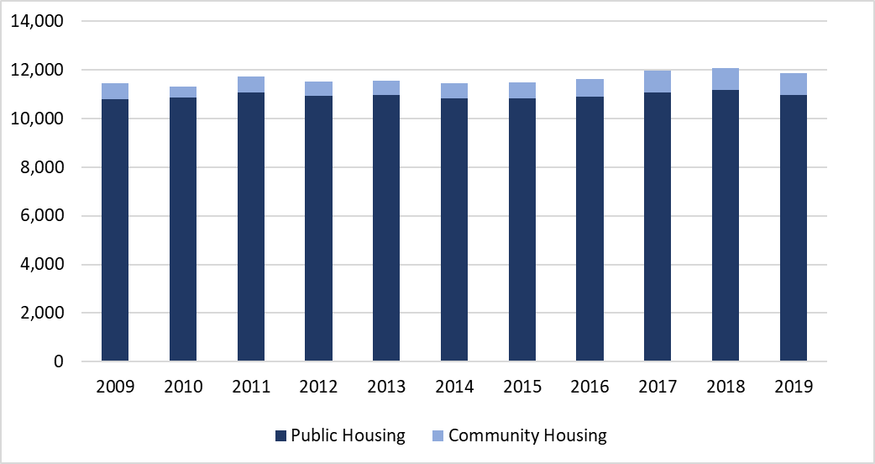

Table 5 Social housing dwellings in comparison to population and households, States and Territories, 30 June 2019[41]

|  |  |  |  |  |  |  |  |  |  |
| --- | --- | --- | --- | --- | --- | --- | --- | --- | --- |
| Social housing dwellings | NSW | Vic | Qld | WA | SA | Tas | ACT | NT | Total |
| Per 1,000 people | 19.4 | 12.3 | 14.0 | 16.6 | 26.5 | 26.3 | 27.8 | 50.9 | 17.3 |
| Per 100 households | 5.2 | 3.2 | 3.7 | 4.4 | 6.5 | 6.2 | 7.1 | 15.8 | 4.5 |
| Total dwellings (,000) | 156.8 | 81.1 | 71.4 | 43.6 | 46.4 | 14.0 | 11.9 | 12.5 | 437.7 |

Table 6 Social housing in comparison to population and households, ACT, 30 June 2016 to 30 June 2019[42]

|  |  |  |  |  |  |
| --- | --- | --- | --- | --- | --- |
| ACT | 2016 | 2017 | 2018 | 2019 | % change 2016-2019 |
| Social housing dwellings | 11,632 | 11,960 | 12,076 | 11,862 | 2.0% |
| Population | 396,100 | 410,300 | 420,900 | 426,700 | 7.7% |
| Dwellings per 1,000 people | 29.4 | 29.1 | 28.7 | 27.8 | -5.4% |
| Households | 157,697 | 160,975 | 163,953 | 167,040 | 5.9% |
| Dwellings per 100 households | 7.4 | 7.4 | 7.4 | 7.1 | -4.0% |

The 2016 Census found that almost 1,600 people in the ACT were experiencing homelessness.[43] As at 3 August 2020, there were 2,488 applications on the Housing ACT waiting list for public housing, with an average waiting time for standard housing of 1,268 days, or almost 3.5 years (see Table 7). It has been estimated that there is currently a social housing shortfall of 3,100 dwellings in the ACT, with 8,500 additional social housing dwellings needed by 2036 to meet the ACT’s current unmet and projected need.[44]

Table 7 Housing ACT social housing waiting list and times, 3 August 2020[45]

|  |  |  |
| --- | --- | --- |
| Application Category | Number of Applications | Average Waiting Time (days) |
| Priority Housing | 142 | 195 |
| High Needs Housing | 1,466 | 802 |
| Standard Housing | 880 | 1,268 |
| Total applications | 2,488 | n/a |

More public and community housing is the most cost-effective solution to chronic homelessness. The affordable rents, security of tenure, and other supports available to financially vulnerable people in social housing reduces their risk of homelessness by more than half.[46] Direct public investment in social housing is also a cost effective way to boost growth in jobs and incomes. For every dollar invested, it is estimated to boost GDP by $1.30.[47]

*“When I went onto Newstart, which was a while ago, I graduated, then I couldn’t get a job for quite a long time. One of the things I realised – my rent at that stage was $125. Even with that relatively low rent, it became obvious that on normal Newstart the ends weren’t going to meet together… On normal Newstart, even with rent assistance, and with what should be some good spending habits, to feed oneself can be hard.”*

– Male, single, aged 40, on Newstart[48]

“Although the ACT government has implemented a number of initiatives to address homelessness, long term solutions are urgently needed to address this housing crisis. A substantial investment needs to be made into increasing the number of social and public housing properties to meet the long waiting list and the increased demand that the economic impact of COVID-19 will have on many ACT households. Private rental is not an option for individuals and families on low incomes, and without housing options people will be left with choices such as rough sleeping, couch surfing or camping out. These options are not acceptable for any one and will only further disadvantage those who are already vulnerable.”

– Nicole Wiggins, Early Morning Centre, 2020

### Low-income homeowners

Based on 2017-18 data, 64% of ACT households owned their own home – 40% owned with a mortgage and 25% owned without a mortgage – and 34% were renting.[49] Among low-income households in the ACT, the rate of home ownership is lower but still significant, with almost a quarter owning their own home with a mortgage and around a fifth being homeowners with a mortgage.[50] Over half of low-income households in the ACT were renting. On average, housing costs for low-income owner-occupier households with a mortgage account for just over 30% of their gross household income, suggesting they are at greater risk of housing stress.[51]

Our analysis of CPI changes over the past five years found that the Canberra CPI for property rates and charges has increased by 51.7% compared to 17.0% nationally. This increase reflects the impact of the ACT Government’s tax reform program which commenced in 2012. The aim of this tax reform is:

to create a more reliable revenue source through general rates to fund our essential services such as hospitals, schools, transport and city maintenance. Inefficient and unfair taxes such as stamp duty and insurance duty will continue to be reduced.[52]

In the simplest terms, revenue previously raised through stamp duty paid by the purchaser of a property will, over time, be replaced by increasing revenue from general rates paid by homeowners.

The ACT Government recently commissioned an analysis of the distributional impacts, progressivity, and equity of the tax reform program.[53] This analysis concluded that it ‘can be seen that the rates are progressive – as incomes increase, the proportion of the total rates paid by each income quintile increases’ – i.e., lower income households are now paying a lower proportion of the total stamp duty and general rates revenue received by the ACT Government (see Table 8).[54] But, at the household level, the analysis found that ‘lower income families are spending more on stamp duty and rates as a proportion of their income, and that this is higher under the new tax policy’ (see Table 9).[55] From this perspective, stamp duty and general rates are not a progressive form of taxation and the reforms have not changed this. As shown in Table 9, the analysis also found that lower-income, pensioner, and female-headed homeowners are spending slightly more on stamp duty and general rates as a proportion of their income under the new tax policy.[56] This is partly due to these being taxes on actual or imputed wealth, not income. For example:

… rates are based on unimproved value of land, not on income. This means a low income pensioner can be paying rates on a high value block of land. While subsidies based on income and pensioner status are applied, the rates and stamp duty for low income families as a proportion of their income after any subsidies is still higher than for high income families.[57]

Table 8 The impact of tax reform on the general rate distribution (net of rebate) by income quintile, average 2012 – 2018[58]

|  |  |  |  |
| --- | --- | --- | --- |
| Quintile | New Tax Policy (%) | Old Tax Policy (%) | Difference (% points) |
| Q1 | 8.73 | 9.02 | -0.29 |
| Q2 | 12.03 | 12.51 | -0.48 |
| Q3 | 17.54 | 18.40 | -0.87 |
| Q4 | 21.93 | 22.71 | -0.78 |
| Q5 | 39.78 | 37.36 | 2.42 |

Table 9 The impact of tax reform on rates and stamp duty paid by income quintile and selected homeowner categories, average 2012 – 2018[59]

|  |  |  |  |  |  |  |
| --- | --- | --- | --- | --- | --- | --- |
| Quintile or Homeowner category | New Tax Policy  ($) | Old Tax Policy  ($) | Difference  ($) | New Tax Policy  (% of income spent) | Old Tax Policy  (% of income spent) | Difference  (% points) |
| Q1 | 1,532 | 1,378 | 153 | 5.91 | 5.32 | 0.59 |
| Q2 | 2,768 | 2,738 | 31 | 4.70 | 4.65 | 0.05 |
| Q3 | 4,096 | 4,420 | -324 | 5.07 | 5.47 | -0.40 |
| Q4 | 5,019 | 5,250 | -231 | 4.59 | 4.79 | -0.21 |
| Q5 | 6,511 | 6,325 | 186 | 4.13 | 4.01 | 0.12 |
| Low-income homeowner | 2,051 | 1,937 | 115 | 4.84 | 4.57 | 0.27 |
| Pensioner homeowner | 2,346 | 1,988 | 359 | 4.04 | 3.42 | 0.62 |
| Female-headed homeowner | 3,365 | 3,283 | 82 | 4.18 | 4.08 | 0.10 |

Examples prepared as part of the 2019-20 ACT Budget’s cost of living analysis found that general rates could now account for between 5.24% to 15.64% of the income of a single aged pensioner who owns a house.[60] This was after applying the ACT Government’s pensioner rates rebate of 50% capped at $700.[61] Owner-occupiers can also apply for a rates deferral if they are a pensioner, aged over 65, or are suffering significant financial hardship, with simple interest applied to the deferred amount. Ratepayers aged 65 or over who own at least 75% equity in their home can indefinitely defer their rates charges until such time as their property is sold.[62] As part of the ACT Government’s COVID-19 Economic Survival Package the deferral of rates payments has been made available to families experiencing financial hardship because of the COVID-19 pandemic. This deferral is available for one year from the date of application and includes current charges and any arrears, and no interest will be charged during the deferral period. Under this package, from 1 July 2020, a rates rebate of $150 will be automatically applied to 2020-21 rates bills for all residential properties in the ACT.

Land taxes are a critical means through which the ACT Government can raise revenue to pay for essential community services and infrastructure. Based on the proportion of income households in different quintiles spend on stamp duty and general rates, the ACT Government’s tax reform program does not appear to have made the system more progressive. Overall, the reforms appear to have left low-income owner-occupier households slightly worse off. Rates rebates and deferrals for pensioners and others are welcome measures that the ACT Government has used to try to address the impact of increases in general rates, but they do not appear to have been sufficient to make the new tax system progressive or these taxes more affordable for low-income households.

There needs to be close and careful monitoring of the impact of this tax reform on low-income homeowners for whom general rates may account for a significant and growing proportion of household income. This is especially a concern for those low-income households that are unlikely to benefit from the reduction or removal of stamp duty. Single parent households which are predominantly headed by women appear to be a key at-risk group, as are older owner-occupiers on low or fixed incomes. Consideration needs to be given to additional measures that could be introduced to ensure that low-income households are not paying a larger proportion of their income on general rates than high-income households.

## Health

Over the past five years, the CPI for health in Canberra has increased by 22.0% – in line with a 21.0% increase nationally. Figure 6 shows the health expenditure classes that grew above and below the overall CPI and that contributed most to the increase in the CPI for health in Canberra, namely:

* Medical and hospital services CPI increased by 27.7%
* Dental services CPI increased by 11.4%.

Figure 6 Change in CPI Health Group and expenditure classes and CPI All Groups, Canberra and Australia, Dec 2014 – Dec 2019[63]

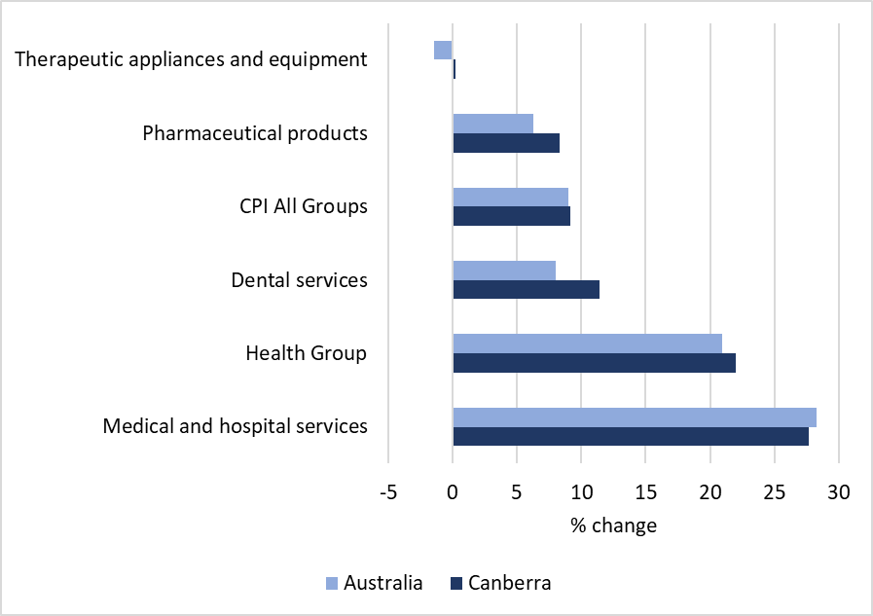

The ACT has some of the lowest rates of patients for whom attendances (specialist and GPs) are bulk billed, creating barriers to healthcare for people on low incomes.[64] In 2019-20, the bulk billing rate for ‘in and out of hospital’ and ‘out of hospital’ services were 70.8% and 76.2% respectively – compared to 80.1% and 87.4% nationally.[65] The average patient contribution per service for ‘out of hospital’ and ‘in hospital’ services in the ACT were $71.62 and $168.74 respectively – compared to $68.24 and $108.98 nationally.

In the ACT, cost is a more common barrier to people accessing health services than in any other metropolitan region of Australia. In 2016-17, 10.8% of people in the ACT aged over 15 years said cost was the reason that they delayed or did not seek specialist, GP, imaging or pathology services when they needed them – compared to 7.6% nationally.[66] In relation to GP services specifically, cost was a barrier for 7.1% of people in the ACT compared to 4.1% nationally. The data also shows that, in 2016-17, the ACT had the highest proportion of patients with out-of-pocket GP costs at 63.7% compared to just 33.8% nationally.[67]

“I feel like Canberra has too many private clinics and private health care and private expectations – that goes for private counselling as well you have to go for a bare minimal arrangement even with [large provider]. The type of freely available (bulk billing) health care and well-being you can actually get is not known unless it’s through word of mouth”

– Bron*, *Imagining Better* report[68]

# Tracking changes in the cost of living for low-income households: SLCI

The Selected Living Cost Indexes (SLCI) measure the cost of various baskets of goods which are specific to a number of different household types – including ‘Age pensioner’ and ‘Other government transfer recipients’ (e.g. Newstart/JobSeeker and Youth Allowance recipients), ‘Employee’, and ‘Self-funded retiree’ households. An examination of changes in the SLCI is important for determining how well Australia’s income support system is doing in terms of helping people to keep up with rising living costs. Our analysis focuses on age pensioner and other government transfer recipient households as these are more likely to represent low-income and disadvantaged households in the ACT.

Each Living Cost Index (LCI) is measured at the national level – unlike the CPI, the SLCI are not produced for each capital city so this analysis is not specific to Canberra or the ACT. In the year from December 2018 to December 2019, the LCI for age pensioner households rose at the same rate as the overall CPI (1.8%), while the LCI for other government transfer recipient households increased at a slightly higher rate (1.9%) (see Figure 7). The LCI for employee households increased at a rate well below the overall CPI (1.0%).

Figure 7 Percentage change in CPI and Selected Living Cost Indexes, Dec 2018 – Dec 2019, Australia[69]

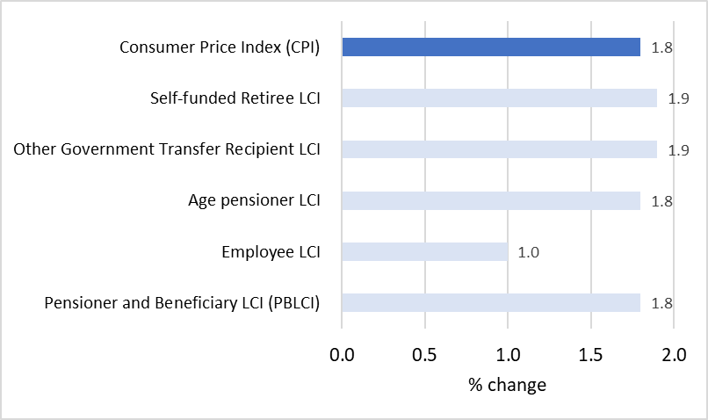

The COVID-19 pandemic has had a significant impact on the CPI and SLCI. In the year from June 2019 to June 2020, the LCI for age pensioner households increased by 1.0% while the overall CPI declined by 0.3% nationally (see Figure 8). The LCI for other government transfer recipient households was unchanged, while the LCI for employee households fell significantly by 2.1%.

Figure 8 Percentage change in CPI and Selected Living Cost Indexes, Jun 2019 – Jun 2020, Australia[70]

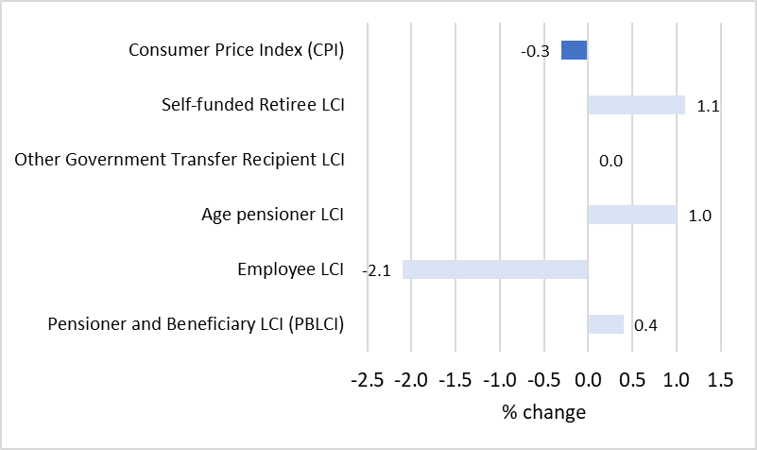

Before the COVID-19 health emergency, the rate of Newstart had not increased in real terms for over 25 years. Over that time, it had fallen well behind increases in the cost of living, especially rising housing costs. In the year from December 2018 to December 2019, this trend continued with living costs for Newstart and Youth Allowance recipients increasing above the overall CPI. While the indexation of these payments with the CPI meant that they did increase over the year (see Figure 9), our analysis shows that Newstart yet again failed to keep up with changes in the actual cost of living for recipients (see Figure 10). The annual increase in payments for Youth Allowance and Age Pension recipients was slightly above the increase in their living costs, but only by $0.40 and $0.30 per week respectively. Single Newstart recipients with and without children effectively experienced a reduction in their income of $0.91 and $1.20 per week respectively after accounting for the change in living costs.

Figure 9 Change in weekly income by income source, December 2018 to December 2019[71]

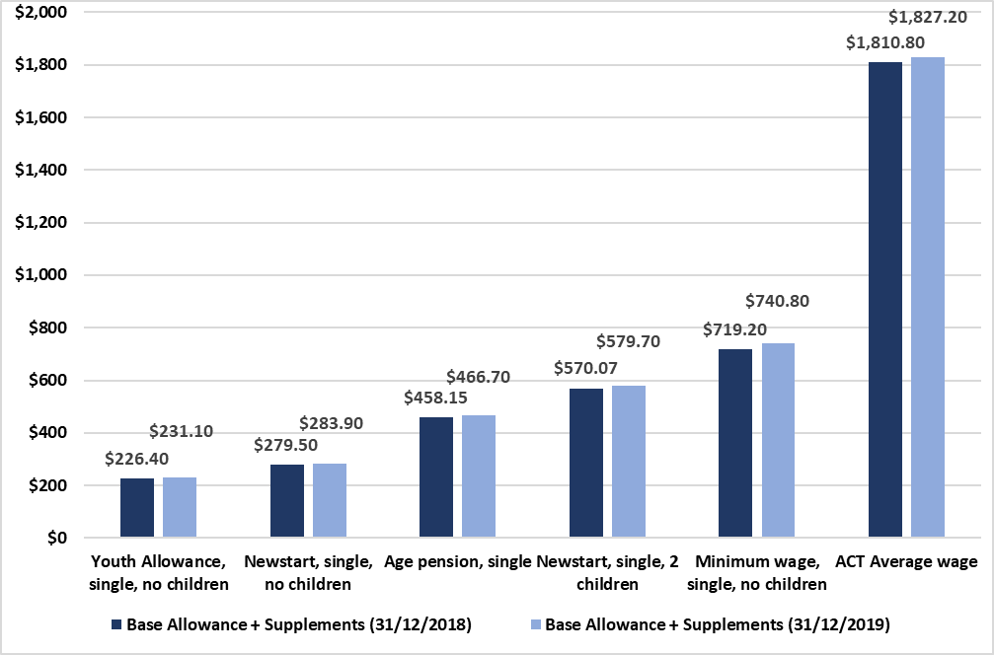

Figure 10 Change in weekly income vs change in living cost, December 2018 to December 2019[72]

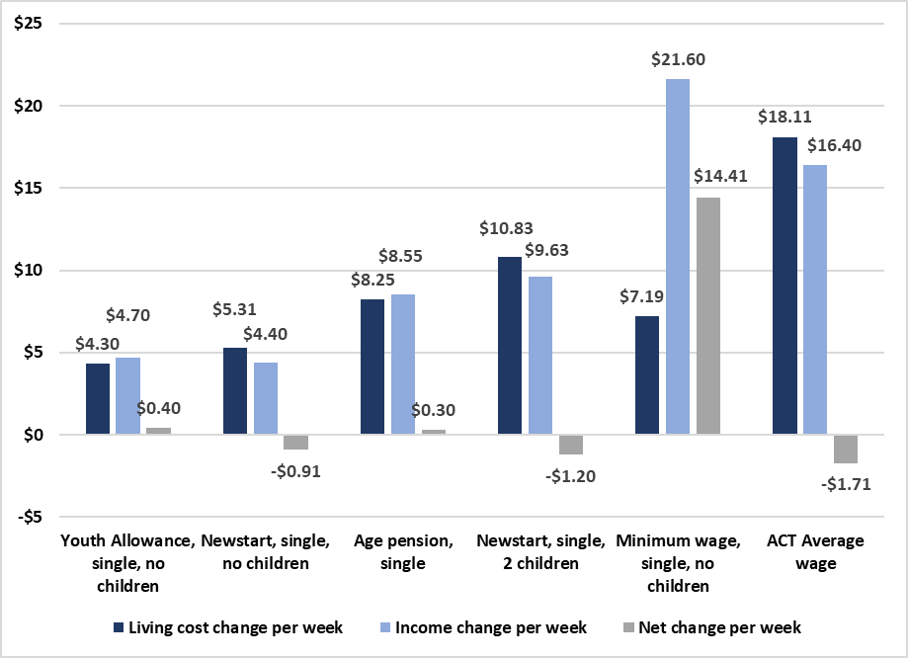

On 27 April 2020, the Australian Government introduced the Coronavirus Supplement of $550 per fortnight which was paid automatically to people receiving the following payments up until 24 September 2020:

* JobSeeker Payment (formerly Newstart)
* Partner Allowance
* Widow Allowance
* Sickness Allowance
* Youth Allowance
* Austudy
* ABSTUDY Living Allowance
* Parenting Payment
* Farm Household Allowance
* Special Benefit.

After 24 September 2020, the Coronavirus Supplement will be reduced by $300 to a rate of $250 per fortnight until 31 December 2020.[73]

The original $550 per fortnight Coronavirus Supplement has seen the incomes of JobSeeker and Youth Allowance recipients increase in real terms for the first time in over 25 years, raising people’s incomes above the poverty line (see Figure 11). When the Coronavirus Supplement is reduced to $250 per fortnight, these incomes will fall back below the poverty line. Recent analysis of the impact of changes to the JobSeeker payment has found that the $550 Coronavirus Supplement reduced the poverty rate for JobSeeker and Youth Allowance recipients from around 67% to just under 7%.[74]

Figure 11 Changes in income support payments due to the introduction, reduction, and removal of the Coronavirus Supplement (in relation to the poverty line)[75]

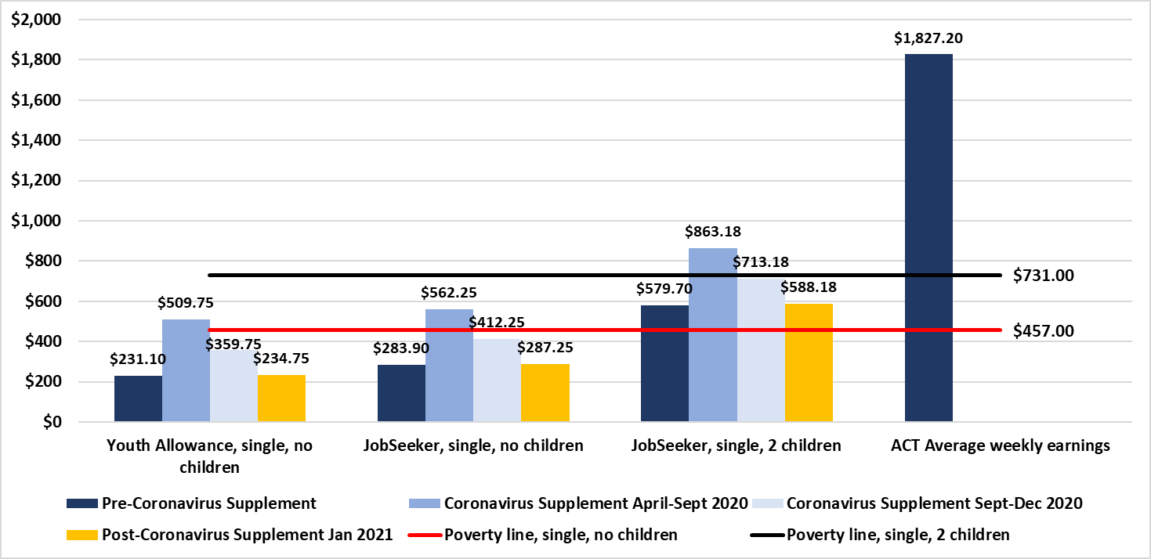

Based on a poverty line of $457 per week for a single person with no children and $731 per week for a single person with two children, we see that the poverty gap – i.e. the difference between income and the poverty line – for JobSeeker and Youth Allowance recipients before the introduction of the Coronavirus Supplement was $226 per week for a single person on Youth Allowance; $173 for a single person on Newstart/JobSeeker; and $151 for a single Newstart/JobSeeker recipient with two children (see Figure 12).The $550 Coronavirus Supplement has erased the poverty gap, raising incomes to levels of $53, $105, and $132 per week above the poverty line respectively. The looming reduction of the Coronavirus Supplement in September 2020 and its pending removal in January 2021 will see the return of the poverty gap.

Figure 12 Poverty gap for JobSeeker and Youth Allowance recipients with the introduction, reduction, and removal of the Coronavirus Supplement[76]

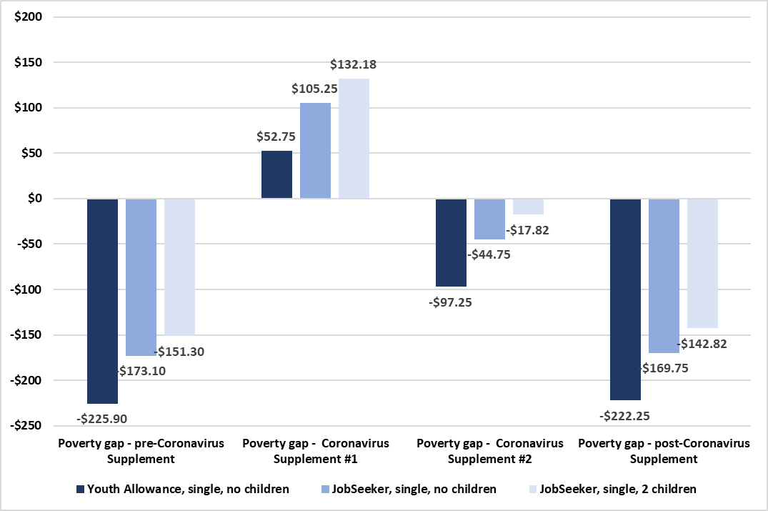

A survey of over 600 people on JobSeeker or other related income support payments who were receiving the Coronavirus Supplement in August 2020 found that the increase to their income had made it much easier to cover the cost of essential goods and services:

* 80.8% reported that they were eating better and more regularly
* 70.7% reported that they were now able to catch-up on bills
* 67.8% reported they were able to pay for medicines/heath treatments
* 58.8% reported that they were finding it easier to pay rent/being able to move into better and safer accommodation
* 56.2% were able to pay off debts
* 51.7% were able to save up for emergencies
* 51.6% were able to save up to purchase major household items (i.e., fridges, freezers, tables)
* 26.0% were able to save up to pay for studying/training.[77]

With increased levels of unemployment, the return of the poverty gap is likely to see the ACT’s poverty rate increase above the pre-COVID level of 8.6% or approximately 30,000 people. In June 2020, 22,676 people in the ACT were receiving income support payments boosted by the Coronavirus Supplement. The number of people in the ACT looking for work while in receipt of JobSeeker or Youth Allowance has more than doubled since before the COVID-19 health emergency. From December 2019 to July 2020, the number of people in the ACT receiving these payments increased by 8,272 (126.3%), from 6,551 to 14,823. Based on the latest ACT job vacancy figures, there is currently only job available for every four of these job seekers.[78] A recent analysis has estimated that the removal of the Coronavirus Supplement would result in the loss of a further 1,120 full-time equivalent jobs in the ACT in 2021-22.[79] These figures suggest we could see the number of people living below the poverty line in the ACT increase by 25% above the pre-COVID level if the Coronavirus Supplement is removed completely, approaching 40,000 people.

To avoid returning to a poverty gap, ACOSS has recommended that the Australian Government:

* Set a minimum income floor across the working age payments system set at the current pension rate (including the Pension Supplement). This is currently $472 per week for a single person.
* Increase base rates of allowances to this income floor. This would require an increase of $185 per week to the single maximum rate of JobSeeker Payment and $235 per week for single, maximum rate of Youth Allowance. This would simplify the income support system, while securing fairness. (Note. These increases would apply to all allowance payments, including Austudy and ABSTUDY).
* In addition, depending on circumstances of need, people would also receive one or more of the following supplements:
  + Housing Supplement: Increase the maximum rate of Commonwealth Rent Assistance by 50% from $70 to $105 per week for a single person without children to more adequately subsidise private rental costs for low-income tenants.
  + Disability and Illness Supplement: Introduce a Cost of Disability and Illness Supplement that recognises the additional costs faced by people with disability.[80] This supplement should be at least $50 per week. This is in addition to ACOSS’s long-standing call for broader access to the Disability Support Pension to avoid people with disability ending up on JobSeeker Payment.
  + Single Parenting Supplement: Introduce a Single Parent Supplement that recognises the added costs of single parenthood. The Single Parent Supplement should be at least $200 per week (and must reflect number and age of children). This could be paid via Family Tax Benefit Part B.
  + Roll universal payments like the Energy Supplement into base rates of income support to simplify the system, recognising that they are intended to assist with basic household expenses.
  + Index income support payments twice per year to wages as well as prices.
  + Income support payments must not be subject to mandatory cashless debit or income management.
  + Ensure all parents receiving income support payments are eligible for childcare subsidies (including additional, transition to work subsidies).[81]

ACOSS has also recommended that income support should urgently be expended to temporary visa holders lacking adequate income who are unable to leave the country.[82] Over one million people are excluded from JobKeeper and JobSeeker payments despite having the right to work, study, or seek asylum. People in this situation should be offered a form of public income support that allows them to meet essential living costs until they obtain permanent residency, sufficient paid employment, or are able to safely leave the country.

ACTCOSS supports ACOSS’s recommendations and its Raise the Rate for Good campaign. As part of that campaign we are calling for the $550 per fortnight Coronavirus Supplement to be kept in place by the Australian Government until our social security system is fixed for good so that it keeps people out of poverty.[83]

“The next 12-24 months are going to be really tough for many Canberrans. As JobKeeper and JobSeeker decrease or come to an end, many more people will find themselves out of work and unable to meet their financial commitments. This is coming at a time when the recent hardship arrangements offered by banks and utility providers will be scaled back, leaving people including those who have never faced financial hardship previously, in precarious financial situations and in need of greater support.”

– Carmel Franklin, CEO, Care Financial Counselling Service   
and the Consumer Law Centre of the ACT

“When my youngest turned eight they moved me from the sole parent pension to the Newstart which is about $150 less. So that was a huge chunk of [money] – because I mean when you get to teenagers they eat a lot, so that was a huge jump from managing, to sort of like battling… so yeah that was quite hard.”

– Claire*, aged 51, single mother of two school-age children   
who left a violent relationship[84]

Somewhere in the second week of my fortnight, I literally don’t have any money anymore, and I have to just go to free food services … And if any expenses come up, you just can’t pay them

– Gary*, single, aged 40, on Newstart[85]

Since the Coronavirus Supplement, I feel I have some dignity again. I am extremely anxious about the future when the supplement stops

– respondent to Raise the Rate campaign   
Coronavirus Supplement survey[86]

“I feel like before Coronavirus we were living in poverty. Always wondering when I wasn’t going to be able to scrape enough together to feed the kids again. At the moment, I can breathe and sleep a little easier knowing everything that needs to be paid is, and the kids are fed. I don’t have anything left over to save but my children are eating better.”

– respondent to Raise the Rate campaign   
Coronavirus Supplement survey[87]

# Taking action on cost of living in the ACT

Ahead of the 2020 ACT Election on 17 October, ACTCOSS has outlined a range of actions needed to be undertaken by the next ACT Government to achieve a just and fair Canberra.[88] These include a number of actions needed to address cost of living pressures for low-income households in the ACT across a range of areas including housing, health, transport, energy, and justice; and for different population groups including Aboriginal and/or Torres Strait Islander people, older people, people with disability, and women, children and families.

Action on fundamentals, including:

* Publicly call for a permanent and adequate increase to JobSeeker, Youth Allowance, and related Commonwealth payments to enable people to cover all basic costs, including keeping a roof over their heads
* Incorporate all economic, social, and cultural rights in the *Human Rights Act 2004* (ACT)including: the right to housing; the right to an adequate standard of living; the right to physical and mental health and the right to a healthy environment
* Conduct a full needs analysis to understand Canberra’s demographic changes, increasing complexity of needs (including an aging population; growing number of births; greater diversity) and the changed Canberra geography
* Adequately fund community services that play a vital role in preventing, reducing, and alleviating the impacts of poverty and disadvantage in the ACT
* Ensure that revenue is collected in a way that is progressive, equitable, efficient, and sufficient to fund quality services and infrastructure that benefit the whole Canberra community in a just and fair way. This must include targeted concessions that ease cost of living pressures for low-income households and targeted investment that addresses the structural causes of poverty and disadvantage.

Action on financial assistance, including:

* Review the ACT Targeted Assistance Strategy to ensure concessions and rebates are targeted to need
* Recognise the contribution of older Canberrans to our community through a range of targeted supports and assistance points in across the city
* Extend financial and other support for all young people transitioning from care
* Increasing funding to financial counselling services.

Action on housing affordability, including:

* Commit to implementation of ACTCOSS’s housing affordability policy recommendations, including:
  + Achieve the target of 15% of the Land Release Program for the supply of public, community, and affordable homes
  + Provide further investment in additional public housing and renewal of current stock
  + Increase effective land transfers to ACT community housing providers and empower them to build more community and affordable housing
  + Develop an Indigenous Housing Strategy for the ACT including a pathway to a community-controlled Aboriginal housing organisation.

Action on health costs, including:

* Improve access to the public health system for Canberrans on low incomes and facing other health disadvantage
* Design and implement a Disability Health Strategy that addresses the poor health outcomes for people with disability that arise from economic disadvantage
* Increase funding for sexual and reproductive health services to improve their affordability and availability.

Action on energy affordability, including:

* Ensure the Utilities Concession and Utilities Hardship Fund eligibility are targeted toward need (including to asylum seekers through the ACT Services Access Card) and continue the Energy Support Voucher program by maintaining the Utilities Hardship Fund
* Implement the ICRC’s recommendation that ACT energy retailers provide their customers with regular ‘better offer notifications’ by mid-2021 at the latest
* Expand energy efficiency and productivity programs for low-income households (including private rental) and support the introduction of a National Low-income Energy Productivity Program in National Cabinet
* Introduce minimum energy performance requirements for rental properties before the end of 2021.

Action on transport costs, including:

* Carry out a comprehensive community needs assessment to ensure transport design, planning, integration, and implementation address the needs of those with transport disadvantage
* Invest in community transport at sustainable levels with long-term commitments so that providers can renew vehicle stock and plan across a multi-year timeframe. There should be a specific community needs analysis for community transport
* Improve other on-demand transport provision including lifting the cap on the ACT Taxi Subsidy Scheme for people with disabilities, as well as delivering full compliance with the Disability Discrimination Act Transport Standards across the bus network
* Improve the fairness and adequacy of transport-related concessions by extending concessions to learner, probationary and restricted driver’s licences, aligning the discount on licence fees for Health Care Card holders (currently 50% of costs) with Pension Card Holders (100%)
* Investigate the costs and benefits of making all public transport free through a cost benefit analysis.

Action on equal access to justice, including:

* Increase funding to community legal centres, mediation and individual advocacy supports to ensure equal access to justice for all ACT residents, including women and children, Aboriginal and/or Torres Strait Islander people and other Canberrans facing legal and financial disadvantage
* Introduce an income-based approach to ACT Government fines, fees, and other charges to ensure that penalties are not regressive.

Conclusion

Addressing poverty in the ACT requires significant commitment and coordinated action by the ACT and Australian governments. Ensuring people have adequate incomes and affordable housing are fundamental to this. Our economy needs to provide people with secure employment and adequate wages, and when it fails to do so, we need a safety net that ensures people can afford to live a healthy life – e.g., through income support, concessions, and emergency relief. The lack of affordable housing is the biggest single challenge confronting people on low incomes in the ACT. Accessible, affordable, safe, and secure housing provides the necessary foundation from which people can actively meet their social, physical, and emotional needs.

For over 25 years the rate of Newstart, Youth Allowance and other related payments has failed to keep up with the pace of increases in the cost of living, trapping people in poverty. As we grapple with the ongoing health and economic crises brought about by COVID-19, we must ensure everyone is supported to cover the basics. More people than ever will be struggling to find paid work. We cannot turn back to the brutality of people struggling to survive on $40 a day.

In line with the Australian Council of Social Service (ACOSS) and the Raise the Rate for Good campaign, we call on the Australian Government to keep the $550 per fortnight Coronavirus Supplement in place until our social security system is fixed for good so that it keeps people out of poverty.

Inadequate levels of income support and relatively high rental prices in the ACT has meant that low-income households in the ACT are either locked out of the private rental market or experience significant rental stress while trying to maintain a roof over their heads. There is currently a shortfall of over 3,000 social housing properties in the ACT, with a total of 8,500 needed to be built to meet current and projected community need by 2036. Government investment in social housing is essential to avoid deepening and entrenching disadvantage and homelessness in the ACT.

In addition to incomes and housing, there are many other actions that the Australian and ACT governments can, do, and should take to ease the cost of living pressures faced by low-income households. The 2020 ACT Election provides a critical point in time for the development of, and commitment to, actions that will improve the wellbeing of the ACT’s low-income households and our community overall. This report outlines several areas where action is needed, including financial assistance, health, housing, transport, energy, and justice. Cost of living, financial hardship, and poverty are fundamental issues the next ACT Government must act upon to achieve a just and fair Canberra.

**Appendix: Explanatory notes**

ACTCOSS uses the cost of living methodology developed by SACOSS and the following explanatory notes have been adapted from SACOSS.[89]

## Consumer Price Index and Selected Living Cost Indexes

The ABS Selected Living Cost Indexes uses a different methodology to the CPI in that the CPI is based on acquisition (i.e. the price at the time of acquisition of a product), while the living cost index is based on actual expenditure. This is particularly relevant in relation to housing costs where CPI traces changes in house prices, while the SLCI traces changes in the amount expended each week on housing (e.g. mortgage repayments). Further information is available in the Explanatory Notes to the Selected Living Cost Indexes.[90] In that sense, the Selected Living Cost Indexes are not a simple disaggregation of CPI and the two are not strictly comparable. However, both indexes are used to measure changes in the cost of living over time (although that is not what CPI was designed for), and given the general usage of the CPI measure and its powerful political and economic status, it is useful to compare the two and highlight the differences for different household types.

## Limitations of the Selected Living Cost Indexes

The Selected Living Cost Indexes are more nuanced than the generic CPI in that they measure changes for different household types, but there are still a number of problems with using those indexes to show cost of living changes faced by the most vulnerable and disadvantaged in the ACT. While it is safe to assume that social security recipients are among the most vulnerable and disadvantaged, any household-based data for multi-person households says nothing about distribution of power, money and expenditure within a household and may therefore hide particular (and often gendered) structures of vulnerability and disadvantage. Further, the living cost indexes are not state based, so ACT trends or circumstances may not show up.

At the more technical level, the Selected Living Cost Indexes are for households whose predominant income is from the described source (e.g. Age Pension or government transfers). However, the expenditures that formed the base data and weighting (from the 2015-16 Household Expenditure Survey) add up to well over the actual social security payments available (even including other government payments like rent assistance, utilities allowance and family tax benefits). Clearly many households in these categories have other sources of income, or more than one social security recipient in the same household. Like the CPI, the Living Cost Index figures reflect broad averages (even if more nuanced), but do not reflect the experience of the poorest in those categories.

Another example of this ‘averaging problem’ is that expenditures on some items, like housing, are too low to reflect the real expenditures and changes for the most vulnerable in the housing market – again, because the worst-case scenarios are ‘averaged out’ by those in the category with other resources. For instance, if one pensioner owned their own home outright they would generally be in a better financial position than a pensioner who has to pay market rents – but if the market rent were $300 per week, the average expenditure on rent between the two would be $150 per week, much less than what the renting pensioner was actually paying.

The weightings in the Selected Living Cost Indexes are also based on a set point in time (from the Household Expenditure Survey), but over time the price of some necessities may increase rapidly, forcing people to change expenditure patterns to cover the increased cost. There is some adjustment of weightings for this, but these cannot be checked without a new survey. Alternatively, or additionally, expenditure patterns may change for a variety of other reasons. However, the weighting in the indexes does not change and so does not track the expenditure substitutions and the impact that has on cost of living and lifestyle.

Finally, the Selected Living Cost Indexes’ household income figures are based on households that are the average size for that household type: 1.51 people for aged pensioners, and 2.46 for other social security recipients.[91] This makes comparison with allowances difficult. This report focuses on single person households or a single person with two children (to align to the other social security recipient household average of 2.46 persons). However, this is a proxy rather than statistical correlation.

It is inevitable that any summary measure will have limitations, and as noted in the main text, the Selected Living Cost Indexes provide a robust statistical base, a long time series, and quarterly tracking of changes in the cost of living which is somewhat sensitive to low income earners.

## Income support payment calculations – December 2018 to December 2019

Even using the base rate of benefits, the calculation of the relevant weekly incomes is difficult because of the complexity of the income support system which means that payment eligibility and rates change depending on the exact circumstances of the household (e.g. age of children, assets). The calculation is also complex because of changes over time in eligibility and available benefits. However, based on an assumption of a single Age Pensioner and a single Newstart recipient with two children (aged 10 and 14) – with neither receiving Commonwealth Rent Assistance, the basic income supports payments have been calculated as follows:

**Rates at 31 December 2018**

|  | Base rate | Pension supp | Energy supp | FTB A Child u13 | FTB A Child 13-15 | FTB B | Pharmaceutical Benefit | Fortnight Total | Week Total |
| --- | --- | --- | --- | --- | --- | --- | --- | --- | --- |
| Age pension, single | $834.40 | $67.80 | $14.10 | - | - | - | - | $916.30 | $458.15 |
| Newstart, single, no children | $550.20 | - | $8.80 | - | - | - | - | $559.00 | $279.50 |
| Newstart, single, 2 children | $595.10 | - | $9.50 | $182.84 | $237.86 | $108.64 | $6.20 | $1140.14 | $570.07 |
| Youth Allowance, single, no children | $445.80 | - | $7.00 | - | - | - | - | $452.80 | $226.40 |

Source: Centrelink*, A guide to Australian Government payments 20 September-31 December 2018*, Centrelink, Canberra, 2017.

**Rates at 31 December 2019**

|  | Base rate | Pension support | Energy supplement | FTB A Child u13 | FTB A Child 13-15 | FTB B | Pharmaceutical Benefit | Fortnight Total | Week Total |
| --- | --- | --- | --- | --- | --- | --- | --- | --- | --- |
| Age pension, single | $850.40 | $68.90 | $14.10 | - | - | - | - | $933.40 | $466.70 |
| Newstart, single, no children | $559.00 | - | $8.80 | - | - | - | - | $567.80 | $283.90 |
| Newstart, single, 2 children | $604.70 | - | $9.50 | $186.20 | $242.20 | $110.60 | $6.20 | $1159.40 | $579.70 |
| Youth Allowance, single, no children | $455.20 | - | $7.00 | - | - | - | - | $462.20 | $231.10 |

Source: Centrelink, *A guide to Australian Government payments 20 September-31 December 2019*, Canberra, 2018.

## How Pension rates are adjusted

The following explanation of pension indexation has been extracted from a guide produced by the Parliamentary Library:

Currently, pensions (including the Age Pension, Service Pension, Disability Support Pension and Carer Payment) are [indexed twice each year](http://guides.dss.gov.au/guide-social-security-law/5/1/8/50) by the greater of the movement in the [Consumer Price Index](http://www.abs.gov.au/ausstats/abs@.nsf/mf/6401.0?opendocument) (CPI) or the [Pensioner and Beneficiary Living Cost Index](http://www.abs.gov.au/AUSSTATS/abs@.nsf/allprimarymainfeatures/E592A3A56EBC2B31CA257C130017D2FA?opendocument) (PBLCI). They are then ‘benchmarked’ against a percentage of [Male Total Average Weekly Earnings](http://www.abs.gov.au/ausstats/abs@.nsf/mf/6302.0) (MTAWE). The combined couple rate is benchmarked to 41.76% of MTAWE; the single rate of pension is set at 66.33% of the combined couple rate (which is equal to around 27.7% of MTAWE). ‘Benchmarked’ means that after it has been indexed, the combined couple rate is checked to see whether it is equal to or higher than 41.76% of MTAWE. If the rate is lower than this percentage, the rates are increased to the appropriate benchmark level.

The CPI is a measure of changes in the prices paid by households for a fixed basket of goods and services. Indexing pension rates to CPI maintains the real value of pensions over time. The PBLCI measures the effect of changes in prices of the out-of-pocket living expenses experienced by age pensioner and other households whose main source of income is a government payment. The PBLCI is designed to check whether their disposable incomes have kept pace with price changes. The MTAWE benchmark is not intended to maintain the value of the pension relative to costs; it is seen as ensuring pensioners maintain a certain standard of living, relative to the rest of the population.[92]

1. R Tanton, R Miranti and Y Vidyattama, *Hidden disadvantage in the ACT: report for ACT Anti-Poverty Week*, NATSEM, University of Canberra, Canberra, October 2017, viewed 1 April 2019, <<https://www.actcoss.org.au/publications/advocacy-publications/hidden-disadvantage-act-report-anti-poverty-week-2017>>.
2. ibid.
3. E Davidson, *Hidden disadvantage among women in the ACT*, Women’s Centre for Health Matters, Canberra, June 2018, viewed 1 April 2019, <<http://www.wchm.org.au/wp-content/uploads/2018/06/Hidden-disadvantage-among-women-in-the-ACT-final.pdf>>; ACTCOSS unpublished analysis of ABS 2016 Census of Population and Housing using TableBuilder.
4. ACOSS and UNSW, *Poverty and Inequality website*, Data and figures, Rate of poverty by state/territory of residence, n.d., viewed 31 August 2020, <<http://povertyandinequality.acoss.org.au/poverty/rate-of-poverty-by-state-territory-of-residence-of-people/>>; P Davidson, email, 18 May 2020.
5. P Davidson, P Saunders, B Bradbury and M Wong, *Poverty in Australia 2020: Part 1, Overview*. ACOSS/UNSW Poverty and Inequality Partnership Report No. 3, ACOSS, Sydney, 2020, viewed 31 August 2020, <<http://povertyandinequality.acoss.org.au/publication/poverty-in-australia-2020-part-1-overview/>>.
6. ABS, *6302.0 - Average Weekly Earnings, Australia, May 2020*, ABS, Canberra, 2020, viewed 14 September 2020, <<https://www.abs.gov.au/AUSSTATS/abs@.nsf/allprimarymainfeatures/7F76D15354BB25D5CA2575BC001D5866?opendocument>>.
7. P Davidson, B Bradbury and M Wong, *Poverty in Australia 2020: Part 2, Who is affected?*, ACOSS/UNSW Poverty and Inequality Partnership Report No. 4, ACOSS, Sydney, 2020, p. 15, viewed 7 September 2020, <<http://povertyandinequality.acoss.org.au/wp-content/uploads/2020/05/Poverty-in-Australia-2020-Part-2-–-Who-is-affected_Final.pdf>>.
8. Department of Social Services, *DSS Demographics December 2019*, DSS, Canberra, 2020, viewed 31 August 2020, <<https://data.gov.au/dataset/ds-dga-cff2ae8a-55e4-47db-a66d-e177fe0ac6a0/details?q=dss>>.
9. Department of Social Services, *JobSeeker Payment and Youth Allowance Recipients - monthly profile - July 2020*, DSS, Canberra, 2020, viewed 7 September 2020, <<https://data.gov.au/data/dataset/jobseeker-payment-and-youth-allowance-recipients-monthly-profile>>.
10. ACTCOSS, *ACT Cost of Living Report*, ACTCOSS, May 2019, <<https://www.actcoss.org.au/publications/advocacy-publications/act-cost-living-report-2019>>.
11. ABS, *6530.0 - Household Expenditure Survey, Australia: Summary of Results, 2015-16*, ABS, Canberra, 2017, Table 21.1 HOUSEHOLD EXPENDITURE, Broad expenditure groups, Equivalised disposable household income quintiles, ACT, viewed 6 September 2020, <<https://www.abs.gov.au/household-expenditure>>.
12. ABS, *6401.0 - Consumer Price Index, Australia, Dec 2019*, ABS, Canberra, 2020, TABLE 10. CPI: Group, Sub-group and Expenditure Class, Percentage change from corresponding quarter of previous year by Capital City & TABLE 11. CPI: Group, Sub-group and Expenditure Class, Percentage change from previous quarter by Capital City, viewed 7 September 2020, <<https://www.abs.gov.au/AUSSTATS/abs@.nsf/DetailsPage/6401.0Dec%202019?OpenDocument>>.
13. ABS, *6401.0 - Consumer Price Index, Australia, Dec 2019*, ABS, Canberra, 2020, TABLE 11. CPI: Group, Sub-group and Expenditure Class, Percentage change from previous quarter by Capital City, viewed 7 September 2020, <<https://www.abs.gov.au/AUSSTATS/abs@.nsf/DetailsPage/6401.0Dec%202019?OpenDocument>>.
14. ABS, *6401.0 - Consumer Price Index, Australia, Dec 2019*, ABS, Canberra, 2020, TABLE 11. CPI: Group, Sub-group and Expenditure Class, Percentage change from previous quarter by Capital City, viewed 7 September 2020, <<https://www.abs.gov.au/AUSSTATS/abs@.nsf/DetailsPage/6401.0Dec%202019?OpenDocument>>.
15. ACOSS, Brotherhood of St Laurence and ANU Centre for Social Research and Methods, *Energy stressed in Australia*, ACOSS, Sydney, 2018, pp. 4-6, viewed 1 May 2019, <<https://www.acoss.org.au/wp-content/uploads/2018/10/Energy-Stressed-in-Australia.pdf>>.
16. St Vincent de Paul & Alviss Consulting, *ACT energy prices July 2020: an update report of the ACT Tariff-tracking Project*, St Vincent de Paul Society, Melbourne, 2020, p. 2, viewed 6 September 2020, <<https://www.vinnies.org.au/icms_docs/320813_ACT_Energy_Prices_July_2020.pdf>>.
17. ICRC, *Commission releases final report on retail electricity prices for small customers*, Media release, ICRC, Canberra, 5 June 2020, viewed 6 September 2020, <<https://www.icrc.act.gov.au/__data/assets/pdf_file/0003/1556184/Media-Release-Electricity-Final-Report.pdf>>.
18. ibid.
19. ACTCOSS and ACT Shelter, *Stories of home: why housing and homelessness matters in the lead up to the 2016 ACT election*, ACTCOSS, Canberra, 2016, p. 11, viewed 5 November 2018, <<https://www.actcoss.org.au/publications/advocacy-publications/stories-home>>.
20. ABS, *4130.0 - Housing Occupancy and Costs, 2017-18*, ABS, Canberra, 2019, Data cube 12. States and territories, Table 12.3 HOUSING COSTS AS A PROPORTION OF GROSS HOUSEHOLD INCOME, Selected household characteristics, States, and territories, 2017–18, viewed 6 September 2020, <<https://www.abs.gov.au/AUSSTATS/abs@.nsf/DetailsPage/4130.02017-18?OpenDocument>>.
21. Domain, *Domain rental report – June 2020*, Canberra, Domain, Sydney, 2020, viewed 5 September 2020, <[https://www.domain.com.au/research/rental-report/june-2020/#canberra](https://www.domain.com.au/research/rental-report/june-2020/%23canberra)>.
22. Real Estate Institute of Australia, *Best rental affordability results since 2007: REIA*, media release, REIA, Canberra, 1 September 2020, viewed 5 September 2020, <<https://reia.asn.au/wp-content/uploads/2020/09/Media-Release-2-September-2020-Best-Rental-Affordability-Results-since-2007-REIA.pdf>>.
23. Domain, op. cit.
24. SGS Economics & Planning, *Rental Affordability Index, November 2019 release*, SGS Economics & Planning, Canberra, 2019, p. 57, viewed 5 September, <<https://www.sgsep.com.au/assets/main/Projects/SGS-Economics-and-Planning_RAI-November-2019.pdf>>.
25. ibid.
26. Anglicare NSW South, NSW West & ACT, *Rental Affordability Snapshot 2020 - Affordability in ACT and Queanbeyan*, Anglicare NSW South, NSW West & ACT, Canberra, 2020, viewed 7 September 2020, <<https://www.anglicare.com.au/wp-content/uploads/2020/04/RAS-2020-ACT-Queanbeyan.pdf>>.
27. Anglicare Australia, *Rental Affordability Snapshot – Special Update, August 2020*, unpublished ACT data provided by Anglicare Australia, Canberra, 2020, <<https://anglicare-ras.com/the-findings/>>; L Bladen, *Rental affordability in Canberra worsens during pandemic: Anglicare*, The Canberra Times, 1 September 2020, viewed 7 September 2020, <<https://www.canberratimes.com.au/story/6902578/only-one-of-800-canberra-rentals-affordable-for-a-tenant-on-jobseeker/>>.
28. ibid.
29. Productivity Commission, *Vulnerable Private Renters: Evidence and Options*, Commission Research Paper, Productivity Commission, Canberra, 2019, viewed 5 September 2020, <<https://www.pc.gov.au/research/completed/renters>>.
30. ibid.
31. ibid, p. 102.
32. ABS, *4130.0 - Housing Occupancy and Costs, 2017-18*, ABS, Canberra, 2019, Table 21.1, viewed 5 September 2020, <<https://www.abs.gov.au/ausstats/abs@.nsf/mf/4130.0>>.
33. ibid.
34. Productivity Commission, op. cit., p. 13.
35. ibid, p. 117.
36. ACOSS, *Next steps for income support*, Briefing, July 2020, ACOSS, Sydney, 2020, viewed 5 September 2020, <<https://www.acoss.org.au/wp-content/uploads/2020/09/Social-security-next-steps-JUL-UPDATED-2-9_.pdf>>.
37. ibid, p. 2.
38. ACT Government, *August 2020 Economic and Fiscal Update*, ACT Government, Canberra, 2020, viewed 5 September 2020, <<https://apps.treasury.act.gov.au/budget/economic-and-fiscal-update-2020>>.
39. AIHW, *Housing assistance in Australia 2020*, AIHW, Canberra, 2020, Data tables: Social housing households, Table DWELLINGS.2, HOUSEHOLDS.2, HOUSEHOLDS.7 & OCCUPANTS.1, viewed 6 September 2020, <<https://www.aihw.gov.au/reports/housing-assistance/housing-assistance-in-australia-2020/data>>.
40. Productivity Commission, *Report on Government Services 2019*, Productivity Commission, Canberra, 2019, 18 Housing Data Tables, Table 18A.3 Descriptive data – number of social housing dwellings, at 30 June 2018, viewed at, <<https://www.pc.gov.au/research/ongoing/report-on-government-services/2019/housing-and-homelessness/housing>>; AIHW, *Housing assistance in Australia 2020*, AIHW, Canberra, 2020, Data tables: Social housing households, Table DWELLINGS.2: Dwellings, by social housing program and states and territories, at 30 June 2014 to 2019, viewed 6 September 2020, <<https://www.aihw.gov.au/reports/housing-assistance/housing-assistance-in-australia-2020/data>>.
41. Own calculations based on: AIHW, *Housing assistance in Australia 2020*, AIHW, Canberra, 2020, Data tables: Social housing households, Table DWELLINGS.2: Dwellings, by social housing program and states and territories, at 30 June 2014 to 2019; ABS, *3101.0 - Australian Demographic Statistics, Jun 2016, 2017, 2018, 2019*, ABS, Canberra, 2016-2019; ABS, *3236.0 - Household and Family Projections, Australia, 2016 to 2041*, ABS, Canberra, 2019, Series II.
42. Own calculations based on: AIHW, *Housing assistance in Australia 2020*, AIHW, Canberra, 2020, Data tables: Social housing households, Table DWELLINGS.2: Dwellings, by social housing program and states and territories, at 30 June 2014 to 2019; ABS, *3101.0 - Australian Demographic Statistics, Jun 2016, 2017, 2018, 2019*, ABS, Canberra, 2016-2019; ABS, *3236.0 - Household and Family Projections, Australia, 2016 to 2041*, ABS, Canberra, 2019, Series II.
43. ABS, *2049.0 - Census of Population and Housing: Estimating homelessness, 2016*, ABS, Canberra, 2018, viewed 7 September 2020, <<https://www.abs.gov.au/AUSSTATS/abs@.nsf/Lookup/2049.0Main+Features12016?OpenDocument>>.
44. J Lawson, H Pawson, L Troy, R van den Nouwelant and C Hamilton, *Social housing as infrastructure: an investment pathway*, AHURI Final Report 306, Australian Housing and Urban Research Institute Limited, Melbourne, 2018, p. 63, <<http://www.ahuri.edu.au/research/final-reports/306>>.
45. Community Services Directorate, *Social housing waiting list*, Community Services Directorate, Canberra, 2020, viewed 6 September 2020, <<https://www.communityservices.act.gov.au/hcs/services/social_housing/waiting_lists>>.
46. D Prentice and R Scutella, *What are the impacts of living in social housing?*, Technical Paper No. 1/18, Infrastructure Victoria, Melbourne, 2018, viewed 5 September 2020, <<https://www.infrastructurevictoria.com.au/wp-content/uploads/2019/04/Infrastructure-Victoria-Technical-Paper-–-What-are-the-impacts-of-living-in-social-housing-May-2018.pdf>>.
47. KPMG, *Housing Ministers’ Advisory Committee Social Housing Initiative Review*, KPMG, Melbourne, 2012, viewed 5 September 2020, <<http://www.nwhn.net.au/admin/file/content101/c6/social_housing_initiative_review.pdf>>.
48. ACTCOSS, *Food security, food assistance and the affordability of healthy food in Canberra*, ACTCOSS, Canberra, 2019, pp. 26-7, viewed 7 September 2020, <<https://www.actcoss.org.au/publications/advocacy-publications/report-food-security-food-assistance-and-affordability-healthy>>.
49. ABS, *4130.0 - Housing Occupancy and Costs, 2017-18*, ABS, Canberra, 2020, Summary: States and Territories, viewed 6 September 2020, <<https://www.abs.gov.au/ausstats/abs@.nsf/Lookup/by%20Subject/4130.0~2017-18~Main%20Features~States%20and%20Territories~9>>.
50. ABS, *4130.0 - Housing Occupancy and Costs*, 2017-18, ABS, Canberra, 2019, Table 8.5 HOUSEHOLD ESTIMATES, State a3nd territory, By selected household characteristics, Lower income households, viewed 5 September 2020, <<https://www.abs.gov.au/ausstats/abs@.nsf/mf/4130.0>>.
51. ibid.
52. ACT Treasury, *Tax reform – Impacts and outcomes of the Government's tax reform program*, ACT Treasury, Canberra, n.d., viewed 6 September 2020, <<https://apps.treasury.act.gov.au/taxreform>>.
53. Tax and Transfer Policy Institute (TTPI), Australian National University & National Centre for Social and Economic Modelling (NATSEM), University of Canberra, *Analysis of the Impacts and Outcomes of the ACT Tax Reform*, TTPI and NATSEM, Canberra, 2020, viewed 6 September 2020, <<https://apps.treasury.act.gov.au/taxreform>>.
54. ibid, p. 18.
55. ibid, p. 21.
56. ibid, p. 67.
57. ibid, p. 21.
58. ibid, p. 18.
59. Tax and Transfer Policy Institute (TTPI), Australian National University & National Centre for Social and Economic Modelling (NATSEM), University of Canberra, *Analysis of the Impacts and Outcomes of the ACT Tax Reform*, TTPI & NATSEM, Canberra, 2020, viewed 6 September 2020, <<https://apps.treasury.act.gov.au/taxreform>>.
60. ACT Treasury, *Socio Economic Analysis on Taxation and Concessions Policy*, ACT Treasury, Canberra, 2019, viewed 6 September 2020, <<https://apps.treasury.act.gov.au/budget/budget-2019-20/budget-papers>>.
61. ACT Revenue Office, *Rates assistance – 1. Pensioner*, ACT Revenue Office, Canberra, 2020, viewed 6 September 2020, <<https://www.revenue.act.gov.au/home-owner-assistance/rates-assistance?result_1060955_result_page=1>>.
62. ACT Revenue Office, *Rates – 4. Pay your rates*, ACT Revenue Office, Canberra, 2020, viewed 6 September 2020, <<https://www.revenue.act.gov.au/rates?result_1060955_result_page=4>>.
63. ABS, *6401.0 - Consumer Price Index, Australia, Dec 2019*, ABS, Canberra, 2020, TABLE 11. CPI: Group, Sub-group and Expenditure Class, Percentage change from previous quarter by Capital City, viewed 7 September 2020, <<https://www.abs.gov.au/AUSSTATS/abs@.nsf/DetailsPage/6401.0Dec%202019?OpenDocument>>.
64. Senate Community Affairs Committee, *Answers to estimates questions on notice: health portfolio: supplementary budget estimates 2019 – 2020, 23 October 2019*, Ref No: SQ19-000826, 2019, viewed 5 September 2020, <<https://www1.racgp.org.au/RACGP/media/AJGP/documents/Appendices/GP-bulk-billing-rates-by-electorate.pdf>>.
65. Department of Health, *Annual Medicare Statistics – 2009-10 onwards*, Table 10. ACT, Department of Health, Canberra, 2020, viewed 5 September 2020, <<https://www1.health.gov.au/internet/main/publishing.nsf/Content/Annual-Medicare-Statistics>>.
66. AIHW, *Patients' out-of-pocket spending on Medicare services 2016–17*, Data tables: Patients' out-of-pocket spending on Medicare services, 2016–17, Cost barrier-PHN, Canberra, 2018, viewed 5 September 2020, <<https://www.aihw.gov.au/reports/health-welfare-expenditure/patient-out-pocket-spending-medicare-2016-17/data>>.
67. ibid, GP-PHN.
68. ACTCOSS, *Imagining better: reflections on access, choice and control in ACT health services for people with disability*, report of the Appreciative Inquiry Project supported by the ACT Office for Disability, ACTCOSS, Canberra, 2019, viewed 5 September 2020, <<https://www.actcoss.org.au/sites/default/files/public/publications/2019-report-imagining-better-act-health-services-for-people-with-disability.pdf>>. *Not her real name.
69. ABS, *6467.0 - Selected Living Cost Indexes, Australia, Dec 2019*, ABS, Canberra, 2020, viewed 7 September 2020, <<https://www.abs.gov.au/AUSSTATS/abs@.nsf/allprimarymainfeatures/8A87AA80C7CE5445CA25855F00211B90?opendocument>>.
70. ABS, *6467.0 - Selected Living Cost Indexes, Australia, Jun 2020*, ABS, Canberra, 2020, viewed 7 September 2020, <<https://www.abs.gov.au/AUSSTATS/abs@.nsf/allprimarymainfeatures/E592A3A56EBC2B31CA257C130017D2FA?opendocument>>.
71. Own calculations based on: Centrelink, *A guide to Australian Government payments, 20 September to 31 December 2018*, Centrelink, Canberra, 2018; Centrelink, *A guide to Australian Government payments, 20 September to 31 December 2019*, Centrelink, Canberra, 2019; Fair Work Commission, *National Minimum Wage Order 2018*, Fair Work Commission, Melbourne, 2018; Fair Work Commission, *National Minimum Wage Order 2019*, Fair Work Commission, Melbourne, 2019; ABS, *6302.0 - Average Weekly Earnings, Australia, Nov 2018*, ABS, Canberra, 2019; ABS, *6302.0 - Average Weekly Earnings, Australia, Nov 2019*, ABS, Canberra, 2020.
72. Own calculations based on: Centrelink, *A guide to Australian Government payments, 20 September to 31 December 2018*, Centrelink, Canberra, 2018; Centrelink, *A guide to Australian Government payments, 20 September to 31 December 2019*, Centrelink, Canberra, 2019; Fair Work Commission, *National Minimum Wage Order 2018*, Fair Work Commission, Melbourne, 2018; Fair Work Commission, *National Minimum Wage Order 2019*, Fair Work Commission, Melbourne, 2019; ABS, *6302.0 - Average Weekly Earnings, Australia, Nov 2018*, ABS, Canberra, 2019; ABS, *6302.0 - Average Weekly Earnings, Australia, Nov 2019*, ABS, Canberra, 2020.
73. Services Australia, *Coronavirus Supplement*, Services Australia, Canberra, 2020, viewed 7 September 2020, <<https://www.servicesaustralia.gov.au/individuals/services/centrelink/coronavirus-supplement>>.
74. B Phillips, M Gray & N Biddle, *COVID-19 JobKeeper and JobSeeker impacts on poverty and housing stress under current and alternative economic and policy scenarios*, ANU Centre for Social Research and Methods, Canberra, 2020, p. iv, viewed 7 September 2020, <<https://csrm.cass.anu.edu.au/sites/default/files/docs/2020/8/Impact_of_Covid19_JobKeeper_and_Jobeeker_measures_on_Poverty_and_Financial_Stress_FINAL.pdf>>.
75. Own calculations based on: Centrelink, *A guide to Australian Government payments,* 20 September to 31 December 2019; 20 March to 30 June 2020; & 1 July to 19 September 2020, Centrelink, Canberra, 2019-20; ABS, *6302.0 - Average Weekly Earnings, Australia, Nov 2019*, ABS, Canberra, 2020; & ACOSS & UNSW, Poverty and Inequality website, *Data and figures, Poverty lines by family type*, ACOSS & UNSW, Sydney 2020, viewed 31 August 2020, <<http://povertyandinequality.acoss.org.au/poverty/poverty-lines-by-family-type/>>.
76. Own calculations based on, Centrelink, *A guide to Australian Government payments*, 20 September to 31 December 2019; 20 March to 30 June 2020; & 1 July to 19 September 2020, Centrelink, Canberra, 2019 & 2020; ACOSS & UNSW, Poverty and Inequality website, *Data and figures, Poverty lines by family type*, ACOSS & UNSW, Sydney 2020, viewed 31 August 2020, <<http://povertyandinequality.acoss.org.au/poverty/poverty-lines-by-family-type/>>.
77. ACOSS, *‘If it wasn’t for the Supplement, I’ve no idea where I’d be’: survey of more than 600 people receiving the new rate of JobSeeker or related income support*, ACOSS, Sydney, 2020, viewed 14 September 2020, <<https://www.acoss.org.au/wp-content/uploads/2020/09/If-It-Wasnt-For-The-Supplement-I-Dont-Know-Where-Id-Be-August-2020-JobSeeker-Survey.pdf>>.
78. Own calculation based on ACT Treasury, *Job Vacancies — May 2020*, ABS Cat. No. 6354.0, ACT Treasury, Canberra, 2020, viewed 7 September 2020, <<https://apps.treasury.act.gov.au/snapshot>>.
79. Deloitte Access Economics, *Estimating the economic impacts of lowering current levels of income support payments*, Report for the Australian Council of Social Service, Deloitte Access Economics, Sydney, 2020, p. 61, viewed 15 September 2020, <<https://www.acoss.org.au/wp-content/uploads/2020/09/Final-ACOSS-Coronavirus-Supplement-to-ACOSS-09.09.2020.pdf>>.
80. J Li, L Brown, H.N. La, R Miranti and Y Vidyattama, *Inequalities in standards of living: evidence for improved income support for people with disability*, Report commissioned by the Australia Federation of Disability Organisations, NATSEM, Institute for Governance and Policy Analysis, University of Canberra, Canberra, September 2019, viewed 14 September 2020, <<https://www.afdo.org.au/wp-content/uploads/2019/09/02A-NATSEM-Online-Disability-Report.pdf>>.
81. ACOSS, *Next steps for income support*, Briefing, July 2020, ACOSS, Sydney, 2020, viewed 7 September 2020, <<https://www.acoss.org.au/wp-content/uploads/2020/09/Social-security-next-steps-JUL-UPDATED-2-9_.pdf>>.
82. ACOSS, *Who misses out on access to Australia’s safety net under Covid19*, Briefing, ACOSS, Sydney, 21 April 2020, viewed 14 September 2020, <<https://www.acoss.org.au/wp-content/uploads/2020/04/Who-misses-out-Briefing-ACCESSIBLE-FINAL.pdf>>.
83. ACOSS, *Raise the Rate for Good*, ACOSS, Sydney, 2020, viewed 7 September 2020, <<https://raisetherate.org.au/>>.
84. ACTCOSS, *Food security, food assistance and the affordability of healthy food in Canberra*, ACTCOSS, Canberra, 2019, viewed 7 September 2020, <<https://www.actcoss.org.au/publications/advocacy-publications/report-food-security-food-assistance-and-affordability-healthy>>. *Not her real name.
85. ibid., *Not his real name.
86. ACOSS, *‘I can finally eat fresh fruit and vegetables’: survey of 955 people receiving the new rate of JobSeeker and other allowances*, ACOSS, Sydney, 2020, viewed 7 September 2020, <<https://www.acoss.org.au/wp-content/uploads/2020/06/200624-I-Can-Finally-Eat-Fresh-Fruit-And-Vegetables-Results-Of-The-Coronaviru.._.pdf>>.
87. ibid.
88. ACTCOSS, *ACT Election*, ACTCOSS, Canberra, 2020, viewed 7 September 2020, <<https://www.actcoss.org.au/policy/act-election>>.
89. SACOSS, *SACOSS Cost of Living Update No. 37, December Qtr 2018*, SACOSS, Adelaide, 2019, viewed 12 April 2019, <<https://www.sacoss.org.au/sites/default/files/public/documents/Reports/Cost%20of%20Living%20Reports/190130%20Cost%20of%20Living%20Update37.pdf>>.
90. ABS, *Selected Living Cost Indexes, Australia, December 2018: Explanatory Notes*, Australian Bureau of Statistics, Canberra, 2019, viewed 12 April 2019, <<https://www.abs.gov.au/AUSSTATS/abs@.nsf/Lookup/6467.0Explanatory%20Notes1Dec%202018?OpenDocument>>.
91. ibid.
92. M Klapdor, *Pension indexation: a brief history*, FlagPost blog, Parliamentary Library, Canberra, posted 16 April 2014, viewed 13 April 2018, <<https://www.aph.gov.au/About_Parliament/Parliamentary_Departments/Parliamentary_Library/FlagPost/2014/April/Pension-indexation>>. NOTE: Allowance payments, such as Newstart and Youth Allowance are indexed to the CPI only and are adjusted 6 monthly - every March and September.