Ms Apolline Kohen

ABN: 81 818 839 988

Weston Community Hub

1/6 Gritten St

Weston ACT 2611

ph 02 6202 7200

[actcoss@actcoss.org.au](mailto:actcoss@actcoss.org.au)

www.actcoss.org.au



Acting Committee Secretary

Senate Standing Committees on Community Affairs

PO Box 6100

Parliament House

Canberra ACT 2600

Via email: [community.affairs.sen@aph.gov.au](mailto:community.affairs.sen@aph.gov.au)

Dear Ms Kohen

Submission: Inquiry into the Social Services and Other Legislation Amendment (Extension of Coronavirus Support) Bill 2020

Thank you for inviting the ACT Council of Social Service (ACTCOSS) to provide a written submission to the Inquiry into the Social Services and Other Legislation Amendment (Extension of Coronavirus Support) Bill 2020.

ACTCOSS represents not-for-profit community organisations and advocates for social justice in the ACT. ACTCOSS is part of the national network of Councils of Social Service.

ACTCOSS supports the submission made by the Australian Council of Social Service (ACOSS) to this inquiry.

ACTCOSS recommends to the Community Affairs Legislation Committee that the rate of JobSeeker, Youth Allowance and other income support payments be increased permanently and adequately beyond this period as recommended by ACOSS through the Raise the Rate for Good campaign. An increase to the base rate of JobSeeker of $185-$275 per week would allow people to cover the essentials. There must be additional support for people in private rental, people with disability or illness and people with family caring responsibilities.

ACTCOSS welcomed the introduction of the Coronavirus Supplement of $550 per fortnight in April 2020. This saw the rate of JobSeeker, Youth Allowance and other income support payments increase in real terms for the first time in over 25 years. The $550 per fortnight Coronavirus Supplement also saw these payments increase to a level above the poverty line, lifting thousands of people out of poverty.

The Coronavirus Supplement has played a critical role in supporting the ACT community and our economy during the COVID-19 pandemic. Between December 2019 and June 2020, the number of people in the ACT receiving Newstart Allowance, Sickness Allowance, JobSeeker Payment and Youth Allowance (Other) more than doubled, increasing by 122% – the highest rate of increase in Australia.[1] Almost 23,000 people in the ACT are currently receiving income support payments that have been boosted by the Coronavirus Supplement.[2]

Prior to the COVID-19 pandemic, ACOSS and UNSW estimated that almost 30,000 people in the ACT were living below the poverty line.[3] Recent ANU analysis indicates that the number of Canberrans living in poverty has increased to approximately 38,000 people.[4] As shown in the Table below, poverty rates decreased significantly across all regions of the ACT when the Coronavirus Supplement was introduced at the rate of $550 per fortnight in April 2020. When the rate was reduced by $300 per fortnight in late September 2020 (to $250 per fortnight), poverty rates were estimated to have increased to a level significantly higher than the pre-COVID-19 poverty rate. Reducing the Coronavirus Supplement by a further $100 (to $150 per fortnight) from 1 January 2021 is likely to widen and deepen poverty across the ACT.

Based on our own calculations, reducing the Coronavirus Supplement to $150 per fortnight will see income support payments fall much further below the poverty line. As shown in the charts below, this will mean a young person looking for work while receiving Youth Allowance (other) will receive payment that is $147 per week below the poverty line. A single parent with two children who receives JobSeeker will see their income fall to $67 per week below the poverty line.

Poverty rates by SA3 region, ACT, March-October 2020[5]

| **Region** | **March 2020**  **Poverty Rate** | **June 2020**  **Poverty Rate** | **October 2020**  **Poverty Rate** |
| --- | --- | --- | --- |
| Belconnen | 7.5% | 5.7% | 10.5% |
| Gungahlin | 5.7% | 4.7% | 9.1% |
| North Canberra | 8.9% | 8.5% | 11.9% |
| South Canberra | 5.3% | 4.4% | 7.5% |
| Tuggeranong | 6.4% | 5.1% | 10.1% |
| Weston Creek | 5.6% | 4.2% | 8.3% |
| Woden | 5.1% | 4.0% | 7.6% |

Chart 1 Changes in weekly income support payments in relation to poverty lines)[6]

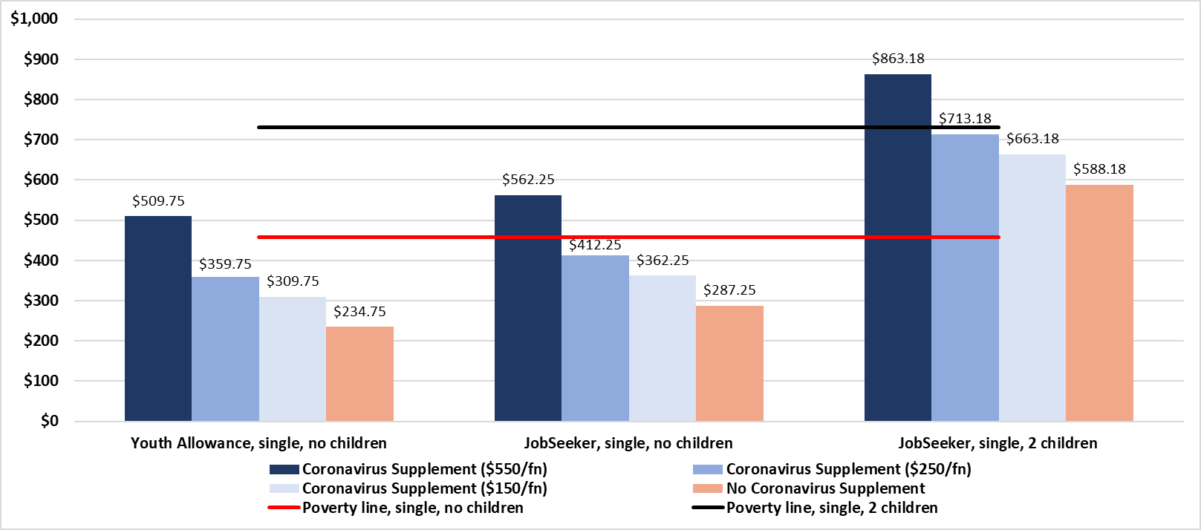

Chart 2 Poverty gap per week[7]

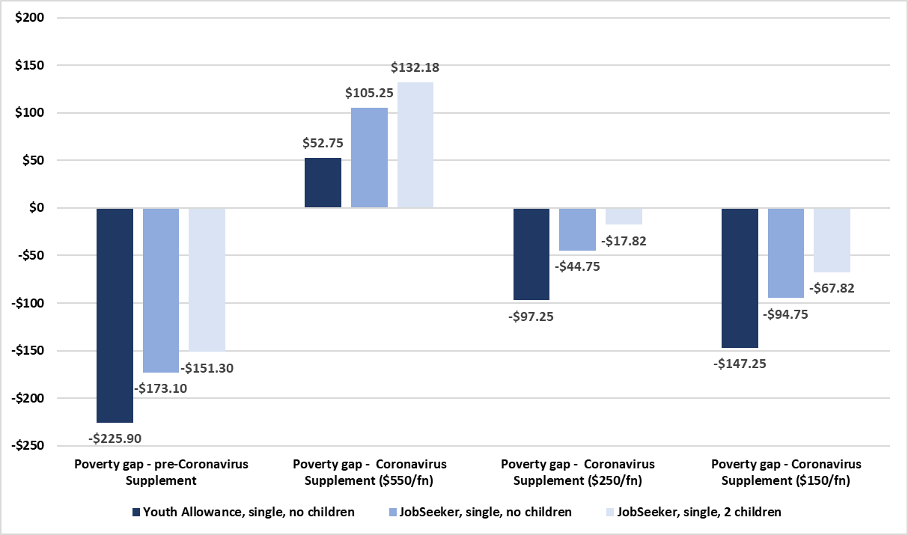

Further reducing the Coronavirus Supplement by $100 per fortnight from 1 January 2021 will impact heavily on around 23,000 individuals and their families already struggling to afford the basics of a healthy living. Anglicare Australia’s Rental Affordability Snapshot undertaken in August 2020 found that out of 768 private rentals advertised in the ACT only one property was affordable for a JobSeeker recipient with the Coronavirus Supplement of $550 per fortnight.[8] None of the surveyed private rental properties would have been affordable when the supplement was reduced by $300 per fortnight in September 2020.

In the Explanatory Memorandum it is noted that the Social Services and Other Legislation Amendment (Extension of Coronavirus Support) Bill 2020 engages with ‘the right of everyone to an adequate standard of living for an individual and their family, and the continuous improvement in living conditions in Article 11 of the International Covenant on Economic, Social and Cultural Rights’. Reducing income support payment rates further below the poverty line contravenes this right.

Over one million people in Australia do not have access to income support (including JobSeeker Payment, Youth Allowance or Special Benefit) or the JobKeeper wage subsidy, despite having the right to work, study, or seek asylum. In addition to increasing the rate and extending the duration of the Coronavirus Supplement, ACTCOSS supports extending access to income support to people without citizenship or permanent residency who have lost income or employment due to the COVID-19 pandemic as soon as possible.

Reducing the Coronavirus Supplement will also impact negatively on the broader ACT community and its economic recovery. Deloitte Access Economics has estimated that removing the Coronavirus Supplement completely would result in reduced consumption per person (by $504), reduced economic output per person (by $382), and the loss of 1,120 full-time equivalent (FTE) jobs in the ACT in 2021-22.[9]

As a key anti-poverty measure in the ACT and nationally, we recommend a permanent and adequate increase to income support payments ensuring that our social security system keeps people out of poverty.

Yours sincerely

Dr Emma Campbell  
CEO

Email: [ceo@actcoss.org.au](mailto:ceo@actcoss.org.au)

19 November 2020

1. M Klapdor, *The impact of COVID-19 on JobSeeker Payment recipient numbers by electorate*, Research Paper Series, 2020–21, Parliamentary Library, Department of Parliamentary Services, Canberra, 8 September 2020, p. 9, <<https://www.aph.gov.au/About_Parliament/Parliamentary_Departments/Parliamentary_Library/pubs/rp/rp2021/COVID-19JobSeekerRecipientNumbersElectorateUpdate>>.
2. Department of Social Services, *DSS Payment Demographic Data June 2020*, DSS, Canberra, 2020, <<https://data.gov.au/data/dataset/dss-payment-demographic-data>>.
3. ACOSS & UNSW, Poverty and Inequality website, Data and figures, Rate of poverty by state/territory of residence, 2020, <<http://povertyandinequality.acoss.org.au/poverty/rate-of-poverty-by-state-territory-of-residence-of-people/>>; P Davidson, email, 18 May 2020.
4. B Phillips, unpublished data, ANU Centre for Social Research and Methods, Canberra, October 2020.
5. B Phillips, unpublished data, ANU Centre for Social Research and Methods, Canberra, October 2020.
6. Own calculations based on: Centrelink*, A guide to Australian Government payments, 20 September to 31 December 2019; 20 March to 30 June 2020; & 1 July to 19 September 2020*, Centrelink, Canberra, 2019-20; ABS, 6302.0 - Average Weekly Earnings, Australia, Nov 2019, ABS, Canberra, 2020; & ACOSS & UNSW, Poverty and Inequality website, Data and figures, Poverty lines by family type, ACOSS & UNSW, Sydney 2020, <<http://povertyandinequality.acoss.org.au/poverty/poverty-lines-by-family-type/>>.
7. Own calculations based on, Centrelink, *A guide to Australian Government payments, 20 September to 31 December 2019; 20 March to 30 June 2020; & 1 July to 19 September 2020*, Centrelink, Canberra, 2019 & 2020; ACOSS & UNSW, Poverty and Inequality website, Data and figures, Poverty lines by family type, ACOSS & UNSW, Sydney 2020, <<http://povertyandinequality.acoss.org.au/poverty/poverty-lines-by-family-type/>>.
8. Anglicare Australia, *Rental Affordability Snapshot – Special Update, August 2020*, unpublished ACT data provided by Anglicare Australia, Canberra, 2020, <https://anglicare-ras.com/the-findings/>; L Bladen, *Rental affordability in Canberra worsens during pandemic: Anglicare*, The Canberra Times, 1 September 2020, <<https://www.canberratimes.com.au/story/6902578/only-one-of-800-canberra-rentals-affordable-for-a-tenant-on-jobseeker/>>.
9. Deloitte Access Economics, *Estimating the economic impacts of lowering current levels of income support payments*, Report for the Australian Council of Social Service, Deloitte Access Economics, Sydney, 2020, <<https://www.acoss.org.au/wp-content/uploads/2020/09/Final-ACOSS-Coronavirus-Supplement-to-ACOSS-09.09.2020.pdf>>.