Logo: ACT Council of Social Service Inc. (ACTCOSS).Factsheet

October 2021

Poverty and COVID-19 in the ACT

Disadvantage in the ACT tends to be hidden behind high averages across indicators such as income, education, and employment. Closer analysis reveals that a sizeable number of people in the ACT do experience poverty and disadvantage.

During the COVID-19 pandemic:

* the number of people **living in poverty** has increased from just under 30,000 people to just over **38,000 people, including approximately 9,000 children**[1]
* when the Australian Government introduced the Coronavirus Supplement,JobSeeker increased above the poverty line and **ACT’s poverty rate dropped from 8.6% to 5.2%** - when this wasremoved, JobSeeker returned to below the poverty line and **ACT’s poverty rate rose to 9.0%**
* during the 2020 lockdown **the number of people receiving income support while looking for work more than doubled** peaking at just under 15,000 people – during the 2021 lockdown this number has peaked at 9,500 people, still **33% above the pre-COVID level**
* during the 2021 lockdown, **64,000 people who lost work or income received the COVID Disaster Payment** – this payment will cease 3 weeks after ACT reaches the 80% fully vaccinated milestone.

Even before the COVID-19 pandemic:

* The **ACT’s poverty rate had increased** from 8.0% to 8.6% between 2016 and 2018
* almost **40,000 Canberrans** lived in households that were among Australia’s **most disadvantaged**[2]
* over **25,000 people** in low-income households were experiencing **food stress**[3]
* the ACT had the **highest rate of rental stress** among lower income private rental households at 73%.

|  |
| --- |
| **Quote us** ►: “For most of us, the ACT offers an excellent quality of life and supports a strong sense of wellbeing. Amidst the prosperity, significant poverty exists in the ACT. In the wake of COVID-19, there are now over 38,000 Canberrans living below the poverty line.  “The ACT has the highest average weekly earnings in Australia. However, for those on low incomes, the cost of living in Canberra means many cannot afford the fundamentals of a healthy life such as food, housing, health services, and energy.  “Our [*2021 ACT Cost of Living Report*](https://www.actcoss.org.au/publications/advocacy-publications/2021-act-cost-living-report) found that over the past five years changes in the cost of living have hit Canberra’s low-income households the hardest. These households spend a greater proportion of their income on essential goods and services. Over the last five years, prices for some of these essentials grew significantly in Canberra, with electricity and gas prices rising by 28% and 26% respectively, health costs up 19%, and housing costs increasing by 16%.  “Since 2016, Anglicare Australia’s annual [*Rental Affordability Snapshot*](https://www.anglicare.com.au/anglicare-research-rental-affordability-forcing-more-canberrans-into-financial-hardship/) has consistently found a severe shortage of affordable private rental properties for low-income households in Canberra. In March 2021, out of 1,002 private rental properties advertised in Canberra none were affordable for households on working age social security payments.  “Ensuring people have adequate incomes and affordable housing is fundamental to reducing poverty and inequality in the ACT. We need the Australian Government to provide a permanent and adequate increase to JobSeeker and related income support payments to keep people out of poverty. The Australian and ACT governments must urgently work together to address the shortfall of over 3,000 social housing dwellings in Canberra.  “A just and fair Canberra requires an inclusive economy. Targeted measures that address cost of living for low-income households are an essential part of this. Targeted concessions, rebates and subsidies must be designed to relieve cost of living pressures for households with low incomes or experiencing other forms of hardship. By alleviating poverty and reducing inequality targeted measures benefit everyone.  “At the same time, tax revenue must be sufficient to fund quality services, affordable housing, and community infrastructure that address the structural causes of poverty and disadvantage while benefiting all Canberrans.”  Dr Emma Campbell, CEO, ACTCOSS |

The following groups face an elevated risk of experiencing poverty and/or socioeconomic disadvantage in the ACT:

* Aboriginal and/or Torres Strait Islander people
* People from culturally and linguistically diverse backgrounds
* People with disability
* Older people aged 65 years and older
* Women.[4]

# Poverty across the ACT during COVID-19

Prior to the COVID-19 pandemic, ACOSS and UNSW estimated that almost 30,000 people in the ACT were living below the poverty line, representing 8.6% of the total population. More recent ANU analysis indicates that the number of Canberrans living in poverty has increased to approximately 38,000 people, with poverty rates varying across Canberra regions – ranging from between 8% to 12%.

Poverty rates by SA3 region, ACT, March-October 2020

|  |  |  |  |
| --- | --- | --- | --- |
| Region | March 2020  Poverty Rate | June 2020  Poverty Rate | October 2020  Poverty Rate |
| Belconnen | 7.5% | 5.7% | 10.5% |
| Gungahlin | 5.7% | 4.7% | 9.1% |
| North Canberra | 8.9% | 8.5% | 11.9% |
| South Canberra | 5.3% | 4.4% | 7.5% |
| Tuggeranong | 6.4% | 5.1% | 10.1% |
| Weston Creek | 5.6% | 4.2% | 8.3% |
| Woden | 5.1% | 4.0% | 7.6% |

This data indicates that the increase in the rate of JobSeeker and related working-age payments through the Coronavirus Supplement of $550 per fortnight and the introduction of the JobKeeper payment of $1,500 per fortnight per eligible employee saw a significant reduction in poverty rates across the ACT. The phasing out of the Coronavirus Supplement and JobKeeper payments from late September 2020 saw a significant increase in ACT poverty rates to above pre-COVID levels.

# The rise and fall of income support during COVID-19

During the COVID-19 pandemic the number of people in the ACT who have received income support while looking for work more increased significantly, more than doubling within the first two months of the health emergency. This number has yet to recover to the pre-COVID level. Since the 12 August 2021 lockdown, 64,000 Canberrans who have lost work or income have received the COVID Disaster Payment.

Total JobSeeker Payment and Youth Allowance (other) recipients by sex, ACT, March 2020 – August 2021

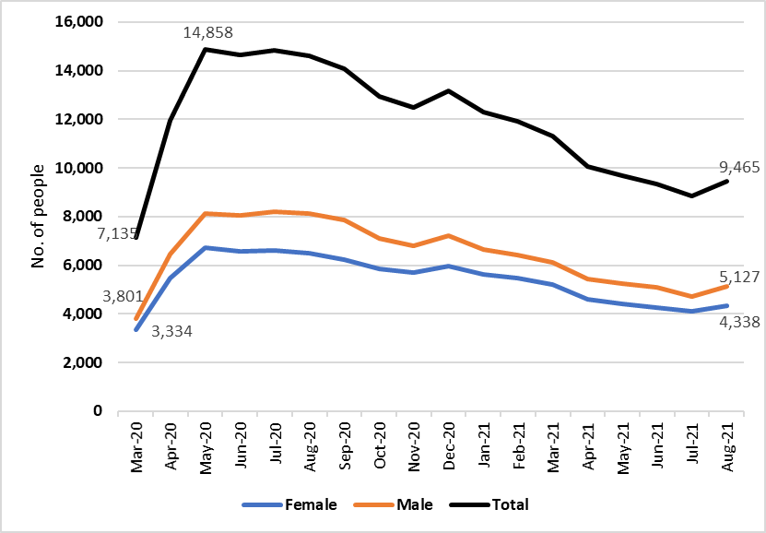

The original Coronavirus Supplement saw these income support payments increase in real terms for the first time in over 25 years and to a level above the poverty line. As the supplement was phased out, these payments returned to well below the poverty line – even with a permanent increase by $50 per fortnight from 1 April 2021.

Changes in income support payments due to the introduction, reduction, and removal of the Coronavirus Supplement (in relation to the poverty line)

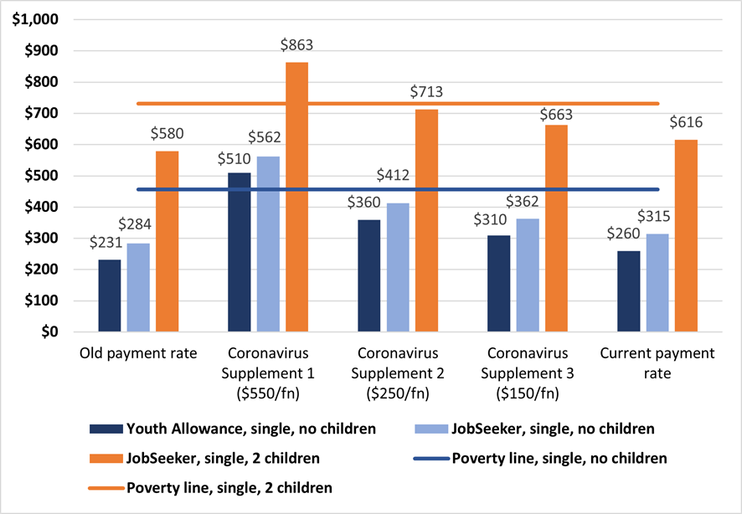

Poverty gap for JobSeeker and Youth Allowance recipients with the introduction, reduction, and removal of the Coronavirus Supplement

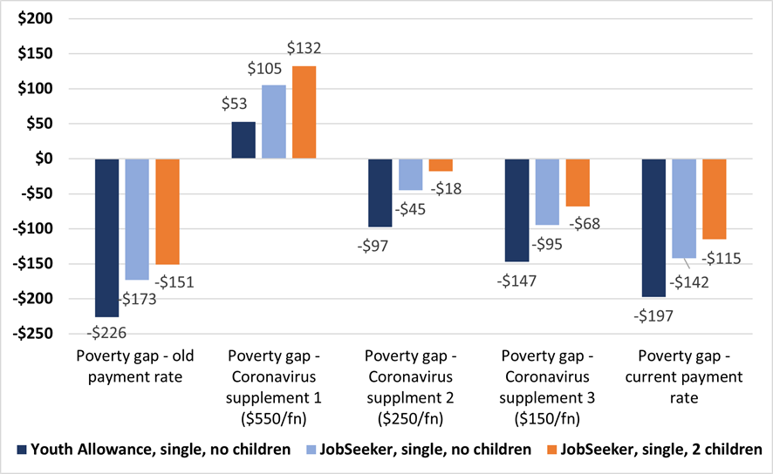

# Cost of Living

A recent analysis by the Australian Bureau of Statistics (ABS) found that between 2005 and 2020, the prices of non-discretionary (or essential) goods and services increased at a significantly higher rate than for discretionary (or non-essential) goods and services – 43.8% compared to 31.8%. This higher rate of increase in the prices of essential goods and services has had a disproportionate impact on low-income households as they spend a greater proportion of their income on these essential items.

Cumulative Inflation 2005/06 to December 2020 quarter

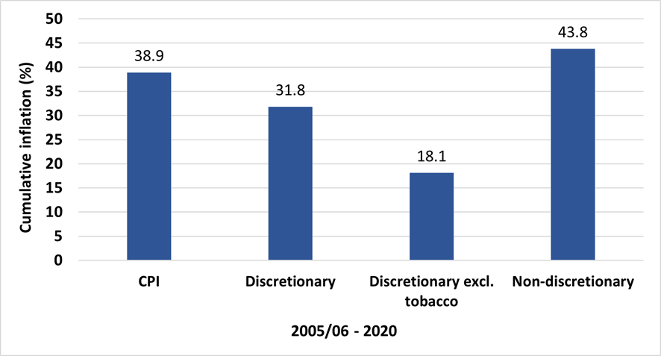

Over the last five years Canberrans have seen the prices of essential goods and services increase significantly and at rates above the overall CPI for Canberra and nationally. These include:

* electricity (27.7% increase)
* gas (26.2% increase)
* health (18.6% increase)
* education (18.0% increase)
* housing (15.7% increase)
* meat and seafood (13.4% increase)
* fruit and vegetables (11.6% increase).

# The ACT’s housing affordability crisis

Housing is the most significant expense for low-income households in the ACT, for whom housing makes up a significantly higher proportion of their income.

Housing costs as a proportion of gross household income, ACT, 2017-18

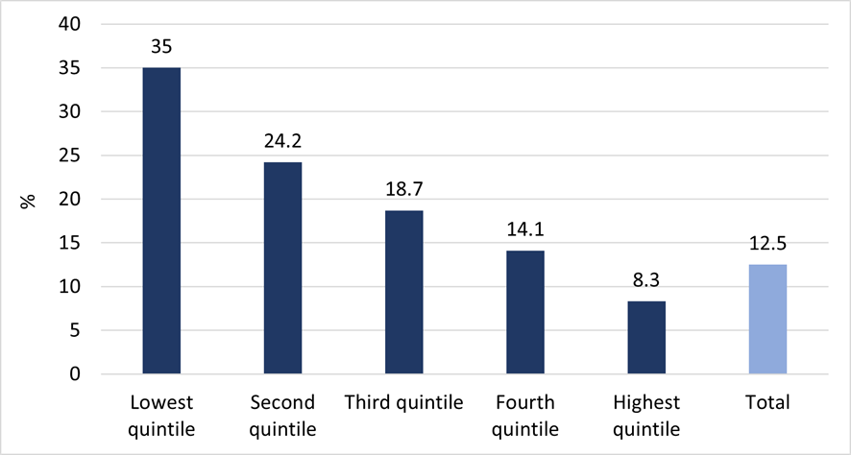

A chronic lack of affordable housing has led to a housing crisis in Canberra. Without significant federal and territory government investment in social housing, the ACT’s affordable housing crisis will continue to worsen, deepening and entrenching disadvantage and homelessness in our community.

* Canberra is currently the most expensive capital city in which to rent
* the ACT had the highest rate of rental stress among lower income private rental households at 73%
* In March 2021, out of 1,002 private rental properties advertised in Canberra none were affordable for households on working age social security payments.
* There is a shortfall of over 3,000 social housing dwellings in the ACT
* Since 2014, the social share of social housing has declined from 7.6% to 6.7%
* The 2016 Census counted 1,600 people experiencing homelessness in the ACT
* As of 4 October 2021, there were 2,965 households on the ACT’s social housing waiting list. The average wait time for standard housing is now over 4 years (1,472 days).

# Solutions to Poverty

* Set a serious goal of full employment
* Commit to a flexible employment and training guarantee to improve the employment prospects of people unemployed long-term
* Permanently lift social security payments above the poverty line
* Increase Rent Assistance so that everyone around the country receives enough rental support
* Build more social housing to improve the supply of secure and affordable homes.

# Raise the Rate for Good campaign

ACOSS is running the **Raise the Rate for Good** campaign which is calling on the Australian Government to permanently and adequately raise the rate of the unemployment and related payments so that they keep people out of poverty.

Raise the Rate website: [raisetherate.org.au](https://raisetherate.org.au/) | #RaiseTheRateForGood

# Everybody’s Home campaign

The **Everybody’s Home** campaign is calling for a better, fairer housing system for everyone.

Everybody’s Home website: [everybodyshome.com.au](https://everybodyshome.com.au/)

# Further reading

**ACT Cost of Living Report, 2021**<https://www.actcoss.org.au/publications/advocacy-publications/2021-act-cost-living-report>

**Hidden disadvantage in the ACT: Report for ACT Anti-Poverty Week 2017**<https://www.actcoss.org.au/publications/advocacy-publications/hidden-disadvantage-act-report-anti-poverty-week-2017>

**ACOSS & UNSW Poverty and Inequality in Australia website**  
[http://povertyandinequality.acoss.org.au](http://povertyandinequality.acoss.org.au/)

# Connect

ACTCOSS website: [www.actcoss.org.au](http://www.actcoss.org.au) | Twitter: [@ACTCOSS](https://twitter.com/actcoss)

ACOSS website: [www.acoss.org.au](http://www.acoss.org.au) | Twitter: [@ACOSS](https://twitter.com/acoss)

1. Unless otherwise referenced, data presented in this factsheet is drawn from: ACTCOSS, [*2021 ACT Cost of Living Report*](https://www.actcoss.org.au/publications/advocacy-publications/2021-act-cost-living-report), ACTCOSS, Canberra, 2021, accessed 15 October 2021.
2. ABS, [*Experimental Index of Household Advantage and Disadvantage, 2016*](https://www.abs.gov.au/AUSSTATS/abs@.nsf/Lookup/4198.0Main+Features12016?OpenDocument), cat. no. 4198.0, ABS, Canberra, 2019, State and territory, percentage of persons, IHAD, 2016, Table 6, accessed 25 June 2019.
3. ACTCOSS*, Food security, food assistance and the affordability of healthy food in Canberra*, ACTCOSS, Canberra, May 2019, p. 22, viewed 25 June 2019, <<https://www.actcoss.org.au/publications/advocacy-publications/report-food-security-food-assistance-and-affordability-healthy>>.
4. ABS, *Experimental Index of Household Advantage and Disadvantage, 2016*; E Davidson, [*Hidden disadvantage among women in the ACT*](http://www.wchm.org.au/wp-content/uploads/2018/06/Hidden-disadvantage-among-women-in-the-ACT-final.pdf), Women’s Centre for Health Matters, Canberra, June 2018, accessed 1 April 2019; ACTCOSS unpublished analysis of ABS 2016 Census of Population and Housing using TableBuilder.