Logo: ACT Council of Social Service Inc. (ACTCOSS).Factsheet

December 2021

2021 ACT Community Sector Demand Snapshot

This factsheet provides a snapshot of key findings for the ACT from the Australian Community Sector Survey (ACSS) 2021.[1] The survey was conducted in September 2021 across Australia by the Social Policy Research Centre at UNSW Sydney in collaboration with the Australian Council of Social Service (ACOSS) and the network of Councils of Social Service of Australia (COSS Network), supported by Bendigo Bank.

# Services are confronting increased poverty and disadvantage in the community

Over two thirds (67%) of ACT community sector staff, including CEOs and managers, reported that in 2021, levels of poverty and disadvantage have increased among the groups they support. This is likely due to the prolonged effect of the pandemic and the impacts of service disruptions in 2020, as well as inadequate financial supports for households.

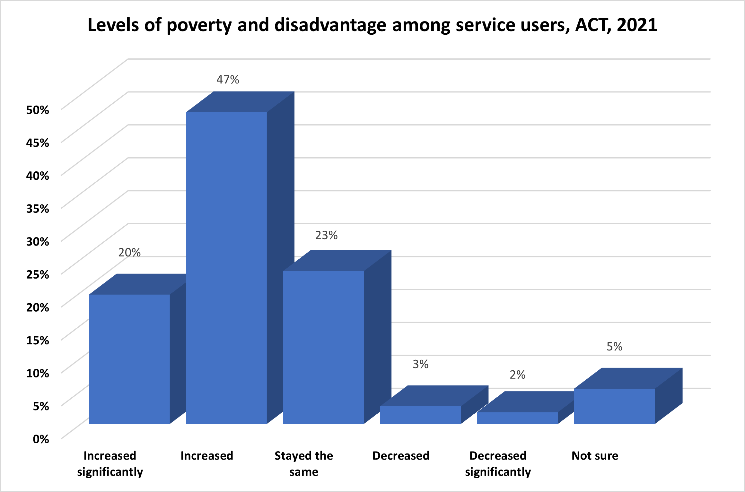

Main challenges affecting the people and communities their organisations support included social isolation (81%), housing affordability and homelessness (76%), lack of access to mental health supports (71%), cost of living pressures (65%), and a lack of COVID-19 financial support and inadequate Centrelink payments (42%).

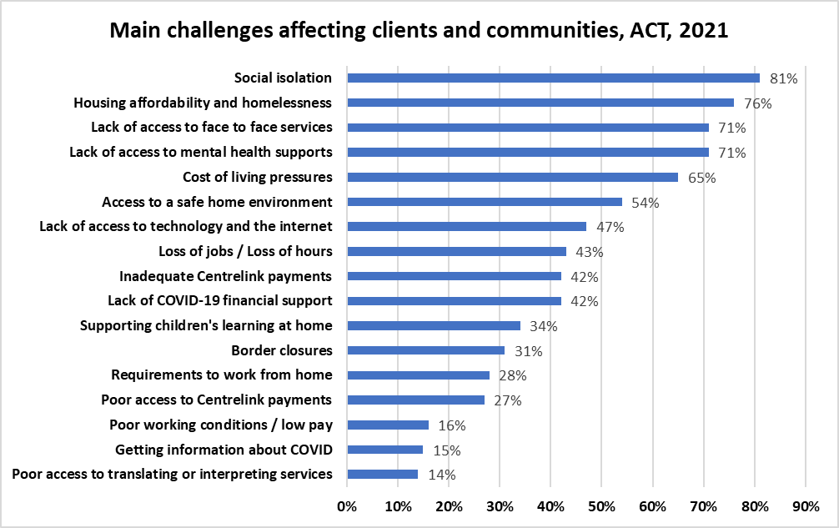

|  |
| --- |
| We have seen a dramatic increase in homelessness and housing instability… Housing/rental prices have increased significantly and we have also seen an increasing number of people moving into the area from the larger cities without realising that the housing situation here is much worse.  - Frontline worker, financial support service, ACT |

# Demand for community services has increased in 2021

Almost four in five participants (78%) reported that levels of demand for their main service increased. Almost half (48%) of housing and homelessness services staff said they were rarely or never able to meet demand.

Concerningly, over one fifth of participants (21%) reported decreased availability of funding to support their work. Over three quarters (77%) of workers report growing complexity of need among service users during 2021.

|  |
| --- |
| Demand for housing services and DV support grew significantly. We cannot service all clients who contact us as we don’t have enough staff and the funding we receive won’t cover more resourcing.  **- Project officer, child, youth and family service, ACT** |

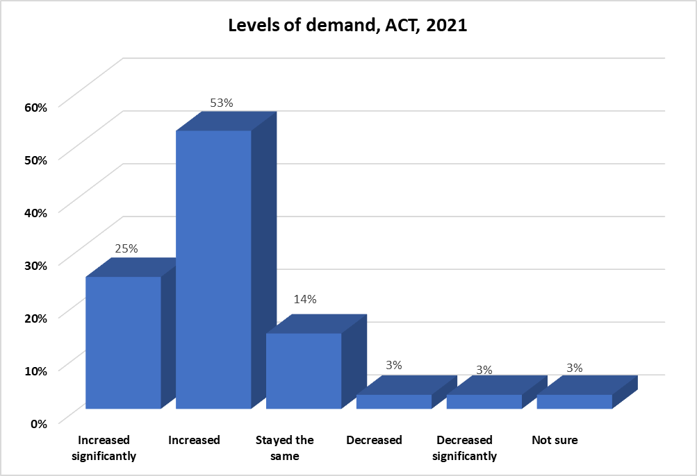

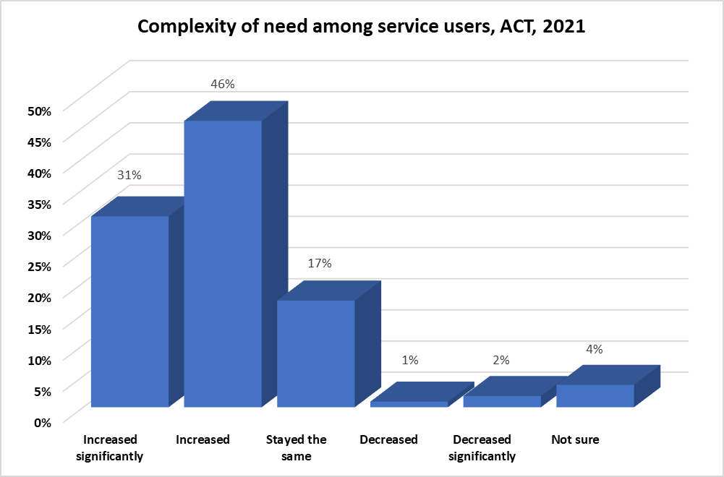

|  |
| --- |
| Complexity and levels of need of individuals and families in the community is dramatically increasing and so demands upon our member organisations are dramatically increasing.  - CEO, legal, advocacy or peak body, ACT |

# Ability of community services to meet demand fell in 2021

In 2021, just 4% of participants said their service was ‘always’ able to meet demand. This proportion has plummeted from 2020, when 20% of participants agreed. Over half of participants (51%) reported increases in the numbers of clients their service was unable to support.

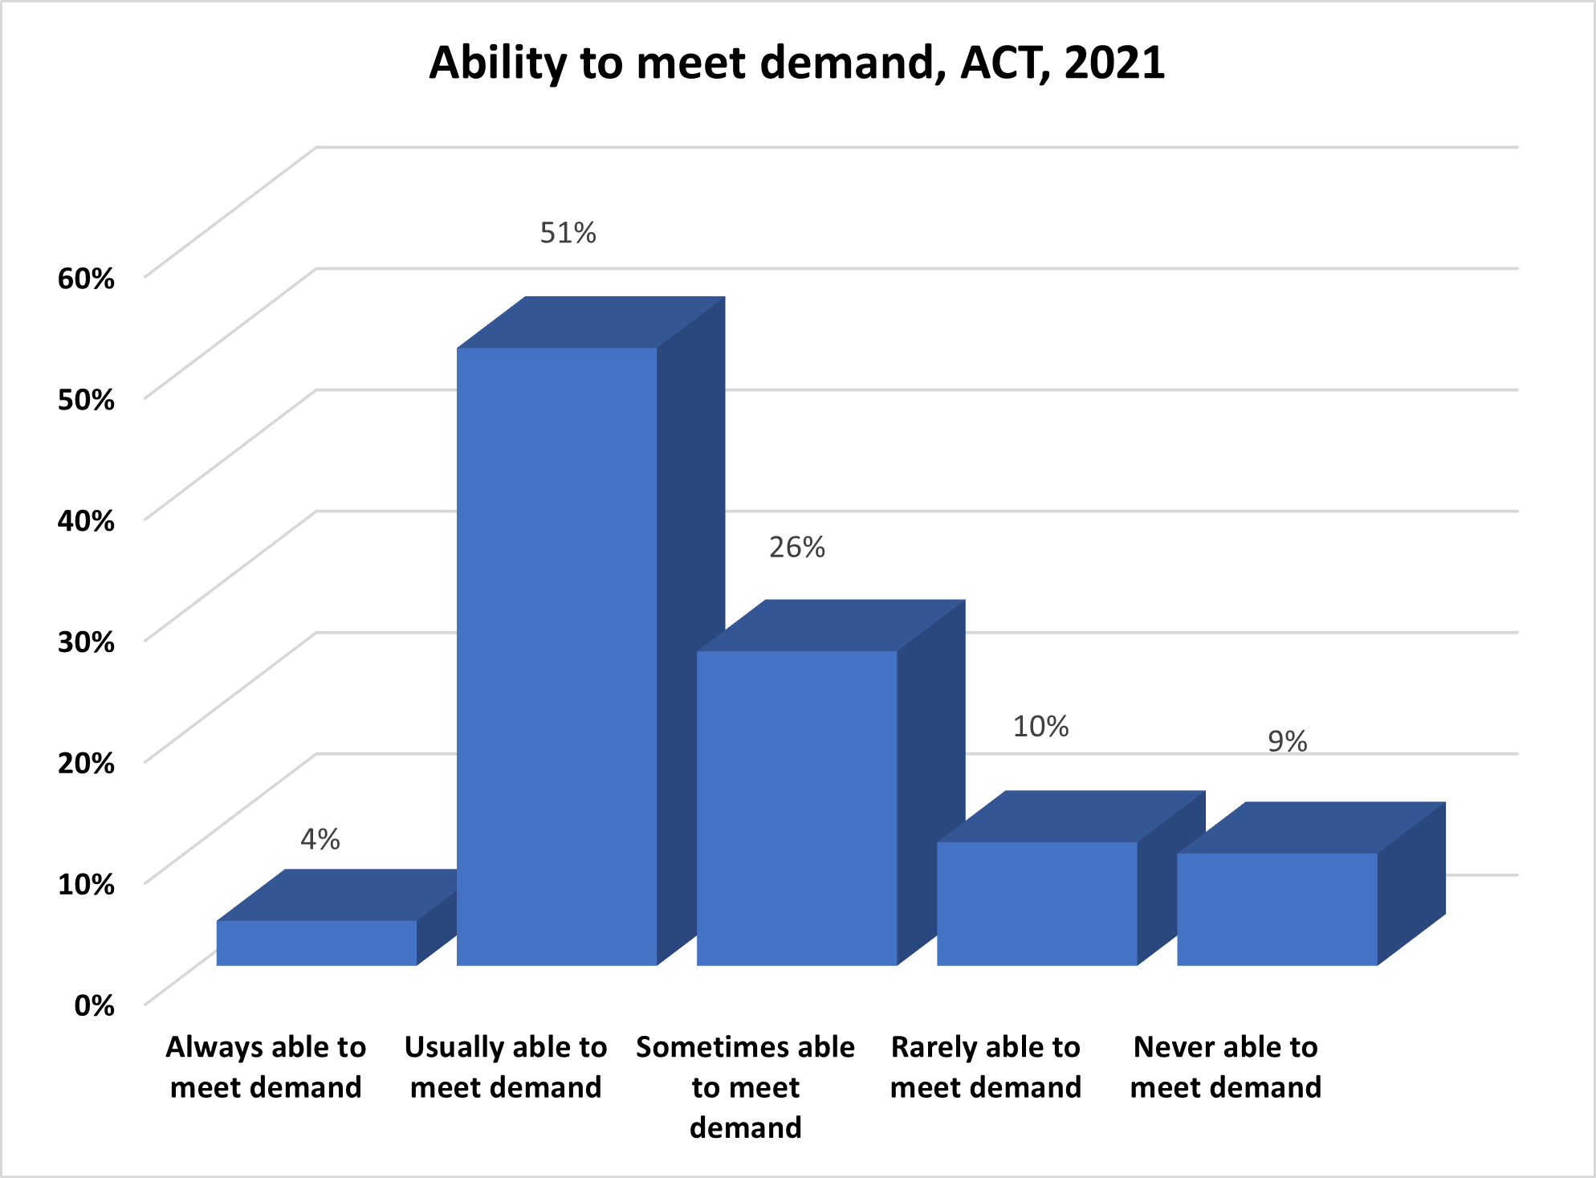

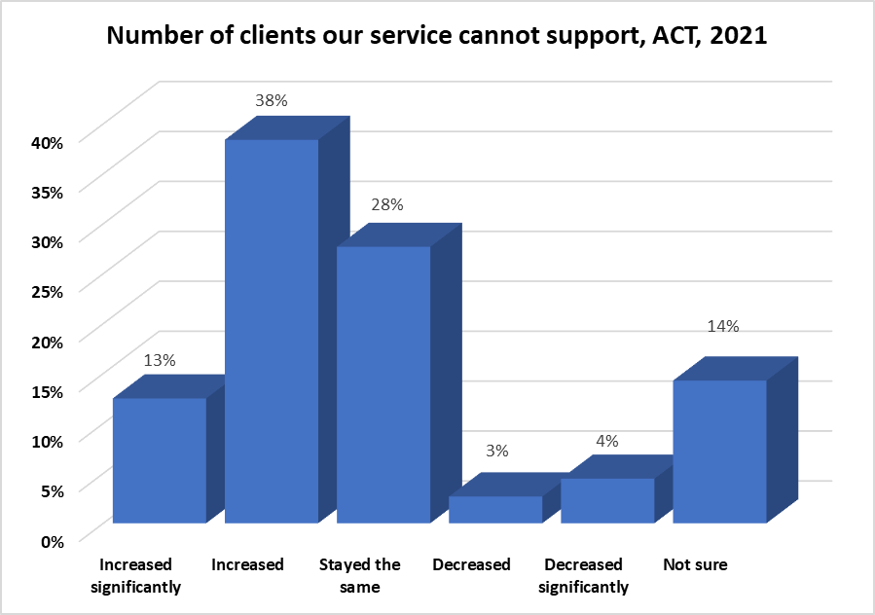

While often difficulties in meeting community needs arose because those needs had increased, participants also reported that the pandemic had reduced capacity; that options for referral were limited; and that there were insufficient resources to hire the staff required to deliver services.

|  |
| --- |
| Small amounts (in the context of government) of funding for the community sector could bring about huge improvements in outcomes for the people they service, and yet the penny pinching around funding for community organisations continues. Indexation doesn’t keep up with costs. Services are underfunded for the outcomes demanded.  - CEO, legal, advocacy or peak body, ACT |

# Despite these challenges, the sector has strengthened Australia’s recovery

Although the community sector encountered profound challenges during 2021, it adapted service delivery to navigate changed circumstances, making a significant and essential contribution to ACT’s COVID response. Over half (53%) of survey participants said that in 2021 there were increases in how effectively their service was able to operate during COVID lockdowns, and 30% reported increases in their access to technology to engage with clients and communities. In addition to undertaking core operational work assisting service users, the community sector has also helped increase vaccination rates, promoted digital literacy and access to technology, and provided urgent emergency relief and financial support. This is an invaluable contribution to the community that reaffirms the importance of the sector to people in need.

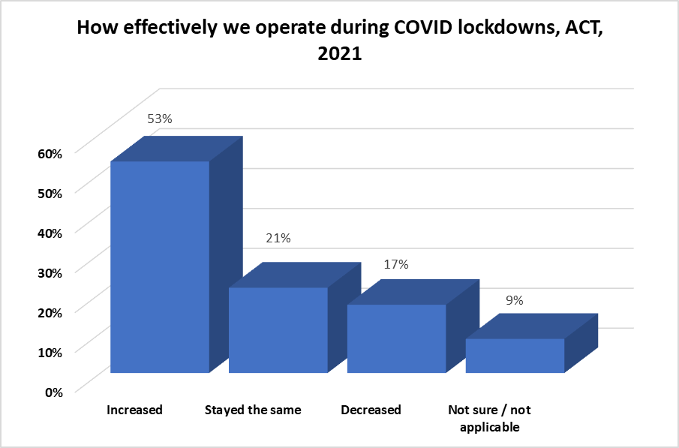

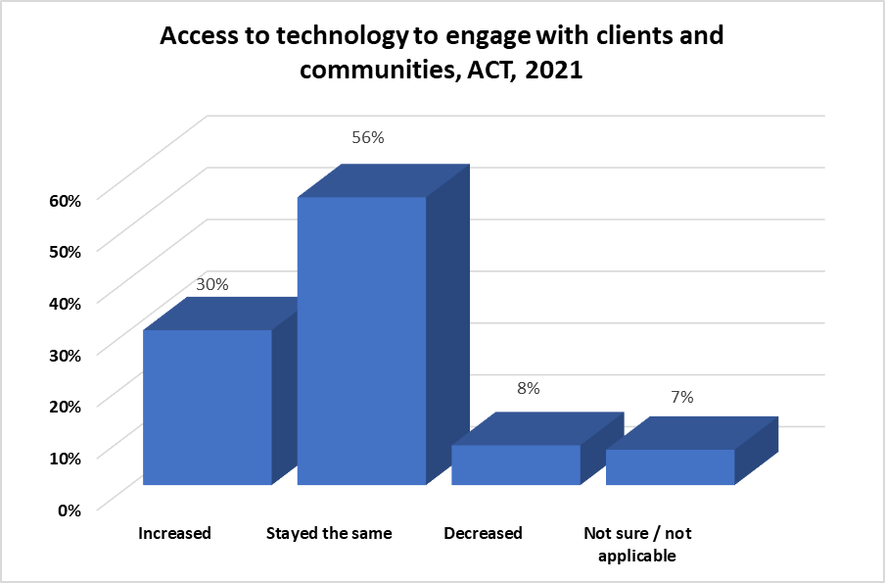

# ACTCOSS joins with ACOSS in calling for a national COVID-19 recovery plan

A national COVID-19 recovery plan should include a new strategic partnership between the Australian Government and the community sector, to strengthen the working relationship and ensure the expertise and importance of the sector is embedded in government administration and policy development. This partnership would include:

* a new approach to the funding of community services based on need
* a new approach to the delivery of services based on genuine collaboration and co-design principles
* longer funding cycles, more holistic resourcing for organisations and an end to precarious funding arrangements.

ACTCOSS also calls on the ACT Government to work closely with the ACT community sector to ensure proper resourcing and funding certainty.

Read ACOSS’s 2021 ACSS demand snapshot *Meeting demand in the shadow of the Delta outbreak: community sector experiences* at the ACOSS website: [acoss.org.au](https://www.acoss.org.au/).

ACT Council of Social Service Inc. | Weston Community Hub, 1/6 Gritten St, Weston ACT 2611  
Ph: 02 6202 7200 | actcoss@actcoss.org.au | www.actcoss.org.au

ACTCOSS is committed to reconciliation, acknowledges the traditional custodians of the land and pays respect to elders past and present.

ACTCOSS advocates for social justice in the ACT and represents not-for-profit community organisations.

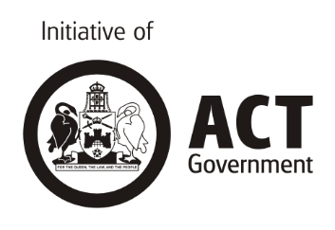

1. This snapshot has been produced using unpublished data for the ACT from the 2021 Australian Community Sector Survey provided to ACTCOSS by the Social Policy Research Centre at UNSW Sydney. It also draws from the national 2021 ACSS demand snapshot cited as: N Cortis and M Blaxland, *Meeting demand in the shadow of the Delta outbreak: Community Sector experiences. Demand Snapshot 2021*, ACOSS, Sydney, 2021.