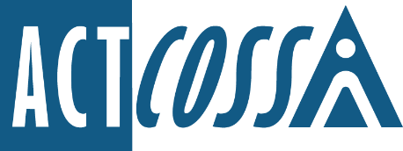

ACT Council of Social Service Inc.
1/6 Gritten Street, Weston ACT 2611
ph. 02 6202 7200
e. actcoss@actcoss.org.au
w. actcoss.org.au
abn. 81 818 839 988

19 August 2022

Ms Barbara Deegan, Chair
The Inquiry into the Legislative, Workplace Governance and Clinical Frameworks of Dhulwa
GPO Box 158
Canberra ACT 2001

Via email: dhulwainquiry@act.gov.au

Dear Ms Deegan
Dhulwa Inquiry
ACT Council of Social Service (ACTCOSS) is grateful for the opportunity to make a submission to the Inquiry into the Legislative, Workplace Governance and Clinical Frameworks of the Dhulwa Secure Mental Health Facility. ACTCOSS advocates for social justice and represents not-for-profit community organisations in the ACT.
In preparing this submission, we have consulted with Advocacy for Inclusion (AFI), ACT Disability and Aged Care Advocacy Service (ADACAS), the Mental Health Community Coalition ACT (MHCC ACT), the ACT Mental Health Consumer Network (ACT MHCN), the Canberra Mental Health Forum (CMHF) and Carers ACT.
Some of these organisations are making submissions which we endorse. We are not experts in forensic mental health, nor are we direct service providers, so we encourage you to carefully consider the advice of these organisations as it is informed by lived experience and expertise in supporting consumers with complex mental health needs.
ACTCOSS appreciates that this inquiry was prompted by serious safety concerns from staff working at Dhulwa, and we believe it is important that both staff and consumers feel safe and respected and are free from violence while at the facility. However, we believe the inquiry has been framed in such a way as to suggest that the needs and rights of workers and consumers are diametrically opposed. This adversarial tension has been exasperated by the short time frame for making submissions and the lack of dedicated and supported consultation with consumers and carers.
Poor consultation with consumers and carers is symptomatic of a broader and systemic lack of transparency with regard to processes, procedures and policies at Dhulwa and the mental health system in the ACT. Consumers, carers and advocates find it extremely difficult to navigate the system, which can add to anxiety and lead to further deterioration of relationships with staff.
Without clear and accessible policies, procedures and guidelines there is no clear framework for staff to make decisions in a supported and transparent way, especially when they do not have the time or resources to explain policies to concerned carers or anxious consumers. This contributes to a lack of trust between staff, consumers and carers and oversight bodies. All policies and procedures must be culturally sensitive and recognise the different needs of Aboriginal and/or Torres Strait Islander peoples, people from refugee or migrant background, LGBTIQ+ people, women and those with disabilities. All policies must be made publicly available with opportunities for regular oversight and review.
and must be publicly available with opportunities for regular oversight and review.
Beyond this inquiry, we know that major decisions about mental health policies, strategies and services should be co-designed with people with lived experience of those services. In particular, we need to ensure that services are culturally safe for Aboriginal and Torres Strait Islander people and appropriate for women and LGBTIQ+ people as well as those with disabilities. Good co-design processes with regards policy and service delivery at Dhulwa has been lacking.
In many instances, mental ill-health can co-occur with disability. Policies and procedures should reflect a social rather than a medical understanding of disability and supports much be tailored and targeted to need. For more information on this please see ACTCOSS’s Imaging Better report and other publications available on the ACTCOSS website.
For example, it is not clear how effective NDIS plans are in Dhulwa, or how well people are able to transition their plans between the Alexander Maconochie Centre (AMC), Dhulwa, Gawanggal, and the community. Given that consumers potentially move through each of these spaces several times during a stay, it is important that diagnostic screening, NDIS plans, and other disability supports are coordinated and available across and throughout all facilities.
We need to see earlier supports and interventions, particularly through connection to community services and advocacy support. As the recommendations from this inquiry are implemented, there must be sufficient funding for the community sector organisations that support consumers and carers before, during and after a stay at a secure mental health facility. This should include robust support for carers and advocacy organisations, but also organisations that can help maintain a sense of connection to community for consumers.
ACTCOSS would also like to see more information about how the Optional Protocol to the Convention Against Torture (OPCAT) and the National Preventive Mechanism (NPM) will be applied within Dhulwa, and what resources staff and consumers will receive to participate with oversight and compliance activities.
ACTCOSS is unequivocally supportive of safe working environments for staff at Dhulwa, but we do not believe this outcome is at odds with ensuring human rights are met for consumers, nor that it can be carried out without meaningful consultation with consumers, carers, and advocacy organisations.

Yours sincerely
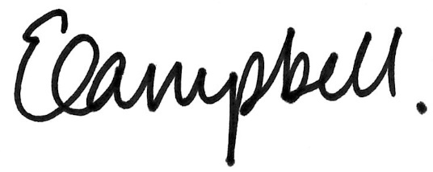
Dr Emma Campbell
Chief Executive Officer
Email: ceo@actcoss.org.au

