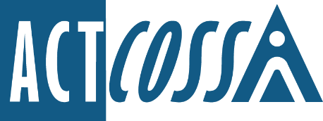

ACT Council of Social Service Inc.
1/6 Gritten Street, Weston ACT 2611
ph. 02 6202 7200
e. actcoss@actcoss.org.au
w. actcoss.org.au
abn. 81 818 839 988

8 August 2022

Ms Leanne Castley MLA (Chair)
Standing Committee on Economy and Gender and Economic Equality
ACT Legislative Assembly

Via email: LACommitteeEGEE@parliament.act.gov.au

Dear Ms Castley
Inquiry into Housing and Rental Affordability
The ACT Council of Social Service (ACTCOSS) advocates for social justice in the ACT and represents not-for-profit community organisations. ACTCOSS’s vision is for Canberra to be a just, safe and sustainable community in which everyone has the opportunity for self-determination and a fair share of resources and services
We welcome this opportunity to make a submission to this inquiry into housing and rental affordability.
Recommendations
- Undertake research to quantify and better understand the proportion of homes in the ACT and Queanbeyan that are vacant or let as short-term rentals.
- Undertake inter-jurisdictional comparisons to:
  - Determine the gravity of the situation in the ACT
  - Assess measures to encourage vacant properties or short-term lets to be returned to the residential private rental market
  - Investigate revenue raising opportunities from vacant properties to reinvest in the provision of social and affordable housing
  - Conduct a cost benefit analysis to see whether resources required to return a proportion of these dwellings to the private rental market would reap sufficient benefit for people most at risk from housing insecurity and homelessness

The ACT’s Housing Crisis
As noted in the ACTCOSS Cost of Living 2022 Report, and in the ACTCOSS Budget Priorities submission, housing is the biggest cost of living pressure for low-income households in the ACT.
With a population of 431,500 the ACT is one of the smaller jurisdictions. Nevertheless, housing issues are substantial and Canberra has held a position as one of the most unaffordable housing markets in the country for many years. In fact, the ACT is facing a housing crisis.
Of the 32% of households in rental accommodation in the ACT, 23% are renting privately, 6% are in public housing and 0.5% are in community housing. The ACT continues to have higher rates of rental stress than other Australian jurisdictions, with more than 73% of lower income private rental households spending more than 30% of their incomes on housing. Canberra has been Australia’s most expensive capital city to rent a house since late 2018 and to rent a unit since late 2020.
We know that there is a shortfall of approximately 3,100 social housing dwellings in the ACT, with 8,500 additional social housing dwellings needed by 2036 to meet the ACT’s current unmet and projected need.
The 2016 Census counted 1,600 people experiencing homelessness in the ACT. While 4,000 clients were assisted by specialist homelessness services in the Territory, more than 30% of these clients did not have their needs for accommodation met.
Despite this growing crisis, there has been a clear failure by the Federal and Territory Governments to deliver more social and affordable homes to meet growing demand. In 2021, there were 322 fewer public housing dwellings than in 2018 in the ACT.
Despite clear need, social housing households only make up 6.7% of all ACT households. This proportion – or social share – of households has been declining since 2014 when it was 7.6%. Meanwhile the number of applicants for public housing has increased by more than 21% over the last year, with the wait time for standard housing increasing by almost a year. As at March 2022, there were 3,028 applications for social housing in the ACT, with the average waiting time for standard housing being 1,585 days or 4.3 years.
For those who can access public housing, the conditions of the dwellings are worsening. In 2021, more than a quarter (26.6%) of public housing households had less than four working facilities and more than two major structural problems. Tenants with disabilities found that public housing amenities did not meet their needs 29% of the time.

Private Rental Market Affordability in the ACT
Anglicare’s 2022 Rental Affordability Snapshot highlighted that out of 1354 private rentals advertised for rent in the ACT and Queanbeyan on 18 March 2022, only:
- 5 (0.3%) were suitable for at least one household type living on income support payments without placing them in housing stress
- 36 (2.65%) were suitable for at least one household type living on minimum wage without placing them in housing stress.
For single people on Jobseeker, or the Disability Support Pension not a single property was affordable. A single person on Youth Allowance did not earn enough to afford even a room in a share house. For all household types except one, the number of affordable and appropriate rentals had declined since 2021.
In the private rental market, where there are a significant number of applicants, many people on low incomes or from marginalised communities face the additional barrier of discriminatory decisions by landlords and property agents. For example, applicants who rely wholly or partly on Commonwealth income support for their income struggle to secure accommodation when competing with people in paid employment. People of Aboriginal and/or Torres Strait Islander backgrounds and migrant and refugee backgrounds frequently experience racism and discrimination when applying for tenancies leading to lower rates of success in securing private rental properties. For people with disability, even if they are able to afford private rental properties, a very small proportion of properties are adapted or adaptable for specific requirements and needs.
The lack of affordable rentals is a crisis facing not only those individuals and families who rely on income support but by others in full-time work also. The census data tells us that any Canberran earning less than $45,000 and paying median market rent is in a housing crisis. People in housing crisis have no savings capacity and as a result cannot afford to meet rising cost of living pressures.
Research published by Everybody’s Home in 2021 found that essential disability support, aged care, childcare, hospitality and supermarkets workers would need to use between one third and two-thirds of a normal week’s wages to rent an apartment in most Canberra suburbs. To rent in the inner North or South, an essential community sector worker would need to sacrifice more than two thirds of a full working week’s income to rent an apartment.
Housing insecurity and homelessness are no longer issues only affecting Canberrans accessing community services. They are also a real concern for the community sector workforce who cannot afford the rising rents of Canberra’s houses and apartments.
The ongoing Territory housing crisis, particularly a lack of affordable rentals, is leaving individuals and families unable to cover the costs of basics such as travel, utilities, healthcare and transport because of the huge proportion of their income being required for housing costs. This places huge stress on the physical and mental health of Canberrans, leading to poorer wellbeing outcomes and resultantly additional costs and pressures for Canberra’s health and community services.
There is clear market failure in the provision of affordable and accessible rental properties through the private rental market. ACTCOSS, ACT Shelter and the Community Housing Industry Association (CHIA) have been continually calling on the Territory and Federal government for increased and sustained investment in social and affordable housing.
Many of the policies of the last 10 years, especially at the Federal level, have been focused on home purchase outside of social and affordable models of housing provision. ACOSS' Submission to Productivity Commission on the review of the National Housing and Homelessness Agreement highlights the role that Commonwealth policy levers, particularly, housing tax concessions play in inflating housing prices.

Impact of Property Vacancy on Housing Availability and Rental Affordability
ACTCOSS doesn’t believe that property vacancy is as significant a problem in the ACT as the lack of public, social and affordable housing in the Territory.
According to research by Domain, the ACT has a rental vacancy rate of 0.8% (as at July 2022), in line with a national average of 0.9%. On census day, around 6% of properties in the ACT were unoccupied. This is the lowest proportion of any jurisdiction.
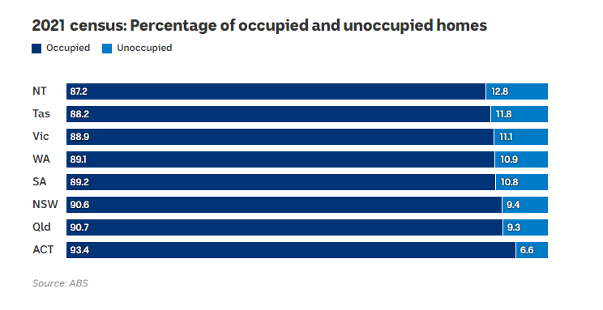
Note that a vacant home may mean that someone is in hospital, on holiday, staying at a partner’s house on a business trip. It may not mean homes that could be made easily and readily available for occupancy. Further, the number of unoccupied homes in the ACT has decreased since the last census.

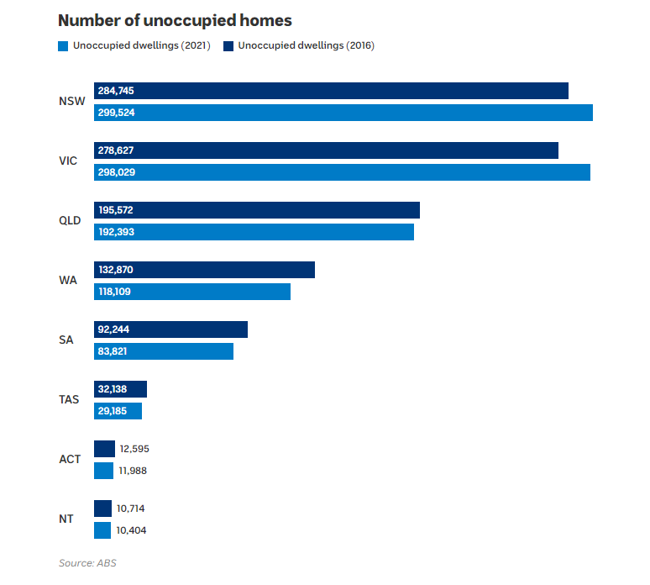

Recommendations
If not immediately revealed by this inquiry, ACTCOSS recommends that the ACT Government should:
- Undertake research to quantify and better understand the proportion of homes in the ACT and Queanbeyan that are vacant or let as short-term rentals.

- Undertake inter-jurisdictional comparisons to
  - determine the gravity of the situation in the ACT
  - possible measures to encourage vacant properties or short-term lets to be returned to the residential private rental market
  - revenue raising opportunities from vacant properties or short-term lets to reinvest in the provision of social and affordable housing
  - a cost benefit analysis to see whether the resources required to return a proportion of these dwellings to the private rental market would reap a sufficient benefit for people most at risk from housing insecurity and homelessness.
If the ACT has a significant number of vacant properties and short-term rentals, the resources required to implement measures to successfully return those properties to the market may outweigh the benefits. If any properties were returned to the market, most properties returned would likely be high-cost rentals and would not support people on the lowest income quintiles who are most at risk of housing insecurity and homelessness.
Further, many levers that most impact the private rental market, such as capital gains tax and negative gearing, are held by the Commonwealth Government.
The medium-term solution to the territory wide shortage of social and affordable rentals is not the private rental market. It is the building of significant numbers of public social housing dwellings and community housing provider-delivered social and affordable rental dwellings.
We point the Committee members to the raft of earlier submissions by the ACT Council of Social Service which provide analysis of and recommendations for relieving the ACT’s housing crisis.
For ease here are a list of our most recent submissions and the key recommendations from them:
- ACTCOSS and ACT Shelter joint submission to the ‘Productivity Commission’s Inquiry into the National Housing and Homelessness Agreement which made recommendations including:

  - The development of a comprehensive National Housing Strategy with a whole-of-system approach to housing investment and policy

  - CHC/CSHA debt should be forgiven and returned to States/Territories on an annual recurrent basis

  - An urgent review by the Productivity Commission of the effectiveness and efficiency of Commonwealth Rent Assistance as a housing subsidy.

- Submission: Draft Planning Bill

- Inquiry into Auditor General Report: 4/202 Residential Land Supply and Release

- Submission: Parliamentary Inquiry: Housing affordability and supply in Australia

- ACTCOSS’ Build to Rent Position Paper which made recommendations including:

  - Utilise Community Housing Providers (CHPs) to build via the National Housing Finance and Investment Corporation (NHFIC) scheme

  - Incentivise provision of increased volume of housing units delivered above indicated base level of 15%

  - Refer to not for profit community organisations as specialists, and providing them with additional funding to support an effective, sustainable, response to the housing crisis which includes community housing.

  - Directly fund community housing.

We also refer the committee to submissions to this inquiry by ACT Shelter and Advocacy for Inclusion.

Yours sincerely

Dr Emma Campbell
CEO, ACT Council of Social Service
emma.campbell@actcoss.org.au

ABS ACT Community Profile, table 33 Tenure and Landlord Type by Dwelling Structure, https://quickstats.censusdata.abs.gov.au/census_services/getproduct/census/2016/communityprofile/8?opendocument, accessed 8 August 2022.
Productivity Commission, ‘Table GA.3 Proportion of lower income private rental households paying more than 30 per cent of income on housing costs, by State and Territory’ [data tables], Report on Government Services 2021: G Housing and homelessness, Productivity Commission, 2021, accessed 22 June 2021.
Domain, March 2022 Rental Report, Domain website, n.d., accessed 21 April 2022.
J Lawson, H Pawson, L Troy, R van den Nouwelant and C Hamilton, Social housing as infrastructure: an investment pathway, AHURI Final Report 306, Australian Housing and Urban Research Institute Limited, 2018, p 63, accessed 22 June 2021.
Productivity Commission, Report on Government Services 2021: G Housing and homelessness, Productivity Commission, 2021, accessed 22 June 2021.
Productivity Commission, Report on Government Services 2021: G Housing and homelessness, Productivity Commission, 2021, accessed 22 June 2021.
AIHW, ‘Table SOCIAL SHARE.1: Social housing households and all Australian households, by states and territories, at 30 June 2010 to 2020’ [data tables], Housing Assistance in Australia, 2021, accessed 8 July 2021
ACT Government Community Services Directorate, Social Housing Waiting List, ACT Government Community Services Directorate, 5 July 2021, accessed 8 July 2021
ACT Government Community Services Directorate, Social Housing Waiting List, ACT Government Community Services Directorate, 7 March 2022, accessed 21 April 2022
Productivity Commission, Report on Government Services 2021: G Housing and homelessness, Productivity Commission, 2021, accessed 22 June 2021.
ABS Housing: Census, 2021 | Australian Bureau of Statistics (abs.gov.au), Australian Government 2022, accessed 8 August 2022.

