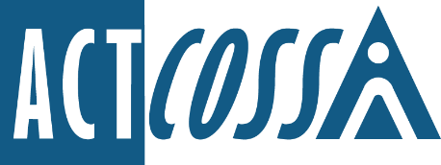

ACT Council of Social Service Inc.
1/6 Gritten Street, Weston ACT 2611
ph. 02 6202 7200
e. actcoss@actcoss.org.au
w. actcoss.org.au
abn. 81 818 839 988

28 February 2022

Standing Committee on Education and Community Inclusion
ACT Legislative Assembly
GPO Box 1020
Canberra ACT 2601

Via email: LAcommitteeECI@parliament.act.gov.au

Inquiry into the ACT Auditor General’s report No 6 of 2021: Teaching Quality in ACT Public Schools

The ACT Council of Social Service (ACTCOSS) advocates for social justice in the ACT and represents not-for-profit community organisations.
ACTCOSS welcomes the opportunity to respond to this Inquiry on teaching quality in ACT Public Schools.
The ACT Government clearly holds Inclusive Education as a priority within its Future of Education Strategy. We believe this inquiry, as with others relating to the education system in the ACT, represents an opportunity to put this priority into practice.
ACTCOSS is guided in this submission by the definition of Inclusive Education offered by Imagine More as an education setting where all students are physically present and participating in the same classroom, in the same playground and at the same time as all children in the school community. This definition aligns with the UN Convention on the Rights of Persons with Disabilities, Article 24, General Comment No. 4, Paragraph 11.
We note that the Education Directorate has not yet agreed upon a definition of Inclusive Education to drive its Future of Education Strategy and suggest that this is done as a matter of urgency.
Segregation, including the use of Specialist Schools, Learning Support Units and withdrawal from mainstream classrooms, does not constitute Inclusive Education.
A review of more than 280 research studies conducted in 25 countries consistently showed that inclusive education settings where children with disabilities were educated alongside their peers conferred substantive benefits for academic, vocational, cognitive and social development. Research from Children and Young People with Disability Australia (CYDA) also shows the benefits of fully inclusive education for all students and demonstrates a lack of evidence for any benefits of segregated education settings.
In particular, this research shows that in inclusive settings, students (who do and do not experience disability) receive higher-quality instruction that is better suited to individual needs. Teachers who participate in inclusive education also grow professionally and develop more confidence as teachers.
ACTCOSS notes that the Auditor General’s report makes no mention of inclusivity, accessibility or disability in the ACT public education system. We know that segregation has a significant impact on teaching quality and student outcomes, and we know that the ACT has an especially high number of segregated education settings compared with other jurisdictions.
We welcome the opportunity to discuss these issues with the committee further.

Yours sincerely

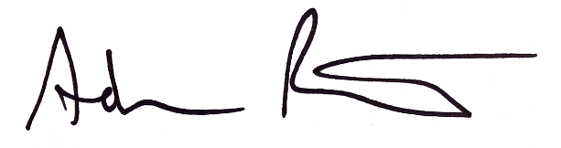
Adam Poulter
Deputy Chief Executive Officer
Email: adam.poulter@actcoss.org.au

Committee on the Rights of Persons with Disabilities General Comment No. 4 (2016) on the right to inclusive education CRPD/C/GC/4 25 November 2016 para 11.
Kathy Cologon Towards inclusive education: A necessary process of transformation, Department of Educational Studies, Macquarie University, For Children and Young People with Disability Australia, 2019, https://www.cyda.org.au/images/pdf/towards_inclusive_education_a_necessary_transformation.pdf

