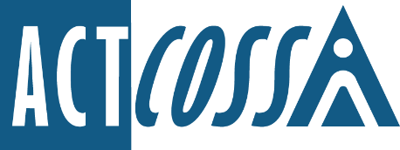

ACT Council of Social Service Inc.
1/6 Gritten Street, Weston ACT 2611
ph. 02 6202 7200
e. actcoss@actcoss.org.au
w. actcoss.org.au
abn. 81 818 839 988

14 January 2022

Standing Committee on Health and Community Wellbeing
ACT Legislative Assembly
GPO Box 1020
Canberra ACT 2601

Via email: LACommitteeHCW@parliament.act.gov.au

Dear Committee on Health and Community Wellbeing
Inquiry into Public Health Amendment Bill 2021 (No 2)
I write on behalf of the ACT Council of Social Service (ACTCOSS) to make a submission to the Inquiry into Public Health Amendment Bill 2021 (No 2).
ACTCOSS is supportive of the proposed Public Health Amendment Bill.
Public health measures should have a legislative foundation wherever possible, to avoid overreach of government powers and to ensure appropriate oversight mechanisms. A regulatory framework to manage the health risks around COVID-19 is better suited to addressing public health concerns than a Public Health Order. It also improves overall accountability and transparency as the Human Rights Commission noted in their submission to the COVID-19 Legislative Assembly Inquiry.
We welcome the Bill’s intent to formalise avenues for people to seek internal reviews about exemption applications and to introduce the capacity for external reviews of decisions around quarantining, isolating or entry into the ACT for health or compassionate reasons.
We support the principles of mandating necessary measures, such as vaccination in targeted areas, as well as mechanisms to enable test, trace, isolate and quarantine orders. We must also safeguard the community sector and the most vulnerable and disadvantaged in our community through this process.
It is vital that there are communication channels in place to ensure community service providers are given adequate time for planning and implementation of mandates and have clear mechanisms to raise questions and feedback where necessary.
For the broader ACT community, there need to be protections in place for vulnerable and disadvantaged people, so that they are not disproportionately penalised for not adhering to mandates due to their circumstance. Some people may not be aware of mandates or be in a position to enact those mandates. It is vital that fines are only issued as a last resort, are proportionate to an individual’s income, and do not cause unnecessary hardship.
In the first instance, police should take an educative rather than a punitive response to those not adhering to mandates. We note, that 18ZO (2) in Division 6C.7 of the drafted Public Health Amendment Bill 2021 reads, a ‘police officer may (emphasis added) warn them that they do not have to answer the question or do anything but that anything they say or do may be used in evidence’. We believe the word ‘may’ should be replaced by ‘must’ or equivalent.
As COVID-19 becomes endemic, we need to ensure that our responses are sound, just and continue to protect the most vulnerable members of our communities.

Yours sincerely
Dr Emma Campbell
Chief Executive Officer
Email: emma.campbell@actcoss.org.au

