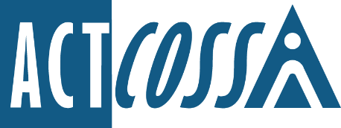

ACT Council of Social Service Inc.
1/6 Gritten Street, Weston ACT 2611
ph. 02 6202 7200
e. actcoss@actcoss.org.au
w. actcoss.org.au
abn. 81 818 839 988

12 January 2022

Waste Policy
Transport Canberra and City Services Directorate
PO Box 158
Canberra ACT 2601

Via email: singleuseplastics@act.gov.au

Dear Waste Policy Team
Single-use Plastics: Tranche 2
I write on behalf of the ACT Council of Social Service (ACTCOSS) to make a submission on Single-use Plastics: Tranche 2.
Broadly, ACTCOSS advocates that action on climate change and waste is a social justice issue. People living in low-income households are more likely to be negatively impacted by climate change and pollution caused by plastic and other toxic waste.
However, any mitigation and adaptation measures to counter climate change and waste must be part of a just transition. Action on waste and climate change should be aimed at reducing poverty and inequality and improving wellbeing. It should not entrench or exacerbate disadvantage.
ACTCOSS notes the widespread concerns of Disabled People’s Organisations and Disability Representative Organisations about proposals to ban plastic straws. These groups have noted that single-use plastic straws are an essential accessibility tool for some people with disability. The national peak body People with Disability Australia has compiled a useful guidance and reading list on this issue.
Plastic straws allow those who cannot lift or hold cups, or who are at risk of aspirating, to consume liquids safely. Plastic straws can be essential for hydration and medication use. Currently, there are no suitable alternatives to single-use plastic straws. Existing alternatives are not adjustable, can be expensive, may not be heat safe, and can pose a choking, injury, hygiene or allergen risk.
Plastic straws are essential to everyday life for some people with disability. Without readily accessible plastic straws, many social spaces like cafes and bars are inaccessible. The consequences of plastic straws not being readily accessible may include people with disability facing barriers to accessing an essential item, an increased risk of injury or fatality from use of inappropriate alternatives, or prevention of people with disability from equally participating in their community.
The consultation paper invites people to choose from the two different models currently in place in Queensland and South Australia respectively. Both limit access to plastic straws. Both options are problematic for people with disability.
The Queensland model does not provide any possibility for people with disability who require a plastic straw to access one and so should not be considered in the ACT.
The South Australian model of ‘straws on request’ is also problematic. A ‘straws on request’ model imposes barriers on people with disability which do not apply to people without disability, and raises significant concerns about equal participation, privacy and stigma.
Feedback provided to Disabled People’s Organisations by hospitality providers suggests that many venues would be unwilling to operate a request model. This means that straws are likely to become completely unavailable and that the South Australian model will devolve into the Queensland model over time.
Our work to reduce waste should reflect the principles of a just transition. However, the policy of restricting plastic straws under either of these models would not achieve this. Instead, it will create a situation of indirect discrimination whereby a provision applying to everyone has a disproportionate and harmful impact on those least able to bear it, in this case people with disability. For these reasons, any attempt to limit the availability of plastic straws in the ACT should not proceed without the support of Disabled People’s Organisations.
While developing this submission, we consulted with Advocacy for Inclusion (AFI) incorporating People with Disability ACT. We understand that AFI are also making a submission along these lines and commend it to the Committee.
Yours sincerely
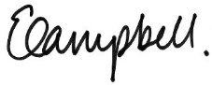
Dr Emma Campbell
Chief Executive Officer
Email: emma.campbell@actcoss.org.au

