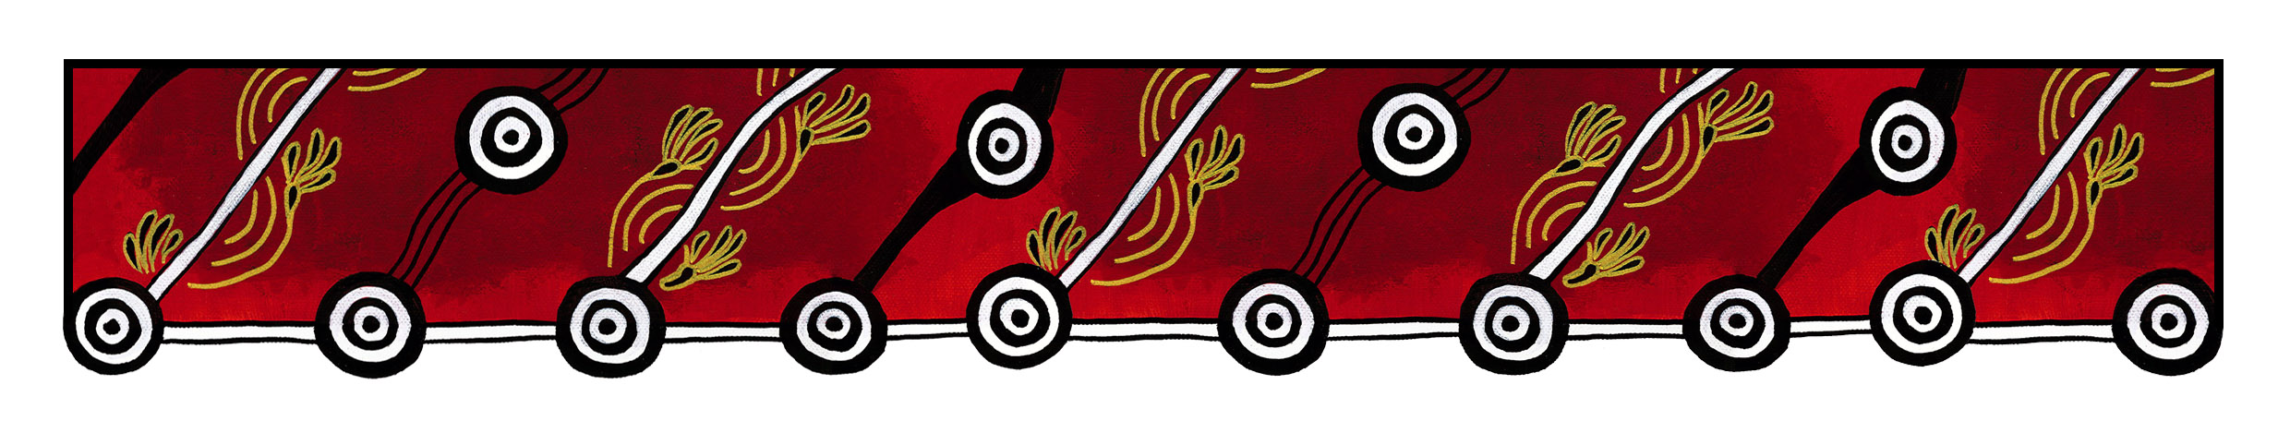

ACT Council of Social Service (ACTCOSS) logo

|  |
| --- |
| Gulanga Good Practice Guides  The guides provide information on topics that aim to assist organisations implement and embed good practice when working and engaging with Aboriginal and/or Torres Strait Islander peoples, particularly within the ACT and region. Each guide provides a general overview, which we hope will generate change and discussion within a workplace. Links are provided at the end of each guide for further information and research. Feedback on the guides can be directed to: [gulanga@actcoss.org.au](mailto:gulanga@actcoss.org.au) or by phone to 02 6202 7200. |

‘Confirmation of Aboriginal Identity’ Form

Created June 2020

*For this guide, the term ‘Aboriginal peoples’ (plural) is used to refer to the descendants of the original inhabitants of mainland Australia and outer islands, such as Groote Eylandt, Tasmania and Hinchinbrook Island.*

A ‘Confirmation of Aboriginal Identity’ or ‘Confirmation of Aboriginality’ is a form completed by an Aboriginal person and endorsed by a participating incorporated Aboriginal organisation. It is expected that the endorsing organisation treats their role in the process with integrity. Not all Aboriginal organisations participate in endorsing forms.

When government and non-government agencies are administering targeted services and programs such as employment, education and housing, the form assists to ensure those targeted services and programs reach Aboriginal peoples. The form is not intended to be used to prove an individual’s Aboriginal identity in everyday life.

The form generally includes three common criteria. This can vary to include less or more detail. It is essential that all criteria apply. The three common criteria are:

1. **The person is of Aboriginal descent.** A person of Aboriginal descent can normally trace their lineage through an apical or shared ancestor(s). It is also understood that some individuals choose not to acknowledge their Aboriginal ancestry, and this is a personal choice.
2. **The person identifies as an Aboriginal person.** A person who identifies as an Aboriginal person will have historical and ongoing connections to their ancestral lands, families, kinships systems, communities, cultural practices, and lifestyles, to name a few. This normally occurs from birth. The individual wholeheartedly chooses to say they are an Aboriginal person.
3. **The person is accepted or recognised as an Aboriginal person by the community in which he/she/they lives or has lived and continues ongoing connection with their family and kinships groups.** A person who is accepted and recognised as an Aboriginal person by their community(s) is an important criterion. Acceptance, recognition and connectedness with their families, extended families or kinship groups is an integral part of Aboriginal identity. Most Aboriginal peoples seek, build, and maintain relationships with other Aboriginal peoples where they live, and when they are visiting other regions. They may also attend gatherings to maintain connections with other nations of Aboriginal peoples and their cultures.

An organisation can choose not to endorse an individual’s form. The person may decide to seek other options.

## Other Options

In some circumstances, other options may be accepted by an agency to confirm a person’s Aboriginal identity. For example, a person may have recently re-located to a region or a person is escaping domestic or family violence. Or perhaps they are estranged from their family.

**Letter of Support or Verification:** Generally, a ‘Letter of Support or Verification’ might tell a story about the relationship between a known member of the Aboriginal community and the Aboriginal person. It might state:

* How long they have known the person, and their relationship
* If they know their family, and who they are
* If they have any connections within the community
* If they have volunteered or participated in community events with other Aboriginal peoples.

**Referee:** A ‘Referee’ might provide specific information for a specific purpose. For example, they may answer some key questions for a person to access a service or program.

**Aboriginal Community Members:** Aboriginal Elders, family members, staff and associates can sometimes assist with confirming a person’s Aboriginal identity. The information can be confirmed in person or over the phone by a known member of the Aboriginal community.

As mentioned previously, it is important that agencies administering targeted services and programs ensure those services and programs reach Aboriginal peoples.

If possible, consult with Aboriginal staff and stakeholders to discuss this topic further.

Further information and research

Australian Institute of Aboriginal and Torres Strait Islander Studies: Proof of Aboriginality

<https://aiatsis.gov.au/research/finding-your-family/before-you-start/proof-aboriginality>

Australian Institute of Aboriginal and Torres Strait Islander Studies: AIATSIS Map of Indigenous Australia

<https://aiatsis.gov.au/explore/articles/aiatsis-map-indigenous-australia>

NSW Aboriginal Land Council / Local Aboriginal Land Council / Confirmation of Aboriginality

<https://alc.org.au/confirmation-of-aboriginality/>

Reconciliation Australia / Share our Pride / 1. First Australians

<http://shareourpride.reconciliation.org.au/sections/first-australians/>

Australian Human Rights Commission / Quick Guide / Identified Positions

[https://humanrights.gov.au/quick-guide/12047#](https://humanrights.gov.au/quick-guide/12047)

Gulanga Program | ACT Council of Social Service Inc. | gulanga@actcoss.org.au | www.actcoss.org.au

ACTCOSS is committed to reconciliation, acknowledges the traditional custodians of the land and pays respect to elders past and present.