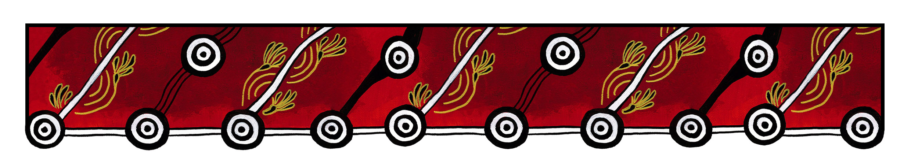

ACT Council of Social Service (ACTCOSS) logo

|  |
| --- |
| Gulanga Good Practice Guides  These guides provide information on topics that aim to assist organisations implement and embed good practice when working and engaging with Aboriginal and/or Torres Strait Islander peoples, particularly within the ACT and region. Each guide provides a general overview, which we hope will generate change and discussion within a workplace. Links are provided at the end of each guide for further information and research. Feedback on the guides can be directed to [gulanga@actcoss.org.au](mailto:gulanga@actcoss.org.au) or by phone to 02 6202 7200. |

Dates of Significance: The Apology

13 February 2008

Created June 2020

*For this guide, ‘Dates of Significance’ is a term commonly used to celebrate, commemorate, and reflect on dates of importance to Aboriginal and/or Torres Strait Islander peoples and their communities.*

On 13 February 2008, Prime Minister Kevin Rudd delivered an official apology to express regret for past government policies that resulted in the forced removal of Aboriginal and/or Torres Strait Islander children from their families. On the previous day, a Welcome to Country ceremony was included for the first time at the Opening of Parliament.

Today, this date is commonly referred to as the ‘Anniversary of the Apology’.

Below are some ways workplaces commemorate the Anniversary of the Apology:

* Attend an event in your community or organise your own event.
* Download a copy of the Apology to print and display.
* As a workplace, watch a film/documentary/panel discussion relating to The Apology and share any reflections.
* Organise a morning tea and ask staff to read a story from a member of the Stolen Generations.
* As a workplace, discuss and research how to embed good practice when working with members of the Stolen Generations, their descendants, and their families.
* Visit the Parliament House exhibition, Apology to Australia's Indigenous Peoples.
* Obtain resources relating to The Apology for your workplace library.

Further information and research

Australian Human Rights Commission: Bringing them Home report (1997)

<https://humanrights.gov.au/our-work/bringing-them-home-report-1997>

Parliament of Australia: Apology to Australia’s Indigenous Peoples

<https://www.aph.gov.au/Visit_Parliament/Whats_On/Exhibitions/Custom_Media/Apology_to_Australias_Indigenous_Peoples>

Stolen Generations Testimonies Foundation

<http://www.stolengenerationstestimonies.com/>

Healing Foundation

<https://healingfoundation.org.au/>

After the Apology

<https://aftertheapology.com/>

Gulanga Program | ACT Council of Social Service Inc. | gulanga@actcoss.org.au | www.actcoss.org.au

ACTCOSS is committed to reconciliation, acknowledges the traditional custodians of the land and pays respect to elders past and present.