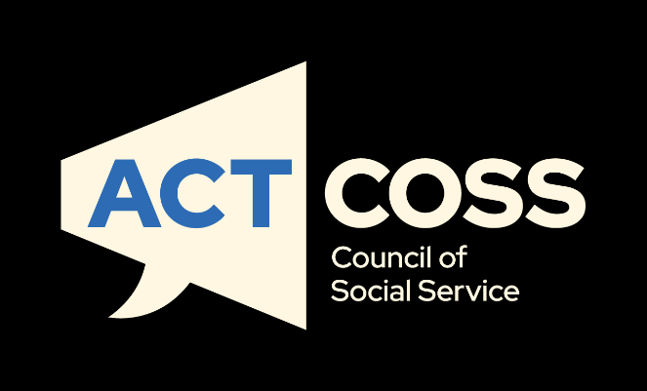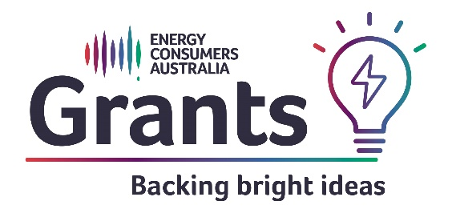
A Just and Inclusive Gas Transition in the ACT
Prioritising equity on our pathway to electrification
actcoss@actcoss.org.au
actcoss.org.au
02 6202 7200
ABN 81 818 839 988
02 6202 7200
ABN 81 818 839 988
actcoss@actcoss.org.au
actcoss.org.au

About ACTCOSS
ACTCOSS acknowledges Canberra has been built on the land of the Ngunnawal people. We pay respects to their Elders and recognise the strength and resilience of Aboriginal and/or Torres Strait Islander peoples. We celebrate Aboriginal and/or Torres Strait Islander cultures and ongoing contributions to the ACT community.
The ACT Council of Social Service Inc. (ACTCOSS) advocates for social justice in the ACT and represents not-for-profit community organisations.
ACTCOSS is a member of the nationwide COSS Network, made up of each of the state and territory Councils and the national body, the Australian Council of Social Service (ACOSS).
ACTCOSS’s vision is for Canberra to be a just, safe and sustainable community in which everyone has the opportunity for self-determination and a fair share of resources and services.
The membership of the Council includes the majority of community-based service providers in the social welfare area, a range of community associations and networks, self-help and consumer groups and interested individuals.
ACTCOSS advises that this document may be publicly distributed, including by placing a copy on our website.
Contact Details
Phone 02 6202 7200
Address Weston Community Hub, 1/6 Gritten St, Weston ACT 2611
Email actcoss@actcoss.org.au
Web actcoss.org.au
CEO Dr Gemma Killen
Policy Officer Geoff Buchanan
February 2023
© Copyright ACT Council of Social Service Incorporated
This publication is copyright, apart from use by those agencies for which it has been produced. Non-profit associations and groups have permission to reproduce parts of this publication as long as the original meaning is retained and proper credit is given to the ACT Council of Social Service Inc (ACTCOSS). All other individuals and Agencies seeking to reproduce material from this publication should obtain the permission of the CEO of ACTCOSS.
An ACT Government funded initiative.
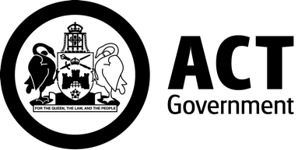
Table of Contents
About ACTCOSS 2
Acronyms 5
Introduction 6
Equity issues in phasing out fossil-fuel gas in the ACT 8
Energy equity and wellbeing 9
Income, housing, intersectionality and energy equity 12
Putting equity and inclusion front and centre of energy transition planning in the ACT 16
ourPower: a vision for clean, affordable, dependable energy for all 16
Power Shift 19
The Energy Equity Work Program 20
Current policy context for a just and inclusive transition in the ACT 21
Steps towards phasing out fossil-fuel gas in the ACT 26
Prohibiting new gas connections 27
Programs supporting households to transition from gas to electric 28
Home Energy Support Program 30
Energy Efficiency Improvement Scheme 30
Sustainable Household Scheme 32
Gaps and opportunities for just and inclusive gas transition measures 33
Prioritising targeted energy supports for priority households 34
Minimum energy efficiency standards for rental properties 34
Equitable distribution of costs when phasing out the ACT gas distribution network 35
Disconnection and abolishment costs 36
Conclusion 37
Appendix: ACT Government Energy Efficiency and DER Supports for Households and Small Business 39
Business Energy and Water Program 40
Energy Assistance Community Partnerships 41
Energy Efficiency Improvement Scheme 42
Energy Efficiency Improvement Scheme, All-Electric Program, and Solar Stimulus Program – Housing ACT 44
Home Energy Assessment Webtool 45
Home Energy Support Program 46
Low Income Household Program 49
Make the Switch project 50
NextGen Energy Storage Program 51
Renters’ Home Energy Program 54
Solar for Business Program 55
Sustainable Home Advice Program 56
Sustainable Household Scheme 59
Utilities Concession 62
Utilities Hardship Fund 63
Wood Heater Replacement Program 64

Acronyms
ABS Australian Bureau of Statistics
ACOSS Australian Council of Social Service
ACT Australian Capital Territory
ACTCOSS ACT Council of Social Service Inc.
AEMA Australian Energy Markets Agreement
AER Australian Energy Regulator
CALD Culturally and Linguistically Diverse
CEC Clean Energy Council
CPI Consumer Price Index
CRA Commonwealth Rent Assistance
DER Distributed Energy Resources
ECA Energy Consumers Australia
EEIS Energy Efficiency Improvement Scheme
EPSDD Environment, Planning and Sustainable Development Directorate
ESC Energy Savings Contribution (under the EEIS)
EST Energy Savings Target (under the EEIS)
LFiT Large-scale feed-in tariff scheme
LIEEP Low-Income Energy Efficiency Project
NERL National Energy Retail Law
NRAS National Rental Affordability Scheme
PAGA Parliamentary and Governing Agreement
PHT Priority Household Target (under the EEIS)
SACOSS South Australian Council of Social Service
SDG Sustainable Development Goals
TEC Total Environment Centre
USA United States of America

Acknowledgements
This project was funded by Energy Consumers Australia Limited (www.energyconsumersaustralia.com.au) as part of its grants process for consumer advocacy projects and research projects for the benefit of consumers of electricity and natural gas.

The views expressed in this document do not necessarily reflect the views of Energy Consumers Australia.

Introduction
Fossil-fuel gas use currently accounts for approximately 20% of greenhouse gas emissions in the ACT. On 4 August 2022, the ACT Government announced that ‘it will phase out fossil fuel gas by 2045 by electrifying Canberra over the next two decades’. In its position paper, Powering Canberra: Our Pathway to Electrification, the ACT Government has reaffirmed its commitment to ensuring a just transition and supporting households with lower incomes and renters.
This report highlights the need for equity to be front and centre of the phasing out fossil-fuel gas and the pathway to electrification. Climate change is a social justice issue. Globally and within our own community, disadvantaged groups are more likely to be negatively impacted by climate change. Climate action is also a social justice issue. Climate action through mitigation and adaptation measures must not entrench or exacerbate disadvantage. Instead, climate action should aim to reduce poverty and inequality and improve wellbeing.
In 2015 the United Nations General Assembly set up 17 interlinked Sustainable Development Goals (SDGs) which are intended to be achieved by 2030. SDG 7 aims to ‘ensure access to affordable, reliable, sustainable and modern energy for all’. SDG 7 is seen as an enabler of other SDGs if achieved through a just and inclusive ‘energy transition that seizes the opportunity to significantly improve the wellbeing of people, and planet’.
An inclusive and just energy transition can catalyse transformational co-benefits for the achievement of the [SDGs]. Energy is inextricably linked to virtually all the SDGs, and at the same time progress made towards achieving advancement of the other SDGs can also contribute to achieving SDG 7. Transforming the world’s energy systems will create new jobs, advance gender equality, and empower people, communities, and societies. Based on the concept of 'leaving no one behind', a just and inclusive energy transition will enhance human well-being, health, and capabilities, increase resilience, and drive innovation towards a sustainable society at all levels, while also driving huge investments. Although the transition pathways will vary based on the individual needs of countries and regions, all pathways must be just and inclusive in order to accelerate collective actions to deliver on the SDGs and the Paris Agreement and to ensure the ‘future we want’.
Just and inclusive climate action presents an opportunity to ensure that low-income households and other disadvantaged groups have access to clean, dependable and affordable energy; distributed (or consumer) energy resources (e.g., rooftop solar, battery storage, and electric vehicles); and healthy and affordable housing that is energy efficient.
Based on the latest climate science, the Australian Council of Social Service (ACOSS) has called on the Australian Government to aim to cut emissions by 75% by 2030; at the very least match commitments from our key allies to halve our emissions by 2030 and reach net zero emissions by 2035. ACOSS and members of the broader Australian community sector have called for this to be achieved through fair, fast and inclusive climate action.
The ACT Government has committed to achieving net zero greenhouse gas emissions by 2045. In 2020, the ACT achieved its 100% renewable electricity target through the Large-scale Feed-in Tariff (LFiT) scheme. This has left natural (fossil-fuel) gas as one of the largest remaining contributors to ACT greenhouse gas emissions, accounting for an estimated 22% of ACT emissions in 2020. The ACT Climate Change Strategy 2019-25 includes a commitment to:
Develop a plan for achieving zero emissions from gas use by 2045, including setting timeframes with appropriate transition periods for phasing out new and existing gas connections [by 2024].
Two pathways have been identified for achieving this, with some potential for overlap between them: electrification; and/or replacing fossil-fuel gas with renewable gas (e.g., hydrogen or bio-methane). The ACT Government has now committed to an electrification pathway that ‘will include investigating the use of renewable gases, like hydrogen and biomethane, for specific uses where electrification is not an appropriate option’.
In undertaking climate action the ACT Government has committed ‘to working closely with the community, ensuring a just transition for those impacted by the shift to net zero emissions, and growing sustainable industries and jobs’. It has been acknowledged that ‘electrification or green gas alternatives would require infrastructure changes and upgrades, and consumer behavioural change’ and that there will be consumers who will find it difficult to cease using fossil-fuel gas entirely and that the gas transition therefore ‘needs to be made in a measured, planned way’.
This report aims to inform the next steps in the ACT Government’s energy transition planning. It aims to ensure that equity is placed front and centre in the development of the Integrated Energy Plan so that it enables a just and inclusive transition. First, the report sets out some key equity issues in phasing out fossil-fuel gas in the ACT, highlighting the relationship between energy and wellbeing with a focus on income, housing, and intersectionality. Second, the report outlines tools developed by and with energy consumer advocates to guide energy policymakers and other stakeholders in decision making. Third, the report sets out the current policy context for a just and inclusive transition in the ACT, including measures the ACT Government has already put in place that support households to transition from gas to all-electric – the appendix to the report provides a detailed summary of all of these measures. The final section of the report discusses some gaps and opportunities for a just and inclusive energy transition in the ACT.

Equity issues in phasing out fossil-fuel gas in the ACT
Phasing out fossil-fuel gas presents both an opportunity and a threat in relation to social justice and equity outcomes from climate action in the ACT. As has been observed in the USA, climate policies and programs that have treated equity as an afterthought and ignored starting-line disparities have exacerbated health and wealth gaps. Starting energy transition planning with equity provides an invaluable opportunity to address disparities, reduce poverty and inequality, and improve wellbeing outcomes for all. A critical first step is to identify starting-line disparities in terms of those households most at risk of being left behind, what barriers they face, and how these can be addressed as a top priority. Especially in the case of phasing out fossil-fuel gas, failing to prioritise support for vulnerable households leaves them at risk of being stranded on increasingly expensive infrastructure with rising gas prices – thus exacerbating poverty and inequality in our community.

Energy equity and wellbeing
In the Powering Canberra position paper, the ACT Government has committed to deliver an Integrated Energy Plan for the ACT by 2024 as part of phasing out fossil-fuel gas through a coordinated and planned approach to maintain a secure, affordable, and reliable energy supply across the ACT. In line with Recommendation 2 of the UN Technical Working Group on Enabling SDGs Through Inclusive, Just Energy Transitions, social equity and inclusiveness should be at the centre of this plan. This means explicitly prioritising the needs of vulnerable households in developing the ACT’s pathway to electrification and ‘enhancing prosperity and reducing inequality by empowering populations through modern energy access’. This recommendation is based on the disproportionate influence energy transitions will have on the achievement of SDGs.
In the ACT context, the energy transition will have significant influence on the achievement of improvements across the 12 domains of the ACT Wellbeing Framework (Figure 1). Through the ACT Wellbeing Framework, ‘the ACT Government and community work in partnership to lift the quality of life of all Canberrans, particularly those with lower wellbeing than average’. The positive relationship between energy equity measures and individual and community wellbeing was highlighted in a review of the Australian Government’s Low-Income Energy Efficiency Project (LIEEP) which ran from 2013-2016 and ‘involved 20 consortia trialling innovative ways of supporting low-income households to reduce their energy consumption and corresponding bills’ (Table 1).
Putting equity front and centre of the ACT’s energy transition also aligns with notion of social innovation – something that ACTCOSS drew attention to in its submission to a recent ACT Legislative Assembly inquiry into renewable energy innovation in the ACT. In the context of energy transitions, social innovation has been defined as:
innovation that is social in its means and which contributes to low carbon energy transition, civic empowerment, and social goals pertaining to the general wellbeing of communities … [I]n addition to contributing to low carbon energy transition [social innovation] seeks to attain particular social goals, like community empowerment, alleviating (energy) poverty, (energy) justice, social equality, and increasing the wellbeing of local communities.
In the context of phasing out fossil-fuel gas and developing a pathway to electrification, social innovation would contribute to addressing socioeconomic and sociocultural dimensions that contribute to wellbeing across our diverse ACT community alongside the energy transition.
Figure 1 ACT Wellbeing Framework
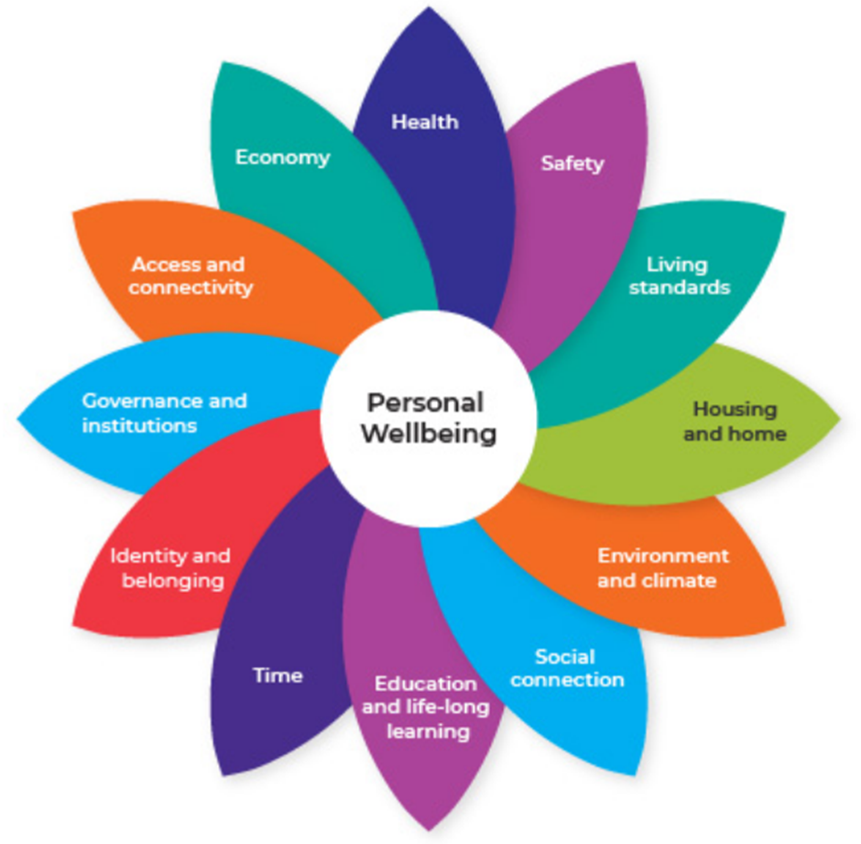
Source: ACT Government, Domains and indicators, ACT Wellbeing Framework, 2022, accessed 18 September 2022.

Table 1 Co-benefits reported in the Low-income Energy Efficiency Project Pilots
Household Co-Benefits | - Social inclusion  - Physical, mental and emotional health and wellbeing  - Increased disposable income  - Quality of life  - Overcoming physical barriers
Social Co-Benefits | - Employment opportunities  - Health care system  - Building family harmony  - English language improvements for CALD  - Ethical recycling  - Cultural awareness and understanding
Consortia Co-Benefits | - Experience  - Network establishment  - Boost to the industry
Source: R Bedggood, C O’Mahony, F Pervan & P Buergelt, Empowering low-income households: delving into the co-benefits identified in the Low Income Energy Efficiency Project Reports. Final Report, GEER Australia, Swinburne University of Technology and Charles Darwin University, 2018.

Income, housing, intersectionality and energy equity
The Powering Canberra position paper notes that retail gas prices are expected to increase by around 19% from 2022-2029 due to rising wholesale costs and distribution costs. In relation to the latter it is noted that:
When we pay for our gas supply, a part of our bill is actually paying to maintain the network that delivers the gas to our homes and businesses. If there are fewer connections, then the maintenance cost needs to be shared across fewer customers, meaning that this part of their bill will increase which will encourage more people to disconnect from gas and further increase costs for those who want to stay connected to the gas network.
Many households, especially those on low incomes, renting their home and/or living in apartments, will be at risk of being caught between remaining on the gas network with increasing gas prices and overcoming financial and other barriers to transitioning from gas to electric appliances.
A survey of 1,892 Canberrans in February 2022 through the ACT Government’s YourSay Community Panel found that 37% of respondents did not have much say or influence in what energy sources were used in their household – renters, apartment dwellers, and those on lower incomes reported having less influence and agency over energy choices and were less likely to have considered switching from gas to electricity. Of those with gas appliances or systems, 60% perceived the cost of transitioning from gas to electric as a barrier, while 54% said rebates or other incentives would encourage them to transition. The most common gas appliances in people’s homes were water heating (73%), cooktop appliances (66%), and home heating (57%).
The 2021 Census of Population and Housing found that out of 168,400 occupied private dwellings in the ACT 30.7% are rented (51,681 dwellings) and that 19.4% are flats or apartments (32,669 dwellings). It has been estimated that around 9% of Canberrans live in households with incomes below the poverty line – approximately 38,300 people, including around 9,000 children. Low-income households in the ACT have been hit hardest by Canberra’s housing affordability crisis – especially in the private rental market. The ACT has the highest proportion of households receiving Commonwealth Rent Assistance (CRA) who are being paid at the maximum payment rate – 83.1% compared to 79.1% nationally. More than half (55.1%) of ACT households receiving CRA are experiencing rental stress (i.e., paying more than 30% of income on rent) – 29.1% are experiencing severe rental stress, paying more than 50% of income on rent.
Low-income households in the ACT have felt the greatest impact of rising energy costs. These households spend a significantly higher proportion of their income on gas and electricity (Figure 2). Energy costs are often exacerbated for these households by poor home energy efficiency and lack of access to the benefits of distributed energy resources (DER) such as rooftop solar panels and household battery storage systems. Low-income households face what has been referred to as a ‘poverty premium’ as the upfront cost of transitioning from gas to energy efficient electric appliances (further boosted by DER) prevents them from accessing significant long-term energy savings.
ABS CPI data shows that over the past five years ACT households have seen the price of electricity increase by 28.1% compared to 3.0% nationally. Over the same period, household gas prices in the ACT have increased by 24.0% compared with 12.7% nationally. Over the past 20 years, electricity prices in Canberra have increased by almost 60%, while gas prices have doubled (see Figure 3). As noted above, gas prices are expected to rise by around 19% over the coming seven years.
Figure 2 Energy (domestic fuel and power) expenditure as a proportion of equivalised disposable household income by income quintile, ACT, 2015-16
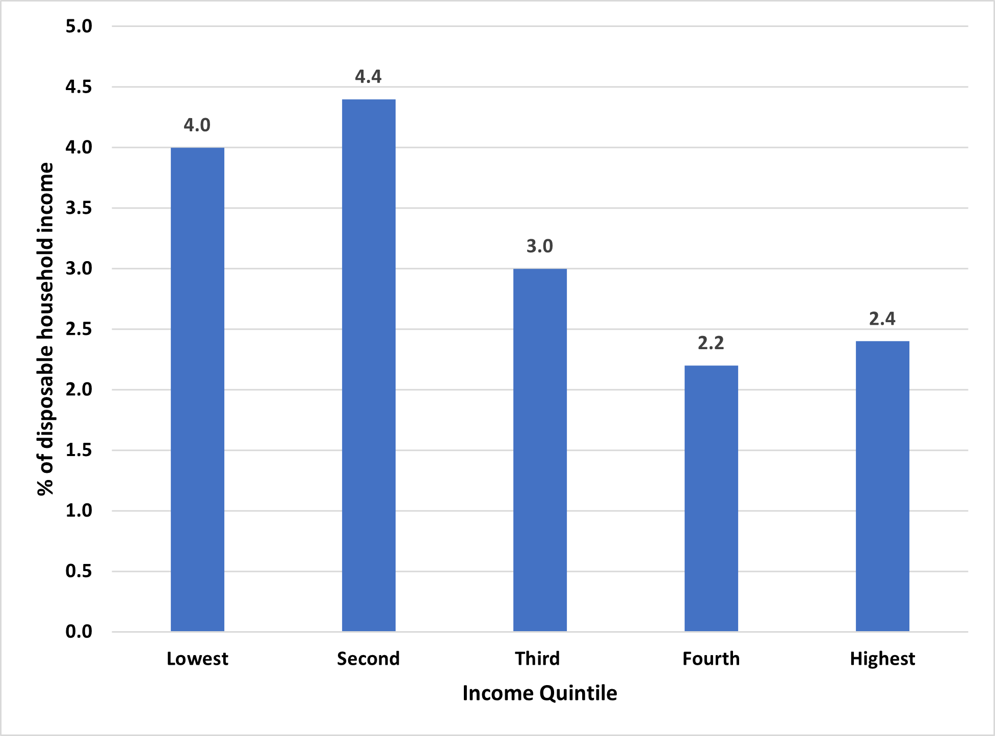
Source: ABS, ‘Table 22.1 Household expenditure: Broad expenditure groups, equivalised disposable household income quintiles, ACT’, Household Expenditure Survey, Australia: Summary of Results, 2015–16, ABS, 2017, accessed 2 May 2022.

Figure 3 Energy retail price indices (inflation adjusted), Canberra and Australia, 2000-2020
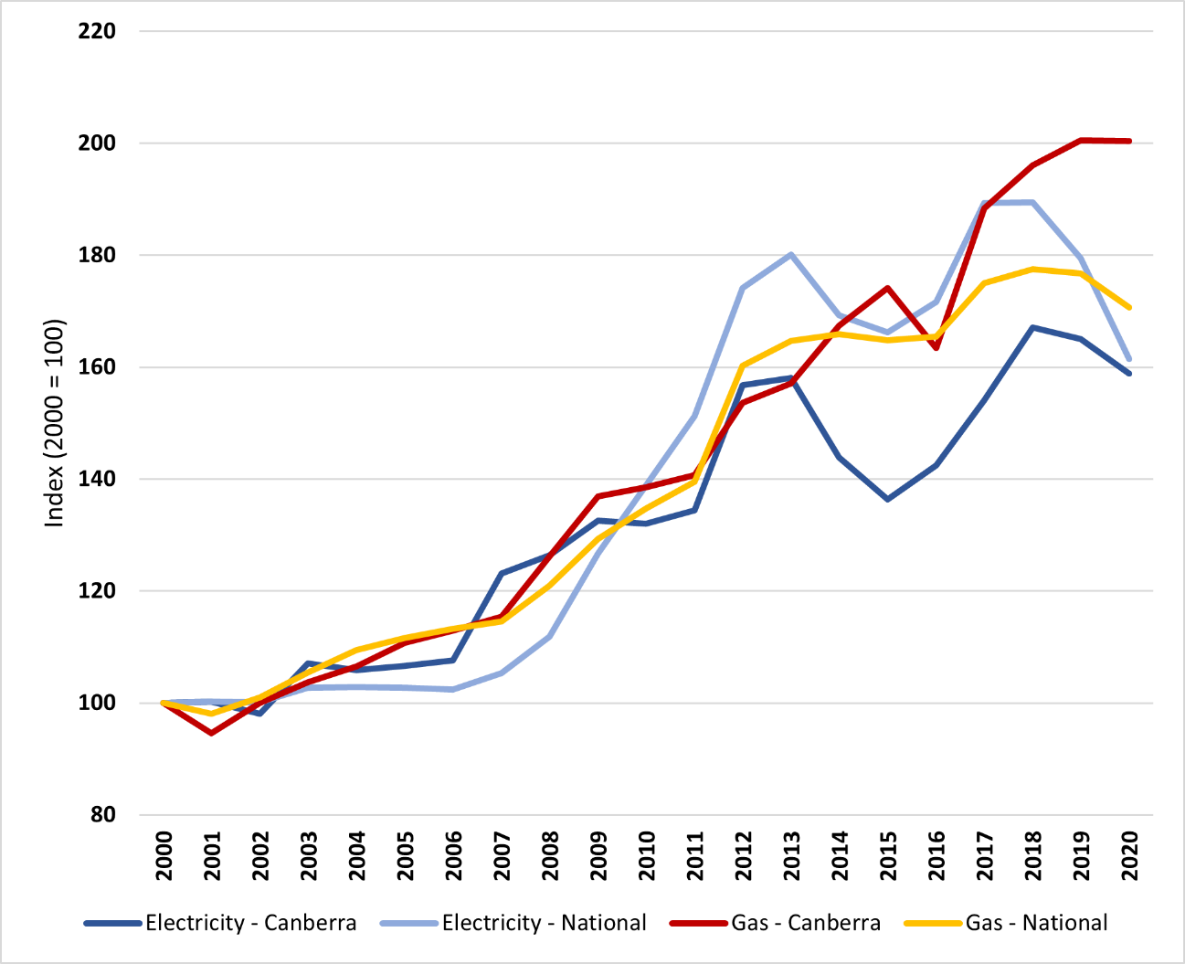
Source: Adapted from: AER, ‘Figure 6.10: Energy retail price indices (inflation adjusted)’, State of the Energy Market Report 2021, Australian Energy Regulator, 2021, accessed 12 July 2021.
While income and housing status represent key equity indicators in the energy transition it will be critical to identify ways in which people experience multiple and intersecting forms of discrimination and disadvantage – what is referred to as intersectionality. Intersectionality considers how identities, social positions and experiences are shaped by a range of social categories of difference including:
- Aboriginality
- culture
- race
- ethnicity
- faith
- socio-economic status
- ability
- sexuality
- gender identity
- education
- age
- migration status.
Attention to intersectionality is critical to ensure energy transition planning is inclusive and that resulting equity measures are appropriate and targeted.

Putting equity and inclusion front and centre of energy transition planning in the ACT
As the ACT Government begins to plan for the phasing out of fossil-fuel gas and set out the pathway to electrification, it is critical that equity is built into this from the start. This section of the report outlines two key tools developed by energy consumer advocates to guide decision making: ourPower and Power Shift. It also notes work that is underway within the Australian Government to develop an energy equity framework to guide policymakers.

ourPower: a vision for clean, affordable, dependable energy for all
A key tool that ACT Government should use in developing its Integrated Energy Plan is ourPower. ourPower is an initiative of the Australian Council of Social Service (ACOSS) and the Total Environment Centre (TEC) with the support of Energy Consumers Australia (ECA). ACTCOSS participated in the collaborative process to develop ourPower which is both:
- a statement by energy users about the future we want and a basis for working together with industry and governments to get there; and
- a tool for anyone making decisions about the energy transition – policy makers, regulators, industry leaders or groups representing energy users and communities.
ourPower sets out a vision, guiding values, and five principles to guide energy transition decision making (Figure 4).
As one of the five principles, ‘Be people focused’ includes ensuring that ‘people and communities who are socially or financially disadvantage must be front and centre’. The principle of ‘Be just and fair’ refers to:
[managing the energy transition] in a way that is just, fair and inclusive, and ensure no one is left behind. This includes people who are socially and financially disadvantage, and workers and communities impacted by the evolution of the energy system. The costs and benefits of the transition must be equitably shared, recognising that governments will play a role in supporting access to clean, affordable, dependable energy and just and fair outcomes.
Examples of the ‘Be just and fair’ principle in action include:
- Public spending should be targeted to achieve economic and environmental benefits and reduce inequality. Public policy related costs should be met through progressive means like government budgets and not regressively via energy bills
- Distribute costs, benefits and risks transparently and fairly to facilitate positive outcomes
- Where energy remains unaffordable for people experiencing financial disadvantage, governments should provide adequate and equitable financial support to meet their essential needs
- To maintain access to energy, identify and manage hardship and vulnerability early and without penalties, and provide assistance through trusted and appropriately experienced community services.
As a guide for transition decision making, ourPower encourages the co-design of solutions using human-centred design principles as part of an iterative process (Figure 5).
Figure 4 ourPower vision, guiding values, and principles
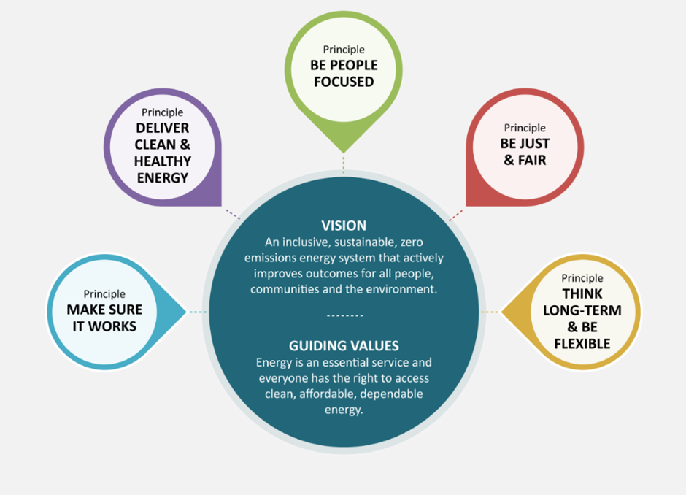
Source: ACOSS & Total Environment Centre, What is ourPower?, ourPower, n.d., accessed 18 September 2022.
Figure 5 Process for applying ourPower
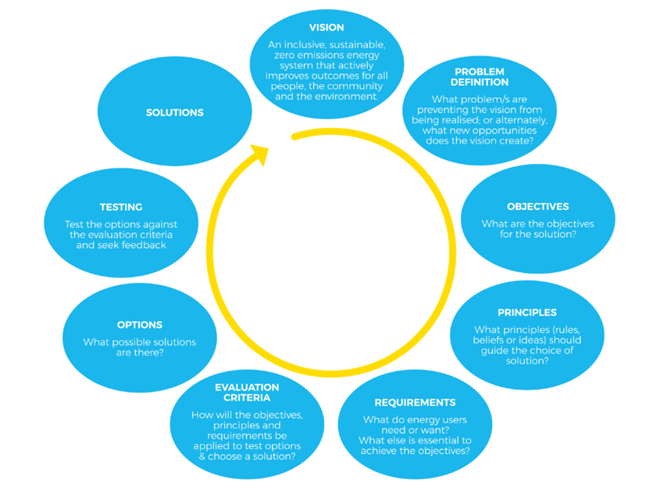
Source: ACOSS & Total Environment Centre, What is ourPower?, ourPower, n.d., accessed 18 September 2022.

Power Shift
Through its Power Shift research, Energy Consumers Australia asked ACIL Allen to develop a framework for policymakers to target energy services and programs – The Supporting Households Framework. This framework identifies three key factors that impact on the choices available to households around energy – motivation, ability and opportunity (Table 2).
This framework can support household segmentation and provide an indication of which tools and services are most likely to help a household based on an understanding of what it can and cannot do in terms of transitioning from gas to electric (Table 3). In designing and delivering supports and services, attention to intersectionality is particularly important – this includes identifying appropriate providers and/or locations of support such as community organisations that work closely with and are trusted by particular groups within the community.
Table 2 Power Shift summary of factors that influence a household’s motivation, ability and opportunity
Motivation | Ability | Opportunity
- Attitude towards the behaviour, for example, the perceived costs and benefits, the importance of energy, and cultural considerations  - Alignment with choices made within the household's circle of influence  - Likelihood of success  - Unwillingness to create disharmony/conflict | - Literacy, numeracy, problem solving and research skills  - Language barriers  - Ability to self-advocate, negotiate  - Belief in the ability to succeed  - Trust in others  - Ability to influence behaviour of all household members  - General interest in, and capability using, technology | - Type of housing  - Home ownership status  - Scope to manage the energy bill - for example, to choose a better energy deal, to improve the building fabric, to install more energy efficient appliances, to change the way energy is used  - Access to liquid funds
Source: Energy Consumers Australia, Power Shift Final Report, Energy Consumers Australia, Sydney, February 2020, p. 49, accessed 18 September 2022.
Table 3 Power Shift tools and services to help households manage their energy bills
Information, advice and non-financial support | Incentives | Financial support | Regulation | Support services
Awareness campaigns  Word of mouth communication / role / models / exemplars  General / tailored / personalised information  Market-based tools & services | Feedback on outcomes - general, specific and timely  Control of devices by third party  Incentivise desired / penalise | Energy performance contracts, loans  Grants, subsidies  Government investment in public housing upgrades  Fund community organisations to provide services | Minimum performance standards  Information provision, schemes (e.g., energy efficiency), technologies  Remove market, policy, regulatory barriers | Access to community services that can support and assist households taking action
Source: Energy Consumers Australia, Power Shift Final Report, Energy Consumers Australia, Sydney, February 2020, p. 51, accessed 18 September 2022.

The Energy Equity Work Program
ACTCOSS is a member of the Stakeholder Reference Group for the Australian Government’s Energy Equity Work Program. Like ECA’s Power Shift, this work program is developing an energy equity framework to support policymakers to better design and target programs based on household needs. Once completed, this may also provide useful guidance for ACT Government in ensuring equity is front and centre of the Integrated Energy Plan. A preliminary guide to equitable energy programs has proposed four key components of a national, coordinated strategy:
- Measure: a comprehensive range of factors associated with energy hardship – Drivers, Indicators and Outcomes take us beyond simplistic income-based metrics
- Assess: different levels of energy hardship based on severity and duration – Based on the factors detected, identify the levels of hardship that need addressing
- Strengthen: select appropriate initiatives based on household needs – Based on the levels of hardship, select Prevention, Support, or Relief strategies
- Track: evaluate program outcomes and monitor energy hardship over time – Repeat Measure and Assess, report the impact, and Strengthen appropriately.
As outlined in the next section, the ACT Government has committed to a just transition to net zero greenhouse gas emissions. To achieve this, it will be critical to put equity front and centre of phasing out fossil-fuel gas on the pathway to electrification, building on steps already being taken to support low-income and other households at risk of being left behind.

Current policy context for a just and inclusive transition in the ACT
With the release of the Powering Canberra position paper, the ACT Government has made a clear commitment to achieving net zero greenhouse gas emissions via an electrification pathway and a just transition away from fossil-fuel gas by 2045. The ACT Government’s commitment to achieving net zero by 2045 and 100% renewable electricity by 2020 is legislated under the Climate Change and Greenhouse Gas Reduction Act 2010. When first legislated in 2010, the ACT Government committed to achieving net zero by 2060. In 2018 the emission reduction targets were updated based on the latest climate science at that time. These targets align with the emission reductions needed to implement the Paris Agreement. The ACT's legislated targets are to reduce greenhouse gas emissions (from 1990 levels) by:
- 40% by 2020
- 50 to 60% by 2025
- 65 to 75% by 2030
- 90 to 95% by 2040 and
- 100% (net zero emissions) by 2045.
When exercising their functions under the Climate Change and Greenhouse Gas Reduction Act 2010, the Minister must ‘have regard to how measures to address climate change may affect people who are socially or financially disadvantaged’. The Act also established the Climate Change Council to advise the Minister, with membership to include ‘a person to represent people who are socially or financially disadvantaged’.
In 2011, the ACT Government released the ACT Sustainable Energy Policy 2011-2020. This policy included support for low-income households under two key measures:
Measure 5: The ACT will seek to address the impact of rising energy prices on households through ongoing monitoring of the suitability of concession arrangements, indexing concession payments based on changes in the cost of living and by investing in energy efficiency measures that can reduce energy costs for low-income households.
Measure 9: The ACT will, subject to a regulatory impact assessment, establish a new ambitious energy savings initiative, funded by energy users, providing support to low-income households and stimulating the broad-scale energy efficiency improvements of homes and small businesses across the Territory.
In 2012, in line with Measure 9 above, the ACT Government established the Energy Efficiency Improvement Scheme (EEIS) under the Energy Efficiency (Cost of Living) Improvement Act 2012. The objects of this Act are to:
- encourage the efficient use of energy; and
- reduce greenhouse gas emissions associated with energy use in the Territory; and
(c) reduce household and business energy use and costs; and
(d) increase opportunities for priority households to reduce energy use and costs.
Priority households are currently defined by the Minister as a residential premise where at least one person who lives there meets one or more of the following criteria:
(a) is a recipient of an ACT Government energy concession; or
(b) holds a Commonwealth pensioner concession card or health care card; or
(c) holds a Department of Veterans Affairs pensioner concession card, TPI gold repatriation health care card, war widows repatriation health care card, or gold repatriation health care card; or
(d) holders of a Commonwealth seniors health card; or
(e) holders of a Commonwealth low-income health care card; or
(f) recipients of a Commonwealth disability support pension; or
(g) people accessing an energy retailer’s hardship program (however described); or
(h) people referred to a NERL retailer by a referring organisation
(i) people living in a priority dwelling.
Also in relation to support for the low-income households, the ACT Sustainable Energy Policy 2011-2020 notes the trial of an outreach program through a number of community organisations ‘to help low income households improve their energy and water efficiency through education and retro-fit measures’. This support continues to be provided through the Low Income Household Program currently delivered by St Vincent de Paul Society’s Energy Efficiency Outreach Team.
In 2019, the ACT Government released its ACT Climate Change Strategy 2019-25 in which it committed to:
- a just transition to net zero emissions that supports low-income households and the most vulnerable in our community, and will work with industry to re-train affected workers and pursue opportunities for new, zero emissions industries.
- seek to partner with vulnerable households and community service providers to ensure low-income households can participate in the shift to net zero emissions and are not disproportionately affected by new measures. A coordinated mix of concessions, rebates, loans, education, dispute resolution and consumer advocacy programs will be required. These will be designed to address the barriers faced by groups such as low-income households, renters, those in public housing, elderly people, people with disabilities and illness, sole parents, people in energy poverty or who are working but on low incomes and not eligible for current concessions.
- partner with community service organisations to identify vulnerable and disengaged sectors of the community and implement measures to support their participation in shifting to net zero emissions.
- develop a plan for achieving zero emissions from gas use by 2045, including setting timeframes with appropriate transition periods for phasing out new and existing gas connections [by 2024].
At least 10 measures in the ACT Climate Change Strategy 2019-25 are aimed at electrification and reducing emissions from gas, including supporting consumers to transition from gas to electricity (Table 4).
Table 4 Actions to reduce emissions from gas and to transition from gas to electricity, ACT Climate Change Strategy 2019-25
No. | Goal | Action | Timing
4.03 | Reduce emissions from gas | Amend planning regulations to remove the mandating of reticulated gas in new suburbs. | By 2020
4.04 | Reduce emissions from gas | Conduct a campaign to support the transition from gas by highlighting electric options and savings opportunities to the ACT community. | From 2020
4.05 | Reduce emissions from gas | Develop a plan for achieving zero emissions from gas use by 2045, including setting timeframes with appropriate transition periods for phasing out new and existing gas connections. | By 2024
4.09 | Climate-wise, zero emissions public housing | Continue to upgrade to efficient-electric appliances in existing public housing properties where technically feasible and assess the cost and benefits of shifting to all-electric public housing. | From 2019
4.10 | Climate-wise, zero emissions public housing | Ensure all newly constructed public housing properties are all-electric (fitted with electric appliances) from 2019. | From 2019
4.12 | Climate-wise, zero emissions low-income homes | Trial facilitating access to interest free loans or other innovative finance for gas to electric upgrades and deep retrofits of low-income homes. | By 2022
4.18 | Climate-wise, zero emissions buildings | Trial incentives and other measures to encourage all-electric, high efficiency apartment and commercial buildings. | By 2024
4.19 | Climate-wise, zero emissions buildings | Expand the Energy Efficiency Improvement Scheme to increase support for low-income priority households and further encourage a shift from gas to high efficiency electric appliances. | From 2020
5.13 | Zero Emissions Government | Ensure all newly built or newly leased Government buildings and facilities are climate-wise and all-electric (where fit for purpose). | From 2020
5.14 | Zero Emissions Government | Replace all space and water heating systems in Government facilities with electric systems at the end of their economic lives (where fit for purpose). | From 2020
Source: ACT Government, ACT Climate Change Strategy 2019-25, Environment, Planning and Sustainable Development Directorate, Canberra, 2019, accessed 18 September 2022.
In November 2020, the newly elected ACT Government set out its next steps on climate change action under the ACT Labor and Greens Parliamentary and Governing Agreement which covers the term of the 10th ACT Legislative Assembly from 2020 to 2024 (Box 1).

Box 1 Parliamentary and Governing Agreement next steps on climate action – phase out of fossil-fuel gas by 2045 at the latest
The ACT Labor and Greens Agreement will take the next essential steps to a net zero-emissions ACT, through the following actions:
- Phase out of fossil-fuel-gas in the ACT by 2045 at the latest, support energy grid stability and support vulnerable households, by doing the following:
  - Implement a program of zero-interest loans of up to $15,000 for households and not-for-profit community organisations to assist with the upfront costs of investing in: rooftop solar panels; household battery storage; zero emission vehicles and efficient electric appliances. The program will include an education and communications component about energy efficiency and the shift from gas to electric.
  - Progress a project with relevant asset owners and key stakeholders to reduce the emissions intensity of the existing ACT gas network as much as is possible, by injecting zero-emissions gas alternatives.
  - Enact minimum energy efficiency standards regulations for rental properties in 2021 with progressive implementation over the coming years.
  - Implement a five-year, $50 million program to improve building efficiency and sustainability for social and public housing, low-income owner-occupiers, and the lowest performing rental properties; this includes upgrades to government housing, and financial incentives to implement minimum energy efficiency standards in rental properties.
  - Deliver at least 250MW of new ‘large-scale’ battery storage distributed across the ACT.
  - Develop the Molonglo Commercial Centre as an all-electric commercial centre (no new connections to gas mains network, but allow transition gas arrangements such as tanks), in partnership with expert stakeholders, and use lessons from this project to assist the phase out of fossil-fuel gas in the ACT, and demonstrate national best practice.
  - Legislate to prevent new gas mains network connections to future stages of greenfield residential development in the ACT in 2021-22. Future stages of Jacka and Whitlam will be all-electric.
  - Commence a transition project, working with industry and other stakeholders, to advance all-electric infill developments, with a goal of no new gas mains network connections to future infill developments from 2023.
  - Ensure all new ACT Government buildings and facilities are fossil-fuel-gas free, including new leases. All retrofitting in Government buildings and facilities will have a goal of net-zero emissions post retrofit.

Steps towards phasing out fossil-fuel gas in the ACT
While only indicative, modelling reported in the ACT Climate Change Strategy 2019-25 found that to achieve its targets there would need to be ‘around 60,000 existing households not connected to gas by 2025, increasing to 90,000 in 2030 and all houses by 2045’. This would equate to roughly halving the number of households connected to gas by 2025, and a 75% reduction by 2030. Meanwhile, new gas connections in the ACT in recent years have continued to increase - from 2016-17 to 2020-21, the number of residential gas customers in the ACT increased by 9% (Figure 6). As at 31 March 2022, there were 127,301 residential gas customers in the ACT – down slightly from 127,926 in 2020-21. As a proportion of ACT residential electricity customers (186,676), 69% are residential gas customers. These figures highlight the scale of the challenge of phasing out fossil-fuel gas for households in the ACT by 2045.
Figure 6 Residential gas customers, ACT, 2016-17 to 2020-21
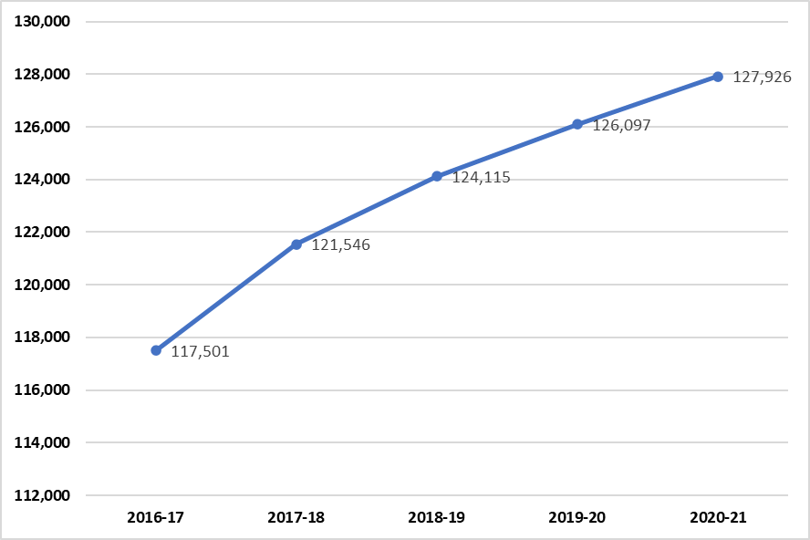
Source: Australian Energy Regulator, Retail energy market performance update for Quarter 3 2021-22, AER, Melbourne, 30 June 2022, Schedule 2, accessed 18 September 2022.

Prohibiting new gas connections
A critical first step towards phasing out fossil-fuel gas is to stop new connections to the gas network. In 2020, ACT planning regulations were amended to remove the mandating of reticulated gas in new suburbs. Under the 2020 Parliamentary and Governing Agreement, the ACT Government has committed to both:
- legislate to prevent new gas mains network connections to future stages of greenfield residential development in the ACT in 2021-22
- commence a transition project, working with industry and other stakeholders, to advance all-electric infill developments, with a goal of no new gas mains network connections to future infill developments from 2023.
A legal barrier to meeting these commitments relates to the national energy legislation framework, including the National Gas Law. These laws include an obligation for gas distributors to provide new connections to proponents who request it. The ACT’s gas distributor Evoenergy has noted that this means it cannot refuse to connect new customers: ‘[a]s an open access network, we are required to make connection offers and provide third parties with access to our network’. Under the Australian Energy Markets Agreement (AEMA) jurisdictions are allowed ‘to modify the operation of national energy laws for the purposes of environmental (including greenhouse gas reduction), energy efficiency and planning issues within their own jurisdiction’. On 4 August 2022, the Climate Change and Greenhouse Gas Reduction (Natural Gas Transition) Amendment Bill 2022 was presented in the ACT Legislative Assembly. This Bill includes,
the creation of a new regulation-making power that would enable new natural gas connections to be prohibited in prescribed circumstances. The power relates solely to new natural gas connections, and does not extend to 100 per cent renewable gas connections.
While prohibiting new fossil-fuel gas connections is a key step, the biggest challenge will be to transition over 130,000 ACT households and businesses from gas to all-electric by 2045.

Programs supporting households to transition from gas to electric
The ACT Government has already established several programs to support households and businesses to improve energy efficiency and reduce their energy bills, and to access the benefits of distributed energy resources (e.g., rooftop solar, household battery storage, and electric vehicles). Many of these programs are also effectively available to help households transition from gas to electric. Some of these programs are open to all households while others are targeted to specific households such as low-income households and renters. In addition to these programs, legislation and regulation also has a role to play, as noted in relation to the prohibition of new gas connections in the ACT. There is also potential for such measures to address equity issues in the energy transition as with the ACT Government’s commitment to introduce minimum energy efficiency standards for rental properties in the ACT.
ACT Government household and business energy programs and energy equity and inclusion measures currently in place include:
- Business Energy and Water Program
- Energy Assistance Community Partnerships
- Energy Efficiency Improvement Scheme
- Home Energy Assessment Webtool
- Home Energy Support Program
- Low Income Household Program
- Make the Switch project
- NextGen Energy Storage Program
- Renters’ Home Energy Program
- Solar for Business Program
- Sustainable Home Advice Program
- Sustainable Household Scheme
- Utilities Concession
- Utilities Hardship Fund
- Wood Heater Replacement Program
A description of each of these programs and equity measures is provided in the appendix to this report. In this section we provide details of three of the key programs that currently support households to replace gas appliances with energy efficient electric appliances: the Home Energy Support Program, the Energy Efficiency Improvement Scheme, and the Sustainable Household Scheme.

Home Energy Support Program
As noted earlier, under the PAGA the ACT Government committed to implement a five-year, $50 million program to improve building efficiency and sustainability for public and community housing, low-income owner-occupiers, and the lowest performing rental properties; this includes upgrades to government housing, and financial incentives to implement minimum energy efficiency standards in rental properties.
Initially named the Vulnerable Household Support Scheme, the first stage of the Home Energy Support Program was launched on 31 March 2022. This provided rebates of up to $2,500 to eligible low-income homeowners to install rooftop solar. On 15 September 2022, the program was expanded to include rebates of up to $2,500 for energy efficient electric appliances (i.e., reverse cycle heating and cooling, hot water heat pumps, and electric stove tops). As a result, the program now provides up to $5,000 in rebates for eligible homeowners. The program has an option to pay for the rest of your chosen products with an interest-free loan through the ACT Government’s Sustainable Household Scheme.
To be eligible for these rebates the applicant must:
- be a resident of the ACT who holds an Australian Government Pensioner Concession Card or a Department of Veterans’ Affairs Gold Card
- have attended a free online workshop
- have an eligible property, which includes that you own and occupy the home in which the product will be installed.
In the first half of 2022, a pilot was established under the program with Rentwell and Home Ground Real Estate as rental providers eligible for the affordable community housing land tax exemption. This pilot included rebates for ceiling insulation and closed on 30 June 2022.
The Home Energy Support Program has yet to be expanded to support energy efficient electrification of social housing and private rental properties.

Energy Efficiency Improvement Scheme
Under the Energy Efficiency Improvement Scheme (EEIS) electricity retailers operating in the ACT are required to help households and small-to-medium businesses save energy under the Energy Efficiency (Cost of Living) Improvement Act 2012. The scheme aims to:
- encourage the efficient use of energy
- reduce greenhouse gas emissions
- reduce household and business energy use and costs
- increase ways for priority households to reduce energy use and costs.
There are two tiers of electricity retailers in the legislation:
- Tier 1 retailers have at least 5,000 customers in the ACT and sell at least 500,000 MWh of electricity to customers in the ACT within a compliance period (which is a calendar year) – ActewAGL is currently the only Tier 1 retailer in the ACT
- Tier 2 captures all other retailers.
Tier 1 retailers must meet their energy savings obligation under the scheme by delivering eligible energy savings activities to households and small-to-medium businesses.
Eligible activities include:
- efficient electric space heating and cooling systems
- electric hot water heat pumps
- insulation
- other items that provide energy savings and reduce energy bills while maintaining quality of life.
Retailers may choose which of the eligible activities they deliver to meet their obligation. They can also get energy savings factors from businesses that can deliver activities on their behalf, called Approved Energy Savings Providers.
Tier 1 retailers must deliver a proportion of their energy savings to priority households as specified by the Priority Household Target (PHT). This target is re-set each year and is currently 40%.
As noted in Powering Canberra:
The EEIS also aims to increase opportunities for low-income households to reduce energy use and costs through a Priority Household Target, which means that 40% EEIS savings must be delivered in priority households. Priority households are defined as households in which at least one resident holds an eligible concession, are experiencing financial hardship or are residents of priority dwellings. These households are most affected by energy price rises, but least able to invest in efficient items and reduce their energy demand.
Tier 2 retailers can choose to deliver eligible activities or pay an Energy Savings Contribution (ESC) to the ACT Government. The ESC is spent on initiatives in accordance with the Objects of the Energy Efficiency (Cost of Living) Improvement Act 2012. Contributions are currently used to fund:
- the administration of the scheme
- ACT Government-led energy efficiency programs.
All Tier 2 retailers are currently paying the ESC.
In recent years, Housing ACT and the Environment, Planning and Sustainable Development Directorate (EPSDD) have used the EEIS to undertake energy efficiency improvements in public housing in partnership with ActewAGL. This has predominantly involved replacing inefficient gas heating and gas hot water systems. This use of the EEIS has been complemented by Housing ACT and EPSDD’s $200,000 All-Electric Program focused on replacing gas cooking appliances with electric alternatives in public housing dwellings. As part of the ACT Government’s COVID-19 economic survival package announced in May 2020, the Solar Stimulus Package provided $365,000 for Housing ACT to work in collaboration with EPSDD to install solar roof top systems at 10 Housing ACT properties managed by community housing providers and two large multi-unit properties.

Sustainable Household Scheme
Under the PAGA, the ACT Government committed $150 million over five years to implement a program of zero-interest loans of up to $15,000 for households and not-for-profit community organisations to assist with the upfront costs of investing in: rooftop solar panels; household battery storage; zero emission vehicles and efficient electric appliances. The scheme also includes an education and communications component about energy efficiency and the shift from gas to electric. The scheme opened to eligible ACT homeowners in June 2021 and was expanded to not-for-profit community groups in August 2022.
The scheme provides a zero-interest loan from $2,000 to $15,000 to buy energy-efficient products, including:
- rooftop solar panels
- household battery storage systems
- electric heating and cooling systems
- hot water heat pumps
- electric stove tops
- electric vehicles
- electric vehicle charging infrastructure
- installation costs for these products.
The loans are provided by Brighte as the ACT Government’s partner in the scheme.
Over the life of the scheme, a household or community organisation can install one product or a bundle of eligible products. Together, these can be valued at up to $15,000. Renters can only use the scheme to access loans for new or used electric vehicles. Rental providers wishing to make upgrades to their rental property can access a loan under the Scheme, noting that each household may borrow a maximum of $15,000 over the life of the scheme. A household may choose to make upgrades on their residence, an owned rental property or a combination of both, up to the $15,000 limit.
While the Sustainable Household Scheme is not targeted at low-income homeowners, zero-interest (or no-interest) loans are often a means to provide affordable finance to low-income households for the purchase of essential goods and services. While completely separate from the Sustainable Household Scheme, local community organisations Care Financial Counselling Service and The Salvation Army both provide no-interest loan schemes for low-income households that can also be used to purchase electric household appliances (among other things).

Gaps and opportunities for just and inclusive gas transition measures
A key task for the ACT Government – in partnership with the ACT community – when developing the Integrated Energy Plan will be to identify gaps and opportunities to ensure that the phasing out of fossil-fuel gas on the pathway to electrification is just and inclusive. This section of the report outlines some preliminary gaps and opportunities.

Prioritising targeted energy supports for priority households
The ACT Government has allocated $150 million over five years for homeowners through the Sustainable Household Scheme while one-third of that amount – $50 million over five years – has been allocated to the Home Energy Support Program to support those most at risk of being left behind. Research on similar rebate and incentive programs in the USA showed that these programs disproportionately favoured those on the highest incomes. For example, by 2015, households in the USA had received $18 billion in rebates and tax credits for installing solar panels, buying zero emission vehicles and other ‘clean energy’ investments. The top income quintile received 90% of these funds and the bottom three quintiles received 10%. This grossly disproportionate split was present across all funds targeting clean energy uptake in the USA.
Recent modelling commissioned by the ACT Government on the effect of incentives on the uptake of electric vehicles in the ACT found that high income households were far more likely to switch to electric vehicles even without incentives. The researchers concluded that:
Policies that increase the electric vehicle take-up in lower income households are likely to have the greatest effect, and also likely to benefit these households by freeing them from the need to pay for fuel.
This research suggests there is a need to ensure that rebates and financial incentives are targeted to need. This includes ensuring that there is a progressive and responsible redistribution of public funds to support a just and inclusive transition – as opposed to a ‘trickle-down transition’ that disproportionately benefits higher income households at significant social cost.

Minimum energy efficiency standards for rental properties
Under the PAGA the ACT Government committed to enact minimum energy efficiency standards regulations for rental properties in 2021 with progressive implementation over the coming years. These regulations are expected to be enacted later in 2022 informed by public consultation on the ACT Government’s proposed standard. The ACT Government is proposing the following as an initial minimum energy efficiency standard for rental homes in the ACT:
Rental homes with less than R2 ceiling insulation are required to install or upgrade to a minimum of R5.
In response, ACTCOSS and other energy consumer and tenant advocates expressed a need for a more ambitious standard, ideally one that required energy efficient electric heating and cooling and hot water. The proposed minimum ceiling insulation standard clearly provides no regulatory support for renters to transition from gas to all-electric. It is not yet clear how the Home Energy Support Program will look to address this through financial support or incentives for rental providers to transition their rental properties from gas to electric. The PAGA notes the ACT Government’s intention to link regulation and financial incentives via the $50 million Home Energy Support Program, i.e., the introduction of financial incentives to implement minimum energy efficiency standards in rental properties.
With rental properties accounting for just over 30% of occupied private dwellings in the ACT it will be critical to prioritise the development of an effective set of measures to ensure renters are not left behind on the path to electrification.

Equitable distribution of costs when phasing out the ACT gas distribution network
As highlighted in the Powering Canberra position paper, as fossil-fuel gas is phased out in the ACT households remaining connected to the network are likely to face significant gas price increases as the cost of maintaining the network is recovered from a declining customer base (alongside rising wholesale gas costs). For some households this may be a choice they can afford to make based on their own preferences, while others will lack that luxury due to being unable to afford to transition to all-electric or being restricted due to the tenure and/or type of housing they live in (e.g., renting an apartment).
Every five years, Evoenergy (the gas distribution network service provider for the ACT) needs to apply to the Australian Energy Regulator to approve its revenue requirements – setting the network costs to be recovered from customers over the next five years. As part of its most recent determination – for 2021-26 – the AER approved Evoenergy’s proposal to apply accelerated depreciation to new assets given the uncertain future of the ACT’s gas network as a result of the ACT Government’s commitment to achieve net zero greenhouse gas emissions by 2045. Accelerated depreciation would mean Evoenergy could recover the costs of purchasing new gas network assets from its customers over a shorter period than would normally be permitted by the AER. In part, Evoenergy proposed accelerated depreciation as a precautionary measure to manage the risk that ‘consumers who find it difficult or not feasible to move away from gas will be left to pay an unfair share of costs’.
In our engagement with Evoenergy’s gas network 2021-26 access arrangement proposal, ACTCOSS identified an urgent need for a clear and coordinated approach that ensures a fair and equitable distribution of costs of phasing out the gas distribution network in the ACT and elsewhere in Australia. In response, the AER produced an information paper on regulating gas pipelines under uncertainty which set out eight potential options it has as a regulator to address the implications of falling gas demand. In addition to these options, the AER’s information paper also addresses the question of whether governments or taxpayers should pay for stranded gas network assets. In preparing the Integrated Energy Plan by 2024, it will be important to explore options to ensure the fair and equitable distribution of the cost of phasing out our gas distribution network between current and future customers and the broader community. In doing so it will be worth reviewing the options identified in the AER’s information paper and from other sources. This will be especially timely given that Evoenergy is likely to begin preparing its gas network 2026-2031 access arrangement proposal for the AER in 2024.

Disconnection and abolishment costs
The Powering Canberra position paper notes that once a household has replaced all of its gas appliances, they can either permanently abolish the gas connection or temporarily disconnect by closing the gas account. While a temporary disconnection costs around $150 plus an administration fee, permanently abolishing a gas connection costs around $770-800. Either cost may present a barrier to a low-income household to either temporarily disconnect or permanently abolish their gas connection. To support low-income households to transition from gas to all-electric ACT Government should consider options to allow for temporary disconnection or abolishment at low or no cost. One option may be to cover this cost under the EEIS for priority households who have had their had their last gas appliance removed.
At the same time, it is important to ensure that households are aware that if they fail to close their gas account or abolish their gas connection after their last gas appliance has been removed they will continue to receive a gas bill for the supply charge even if no gas has been used.

Conclusion
The ACT Government’s Powering Canberra position paper has provided much-needed certainty about the future of gas in the ACT’s energy system. The preparation of an Integrated Energy Plan for the ACT by 2024 presents an opportunity to ensure that equity is built into our pathway to electrification and the phasing out of fossil-fuel gas. Too often equity, social justice and inclusion are an afterthought in energy planning and decision making. To deliver on its commitment to a just transition to net zero greenhouse gas emissions by 2045, the ACT Government will need to put equity and inclusion front and centre in the development of the Integrated Energy Plan. A just and inclusive transition means more than ensuring no one is left behind. The ACT’s energy transition provides a transformational opportunity to reduce poverty and inequality and improve wellbeing outcomes in our community.
This report has highlighted steps that have already been taken by the ACT Government to support a just and inclusive transition – namely by assisting households to change from gas to all-electric appliances. However, the report also highlights some key gaps that will need to be addressed to achieve a just and inclusive transition. A more detailed examination of gaps and opportunities is needed to inform the Integrated Energy Plan so that it prioritises equity in pursuit of a just and inclusive transition. A key part of this will be building our understanding of who is at risk of being left behind in this energy transition, why, and how that risk can be avoided, mitigated or managed.
This report has identified two key resources developed by energy consumer advocates to support energy policymakers in decision making around the energy transition and targeting support. ourPower and Power Shift set out guiding principles and provide practical tools that can assist in the development of the ACT Government’s Integrated Energy Plan and the design of targeted measures to support households to transition away from gas. Work currently underway within the Australian Government’s Energy Equity Work Program will potentially provide valuable guidance towards the development of measures for and the measurement of energy equity and wellbeing. Tracking our progress towards a just and inclusive transition in the ACT will be an essential task.
Achieving a just and inclusive transition is a challenging but critical task. Putting equity and inclusion front and centre of energy transition planning means dealing with the biggest challenges first. This includes addressing systemic and structural barriers and power imbalances. If these barriers and imbalances are not prioritised or addressed too late or not at all, then the risk of the energy transition exacerbating poverty and inequality is increased. A poorly targeted, trickle-down transition that disproportionately benefits higher-income households comes at significant social cost – widening inequality and misdirecting public resources to where they are not needed. As we phase out fossil-fuel gas in the ACT, it will be critical to prioritise the development of appropriate and targeted measures that ensure not only that no one is left behind, but that the needs of those most at risk are addressed first.

Appendix: ACT Government Energy Efficiency and DER Supports for Households and Small Business
This appendix provides key details of current measures by the ACT Government to support energy affordability, energy efficiency and the uptake of distributed energy resources. These programs are listed alphabetically as follows:
- Business Energy and Water Program
- Energy Assistance Community Partnerships
- Energy Efficiency Improvement Scheme
- Home Energy Assessment Webtool
- Home Energy Support Program
- Low Income Household Program
- Make the Switch project
- NextGen Energy Storage Program
- Renters’ Home Energy Program
- Solar for Business Program
- Sustainable Home Advice Program
- Sustainable Household Scheme
- Utilities Concession
- Utilities Hardship Fund
- Wood Heater Replacement Program
The information provided below is drawn mainly from the ACT Government’s Everyday Climate Choices website and was current as at 18 September 2022. Everyday Climate Choices has replaced Actsmart as the central site for ACT Government information to help households and businesses to reduce energy bills and greenhouse gas emissions.

Business Energy and Water Program
Target group(s)
- Small-to-medium businesses
Service type(s)
- Rebates
Provider(s)
- Environment, Planning and Sustainable Development Directorate
About the program
The Business Energy and Water Program helps you lower your business's running costs. If eligible, you could claim a rebate of up to $5,000 to upgrade to water-efficient and energy-efficient technologies. These include:
- appliances
- cooling or heating
- hot water
- insulation
- lighting
- refrigeration
- tapware and toilets.
How it works
If your business is eligible the ACT Government will cover 50% of the cost (up to $5,000) when upgrading to more sustainable water and energy systems.
An energy assessor will visit your workplace to:
- work out how much energy and water your business uses
- give you a tailored plan to improve energy and water use.
You can claim back 50% of the cost (up to $5,000) of our recommended improvements when you participate in this program.
Who can take part
If your business operates in the ACT and either:
- pays electricity bills of up to $25,000 a year (incl GST)
- employs no more than 20 staff.
Cost
It is free to register and participate, even if you choose not to do the upgrades. You will pay the full cost of any upgrades before you receive the rebate.
Contact
Phone: 13 22 81
Email: businessenergy@act.gov.au
Website: https://www.climatechoices.act.gov.au/policy-programs/business-energy-and-water-program

Energy Assistance Community Partnerships
Target group(s)
- People experiencing energy hardship
Support type(s)
- Information, advice and non-financial support
- Support services
Provider(s)
- Care Inc. Financial Counselling Services
- St Vincent de Paul Society (Canberra/Goulburn)
About the program
The Energy Assistance Community Partnerships (EACP) Program aims to:
- Increase the knowledge, capability, and capacity of a wide range of community organisations who support Canberrans experiencing energy hardship.
- Increase energy wellbeing across the community
- Extend the reach of energy wellbeing services to those not currently engaged with service providers
- Work towards equity of energy wellbeing across the ACT.
How it works
Through this program Care and St Vincent de Paul Society collaborate to:
- inform the public and community sector organisations about utility hardship assistance measures available
- improve capability and expand the capacity of services they currently offer, including training to enable other community service providers to identify energy hardship issues and direct clients as appropriate
- leverage existing networks to identify and access current gaps in outreach and increase referral rates to Care and St Vincent de Paul Society
- collect data and report on activities resulting from the EACP programs.

Energy Efficiency Improvement Scheme
Target group(s)
- Households
- Small-to-medium businesses
The EEIS currently has a 40% Priority Household Target which includes:
- Low-income households
- People experiencing energy hardship
- Social housing tenants
Support type(s)
- Energy efficient electric appliance upgrades
- Regulation
About the scheme
Electricity retailers are required to help households and small-to-medium businesses save energy under the Energy Efficiency (Cost of Living) Improvement Act 2012. The scheme aims to:
- encourage the efficient use of energy
- reduce greenhouse gas emissions
- reduce household and business energy use and costs
- increase ways for priority households to reduce energy use and costs.
What do electricity retailers have to do?
There are two tiers of electricity retailers in the legislation:
- Tier 1 retailers have at least 5,000 customers in the ACT and sell at least 500,000 MWh of electricity to customers in the ACT within a compliance period (which is a calendar year).
- Tier 2 captures all other retailers, of which there are currently over 20 operating in the ACT.
Tier 1 retailers must meet their energy savings obligation under the scheme by delivering eligible energy savings activities to households and small-to-medium businesses. ActewAGL is the only provider currently doing this in the ACT.
There are over 20 eligible activities, including:
- efficient electric space heating and cooling systems
- electric hot water heat pumps
- insulation
- other items that provide energy savings and reduce energy bills while maintaining quality of life.
Retailers may choose which of the eligible activities they deliver to meet their obligation. They can also get energy savings factors from businesses that can deliver activities on their behalf, called Approved Energy Savings Providers.
Tier 1 retailers must deliver a proportion of their energy savings to priority households as specified by the Priority Household Target (PHT). This target is re-set each year.
Tier 2 retailers can choose to deliver eligible activities or pay an Energy Savings Contribution (ESC) to the ACT Government. The ESC is spent on initiatives in accordance with the Objects of the Act. Contributions are currently used to fund:
- the administration of the scheme
- ACT Government-led energy efficiency programs.
At the moment, all Tier 2 retailers are paying the ESC.
What does it mean for households and business?
Tier 1 electricity retailers must deliver eligible energy-saving activities, such as appliance upgrades, to households and small-to-medium businesses. The electricity retailer chooses the activities they deliver to meet their obligation.
They must also deliver a proportion of their total energy savings to priority households, which are those experiencing barriers to accessing energy-efficiency upgrades. Households or businesses can contact their electricity retailer to find out if they are offering energy-efficiency upgrades under the scheme.
Even though some costs associated with energy saving activities may be passed on to consumers via electricity bills, by increasing energy efficiency, we are reducing overall demand. This reduces the overall cost of electricity, meaning that even households and businesses that do not receive energy-efficiency upgrades under the scheme should benefit from these reductions.
How do electricity retailers meet their obligations?
Electricity retailers operating in the ACT are obligated to achieve energy savings as outlined in the scheme’s legislation.
An Energy Savings Target (EST) is set for each compliance year. Retailers must meet this target, which is a percentage of their total electricity sales in the ACT. There are also other scheme parameters to be met.
Legislation
- Energy Efficiency (Cost of Living) Improvement Act 2012
Contact
- Email: EPD-EEIS@act.gov.au
- Website: https://www.climatechoices.act.gov.au/policy-programs/energy-efficiency-improvement-scheme

Energy Efficiency Improvement Scheme, All-Electric Program, and Solar Stimulus Program – Housing ACT
Target group(s)
- Social housing tenants
Support type(s)
- Energy efficient electric appliance upgrades (EEIS and All-Electric Program)
- Rooftop solar (Solar stimulus program)
About the schemes
The Energy Efficiency Program for public housing properties is an ACT Government initiative delivered under contract by ActewAGL. The Program forms part of the boarder Energy Efficiency Improvement Scheme run by the Environment, Planning and Sustainable Development Directorate (EPSDD).
The program is in its third year and the primary objective is to assist low-income households to reduce their energy bills and greenhouse gas emissions through the provision of energy efficient products and upgrades.
The program aimed to replace predominantly inefficient gas heating, and gas hot water systems in 2,200 eligible public housing properties by December 2021. At 30 June 2021, the program exceeded this target, with 2,685 installations completed.
Housing ACT is undertaking the All-Electric Program, with $200,000 available to replace gas cooking appliances with electric alternatives. This program compliments the Energy Efficiency Improvement Scheme and in addition to the emissions savings, households will save $300 per year in gas connection charges. At 30 June 2021, 66 properties have been disconnected from the gas network.
Since the ACT Government announced the $365,000 Solar for Public Housing program in May 2020, Housing ACT, in collaboration with EPSDD, worked for the Solar Stimulus Project installing solar rooftop systems to 10 Housing ACT properties and two large multi-unit properties. The 10 properties and one of the multi-unit properties installations were completed and delivered by 30 June 2021. The second multi-unit property solar system was expected to be fully functional in early 2021–22.

Home Energy Assessment Webtool
Target group(s)
- Households
- Renters (this webtool was originally designed for Renters’ Home Energy Program)
Support type(s)
- Information, advice and non-financial support
Provider(s)
- Environment, Planning and Sustainable Development Directorate
- Australian Energy Foundation (Contractor)
About the webtool
This webtool has been designed for renters but it also provides useful information for other households.
This is an opportunity to:
- identify the quickest and most cost-effective ways to reduce your energy use and bills
- improve the comfort of your home
- receive a tailored report on how to reduce your energy costs in your home.
The assessment should take around half an hour to complete. At the end of the assessment you will be able to download your report instantly.
Contact
Phone: 13 22 81
Email: sustainablehomeadviceprogram@act.gov.au
Website: https://actsmart-hea.com.au/

Home Energy Support Program
Target group(s)
- Low-income homeowners
- Social housing tenants
- Private renters
Support type(s)
- Financial support
- This program currently provides rebates and zero-interest loans for low-income homeowners for:
- Energy efficient electric appliance upgrades
- Rooftop solar.
Provider(s)
- Environment, Planning and Sustainable Development Directorate
- Brighte (zero-interest loans)
About the program
The Program provides up to $5,000 in rebates for eligible homeowners to help with the upfront costs of installing energy efficient products and undertaking sustainable upgrades.
Eligible homeowners can access a rebate of up to $2,500 for the installation of rooftop solar, and an additional rebate of up to $2,500 to install:
- reverse cycle heating and cooling
- hot water heat pumps
- electric stove tops.
Other energy efficiency products may be added in future.
The Program has an option to pay for the rest of your chosen products with an interest-free loan.
The maximum rebate amount per property is up to $5,000.
How it works
Rebate A - Up to $2,500 is available to help eligible households with the cost of installing an eligible rooftop solar system.
Rebate B - An additional rebate of up to $2,500 is available for eligible homeowners to install energy efficiency products such as reverse cycle heating and cooling, hot water heat pumps and electric stove tops.
You can choose from two options to pay for your installations:
Option 1 – Rebate only, with the remaining costs paid using your own funds. The ACT Government will process your rebate. You pay the supplier for your upgrade/s directly.
Option 2 – Rebate and interest-free loan. Brighte is our partner and will process your rebate and loan.
For more information on the interest-free loan, see the Sustainable Household Scheme.
Who can take part
To be eligible for the rebate, you must:
- be a resident of the ACT who holds an Australian Government Pensioner Concession Card or a Department of Veterans’ Affairs Gold Card
- have attended a free online workshop
- have an eligible property, which includes that you own and occupy the home in which the product will be installed.
The workshop will provide information on the Program, how to apply, and will help you with your energy efficient choices.
If you are applying for the rebate and interest-free loan option, you must also meet the requirements of the loan provider.
For full details regarding eligibility, refer to:
- Terms and Conditions [PDF 210KB]
- Guidelines [PDF 490KB]
- Frequently asked questions [PDF 250KB]
Sustainability upgrades to strata properties
Under the Managing Buildings Better reforms, body corporate organisations can no longer refuse unit owners requests to install sustainability infrastructure for purely aesthetic reasons.
Cost
There are no fees or account-keeping costs associated with the loan or rebate.
There may be modest fees applied to loans in arrears. You can repay the loan early with no penalty fee.
You must meet the standard credit criteria to get a loan. This includes a good credit history and the ability to repay the loan without hardship. The loan provider must follow the responsible lending practices in the National Consumer Protection Credit Act 2009.
If you cannot repay the loan, the loan provider has supports in place to help. You will need to contact them as soon as you start to experience hardship.
A credit check is not needed for the rebate application.
Contact
Sustainable Home Advice
- Phone: 1300 141 777
- Email: homeenergysupport@act.gov.au
- Website: https://www.climatechoices.act.gov.au/policy-programs/home-energy-support-rebates-for-homeowners

Low Income Household Program
Target group(s)
- Low-income households
Support type(s)
- Information, advice and non-financial support
Provider(s)
- St Vincent de Paul Society (Canberra/Goulburn)
About the program
This free program gives people in lower-income households practical ways to reduce their energy and water bills. This helps make their home more sustainable to cope with the effects of climate change.
Energy efficiency assessors can visit your home to help you find ways to:
- reduce your energy and water use
- save money
- improve the comfort of your home.
You can get an information kit with energy-saving tips and help with draught-proofing your home.
Cost
There is no cost to eligible households.
Who can take part
You can take part in the program if you meet the National Rental Affordability Scheme (NRAS) income limits, or if you hold a:
- Centrelink Pensioner Concession Card
- Low Income Health Care Card
- Veterans' Affairs Pensioner Concession Card.
Contact
St Vincent de Paul Society Energy Efficiency Outreach team
- Phone: 6234 7408
- Email: energyefficiency.cg@vinnies.org.au
- Website: https://www.climatechoices.act.gov.au/policy-programs/low-income-household-program

Make the Switch project
Target group(s)
- Households with a gas connection
Support type(s)
- Information, advice and non-financial support
Provider(s)
- Conservation Council ACT Region
About the project
The Make the Switch website aims to answer questions people may have about gas versus electricity and educate Canberrans about the effectiveness of technologies in our cold climate, and the savings that can be made by going all-electric. It provides independent information about the environmental impacts of the gas industry and practical advice about how householders can go gas-free and take meaningful action to address climate change.
Make the Switch calculator
The Make the Switch website includes a calculator developed by a team of experts to help householders understand the impacts of their gas usage, and their options for and potential savings over 10 years from switching from gas to an all-electric home. The aim was to strike a balance between being straightforward enough for most people to get easy-to-understand results and complex enough to allow some individual customisation.
The calculator is intended to be indicative only. People should do more research into their options and should not rely on a single source of information.
Developed in Canberra, the calculator uses assumptions based on ACT gas and electricity retail prices, typical household energy consumption, and Australian appliance retail prices and performance. All of these factors are subject to potentially substantial variations.
Canberra is located at 35°S, 149°E and about 600 metres above sea level. Canberra’s climate has distinct seasons: winter days range from 0° to 11°C (average) with frosty and foggy mornings and extreme lows of -5°C; summer days range from 13° to 28°C (average), with an average of 33 days above 30°C and extremes of up to 42°C. Canberra generally has low humidity, clear sunny days, and annual average of 615mm rainfall.
The team researched gas and electric appliances and energy supply data to generate meaningful default values and options.
Contact
Conservation Council ACT Region
- Phone: (02) 6229 3200
- Email: info@conservationcouncil.org.au
- Website: https://maketheswitch.org.au/

NextGen Energy Storage Program
Target group(s)
- Homeowners
- Businesses
Support type(s)
- Financial support
This program provides rebates for:
- Battery storage
Provider(s)
- Environment, Planning and Sustainable Development Directorate
- Approved Next Gen retailers
About the program
The Next Gen program supports the development of the energy storage industry in the ACT, along with research and training.
Who can take part
The rebate is available for homes and businesses within the ACT.
To be eligible for a rebate, your new battery system must be:
- coupled with solar panels
- connected to the electricity grid
- a new system that has not already been supported by the program.
How it works
For households, the rebate is $3,500 (excluding GST) or 50% of the battery price (excluding GST) – whichever is lowest.
For businesses the rebate is $35,000 (excluding GST) or 33% of the battery price (excluding GST) – whichever is lowest.
Reach out to any of the Next Gen retailers listed below and discuss your requirements. They will be able to answer your questions and work out the best system to meet your needs. You will receive the rebate amount from the retailer who will automatically include the reduction on your quote.
Current retailers are:
- ADS Solar
- Ausgreen Solar Solutions
- ECG Electrical
- EPC
- First Sun Solar
- G Star Energy
- Innovate Energy
- LECA
- Malwa
- Mondiaux Solar
- Polygon energy
- Power Ideas
- RBE
- Reposit
- Select Electrical and Solar Solutions
- Solar4Life
- Solar Forever Canberra
- Solargain
- Solarhub
- Solar Battery Group
- Stag Electrical
- Sunbuilt Solar
- Stored Solar
- Sunstak
New battery installations must be sourced from an approved Next Gen retailer. You cannot access the rebate by using a retailer who is not on the list.
You can apply for a rebate under this program and a loan under the Sustainable Household Scheme. You need to follow all the terms and conditions of both programs to be eligible. For more information, see the Sustainable Households Scheme.
Safety and reliability
The Clean Energy Council (CEC) operates a scheme to accredit solar and battery retailers. This makes sure they are across the latest safety requirements. Next Gen retailers must use batteries which are CEC accredited.
Energy storage systems must comply with ACT legislation and relevant Australian and international standards. We recommend that you monitor the Australian Competition and Consumer Commission (ACCC) and Access Canberra websites for battery recalls.
The rebate only covers energy storage systems from the CEC's approved list.
Your retailer must give you:
- information on how to safely use your battery
- a 10-year or more warranty for your battery and inverter.
Check that the warranty covers the way you intend to use the battery.
Contact
Next Gen program team
- Email: NextGen@act.gov.au
- Website: https://www.climatechoices.act.gov.au/policy-programs/next-gen-energy-storage

Renters’ Home Energy Program
Target group(s)
- Renters
Support type(s)
- Information, advice and non-financial support
Provider(s)
- Environment, Planning and Sustainable Development Directorate
About the program
The Renters’ Home Energy Program is a free and easy way to:
- save on your home energy bills
- get tips on the quickest, cheapest and best ways to reduce energy use
- make your home more comfortable without using more gas or electricity.
It also helps you reduce your impact on the environment.
Who can take part
The program is for anyone living in a rented home in the ACT.
If you own a home or rental property in Canberra, you can use the online tool or visit the Sustainable Home Advice Program.
How it works
You can choose to get a free home energy assessment and expert advice online, by phone or in your home.
Online
The Renters’ Home Energy Webtool is a series of online questions. It takes about 30 minutes to complete.
It will ask straightforward questions about your home. You will get a tailored list of actions you can take to make your home more comfortable and to reduce your energy use and costs.
Phone or at home
An independent energy expert to do the assessment with you. They will call you or come to your house to do a free 60-minute home energy assessment.
The expert will talk through each part of the home with you. They will suggest actions you can take as a renter to make your home more energy efficient.
Cost
The Renters’ Home Energy Program is free.
Contact
ACT Sustainable Home Advice Line
- Phone: 1300 141 777
- Email: SustainableHomeAdviceProgram@act.gov.au
- Website: https://www.climatechoices.act.gov.au/policy-programs/renters-home-energy-program

Solar for Business Program
Target group(s)
- Business
Support type(s)
- Information, advice and non-financial support
Provider(s)
- Environment, Planning and Sustainable Development Directorate
About the program
The Solar for Business Program helps businesses adopt solar energy.
If you are an ACT business, you can get free tailored advice on the best rooftop solar system for you.
Our team can also help with advice on any Federal Government rebates that may be available.
How it works
You can get advice about installing rooftop solar PV systems.
A solar energy expert can:
- explain the basics of solar technology and the specific benefits for your business
- look at how your business uses electricity, and your solar needs
- compare quotes based on your business goals (budget, savings or quality)
- give cost estimates on a case-by-case basis.
You can get solar advice via phone or email. An expert can also visit your business.
Get details about installing solar and choosing providers from the Clean Energy Council.
Who can take part
To be eligible, your business must operate from registered premises in the ACT (not a home).
Cost
If your business is eligible, you can get tailored advice for free.
Contact
Actsmart Business Team
- Phone 13 22 81
- Email: businessenergy@act.gov.au
- Website: https://www.climatechoices.act.gov.au/policy-programs/solar-for-business-program

Sustainable Home Advice Program
Target group(s)
- Households
Support type(s)
- Information, advice and non-financial support
Provider(s)
- Environment, Planning and Sustainable Development Directorate
About the program
The Sustainable Home Advice Program helps you understand your energy use and the best ways to make your home more sustainable.
You can get free advice tailored to your home on a range sustainability measures. You can:
- do a home energy self-assessment
- get energy efficiency tips
- attend one of our workshops
- use our online tools to help you choose the right plants for your garden and use the right amount of water.
There are also other resources available.
How it works
Come to us for advice backed by data. Get reliable and simple solutions that you can put into action.
Phone and email advice
Our team can help you reduce greenhouse gas emissions and save money.
They can talk to you about actions for households, such as:
- free or low-cost ways to save energy with heating, cooling, hot water and other appliances
- home improvements to increase energy efficiency, including insulation and window treatments
- different systems for heating and cooling your home, cooking, hot water and other appliances
- ways to make your garden adaptable to the changing climate and save water
- understanding electric vehicles
- energy-efficient home design.
Workshops and other events
Learn how to make take small steps to improve your home's sustainability and save money at one of our free online workshops. To register, choose something you are interested in from the events list.
Self-assessment for householders
Use our Home Energy Assessment Webtool. It is aimed at renters, but homeowners will find it valuable too.
You will get a tailored report with advice on how to reduce energy use and keep your home comfortable.
If you need extra help, contact us for free in-home or over-the-phone energy assessments.
Short step-by-step videos
DIY videos to help you save money and reduce energy use in your home include:
- Identifying draughts in your home
- Borrowing a Home Energy Action Kit
- How to winter-proof your windows
- How to seal gaps in your home
- How to draught-proof doors
- How to draught-proof vents
Who can take part
The Sustainable Home Advice Program is available to ACT residents.
If you are renting, visit our Home Energy Assessments for Renters.
Cost
It is free to use our advice line or attend a workshop.
Contact
Sustainable Home Advice
- Phone: 1300 141 777
- Email: SustainableHomeAdviceProgram@act.gov.au
- Website: https://www.climatechoices.act.gov.au/policy-programs/sustainable-home-advice-program

Sustainable Household Scheme
Target group(s)
- Homeowners
- Not-for-profit community organisations
- Renters (for electric vehicles only)
Support type(s)
- Financial support
This program provides zero-interest loans for the purchase and/or installation of:
- Energy efficiency electric appliances
- Rooftop solar
- Battery Storage
- Electric vehicles
Provider(s)
- Environment, Planning and Sustainable Development Directorate
- Brighte (zero-interest loan provider)
About the program
This scheme provides zero-interest loans to help with the costs of energy-efficient upgrades.
Brighte is our partner and loan provider for the scheme.
If you are eligible, you can get a loan from $2,000 to $15,000. You can repay the loan over up to 10 years.
How it works
If you are eligible, you can get a loan from $2,000 to $15,000 to buy energy-efficient products. These include:
- rooftop solar panels
- household battery storage systems
- electric heating and cooling systems
- hot water heat pumps (HWHP)
- electric stove tops
- electric vehicles (cars)
- electric vehicle charging infrastructure
- installation costs for these products.
Over the life of the scheme, you can install one product or a bundle of products from the list of eligible products. Together, these can be valued at up to $15,000.
You may borrow more than $15,000 depending on your loan application credit check. The loan provider may charge interest on funds borrowed above the limit.
Your repayments will begin when you either:
install the product or system and it is operational
buy the electric vehicle.
You can apply for a loan under this scheme and a subsidy under another program, such as the Next Gen Energy Storage Program.
Buyers Guides
- Rooftop solar panels [PDF 2.6MB]
- Household battery storage systems [PDF 2.1M]
- Electric heating and cooling systems [PDF 171KB]
- Hot water heat pumps [PDF 192KB]
- Electric stove tops [PDF 86KB]
- Electric vehicles [PDF 136KB]
- Electric vehicle charging infrastructure [PDF 87KB]
Who can take part
Households
It is open to residents of the ACT who either own a home or hold a current driving licence (when applying for a loan for an electric vehicle).
You must meet the scheme's eligibility criteria and Brighte's lending criteria. This includes attending a free one hour live online workshop. These workshops will help you with your energy efficiency choices.
To check if you are eligible, read:
- Terms and Conditions [PDF 276kB]
- Guidelines [PDF 744KB]
- Frequently asked questions [PDF 433KB]
Community Groups
Eligible groups can get a loan from $2,000 to $15,000 to buy energy-efficient products.
A group must meet the Scheme's eligibility criteria and Brighte's lending criteria. This includes attending a free one hour live online workshop or participating in the Business Energy and Water program. These resources will help you with your energy efficiency choices.
Important: Before applying for a loan, you will need to check if you need to obtain relevant approvals. Check the FAQs for more details.
To check if your group is eligible, read:
- Terms and Conditions [PDF 111KB]
- Guidelines [PDF 589KB]
- Frequently asked questions [PDF 581KB]
Cost
No establishment fees or account-keeping costs
You can repay the loan early with no penalty fee. But if you fall behind in your loan repayments, the loan provider may charge a fee.
You must meet standard credit criteria for the loan. This includes a good credit history and the ability to repay the loan without hardship.
If you cannot repay the loan, the loan provider will have hardship support to help you.
The loan provider must follow the responsible lending practices in the National Consumer Protection Credit Act 2009.
To assist with reducing the loan size, Pensioner Concession Card and Veterans’ Affairs Gold Card holders may also be eligible for rebates on rooftop solar installation and other energy efficient products as part of the Home Energy Support program.
Contact
- Sustainable Household Scheme
- Phone: 13 22 81
- Email: SHS@act.gov.au
- Website: https://www.climatechoices.act.gov.au/policy-programs/sustainable-household-scheme

Utilities Concession
Target group(s)
- Low-income households
Support type(s)
- Financial support
Provider(s)
- ACT Revenue Office
- The Utilities Concession is applied by electricity retailers to eligible customers’ accounts
About the program
An energy rebate or concession is available to eligible households. The Utilities Concession covers electricity, gas, water or sewage costs but is only applied to electricity bills. The Utilities Concession is also available to eligible residents of ACT caravan parks and retirement villages with embedded electricity networks. The concession will be paid directly to eligible residents rather than as a reduction applied to utility bills.
The rebate covers up to $750 per year. In the 2022-23 financial year, an additional one-off rebate of $50 will be provided to the Utilities Concession taking it up to $800.
How it works
Apply for a rebate through your energy provider. For residents in a caravan park or retirement village with an embedded network, contact the ACT Revenue Office.
The rebate is calculated on a daily basis and applied to your utility account.
The rebate is only available for your main household.
Who can take part
ACT residents with one of these cards may be eligible:
- Centrelink Pensioner Concession Card
- Centrelink Low Income Health Care Card
- ACT Service Access Card
- Veteran’s Affairs Pensioner Concession Card or Gold Card.
Contact
ACT Revenue Office
- Phone: (02) 6207 0028 - Select Option 5
- Email: concessions@act.gov.au
- Website: https://www.revenue.act.gov.au/community-assistance/utilities-concession

Utilities Hardship Fund
Target group(s)
- Low-income households
- Households experiencing energy hardship
Support type(s)
- Financial support
Provider(s)
- ACT Government
- Selected ACT energy retailers (ActewAGL, Origin Energy, Energy Australia, and Red Energy)
About the fund
The ACT Government has committed $1 million over four years from 2021-22 to 2024-25 for the continuation of the Utilities Hardship Fund. Four ACT energy retailers – ActewAGL, Origin Energy, Energy Australia, and Red Energy – collectively make a matching co-contribution with their individual contributions being proportionate to their share of the market. The fund is designed to assist those Canberrans who need the greatest level of support in paying their utility bills and is administered by the participating energy retailers under a Memorandum of Understanding with ACT Government.

Wood Heater Replacement Program
Target group(s)
- Households with wood heaters
Support type(s)
- Financial support
This program provides rebates for:
- Energy efficient electric heating upgrades
Provider(s)
- Environment, Planning and Sustainable Development
About the program
The Wood Heater Replacement Program gives you a rebate for replacing your wood heater with an efficient electric heating system. You can also get a rebate for permanently closing off and removing your wood heater.
How it works
If you are eligible, you can apply for these rebates:
- $250 for permanently closing off open fireplaces and removing wood heaters.
- $750 for removing a wood heater and installing an electric reverse-cycle split system with a 3-star energy rating or higher.
- $750 for removing a wood heater and upgrading an electric reverse-cycle system with a 3-star energy rating or higher.
- $1,250 for removing a wood heater and installing a ducted electric reverse-cycle system.
Who can take part
You can apply for the Wood Heater Replacement Program if:
- you are an ACT ratepayer
- your property is residential.
You can also apply if you are a residential rental provider. Both you and your tenant must sign the application form.
Only one rebate is available per property.
Cost
It is free to apply for the Wood Heater Replacement Program.
Contact
- Website: https://www.climatechoices.act.gov.au/policy-programs/wood-heater-replacement-program
02 6202 7200
ABN 81 818 839 988
actcoss@actcoss.org.au
actcoss.org.au

A Barr MLA & S Rattenbury MLA, Powering Canberra: our pathway to electrification [joint media release], ACT Government, 4 August 2022, accessed 18 September 2022.
ACT Government, Powering Canberra: our pathway to electrification – ACT Government Position Paper, ACT Government, Canberra, 2022, accessed 14 August 2022.
N Islam & J Winkel, Climate change and social inequality [PDF], DESA Working Paper No. 152, United Nations Department of Economic and Social Affairs, October 2017, accessed 18 September 2022.
United Nations Department of Economic and Social Affairs, Sustainable Development Goals, https://sdgs.un.org/ , 2022, accessed 18 September 2022.
United Nations Department of Economic and Social Affairs, Goal 7 Ensure access to affordable, reliable, sustainable and modern energy for all, Sustainable Development Goals, 2022, accessed 18 September 2022.
The TWG on Enabling SDGs Through Inclusive, Just Energy Transitions, Theme report on enabling SDGs through inclusive, just energy transitions: towards the achievement of SDG 7 and net-zero emissions [PDF], United Nations, 2021, p. iv, accessed 18 September 2022.
The TWG on Enabling SDGs Through Inclusive, Just Energy Transitions, Theme report on enabling SDGs through inclusive, just energy transitions: towards the achievement of SDG 7 and net-zero emissions, p. 1
ACOSS, Securing fast, fair and inclusive climate action, ACOSS website, 2022, accessed 18 September 2022.
ACOSS, Community Sector Climate Change Declaration, ACOSS website, 2021, accessed 18 September 2022.
ACT Government, Large-scale feed-in tariffs and reverse auctions, Everyday Climate Choices website, 2022, accessed 18 September 2022.
ACT Government, ACT Sustainable Energy Policy 2020-25 Discussion Paper [PDF], Environment, Planning and Sustainable Development Directorate, Canberra, 2019, p. 55, accessed 18 September 2022.
ACT Government, ACT Climate Change Strategy 2019-25, Environment, Planning and Sustainable Development Directorate, Canberra 2019, p. 10, accessed 18 September 2022.
ACT Government, Powering Canberra: our pathway to electrification, p. 12.
ACT Government, Parliamentary & Governing Agreement 10th Legislative Assembly Australian Capital Territory [PDF], Canberra, 2020, Appendix 1: Policy issues of particular interest, accessed 18 September 2022.
ACT Government, ACT Sustainable Energy Policy 2020-25 Discussion Paper, p. 55
ACT Government, ACT Sustainable Energy Policy 2020-25 Discussion Paper, p. 6
R Norton, J Lewis, C Klinger & N Goldmann, Leading with equity and justice in the clean energy transition: getting to the starting line for residential building electrification, Green & Healthy Homes Initiative, Baltimore, 2021, accessed 17 September 2022.
The TWG on Enabling SDGs Through Inclusive, Just Energy Transitions, Theme report on enabling SDGs through inclusive, just energy transitions: towards the achievement of SDG 7 and net-zero emissions, pp. 1-2
ACT Government, ACT Wellbeing Framework, 2022, accessed 18 September 2022.
R Bedggood, C O’Mahony, F Pervan & P Buergelt, Empowering low-income households: delving into the co-benefits identified in the Low Income Energy Efficiency Project Reports. Final Report, GEER Australia, Swinburne University of Technology and Charles Darwin University, 2018, p. 11, accessed 17 September 2022.
https://www.actcoss.org.au/publications/advocacy-publications/submission-inquiry-renewable-energy-innovation-act
T Hoppe & G de Vries, Editorial: Social Innovation and the Energy Transition, Sustainability, 11(1), 141, 2019, pp. 8-9, accessed 16 September 2022.
ACT Government, Powering Canberra: our pathway to electrification, p.14.
ACT Government, Powering Canberra: our pathway to electrification, p.18.
ACT Government, Gas transition survey final report, YourSay Panel, ACT Government, 17 February 2022, pp. 9, 11-12, accessed 17 September 2022.
ACT Government, Gas transition survey final report, pp. 13-14.
ACT Government, Gas transition survey final report, p. 6.
https://www.abs.gov.au/census/find-census-data/quickstats/2021/8
ACTCOSS, 2022 ACT Cost of Living Report, ACTCOSS, Canberra, 2022, accessed 17 September 2022.
Productivity Commission, ‘Table GA.12 Income units receiving CRA and paying enough rent to be eligible for maximum assistance, by jurisdiction’ [Data Tables], Report on Government Services 2022: G Housing and Homelessness, Productivity Commission, 2022, accessed 25 April 2022.
Productivity Commission, ‘Table GA.13 CRA Income units paying more than 30 per cent of income on rent, with and without CRA, by selected equity group’ & ‘Table GA.14CRA Income units paying more than 50 per cent of income on rent, with and without CRA, by selected equity group’ [Data Tables], Report on Government Services 2022: G Housing and Homelessness, Productivity Commission, 2022, accessed 25 April 2022.
ACTCOSS, 2022 ACT Cost of Living Report, pp.18-21; see also ACOSS, Brotherhood of St Laurence & ANU Centre for Social Research and Methods, Energy stressed in Australia [PDF], ACOSS, Sydney, 2018, accessed 17 September 2022.
SACOSS, Fact sheet: poverty premiums, SACOSS, Adelaide, 2017, accessed 18 September 2022.
Community Services Directorate, Fact sheet 2: Intersectionality, Community Services Directorate, Canberra, 2022, accessed 18 September 2022.
Community Services Directorate, Fact sheet 2: Intersectionality.
ACOSS & Total Environment Centre, ourPower Booklet [PDF], ourPower, n.d., accessed 18 September 2022.
ACOSS & Total Environment Centre, ourPower Booklet, p. 7.
ACIL Allen, Supporting households to manage their energy bills: a strategic framework [PDF], Report to Energy Consumers Australia, ACIL Allen, 19 November 2018, accessed 18 September 2022.
A preliminary guide to equitable energy programs created by Department of Industry, Science, Energy and Resources based on: R Bedggood, J Gardner, R Gordon, H Adams, L Reade, W Miller, L Poruschi, R Russell-Bennett, R McAndrew & K Letheren, Assessing energy inequity and the distributional effects of energy policies – Final report, GEER Australia, Swinburne University of Technology, Melbourne, 2021, accessed 18 September 2022.
ACT Government, ACT Sustainable Energy Policy 2011-2020 [pdf], Environment and Sustainable Development, ACT Government, 20, accessed 20 August 2022.
ACT Government, ACT Climate Change Strategy – Targets, Everyday Climate Choices website, 2022, accessed 18 September 2022.
Climate Change and Greenhouse Gas Reduction Act 2010, Part 3 14 (2) (a)
Climate Change and Greenhouse Gas Reduction Act 2010, Part 4, 20 (2) (b) (vii)
ACT Government, ACT Sustainable Energy Policy 2011-2020, p. 3, accessed 20 August 2022.
Energy Efficiency (Cost of Living) Improvement (Priority Households) Determination 2020, accessed 20 August 2022.
ACT Government, ACT Sustainable Energy Policy 2011-2020 [pdf], p. 15.
ACT Government, ACT Climate Change Strategy 2019-25, Environment, Planning and Sustainable Development Directorate, Canberra, 2019, p. 4, accessed 18 September 2022.
ACT Government, ACT Climate Change Strategy 2019-25, p. 47.
ACT Government, ACT Climate Change Strategy 2019-25, p. 7.
ACT Government, Parliamentary & Governing Agreement 10th Legislative Assembly Australian Capital Territory, Appendix 1.
ACT Government, ACT Climate Change Strategy 2019-25, p. 39.
Australian Energy Regulator, Retail energy market performance update for Quarter 3 2021-22, AER, Melbourne, 30 June 2022, Schedule 2, accessed 18 September 2022.
Planning and Development (Draft Variation No 373) Consultation Notice 2022.
ACT Government, Parliamentary & Governing Agreement 10th Legislative Assembly Australian Capital Territory, Appendix 1.
Evoenergy, Overview – Access arrangement information, ACT and Queanbeyan-Palerang gas network 2021-26, Submission to the Australian Energy Regulator, (Evoenergy GN21 Overview), Evoenergy, Canberra, June 2020, p. 23, accessed 18 September 2022.
Climate Change and Greenhouse Gas Reduction (Natural Gas Transition) Amendment Bill 2022
Climate Change and Greenhouse Gas Reduction (Natural Gas Transition) Amendment Bill 2022
Under the ACT Government’s affordable community housing land tax exemption property owners may be eligible for a land tax exemption when they rent their property through a registered community housing provider for affordable community housing purposes. ACTCOSS had advocated that private rental properties participating in this scheme should be prioritised for financial support under the Home Energy Support Scheme in recognition of the social benefit they provide.
ACT Government, Powering Canberra: our pathway to electrification, p. 26.
Community Services Directorate, Annual Report 2020-21, ACT Government, Canberra, p. 97, accessed 18 September 2022.
ACT Government, Sustainable Household Scheme Frequently Asked Questions [PDF], ACT Government, Canberra, August 2022, accessed 18 September 2022.
J Nguyen, The Adoption of Zero-Emissions Vehicles by Low-Income Consumers in California: An outcome evaluation of the clean vehicle rebate project, Masters Thesis, San Jose State University, 2020, accessed 23 August 2022.
Y Vidyattama, D Sinclair, J Schirmer & R Tanton, ‘What would it take to get Australians to buy electric cars? Canberra provides a guide’, The Conversation, 8 April 2022, accessed 18 September 2022.
Environment, Planning and Sustainable Development Directorate, Consultation paper: minimum energy efficiency standards for rental homes in the ACT [pdf], ACT Government, Canberra, 2021, accessed 16 December 2021.
ACTCOSS, Submission: Minimum energy efficiency standards for rental homes in the ACT consultation paper, ACTCOSS, Canberra, December 2021, accessed 18 September 2022.
Australian Energy Regulator, Final decision: Evoenergy access arrangement 2021 to 2026 – Overview, AER, Melbourne, 2021, p. 10, accessed 18 September 2022.
ACTCOSS, Submission: Evoenergy gas network 2021-26 access arrangement revised proposal and AER draft decision, ACTCOSS, Canberra, February 2021, accessed 18 September 2022.
Australian Energy Regulator, Regulating gas pipelines under uncertainty – information paper, AER, Melbourne, November 2021, accessed 18 September 2022.
For example, Gridworks provide an interesting discussion of financial approaches to the gas transition in California (including the option of securitisation and financial assistance for low-income customers) in: Gridworks, California’s gas system in transition: equitable, affordable, decarbonized and smaller, Gridworks, 2019, accessed 18 September 2022.
ACT Government, Powering Canberra: our pathway to electrification, p. 24.

