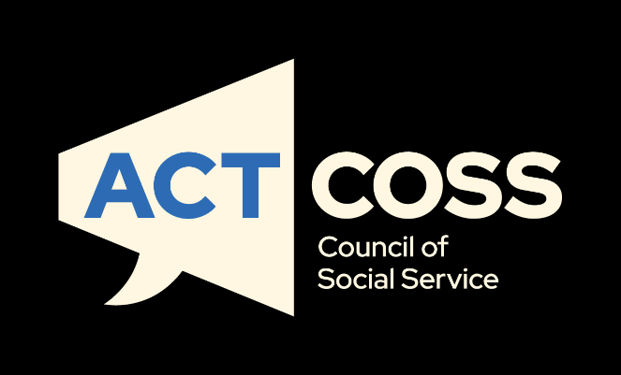
Inquiry into the extent and nature of poverty in Australia
February 2023
actcoss@actcoss.org.au
actcoss.org.au
02 6202 7200
ABN 81 818 839 988
02 6202 7200
ABN 81 818 839 988
actcoss@actcoss.org.au
actcoss.org.au

About ACTCOSS
ACTCOSS acknowledges Canberra has been built on the land of the Ngunnawal people. We pay respects to their Elders and recognise the strength and resilience of Aboriginal and/or Torres Strait Islander peoples. We celebrate Aboriginal and/or Torres Strait Islander cultures and ongoing contributions to the ACT community.
The ACT Council of Social Service Inc. (ACTCOSS) advocates for social justice in the ACT and represents not-for-profit community organisations.
ACTCOSS is a member of the nationwide COSS Network, made up of each of the state and territory Councils and the national body, the Australian Council of Social Service (ACOSS).
ACTCOSS’s vision is for Canberra to be a just, safe and sustainable community in which everyone has the opportunity for self-determination and a fair share of resources and services.
The membership of the Council includes the majority of community-based service providers in the social welfare area, a range of community associations and networks, self-help and consumer groups and interested individuals.
ACTCOSS advises that this document may be publicly distributed, including by placing a copy on our website.
Contact Details
Phone 02 6202 7200
Address Weston Community Hub, 1/6 Gritten St, Weston ACT 2611
Email actcoss@actcoss.org.au
Web actcoss.org.au
CEO Dr Gemma Killen
Policy Officer Avan Daruwalla
February 2023
© Copyright ACT Council of Social Service Incorporated
This publication is copyright, apart from use by those agencies for which it has been produced. Non-profit associations and groups have permission to reproduce parts of this publication as long as the original meaning is retained and proper credit is given to the ACT Council of Social Service Inc (ACTCOSS). All other individuals and Agencies seeking to reproduce material from this publication should obtain the permission of the CEO of ACTCOSS.
An ACT Government funded initiative.
Table of Contents
About ACTCOSS 2
Acronyms 4
Introduction 5
The impacts of poverty amongst different demographics and communities 6
Mechanisms to address and reduce poverty 6
Recommendations 7
Rates and drivers of poverty 7
The relationship between economic conditions and poverty 8
The impact of poverty on individuals 11
Housing security 11
Energy costs and concessions 14
The relationship between income support payments and poverty 16

Acronyms
ABS Australian Bureau of Statistics
ACCC Australian Competition and Consumer Commission
ACOSS Australian Council of Social Service
ACT Australian Capital Territory
ACTCOSS ACT Council of Social Service Inc.
AER Australian Energy Regulator
AHURI Australian Housing and Urban Research Institute
CPI Consumer Price Index
CRA Commonwealth Rent Assistance
DSP Disability Support Pension
GDP Gross Domestic Product
GST goods and services tax
SACOSS South Australian Council of Social Service

Introduction
The ACT Council of Social Service (ACTCOSS) welcomes this opportunity to make a submission to the Inquiry into the extent and nature of poverty in Australia. In this submission we draw heavily from our 2022 ACT Cost of Living Report and focus on inequality and poverty in the ACT region.

ACTCOSS is supportive of submissions from the Australian Council of Social Service (ACOSS) and others in the COSS network, as well as the Raise The Rate campaign calling on the Government to permanently and adequately raise the rate of income support payments to keep people out of poverty, and the Everybody's Home campaign for a better, fairer housing system.

Whilst the ACT has the highest average weekly earnings in Australia, the incredibly high cost of living in Canberra means that many households cannot afford the fundamentals of a healthy life such as housing, food, transport, health services and energy.

The most recent ACTCOSS Cost of Living report for the ACT indicates that:
  - The withdrawal of JobKeeper and the Coronavirus Supplement saw the poverty rate in the ACT increase to approximately 9%, representing an estimated 38,300 Canberrans – including approximately 9,000 children.
  - ACT has an estimated shortfall of 3,100 social housing properties, with 8,500 additional social housing dwellings needed by 2036 to meet the ACT’s current and projected need.
  - At the 2016 Census, there were almost 1,600 people experiencing homelessness in the ACT.

The COVID-19 pandemic, natural disasters and the war in Ukraine have all had a significant impact on low-income households in Australia including incomes, employment, and fluctuating cost of living. Despite the $50/fortnight payment increase to JobSeeker in April 2021, the phasing out of the Coronavirus Supplement between December 2020 and December 2021 has returned the support payment to well below the poverty line.
As of December 2021:
  - A single person without children on JobSeeker has an income $138 below the poverty line of $457 per week.
  - A single person on Youth Allowance (other) has an income $197 below the poverty line per week.
  - A single parent with two children, on JobSeeker has an income $108 below the poverty line of $731 per week.

The impacts of poverty amongst different demographics and communities
Marginalised and oppressed community groups face an elevated risk of experiencing socioeconomic disadvantage and poverty. Notably, Aboriginal and/or Torres Strait Islander people, people from culturally and linguistically diverse backgrounds, people with disability, people aged 65 years and older and women are all disproportionately vulnerable to poverty.
Policy concerning poverty alleviation and cyclical disadvantage cannot be appropriately addressed without meaningful consideration of diverse communities. The accessibility, useability and effectiveness of services and strategies relies on active consultation with marginalised community members.

Whilst we do not have access to clear demographic poverty data around these populations, we have consistently heard from our member organisations that where demand for their social client services has rapidly increased in recent years, demand amongst vulnerable and marginalised groups has increased exponentially.

Mechanisms to address and reduce poverty
ACTCOSS is of the firm belief that reducing poverty and alleviating cost of living pressure is a shared and pressing responsibility for state/territory Governments and the Federal Government. Targeted support and concessions, transport, and healthcare services are all integral action areas for the ACT Government to tackle, however if the Federal Government remain idle then low-income households and individuals will continue to struggle with cost of living pressures and housing unaffordability.
The rapidly increasing cost of living coupled with the withdrawal of COVID-19 income support measures has hit low-income households hardest. Following recession, our community has left behind those with complex needs resulting in increased demand for support and social services from our underfunded, overworked, and underpaid community sector.
Building more social and affordable housing is a critical responsibility of both levels of government in providing stability, safety and shelter. Further, to meet the human rights of all Australians and ensure that all community members can cover the cost of essentials, the Federal Government needs to commit to a minimum income floor in our income support system by lifting all base rates of payment to at least $73 a day (the same level as the pension and pension supplement) and indexing them to wages as well as prices.
Reinforcement of the urgent need for the government to take action against the below recommendations is provided in subsequent sections of this submission.

Recommendations
ACTCOSS calls upon the Australian Government to take actions to redress a range of cost of living issues and lift disadvantaged community members out of poverty by investing in:
- A minimum income floor in our income support system by lifting all base rates of payment to at least $73 a day (the same level as the pension and pension supplement) and indexing them to wages as well as prices
- Supplementary payments that meet specific needs, including the maximum rent threshold for Commonwealth Rent Assistance (CRA) by 50% (resulting in a doubling of the payment), providing a Disability and Illness Supplement of at least $55 a week, as well as a Single Parent Supplement that recognises the costs of single parenthood
- The abolition of compulsory income management and establishment of an independent Social Security Commission to advise the Parliament on income support payment settings ongoing.
- A 25,000 dwelling per year social and affordable housing package to reduce homelessness and kick-start housing construction and growth in jobs and incomes
- A new affordable rental investment incentive scheme
- A national First Nations housing strategy to boost the stock of community housing and new remote housing agreement
- Social and affordable housing to address the current and projected shortfall (in partnership with State/Territory Governments)
- Energy concessions reforms that are targeted and sufficient to meet need including modelling percentage-based energy concessions, and reviewing and expanding eligibility criteria

Rates and drivers of poverty
The COVID-19 pandemic, subsequent recession and record high unemployment, were accompanied by a major decline in poverty due to the introduction of robust income supports (the JobKeeper Payment and Coronavirus Supplement) which temporarily lifted countless households out of poverty. In the ACT our poverty rate dropped from a pre-COVID estimate of 8.6% to 5.2% by October 2020. Following withdrawal of JobKeeper and the Coronavirus Supplement, the ACT poverty rate increased above pre-COVID estimates to approximately 9%, representing an estimated 38,300 Canberrans – including approximately 9,000 children.

The relationship between economic conditions and poverty
The COVID-19 pandemic, natural disasters and the war in Ukraine have all produced major stressors to cost of living for low-income households in Australia. March 2022 saw the largest quarterly and annual increases in the Consumer Price Index since the introduction of the goods and services tax (GST) on 1 July 2000 (and CPI continued to rise further in 2022). Recent years have also brought huge increases in the price of essential goods and services, incomparable to growth seen in the past two decades.
In the ACT, the last five years have seen the price of goods and services increase by:
  - automotive fuel (34.9%) and transport (19.2%)
  - electricity (28.1%) and gas (24.0%)
  - medical and hospital services (21.4%)
  - housing (19.0%) and rents (13.1%)
  - education (17.0%)
  - meat and seafoods (15.8%).

These price increases have a major impact on low-income households, especially in facing the withdrawal of COVID-19 supports and resulting poverty. Low-income households (those in the 1st and 2nd income quintiles/bottom 40% of the income distribution) are also disproportionately impacted by pricing of essential goods and services, and this non-discretionary spending accounts for a greater proportion of their income than higher-income households.
Table 1 below shows how expenditure across different groups of goods and services varies depending on household income, highlighting that housing, food, and transport account for over half (55.1%) of expenditure for ACT households in the lowest income quintile.

Table 1 Proportion of household expenditure on goods and services by equivalised disposable household income quintiles, ACT, 2015-16 (%)
Goods and services | Q1 - low | Q2 | Q3 | Q4 | Q5 - high | All
Current housing costs (selected dwelling) | 23.2 | 18.4 | 22.3 | 13.6 | 14.0 | 17.7
Food and non-alcoholic beverages | 20.5 | 17.1 | 17.2 | 15.1 | 14.2 | 16.1
Transport | 11.4 | 12.4 | 12.7 | 16.5 | 14.4 | 13.4
Recreation | 9.5 | 10.7 | 12.9 | 13.8 | 22.1 | 14.4
Household furnishings and equipment | 9.0 | 3.3 | 5.2 | 3.9 | 3.4 | 4.5
Domestic fuel and power | 4.0 | 4.4 | 3.0 | 2.2 | 2.4 | 2.8
Miscellaneous goods and services | 3.9 | 4.2 | 9.2 | 7.9 | 12.4 | 8.5
Communication | 3.8 | 3.1 | 2.9 | 2.8 | 2.4 | 2.8
Medical care and health expenses | 3.4 | 5.7 | 4.5 | 7.1 | 5.4 | 5.5
Clothing and footwear | 3.3 | 3.0 | 4.6 | 3.6 | 2.5 | 3.2
Household services and operation | 2.6 | 5.2 | 3.5 | 3.7 | 2.4 | 3.1
Alcoholic beverages | 1.6 | 2.3 | 2.2 | 2.1 | 1.6 | 1.8
Education | 1.6 | 6.3 | 3.4 | 3.2 | 4.6 | 3.6
Personal care | 1.3 | 2.7 | 2.0 | 1.6 | 1.5 | 1.7
Tobacco products | 0.3 | 1.1 | 0.8 | 0.2 | 0.1 | 0.4
Source: ABS, ‘Table 21.1 Household Expenditure, Broad expenditure groups, Equivalised disposable household income quintiles, ACT’, Household Expenditure Survey, Australia: Summary of Results, 2015-16 financial year, ABS, 2017, accessed 8 July 2021.

Table 2 illustrates the increasing cost of living in the ACT and Australia given changes in the Australian Bureau of Statistics’ (ABS) Consumer Price Index (CPI) over the 12 months from December 2020 to December 2021 and over the five years from December 2016 to December 2021.

Table 2 CPI changes for key household expenditure areas, Canberra and Australia, Dec 2020 – Dec 2021 and Dec 2016 – Dec 2021
Cost of Living area | Canberra CPI Change - 1yr  Dec20-Dec21  (%) | Australia CPI Change - 1yr  Dec20-Dec21  (%) | Canberra CPI change - 5yrs  Dec16-Dec21  (%) | Australia CPI Change - 5yrs  Dec16-Dec21  (%)
Food & Non-Alcoholic Beverages | 1.9 | 1.9 | 8.0 | 8.2
- Bread and cereal products | 0.9 | 1.2 | 4.3 | 5.6
- Meat and seafoods | 2.1 | 2.5 | 15.8 | 15.7
- Dairy & related products | 1.9 | 1.8 | 8.6 | 9.7
- Fruit and vegetables | 0.1 | 0.2 | 0.9 | 2.6
- Food products n.e.c. | 1.5 | 1.6 | 3.0 | 3.4
- Non-alcoholic beverages | 1.6 | 2.0 | 9.5 | 8.1
- Meals out and takeaway foods | 2.7 | 2.4 | 11.1 | 10.5
Alcohol & Tobacco | 1.1 | 1.1 | 31.2 | 35.2
- Alcohol | 1.3 | 1.1 | 11.5 | 9.1
- Tobacco | 0.9 | 1.1 | 82.1 | 82.9
Clothing & Footwear | -1.6 | -0.3 | -3.8 | -3.8
Housing | 5.1 | 4.0 | 19.0 | 8.2
- Rents | 3.0 | 0.4 | 13.1 | 0.7
- New dwelling purchase | 8.0 | 7.5 | 18.0 | 14.7
- Property rates & charges | 10.1 | 3.3 | 36.9 | 12.6
- Utilities | 0.9 | 2.3 | 21.0 | 5.2
- Water & sewerage | 1.5 | 0.3 | 6.0 | 4.5
- Electricity | 6.6 | 3.0 | 28.1 | 3.0
- Gas | -6.2 | 2.6 | 24.0 | 12.7
Furnishings, household equipment/ services | 5.0 | 3.6 | 7.1 | 7.0
Childcare | 8.8 | 6.5 | 7.9 | 13.8
Health | 2.3 | 3.3 | 16.5 | 17.6
- Pharmaceutical products | -0.6 | 1.0 | 4.8 | 5.1
- Therapeutic appliances and equipment | 0.0 | 0.5 | 3.2 | 1.0
- Medical and hospital services | 3.1 | 4.3 | 21.4 | 23.0
- Dental services | 1.9 | 0.9 | 6.8 | 7.4
Transport | 14.2 | 12.5 | 19.2 | 17.3
- Automotive Fuel | 34.7 | 32.3 | 34.9 | 34.5
- Public Transport | 0.1 | 1.0 | 5.4 | 5.7
Communication | -0.4 | -0.5 | -13.6 | -14.0
- Telecommunication Equipment & Services | -0.8 | -0.8 | -15.3 | -15.2
Recreation & culture | 1.7 | 2.1 | 8.3 | 5.8
- Audio, visual and computing equipment | 0.0 | 0.4 | -18.3 | -19.9
- Audio, visual and computing media & services | 3.5 | 3.2 | 9.9 | 7.8
Education | 2.6 | 0.6 | 17.0 | 12.1
Insurance & financial services | -0.6 | 2.2 | -3.2 | 7.1
- Insurance | 2.6 | 3.4 | 8.9 | 13.8
CPI All Groups | 4.0 | 3.5 | 12.1 | 10.2
Source: ABS, ‘Table 10. CPI: Group, Sub-group and Expenditure Class, Percentage change from corresponding quarter of previous year by Capital City’ and ‘Table 11. CPI: Group, Sub-group and Expenditure Class, Percentage change from previous quarter by Capital City’ [time series spreadsheets], Consumer Price Index, Australia, Reference period December 2021, ABS, 2021, accessed 21 April 2022.
Since December 2021, prices of most essential goods and services have continued to rise. March 2022 saw the highest quarterly and annual price rises in over 20 years.

The impact of poverty on individuals
We know that poverty impacts all aspects of quality of life across a spectrum of issues. Without access to a sufficient income, individuals and their families struggle to meet their basic needs and maintain stability. Employment, health, and education outcomes all suffer where people are financially disadvantaged and locked out of income security.

Housing security
Housing has consistently presented the greatest cost of living pressure for low-income households in the ACT. As a shared responsibility, housing is an area for much needed intervention and investment from both State/Territory and Federal Governments. In the ACT, housing costs low-income households on average between 24% and 35% of their gross household income (Figure 1). As the second most expensive capital city to purchase a house in (after Sydney), Canberra’s cost of purchasing a home is completely unaffordable. Likewise, Canberra’s private rental market is also becoming less and less affordable.

Figure 1 Housing costs as a proportion of gross household income, ACT, 2017-18
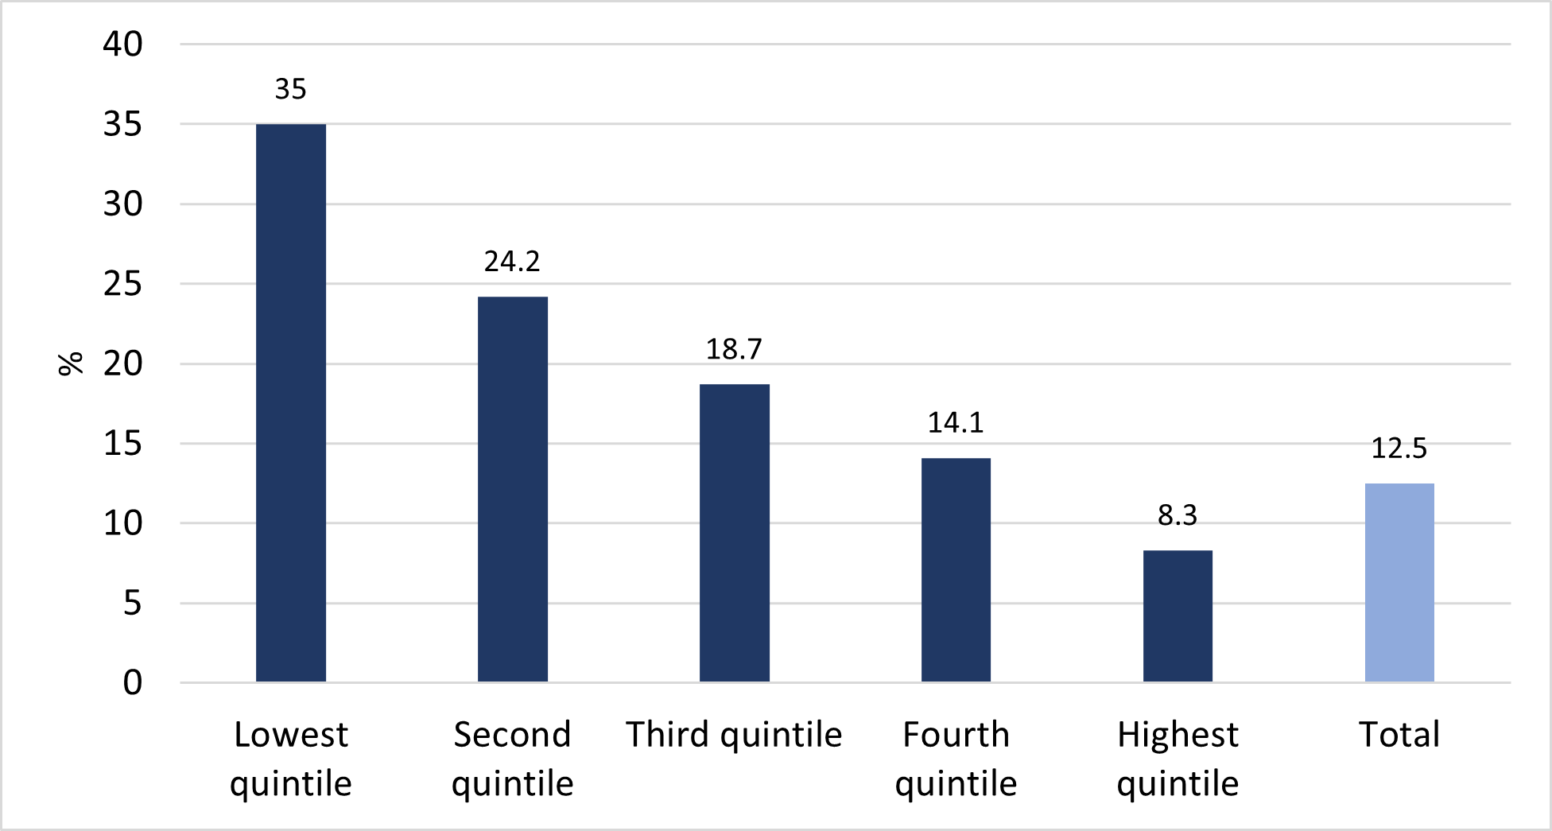
Source: ABS, ‘Table 12.3 Housing Costs as a Proportion of Gross Household Income, Selected household characteristics, States, and territories, 2017–18’, Housing Occupancy and Costs, 2017-18 financial year, ABS, 2019, accessed 8 July 2021.
A household in the two lowest income quintiles is in housing stress when spending more than 30% of gross household income on housing. The ACT has Australia’s highest rate of rental stress among lower income private rental households at 61.3%.
Commonwealth Rent Assistance (CRA) provides much-needed assistance to low-income tenants in private housing but has failed to keep up with rent increases. Even where a person receives the maximum amount of CRA combined with JobSeeker payments (which would total $390/week for a single person at the maximum), the amount would be insufficient to pay rent. The ACT has the highest proportion of households receiving CRA who are being paid at the maximum payment rate – 82.1% compared to 76.3% nationally. More than half (53.9%) of ACT households receiving CRA are experiencing rental stress and 28.4% are experiencing severe rental stress (paying more than 50% of income on rent).
CRA needs to be significantly increased to address the major burden of housing stress that is keeping many people in poverty. Maximum rent thresholds for low-income rentals need to increase by 50%, which would result in a payment increase of 100%, a doubling of the payment.
Additionally, the chronic shortage of affordable private rentals is exacerbated by, and in turn worsens the impacts of the shortage of social and affordable housing in the ACT.
It has been estimated that the ACT has:
  - A shortfall of 3,100 social housing properties,
    - with 8,500 additional social housing dwellings needed by 2036 to meet the ACT’s current and projected need.
  - A current shortfall of 2,400 affordable housing dwellings in the ACT,
    - with 3,400 additional affordable housing dwellings required by 2036 to meet current and projected need.

Government investment in social housing stock is essential to address this major shortfall. The urgency of investment is underlined by the 3,169 applications for social housing in the ACT as of 30 January 2023. These applications for standard housing are facing an average waiting time of 1,089 days (Table 3).

Table 3 Housing ACT social housing waiting list and average wait times, 30 January 2023
Application Category | Number of Applications | Average Waiting Time (days)
Priority Housing | 153 | 324
High Needs Housing | 2,050 | 1,150
Standard Housing | 966 | 1,793
Total applications | 3,169 | n/a
Source: ACT Government Community Services Directorate, Social Housing Waiting List, ACT Government Community Services Directorate, 30 January 2023, accessed 2 February 2022.
Responding to chronic homelessness and the housing affordability crisis requires direct public investment in social housing. This is a cost-effective way to boost growth in jobs and incomes while also avoiding significant social costs associated with homelessness and related issues such as domestic and family violence. It has been estimated that for every $1 million of public investment in social housing, gross domestic product (GDP) is boosted by $1.3 million. Affordable rents, security of tenure, and other supports available to financially vulnerable people in social housing reduce their risk of homelessness by more than half.

Energy costs and concessions
With electricity and gas costs on the rise, low-income households are spending a concerningly high proportion of their income on energy costs, particularly given poor home energy efficiency, and lack of access to renewable solutions (including solar panels and battery storage systems). The high cost of energy in the ACT and nationally require that targeted and sufficient energy concessions be implemented. If the Government does not ensure that energy concessions meet need then low-income households will be left worse off and further disadvantaged.

In December 2022, the South Australian Council of Social Service (SACOSS) and Australian Council of Social Service (ACOSS) released their Summary Report: 'Reforming electricity concessions to better meet need'. The report analyses energy costs and inequities, underscoring the need for Energy Ministers to enable more effective and robust energy concessions. With approximately 3 million Australian households receiving energy concessions or rebates, far too many of these and other people are still unable to afford energy costs. There is also significant concern that eligibility restrictions and criteria for concessions are unsuitable and have created accessibility barriers for many people struggling with the cost of energy.

Concessions that fail to make energy costs accessible to low-income households can have serious negative health and social outcomes. Consequences of energy unaffordability are vast and include growing energy debt, defaulting on other financial obligations (which can lead to loss of housing), forgoing other essential goods and services (including food and medicine), and being forced to limit energy consumption and living in harmful indoor temperatures.

Flat rate concessions are simply not appropriate to meet needs, nor do they respond to the significant changes that the market sees in prices, seasons, circumstances, and technology. In 2018, the Australian Competition and Consumer Commission (ACCC) determined that flat rate concessions were a poorly targeted and inefficient policy and not fit for purpose (particularly given differing income and consumption levels amongst different households). The ACCC joined countless energy researchers and advocates calling for Energy Ministers to establish means testing, more targeted concessions in addition to fixed rebates, percentage discounts and other interventions to improve energy access.

In the ACT the price of electricity is expected to increase by 4% in 2022-23 (on top of existing increases in recent years. Simultaneously, the ACT is acting in line with commitments to transition to net zero greenhouse gas emissions earlier than most other jurisdictions (excluding Tasmania). These compounding factors are likely to leave low-income households in additional financial stress without appropriate mechanisms to protect against prohibitive energy prices.

It is imperative that the ACT’s Utilities Concession is adjusted to reflect the high costs of electricity and gas (as well as other utilities including water) for low-income households. Further, the State and Territory Government needs to invest in supports that can reduce the expense of energy bills for low-income energy inefficient households (e.g., those lacking insulation). By improving the minimum standard for energy efficiency in rental properties, Governments can improve environmental outcomes as well as improving conditions for renters in these properties (e.g., by including energy efficient heating and cooling requirements).

Earlier this month, ACTCOSS released our 2023 report - A Just and Inclusive Gas Transition in the ACT about prioritising equity on the ACT’s pathway to electrification. The report finds that systemic barriers and poverty will be exacerbated by energy transition if targeted and appropriate measures are not employed to ensure that disproportionately benefits higher-income households. Low-income households experience a ‘poverty premium’ when trying to access long-term energy savings as the upfront costs of transitioning from gas to electric appliances can be so prohibitive. Further, the phasing out of fossil-fuel gas in the ACT is likely to leave those low-income households (who cannot afford to transition) paying significantly increased gas prices due to the high costs of declining customers and rising wholesale prices. Without the disposable income necessary to transition to become an all-electric household, or as private renter who does not necessarily have oversight over household energy sources – people with the least may be left paying the most.

The relationship between income support payments and poverty
The phasing out of the Coronavirus Supplements between December 2020 and December 2021 recreated the poverty gap that had been alleviated by the temporary supplements. Since then, poverty rates have continued to grow.
The removal of the Coronavirus Supplement on 31 March 2021 returned income support payments to between $100 and $200 per week below the poverty line. This was despite a $50 per fortnight increase to the base rate from 1 April 2021 – the first real increase in these payments in over 25 years. By December 2021, payments for a single person with no children on JobSeeker or Youth Allowance (other) were $138 and $197 below the poverty line per week (Figure 2). For a single parent on JobSeeker the payment dropped to $108 below the poverty line per week.

Figure 2 Weekly income poverty gap by income type, December 2020 – December 2021
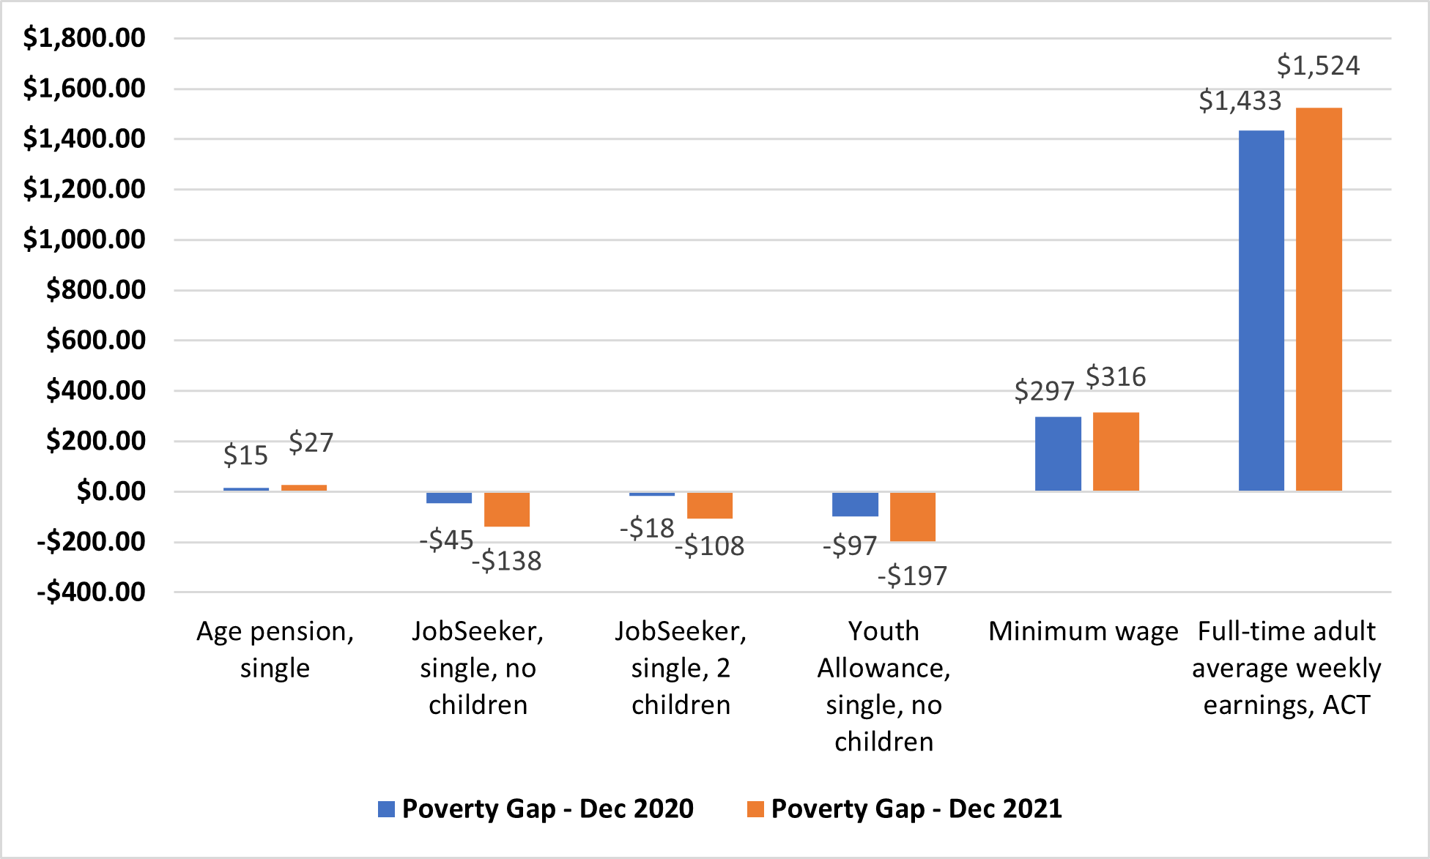
Source: Chart derived from Services Australia, A guide to Australian Government payments, Historical versions from 20 September – 31 December 2020 to 20 September – 31 December 2021, Services Australia, Canberra, 2020-21, accessed 21 April 2022.
For JobSeeker and Youth Allowance (other) recipients the loss of the Coronavirus Supplement meant that while weekly living costs increased by around $10-$20 per week, their incomes fell by between $90-$100 per week – in real terms this meant an even bigger reduction in income of between $104-$110 per week (Figure 3).

Figure 3 Change in weekly income vs change in living costs, December 2020 – December 2021
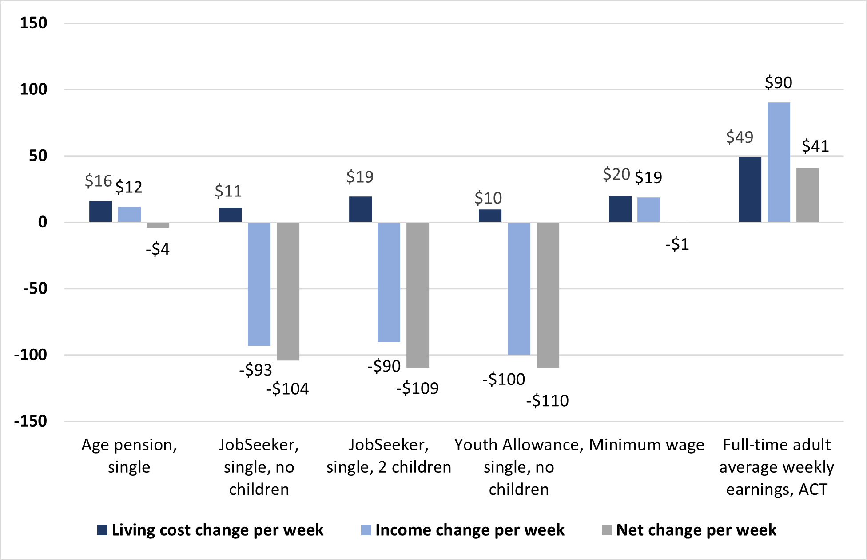
Source: Chart derived from ABS, Selected Living Cost Indexes, Australia, Reference period December 2021, ABS website, 2022; Services Australia, A guide to Australian Government payments, Historical versions from 20 September – 31 December 2020 to 20 September – 31 December 2021, Services Australia, Canberra, 2021-22, accessed 21 April 2022; Fair Work Commission, National Minimum Wage Order 2020, Fair Work Commission, Melbourne, 2020; Fair Work Commission, National Minimum Wage Order 2021, Fair Work Commission, Melbourne, 2021; ABS, Average Weekly Earnings, Australia, Nov 2020 & Nov 2021, ABS, Canberra, 2021-22, accessed 21 April 2022.
For Anti-Poverty Week 2022, Care Financial Counselling Service and Advocacy For Inclusion prepared example budgets for a person on Disability Support Pension (DSP) living in different situations and for a low-income family living in the ACT.
Care Financial presents budgets for a person on DSP in public housing (Table 4), and for a low-income family (Table 5). Likewise, in their White Paper on Income Support, Advocacy for Inclusion has presented an example budget (Table 6) for a person on Disability Support Pension (DSP) living in a private rental with substantial barriers to accessing transport and a cost of disability premium. All these budgets are drawn from data and the lived experience of ACT consumers.

Table 4 – Example Budget for Person on DSP in public housing (prepared by Care Inc Financial Counselling Service)
1/10/2022 | INCOME | Person 1
 | Gross | 936.80
Single person household | Tax
 | Nett | 936.80 | Total
 | Supplement | 75.60 | Household
Fortnightly DSP $1026.50 | Energy Supp | 14.10 | Income
Annual Income $30,635.80 | TOTAL | 1,026.50 | 1,026.50
EXPENDITURE - Fortnight |  | (Per Annum)
HOUSING | $
Rent | 234.20
Rent arrears $430 paying $30 p/fn | 30.00
Rates - General / Water & Sewerage
Insurance- Contents | 15.00
Electricity | 55.00
Gas
Internet | 40.00
Telephone - mobile prepaid $40 p/m | 20.00
Maintenance/Replace Goods | 5.00
Other (specify) | 10.00 | lawnmowing/garden help
Sub-Total | 409.20
PERSONAL
Superannuation/Life Insurance/Union fees
Medical/chemist/gap payments | 103.00 | ongoing chronic health conditions and scripts
Optical/dental | 40.00 | needs new dentures/glasses
Education/Child Pocket Money
Food/Supermarket | 205.00 | allergies- needs special foods
Milk/bread | 10.00
Lunches, Take-aways
Smokes
Clothes/Dry Cleaning | 5.00 | needs orthotics
Sport/Hobbies/Lotto
Newspapers/subcriptions/memberships
Entertainment/Recreation
Gifts, Christmas | 20.00 | family
Child Care/Child Support Payments
Haircuts/Personal items/Holidays | 5.00
Pets/Vets | 10.00 | dog food/tworm tablets
Sub-Total | 398.00
TRANSPORT
Registration -Car/Trailer/Van | 22.00
NRMA Membership | 4.00
Petrol/oil | 70.00
Repairs/service | 40.00
Public Transport/Taxis/Parking | 5.00
Licence |  | free with pension card
Car Insurance | 25.00
Other (specify)
Sub-Total | 166.00
TOTAL LIVING EXPENSES | 973.20
REGULAR REPAYMENTS
Centrelink advance - new tyres | 40.00 | $400 o/s
BNPL - winter clothes and shoes | 27.00 | $88 o/s
Vet bill - operation | 20.00 | $227 o/s
TOTAL REPAYMENTS | 87.00
TOTAL EXPENDITURE | 1,060.20
 |  | SURPLUS/DEFICIT | -33.70
C This I/E Sheet prepared by Care Inc Financial Counselling Service, Ph 6257 1788

Table 5 – Example Budget for Person on DSP with transport barriers and disability costs in private rental (prepared by Advocacy for Inclusion)
  - AFI have prepared an estimated model household Budget for a fortnight in Canberra (assumes person in rented accommodation, single, unable to drive with additional cost of disability needs for food prep, transport, heating)
Expenses | Amount ($)
Rent | 1300
Basic utilities (electricity, gas, water) | 97.38
Mobile phone and home internet | 13.85 + 34.62
Taxi’s | 246.00
Groceries + cost of disability loading | 246.00 + 8.61
Personal care and pharma + cost of disability loading | 54.25 + 1.90
Healthcare/pharma/dental/unanticipated event | 240.00
Total Due (not incl. unanticipated event) | 2002.61
Total Income (DSP + CRA + Supplements) | 1178.1
Total Left Over | -$824.51
Commentary on sources and some assumptions
Rent: $650 per week corresponds to SQM Research Weekly Rents Index which represents the combined median weekly rent for all houses and all units in Canberra for the week 28 September 2022
Basic utilities: figure taken from Canberra.com.au – the available cost of living material is distributed by the Australian Capital Territory Government as a general reference source. The figures also correspond with prices in Finder’s Consumer Sentiment Tracker.
Phone and internet: the average phone bill estimate represents a mid-point of $30 p/m ($28 for prepaid and $33 for post-paid) (Canstar Blue, 2022). Finder (2022) states the average broad band user spends $75 p/m on their internet plan
Taxi’s: 13% of DSP recipients live in postcode 2615. The estimated fare from this postcode to Canberra Hospital is $70 one way, to the closest supermarket is $15 one way, and to the city centre $55 one way. Assuming 2 x return supermarket trips, 1 x return hospital and 2 x return city centre trips per fortnight (and taking ACT Taxi Subsidy Scheme into account). This estimate is also conservative as it does not take into account extra costs associated with Wheelchair Accessible Vehicles. For a similar estimate, see ACTCOSS’s (2016) ACT Cost of Living Report: Transport, p. 56.
Groceries + cost of disability loading: Canstar Blue research found that $123 represents the average weekly grocery bill for a low-income household, as of July 2022. The disability loading represents the extra, hidden costs of disability. Comparing different survey responses, Frisch (2001) states that it is reasonable to anticipate additional costs between 2 and 5 percent for groceries. A conservative mid-point estimate (3.5%) was used here.
Personal care and pharma + cost of disability loading: This figure corresponds to Hughes and Purdey’s (1999) Survey results regarding median annual costs for people with disability. It has been updated to reflect 2022 values. The cost of disability loading refers to Frisch’s (2001) estimate of 2-5%. A conservative mid-point estimate (3.5%) was used here.
Healthcare/pharma/dental/unanticipated event: Household whitegood repair estimates start at $195 in the main suburbs of Canberra. Conservative one-off estimate here equates to an appliance repair which requires additional part (+$45.00). This cost is difficult to calculate as it could cover a large range. For example, emergency dental such as root canal can cost up to $1100; a dental extraction may be up to $600. Note: Approximately 40% of DSP recipients could not raise $2000 within a week.
C These estimates prepared by Advocacy for Inclusion Contact Craig Wallace Head of Policy Craig@advocacyforinclusion.org.
The example budgets for the DSP recipient (Table 4 and 5) demonstrate that it is impossible to rent privately on Centrelink payments, and that living in public housing is still unaffordable. In both cases there is no financial flexibility for when things inevitably go wrong (i.e., when a washing machine/car need significant repairs or in the case of illness not covered by Medicare etc). However, comparatively it is still far preferable for people on income support to be housed in government funded public housing (speaking to the urgent need for investment in more fit-for-purpose public housing).

Table 6 – Example Budget for low income family (prepared by Care Inc Financial Counselling Service)
Context of example budget:
  - Husband 37yrs and wife 35yrs with two children aged 8 & 12
  - $550 per week rent
  - Husband full-time on approx. median wage $65,000 ($1,000 per week net)
  - Wife 3 days a week on minimum wage $21.38/hr or $513.12 per week ($476.12 per week net)
  - $3,500 credit card debt at 15%. $5,000 limit $100 per month repayment
  - $10K car loan 5yrs at 8% $200 per month repayment
  - Second car owned outright
  - Basic health cover $250 per month
  - $2,000 holiday each year
  - $1,000 Christmas and birthdays
  - Average electricity per annum $1,600 (low estimate): selectra.com.au
  - Gas $150 per quarter: Canstar average gas bills (low estimate)
  - Phone/Internet: 2 X moblie at $50 per month each & home internet at $80 per month
  - Average weekly supermarket spend: Canstar Blue: Australian Living Costs

Date: 23 September 2022 | INCOME
 | Gross Income | 2,500.00
Name: Mr Client | minus tax | 500.00 |  | Total
 | Net income | 2,000.00 |  | Household
Name: Mrs Client | Gross Income | 1,026.24
 | minus tax | 74.00
 | Net income | 952.24
Weekly | Centrelink Income |  |  | Income
Fortnightly | Family Payments - FTB A |  | 243.74
Monthly | Renet Assistance |  | 74.48
 | TOTAL | 2,952.24 | 318.22 | 3,270.46
EXPENDITURE | Fortnightly amount
HOUSING | $
Rent/Mortgage | 1,100.00
Land Rates
Water and Sewerage | 9.62 | $250 p.a estimate and if lease
Electricity | 61.54 | $400 per quarter
Gas | 23.08 | $150 per quarter
Telephone - landline |  | Included in home internet
Telephone - mobile | 46.15 | $100 per month
Building/Contents Insurance | 13.46 | $350 per year
Internet | 36.92 | $80 per month
Pay TV/Stan Netflix | 13.85 | Various at $30 per month
Garden/Home maintenance
Maintenance/Replace Goods
Sub-Total | 1304.62
PERSONAL
Insurance: Funeral/Life/Income Protection |  | Included in superannuation
Union/Super Contributions |  | No personal cont.
Health Insurance | 115.38 | Basic family cover @ $250 per month
Food/Supermarket | 500.00
Milk, bread, top ups | 100.00
Medication/Doctor/Dentist/Optical | 26.93 | $50 per month chemist and est. $100 per yr co-payments
Lunches, take-aways | 100.00
Smokes/alcohol |  | non-smoking/non-drinking
Clothes/Shoes | 76.92 | $2,000 per year for family of 4
Sport, hobbies, lotto | 43.85 | $15 per week lotto $30 per month Gym
Bank fees
Childrens sports | 15.38 | Soccer & Football $400 per year
Entertainment/Recreation | 200.00
School fees | 19.23 | $500 per year for excursions/camps
Education/books/uniforms | 19.23 | $500 per year
Pocket money | 40.00
Gifts, Christmas, Birthdays | 38.47 | $1,000 per year
Hair care, cosmetics, make up |  | Included in grocery and chemist
Pets/Vets | 19.23 | $500per year
Holidays | 76.92 | $2,000 family holiday each year
Sub-Total | 1391.54
TRANSPORT
Car X 2 | 42.31 | $1,100 per year for 2 cars
Fuel/oil | 200.00 | $50 per week for each car
Insurance | 46.15 | $100 per month for 2 cars
Road Service | 3.85 | $100 per year
Repairs/services | 38.46 | $1,000 per year
Public transport/taxis, | 43.08 | $10 per week MyWay and $50 per month Uber/Taxi
licence | 3.23 | 2 X $210.50 for a 5 year licence
Sub-Total | 377.08
TOTAL LIVING EXPENSES | 3073.24
REGULAR REPAYMENTS/DEBTS
Credit card | 46.15 | $100 per month on $3,500 balance with a $5,000 credit limit
Personal loan car | 92.31 | $200 per month
Afterpay average payment | 40.00
TOTAL REPAYMENTS | 178.46
TOTAL EXPENDITURE | 3251.70
 |  | SURPLUS/DEFICIT |  | 18.76
C This I/E Sheet prepared by Care Inc Financial Counselling Service, Ph 6257 1788

The example budget for a low-income family (Table 6) provides a very small surplus of just $18. There is no room in this budget either for any sort of unexpected costs that arise (i.e., medical, educational, transport costs etc). For households in this position, the likelihood of accumulating savings for out-of-pocket costs are miniscule.
Everyone should be able to keep a roof over their head and cover their basic expenses. But right now, the punishingly low rate of income support is forcing people to make heartbreaking decisions between paying their rent or buying food and medicine. These decisions are being made even harder as the prices of such essential goods and services have increased significantly. Raising the minimum income floor in our income support system to at least $73 a day (and indexing them to wages as well as prices) is fundamental to the alleviation of poverty in Australia.

02 6202 7200
ABN 81 818 839 988

actcoss@actcoss.org.au
actcoss.org.au

ACTCOSS, Factsheet: Poverty and COVID-19 in the ACT, ACTCOSS, Canberra, October 2021, accessed 2 May 2022.
J Lawson, H Pawson, L Troy, R van den Nouwelant and C Hamilton, Social housing as infrastructure: an investment pathway, AHURI Final Report 306, Australian Housing and Urban Research Institute Limited, 2018, p 63, accessed 22 June 2021.
J Lawson, H Pawson, L Troy, R van den Nouwelant and C Hamilton, Social housing as infrastructure: an investment pathway, AHURI Final Report 306, Australian Housing and Urban Research Institute Limited, 2018, p 63, accessed 22 June 2021.
The poverty lines used in this report follow the 50% of median income (before housing costs) poverty lines by family type from: P Davidson, B Bradbury, T Hill & M Wong, Poverty in Australia 2020: Part 1, Overview [PDF], ACOSS/UNSW Poverty and Inequality Partnership Report No. 3, ACOSS, Sydney, 2020, accessed 2 May 2022.
ABS, op. cit.; E Davidson, Hidden disadvantage among women in the ACT, Women’s Centre for Health Matters, Canberra, June 2018, <http://www.wchm.org.au/wp-content/uploads/2018/06/Hidden-disadvantage-among-women-in-the-ACT-final.pdf>;
ACTCOSS, 2022 ACT Cost of Living Report, ACTCOSS, Canberra, May 2022, accessed 20 January 2022.
ACTCOSS, Factsheet: Poverty and COVID-19 in the ACT, ACTCOSS, Canberra, October 2021, accessed 2 May 2022.
ABS, CPI rose 2.1% in the March 2022 quarter [media release], ABS, Canberra, 27 April 2022, accessed 28 April 2022.
ACTCOSS, 2021 ACT Cost of Living Report, ACTCOSS, Canberra, August 2022, accessed 28 April 2022.
ABS, Consumer Price Index, Australia, March 2022, Capital cities comparison, Canberra, ABS website, 27 April 2022, accessed 2 May 2022.
Domain, March 2022 House price report, Domain website, n.d., accessed 2 May 2022.
Productivity Commission, ‘Table GA.3 Proportion of lower income private rental households paying more than 30 per cent of income on housing costs, by State and Territory’ [data tables], Report on Government Services 2023: G Housing and homelessness, Productivity Commission, 2023, accessed 2 February 2023.
Productivity Commission, ‘Table GA.12 Income units receiving CRA and paying enough rent to be eligible for maximum assistance, by jurisdiction’ [Data Tables], Report on Government Services 2023: G Housing and homelessness, Productivity Commission, 2023, accessed 2 February 2023.
Productivity Commission, ‘Table GA.13 CRA Income units paying more than 30 per cent of income on rent, with and without CRA, by selected equity group’ & ‘Table GA.14CRA Income units paying more than 50 per cent of income on rent, with and without CRA, by selected equity group’ [Data Tables], Report on Government Services 2023: G Housing and homelessness, Productivity Commission, 2023, accessed 2 February 2023.
J Lawson, H Pawson, L Troy, R van den Nouwelant and C Hamilton, Social housing as infrastructure: an investment pathway, AHURI Final Report 306, Australian Housing and Urban Research Institute Limited, 2018, p 63, accessed 22 June 2021.
L Troy, R van den Nouwelant & B Randolph, Estimating need and costs of social and affordable housing delivery [PDF], UNSW City Futures Research Centre, Sydney, 2019, p. 3, accessed 29 March 2022.
Equity Economics, Nowhere to go: the benefits of providing long-term social housing to women that have experienced domestic and family violence, Equity Economics, 15 July 2021., accessed 5 May 2022.
KPMG, Housing Ministers’ Advisory Committee: Social Housing Initiative Review [PDF], prepared by KPMG for the Department of Housing, September 2012, p 2, accessed 22 June 2021.
D Prentice and R Scutella, What are the impacts of living in social housing? [PDF], Technical Paper No. 1/18, Infrastructure Victoria, Melbourne, 2018, accessed 5 September 2020.
SACOSS, Reforming electricity concessions to better meet need: Summary Report, SACOSS, December 2022, accessed 15 January 2023.
ACCC (2018) Restoring Electricity Affordability and Australia’s competitive Advantage, Retail Electricity Pricing Enquiry, Final Report
AER, State of the Energy Market 2021, AER, Canberra, 2021, p. 270, accessed 12 July 2021.
ACTCOSS, Submission: Minimum energy efficiency standards for rental homes in the ACT consultation paper , ACTCOSS, Canberra, 2021, accessed 2 May 2022.
ACTCOSS, 2023 report - A Just and Inclusive Gas Transition in the ACT, ACTCOSS, Canberra, February 2023, accessed 2 February 2023.

