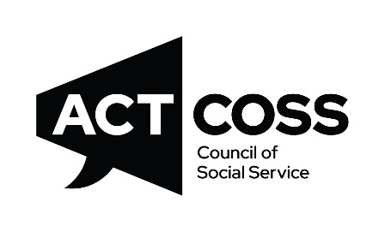

Annual General Meeting 2025

3:45pm Friday 28 November 2024
Denman Village Community Centre

AGENDA

3:15 Registration - due to the Special General Meeting starting at 3:30pm
3:45 Welcome to Country
Welcome and apologies
Approval of Minutes of 2024 Annual General Meeting
4:00 Election of Board Members
4:15 Presentation of reports
- Chair’s report
- Treasurer’s report
  - 2024-25 financial statements
  - Appointment of auditors
- CEO’s report
- Confirmation of Public Officer
4:35 Declaration of Directors and announcement of full Board
4:40 Acknowledgement of outgoing Board members
4:45 Launch of the 2026-2028 ACTCOSS Strategic Plan
4:55 Other business
5:00 Meeting close
Please join us after the meeting for a time of networking as we celebrate another successful year at ACTCOSS!

