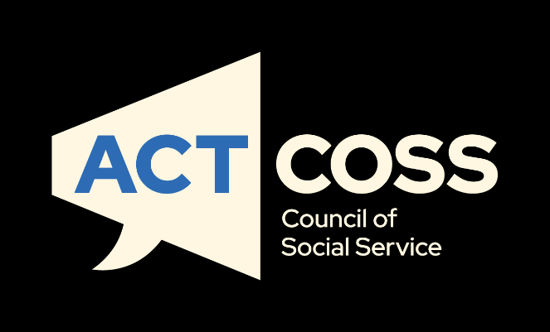
State of the ACT Community Sector Report 2025
actcoss@actcoss.org.au
actcoss.org.au
02 6202 7200
ABN 81 818 839 988
02 6202 7200
ABN 81 818 839 988
actcoss@actcoss.org.au
actcoss.org.au

About ACTCOSS
The ACT Council of Social Service Inc. (ACTCOSS) acknowledges Canberra has been built on the land of the Ngunnawal people. We pay respects to their Elders and recognise the strength and resilience of Aboriginal and/or Torres Strait Islander peoples. We celebrate Aboriginal and/or Torres Strait Islander cultures and ongoing contributions to the ACT community.
ACTCOSS advocates for social justice in the ACT and represents not-for-profit community organisations. ACTCOSS’s vision is for Canberra to be a just, safe and sustainable community in which everyone has the opportunity for self-determination and a fair share of resources and services.
The membership of the Council includes the majority of community-based service providers in the social welfare area, a range of community associations and networks, self-help and consumer groups and interested individuals.
ACTCOSS is a member of the nationwide COSS Network, made up of each of the state and territory Councils and the national body, the Australian Council of Social Service (ACOSS).
ACTCOSS advises that this document may be publicly distributed, including by placing a copy on our website.
Contact Details
Phone 02 6202 7200
Address Weston Community Hub, 1/6 Gritten St, Weston ACT 2611
Email actcoss@actcoss.org.au
Web actcoss.org.au
CEO Dr Devin Bowles
Senior Sector
Development Officer Leanne Bourke, leanne.bourke@actcoss.org.au
December 2025 © Copyright ACT Council of Social Service Incorporated
Acknowledgment of contributors
Leanne Bourke (Project Lead), Michelle Barclay (Project support), Dr Devin Bowles (CEO), with additional support from Emma Agostino, Jacob Priergaard and Penelope Davie.
We acknowledge ACOSS for their significant contribution, including the survey framework that informed the development of our own survey and the previous research that influenced and shaped this work.
We also extend our sincere thanks to the ACT community sector workers for taking the time to complete the survey and share their valuable insights.

This publication is copyright, apart from use by those agencies for which it has been produced. Non-profit associations and groups have permission to reproduce parts of this publication as long as the original meaning is retained and proper credit is given to the ACT Council of Social Service Inc (ACTCOSS). All other individuals and Agencies seeking to reproduce material from this publication should obtain the permission of the CEO of ACTCOSS.
An ACT Government funded initiative.
Table of Contents
About ACTCOSS 3
Acronyms 7
Executive summary 8
Methods 10
1. ACT community sector overview 11
Chapter overview 11
2. Overview of service demands and client complexity 12
Chapter overview 12
2.1 Demand for services and changes in demand 13
2.2 Drivers of demand 17
2.3 Client complexity 18
2.4 Drivers of complexity 19
2.5 Challenges affecting clients accessing services 20
2.6 Client energy hardship 21
2.7 Client financial hardship 22
2.8 Other accessed client services and supports 24
2.9 Capacity to meet demand 25
2.10 Climate related impacts 27
2.11 Responding to growing community demand 28
2.12 Service delivery innovations 34
3. Funding and financial sustainability 35
Chapter overview 35
3.1 Financial position 37
3.2 Financial outlook 37
3.3 Funding sources 39
3.4 ACT Government stream of funding 42
3.5 Adequacy and shortfalls of ACT Government funding 46
3.6 ACT Government funding for core organisational functions 53
3.7 Workforce capacity and staffing challenges 54
3.8 Impacts of inadequate funding 57
3.9 Funding and insurance challenges affecting compliance and risk management 58
3.10 ACT Government indexation 61
3.11 Commissioning 63
3.12 Sustainability of funding 66
4. Workforce overview 67
4.2 Roles in the ACT community sector 70
4.3 Employment status 71
4.4 Hours worked and unpaid labour 72
4.5 Earnings 73
4.6 Time in the sector 75
4.7 Demographics 76
4.8 Volunteers 82
4.9 Housing affordability 83
5. Workforce Challenges 84
Chapter overview 84
5.1 Staffing challenges and workforce capacity 85
5.2 Professional development and supervision 89
5.3 Staff recruitment and retention 91
5.4 Job security uncertainty 92
5.5 Wellbeing and burnout 93
5.6 Measuring workplace burnout 94
5.7 Disillusionment from the sector 99
5.8 Workplace safety 100
5.9 Motivations for staying in the sector 101
5.10 Workers’ future outlook 105
Appendices 108
A. ACT Community Sector Overview 109
1.1 Organisation income 109
1.2 Organisation type 110
1.3 Organisation size 110
1.4 Aboriginal Community Controlled Organisations 112
1.5 Members of ACTCOSS 113
B. ACT Government funding for core organisational functions 114
C. Main service focus area 118
D. Staffing challenges and workforce capacity 121
E. Project endorsement 122
F. Participant information 123
G. Methodology 126

Acronyms
ABS Australian Bureau of Statistics
ACOSS Australian Council of Social Service
ACCO Aboriginal Community Controlled Organisation
ACT Australian Capital Territory
ACTCOSS ACT Council of Social Service Inc.
CEO Chief Executive Officer
FTE Full-time equivalent
SG Superannuation Guarantee




Executive summary
Dr Devin Bowles, Chief Executive Officer
ACT Council of Social Service (ACTCOSS)

In March 2025, ACTCOSS undertook its first ACTCOSS-led ACT-focused survey to provide a detailed picture of the health and sustainability of the local community sector, building on previous national work by ACOSS. This report draws on feedback from 129 community sector workers who generously took the time to share their experiences and insights. This report tells a story of resilience and strain. It shows a sector that is deeply committed to supporting Canberrans through life’s challenges, yet increasingly stretched by rising demand, growing complexity and structural barriers that make sustainability harder every year.
Community services are the backbone of Canberra’s social infrastructure, supporting almost every Canberran at some point – whether through housing assistance, crisis counselling, or programs that build connection and wellbeing. This year’s survey shows unprecedented pressure: 83% of organisations reported increased demand in 2024, compared to 67% in 2022. The reported drivers of demand included cost-of-living pressures (84%), housing insecurity (81%), and lack of mental health support (73%). Complexity is rising too, with 76% reporting an increase in clients presenting with complex needs.
Behind these services are dedicated workers who bring skill, compassion and professionalism to their roles. They are highly educated and deeply values driven. Many have spent years, even decades, serving the community. Employment in the sector continues to grow, with the ACT Long Service Leave Scheme reporting over 36,900 active employees in 2024. This growth reflects the sector’s critical role in supporting our community, and it also demonstrates the urgency of addressing workforce sustainability.
Burnout is widespread – 76% of respondents reported staff exhaustion and burnout, and 59% of workers said they felt emotionally drained. Many staff are working unpaid hours just to keep services afloat. Persistent pay gaps compound these pressures, with ACT community sector workers earning on average $423 less per week (over $22,000 less annually) than ACT public sector counterparts, making it harder to attract and retain skilled staff even as demand grows. At the same time, short-term contracts and last-minute changes to funding create cycles of uncertainty that undermine service continuity and workforce stability.
Funding shortfalls are a critical risk. While 80% of respondents indicated their organisations receive ACT Government funding, only 7% say it covers the full cost of service delivery, and 9% consider their funding sustainable. No respondents reported that indexation adequately covers wage increases. These gaps undermine workforce stability and service continuity.

These challenges are not abstract; they affect real people. When services cannot keep up, waiting lists grow, people are turned away, and urgent needs go unmet. The consequences ripple across the community, deepening disadvantage and increasing pressure on other systems like health and justice.
This report is not just a snapshot of problems; it is a call to action. If our community wants a Canberra where everyone can access the support they need, the government must invest in the social infrastructure that underpins our wellbeing. That means fair pay for community sector workers, sustainable funding that reflects the true cost of service delivery, and a commitment to prevention and early intervention so that crises can be avoided before they occur.
The ACT community sector has shown extraordinary resilience and adaptability. But resilience alone cannot sustain services. Without urgent action, the sector risks losing skilled staff and compromising support for those who need it most. With the right investment and partnership, the sector and government can build a system that meets rising demand, maintains quality and supports the people who support the whole community.
Now is the time for governments and the community to act. We must prioritise social infrastructure alongside physical infrastructure. We must close the pay and entitlement gap, stabilise funding and invest in prevention. Without action, the cost will be measured not only in dollars but in lives—lives without the support they need to thrive.
ACTCOSS extends its sincere thanks to the ACT community sector organisations and workers who took the time to complete the survey and share their experiences. Their voices are at the heart of this report.
Dr Devin Bowles, CEO

Methods
The State of the ACT Community Sector Survey 2025 was conducted by the ACT Council of Social Service Inc. (ACTCOSS) to understand current workforce conditions, service demand, funding, and sector sustainability. The survey was based on the national Australian Community Sector Survey led by ACOSS.
It was distributed via Microsoft Forms and open for three weeks during February–March 2025. The survey was anonymous and open to all ACT community sector workers, including CEOs, senior managers, and board members of volunteer organisations. It was designed to take 5–15 minutes, depending on the respondent’s role.
To capture changes over time, respondents were asked to provide information for three distinct time periods measured at one point in time:
- So far in 2025 (January–March 2025)
- During 2024 (calendar year)
- Last financial year (July 2023–June 2024)
This approach allowed for comparison of recent trends and longer-term patterns in workforce conditions, service demand, and funding.
A total of 129 people completed the survey, including 46 CEOs, senior managers or board members. Participants represented a range of service areas across the ACT community sector.
Data was analysed in aggregated, de-identified form. Responses will inform ACTCOSS’s policy, advocacy, and sector development work, with results published in a forthcoming State of the Sector report. All data collection and management complied with ACTCOSS’s privacy policy and national ethical guidelines.
More details on the methods can be found in Appendix G.

ACT community sector overview

Chapter overview
This chapter provides an overview of the ACT community sector, drawing on survey findings from 129 participating organisations (see Appendix A for detailed results). The responses provide a broadly representative picture of the sector, with diversity evident across organisation size, income levels, and service types. Given this breadth, the findings provide robust insights into the current landscape of the ACT community sector.

Community organisations in the ACT vary widely in both size and operational capacity. They include large entities with multi-million-dollar budgets, medium-sized organisations with paid staff and structured service delivery, and small grassroots groups established voluntarily by people united by a common concern or interest. This range illustrates the many forms of community engagement and the wide scope of services delivered across the ACT.

Organisational income levels also differ considerably. While some organisations operate on large budgets, many work within smaller income ranges, reflecting the varied resourcing of the sector. Service delivery organisations represent the most common organisational type, although the sector also includes peak bodies, vocational education and training providers, and specialist schools. In terms of workforce size, just over a quarter of organisations employ fewer than 20 staff, with approximately 30% having fewer than 50 employees, indicating that small and medium organisations form a substantial part of the sector.

Survey findings also suggest that larger organisations are playing an increasingly prominent role. In part this is due to the ACT Government commissioning process, which appears to direct more work and contracts to them. While the sample is broadly representative, it includes proportionally more larger organisations than may be present across the sector as a whole. Nevertheless, the data provides a meaningful snapshot of the sector, showing consistent patterns that reflect both the diversity of organisations and the structural trends shaping their operations.

Representation of Aboriginal Community Controlled Organisations (ACCOs) remains limited. Only a small proportion of respondents identified as an ACCO, reinforcing the need to increase investment, support, and recognition for Aboriginal-led services, self-determination, and leadership within the ACT community sector.

These findings highlight the diversity of the ACT community sector in terms of size, structure, and purpose, as well as key pressures such as resource distribution and commissioning processes. They also reaffirm the central role of ACTCOSS as a peak body in supporting and advocating for the sector.

Overview of service demands and client complexity

Chapter overview
This chapter examines the mounting pressures facing ACT community sector organisations as they respond to sharply rising service demand and increasingly complex client needs. Survey results show that most organisations have experienced heightened demand over the past year, driven by cost-of-living pressures, housing stress, and limited access to health and mental health supports.

These pressures represent increases upon increases, building on trends observed since 2022, with organisations reporting year-on-year growth in service demand, rising client complexity, and worsening socio-economic conditions. Many services are now supporting clients with multiple, intersecting needs, particularly relating to mental health, housing insecurity, and financial hardship.

Observed escalating demands occurred alongside persistent operational challenges, including funding constraints, staffing shortages, and difficulties engaging volunteers. Some organisations were struggling to meet growing unmet need, while others have implemented strategies to reduce client turn-away rates.

The chapter also explores compounding social challenges affecting communities, including poverty, social isolation, family and domestic violence, and systemic barriers to essential services. Organisations report frequent interactions with clients under severe financial stress, including difficulty paying bills and energy costs. Long waitlists and capacity constraints limit timely support. Climate-related impacts further disrupt service delivery and expose the sector’s limited preparedness for future challenges.

Despite these pressures, community organisations have demonstrated resilience and adaptability by introducing innovative service models such as telehealth, flexible staffing, and stronger partnerships. These adaptations are often reactive and resource-constrained, highlighting the urgent need for sustainable, long-term investment to ensure the sector can meet rising and increasingly complex community needs.

2.1 Demand for services and changes in demand
Survey results indicate a substantial increase in service demand across the community sector, largely attributed to economic, social, and systemic pressures. Respondents reported experiencing higher demand for their services over the past year.
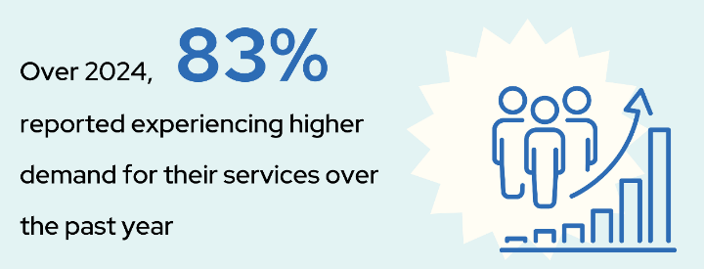
Over 2024:
- 83% experienced higher demand
- 10% stayed the same
- 2% decreased
- 6% were not sure/not applicable.
In addition, survey respondents were asked to reflect on changes in demand, client needs, and operational challenges. A comparison of changes in demand from the 2022 ACT ACOSS survey results with the 2024-25 ACTCOSS survey shows clear increases in demand and client complexity, alongside persistent financial and staffing pressures.

2.1.1 Levels of demand in the community
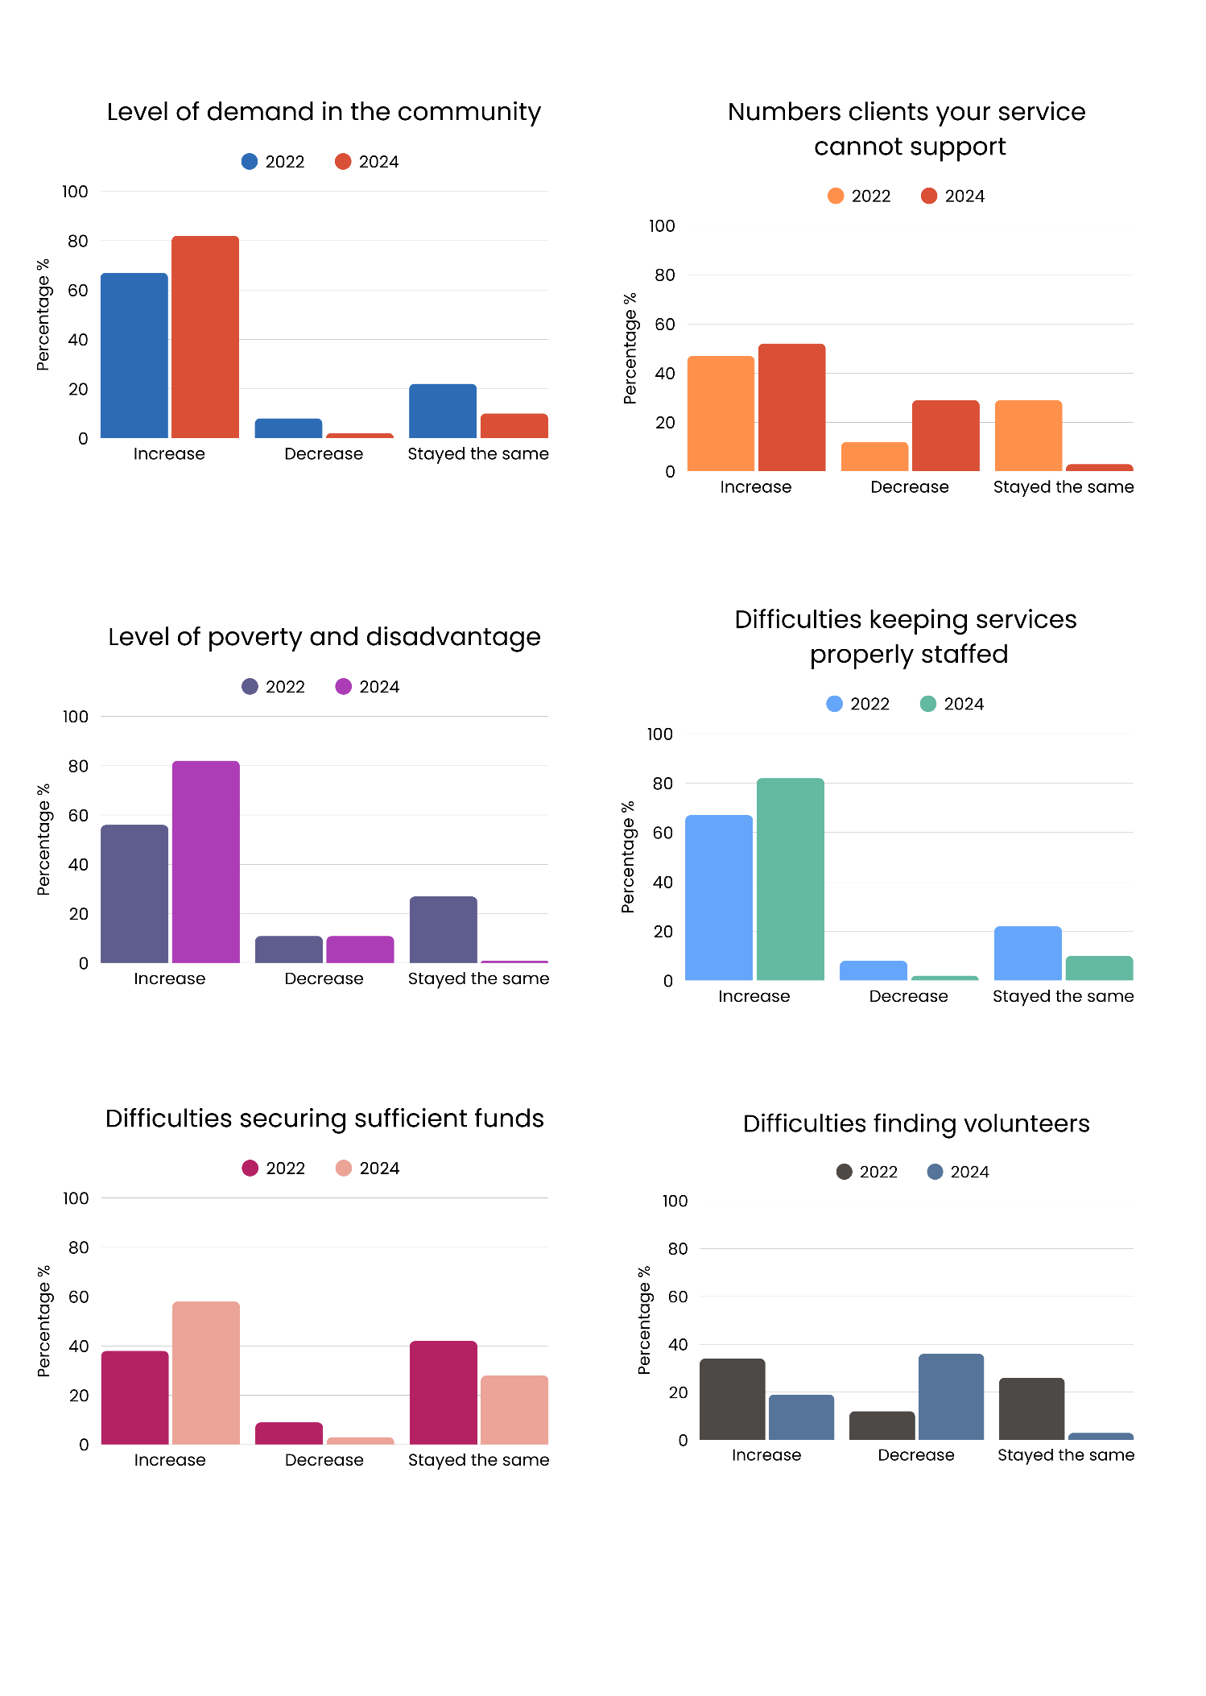
Demand for community services has continued to grow, with most organisations reporting rising pressure on their programs. Survey responses highlight a clear upward trend between 2022 and 2024, with fewer organisations reporting stability or decline in demand.
Figure 1. Levels of demand in the community
- In 2022, 67% of respondents reported an increase in demand, while in 2024 this rose to 83%.
- In contrast, 22% reported no change in 2022 compared with only 10% in 2024
- The proportion reporting a decrease fell from 8% in 2022 to 2% in 2024, while those unsure or not applicable rose slightly from 4% to 6%.
These results demonstrate strong and continuing growth in demand, reinforcing the essential role of the community sector in responding to community needs.

2.1.2 Complexity of need
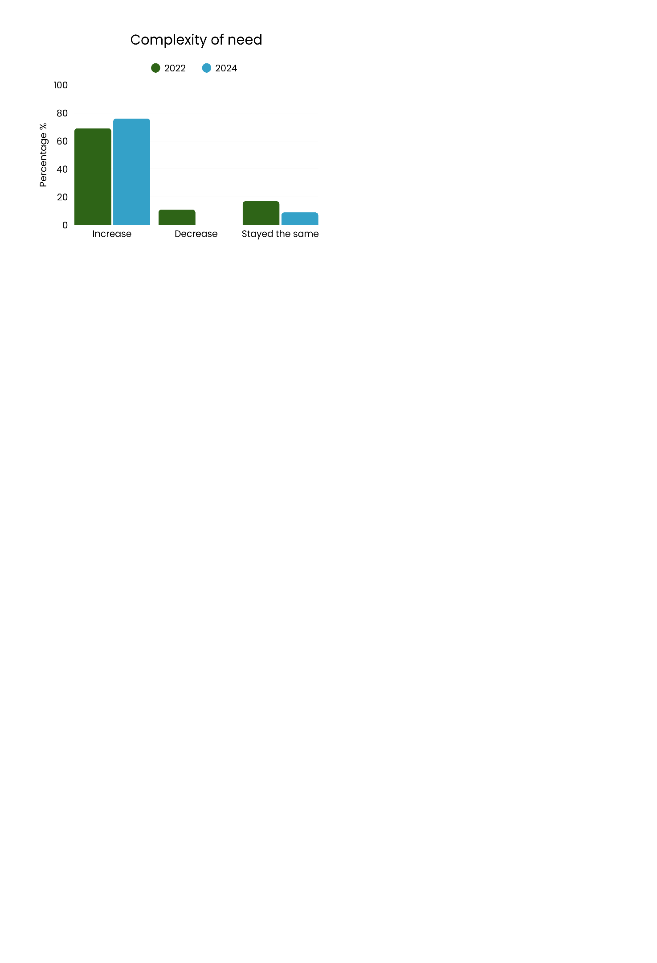
Services also reported growing complexity in client needs, with a clear increase since 2022. Fewer organisations observed stability or decreases, highlighting the ongoing challenge of supporting clients with more diverse and intensive needs.
Figure 2. Client complexity of need
- In 2022, 69% of respondents reported an increase in client complexity, rising to 76% in 2024
- Reports of no change declined from 17% in 2022 to 9% in 2024
- In 2022, 11% said complexity had decreased, whereas in 2024 none reported a decrease
- Not sure or not applicable increased from 3% in 2022 to 15% in 2024.
This points to rising long term levels of client complexity, with many services managing more diverse and challenging needs.

2.1.3 Levels of poverty and disadvantage
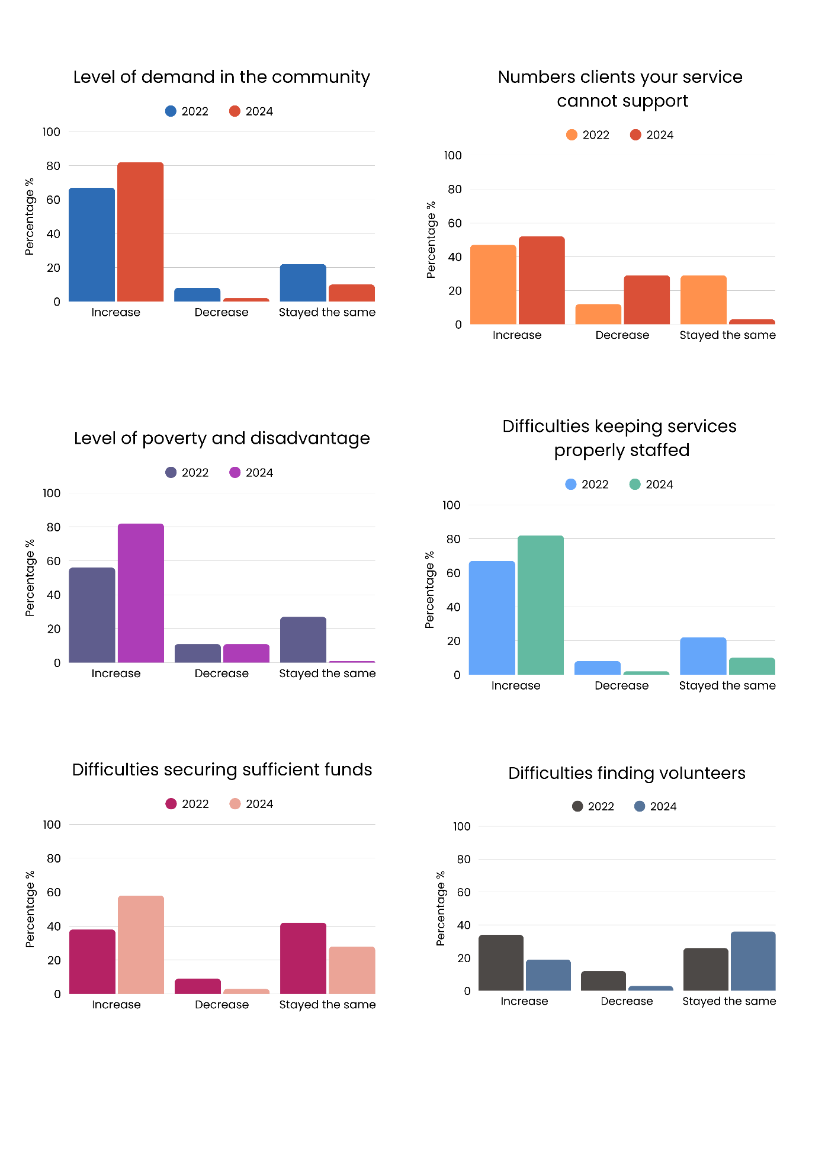
Organisations reported worsening socioeconomic conditions among their clients, with poverty and disadvantage becoming more widespread. Between 2022 and 2024, far fewer services observed stability, pointing to deepening challenges across the community.
Figure 3. Client poverty and disadvantage
- The proportion observing increased poverty and disadvantage grew from 56% in 2022 to 82% in 2024
- Reports of no change fell from 27% to 1%, while decreases held steady at around 11%
- Respondents that were unsure or not applicable remained relatively stable at 7% in 2022, and 6% in 2024.
These results signal a deterioration in clients’ circumstances, highlighting the critical role of community services in responding to growing hardship.

2.1.4 Number of clients services could not support
Organisations reported mixed results on the number of clients they could not support, with some seeing increases and others decreases between 2022 and 2024.
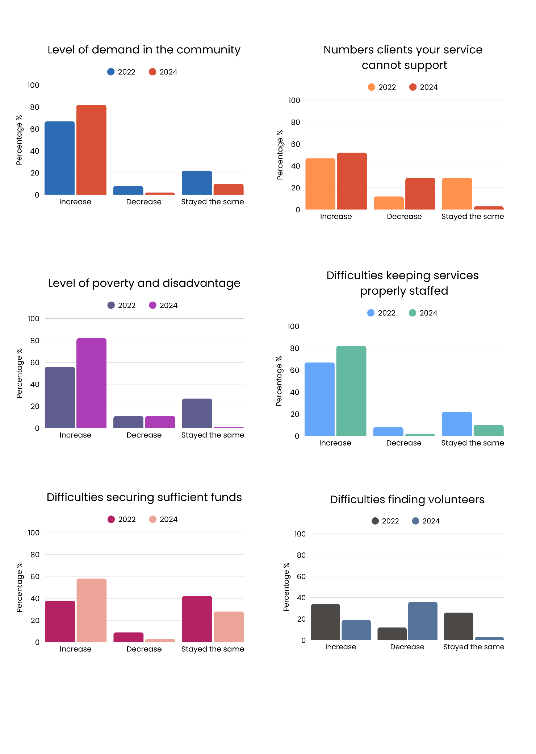
- Respondents reporting increases in the number of clients their service could not support rose slightly from 47% in 2022 to 52% in 2024
Figure 4. Number of clients services could not support
- However, those reporting decreases also rose substantially, from 12% to 29%
- Those reporting no change decreased from 29% to 3% in 2024
- Those that were unsure or not applicable increased from 12% in 2022 to 17% in 2024.
These findings suggest varied experiences across the sector, with some services struggling to meet growing unmet demand, while others have found strategies to reduce the number of clients turned away.

2.1.5 Difficulties securing sufficient funds
Organisations reported increasing difficulty in securing sufficient funding, with more services experiencing funding pressures in 2024 compared with 2022.
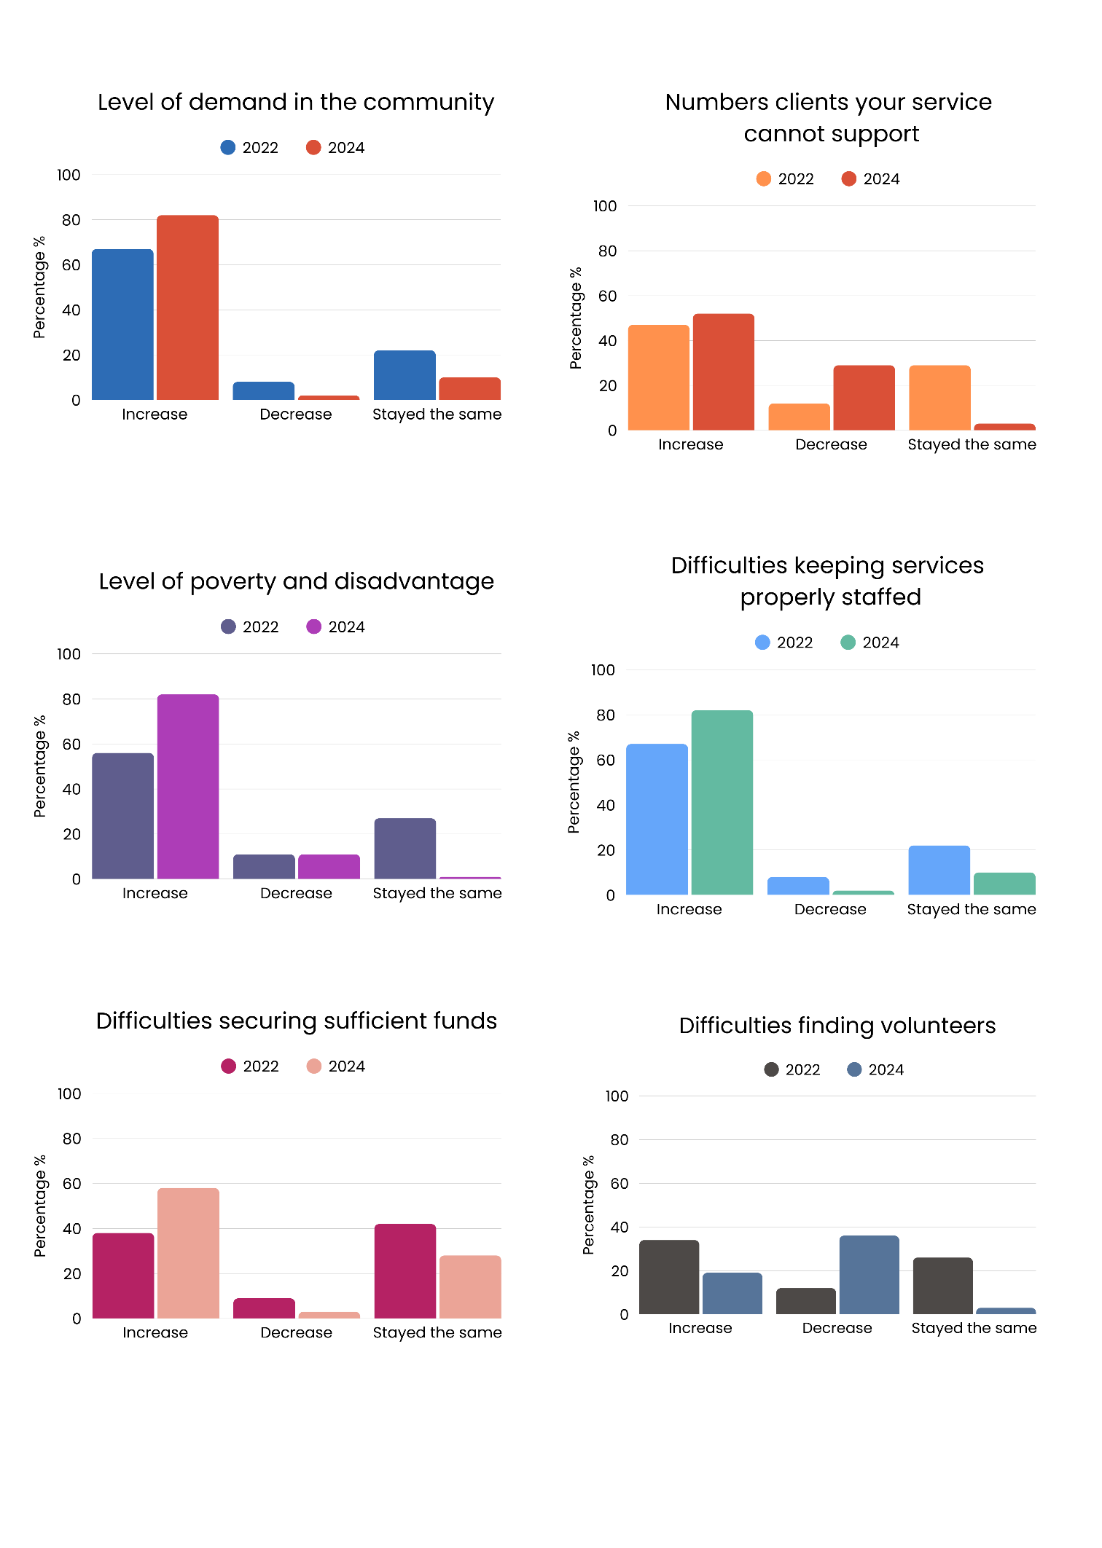
- Funding challenges worsened, with reports of increased difficulty in securing sufficient funds rising from 38% in 2022 to 58% in 2024
Figure 5. Difficulty securing sufficient funds
- Those reporting no change dropped from 42% in 2022 to 28% in 2024
- Decreases fell from 9% in 2022 to 3% in 2024
- Respondents who were unsure or not applicable remained stable at 11% across both periods.
This reflects long-term, mounting funding pressures, with many organisations continuing to deliver services despite ongoing financial strain.

2.1.6 Difficulties keeping services properly staffed
Organisations continued to experience widespread staffing difficulties, with most services reporting persistent workforce pressures between 2022 and 2024.
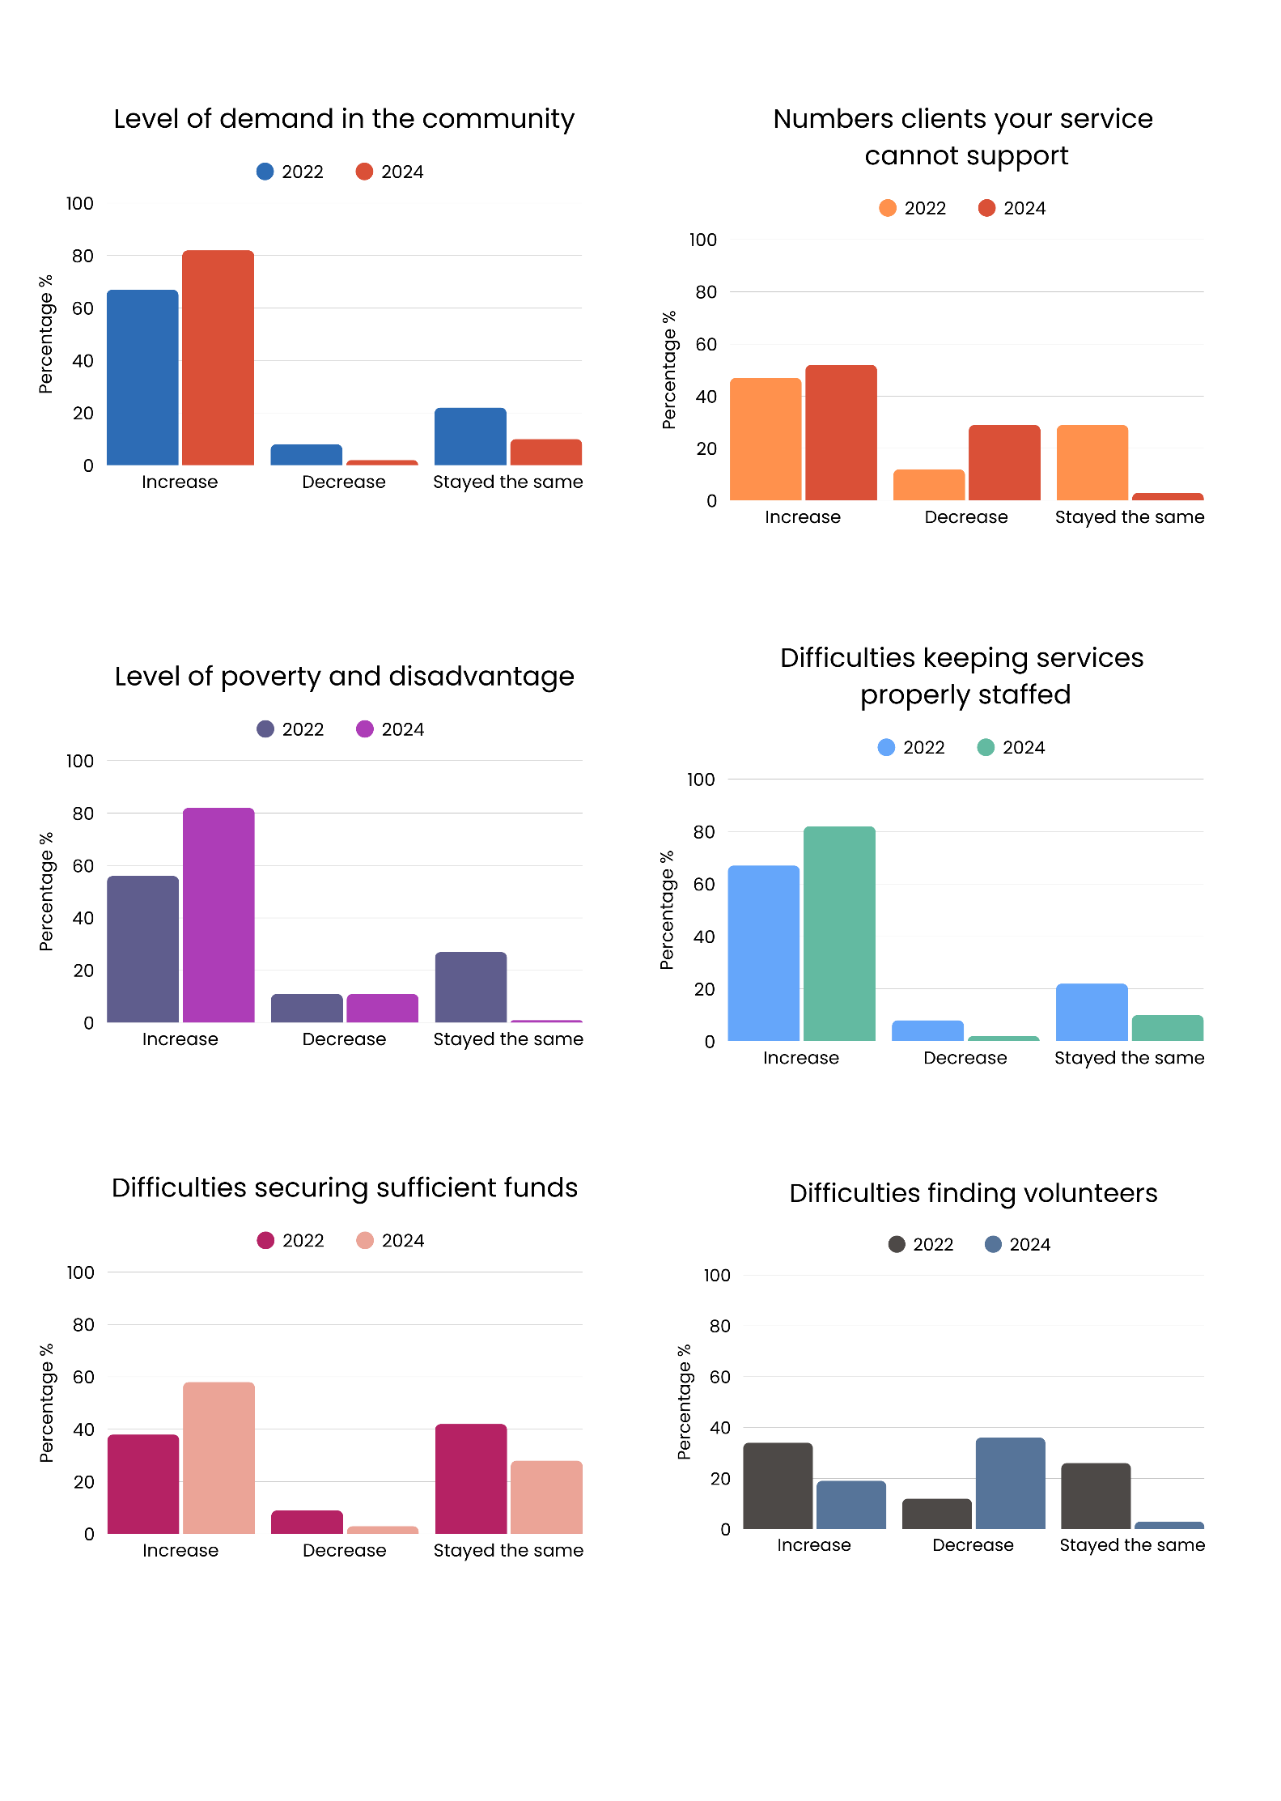
- Staffing difficulties remained widespread, rising slightly from 59% in 2022 to 61% in 2024
Figure 6. Difficulty keeping services properly staffed
- At the same time, no change increased from 25% to 33%
- Reported decreases declined in 2024 to 2% compared to 11% in 2022
- Respondents that were unsure or not appliable, remained steady, with 6% in 2022 and 5% in 2024.
These findings indicate ongoing workforce challenges, with most organisations continuing to face staffing pressures.

2.1.7 Difficulties finding volunteers
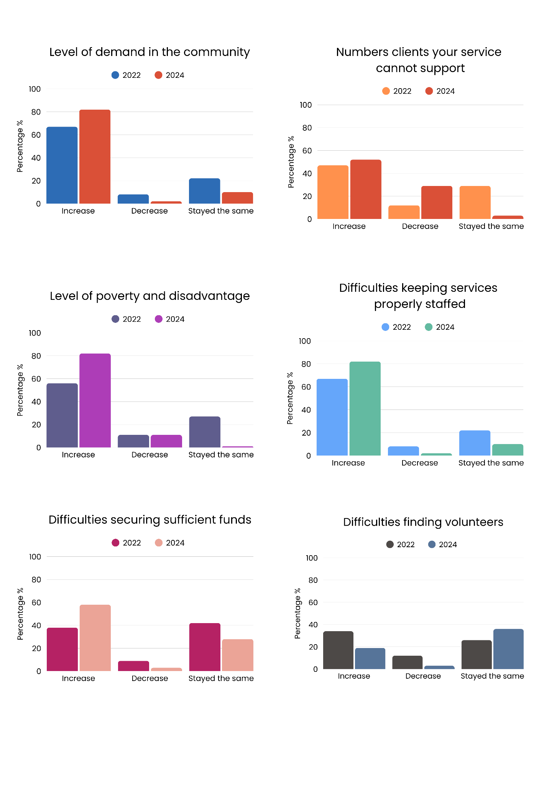
Organisations reported mixed experiences with volunteer recruitment, with fewer services noting increased difficulties in 2024 compared with 2022.
Figure 7. Difficulty finding volunteers
- Volunteer recruitment difficulties declined, with reports of increases falling from 34% in 2022 to 19% in 2024
- Reports of no change rose from 26% in 2022 to 36% in 2024
- Those experiencing a decrease in difficulty declined from 12% in 2022 to 3% in 2024
- Not sure/not applicable responses increased from 28% to 42%.

These results suggest that some organisations may be experiencing less reliance on volunteers, potentially due to factors such as the administrative burden of volunteer management and rising insurance costs, which can limit the feasibility of engaging volunteers despite ongoing community willingness.

Overall, the 2022 and 2024 results highlight mounting pressures across the ACT community sector, with rising demand, increasing client complexity, and worsening poverty and disadvantage. Organisations continue to face persistent financial and staffing challenges, while volunteer engagement remains variable, influenced by administrative and insurance barriers. These findings demonstrate both the resilience of the sector and the urgent need for greater investment to ensure services can keep pace with growing community needs.

2.2 Drivers of demand
Respondents identified a range of factors driving increased demand for support in 2025. The most frequently cited drivers included cost-of-living pressures, housing stress, and limited access to mental health and health services, reflecting the complex and intersecting challenges faced by many in the community.

Key drivers of demand over 2025 for ACT community sector organisations identified by respondents were as follows:
- Cost of living was the most frequently identified driver of demand, reported by 84% of respondents
- Access to affordable housing and homelessness was a major factor recognised by 81%
- Lack of mental health support was noted by 73% of respondents
- Unsafe home environments contributed to demand for services, with 70% reporting this factor
- Social isolation was also identified by 70% as a key driver
- Sickness and/or chronic conditions were reported by 58%
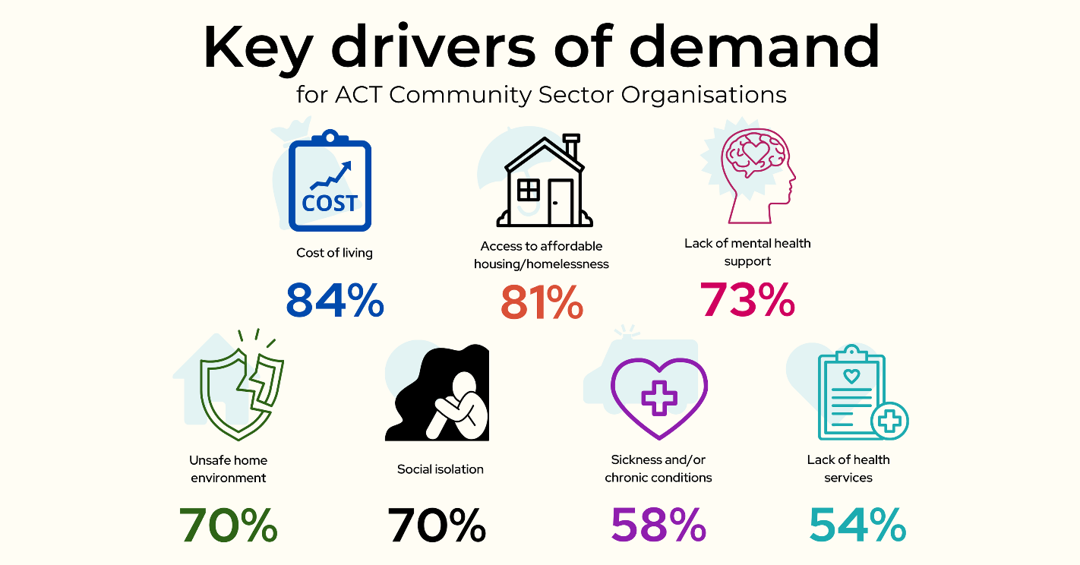
- lack of health services was highlighted by 54% of respondents.

Other contributing factors to increased demand for services in 2025 included:
- Inadequate support from Centrelink, recognised by 51%
- Difficulty accessing decent employment, with 40% indicating this as a driver
- Lack of access to energy or cost of energy was identified by 34%
- Lack of access to digital technology by 25%
- Other was specified by 16%
- Disruption caused by COVID-19, accounted for 13% of respondents
- Impact of disasters and extreme weather events by 7%.
Qualitative responses revealed additional challenges contributing to service demand, including domestic and family violence, sexual assault, and safety concerns; systemic issues such as justice system involvement, discrimination, and lack of culturally appropriate or trauma-informed supports; and gaps in aged care, disability, and mental health services. Respondents also highlighted economic and social pressures such as housing and food insecurity, high energy costs, and gambling-related harm, alongside broader concerns about racism, lack of LGBTIQA+ inclusive services, visa insecurity, and limited community infrastructure.

2.3 Client complexity
Client complexity was a factor driving service demands in 2024. Over three quarters (76%) of respondents reported an increase in clients presenting with complex needs in 2024 compared to 2023, an increase from 69% in 2022. This suggests that services are not only managing higher overall demand but are also engaging with more intensive and complex client issues.
Figure 8. Increase in complexity of need in 2022 compared to 2024
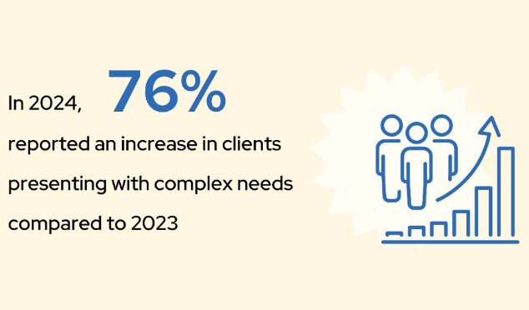
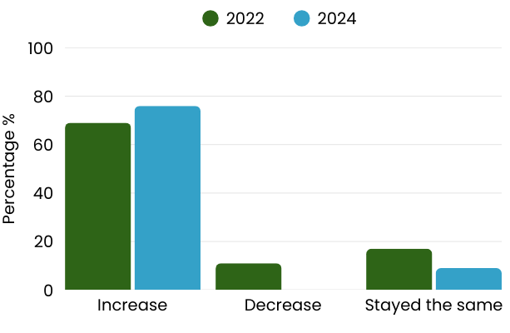

At the same time, 9% of respondents indicated that client complexity had stayed the same and no respondents indicated a decrease in client complexity in 2024 compared to the 2023 period. This was a decrease from 2022, where 17% of respondents indicating client complexity has stayed the same and 11% experiencing a decrease.
These results suggest that client complexity is now a consistently rising pressure for the ACT community sector, with fewer services experiencing stability or decline in this area. This trend points to an increasingly resource-intensive service environment, where complexity is compounding existing demand pressures.

2.4 Drivers of complexity
Respondents identified a range of social and economic issues as key drivers of increasing client complexity in the ACT community sector. The top 5 changes identified contributing to increased complexity were:
- Increased mental health conditions (79%)
- Insecure housing, overcrowding and/or homelessness (76%)
- Increased poverty (70%)
- Family and domestic violence (65%)
- Difficulty accessing government supports (63%).

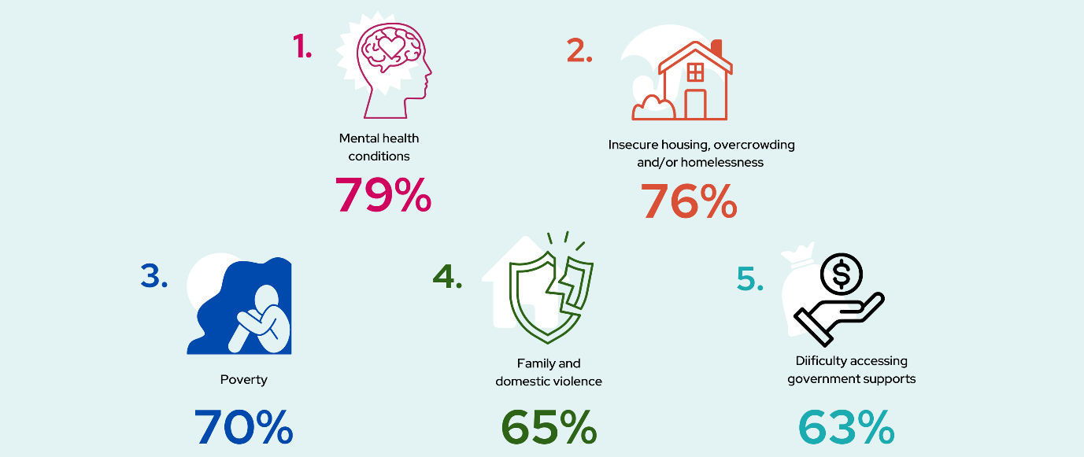
Other issues driving client complexity identified by respondents at ACT Community sector organisations included:
- Increased ill health or disability was identified by 49% of respondents
- Increased drug and/or alcohol use was highlighted by 39%
- Increased legal challenges was noted by 33%
- Increased discrimination against minority groups by 30%
- Lack of access to energy/cost of energy by 30%
- Other was specified by 15%.

Qualitative data further highlights the increasing complexity of client needs being driven by challenges such as lack of family support, rising debt and credit-related issues, systemic advocacy constraints, healthcare system accessibility, advocacy and navigation, and growing discrimination and social issues.

2.5 Challenges affecting clients accessing services
Participants were asked which of these services (if any) had been difficult to access. The most common responses were:
- Emergency financial or food relief (32%)
- Government energy supports (28%) such as the utilities concession and energy support voucher
- Financial counselling (19%)
- Bond loans and rent grants (18%)
- Discounted registration or travel concessions (15%).
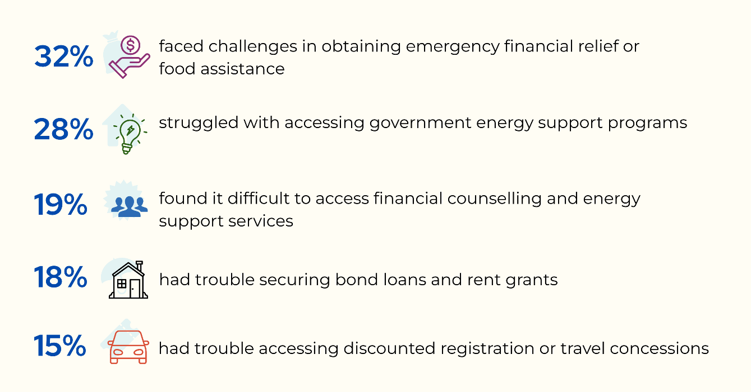
Other supports that were difficult for respondents to access included:
- Ombudsman services (14%)
- No Interest Loan Scheme (13%)
- Energy retailer hardship programs (11%)
- Other (9%)
- Work or Development Plans (7%)
- Gambling services (4%)
- Life Support or Medical Rebates (4%).

Approximately 31% of respondents indicated that they had not experienced any difficulties accessing any of these supports.

Furthermore, qualitative insights revealed concerns about service capacity, eligibility, and program availability. One respondent noted that:
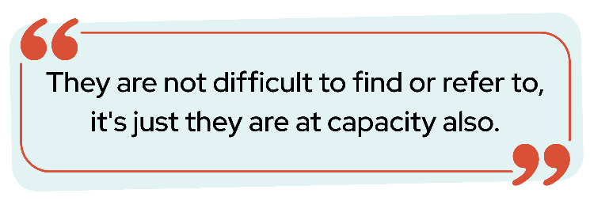

This may suggest that the existence of referral pathways is not the primary issue; rather, the limited capacity of services to accept new clients represents the more significant barrier.
Respondents also described long wait times and high out-of-pocket costs associated with NDIS assessments. Several respondents highlighted the increased pressure arising from tighter eligibility for Energy Support Vouchers, the cessation of the Safer Families payment, and uncertainty regarding the future of Rent Relief. Difficulties accessing Escaping Violence Payments were also noted, alongside concerns that support for essential household costs such as high energy bills remains limited. Broader needs identified included healthcare (including specialist care), aged care support, social groups, and education.

2.6 Client energy hardship
Energy affordability emerged as a critical issue with almost three quarters of respondents (74%) indicating that their clients’ capacity to pay energy bills in the last year had worsened. Approximately one quarter of respondents (26%) indicated that their clients’ position to pay energy bills had stayed the same, and no clients’ positions had improved.

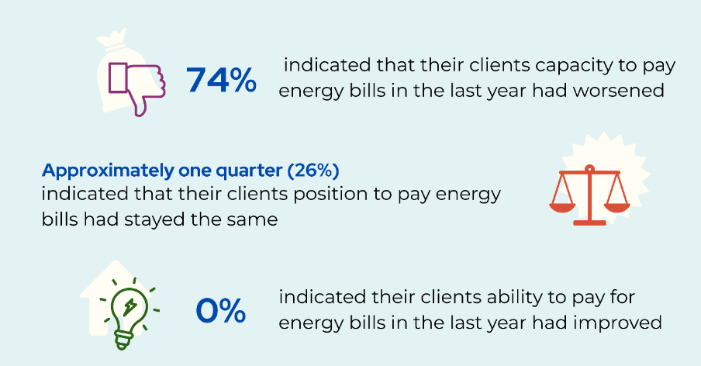

For respondents coming across clients who were under-consuming energy or struggling to pay energy bills:
- 19% had daily interactions with clients
- 27% had weekly interactions
- 38% had interactions sometimes but not every week
- 16% never had interactions.
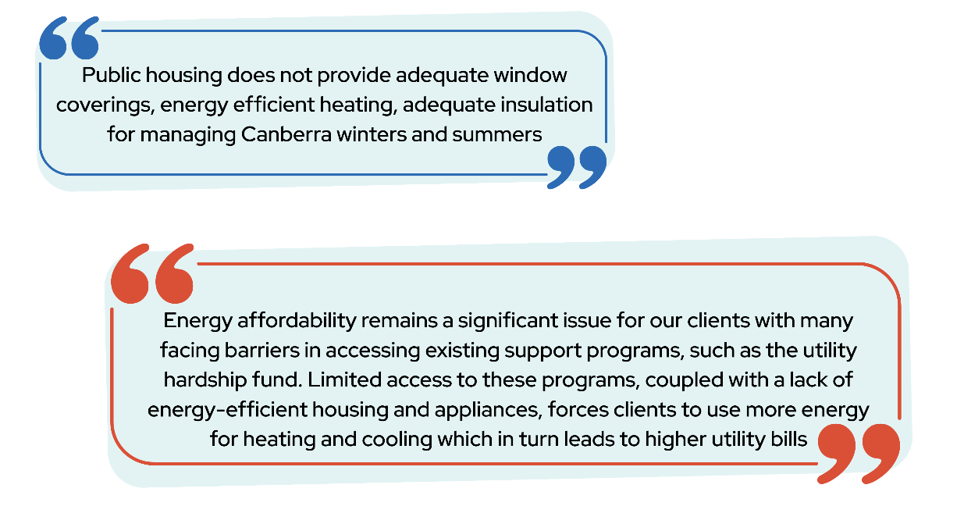
Qualitative feedback emphasised the challenges posed by resource constraints, with respondents observing:

These observations suggest that clients’ energy hardship may be influenced by affordability constraints, structural deficiencies in housing, and limited access to support programs. These factors could contribute to increased energy consumption and higher utility costs.

2.7 Client financial hardship
Clients struggling to pay bills was a prominent presenting issue at ACT community organisations, with:
- 38% of respondents supporting clients daily
- 28% supporting clients sometimes, but not every week
- 24% supporting clients weekly
- 10% of respondents never supporting clients who are struggling to pay bills or facing other financial difficulties in their role.
It is important to note that respondents who reported never supporting clients with financial difficulties may reflect staff whose roles are administrative rather than frontline work.

Qualitative data from respondents highlighted that financial supports and concessions need to be more accessible, adequately funded, and culturally responsive.

Key suggestions included:
- Simplifying application processes
- Expanding eligibility to include low-income workers, students, carers, and multicultural communities
- Increasing assistance for essential costs such as rent, utilities, food, transport, and education
- Improved promotion of available supports and targeted guidance for both clients and organisations.
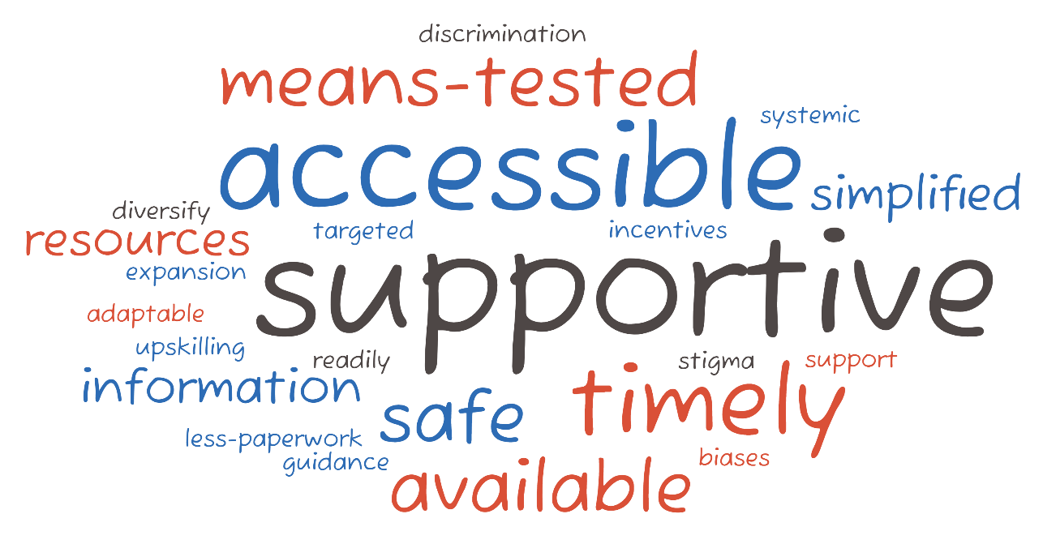

These findings demonstrate financial and energy hardships faced by clients accessing community services in the ACT. The frequency of client support needs places additional demands on service providers, highlighting the importance of enhanced financial assistance, energy support programs, and streamlined access to essential services to help clients meet basic needs.

2.8 Other accessed client services and supports
Respondents were asked which services or supports they had helped their clients access within the last six months. The most frequently accessed services were:
- Emergency financial or food relief – 71%
- Financial counselling to manage debts and budgeting – 54%
- Government energy supports – 45%
- Centrepay – 32%
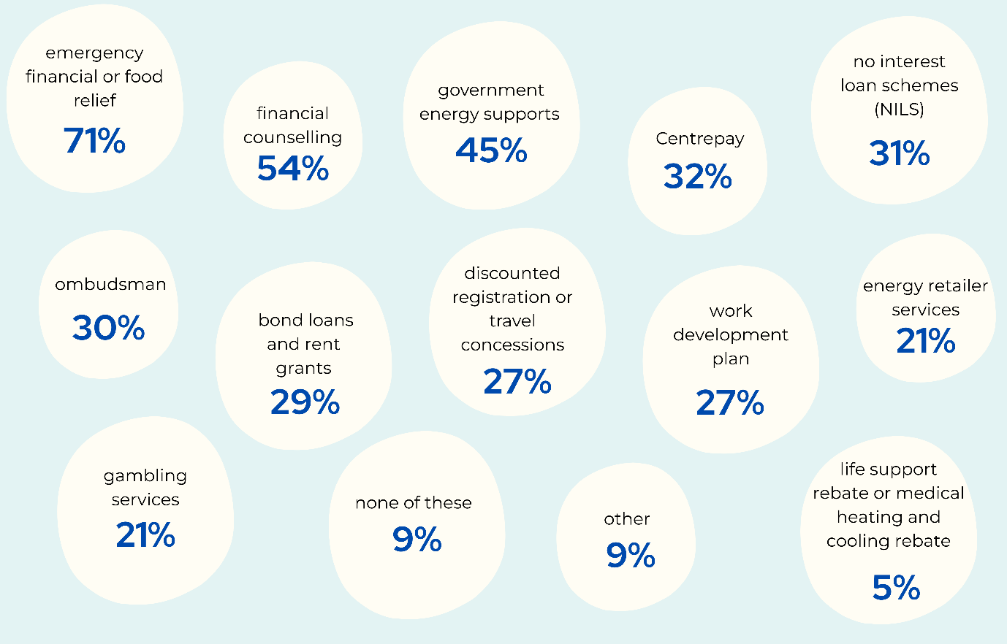
- No interest loan scheme (NILS) – 31%.
Other services and supports respondents helped their clients access, included:
- Bond loans and rent grants – 29%
- Ombudsman (eg, ACT, ACT Ombudsman, Fair Work Ombudsman) – 30%
- Discounted registration / travel concessions – 27%
- Work or development plan (e.g., for a fine) – 27%
- Gambling services – 21%
- Energy retailer services such as customer call centres, websites, and hardship programs – 21%
- Other (please specify) – 9%
- None of these – 9%
- Life support rebate or medical heating and cooling rebate – 5%.

Qualitative responses highlighted additional services clients were supported to access by community organisations. These included services such as free car seat hires, escaping violence payments and programs, funeral support, grants and other forms of funding and housing support processes such as Onelink.

2.9 Capacity to meet demand
Community organisations are facing significant challenges in meeting rising demand due to insufficient funding, resource limitations, staff shortages, and the increasing client complexity. Survey results indicate a shift in service capacity to meet community demand between 2022 and 2025.

- In 2025, the largest proportion of respondents (41%) reported their service was usually able to meet demand, a decrease from 46% in 2022
- This was followed by 33% reporting their service was sometimes able to meet demand, slightly lower than 37% in 2022
- Services rarely able to meet demand accounted for 9% in 2025, compared with 8% in 2022
- The proportion of services never able to meet demand increased from 2% in 2022 to 10% in 2025, indicating growing strain on service capacity
- A small proportion reported their service was always able to meet demand (5% in 2025 compared with 4% in 2022) or were not sure (3% in 2025 and 3% in 2022).
Figure 9. Ability of ACT community organisations to meet demand in 2022 compared to 2025
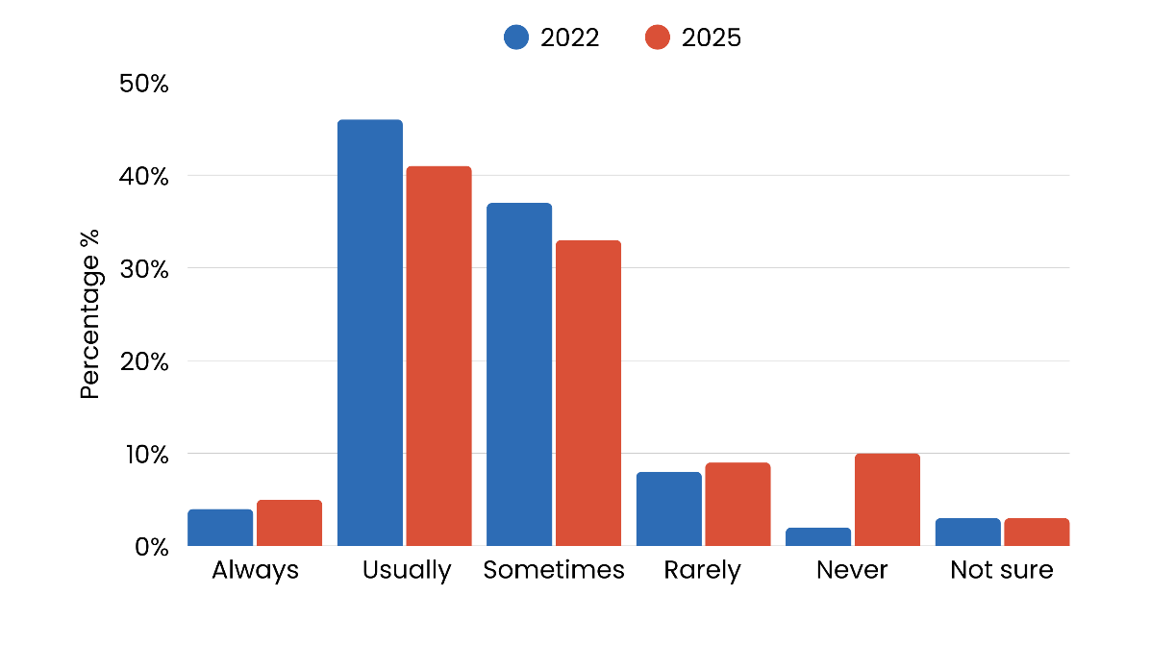

These findings suggest that fewer services are consistently meeting community demand, with a noticeable increase in services unable to meet demand entirely.

Qualitative data from 2025 respondents provides additional insights into ACT community services capacity to meet community needs over 2024. Common themes discussed included:
- Demand for services exceeding capacity
- Increased client complexity
- Insufficient and unpredictable funding
- Lack of sufficient staff and specialised personnel
- Staff and volunteer burnout and turnover
- Financial constraints affecting recruitment
- Long waitlists leading to client disengagement
- Ineffective triage systems
- Gaps in service provision.

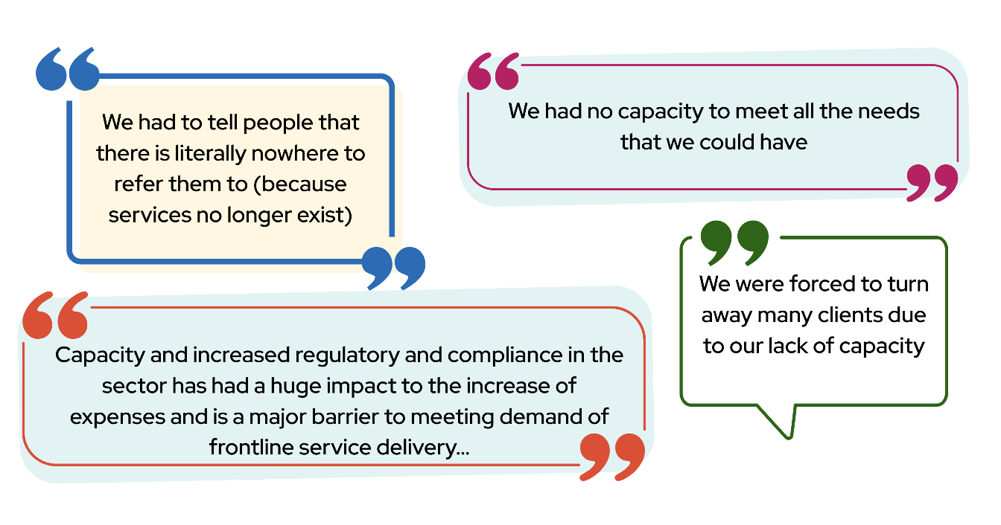
Examples of qualitative responses are included below:

These examples highlight significant strain on ACT community services, driven by insufficient funding, increasing operational costs, and increasing regulatory pressures.

2.10 Climate related impacts
Climate related impacts and preparedness have also been identified as a significant concern for ACT community organisations. Organisations were asked if they believe their organisation is adequately prepared/resourced to deal with the predicted impacts of climate change (e.g. increased demand for services):
- 13% of organisations indicated they were adequately prepared/resourced to deal with the predicted impacts of climate change
- Half (50%) disagreed that they would be adequately prepared
- Over one third (37%) were unsure/not applicable.
Of the organisations reporting on climate-related impacts over the past five years, 35% indicated their operations had been negatively affected, 26% reported no impact, and 39% were unsure or indicated not applicable.

When asked how their organisations could better support communities confronted by disasters, extreme weather events, or other impacts of climate change, respondents agreed on several key measures:
- Approximately four out of five (81%) respondents agreed that Government funding is essential to address the increased demand for services
- Over half (56%) of respondents called for clearer information from the Government on expectations for the community sector and Government services
- Over half (56%) of respondents advocated for flexibility in service delivery targets within contracts to allow for resource diversion during emergencies
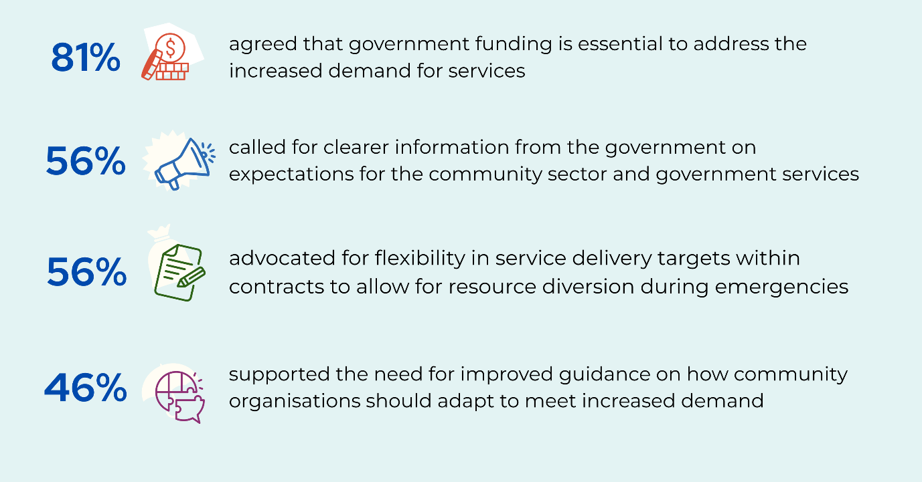
- Under half (46%) of respondents supported the need for improved guidance on how community organisations should adapt to meet increased demand.

Additionally, 10% of respondents indicated ‘other’ supports, with qualitative responses highlighting the need for better infrastructure, such as:
- Climate-resilient buildings
- Enhanced disaster-recovery planning
- Staff training on climate emergency response.
The results demonstrate the urgent need for comprehensive support and resources to help community services adapt to and manage the increasing demands driven by climate change.

2.11 Responding to growing community demand
Survey responses highlight how services adapted to meet community demand in 2022 and 2024-2025. These findings reflect ongoing pressures on services, including rising client numbers, increasing complexity of needs, and limited resources. They also demonstrate the range of strategies services have implemented to manage capacity, maintain accessibility, and respond to urgent client needs. The top 5 responses included (see figure 12):
- A large proportion of respondents (62%) tried to find more funding in 2024, almost doubling since 2022 (35%). This may reflect increased financial pressures
- In 2024, 53% of respondents received referrals because other services were at capacity, higher than 2022, which was 41%
- Waiting times for our service increased, highlighted by 51% in 2024, increasing from 43% in 2022
- Approximately one third (33%) of respondents in 2024, referred people to other services due to lack of capacity, similar to 35% in 2022
- Around one quarter (27%) of respondents in 2024 turned people away due to lack of capacity, decreasing from 35% in 2022.
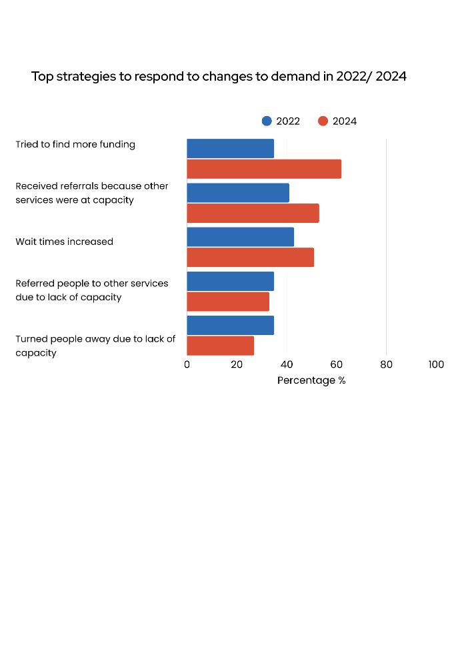
Figure 10. Top 5 strategies used to respond to changes in demand in 2022–2024

2.11.1 Seeking additional funding
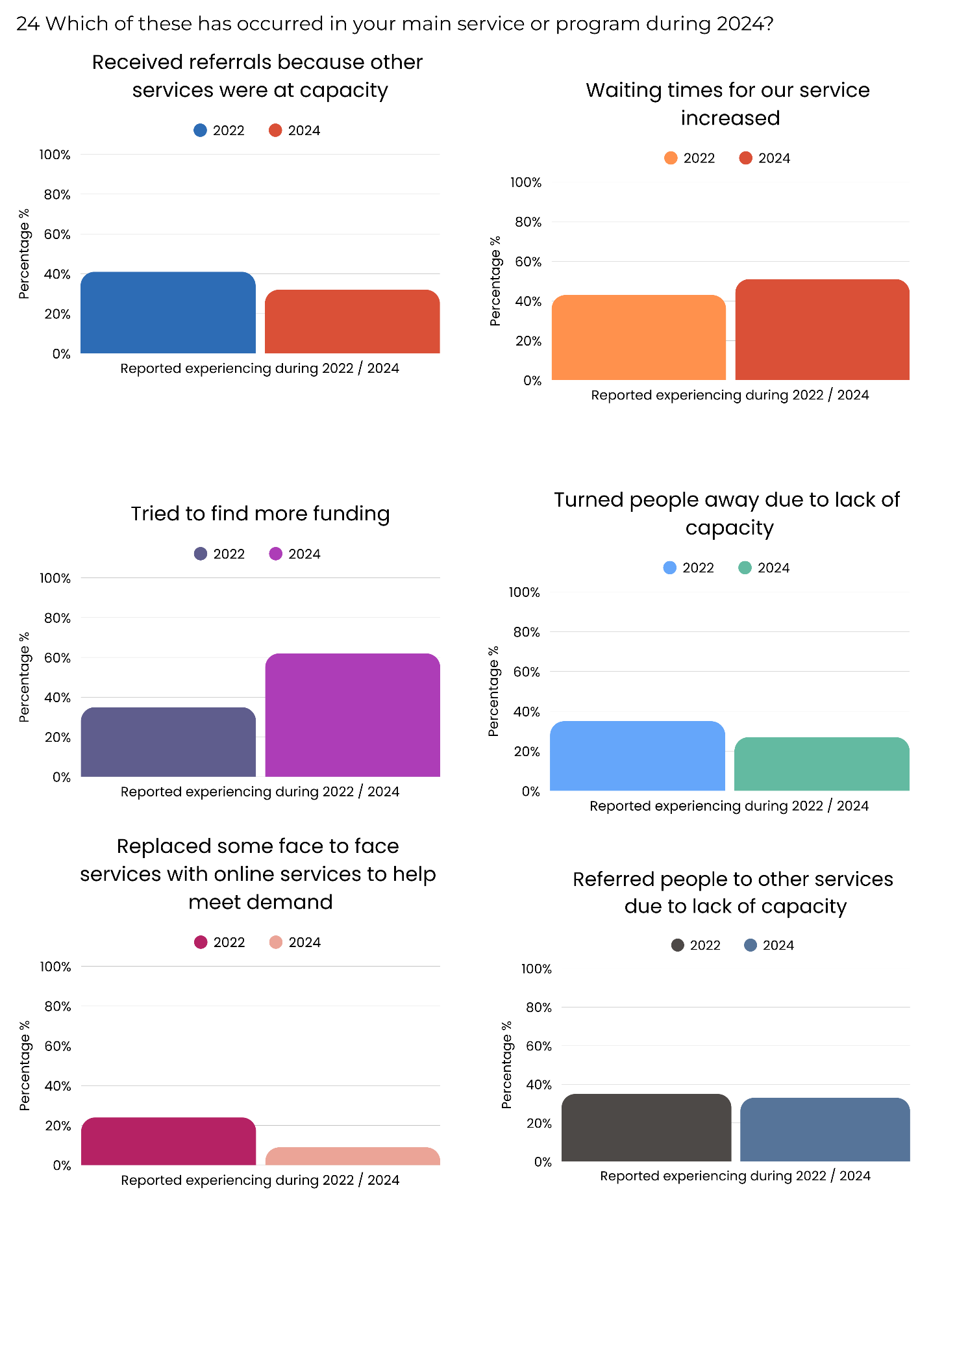
Financial pressures on services have increased, prompting organisations to seek more external resources. Respondents indicated that rising demand and constrained budgets have made securing additional funding a priority.
Figure 11. Tried to find more funding

- In 2022, 35% of organisations reported seeking more funding, rising to 62% in 2024. This was the most frequently reported strategy for responding to demand.
This increase reflects the sector’s growing financial strain and reliance on external funding to meet rising demand.

2.11.2 Increased referrals and waiting times
Respondents indicated that their organisations experienced greater demand pressures between 2022 and 2024, with increased referrals from other services and longer waiting times for their own programs.
- In 2022, 41% of services reported receiving increased numbers of referrals because other services were at capacity, increasing to 53% in 2024
- Organisations reporting waiting times for services rose from 43% in 2022 to 51% in 2024.
Figure 12. Increased referrals from other services because they were at capacity

Figure 13. Increased waiting times for their service

This suggests escalating system-wide demand, with unmet need being shifted between services and contributing to extended wait times within organisations’ own services and programs.

2.11.3 Turning people away or referring elsewhere
Many organisations continued to face capacity challenges that limited their ability to meet client needs. Respondents reported that clients were frequently turned away or referred to other services when demand exceeded capacity.
- Over one third (35%) of organisations reported turning people away due to lack of capacity in 2022, decreasing to 27% in 2024
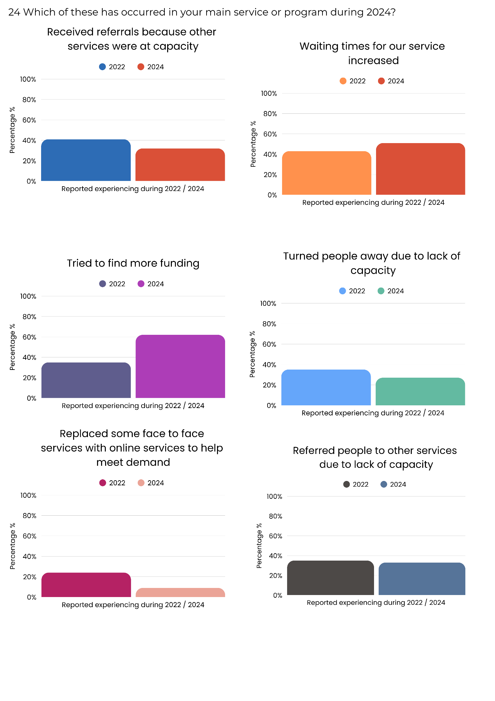
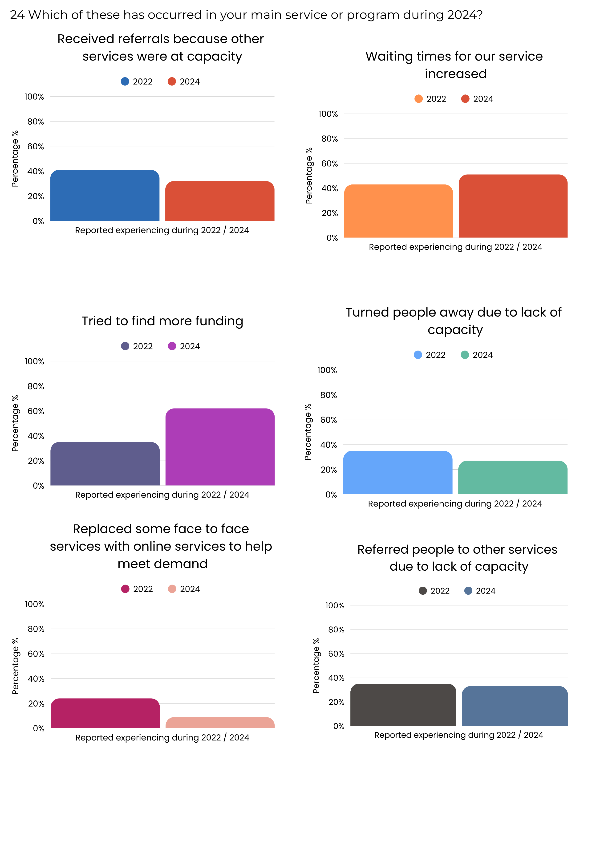
- In 2022, over one third (35%) reported referring clients to other services, decreasing slightly to 33% in 2024.
Figure 14. Turned people away due to lack of capacity

Figure 15. Referred reporting people to other services due to lack of capacity

These findings suggest that clients continue to face barriers to accessing services where and when they are needed.

2.11.4 Changes to service delivery
Organisations adapted the way they deliver services in response to demand pressures. Shifts to online service provision were observed, although these appear to be decreasing over time.
Figure 16. Moved some services online or expanded online services

- In 2022, 24% reported moving some services online, decreasing to 9% in 2024.
This decline likely reflects a return to face-to-face delivery post-pandemic. It also suggests that expanding online services is less frequently required, as most digital programs are now likely reflecting that many online programs were already established during the COVID-19 pandemic, rather than indicating a reduced overall response to demand pressures.

2.11.5 Targeting and adjusting service intensity
Some organisations adapted eligibility criteria or service intensity to manage demand. These approaches were used to reach more clients while controlling service pressures.
- In 2022, almost one in five (19%) targeted services to a smaller group of clients, decreasing to 7% in 2024 (see figure 17)
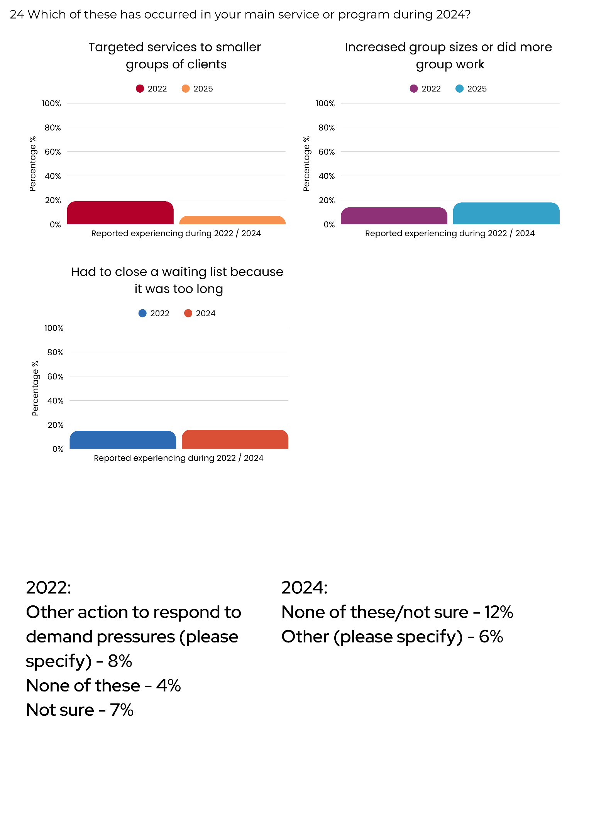
- In 2022, 14% of respondents at their main service or program did more group work, increased group sizes, increasing to 18% in 2024 (see figure 18).
Figure 17. Targeted smaller groups of clients due to lack of capacity

Figure 18. Increased group sizes or did more group work

These findings suggest a shift from restricting access to rationing service intensity. Organisations are adapting delivery models to manage demand while still attempting to serve as many clients as possible.

2.11.6 Closing waiting lists
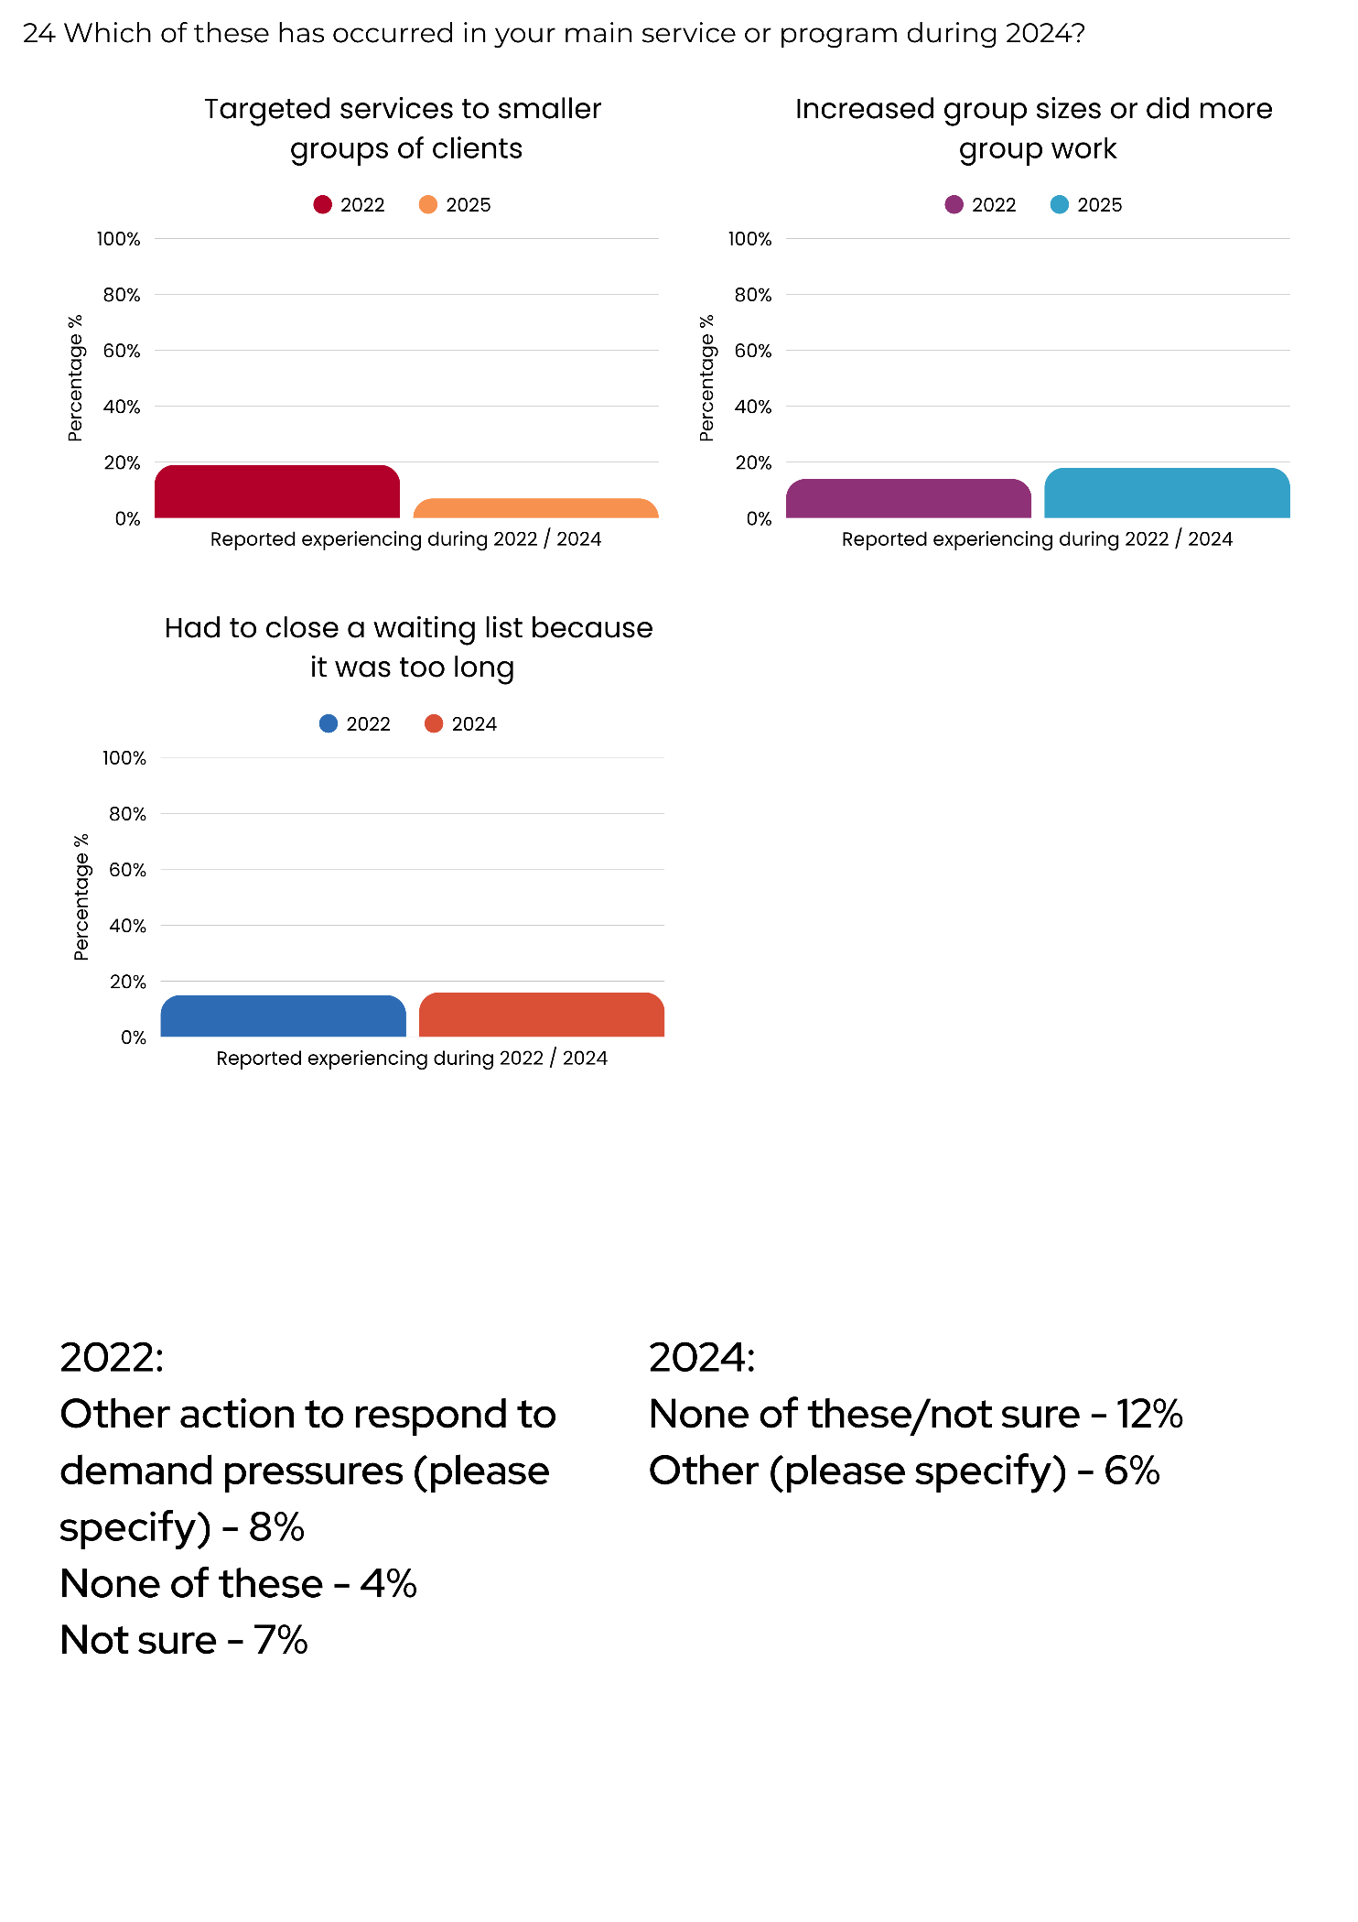
Managing waitlists remained a key strategy for responding to service pressures. Respondents reported that closing waiting lists continued to be necessary in the face of growing demand.
Figure 19. Had to close a waiting list because it was too long

- The proportion of organisations closing waiting lists increased slightly from 15% in 2022 to 16% in 2024.
This reflects ongoing difficulties in keeping up with demand, with some waiting lists becoming unmanageable.

2.11.7 Other actions and uncertainty
A small proportion of organisations reported alternative actions or uncertainty in how to respond to demand pressures.
- In 2022, 8% of organisations selected other actions, decreasing to 6% in 2024
- In 2022, 11% of respondents selected none or not sure, increasing slightly to 12% in 2024.
Qualitative responses highlight the varied nature of "other" actions. Organisations reported:
- Increasing individual counsellor caseloads
- Merging programs and slowing recruitment
- Prioritising clients by levels of perceived risk
- Declining opportunities for feedback requests due to capacity limits
- Referring clients externally to reduce waitlists and avoid service overlap
- Closing regional offices
- Telling clients that no alternative services existed.
These findings suggest that while most organisations adopt specific strategies to manage rising demand, a consistent minority remain uncertain or forced into reactive, sometimes drastic, measures. The decrease in other actions alongside a slight increase in none/not sure responses may indicate both limited capacity to trial new approaches and growing uncertainty about how best to respond under pressure. Importantly, many of the strategies identified across the sector represent short-term adaptations rather than sustainable solutions. Without increased funding and support, community services will remain constrained in their ability to deliver best practice, leaving clients at risk of falling through the gaps.

2.11.8 New strategies to adapt and respond to demand in 2024
Survey responses in 2024 revealed new approaches adopted by organisations to manage demand. These strategies focused on reducing service intensity or controlling visibility to manage client numbers.
- 19% reported decreasing the intensity of contact with individual clients to see more clients
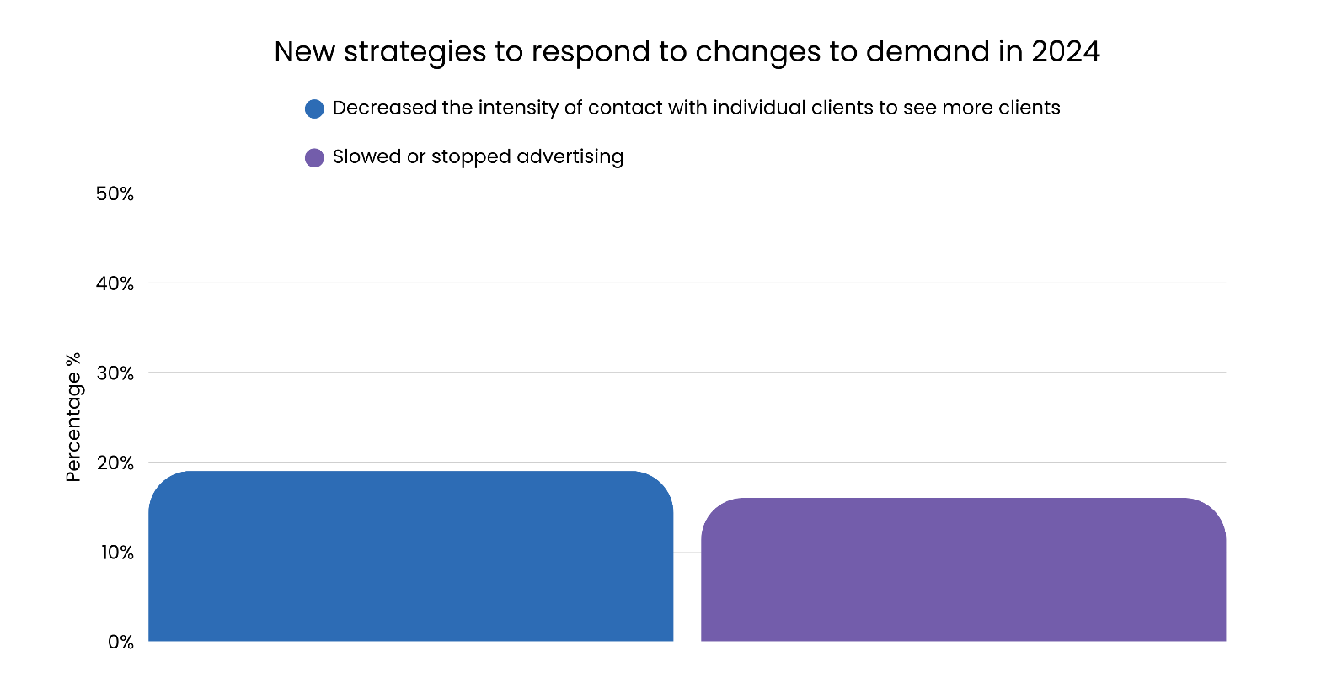
- 16% reported stopping or slowing advertising as a way of controlling demand.
Figure 20. New questions added to capture new strategies used by organisations to respond to changes in demand during 2024

The newly added options in 2024 highlight additional strategies services used to manage increased demand, including decreasing intensity of individual client contact and adjusting advertising. These responses suggest that services were actively experimenting with operational changes to maintain capacity in the face of growing pressures.

2.11.9 After-hours demand on community services
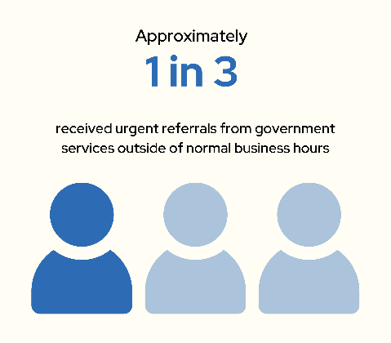
In 2025, services reported additional pressures related to urgent referrals from Government services outside of normal business hours:
- Almost one in three organisations (29%) indicated that they had received such urgent referrals
- More than half of respondents (53%) were either unsure if they had received urgent referrals or considered the question not applicable
- Approximately 18% of organisations reported that they had not received any urgent referrals.
This demonstrates the critical role of the community sector, including as the backstop for government services.

2.12 Service delivery innovations
In response to challenges faced by community organisations, they have implemented innovative service delivery models to extend their reach and improve efficiency. Many organisations have adapted by implementing telehealth and virtual counselling services to address mental health needs and reduce accessibility barriers. Other organisations adopted flexible staffing models and looked to strengthening collaborations with other service providers.
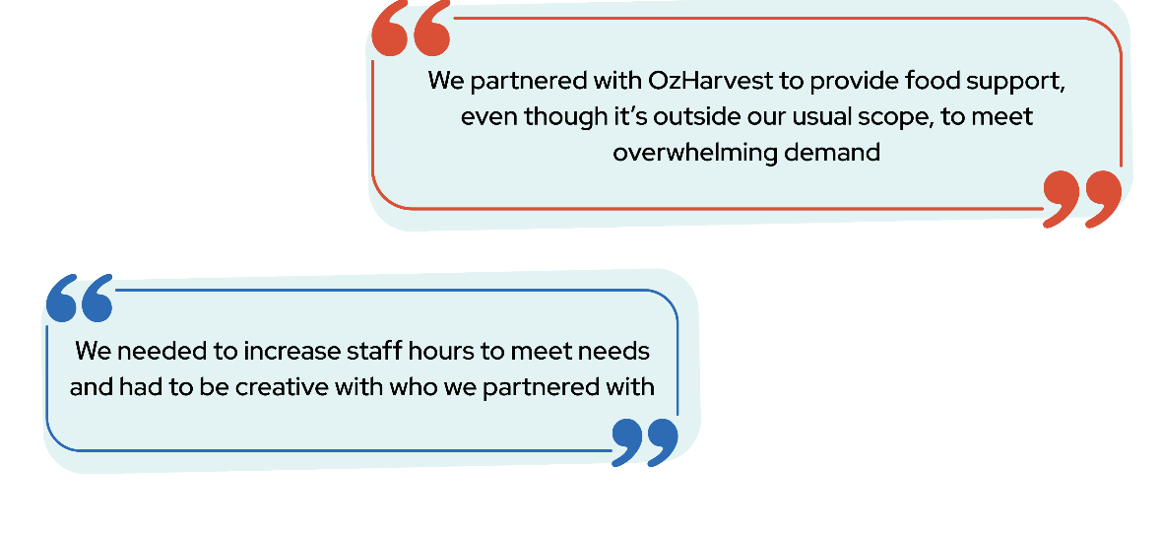
These examples highlight the sector’s resilience and adaptability in addressing service gaps despite resource limitations. However, these innovations are often developed in response to immediate crises rather than as part of a long-term, sustainable strategy.

Funding and financial sustainability

Chapter overview
This chapter presents findings on the financial health, funding arrangements, workforce capacity of ACT community organisations and the impact of the ACT Government’s commissioning process. The results show that while some organisations have maintained stability or achieved modest improvements in their financial position between 2022 and 2025, a large proportion continue to face worsening financial circumstances. Many organisations remain uncertain about their future financial sustainability and their ability to meet rising community needs.

The findings indicate a growing reliance on ACT Government funding as the community sector’s most important source of revenue. In 2021, the ACT Government introduced commissioning to improve sector sustainability and address unmet community needs. It describes commissioning as “a new way of designing, funding and delivering a fit for purpose human services system within the ACT. It is a methodology that ensures our system and the services and programs within it are meeting the needs of our community”.

However, many organisations report that funding remains insufficient to cover the full cost of service delivery, compliance, worker and client safety, governance, evaluation and planning. We note that some organisations have yet to complete or begin the commissioning cycle due to delays, this may have influenced the findings. The ACT Government has acknowledged challenges, stating there is “clear evidence that a range of processes and policies of government have hampered the change effort of commissioning.” An evaluation of the commissioning process has been proposed by the ACT Government.

Funding constraints have clear consequences for organisational capacity and risk management. Many organisations reported being underfunded or not funded at all for critical activities, including policy engagement, collaboration, and planning. Rising insurance costs have further intensified these pressures, with organisations describing difficult trade-offs such as reducing services, limiting staff hours or wages, diverting funds from other programs, or taking on additional risks by selectively insuring services. The majority of organisations expressed support for the establishment of a community insurance fund as a practical solution to these challenges. Insufficient indexation of ACT Government contracts was repeatedly raised as a core concern, compounding the effects of inflation, cost-of-living pressures, and increasing service demand.

Workforce issues also emerged as a major theme. Although there has been some growth in full-time equivalent staff numbers across the sector, attracting and retaining skilled staff remains a widespread challenge. Staff turnover, ongoing difficulties in recruitment, and limited resources for training and development continue to place strain on organisations. These pressures limit workforce stability and compromise the ability of organisations to respond to growing and increasingly complex community needs.

Overall, the findings demonstrate that ACT community organisations face persistent structural challenges that undermine their sustainability. Heavy reliance on ACT Government funding, inadequate funding, indexation, rising insurance costs, and workforce shortages combine to create a fragile operating environment. Addressing these systemic issues through adequate and sustainable funding arrangements is essential to protect the capacity of community organisations to deliver vital services, support vulnerable Canberrans, and contribute to the resilience of the ACT community.

3.1 Financial position
The financial health of organisations is a critical factor in determining their ability to deliver services effectively and plan to address future need. Challenges such as funding sustainability, staff recruitment, and workforce pressures are common themes among organisations striving to maintain their operations and services.

Organisations were asked about their financial position over 2024 and how they expect it to change over 2025. Similar questions were also asked in 2022.

In 2025, regarding their current financial position:
- 39% reported that their financial position had worsened, decreasing from 47% in 2022
- 39% said it had stayed about the same, similar to 38% in 2022
- 17% reported that their financial position had improved, similar to 16% in 2022
- 4% were unsure, increasing from 0% in 2022.
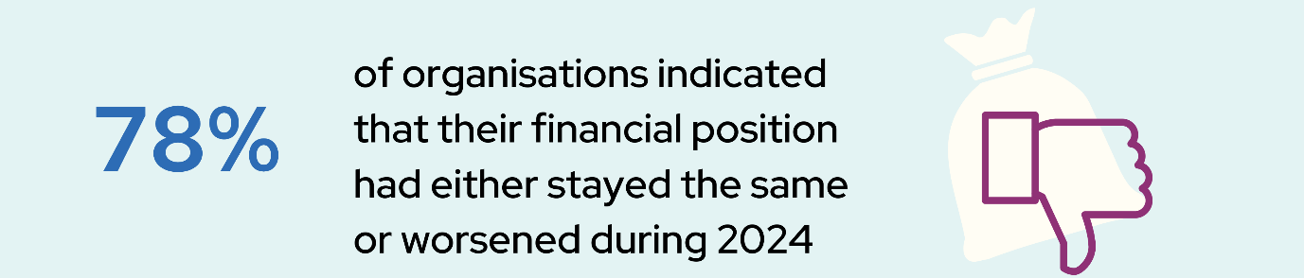
Following a period of declining financial positions, the fact that approximately four in five respondents think that their organisations positions have stayed the same or worsened is concerning. Nevertheless, the decline in respondents who said that their organisations financial position worsened, may reflect some success of commissioning.

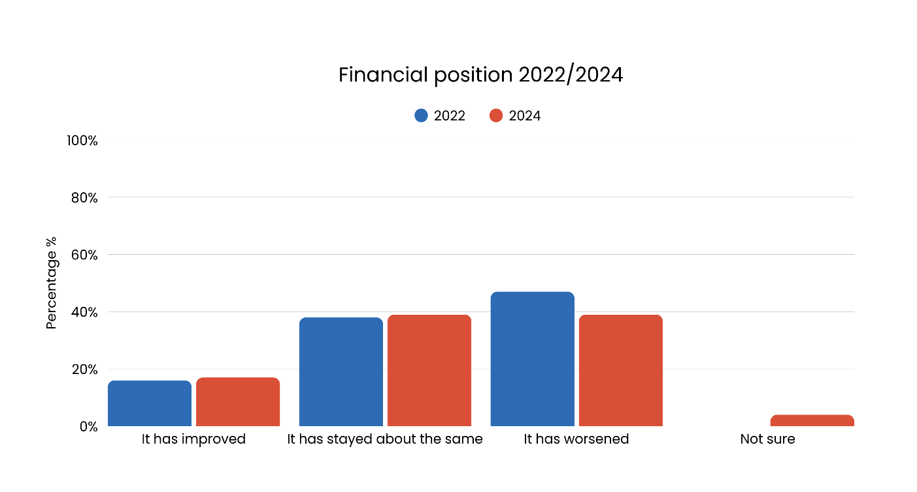
3.2 Financial outlook
Figure 21. Financial position of ACT community organisations over 2022 and 2024
Organisations were asked about their financial outlook for the year ahead, including expectations about funding stability and future service delivery. Responses reflect a sense of growing financial pressure across the sector, with many highlighting concerns about funding sustainability, workforce challenges, and the long-term viability of their programs.
- 50% anticipated their financial position would worsen, similar to 49% in 2022
- 30% expected it to stay the same, decreasing from 46% in 2022
- 15% anticipated an improvement, increasing from 6% in 2022
- 4% were unsure, increasing from 0% in 2022.
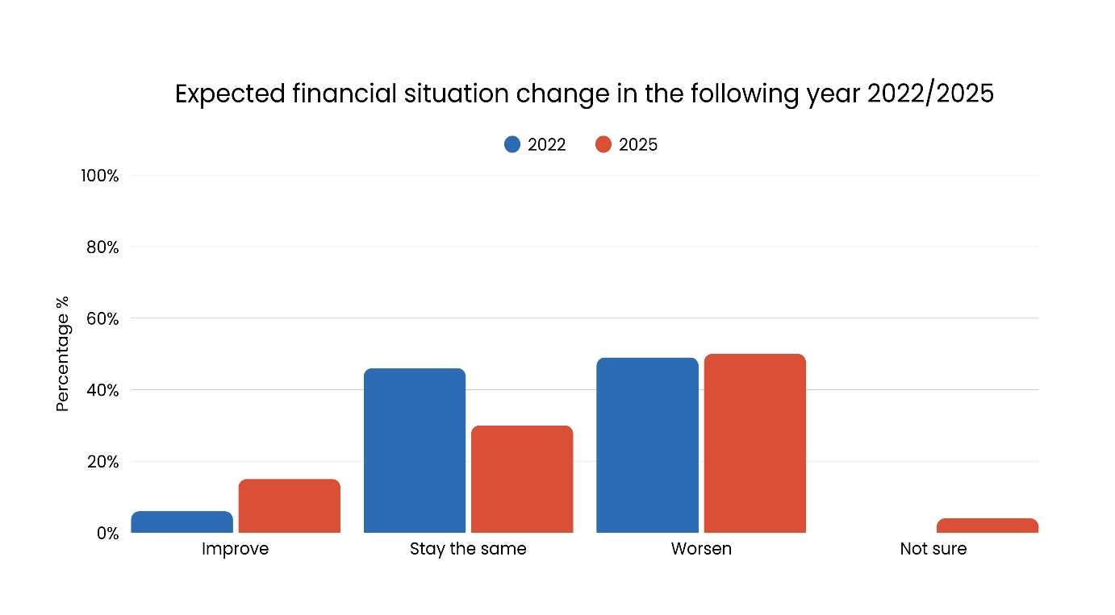
Figure 22. Anticipated financial outlook for ACT community organisations

Comments on the financial outlook highlighted several challenges. Common challenges reported included:
- Concerns about the sustainability of funding
- An observed increase in short-term funding
- Difficulties in recruiting and retaining staff and volunteers
- Increased workforce pressure and burnout
- Sentiment that the financial situation for their services would deteriorate further without additional support from the act government.

These challenges create ongoing uncertainty for the future of services and programs. Many organisations expressed that securing additional funding and grants had become a growing priority, particularly within the community services sector.

These findings point to persistent financial vulnerability within the ACT community sector. Although there has been a modest increase in the proportion of organisations expecting improvement, expectations of worsening or unstable conditions remain dominant. This indicates that optimism is limited and that confidence in the sector’s financial sustainability continues to be constrained, highlighting the need for strengthened and reliable investment to ensure long-term stability.

3.3 Funding sources
In 2024, respondents were asked to identify all the sources from which their organisation had received funding. The results showed that during 2024:
- Four in five (80%) of organisations received funds from the ACT Government, making it the most widespread source of funding
- 65% received funding from philanthropy and donations
- Half of organisations (50%) received funding from the Australian Government
- Approximately one-quarter (26%) of respondents received funding from other funding sources such as client fees or charges
- One in five (20%) received funding from the National Disability Insurance Scheme (NDIS)
- One in five (20%) received funding from the Primary Health Network
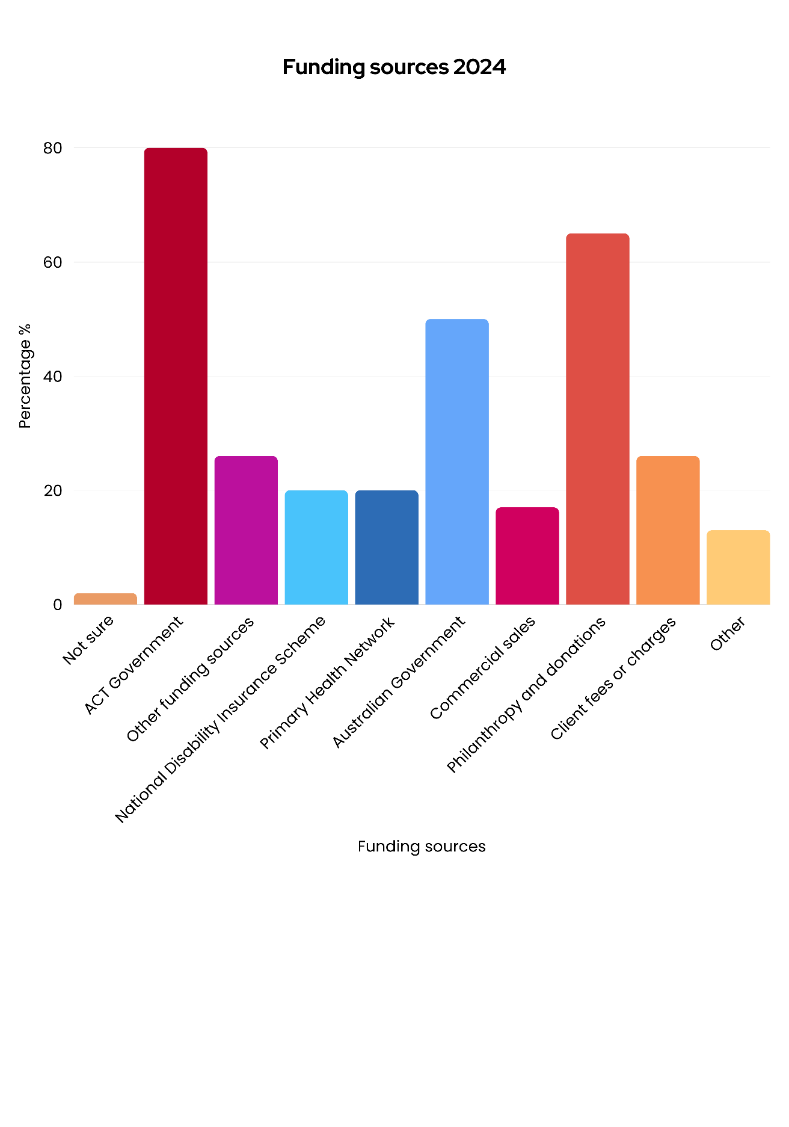
- 17% of organisations received funding from other commercial sources such as retail sales, consultancy services and rents.
Figure 23. Funding sources for ACT community sector organisations

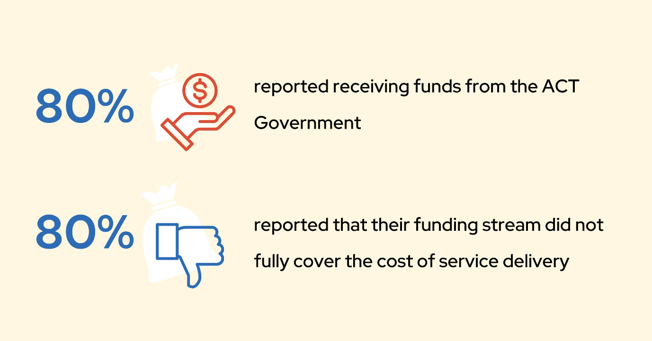
Furthermore, 13% of respondents mentioned receiving funds from other sources, such as:
- Membership fees
- Small sector grants
- Peak body grants or funding
- Corporate partnerships
- Student services amenity fees.
This indicates a broad range of funding sources that community organisations rely on for their financial sustainability.

3.3.1 Most significant source of funding
Organisations were asked to identify their most significant source of funding in 2024. The responses highlight the sector’s strong reliance on ACT Government funding, with fewer organisations drawing primarily on federal, philanthropic, or commercial income streams (see figure 24).

Figure 24. Most significant sources of funding for ACT community sector organisations

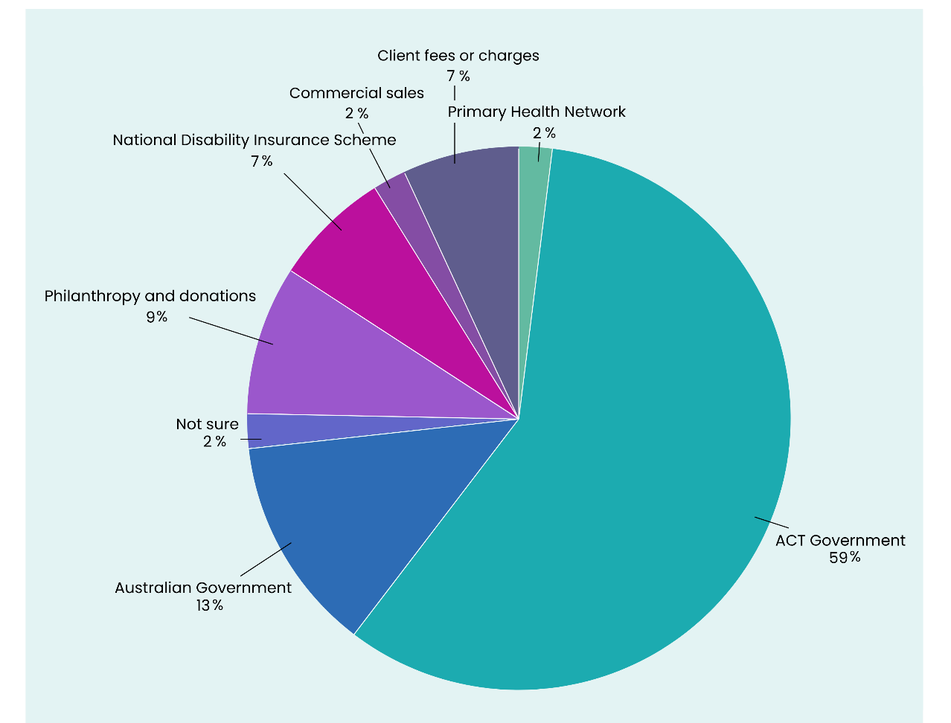
Between 2022 and 2024, there were notable shifts in the most important sources of funding for ACT community sector organisations. The reliance on state and territory Government funding increased, while the proportion of organisations identifying the Australian Government or other sources as their primary funding base declined.
- ACT Government: The proportion of organisations identifying this as their most important source of funding rose from 39% in 2022 to 59% in 2024
- Australian Government (including NDIS and PHNs): Organisations primarily funded by the Commonwealth decreased from 36% in 2022 to 22% in 2024
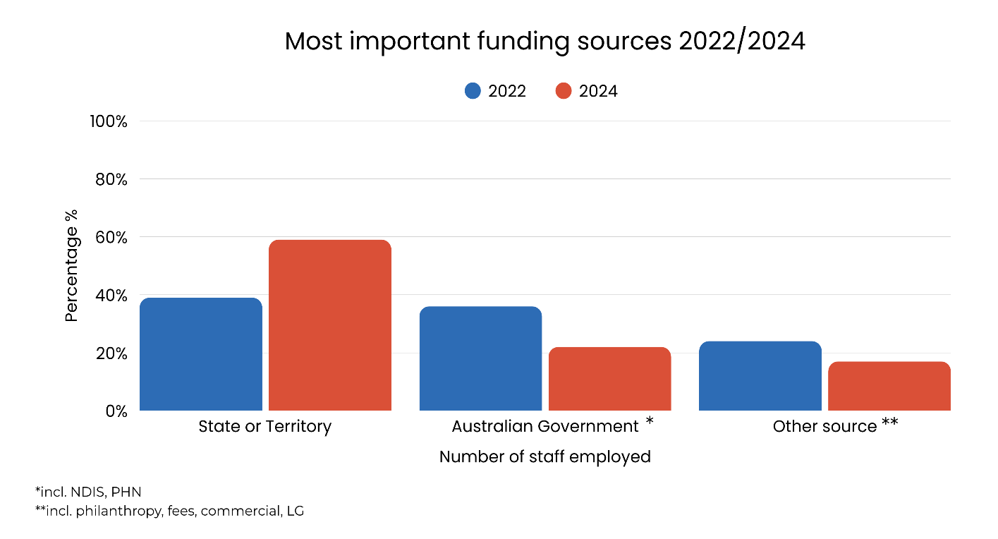
- Other sources (including philanthropy, fees, commercial income, and local Government): The proportion of organisations relying primarily on these sources declined from 24% in 2022 to 17% in 2024.
Figure 25. Most significant sources of funding for ACT community sector organisations 2022 and 2024

Previous analysis of ACT Government budget data shows that investment in the community sector has not kept pace with either population growth or overall government expenditure. In 2009–10, the ACT Government invested approximately $130 million in the community sector, representing 3.6% of total expenditure of $3.7 billion budgeted that year. In 2025–26, the ACT Government projects investment of approximately $252 million, representing only 2.8% of the total $8.93 billion expenditure budgeted for that year. This equates to a 22% decline in the proportion of total expenditure allocated to the community sector.
When adjusted for inflation, an investment of $130 million in 2009–10 was equivalent to $193 million in 2024–25. This means that the ACT Government increased its investment in the community sector by 30.5% between 2009 and 2025, with virtually all this investment for other reasons other than population growth, such as for new programs. Over the same period, total ACT Government expenditure increased by 47.6%, one and a half times faster than the increase in community sector investment. The ACT’s population grew by approximately 35%, approximately 4 percentage points faster than the growth in sector investment.
These findings confirm that even as community organisations have become more reliant on ACT Government funding, systemic underinvestment persists. This underinvestment limits the sector’s capacity to meet growing community demand, particularly in the context of the current cost-of-living crisis, and highlights the importance of transparent and consistent reporting of investment levels in the community sector relative to population growth and need.

3.4 ACT Government stream of funding
Whilst ACT Government was identified as the most significant source of funding for many organisations, most ACT community sector organisations continue to experience a shortfall in Government funding relative to the full cost of service delivery. In 2024-25:
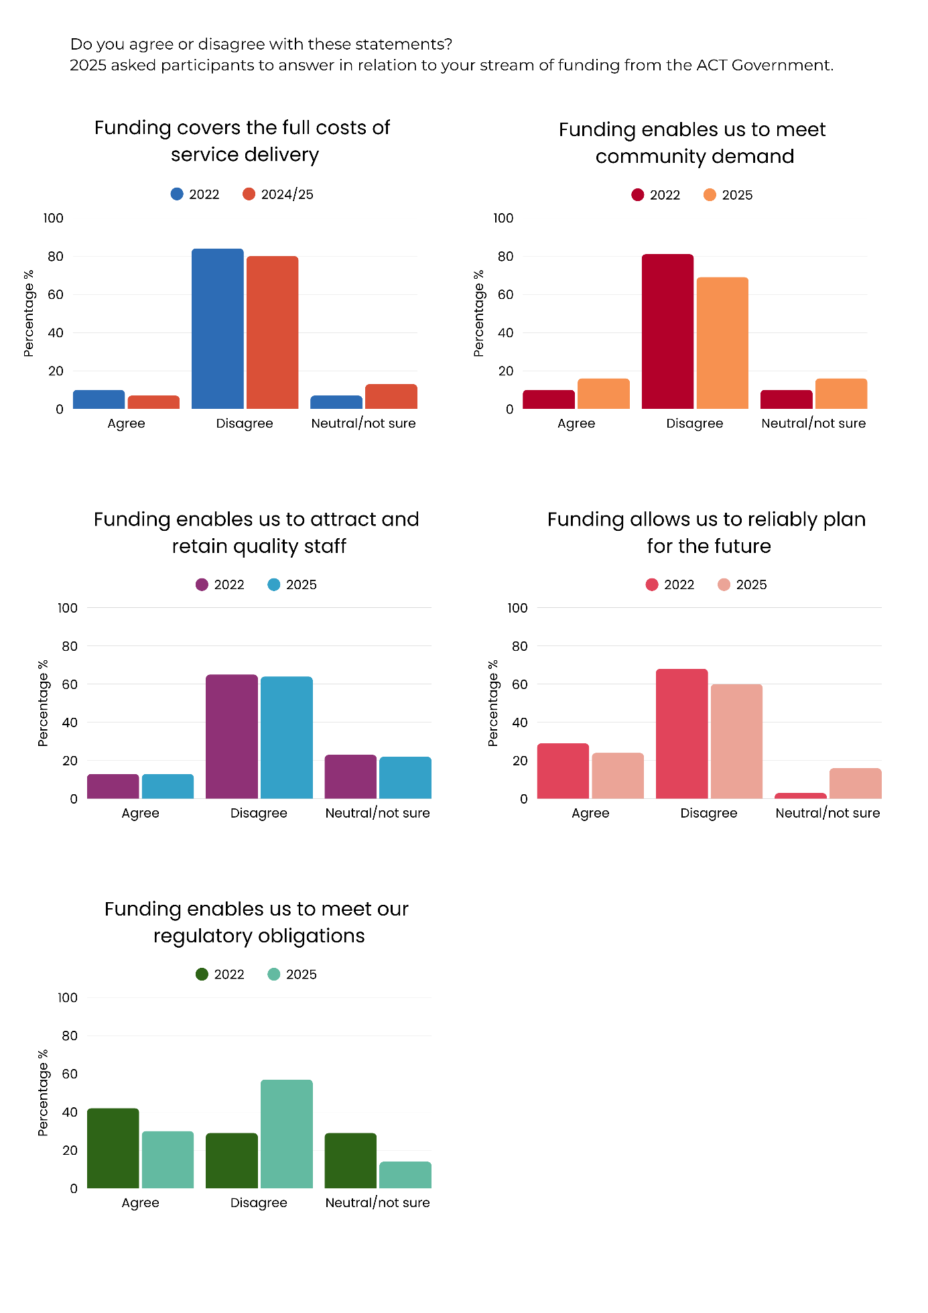
- The majority (80%), disagreed that funding adequately covers service costs, showing a small decrease from 84% in 2022
Figure 26. Funding covers the full cost of service delivery
- 13% of organisations were neutral or unsure about the adequacy of funding, compared with 7% in 2022
- 7% of organisations agreed that act government funding covers the full costs of service delivery, down slightly from 10% in 2022.
Overall, there is little evidence of change between 2022 and 2024-25. These findings highlight that despite being a major funding source, ACT Government contributions often fall short of fully supporting the operational and service delivery costs of community organisations, reinforcing the ongoing challenge of underfunding within the sector.

3.4.1 Community demand and unmet needs
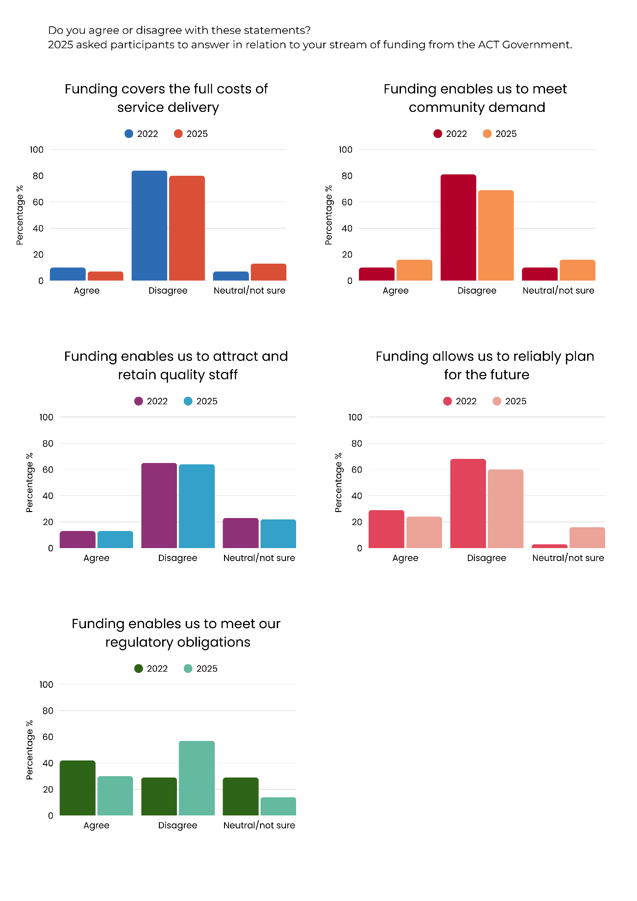
Meeting community demand remains a challenge for organisations reliant on ACT Government funding. In 2025:
Figure 27. Funding enables us to meet community demand
- The majority, 69%, disagreed that community demand, down from 81% in 2022
- 16% of organisations agreed that act government funding enables them to meet community demand, increasing from 10% in 2022
- 16% were neutral or unsure, compared with 10% in 2022.
Overall, there is some suggestion of improvement, possibly due to the outcomes of commissioning.

3.4.2. Attracting and retaining quality staff
Attracting and retaining quality staff is a commonly faced challenge for many organisations. When CEOs, senior management and board members of volunteer organisations were asked whether ACT Government funding enables them to attract and retain quality staff, community organisations reported ongoing challenges. In 2025:
- 64% disagreed that funding enables them to attract and retain quality staff, similar to 65% in 2022
Figure 28. Funding enables us to attract and retain quality staff
- 22% were neutral or unsure if funding enables them to attract and retain quality staff, also similar to 23% in 2022
- 13% of organisations agreed that funding supports them to attract and retain quality staff, unchanged from 13% in 2022.
These findings suggest little to no progress since 2022, with the majority of organisations continuing to report that current funding levels are insufficient to ensure workforce stability and sustainability.

3.4.3 Ability to reliably plan for the future
Organisations were also asked whether ACT Government funding allows them to reliably plan for the future. In 2025:
Figure 29. Funding enables us to reliably plan for the future
- Three in five (60%) disagreed that funding allows their organisation to reliably plan for the future, decreasing from 68% in 2022
- Almost one quarter (24%) agreed that funding supports future planning, a decrease from 29% in 2022
- 16% were neutral or unsure, increasing from 3% in 2022.
Most respondents did not think that ACT Government funding enabled organisations to effectively plan for the future. Overall, there is little evidence of major change in this sentiment, with more respondents being unsure. The increase in organisations reporting uncertainty points to growing instability and unpredictability in funding arrangements, which may make it difficult for the community sector to invest in future capacity, innovation, and workforce development. This uncertainty undermines the sector’s ability to respond strategically to increasing community need and limits opportunities for sustainable service delivery.

3.4.4 Ability to meet regulatory obligations
Organisations were also asked whether ACT Government funding enables them to meet their regulatory obligations. In 2025:
Figure 30. Funding enables us to meet our regulatory obligations
- 57% disagreed that their funding from ACT Government enables them to meet their regulatory obligations, almost doubling from 29% in 2022
- 30% agreed that funding enables them to meet their regulatory obligations, down from 42% in 2022
- 14% were neutral or unsure, compared with 29% in 2022.
These results show a decline in confidence that funding is sufficient to meet compliance and regulatory requirements. While fewer organisations are unsure compared with 2022, the sharp increase in disagreement suggests that regulatory responsibilities are placing a growing strain on already limited resources. This shift highlights the increasing gap between funding levels and the administrative and governance expectations placed on community organisations, adding to the pressures that divert time and resources away from direct service delivery.

3.5 Adequacy and shortfalls of ACT Government funding
Survey findings highlight gaps between the funding provided by the ACT Government and the actual costs of delivering community services. Across multiple areas, including overheads, staffing, professional development, wage growth, safety, and volunteer management, most organisations reported that funding is either under-funded or not funded at all. Very few organisations considered funding to be adequate, pointing to persistent structural shortfalls that threaten workforce stability, service quality, and the sector’s ability to meet growing community demand.

3.5.1 Overheads
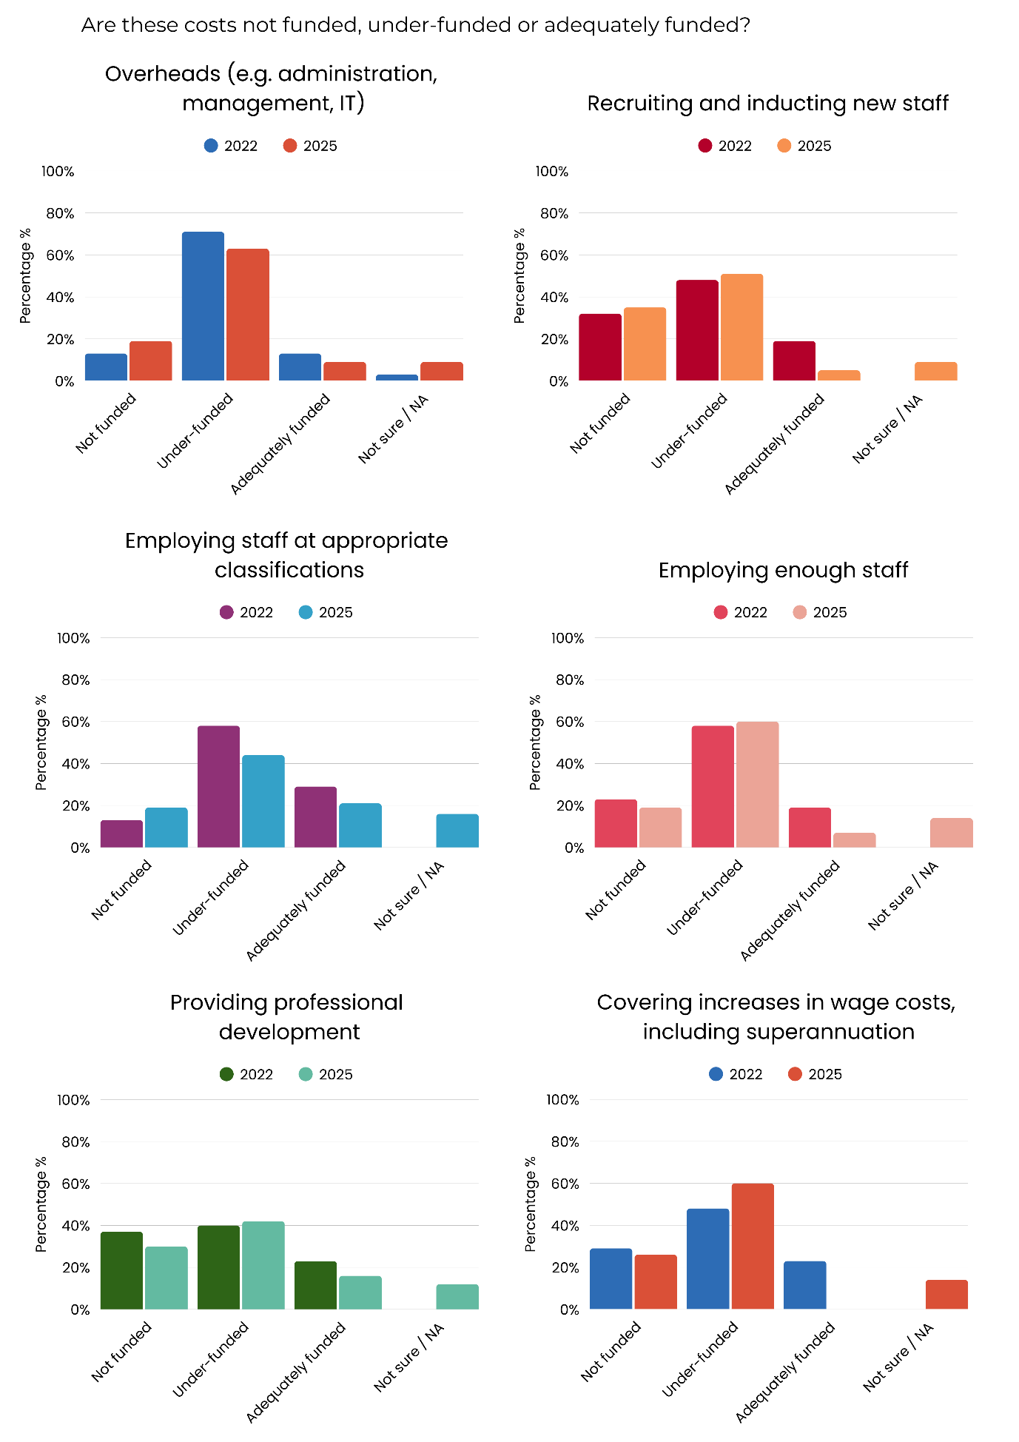
Overheads and administrative burdens emerged as significant challenges for ACT community organisations over the past year. When asked whether ACT Government funding covers overheads such as administration, management, and IT, most organisations indicated a shortfall. In 2025:
Figure 31. Adequacy of funding for overheads (e.g. administration, management, IT)

- 63% of organisations said overhead costs were under-funded, decreasing from 71% in 2022
- almost one in five (19%) reported that overheads were not funded at all, increasing from 13% in 2022
- 9% considered overheads to be adequately funded, decreasing from 13% in 2022
- 9% were unsure or said the question was not applicable, increasing from 3% in 2022.
These results point to a persistent gap in funding for core operational costs, with very few organisations reporting that overheads are adequately supported. The results highlight the fragility of current funding arrangements, which often fail to recognise the essential role of administration and infrastructure in sustaining frontline service delivery. Without sufficient investment in these areas, organisations face ongoing challenges in maintaining efficiency, accountability, and long-term sustainability.

3.5.2 Recruitment, classification and staff development
A sustainable and skilled workforce is central to the delivery of community services, yet survey results show that ACT Government funding continues to fall short in supporting core staffing costs.

Organisations reported persistent challenges in funding the recruitment and induction of new staff, employing staff at the appropriate classification levels, maintaining enough staff to meet community demand, and supporting professional development. Across all four areas, few organisations considered funding to be adequate, with many identifying underfunding or complete lack of funding. These gaps place ongoing strain on workforce stability, limit opportunities for skill development, contribute to staff turnover and burnout, and undermine the sector’s ability to deliver consistent, high-quality services.

Recruiting and inducting new staff
When asked about funding for recruiting and inducting new staff, most organisations reported insufficient support. In 2025:
Figure 32. Adequacy of funding for recruiting and inducting new staff

- Over half of organisations (51%) considered costs for recruiting and inducting new staff under-funded, compared with 48% in 2022
- 35% said these costs were not funded, compared to 32% in 2022
- 9% reported that they were unsure or not applicable, increasing from 0% in 2022
- 5% said these costs were adequately funded, decreasing sharply from 19% in 2022.
These findings suggest a decline in adequate support for recruitment processes. This gap makes it harder to attract and onboard staff effectively, undermining workforce stability and service quality.

Employing staff at appropriate classifications
Organisations were also asked whether funding enables them to employ staff at appropriate classifications. In 2025:
Figure 33. Adequacy of funding for employing staff at appropriate classifications

- Almost half (44%) considered costs associated with employing staff at appropriate classifications as under-funded, decreasing from 58% in 2022
- Approximately one in five (21%) said they were adequately funded, a decrease from 29% in 2022
- 19% said these costs were not funded, up from 13% in 2022
- 16% were unsure or said not applicable, increasing from 0% in 2022.
These results indicate that while fewer organisations report underfunding compared with 2022, a substantial proportion still struggle to employ staff at appropriate classifications. The findings highlight ongoing instability in staffing support. This underlines the persistent challenge for community organisations to maintain a workforce with appropriate skills and classification levels.

Employing enough staff
In relation to employing sufficient staff to meet demand, results again revealed widespread funding challenges. In 2025:
Figure 34. Adequacy of funding for employing enough staff

- Three in five organisations (60%) considered that they were under-funded to employ enough staff, compared with 58% in 2022
- Almost one in five (19%) said these costs were not funded at all, compared with 23% in 2022
- 7% reported adequate funding, decreasing from 19% in 2022
- 14% were unsure or said not applicable, increasing from 0% in 2022.
These findings suggest that most organisations are unable to employ enough staff to meet community needs. The decline in adequate funding reflects a deepening workforce shortage, which risks service gaps and contributes to staff burnout (see chapter 4) as demand continues to rise.

Providing professional development
Organisations were asked whether ACT Government funding adequately supports professional development for staff. In 2025:
Figure 35. Adequacy of funding for staff professional development

- 42% of organisations considered professional development for staff under-funded, compared to 40% in 2022
- Almost one third (30%) said professional development costs were not funded at all, decreasing from 37% in 2022
- 16% reported that professional development was adequately funded, a decrease from 23% in 2022
- 12% were unsure or said not applicable, up from 0% in 2022.
These results indicate that most organisations continue to face limited support for professional development, with very few receiving adequate funding. The decline in adequate funding, combined with persistent underfunding, suggests that staff access to training and skill development remains constrained.

3.5.3. Covering increases in wage costs, including superannuation
Organisations were asked whether ACT Government funding covers increases in wage costs, including superannuation. In 2024-25:
Figure 36. Adequacy of funding for covering increases in wage costs, including superannuation

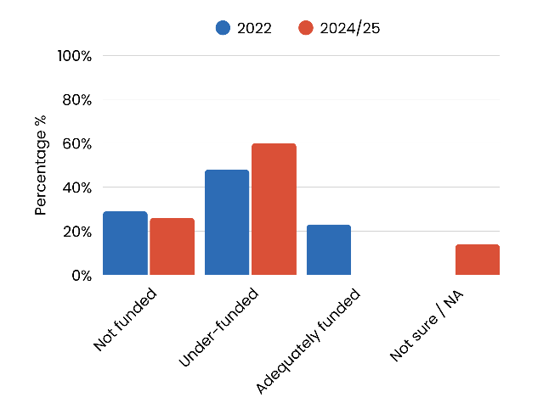
- Three in five (60%) organisations said they were under-funded for wage costs, including superannuation, increasing from 48% in 2022
- Over one quarter (26%) reported increases in wage costs were not funded, decreasing from 29% in 2022
- No organisations reported adequate funding, compared with 23% in 2022
- 14% were unsure or said not applicable, increasing from 0% in 2022.
These results reveal a deterioration in the adequacy of funding for wage and superannuation costs. The complete absence of organisations reporting adequate funding in 2025 signals that wage growth is not being matched by funding increases. This gap places considerable financial pressure on organisations, forcing them to absorb rising employment costs, which in turn undermines pay equity, workforce security, capacity to maintain program delivery at current levels, respond to increasing demand, and the sector’s long-term sustainability.
Uncosted superannuation costs due to indexation have emerged as a significant concern. The legislated increases to the Superannuation Guarantee (SG), saw it rise from 10.5% in 2022-23 to 11.5% in 2024-25, with further increases to 12% in 2025/26. These increases are not being matched by corresponding adjustments in funding. These increases are indexed and mandatory, yet many organisations report that they are not accounted for in Government contracts or funding models. As a result, organisations are left to absorb these costs without additional support, compounding existing financial strain already caused by wage growth. This misalignment between policy and funding mechanisms risks eroding employment conditions and weakening the sector’s ability to attract and retain qualified staff.

3.5.4 Ensuring client and worker safety
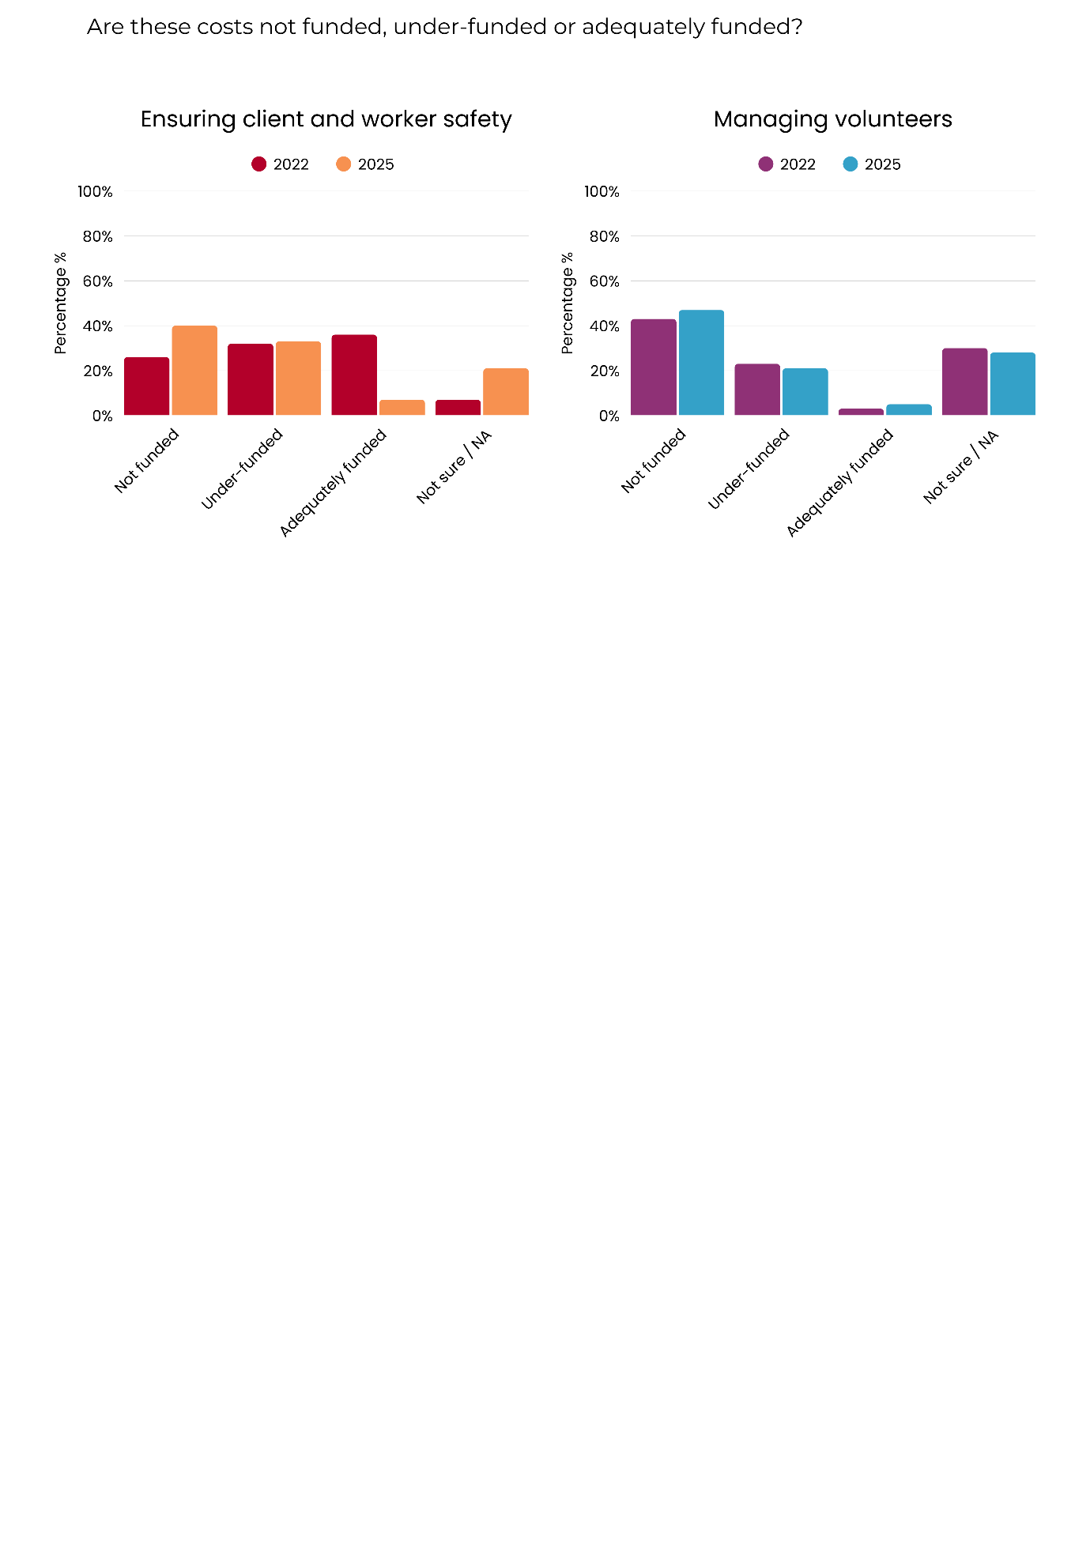
Organisations were asked whether ACT Government funding adequately supports client and worker safety. In 2025:
Figure 37. Adequacy of funding for ensuring client and worker safety

- 40% were not funded to ensure client and worker safety, increasing from 26% in 2022
- 33% of organisations indicated that they were under-funded, increasing slightly from 32% in 2022
- over one in five (21%) organisations were unsure or said not applicable, increasing from 7% in 2022
- 7% considered safety costs adequately funded, decreasing from 36% in 2022.
These findings highlight a concerning decline in adequate funding for safety. The sharp decline in organisations reporting sufficient support, coupled with the rise in those reporting no funding at all, indicates growing pressure on organisations to meet safety responsibilities without appropriate resourcing. This has implications for both staff wellbeing and the safe delivery of services to clients, particularly as demand and complexity of needs continue to rise.

3.5.5 Managing volunteers
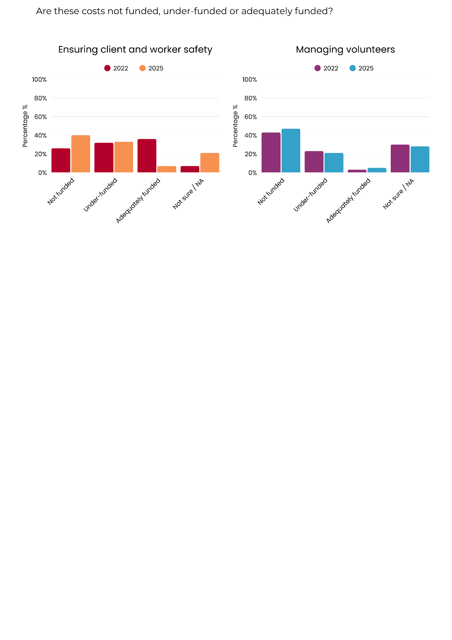
Organisations were asked whether ACT Government funding supports the costs of managing volunteers. In 2025:
Figure 38. Adequacy of funding for managing volunteers

- Almost half (47%) of organisations reported that costs associated with managing volunteers were not funded at all, compared to 43% in 2022
- More than one quarter (28%) of organisations were unsure or said not applicable, compared with 30% in 2022
- Around one in five (21%) of organisations considered costs associated with managing volunteers as under-funded, decreasing slightly from 23% in 2022
- 5% said they were adequately funded to manage volunteers, a small increase from 3% in 2022.
These results show that volunteer management remains largely unfunded, despite volunteers playing a critical role in the community sector’s capacity to deliver services. The persistence of high levels of non-funding suggests that the time, training, and resources needed to coordinate and support volunteers are not adequately recognised within current funding arrangements. This gap risks undermining the sustainability of volunteer contributions, which are often vital to meeting growing community demand.

3.6 ACT Government funding for core organisational functions
Funding for essential organisational functions such as policy engagement, planning, consumer involvement, contract administration, monitoring and evaluation, emergency preparedness, and insurance remains limited for ACT community organisations.

Commissioning has yet to deliver its intended outcome of ensuring sector sustainability and meeting community needs. Although the ACT Government is developing a costing tool to support both government and community organisations in pricing services and programs, it has yet to be rolled out. In the meantime, persistent funding gaps continue to undermine the sector’s ability to plan effectively, manage risk and engage meaningfully in policy and reform processes that shape service delivery in the ACT.
Survey results show that most organisations are underfunded or not funded at all to support core organisational functions, with only a small proportion reporting adequate resourcing.
- On average, 77% of respondents indicated that core organisational functions were not funded at all or were underfunded by the ACT Government
- A further 15% were unsure or reported that measures were not applicable
- 8% reported being adequately funded across these areas.
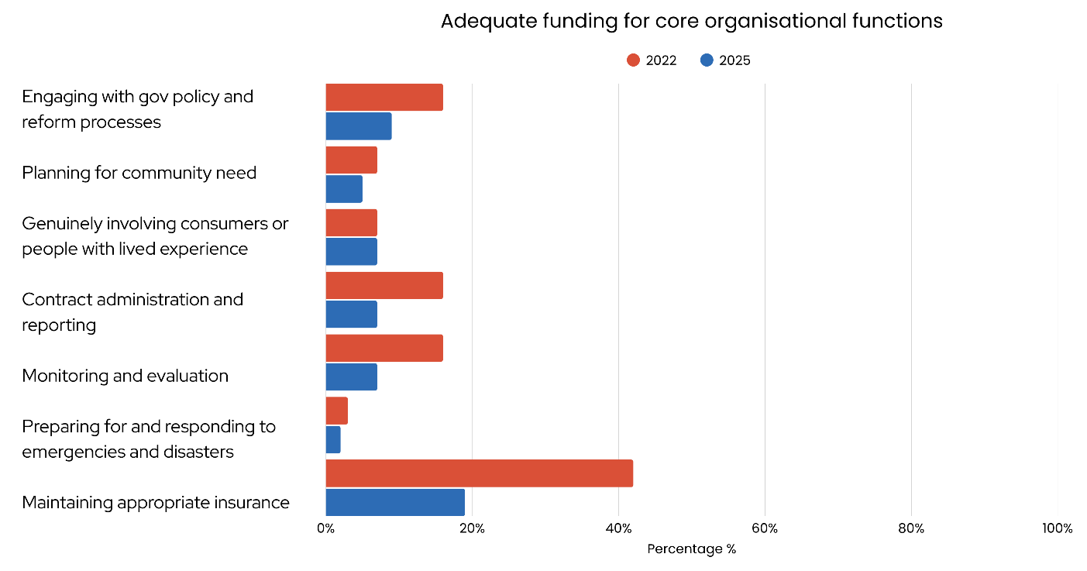
Figure 39. Respondents reporting receiving adequate funding for core organisational functions

This pattern likely reflects inadequacies in current commissioning processes and may also reflect some organisations progression in the commissioning cycle.

3.7 Workforce capacity and staffing challenges
Workforce capacity and stability are critical to the ability of community organisations to deliver services. This section explores changes in full-time equivalent (FTE) staff numbers, experiences of recruitment and retention, and patterns of staff turnover. The findings provide insight into how organisations are managing workforce challenges in the context of sustained demand pressures and uncertainty over funding resulting from the commissioning process.

3.7.1 Number of full-time equivalent staff
Organisations were asked how their FTE staff numbers had changed between 2022 and 2024. In 2025 (see figure 40):
- Almost half (47%) of organisations indicated that their staffing levels had stayed about the same, similar to 49% in 2022
- Over one quarter (27%) reported an increase in FTE staff, increasing from 18% in 2022
- 22% of organisations reported a reduction in staff numbers, decreasing from 30% in 2022
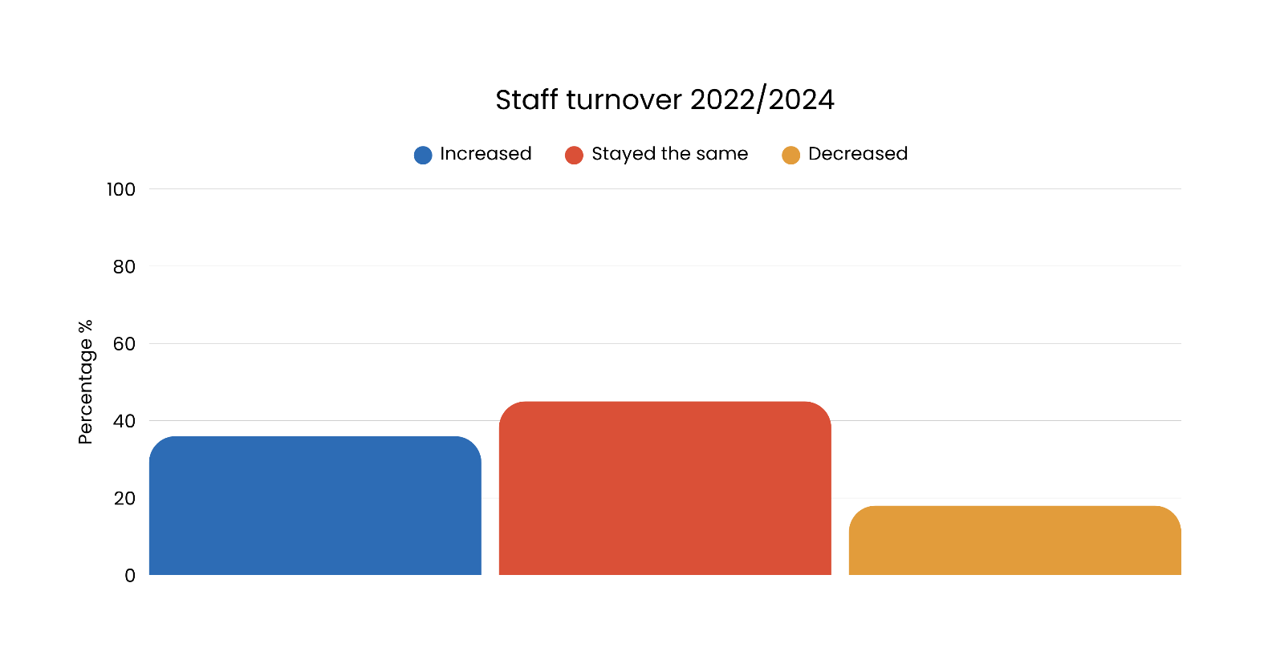
- 4% were unsure or said not applicable, compared with 3% in 2022.
Figure 40. Number of FTE staff in 2022 and 2024

These findings suggest some positive movement in staffing capacity, with fewer organisations reporting reductions and more indicating increases compared with 2022. However, the fact that nearly half reported no change highlights ongoing workforce constraints in a context of growing community demand.

3.7.2 Attract and retain staff
Organisations were also asked whether it had become easier or more difficult to attract and retain staff over the same period. In 2025 (see figure 41):
- 60% reported that attracting and retaining staff had become more difficult
- one third (33%) said it had stayed about the same
- 4% were unsure or said not applicable
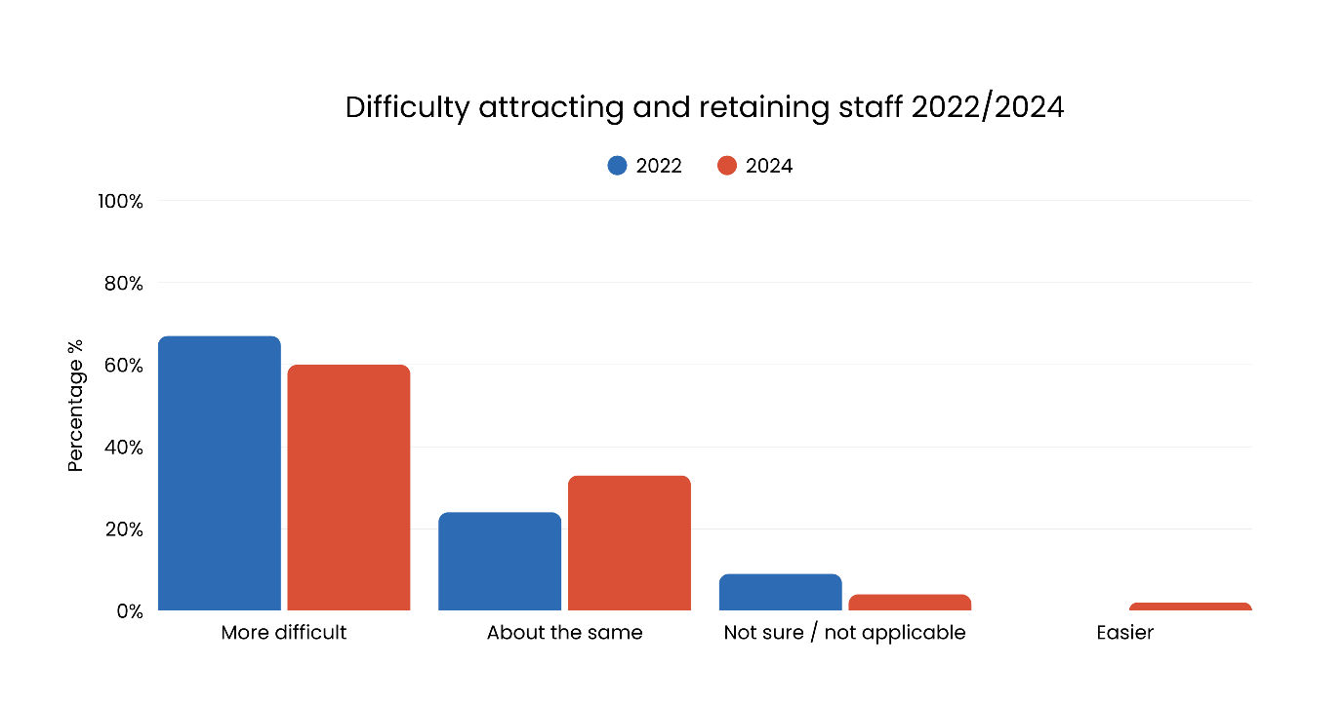
- 2% said it had become easier.
Figure 41. Difficulty in attracting and retaining staff in 2022 and 2024

These results show that while some organisations are increasing staff numbers, challenges in recruitment and retention remain widespread. The persistence of high levels of difficulty in attracting and retaining staff underscores ongoing workforce pressures, which risk undermining organisational stability and the ability to respond to rising service demand.

3.7.3 Staff turnover
Organisations were further asked how they would rate staff turnover in their organisation. In 2025 (see figure 42):
- 36% reported that turnover had increased compared with 49% in 2022 who considered it too high
- 45% said turnover had stayed the same, compared with 52% in 2022 who said it was about right
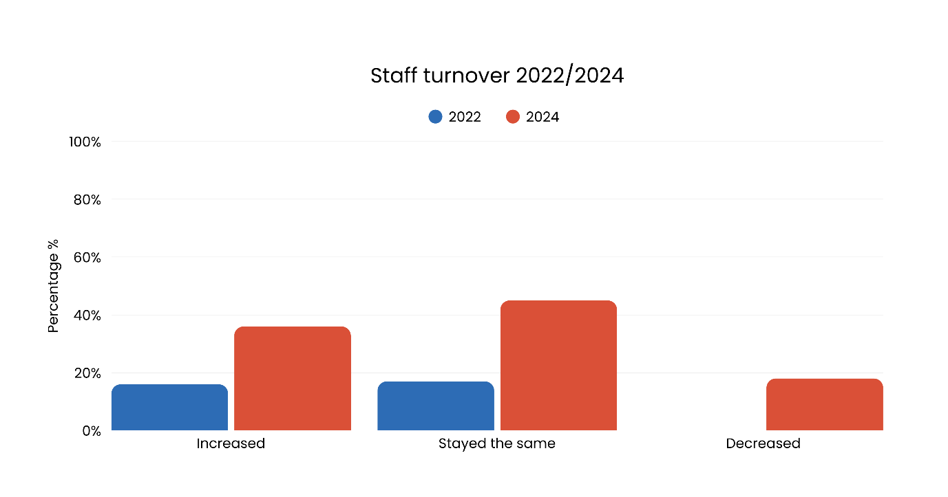
- 18% reported turnover had decreased, compared with 0% in 2022.
Figure 42. Staff turnover rate in 2022-2024

These findings indicate some improvement in staff turnover compared with 2022, with fewer organisations reporting turnover as excessively high. However, more than one third still noted increases, suggesting ongoing instability in workforce retention across the sector.

3.8 Impacts of inadequate funding
Beyond specific funding gaps in areas such as workforce, compliance, and insurance, organisations reported broader impacts of inadequate and insecure funding. These effects extend across service delivery, staff wellbeing, and organisational capacity, creating challenges for the sustainability and effectiveness of the ACT community sector.

3.8.1 Administrative burden
Administrative and financial pressures added further strain. Over 2024-25:
- A majority (70%) of respondents reported an increase in administrative burden
- Approximately one quarter (24%) stated it had remained the same
- 6% were unsure or found the question not applicable
- No organisations reported a decrease.
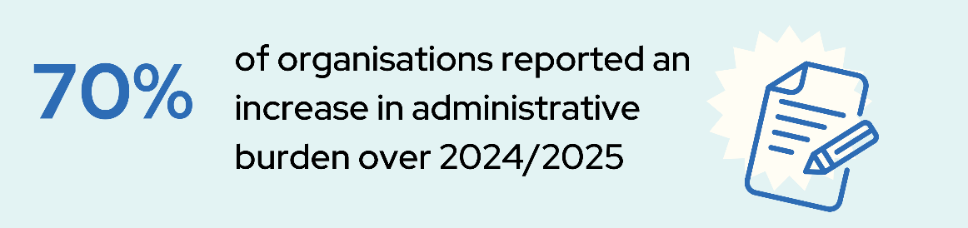

These findings highlight that rising administrative and financial pressures continue to place a strain on organisations, diverting time and resources away from direct service delivery and limiting capacity to respond effectively to community needs.

3.8.2 Other challenges due to inadequate funding
In 2025, organisations identified a range of negative consequences from inadequate funding, including:
- Cuts to the range of services offered
- Increased risk to clients and staff due to inadequate funding
- Limited expansion of existing services
- Limited expansion of new services
- Reductions in workforce numbers
- Heightened stress and uncertainty among staff
- Reductions in ability for employers to provide adequate professional development opportunities
- Forced to find innovative solutions.
The range of negative consequences reported highlight the widespread impact of insufficient funding, affecting staff wellbeing, service expansion, workforce stability, and organisational resilience, and demonstrating the critical need for more secure and adequate funding to support sustainable service delivery.

3.9 Funding and insurance challenges affecting compliance and risk management
Rising insurance costs and limited funding continue to create challenges for ACT community organisations. These pressures affect their ability to meet regulatory obligations, maintain client and worker safety, and manage risk effectively. Organisations face difficult decisions around service delivery, staffing, and operational priorities as they navigate increasing premiums and insufficient funding support.

3.9.1 Rising insurance costs and organisational impact
Community organisations continue to face challenges from rising insurance costs, which affect their ability to deliver services and manage risk effectively. Many organisations report receiving limited or no Government funding to cover these costs, placing additional pressure on already stretched budgets (see page 42 for more information on ACT Government funding).
These increasing insurance cost burdens, affect community organisations abilities to deliver services and manage risk effectively. In 2025:
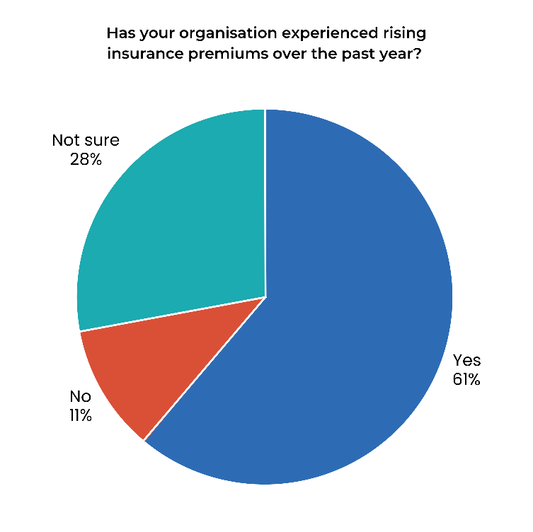
- 61% of organisations reported increases in insurance premiums over the past year
Figure 43. Has your organisation experienced rising insurance premiums over the past year?

- 28% were unsure or not applicable
- 11% had not experienced an increase.

These rising premiums had impacts on service delivery, including:
- Reducing the number of services offered
- Limit staffing or wages for new positions
- Divert funds from other areas
- Increase service costs, or adopt selective insurance arrangements,
thereby taking on the risk of offering some uninsured services.
These findings highlight that rising insurance costs are placing financial and operational pressure on community organisations, forcing difficult trade-offs that can limit service delivery and increase organisational risk.

3.9.2 Perceived drivers of rising insurance costs
Community organisations highlighted a range of interconnected factors driving the rise in insurance costs. These pressures reflect broader economic, environmental, and market trends that amplify financial strain on the sector. Themes within responses included:
- Increased premiums for workers compensation
- Public liability, litigation, property damage, and volunteer insurance
- Climate change
- Cost-of-living pressures
- Inflation
- Stricter risk assessments or heightened perceptions of organisational risk by insurance providers
- Reduced competition in the insurance market.
These factors create a complex risk environment that increases costs for community organisations and underscores the need for targeted strategies to ensure access to affordable and sustainable insurance.


3.9.3 Potential solutions to rising insurance costs
To address these pressures, organisations were asked whether they would support the establishment of a community insurance fund by the ACT Government to help access affordable insurance.
- 82% in support the establishment of a community insurance fund by ACT Government to help community organisations access affordable insurance
- 18% indicated that they were not sure or not applicable
- No organisations (0%) disagreed with the proposed community insurance fund.
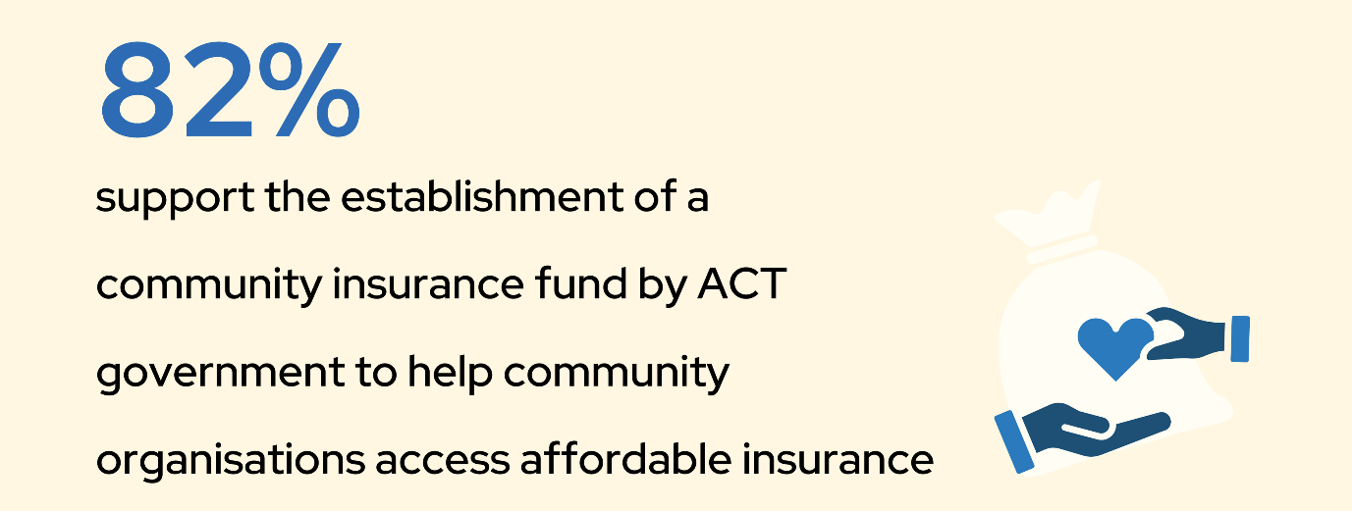

These results indicate widespread support within the community sector for a Government-backed insurance fund, highlighting its potential to alleviate financial pressures, enhance organisational resilience, and ensure the continued delivery of essential services.

3.10 ACT Government indexation
Indexation for the ACT community sector refers to the regular adjustment of funding levels provided by the Government to account for inflation and rising operational costs. This ensures that community organisations can maintain their service delivery standards and continue meeting the needs of the community despite increases in expenses.

3.10.1 Adequacy of indexation
Adequate indexation is essential for ensuring that Government funding keeps pace with inflation and rising operational costs. Without sufficient indexation, community organisations struggle to maintain service quality, meet workforce obligations, and respond effectively to growing community needs.

Survey responses regarding the adequacy of indexation in 2025 showed that:
- The majority of organisations (63%) disagreed that indexation was adequate overall
- 30% neutral or unsure
- Few organisations (7%) agreed that indexation was adequate.
These findings indicate that current indexation levels are widely perceived as insufficient, leaving most organisations financially constrained. Addressing these inadequacies is critical to supporting sustainable service delivery and ensuring organisations can meet the evolving needs of the ACT community.

3.10.2 Indexation familiarity, involvement and communication
Understanding and engaging with the indexation process is essential for organisations to plan effectively and ensure funding meets operational needs. The survey highlighted varying levels of familiarity, involvement, and communication regarding the ACT Government’s indexation formula.
Key findings include:
- Half of respondents (50%) were familiar with the indexation formula
- 27% of respondents were not familiar with the formula
- 23% were unfamiliar or unsure.
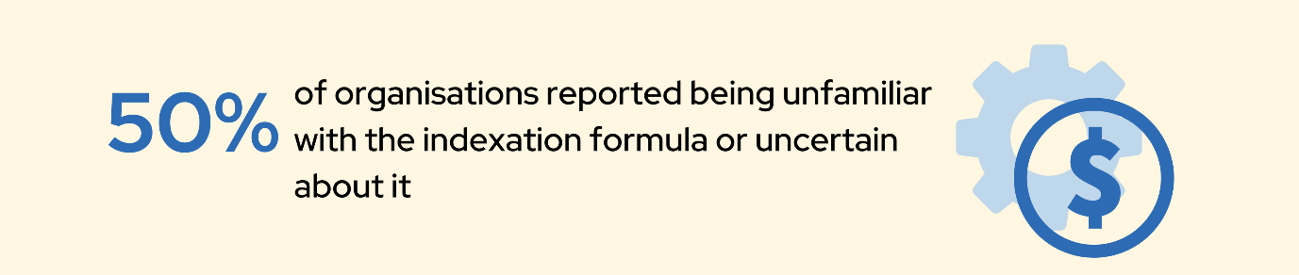
Active involvement in developing the indexation formula was low.
- 95% of organisations were not involved or unsure if they were actively involved in the development process for the indexation formula (56% disagreed, and 39% were neutral or unsure)
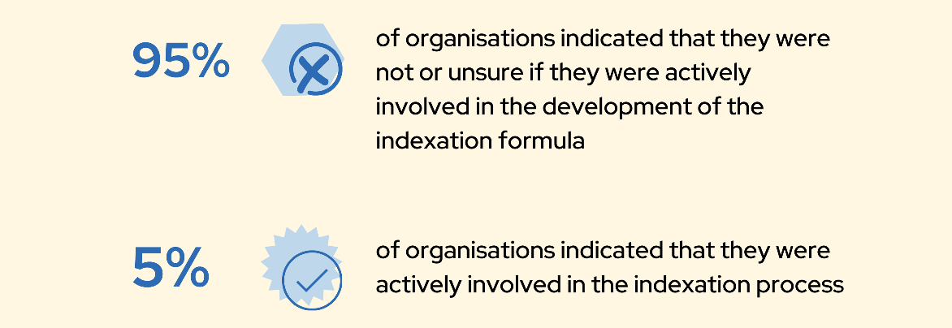
- 5% of organisations reported having input into how the formula for their funding is indexed.

Communication about indexation rates was another area of concern.
- 88% of organisations indicated that they did not receive enough notice about indexation rates or were neutral/unsure (49% disagreed, and 39% were neutral or unsure)
- 12% of organisations agreed that they received sufficient notice about changes to indexation rates.
These results indicate that most organisations have limited knowledge and involvement in the indexation process, and communication regarding changes is generally inadequate. Improved engagement and clearer communication are necessary to ensure organisations can plan and respond effectively to funding adjustments.

3.10.3 Organisational concerns regarding indexation
Further insights came from comments provided by 11 organisations. These comments revealed widespread dissatisfaction, with common concerns including challenges in covering expenses related to:
- Staffing and wages
- Insurance and compliance requirements
- Service delivery and daily operations
- Property maintenance
- Growing demand for health services
- Inadequate indexation and funding failing to keep pace with rising costs.
These findings suggest issues with the current indexation approach, including limited involvement, inadequate communication, and funding that does not align with operational realities. These challenges highlight the need for greater transparency, engagement, and adjustments to ensure indexation better meets organisational needs.

3.11 Commissioning
Commissioning in the community sector is a strategic process introduced by the ACT Government with the aim of improving the delivery of services by allocating funding and resources to achieve efficient, outcomes-based support. This approach seeks to foster innovation, collaboration, and long-term sustainability within community services. However, to date this has not been achieved, and the ACT Government has acknowledged that commissioning needs further refinement, and they are currently undertaking an evaluation of the process.
Organisations were surveyed about their experiences with the ACT Government’s commissioning process. When asked if they had been funded through commissioning to continue similar work:
- 37% disagreed, indicating that they had not been funded through commissioning to continue similar work
- 33% of respondents were unsure or found the question inapplicable, likely due to the timing of the survey. Many organisations were still awaiting outcomes or had not yet begun the commissioning process
- 30% of organisations confirmed they had been funded through commissioning to continue similar work.
Of the 30% of organisations that had been funded through the commissioning to continue similar work, they were asked about the impact of commissioning on the sustainability of funding for pre-existing work:
- Half (50%) of the organisations reported that the process had slightly or significantly worsened the sustainability of funding for pre-existing work
- 43% stated that commissioning had no impact
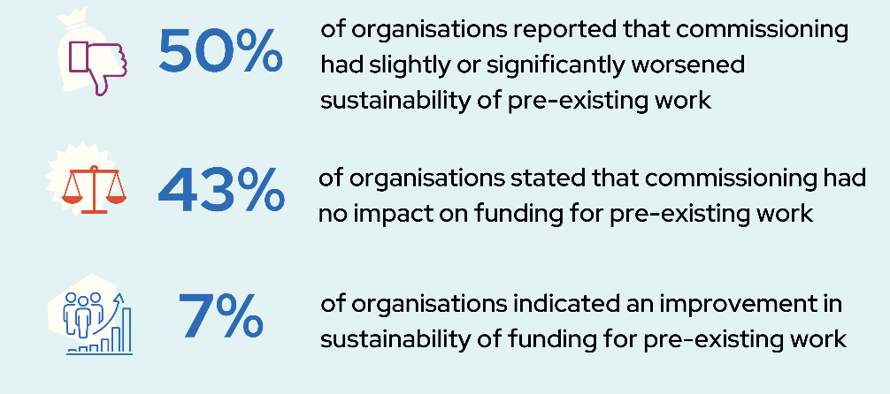
- One (7%) organisation indicated an improvement in sustainability of funding for pre-existing work.

These findings suggest that the changes to the commissioning process have not achieved the aims of improving sustainability for the sector. For many organisations, commissioning has introduced uncertainty or created additional risk for pre-existing programs, highlighting the need for improvements to achieve its intended outcomes of efficiency, collaboration, and long-term security.

3.11.1 Commissioning challenges and concerns
Organisations identified a range of challenges associated with the commissioning process. Many described it as administratively burdensome, requiring significant time and resources to navigate. There was widespread concern about a lack of clarity regarding when and how commissioning occurs, as well as limited transparency about its decision-making processes and capacity to meet intended objectives.
When asked for additional comments about commissioning, organisations highlighted several specific issues:
- Engagement in the commissioning process is unfunded, and adds substantial administrative burden, making day-to-day operations difficult to manage
- There is a lack of clarity about the timing and procedures of commissioning rounds
- Limited transparency raises concerns about whether commissioning achieves its stated objectives
- Commissioning has often failed to address the critical need for secure and sustainable funding, complicating service delivery.
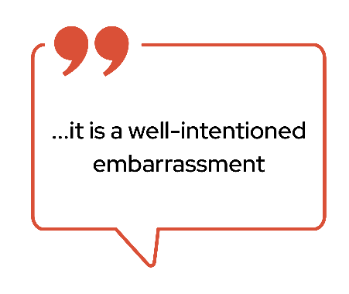
This frustration was expressed in comments left by respondents, with a few examples below:

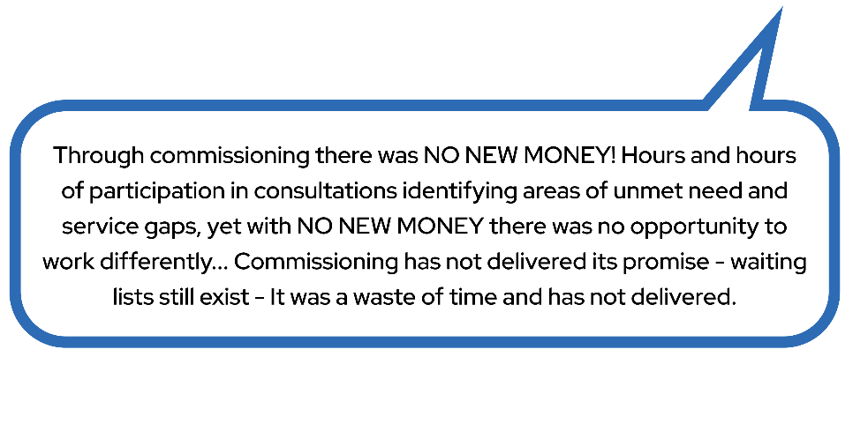

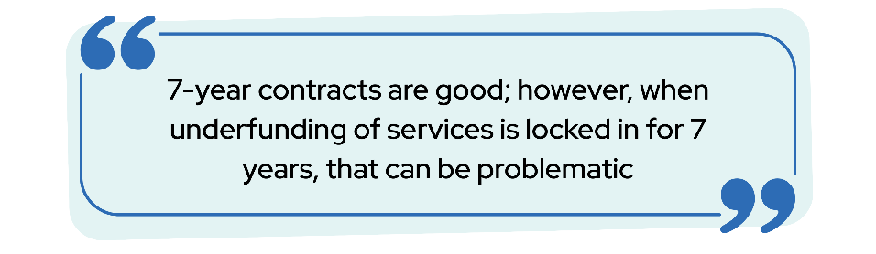
For organisations actively engaged in commissioning at the time of the survey, delays in commissioning streams due to repeated extensions were a notable challenge. These delays created uncertainty and hindered long-term planning. One organisation that had secured a seven-year contract expressed concern about the risks of locking in underfunded services for an extended period:

Overall, these findings highlight the difficulties experienced by ACT community sector organisations when interacting with the current commissioning framework. The ACT Government has acknowledged that existing processes and policies have limited the effectiveness of commissioning and is actively evaluating the approach to improve transparency, reduce administrative burden, and ensure better outcomes in partnership with the sector.

3.12 Sustainability of funding
Adequate and sustainable funding is essential for the ACT community sector to effectively meet the diverse and growing needs of the populations it serves. Funding that accounts for inflation, rising operational costs, and emerging demands is critical to maintaining the quality and breadth of service delivery.
Organisations were asked whether they believed their programs or services funded by the ACT Government were sustainably supported.
- A majority, 74% of organisations, disagreed or strongly disagreed that their funding was sustainable
- 9% agreed or strongly agreed that their funding arrangements were sustainable, while
- 12% indicated that the funding situation had not changed
- The remaining 5% were unsure.

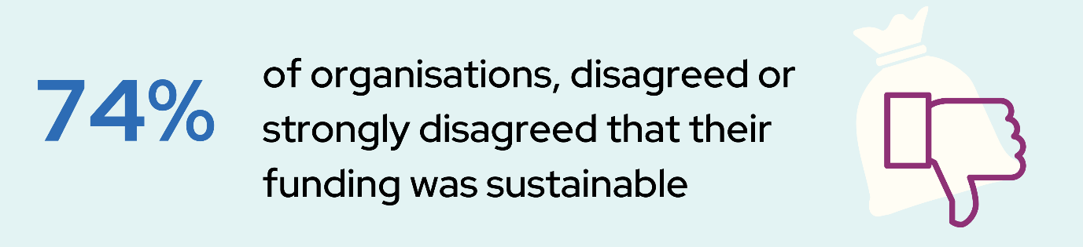
Uncertainty in the sector and organisations was also noted in qualitative responses, emphasising the need for sustainable funding. In qualitative responses, it was common for uncertainty to be linked to tenuous funding or structural changes in the sector:
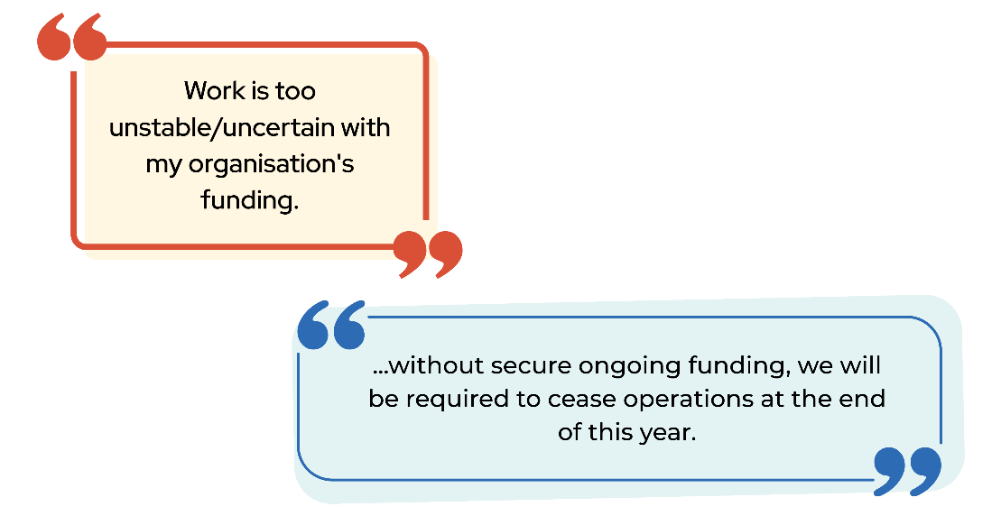

This highlights a widespread concern about the stability and adequacy of funding to support long-term service delivery.

4. Workforce overview
This chapter provides an overview of the ACT community sector workforce, including employment characteristics, earnings, working hours, demographics, qualifications, volunteer engagement, and the focus of service delivery.

Findings indicate a highly educated and predominantly female workforce, with most employees in permanent roles and working across a wide range of community service areas. While full-time equivalent (FTE) staffing levels have remained largely stable, challenges persist around workload, unpaid hours, and workforce sustainability.

Income levels varied across the sector, with many respondents indicating concern about pay adequacy relative to workload and responsibility. Respondents also reported contributing unpaid labour to maintain operations and service delivery, highlighting the extent of under-resourcing within the sector.

The workforce demonstrated considerable experience and diversity, with many identifying as having carer responsibilities, lived experience of disadvantage, or working across multiple service systems. Volunteer participation remains essential, though some organisations noted growing challenges in recruitment and engagement.

Overall, the 2024 findings highlight the ACT community sector’s strong professional capacity and commitment, alongside persistent financial and workload pressures that continue to shape workforce conditions and sustainability.

4.1 All service focus areas
Respondents were given the option to select multiple service categories of their main service or program focus. The responses provide a detailed snapshot of the diverse areas represented within the community sector workforce. These areas highlight the critical needs being addressed by community sector professionals, with a strong emphasis on mental health, child and youth, housing, and family-related supports.
The top 10 service focus areas for organisations in 2025 were:
- Mental health services and supports (36%)
- Child and youth services (33%)
- Domestic and family violence services (29%)
- Housing and homelessness services (26%)
- Community development services (25%)
- Disability services (19%)
- Ageing services (19%)
- Alcohol, tobacco and other drug services (18%)
- Community health (17%)
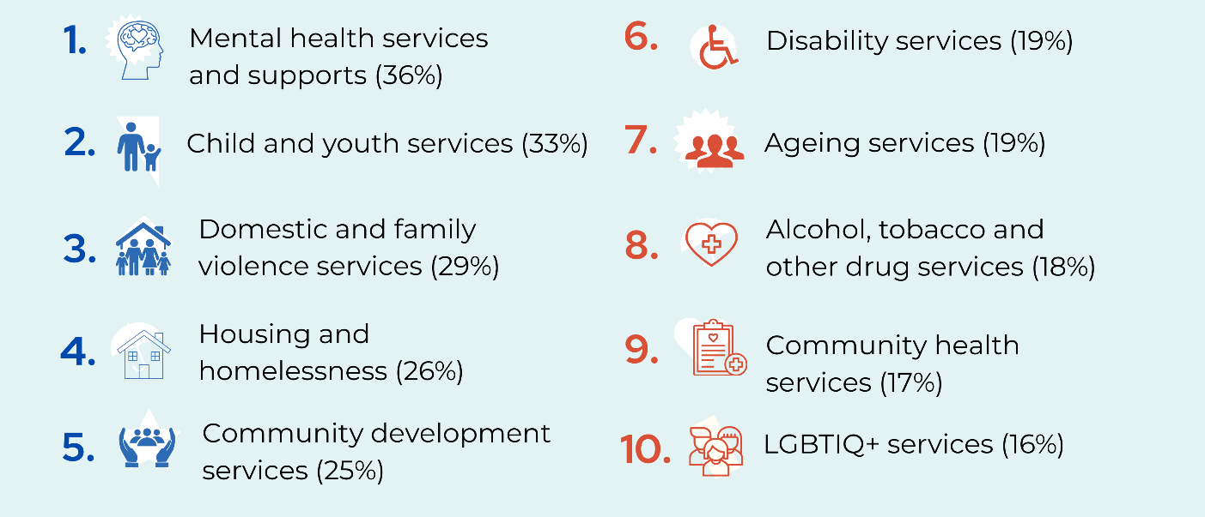
- LGBTQI+ services (16%).
Table 1 outlines the diverse focus areas of services delivered by organisations in the ACT community sector, highlighting the broad range of supports provided across the sector.

Table 1. All service focus areas

Service type focus | Percentage %
Mental health services and supports | 36%
Child and youth services | 33%
Domestic and family violence (DFV) services | 29%
Housing and homelessness services | 26%
Community development services | 25%
Disability services | 19%
Ageing services | 19%
Alcohol, tobacco, and other drugs services | 18%
Community health, health promotion and, sexual health services | 17%
LGBTIQ+ services | 16%
Financial support services | 15%
Emergency relief and food support | 15%
Aboriginal and Torres Strait Islander services | 12%
Legal services | 11%
Supports for carers | 10%
Early childhood education and care (ECEC) | 10%
Migrant and multicultural services | 10%
Other services | 10%
Employment, education, and training services | 8%
Climate change, energy, and disasters | 4%
Hospital, hospice, and palliative care services | 2%
International aid and development | 2%
Environment and animal welfare | 2%
Note: respondents could select multiple responses to indicate all focus areas of their service.

Other responses included:
- Advocacy and sector leadership
- Targeted support services (specific populations/issues)
- Education and welfare programs
- Complex case management and service navigation
- Specialised community services
- Funding and organisational structure (grant-based, voluntary).
These findings demonstrate the sector’s extensive reach, with many organisations working across multiple complex and intersecting areas to meet the evolving needs of the ACT community. Additional information regarding organisations’ main service focus (Appendix C).

4.2 Roles in the ACT community sector
Understanding the distribution of roles within the ACT community sector workforce is crucial for assessing the sector's capacity and leadership structure.
Among respondents in 2025:
- The largest proportion of respondents (34%) identified as frontline workers or practitioners, including roles such as caseworkers, support workers, and therapists
- CEOs or executive-level roles made up 22%, reflecting the leadership emphasis within the sector and a possible sampling effect
- Team leaders or coordinators accounted for 12%
- Senior managers represented 10%
- Office support or central services roles were reported by 8%
- Policy, project, or research roles accounted for 7%
- Board members of volunteer-led organisations represented 4%
- Governance committee members made up 2%.

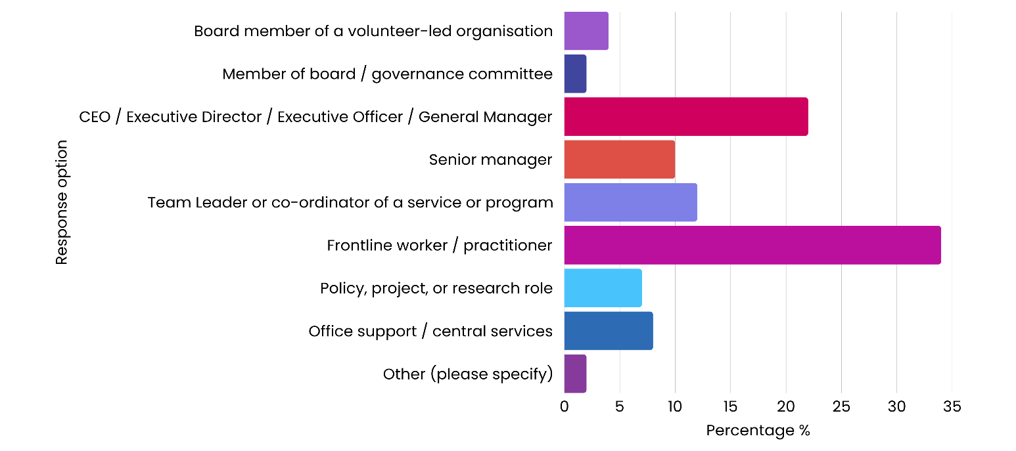
Figure 44. Main role of respondents within their organisation in 2025

For respondents who selected “other”, there were too few responses to provide further detail without risking identification. However, the above responses highlight the diverse range of roles that contribute to the community sector beyond the main categories captured in the survey.

4.3 Employment status
In 2024, CEOs, senior managers and board members of volunteer-led organisations were asked how Full-Time Equivalent (FTE) staff numbers had changed in their organisations.
- Nearly half of the respondents (47%) reported that FTE staff numbers had stayed about the same
- More than one quarter (27%) indicated that FTE staff numbers had increased.
- 22% noted a reduction
- 4% were unsure or found the question not applicable.
Among all respondents surveyed about their employment basis in the community sector, almost three quarters of respondents (72%) were permanent staff, working either full-time or part-time. Employment types in 2025 included:
- Permanent full time/ongoing positions was reported by half (50%) of respondents
- Permanent part time/ongoing positions was reported by more than one in four (22%)
- 9% reported their employment was fixed term full time
- 7% reported their employment as fixed term part time
- 6% were casually employed
- 6% were volunteers.
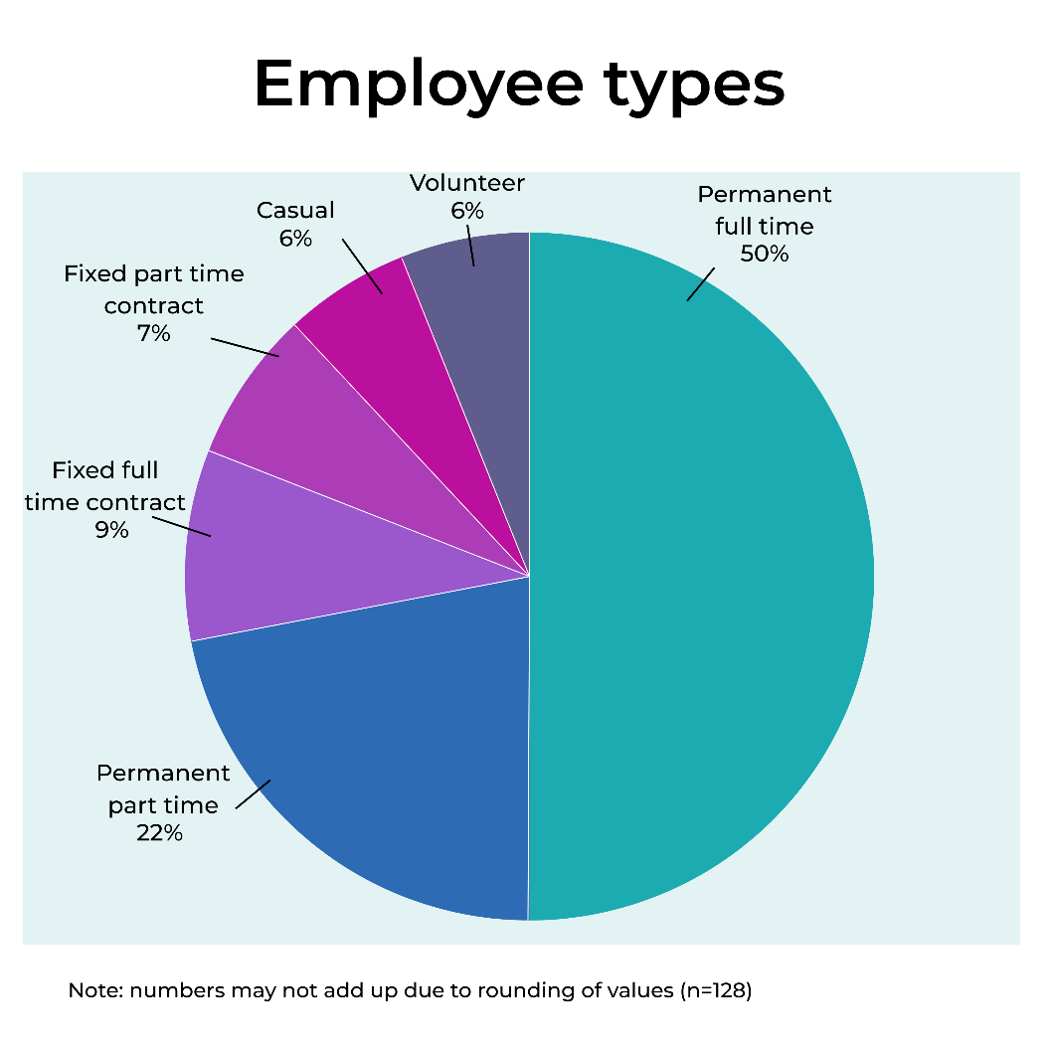
Figure 45. Respondents’ employment types

No respondents indicated being self-employed, freelance, or contractors, and 1% were not sure or preferred not to say.
These results highlight the prevalence of permanent employment arrangements within the community sector.

4.4 Hours worked and unpaid labour
Respondents were asked the number of hours they worked the previous week. Respondents reported working an average of 33 paid hours per week, with a median of 35 hours. In addition, many contributed unpaid labour, averaging 6 hours per week, with a median of 4 hours. Some respondents noted that a portion of these unpaid hours could be accrued as flex time; however, this was not consistent across roles or organisations.

Tasks completed during unpaid hours frequently included essential business-as-usual activities necessary for maintaining service operations. These tasks ranged from:
- Responding to emails
- Undertaking administrative duties, and managing compliance and reporting requirements
- Planning and scheduling
- Client support (e.g. case notes, advocacy, crisis response)
- Staff supervision and engagement
- Training
- Meetings
- Broader community or emergency outreach.
Many respondents also reported engaging in governance-related work such as:
- Preparing board papers
- Preparing funding proposals
- Project-based tasks including grant writing
- Policy development.
The extent to which core operational duties are being performed outside of paid hours indicates systemic under-resourcing within the sector. This reliance on unpaid labour to sustain service delivery raises concerns about staff wellbeing, long-term workforce sustainability, and the adequacy of current funding and staffing models. Addressing this issue is essential to supporting workforce retention and ensuring that organisations can continue to meet growing community needs.

4.5 Earnings
Respondents provided information on their annual income before tax for the previous year, revealing a diverse range of earnings. Income for respondents in 2025 was as follows:
- Over one quarter (26%) of respondents earned $80,000–$99,999 for the previous year before tax
- 17% earned $100,000–$119,999
- 14% learning $60,000–$79,999
- 12% preferred not to say
- 9% earned $140,000 or above
- 6% earned between $120,000-$139,999
- 6% earned $20,000 to $39,999
- 6% under $20,000
- 4% earned between $40,000 and $59,999.

Figure 46. Respondents annual income in the ACT community sector

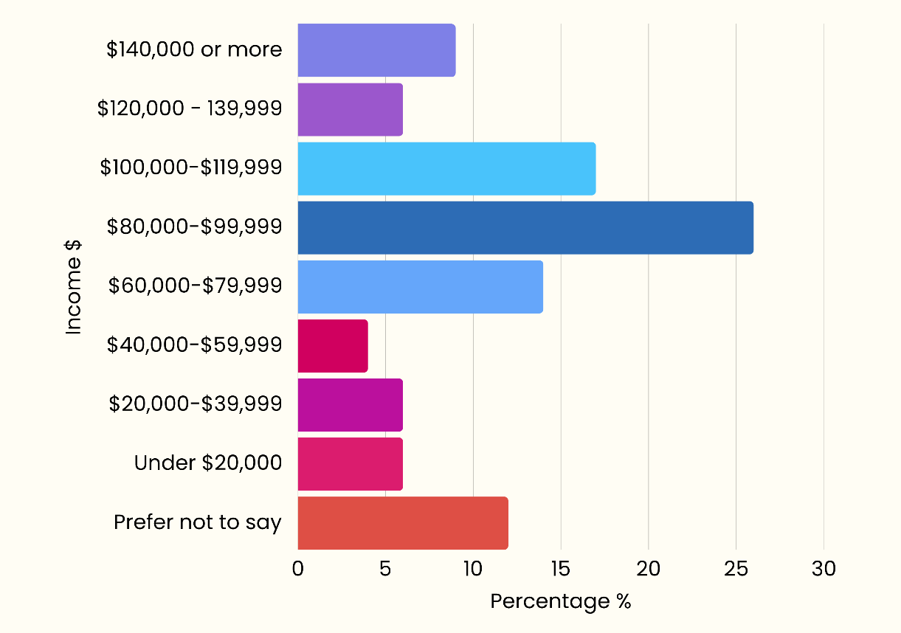

The fact that 30% of respondents for this question identified as CEOs or senior managers, may explain the proportion of higher salaries reported. A further analysis of income data, excluding CEOs, senior manager and Board members revealed that 77% of respondents earned less than $100,000. Of these respondents 41% earned less than $80,000 and 36% earned between $80,000 and $99,999 annually.

The average income in 2024 of all survey respondents from the ACT community sector was $1,686 per week, or $87,679 annually. In contrast, the average employee income in ACT public sector workers which was $2,109 per week in 2024, or $109,716 annually.

This comparison highlights a significant gap between the community sector and the public sector, with community sector workers earning approximately $423 less per week (or $22,037 less annually) than their public sector counterparts. This disparity demonstrates ongoing challenges in attracting and retaining skilled staff within the community sector, particularly when competing with higher-paying public sector roles.

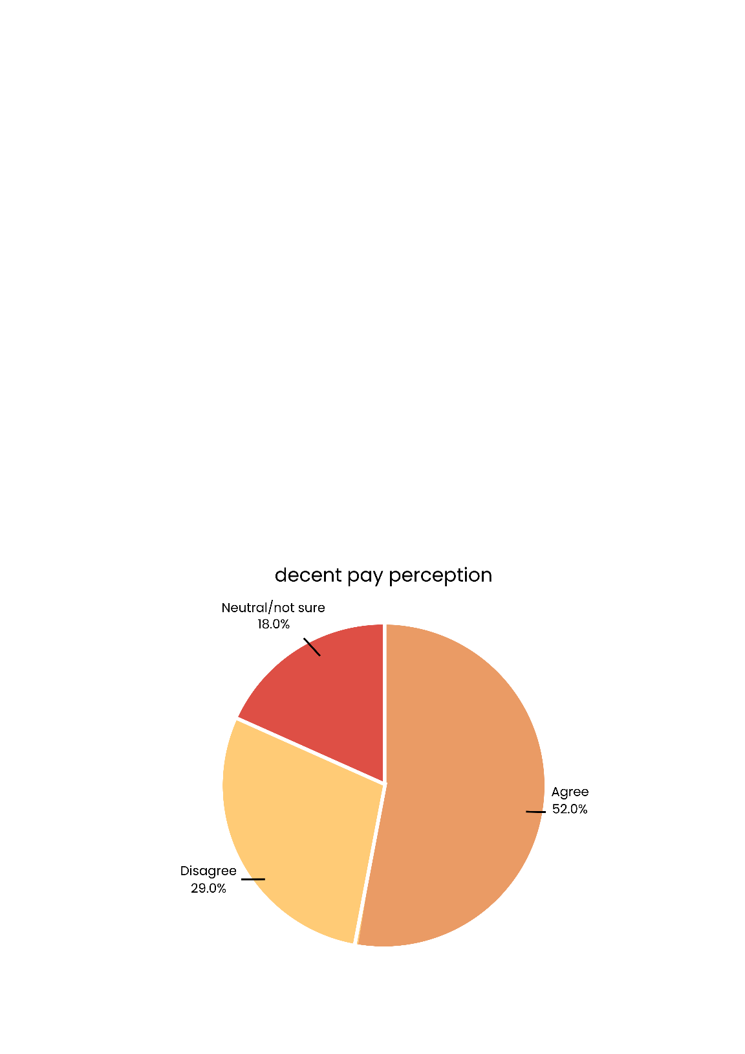
Examining both actual earnings and employee perceptions provides insight into the sector’s ability to attract and retain skilled staff. When respondents were asked if they receive decent pay for the work that they do:
Figure 47. Respondents who think they receive decent pay for the work that they do
- 52% agreed
- 29% disagreed
- 18% indicated that they were neutral/not sure.

With nearly one-third (29%) of respondents disagreeing that they receive decent pay for the work they do, concerns about wage adequacy remain evident within the community sector. This perception aligns with the significant income gap compared to ACT public sector averages. The disparity in earnings, combined with mixed views on pay adequacy, points to potential challenges for workforce retention and overall job satisfaction.

4.6 Time in the sector
Among respondents to a survey question assessing the number of years worked in the community sector, in 2025:
- More than one in four (27%) reported five to less than ten years
- 23% reported between 10 to less than twenty years
- One in five (20%) reported 20 or more years
- 18% had two to less than five years of experience
- 6% reported having less than one year of experience
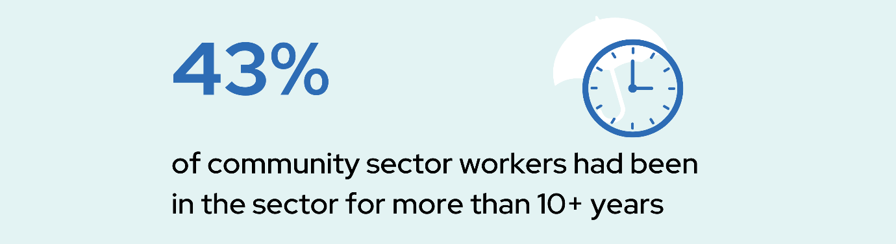
- 6% indicated working between one and less than two years.

This distribution highlights a diverse range of experience levels among community sector workers. Notably, seven in ten respondents (70%) have five or more years’ experience, indicating a seasoned workforce with strong institutional knowledge and capacity for mentoring. Conversely, 30% have fewer than five years with 12% in their first two years. This suggests a relatively limited pipeline of early-career entrants and the need to strengthen recruitment pathways, graduate programs, and onboarding.

The largest cohort (27%) sits in the 5-year to less than 10-year range, highlighting the importance of mid-career retention, leadership development, and role progression to prevent attrition. With one in five (20%) reporting 20+ years, succession planning and knowledge transfer become critical to guard against expertise loss as long-tenured staff approach retirement or career change. Overall, the distribution points to a resilient, experienced sector, and suggests that intentional early-career investment is needed to sustain workforce capacity over time.

4.7 Demographics
Respondents were asked about their gender and age. Participants were also asked if they identified as an Aboriginal and Torres Strait Islander person, a person who speaks a language other than English at home, a person with carer responsibilities, a person with a disability or a person with lived experience of disadvantage and/or use of a community service.

4.7.1 Gender
Understanding the gender composition of the ACT community sector workforce provides important context for workforce diversity and inclusion. Respondents were how they would describe their gender. In 2025:
- The majority (76%) of respondents described their gender as female
- Approximately one in five (21%) described their gender as male
- 2% preferred not to say
- 1% of respondents used another term.
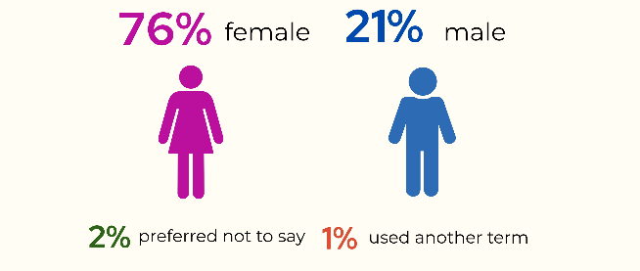

Overall, these findings suggest that the ACT community sector workforce identified as predominantly female, with a smaller proportion of male and gender-diverse respondents represented in the survey.

4.7.2 Age
Understanding the age distribution of the workforce provides insight into experience levels, career stages, and potential future workforce planning needs. The age distribution of the sample showed that in 2025:
- 27% were aged 45–54
- One in four respondents (25%) were aged 35–44
- 19% were aged 25–34
- 16% were aged between 55–64
- 7% were aged 65 and over
- 5% were aged 24 or under
- 2% preferred not to say.

The largest proportion of respondents were aged between 35 and 54 years, accounting for just over half (52%) of the workforce. Around one-quarter (24%) of respondents were under 35 years of age, while nearly one-quarter (23%) were aged 55 years or older.

Figure 48. Comparison of 2022 and 2025 age of the ACT Community Sector Workforce
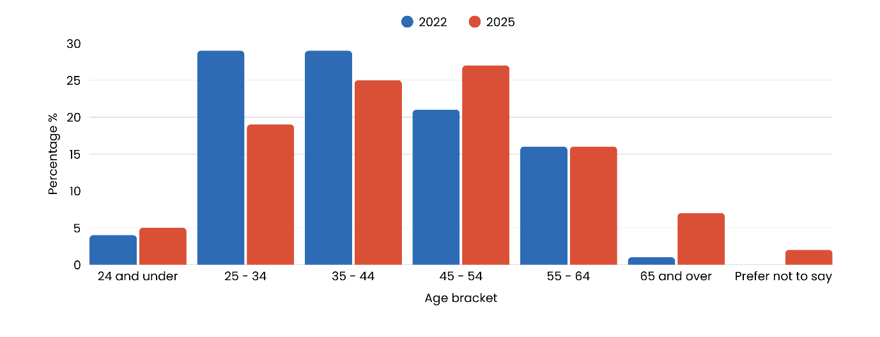

Observing changes between 2022 and 2025 indicates that the workforce may be ageing, with fewer younger people entering the sector. This trend could reflect challenges in attracting early-career professionals, potentially due to competition from the public sector, which offers higher wages and more comprehensive benefits. If this pattern continues, it may impact the sector’s long-term sustainability and capacity, highlighting the importance of strategies to attract and retain younger workers while supporting knowledge transfer from experienced staff.

Retention patterns reveal a strong link between age and tenure in the sector. Among respondents aged 35 years or older, 60% had worked in the community sector for more than five years, demonstrating experience and long-term commitment among mid-career and older staff. While this stability is a strength, it highlights the importance of investing in pathways for younger workers and supporting knowledge transfer to ensure continuity and sector resilience.

4.7.3 Self-Identification with priority populations among respondents
Understanding the diversity of the ACT community sector workforce provides valuable insight into the lived experience, cultural representation, and inclusion embedded within the sector. Capturing this information helps to highlight the extent to which the workforce reflects the communities it serves and informs strategies to strengthen equity and representation.
Response option | Percentage %
Not applicable | 39%
Person with lived experience of disadvantage and / or use of a community service | 24%
Person with a disability | 22%
Person with carer responsibilities | 19%
Person who speaks a language other than English at home | 17%
I prefer not to say | 4%
Aboriginal and / or Torres Strait Islander |  | 3%
Note: respondents could select all that apply.
Respondents were asked if they identified as being part of any priority populations:
Table 2. Self-Identification as part of priority populations
- The largest number of respondents (39%) did not identify with any priority population areas
- Nearly one in four (24%) identified as a person with lived experience of disadvantage and/or use of a community service
- 22% identified as a person with a disability
- Almost one in five (19%) reported they were a person with carer responsibilities
- 17% identified as a person who speaks a language other than English at home
- 4% preferred not to say
- 3% identified as an Aboriginal and/or Torres Strait Islander person.
These results highlight the notable presence of lived experience and diverse backgrounds among respondents, reflecting the importance of recognising and embedding this knowledge in leadership, service design, and workforce development across the community sector.

4.7.4 Education and qualifications
The qualifications and educational background of employees provide valuable insight into the capability and professional strength of the ACT community sector workforce. Understanding the distribution of education levels across different roles also helps to identify areas of workforce development and succession planning within the sector.
The ACT community sector workforce is highly educated. Respondents were asked the highest level of education they had attained. In 2025:
- 46% had a postgraduate degree
- 35% had a bachelor degree
- 13% held a diploma
- 3% had completed high school as their highest level of education
- 2% had completed a Certificate IV
- 2% preferred not to say.

No respondents indicated holding a Cert I, II or III as their highest level of completed education. These findings illustrate a highly educated workforce within the community sector, however, it is important to note that the sample may reflect respondents who are more likely to work in desk-based roles or have more time available to complete the survey compared to those in client-facing positions.

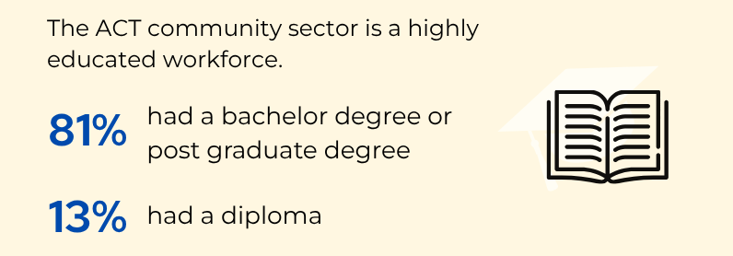
To gain a deeper understanding of how education levels vary by role, additional analyses were conducted to examine frontline workers, senior leaders, and the workforce excluding senior leaders.
CEOs, senior managers, and board members only
To understand educational attainment among leadership, a separate analysis was conducted for CEOs, senior managers, board members, and board members of volunteer-led organisations. Findings indicate that the highest level of educational attainment among these respondents, in 2025:
- 59% held a postgraduate degree
- 35% held a bachelor degree
- 4% held a diploma
- 2% had a high school qualification.
Combined, 93% of CEOs, senior manager, board members and board members of volunteer-led organisations held either a bachelor or postgraduate degree. These findings demonstrate that higher qualifications are concentrated among senior leadership, suggesting the role of advanced education in leadership positions within the sector.
All workers, excluding CEOs, senior managers, and board members
A further analysis was conducted excluding senior leadership positions (CEOs, senior managers and board members) to provide insight into the broader workforce profile. The following roles were analysed:
- Team Leader or co-ordinator of a service or program
- Frontline worker / practitioner (e.g. caseworker, support worker, carer, counsellor, social worker, nurse, psychologist, therapist, lawyer, educator, youth worker, tenancy officer, community worker, advocate)
- Policy, project, or research role
- Office support / central services (e.g. administration, communications, marketing, HR, WHS, facility support)
- Other (please specify).
The findings indicated that among these respondents, the highest level of completed education in 2025, was as follows:
- 38% held a postgraduate degree
- 36% held a bachelor degree
- 17% held a diploma
- 3% had completed high school
- 2% held a Certificate IV.
Combined, 74% of these respondents held either a bachelor or postgraduate degree. This highlights that the overall workforce, outside of senior leadership, is well qualified, with a strong emphasis on tertiary education.

Frontline workers only
To assess qualifications among those in direct service roles, a separate analysis was conducted for frontline workers. Findings indicate that in 2025:
- 39% held a postgraduate degree
- 36% held a bachelor degree
- 20% held a diploma
- 2% held a Certificate IV
- 2% preferred not to say.
These results show that frontline staff are well educated, with the majority holding tertiary qualifications, reflecting the knowledge and expertise required for direct service delivery.

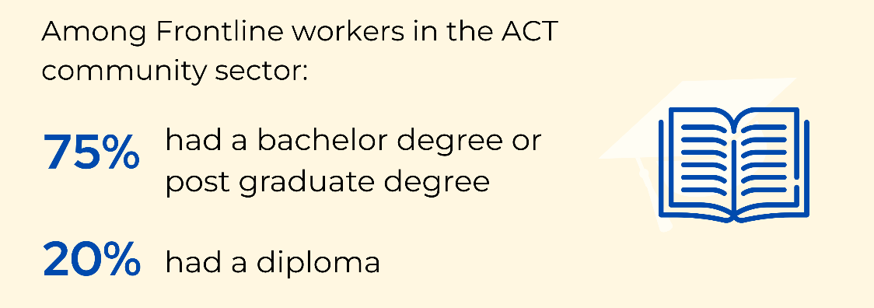

Overall, these analyses reaffirm the capability and professionalism of the ACT community sector workforce. The prevalence of tertiary and postgraduate qualifications across all levels of employment reflects a strong foundation of knowledge, skill, and commitment to quality service delivery.

However, caution should be exercised when interpreting these findings. The survey may not have been equally accessible to all potential respondents, particularly those with limited access to or difficulties with information technology, or those in highly client-facing or time-constrained positions. Consequently, the level of formal education reported may be somewhat higher than that of the broader ACT community sector workforce.

4.8 Volunteers
Volunteers play an important role in supporting service delivery, enhancing community connection, and extending the reach of many organisations across the ACT community sector. Respondents were asked approximately how many volunteers were at their organisation. Volunteer numbers varied between organisations (see figure 49). In 2025:
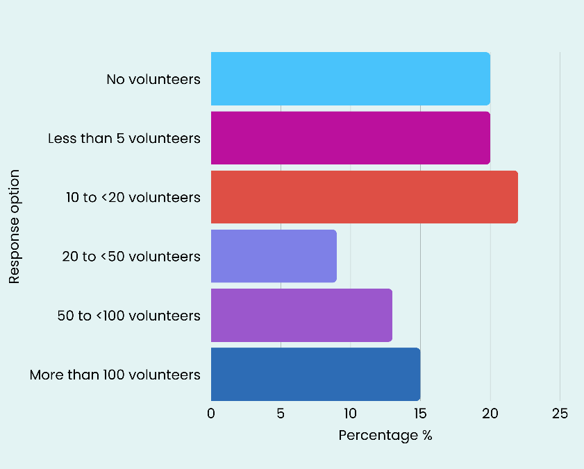
- 22% of respondents reported that their organisation had between 10 to less than 20 volunteers at their organisation
Figure 49. Number of volunteers at ACT community organisations
- One in five (20%) had less than 5 volunteers
- One in five (20%) of organisations had no volunteers
- 15% had more than 100 volunteers
- 13% had between 50 to less than 100 volunteers
- 9% had between 20 to less than 50 volunteers.

Respondents were asked if, over 2024, difficulty in finding volunteers at their main service or program had increased, decreased or stayed the same. In 2024:
- 42% of respondents reported that they were not sure or not applicable about difficulty engaging volunteers at their main service or program
- 36% reported that difficulty had remained the same
- 19% of respondents reported increased difficulty finding volunteers in 2024
- 3% reported a decrease in difficulty.
It is important to note that some of these results may be influenced by the size and capacity of organisations completing the survey. Larger organisations often have more structured volunteer programs and resources, which can lead to higher volunteer numbers.

For example, the 15% of organisations reporting more than 100 volunteers are likely to represent larger entities with extensive service delivery models, and increased capacity to engage with volunteers. Conversely, smaller organisations may struggle to recruit volunteers due to limited capacity, which may explain why 40% of respondents reported either no volunteers or fewer than five.

4.9 Housing affordability
In 2024, CEOs, senior managers and board members were asked whether the poor availability of affordable housing in the local area made it difficult for their organisation to attract and retain staff.
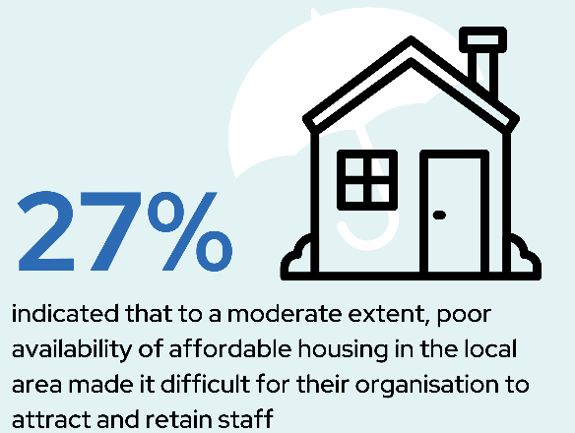
- The majority (53%) reported that availability of affordable housing in the local area had not been an issue for staff at their organisation
- Over a quarter (27%) indicated that it had been an issue to a moderate extent
- 20% were unsure
- No respondents (0%) noted that it had been an issue to a great extent.

These findings suggest that housing affordability may be a challenge for some organisations to staff attraction and retention.

Workforce Challenges

Chapter overview
The previous chapter provided a detailed profile of the ACT community sector workforce, examining employment characteristics, earnings, working hours, demographics, qualifications, volunteer engagement, and the focus of service delivery. These insights established a strong foundation for understanding the composition and capacity of the sector. However, beyond these structural characteristics, the sector faces a range of challenges that directly impact its ability to deliver services effectively and sustain a skilled workforce.

This chapter explores the key workforce challenges, highlighting issues that affect both operational capacity and staff wellbeing. Topics include staffing shortages, absenteeism, exhaustion and burnout, unpaid hours, and recruitment difficulties. It also considers strategies organisations use to maintain service delivery, professional development, supervision practices, job security, and workplace safety.

The chapter also examines motivations for staying in the sector, including passion for the work, workplace flexibility, and organisational loyalty, as well as workers’ future outlook regarding career prospects and financial security.

Comparing data from 2022 to data from 2025 highlights both progress and ongoing pressures. Workforce pressures, including recruitment and retention challenges, limited access to professional development, and reliance on short-term or grant-funded roles, underline the need for strategies that enhance staff capacity and wellbeing. Staff report a strong commitment to their work and to clients, often going above and beyond to maintain high-quality services. Ensuring robust support structures, supervision, and professional development opportunities is essential to sustain this dedication over the long term.

Volunteer engagement remains an important component of the sector’s capacity. While volunteer participation faces evolving challenges, it continues to be a vital resource for organisations, and targeted strategies to support and grow volunteer involvement will further enhance sector resilience.

Overall, this chapter situates the workforce within the broader context of sector strengths and pressures, emphasising the need for ongoing investment, stable funding, and workforce development. By highlighting the commitment and capability of the ACT community sector workforce alongside areas for targeted support, this chapter identifies opportunities to build a sustainable, resilient, and highly effective sector that continues to meet the needs of the community.

5.1 Staffing challenges and workforce capacity
In response to ongoing workforce pressures, organisations employed a range of strategies to sustain service delivery and support staff wellbeing. Issues such as burnout, unpaid work, and recruitment difficulties have become more pronounced. These trends highlight the sector’s continued reliance on staff commitment and flexibility amid persistent resource and capacity constraints.

5.1.1 Staff exhaustion and burnout
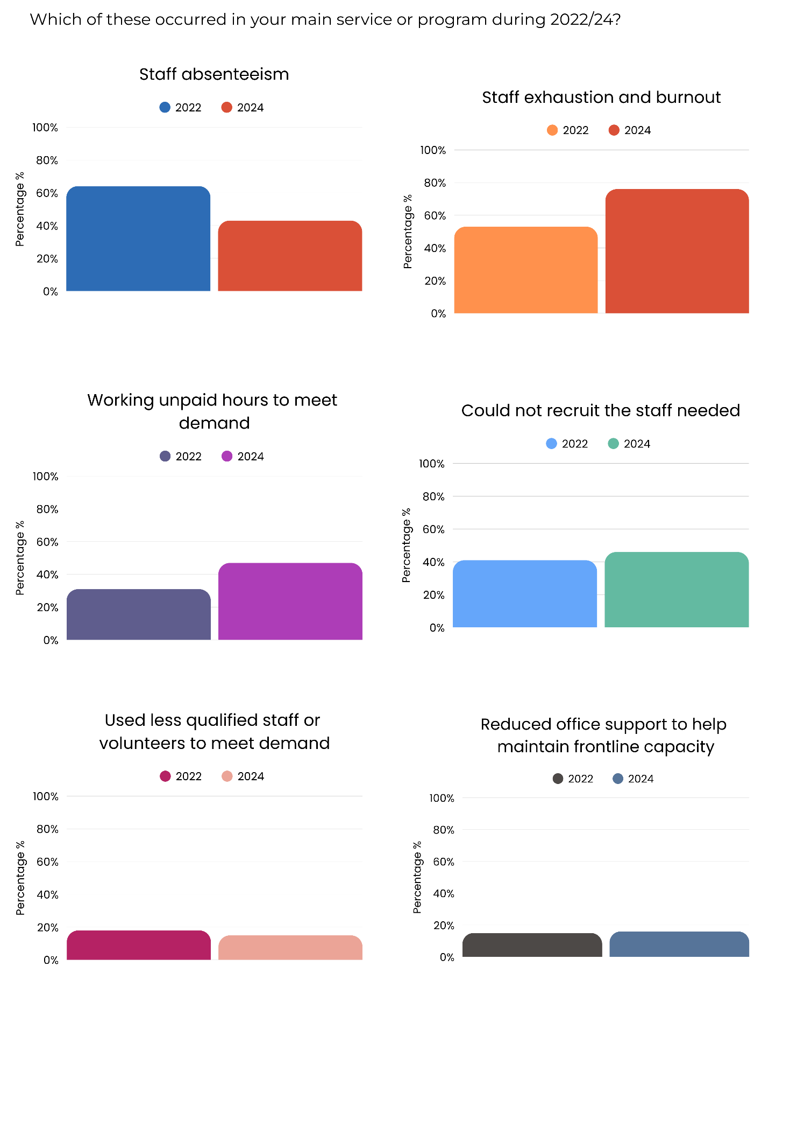
Respondents were asked to indicate whether they observed staff exhaustion and burnout at their main service or program. Staff exhaustion and burnout were the most commonly reported pressures in 2024.
Figure 50. Proportion of respondents indicating that their main service or program experienced staff exhaustion and burnout in 2022 and 2024

- In 2022, 53% of respondents reported staff exhaustion or burnout occurred at their main service or program, increasing to 76% in 2024.
This increase highlights growing concerns around staff wellbeing, reflecting sustained high demand and workload pressures.

5.1.2 Staff working unpaid hours to meet demand
Figure 51. Proportion of respondents indicating that they worked unpaid hours to meet demand in 2022 and 2024

Many respondents reported staff working additional hours to meet demand and maintain service delivery.
- In 2022, 31% of organisations reported staff worked unpaid hours to meet demand, increasing to 47% in 2024.
This suggests that staff are continuing to absorb extra workload to support services, which may contribute to burnout and retention challenges.

5.1.3 Recruitment challenges
Respondents were asked if they observed difficulties in recruiting staff at their main service or program during 2024. Recruiting suitable staff remained a persistent issue over 2022 – 2024.
Figure 52. Proportion of respondents indicating that their main service or program experienced recruitment challenges in 2022 and 2024

- Over two in five (41%) of organisations reported difficulties recruiting staff in 2022, compared to 46% in 2024.
These results suggest ongoing competition for skilled workers in the sector and underline the need for targeted workforce strategies.

5.1.4 Use of less qualified staff or volunteers
At their main service or program, respondents were asked if they had observed the use of less qualified staff or volunteers to help meet demand during 2024. The results showed that some organisations addressed staffing shortages by engaging less qualified staff or volunteers.
Figure 53. Proportion of respondents indicating that their main service or program used less qualified staff or volunteers to meet demand in 2022 and 2024

- Almost one in five (18%) of organisations reported using less qualified staff or volunteers to meet demand in 2022, compared to 15% in 2024.
This suggests that organisations recognise the importance of maintaining a skilled workforce and may be prioritising strategies to recruit and retain qualified staff despite ongoing capacity pressures.

5.1.5 Reducing office support to maintain frontline capacity
Respondents were asked to indicate whether their main service or program had to reduce office support to maintain frontline capacity over 2024. Some organisations reported that they had to reduce office support to prioritise frontline services.
Figure 54. Proportion of respondents indicating that their main service or program reduced office support to maintain frontline capacity in 2022 and 2024

- In 2022, 15% of organisations reported reducing office support to prioritise frontline services, similar to 16% in 2024.

This shows continued efforts to maximise frontline capacity despite limited staffing resources. Compounding consequences of this could include a long-term reduction in office support.
These findings suggest that workload pressures are an ongoing challenge for community sector staff.
Staff exhaustion, working unpaid hours, and recruitment difficulties are widespread, while other strategies are used to maintain service delivery. These findings highlight the need for workforce support, wellbeing initiatives, and targeted recruitment strategies to sustain sector capacity under increasing demand.

5.1.6 Other workplace pressures
Staffing and workload pressures remain a significant concern among respondents, highlighting persistent challenges in maintaining adequate staffing levels, meeting service demands, and ensuring sustainable workplace conditions. These pressures often contribute to increased stress, reduced morale, and potential impacts on service quality.
Figure 55. Respondents who felt under pressure due to understaffing at their organisation
Key findings from the survey indicate, in 2025:
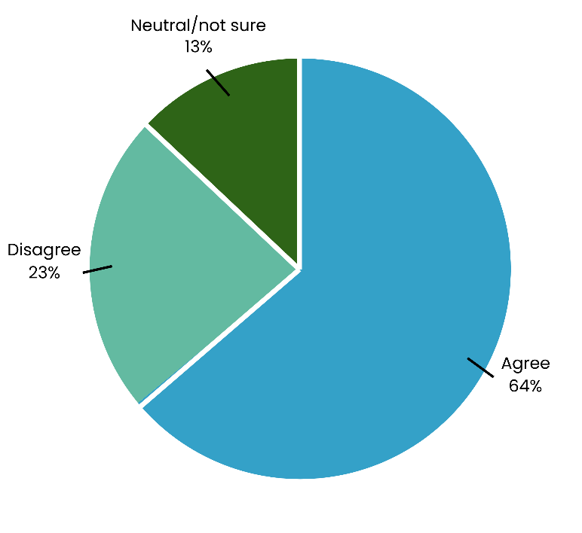
- 64% of respondents agreed they felt under pressure due to understaffing
- 23% disagreed
- 13% were neutral or unsure.
Qualitative responses further highlight the intensity of workload pressures. Respondents frequently described feeling overworked and undervalued, with concerns raised about pay, working conditions, and the sustainability of their roles. Many indicated that high workload was exacerbated by staff shortages, increasing service demand, and administrative responsibilities, making it difficult to maintain work-life balance or provide optimal support to clients.
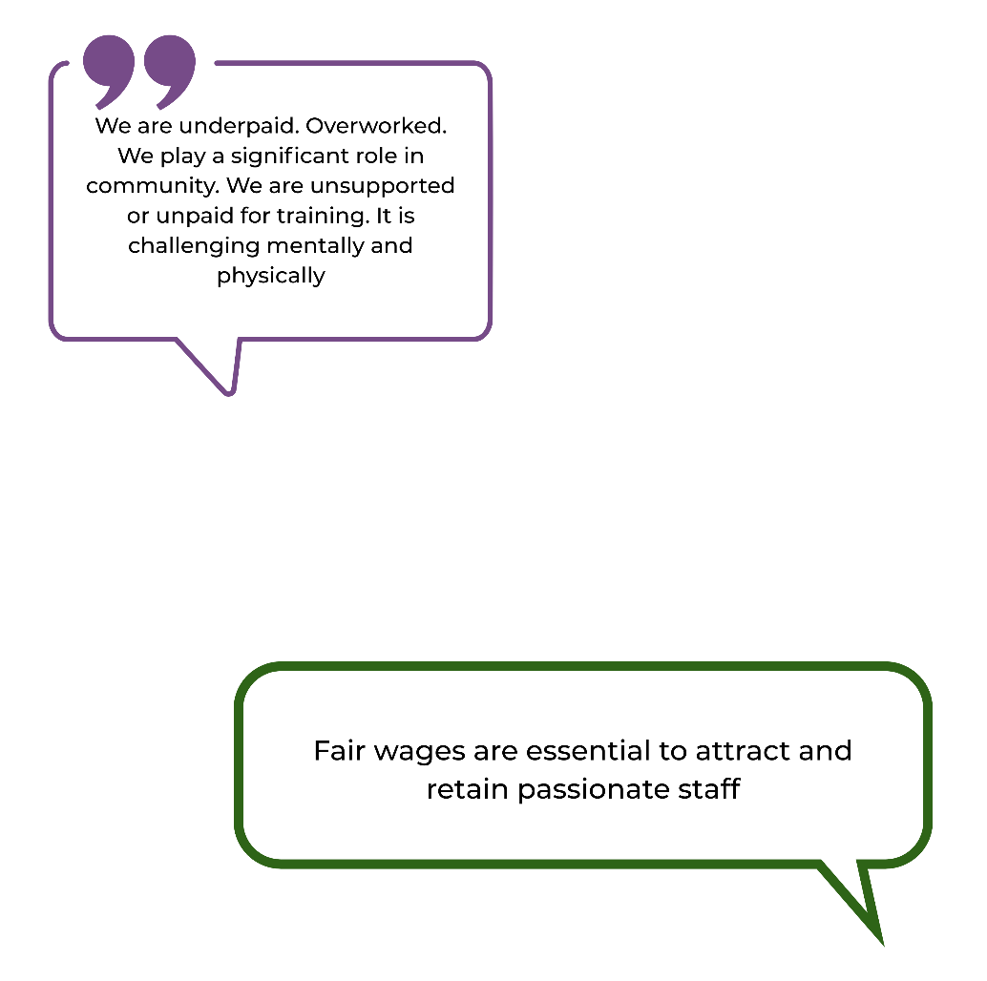
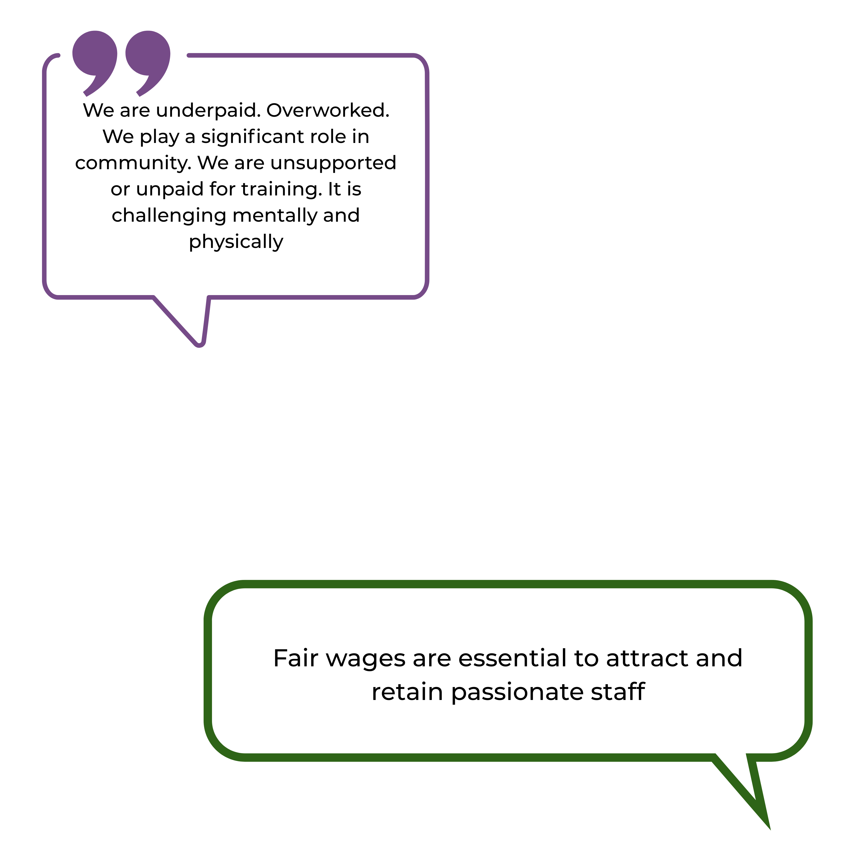
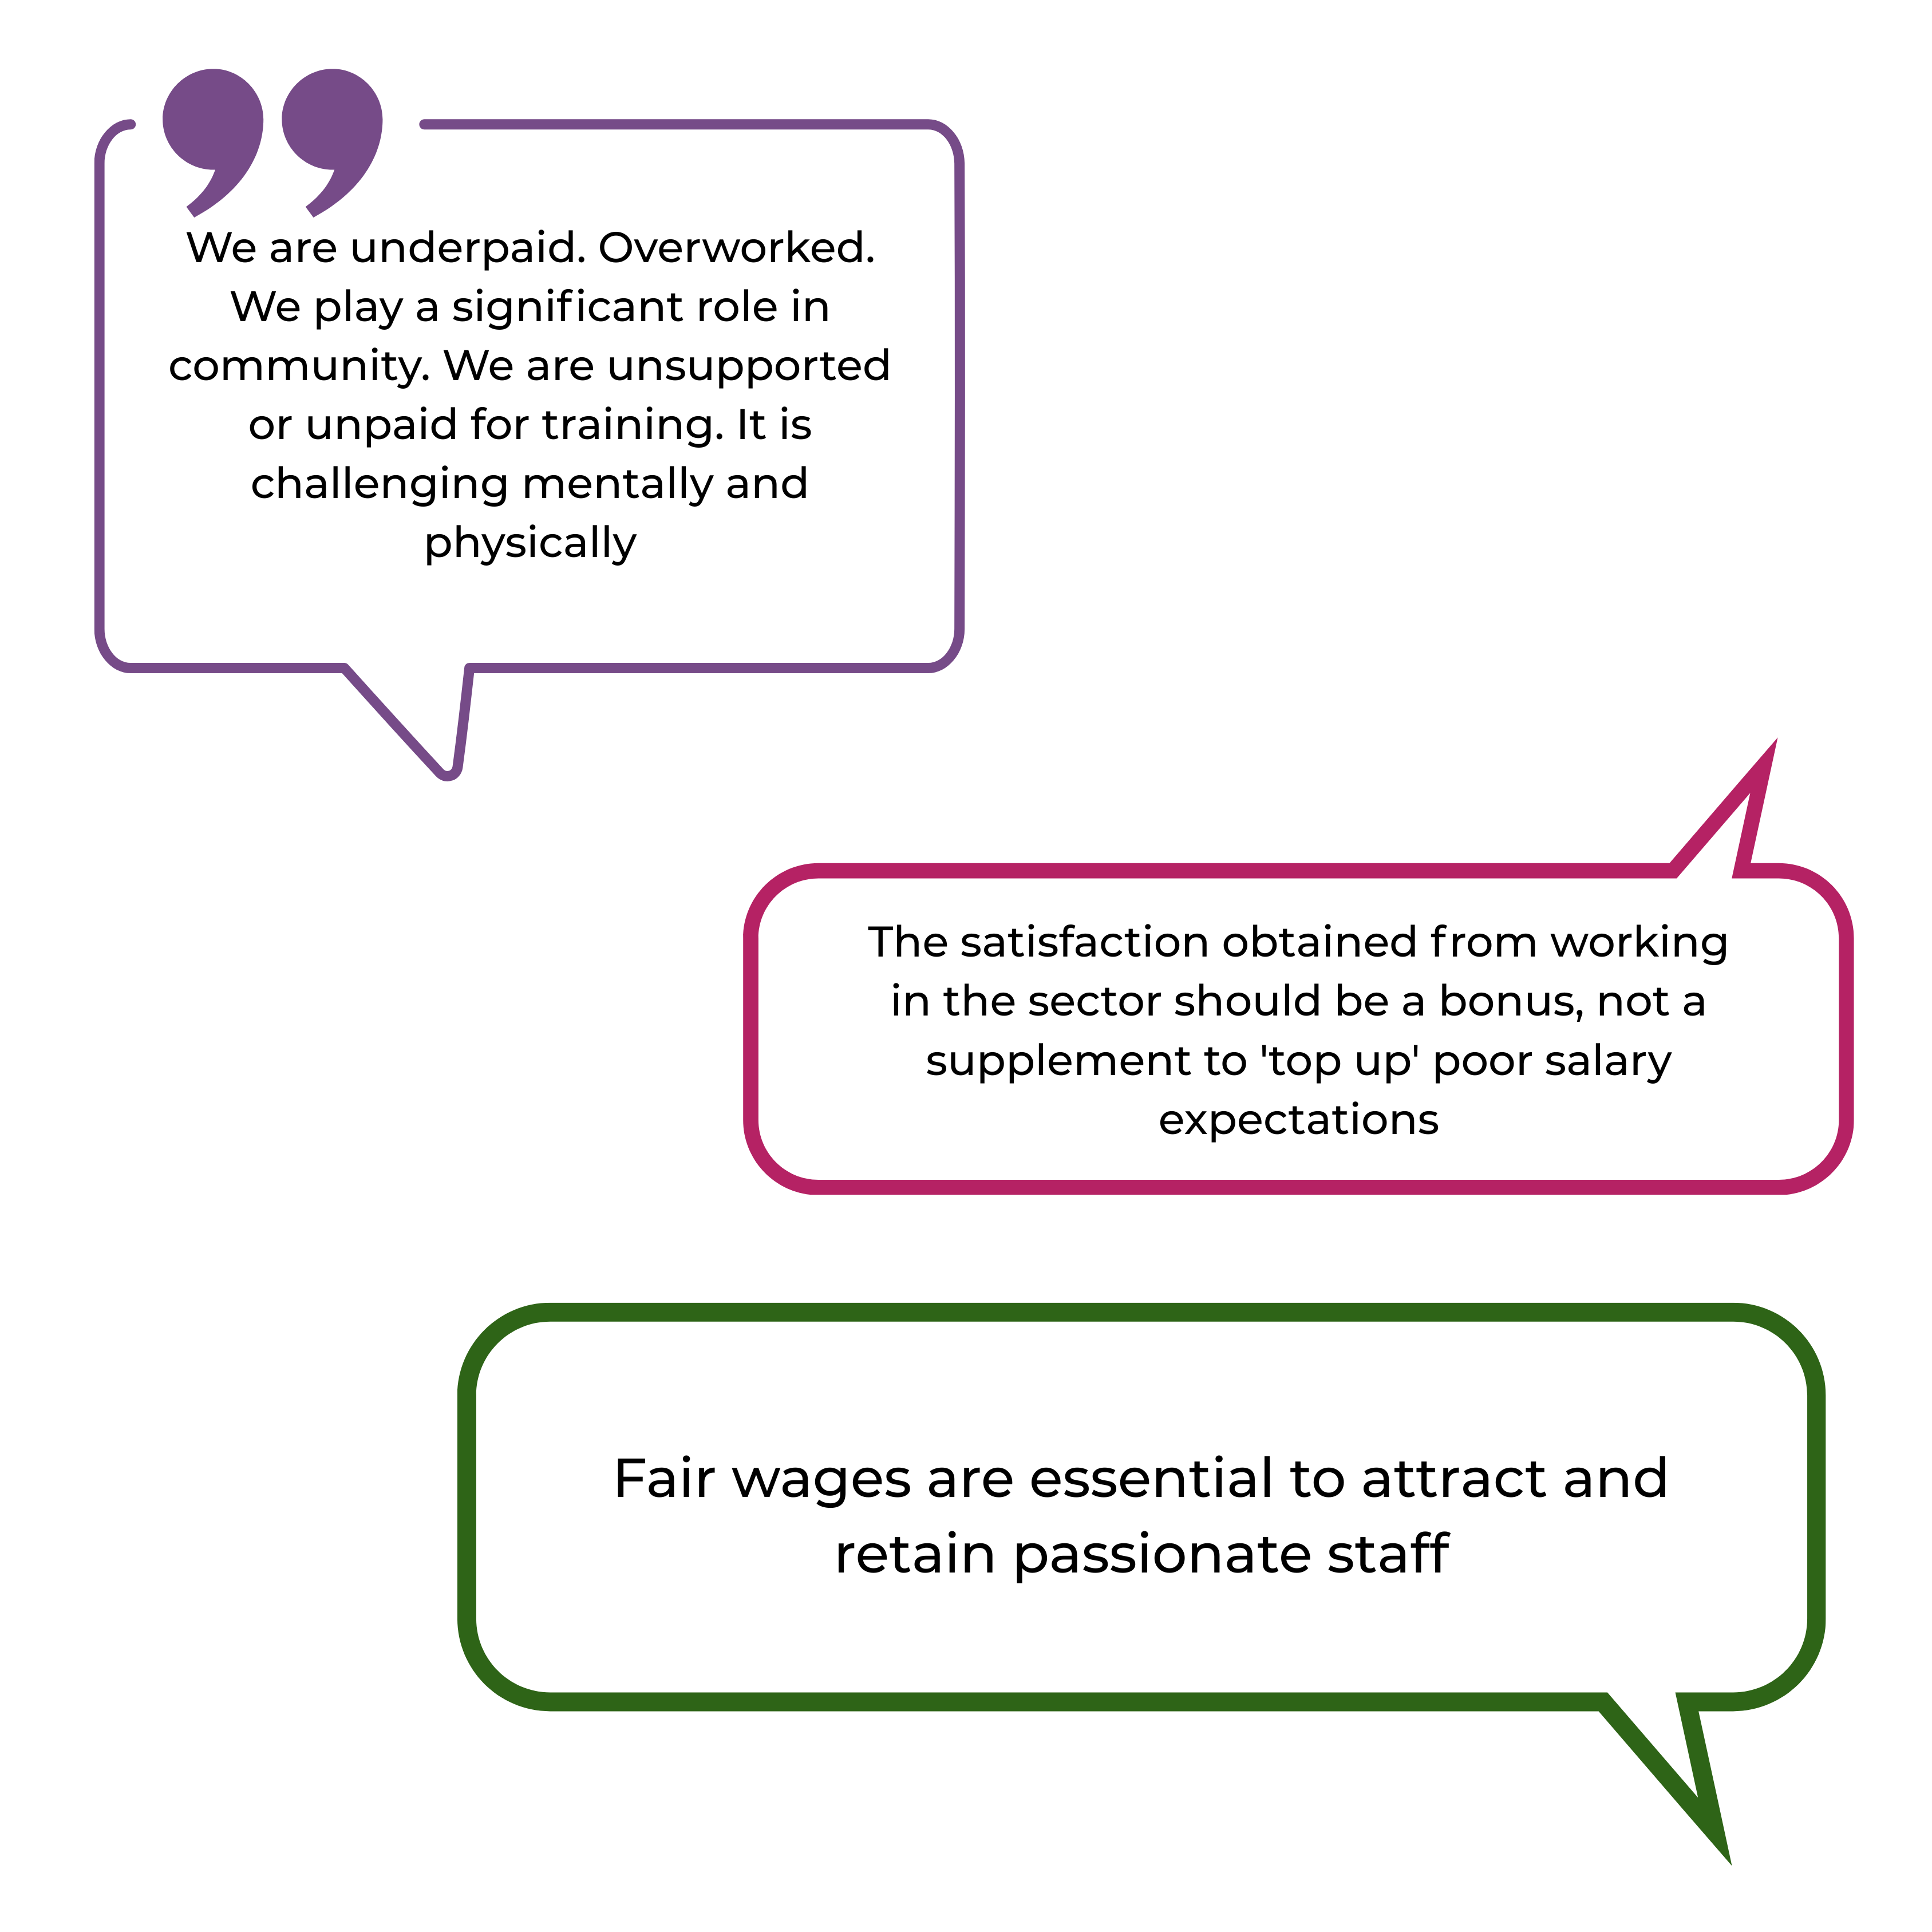
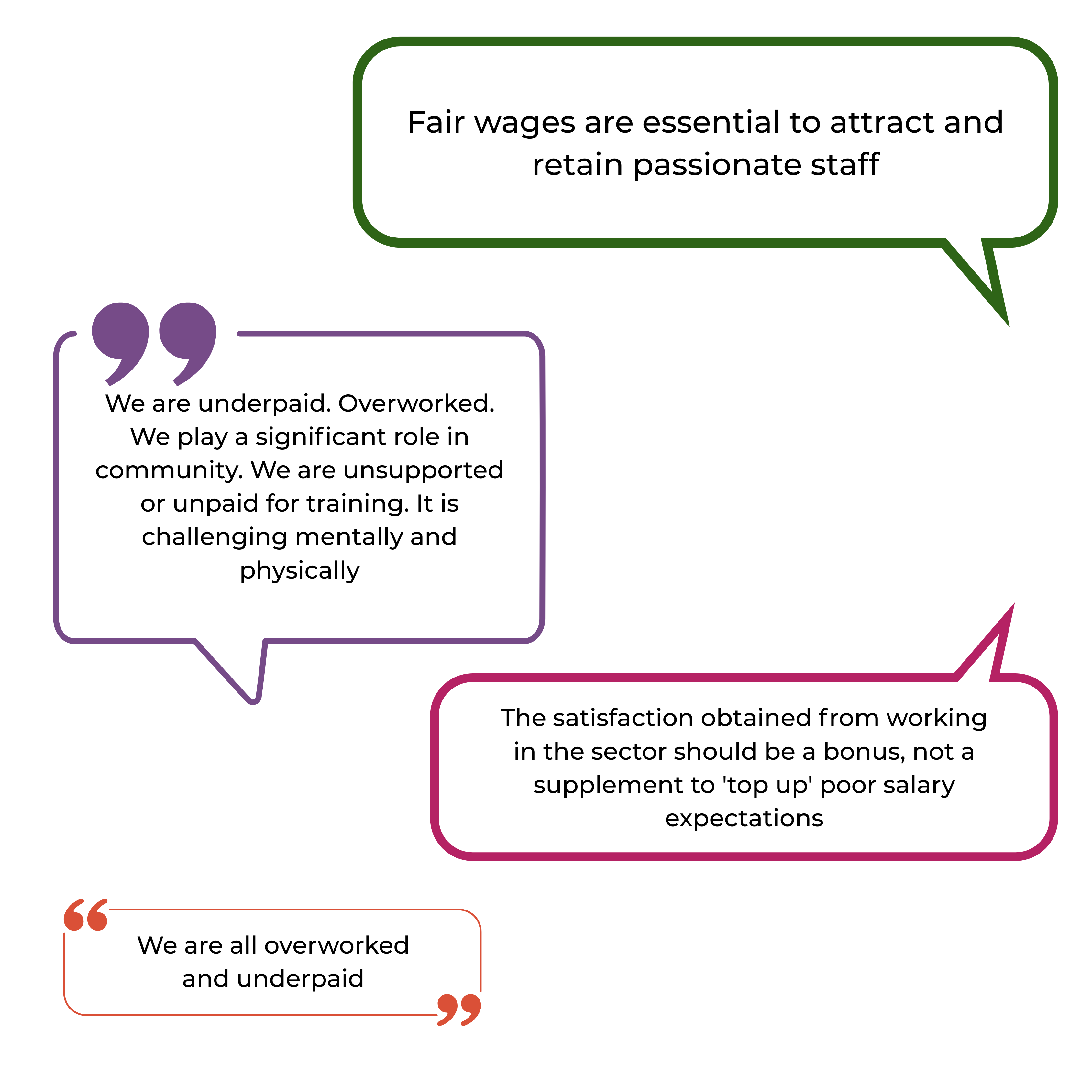

5.2 Professional development and supervision
There are gaps identified in staff training, professional development, and overall workforce support. Some workers feel unprepared to manage complex client needs due to insufficient access to training opportunities and inadequate funding for skill development.

5.2.1 Professional development
When workers were asked whether they receive the professional development they need. In 2025:
Figure 56. Respondents who felt they received adequate professional development at their organisation
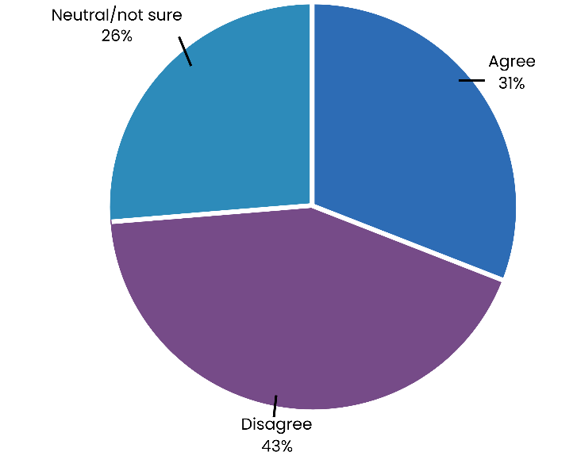
- 31% of respondents agreed that they received the professional development they need
- More than 2 in 5 (43%) of respondents disagreed that they receive the professional development that they need
- 26% were neutral or unsure.
Funding constraints limit the ability of ACT community organisations to provide training and professional development for their staff, with many organisations having to pull funding from other areas to ensure their staff are adequately trained.
Without consistent access to professional development, staff may struggle to adapt to the increasing complexity of client needs, leading to burnout, moral injury and workforce turnover.

5.2.2 Supervision
Supervision plays an important role in ensuring staff feel supported and able to perform their roles effectively. Respondents were asked to indicate the extent to which they receive the supervision and support they need in their work. In relation to supervision in 2025:
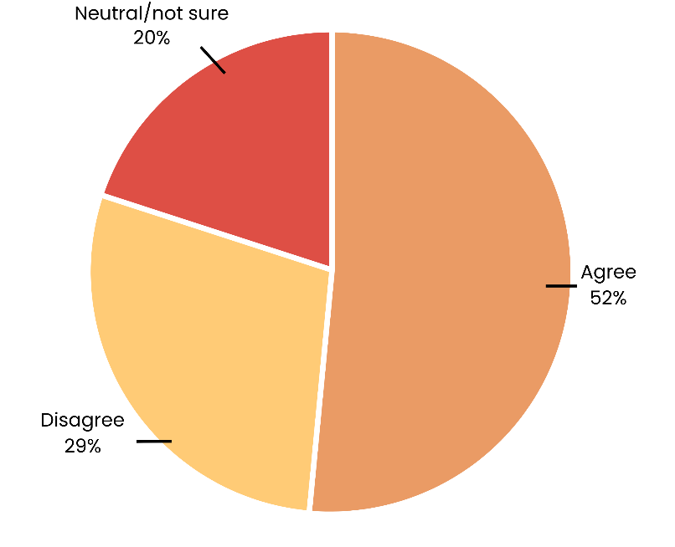
- 52% of respondents agreed they receive the supervision support they need
Figure 57. Respondents who felt they received adequate supervision at their organisation
- More than one in five (29%) disagreed
- 20% were neutral or unsure.
These results suggest that while over half feel adequately supported, almost a third of staff are missing out on the development and supervision needed to sustain their roles long term.

5.3 Staff recruitment and retention
Persistent challenges in staffing, volunteering, and funding continue to impact the ACT community sector’s ability to meet rising service demands. In 2024:
- 61% of respondents reported increased difficulties in keeping services adequately staffed
- A further 33% indicated the situation had remained the same
- 5% were unsure or noted the question was not applicable
- 2% said difficulties decreased.

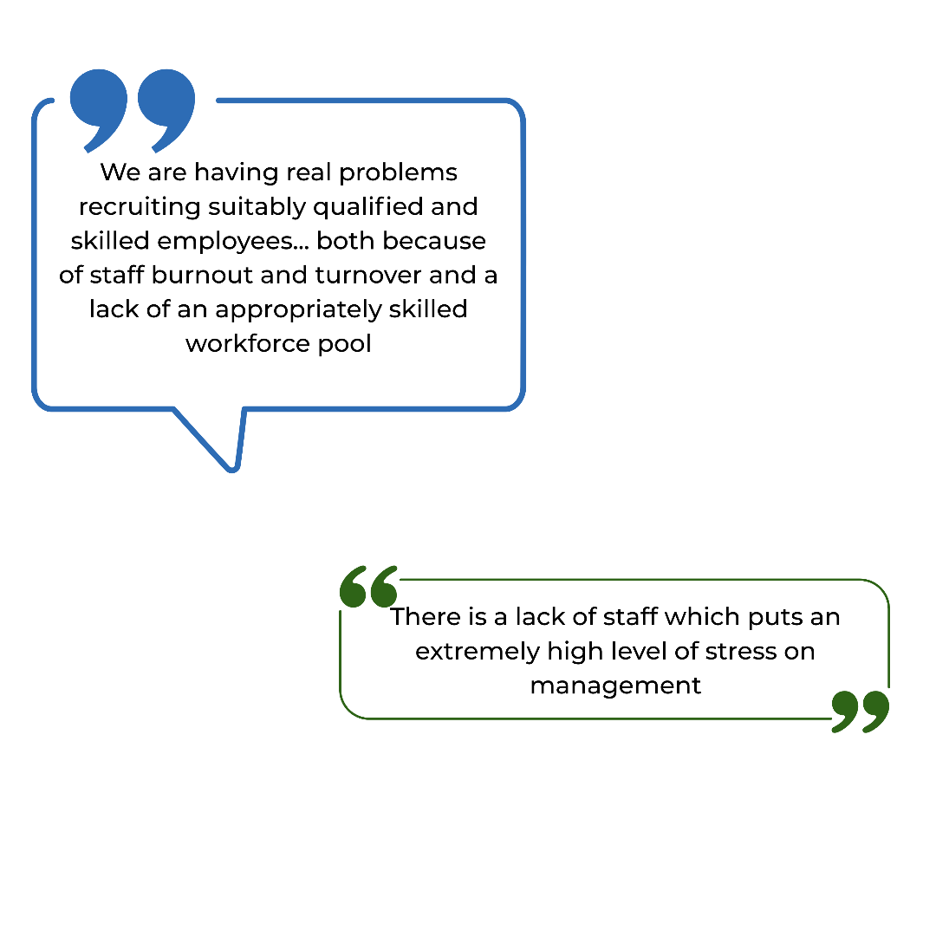
Qualitative responses highlighted the combined effects of high staff turnover, workforce shortages, and the difficulty of attracting suitably qualified staff.

A common theme was the impact of insecure and short-term funding on recruitment and retention. Many roles in community organisations are grant-dependent or tied to limited-term contracts, making it difficult to offer job stability or long-term career development. As a result, staff frequently leave the sector in search of more secure, better-remunerated roles:
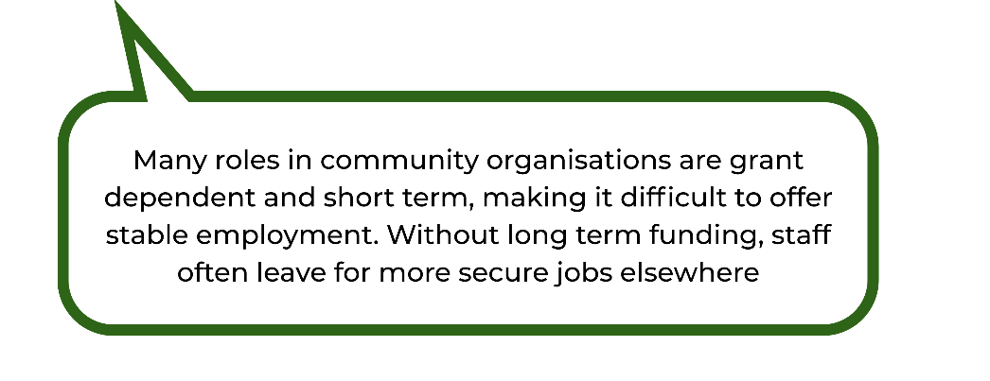

These findings show the urgent need for sustainable, long-term funding models that enable organisations to invest in their workforce, reduce turnover, and offer meaningful, stable employment opportunities.

5.4 Job security uncertainty
Uncertainty around job security was also identified as a workforce issue in 2025. When asked whether they felt their working arrangements were secure:
- Over half of respondents (53%) agreed that they felt their working arrangements were secure
- A quarter of respondents (25%) disagreed
- 21% were neutral or unsure.
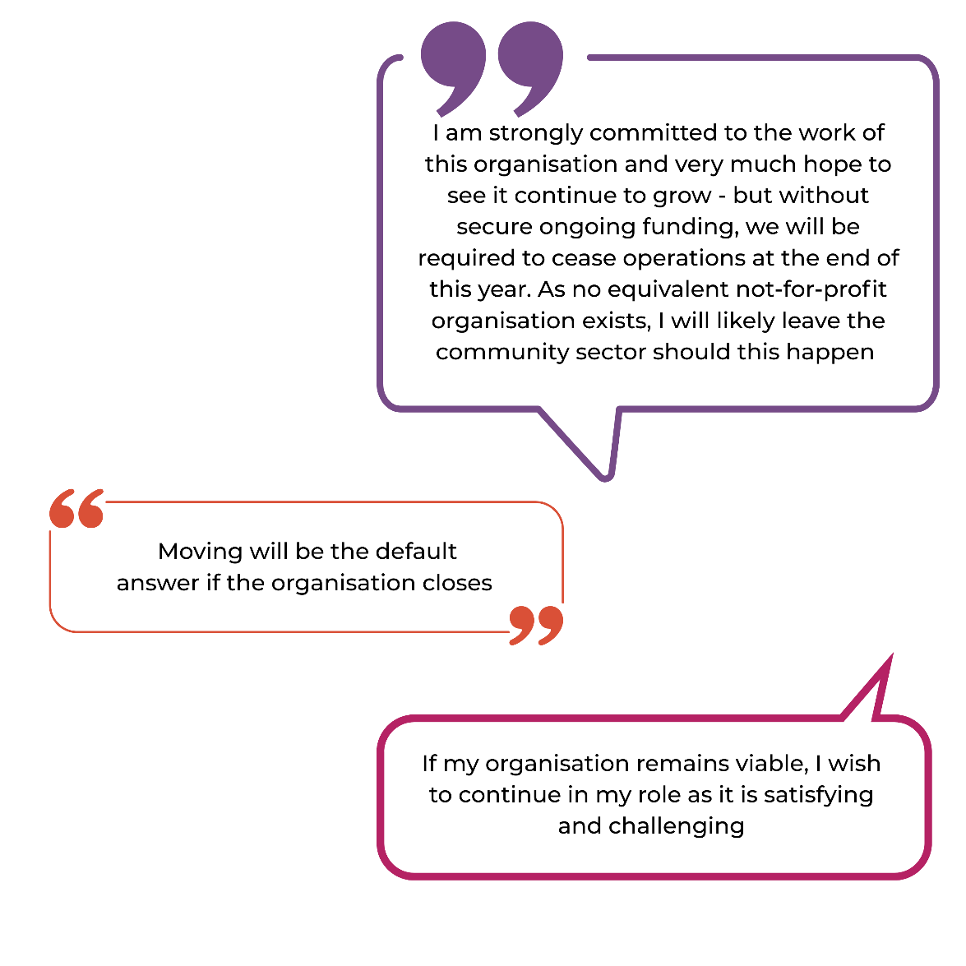

These results suggest that a substantial proportion of the workforce experiences insecurity or ambiguity about the stability of their employment, which may have implications for staff retention and workforce wellbeing. We note that, due to the ACT budget cycle and internal Government processes, many organisations are unable to confirm funding renewal until close to the end date of the relevant contract. As a result, employees often face uncertainty regarding the continuation of their roles.

5.5 Wellbeing and burnout
Workforce wellbeing remains a critical issue across the ACT community sector. Findings from the 2025 survey indicate that many workers continue to experience high levels of emotional and physical strain. Sustained workload pressures, limited staffing, and increasing client complexity are key contributors to burnout, which in turn threatens workforce stability and service quality.

5.5.1 Prevalence of burnout
Burnout and emotional exhaustion continue to be concerns within the ACT community sector, reflecting the cumulative impact of sustained high workloads and limited resources. Many workers report feeling emotionally drained, underscoring the ongoing strain on wellbeing and service delivery capacity.
Staff exhaustion and burnout emerged as the most frequently reported issue within main programs or services.
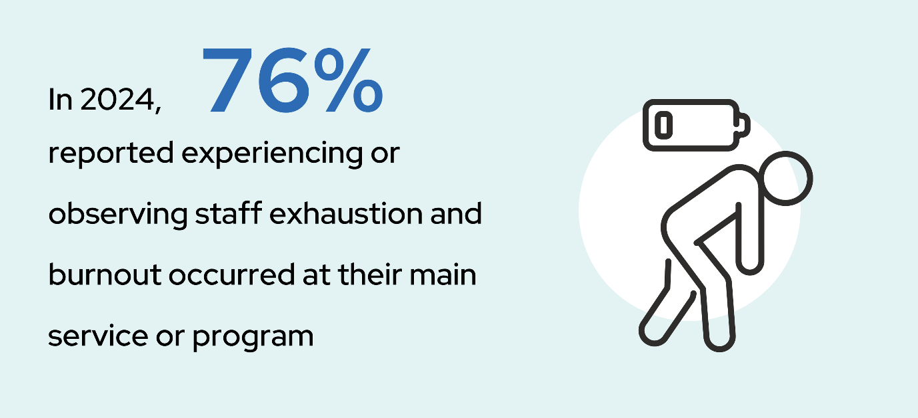
- 76% of respondents indicated that staff exhaustion and burnout had occurred in their main program or service.

These findings suggest the widespread nature of burnout across the sector, emphasising the need for adequate funding that enables targeted workforce support, proactive wellbeing initiatives, and strategies to manage workload pressures effectively.

5.6 Measuring workplace burnout
To measure workplace burnout, respondents were asked to what extent they agreed with a series of statements designed to measure workplace burnout. The findings suggest that mental exhaustion is a key concern, although other indicators of burnout appear less widespread.

5.6.1 Mental exhaustion
Mental exhaustion was a prominent concern among respondents, reflecting the emotional demands of community sector work. This measure captures the extent to which staff feel mentally depleted by their daily responsibilities.

- Mental exhaustion was reported by more than half of respondents, with 53% agreeing or strongly agreeing that they felt mentally exhausted at work
- 25% disagreed or strongly disagreed that they felt mentally exhausted at work
- 21% were neutral or not sure.
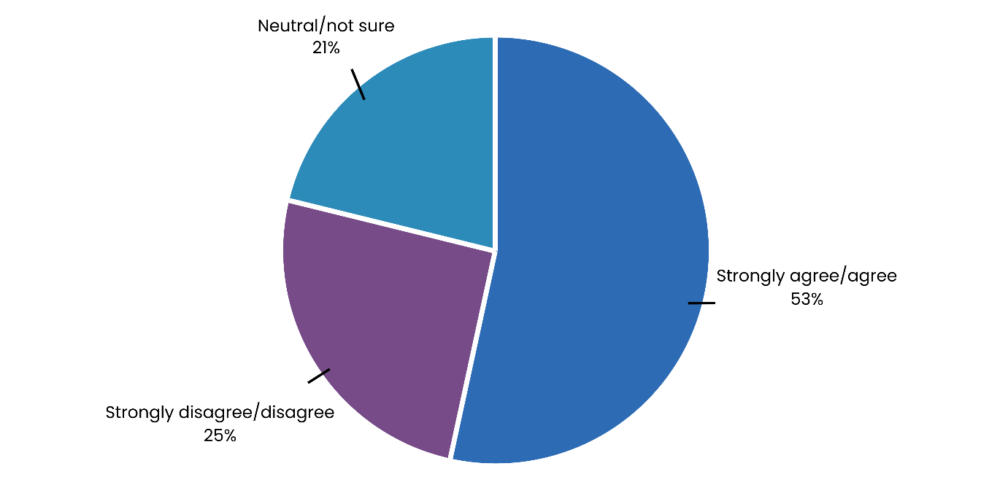
Figure 58. Respondents who experienced mental exhaustion at their workplace in 2025

Findings suggest a substantial risk of burnout across the workforce. These results emphasise the importance of addressing workload pressures and improving recovery opportunities for staff.

5.6.2 Trouble concentrating
Trouble concentrating can be an indicator of cognitive overload and stress among staff. This measure helps identify the extent to which workplace pressures may affect focus and performance.
- Over half (52%) of respondents disagreed or strongly disagreed that they had trouble concentrating at work
- One quarter agreed or strongly agreed that they had difficulty concentrating at work (25%)
- The remaining 23% were neutral or not sure.
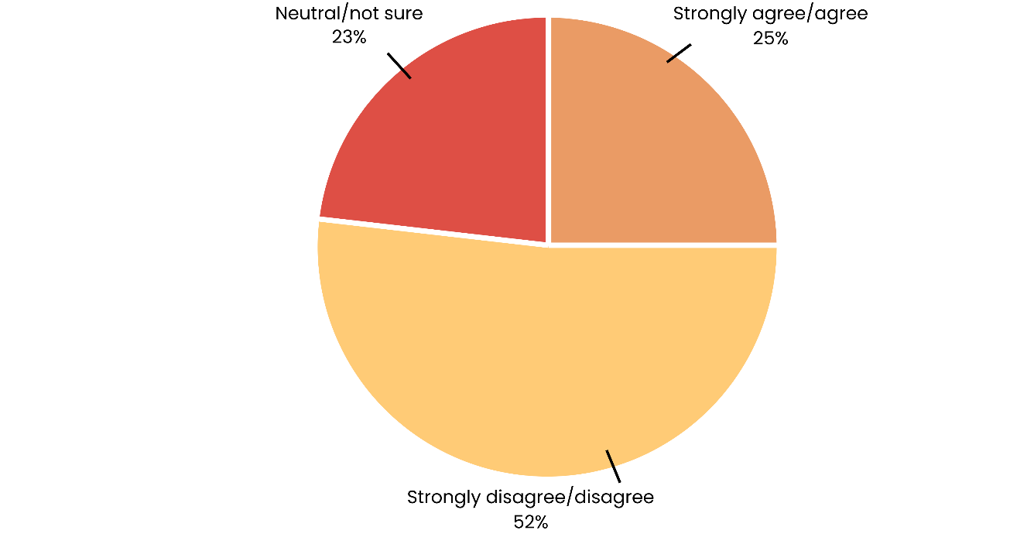
Figure 59. Respondents who experienced trouble concentrating in their role
Most respondents reported being able to maintain concentration despite challenges, suggesting effective coping mechanisms within the workforce. However, a notable minority still experience difficulty focusing, indicating ongoing strain for some employees.

5.6.3 Lack of enthusiasm
Levels of enthusiasm provide insight into staff motivation and engagement. This measure reflects the degree to which workers remain energised and committed in the face of ongoing demands.
- A majority (63%) disagreed or strongly disagreed that they felt a lack of enthusiasm about their work
- 13% agreed or strongly agreed that they struggled to find enthusiasm for their work
- 23% were neutral or not sure.
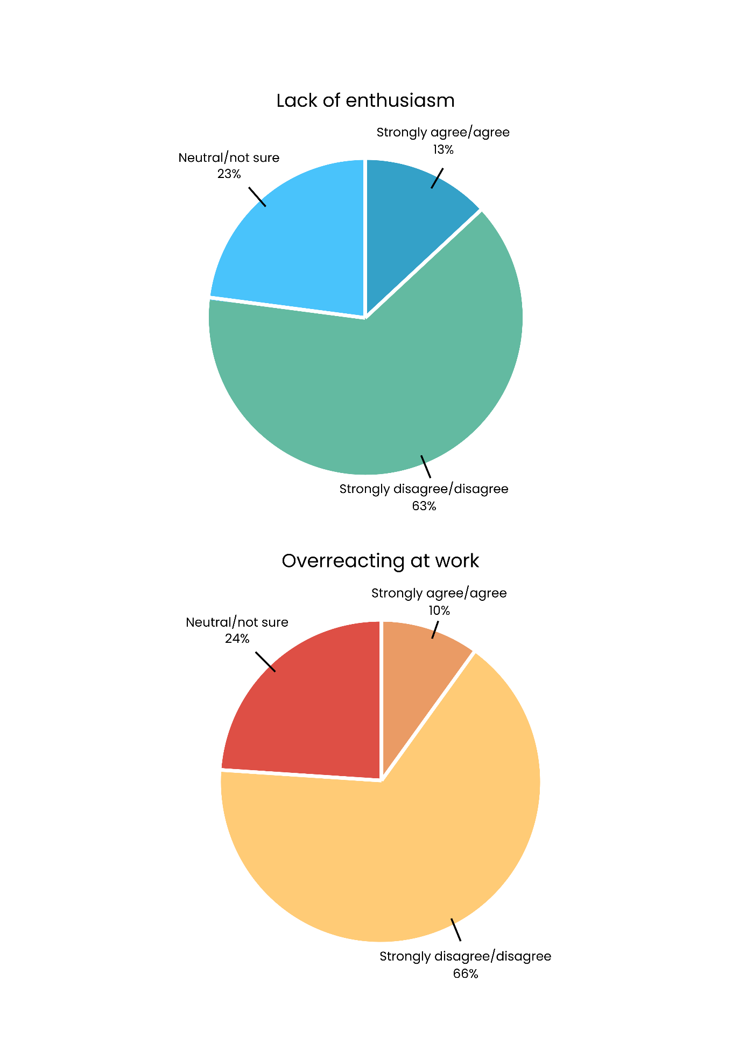
Figure 60. Respondents who experienced lack of enthusiasm in their work
The majority of respondents reported maintaining enthusiasm for their work, highlighting ongoing dedication to their roles. A small proportion showed reduced motivation, suggesting early signs of emotional fatigue for some respondents.

5.6.4 Overreacting at work
Emotional regulation at work can be affected by high stress and prolonged workload pressures. This indicator captures whether staff feel they are responding disproportionately to workplace challenges.
- 66% disagreed or strongly disagreed that they overreacted at work
- Almost one quarter (24%) of respondents were neutral
- 10% of respondents reported overreacting at work.
Figure 61. Respondents who reported overreacting at work
Most respondents reported managing their emotions effectively at work, indicating strong professional resilience. However, the small group who reported overreacting may reflect those most affected by sustained emotional strain.

5.6.5 Burnout and emotional exhaustion

Emotional exhaustion is a key component of burnout, with many workers indicating they feel drained by the demands of their roles.
- 59% agreed that they feel emotionally drained from their work
- 26% disagreed
- 14% were neutral or unsure.
Moreover, burnout and emotional exhaustion were also common themes identified by respondents across multiple qualitative response options.
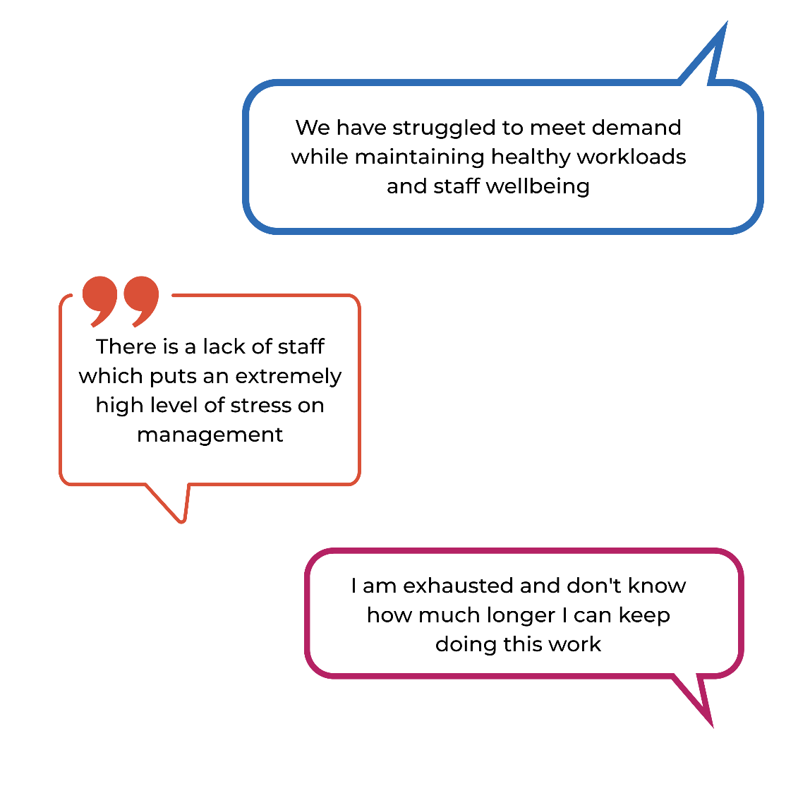
\

These results suggest that while feelings of mental exhaustion and feeling emotionally drained are relatively high among community sector workers, other signs of burnout such as emotional overreaction, loss of concentration, and lack of motivation are less common. This suggests that while the workforce is under pressure, many workers continue to find purpose and maintain emotional regulation in their roles. Nonetheless, the high level of reported mental exhaustion and feeling emotionally drained points to a need for targeted support strategies to address workload and promote wellbeing.

5.7 Disillusionment from the sector
In addition to personal exhaustion, some respondents voiced deeper disillusionment with the systemic nature of challenges in the sector. This was described as a cyclical, frustrating pattern of issues that persist without improvement:

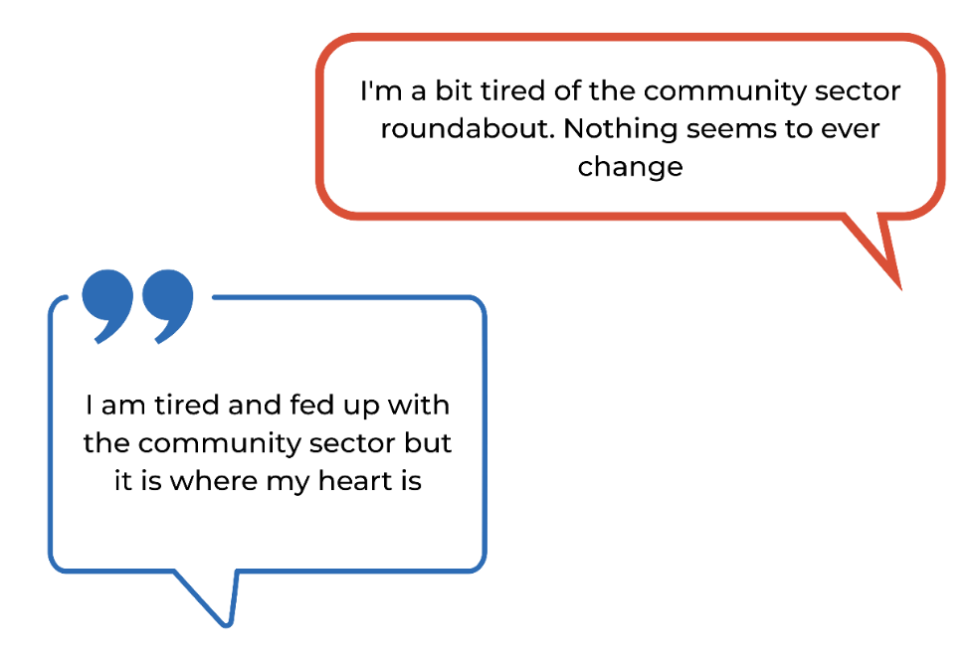

These reflections signal that burnout is not only operational but also existential, with some workers feeling demoralised by what they perceive as stagnation or lack of meaningful reform in the sector.

5.8 Workplace safety
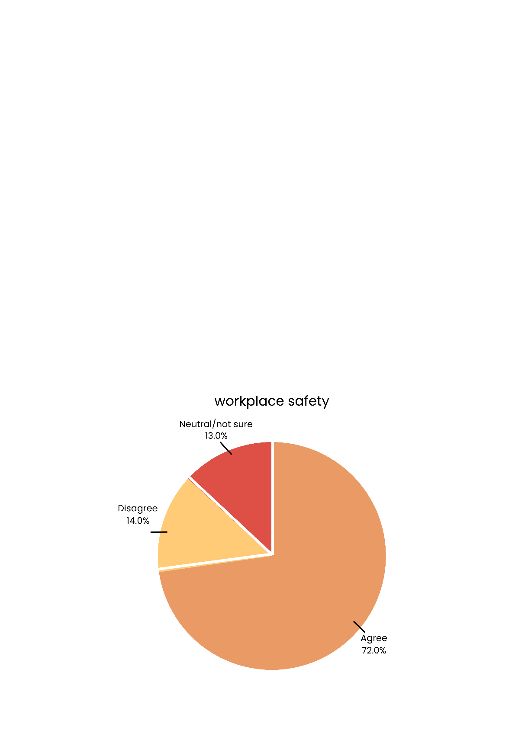
Ensuring that employees feel safe and supported is essential for maintaining a healthy and productive workforce. Workplace wellbeing and safety continue to be concerns for some respondents across the community sector.
Figure 62. Respondents who reported feeling safe at work
In 2025:
- The majority of respondents (72%) reported feeling safe at work
- 14% disagreed that they felt safe at work
- 13% were neutral or unsure.
Although most workers feel secure, the proportion of respondents who do not or are uncertain highlights the need for continued attention to workplace safety measures and organisational culture.

The presence of uncertainty and disagreement indicates that improvements are still needed. Strengthening workplace safety policies and fostering environments where staff feel consistently supported will be vital for sustaining workforce wellbeing and sector capacity.

Qualitative responses highlight the emotional and psychological toll of the work, with some respondents describing long-term impacts:
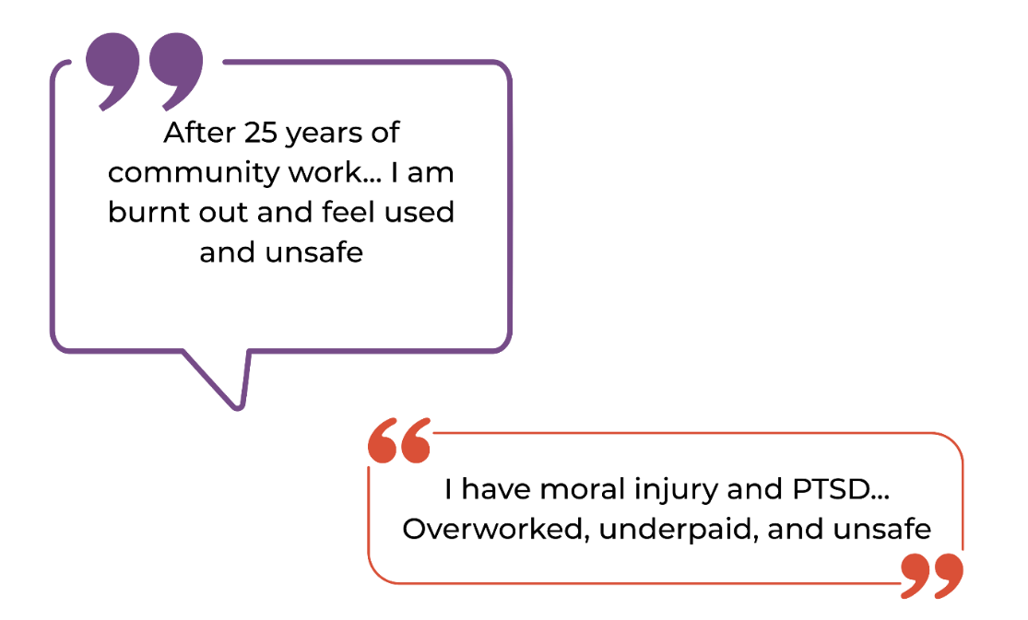

These responses highlight the urgent need for ongoing attention to workplace safety, wellbeing, and support for frontline workers.

5.9 Motivations for staying in the sector
While workforce and wellbeing challenges remain prominent, many respondents also highlighted key motivators for continuing their work in the community sector. Qualitative responses to the question which asked participants to explain their plans for where they expect to be working in 12 months, revealed several common positive themes:
- A passion for the work itself
- Appreciation for workplace flexibility
- Strong alignment with organisational values.

5.9.1 Passion for work
Despite describing experiences of being overworked, underpaid, and unsupported, many respondents also reflected positively on their roles. Respondents spoke about the personal meaning they derived from their work, even when faced with ongoing challenges.
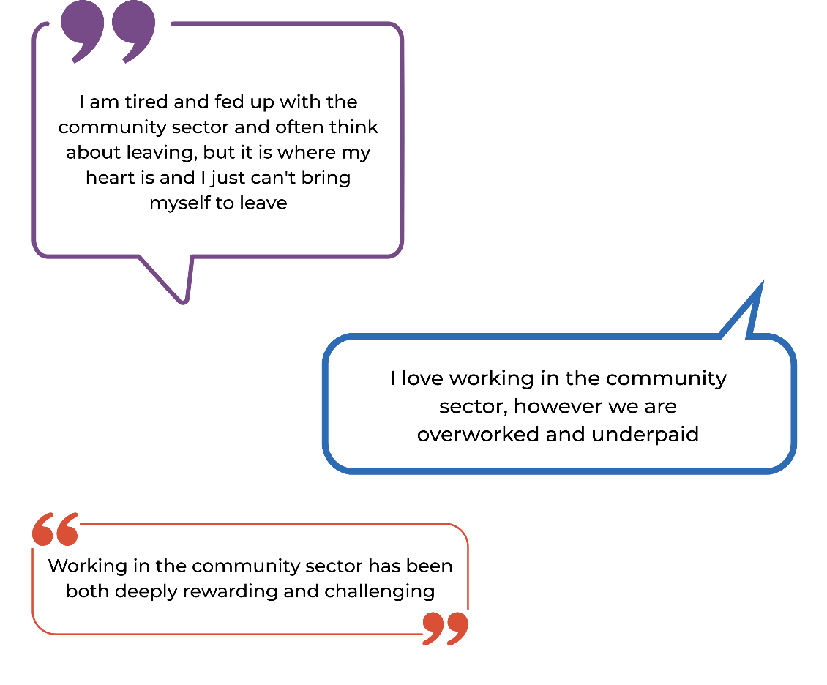

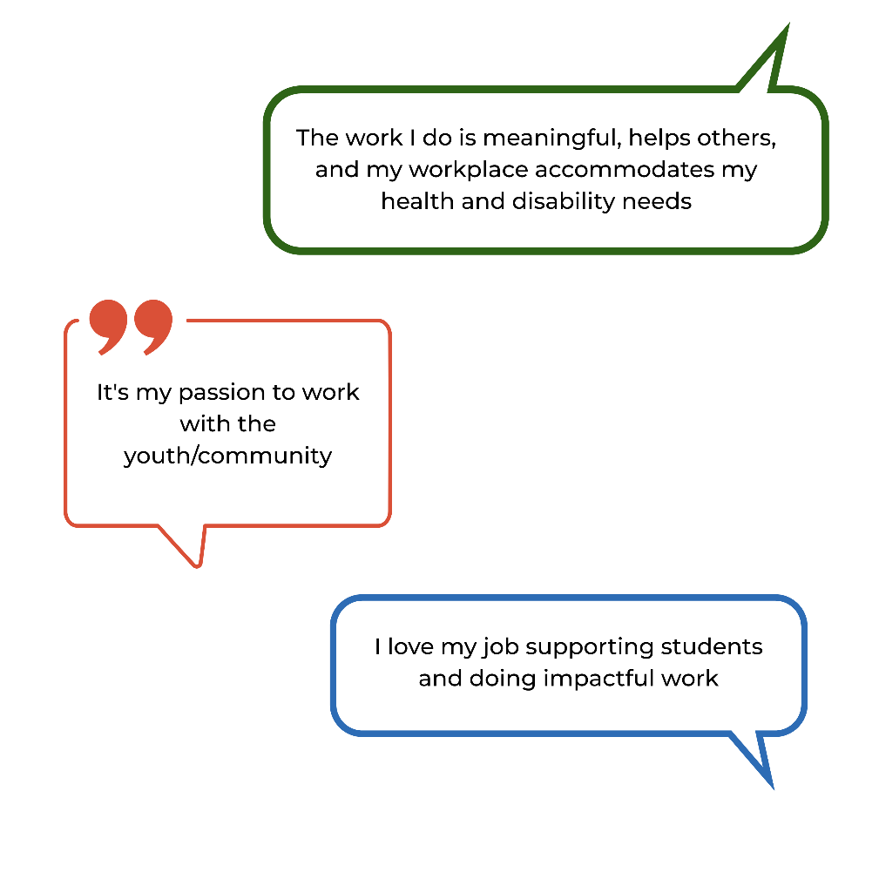
Many respondents described their roles as personally meaningful and emotionally rewarding. They valued the opportunity to contribute to their communities and support people in need. Passion and purpose were commonly cited as the core reasons for remaining in the sector:/

These findings highlight the ongoing strain on workforce capacity and wellbeing, while also acknowledging the strong personal commitment of staff. Addressing issues related to staffing, workload, and recognition is essential to ensure both sustainable service delivery and a supported workforce.

5.9.2 Workplace flexibility and work–life balance
Flexibility and balance were particularly valued, especially by workers managing personal or family commitments. Many respondents noted that while their workloads were high, flexible arrangements helped them manage competing responsibilities:


These comments reinforce the importance of flexibility as a retention factor, particularly in a sector where burnout and emotional load are common.

5.9.3 Organisational loyalty and sector commitment
Some respondents expressed strong alignment with the mission of their organisations and a deep sense of loyalty to their teams, clients, and communities. These values-driven connections often outweighed frustrations with pay or conditions:


These qualitative insights demonstrate that, despite systemic challenges, many workers are drawn to the community sector by more than just employment. Passion, flexibility, purpose, and value alignment continue to play a critical role in workforce retention. Strengthening these aspects through workplace culture, recognition, and policy could support long-term sector sustainability.

5.10 Workers’ future outlook
This section explores workers’ perspectives on their future within the community sector, including career prospects, financial security in retirement, and employment intentions. These findings highlight varied levels of optimism, stability, and concern among respondents about their ongoing engagement in the workforce.

5.10.1 Career prospects
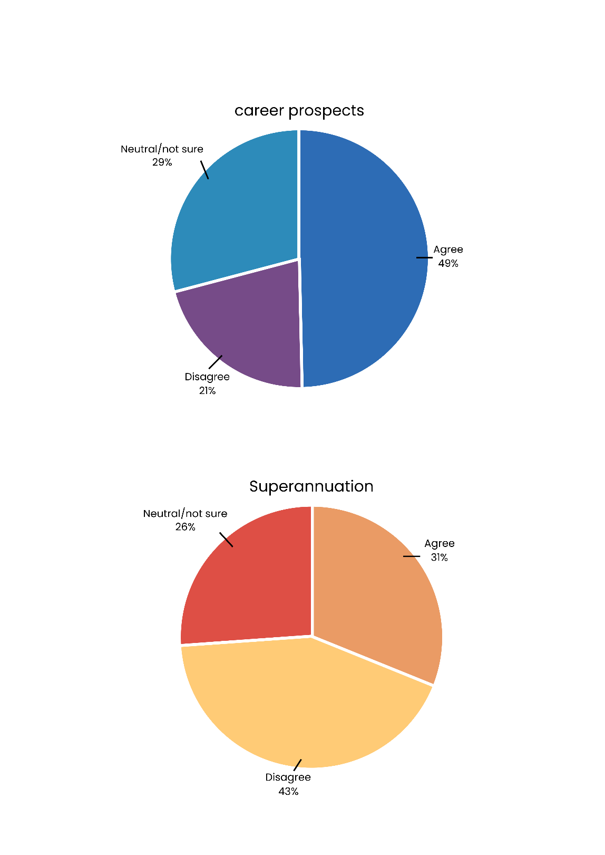
Perceptions of career prospects provide insight into how workers view professional growth and long-term opportunities within the sector. This measure reflects both confidence in career progression and the structural limitations that may restrict advancement.
Figure 63. Respondents who reported believing they had good career prospects
In 2025:
- 49% of respondents agreed that they had good career prospects
- 29% of respondents were neutral/not sure about their career prospects
- 21% disagreed.
While nearly half of respondents felt positive about their future career prospects, a similar portion remained uncertain or pessimistic. This suggests ongoing challenges around career development and mobility within the sector.

5.10.2 Superannuation
Financial wellbeing and retirement security are key aspects of workers’ longer-term outlook.
Respondents were asked whether they expected to have enough superannuation upon retirement, reflecting their confidence in financial stability and job security.
Figure 64. Respondents who reported they expected to have enough superannuation when they retired
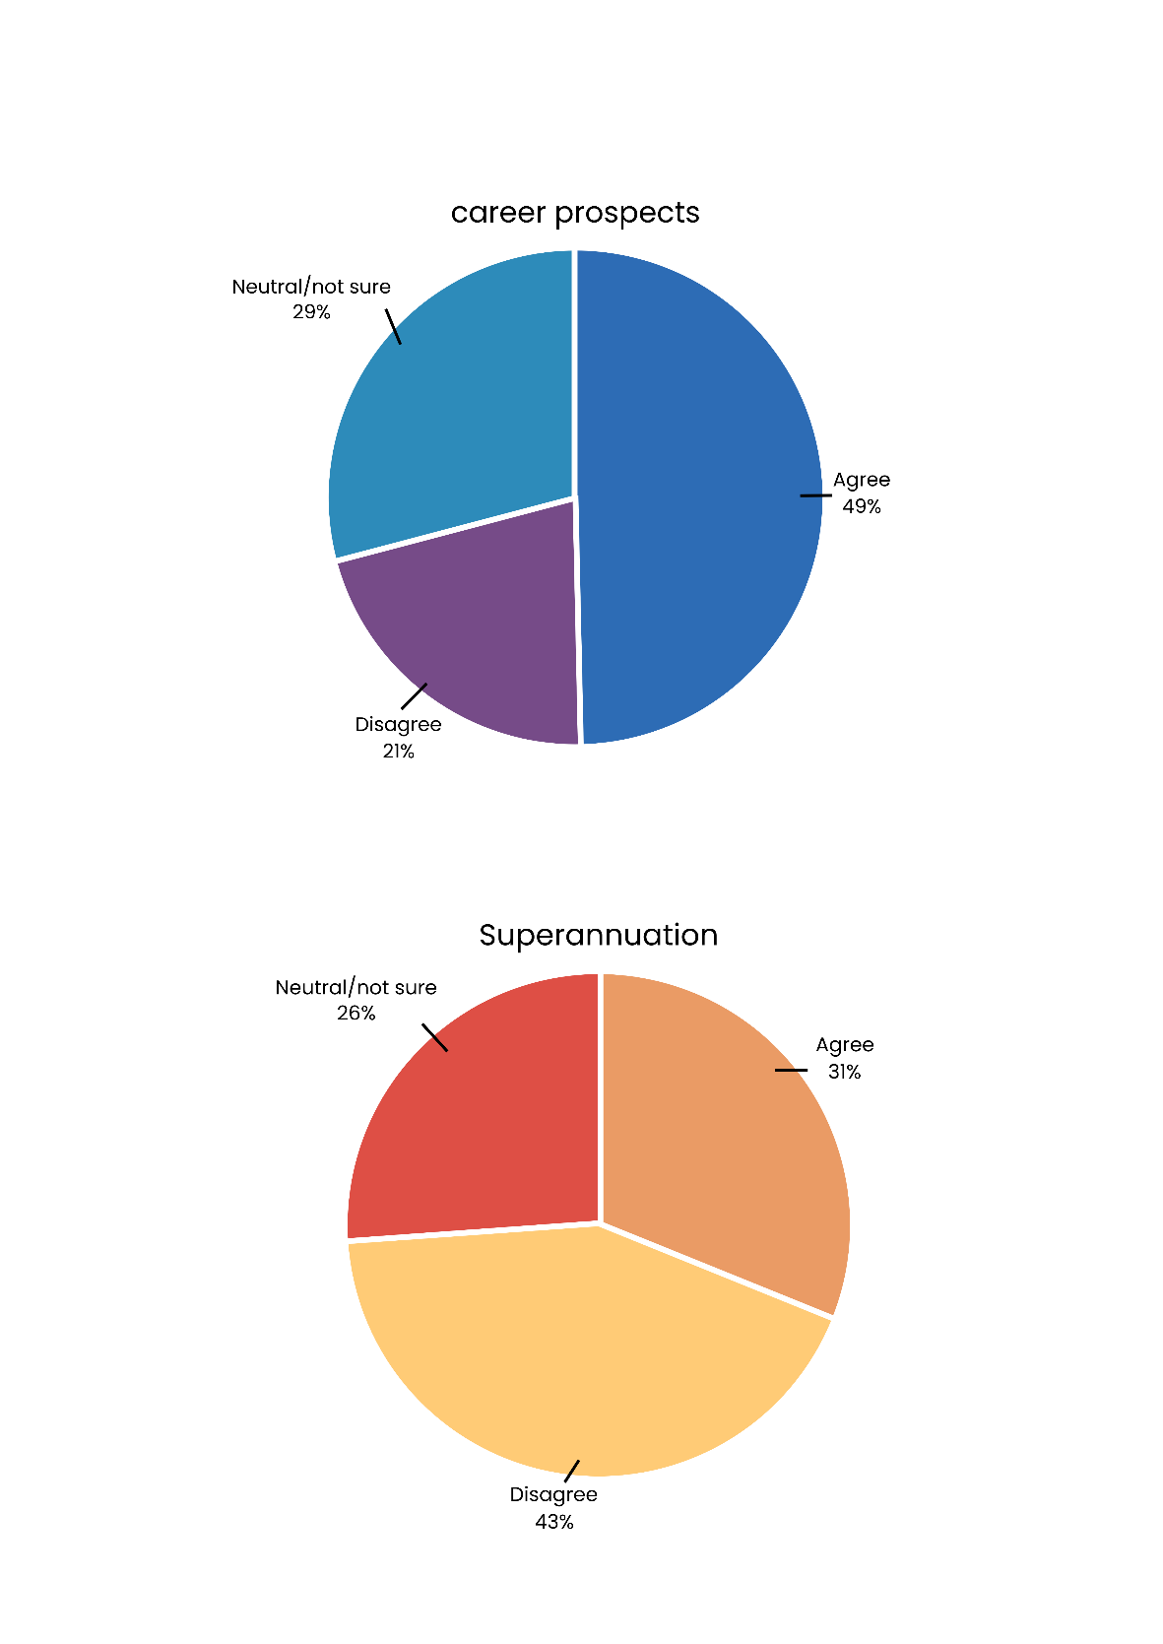
In 2025:
Figure 64. Respondents who reported they expected to have enough superannuation when they retired
- 43% of respondents indicated that they did not expect to have enough superannuation when they retired
- Around 31% of respondents agreed that they expected to have enough superannuation when they retired
- The remaining 26% of respondents were neutral/not sure.
Low confidence in superannuation adequacy is likely linked to lower than ACT average pay.
Employers have typically been unable to fund superannuation beyond the minimum mandated amount. These mandatory increases to employer superannuation contributions have not been reflected in Government funding adjustments, meaning many organisations have had to absorb these additional expenses. This places further strain on already limited budgets and may indirectly affect wage growth, job security, and workers’ long-term financial outcomes.

5.10.3 Employment intentions
Understanding workers’ short-term employment intentions helps gauge sector stability and staff retention. Respondents were asked where they planned to be working 12 months from now. In 2025:
- 67% of respondents indicated that they planned to be working in their current role
- 10% in a different role in their organisation
- 10% in another organisation outside the community sector
- 8% in another community sector organisation
- 6% planned to be retired, or to leave the workforce
- Some respondents (9%) indicated other plans 12 months from now, such as:
- planning to study
- private practice
- not sure/I don’t know.

One respondent noted:

Most workers indicated short-term stability, with the majority intending to remain in their current roles. However, planned movement outside the sector and into retirement may contribute to ongoing workforce turnover pressures.

Across these measures, workers expressed mixed views about their future in the community sector. While many remain committed to their current roles, concerns about career progression and financial security could impact long-term workforce retention and morale.

Appendices
- ACT Community Sector Overview

- ACT Government funding for core organisational functions

- Main service focus area

- Staffing challenges and workforce capacity

- Project endorsement

- Participant information sheet, participant consent form

- Full methodology



ACT Community Sector Overview

Organisation income
ACT community sector organisations reported a wide range of income levels for the 2023–24 financial year, highlighting the sector’s diversity in size and resources. Figure 1a shows the reported income ranges of ACT community sector organisations for the 2023–24 financial year, based on responses from CEOs, board members, and senior managers.
- A large proportion (39%) of organisations indicated that their income for the 2023-24 financial year was between $1 million and $5 million
- Approximately 28% of organisations had less than $1 million in income over the same period
- Approximately 24% over $5 million income over the 2023-24 financial year.
Figure 1a. Organisational income for 2023-24 financial year

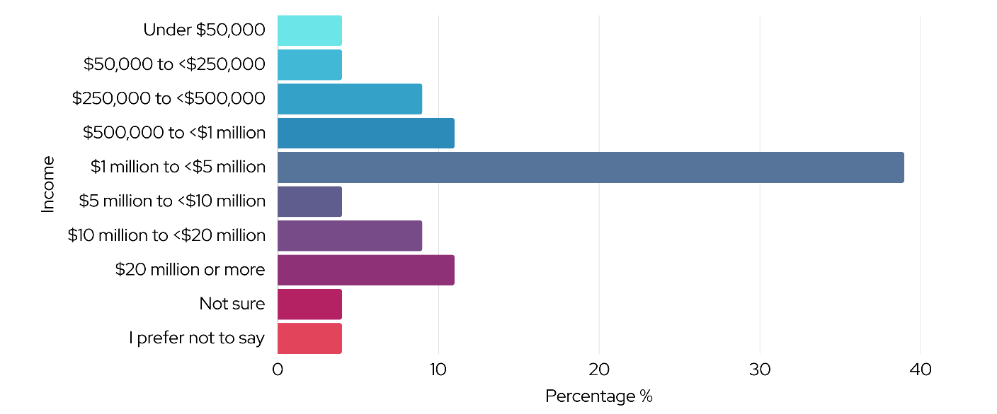

1.2 Organisation type
Respondents were asked which best describes their organisation. The most common organisation type was service delivery (see figure 2a).
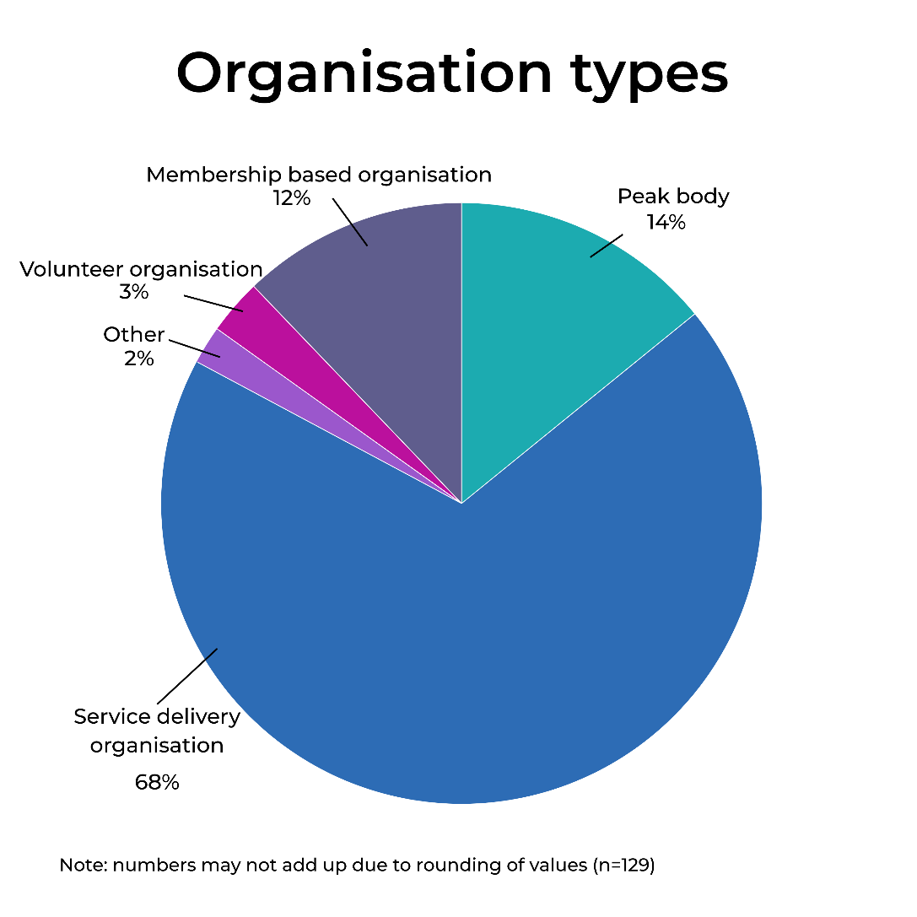
Figure 2a. Respondents organisation types within the ACT Community sector

1.3 Organisation size
Survey responses show a wide variation in the organisation staffing numbers in the ACT community sector in 2025, including all paid staff who work in the ACT.

The organisation size reported in 2025 was as follows (see figure 3a for more detail):
- Less than 20 staff – 26%
- 20 to less than 100 staff – 39%
- 100 to less than 500 staff – 26%
- 500 or more staff – 9%

Small and medium-sized enterprises (SMEs) are typically defined as organisations with fewer than 200 staff. However, for this analysis, a cut-off of fewer than 100 staff was used. Based on the cut-off of fewer than 100, SMEs made up 65% of respondents in 2025, while large organisations (100 staff or more) accounted for 35%. This is a notable increase from 12% in 2022, which likely reflects greater participation by multi-jurisdictional providers and may overrepresent larger national organisations. It is important to note that these figures may not reflect organisation-wide staffing levels and could have been influenced by ambiguity in the survey wording.

Anecdotally, the increase in larger providers may reflect a shift caused by the commissioning process.
Figure 3a. Distribution of organisation size reported in 2022 and 2025. 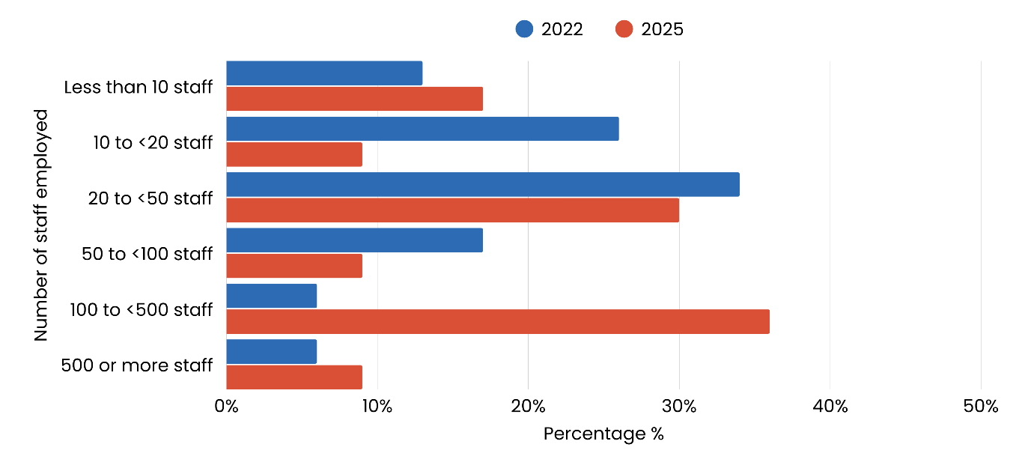Note: Figures reflect organisation-wide staffing and may overrepresent large, national providers.

Key changes between 2022 and 2025 included:
- Organisations with 100 or more staff may have increased from 12% in 2022 to 35% in 2025, possibly due to greater participation from large, multi-jurisdictional organisations
- Small organisations (fewer than 20 staff) appear to have decreased from 39% in 2022 to 26% in 2025, which may reflect lower participation by smaller providers
- Organisations with fewer than 100 staff represented 65% of respondents in 2025, down from 89% in 2022
- While smaller organisations continue to play an important role in the sector, their representation in the survey appears to have declined since 2022.

These shifts may reflect differences in survey methodology and participation rather than a structural change in the sector. The 2025 survey asked respondents to provide organisation-wide staffing numbers, which could have overstated the presence of larger, multi-jurisdictional providers. In contrast, the 2022 survey focused on ACT-based staffing, which may have better represented smaller, local organisations.

Overall, these results should be considered indicative rather than definitive, as they may be influenced by survey design, participation patterns, and reporting practices.

1.4 Aboriginal Community Controlled Organisations

Respondents were asked if their organisation was an ACCO, with two percent indicating that they worked for an ACCO. Responses included:
This limited representation of ACCOs within the survey and sector highlights the need to strengthen Aboriginal and Torres Strait Islander self-determination through increased support, investment, and recognition of community-controlled organisations and leadership.

- 94% indicating they were not an ACCO
- 3% were unsure
- 2% of respondents were from an ACCO.

1.5 Members of ACTCOSS
As a member-based peak body, ACTCOSS sought to understand the extent of its reach within the sector. When asked about their organisation’s membership status, 69% of respondents indicated they were ACTCOSS members, 20% were unsure, and 11% reported not being members.

Respondents also acknowledged the valuable role ACTCOSS plays as an advocate for the sector. Several expressed appreciations for the organisation’s ongoing support, particularly during recent challenges:
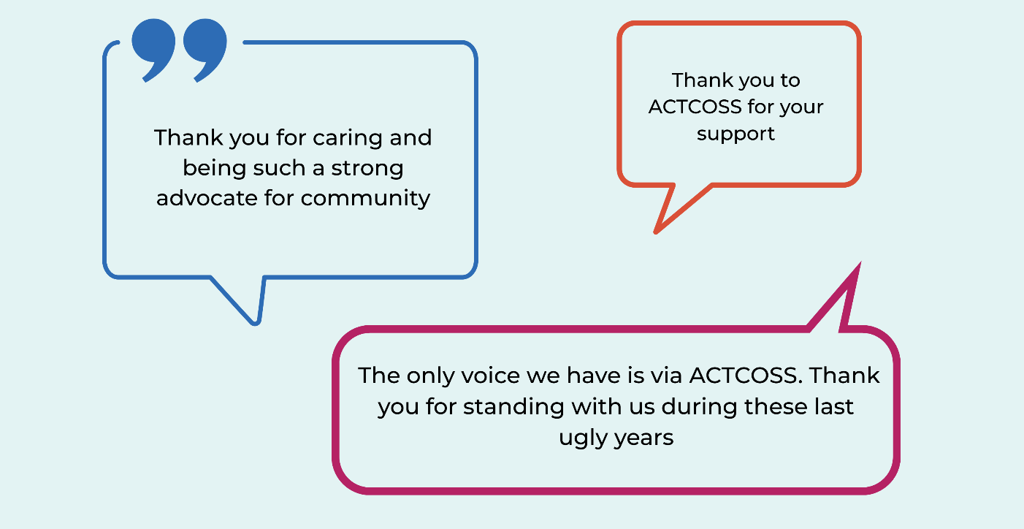

ACT Government funding for core organisational functions

3.6.1 Engaging with Government policy and reform processes
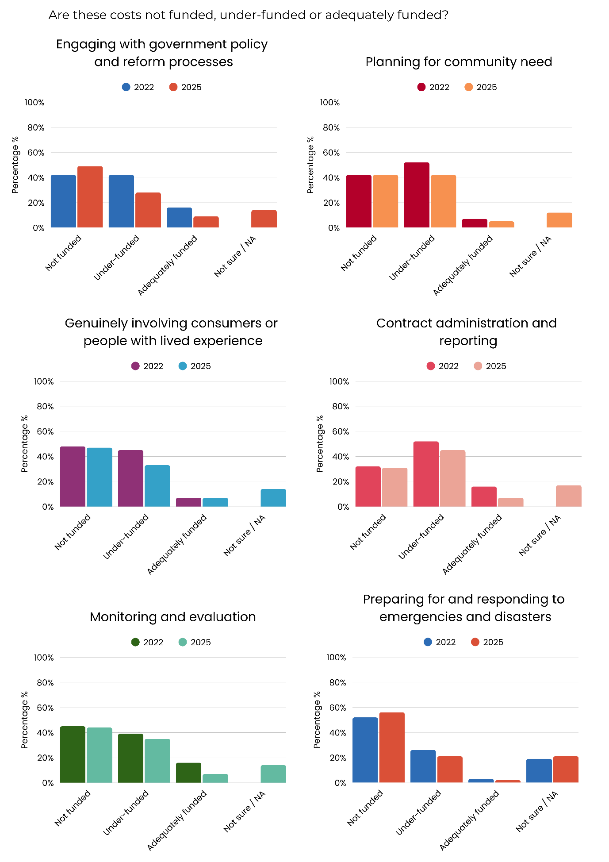
Organisations were asked whether ACT Government funding supports the costs of engaging with Government policy and reform processes. In 2025:
Figure 1b. Adequacy of funding to engage with government policy and reform processes

- Nearly half of organisations (49%) reported that costs associated with engaging with Government policy and reform processes were not funded, compared with 42% in 2022
- 28% of organisations considered the cost under-funded, compared to 42% in 2022
- 14% were unsure or said not applicable, an increase from 0% in 2022
- 9% said they were adequately funded compared with 16% in 2022.

These results indicate that engagement in Government policy and reform processes remains under-resourced. Limited funding restricts organisations’ ability to contribute to systemic reforms and advocate effectively for their communities.

3.6.2 Planning for community need
Organisations were asked whether ACT Government funding supports the costs of planning for community need. In 2025:
Figure 2b. Adequacy of funding to adequately plan for community need

- 42% of organisations reported that costs to adequately plan for community need were not funded at all, unchanged from 2022
- Another 42% considered this function under-funded, compared to 52% in 2022
- 12% were unsure or said not applicable, increasing from 0% in 2022
- 5% indicated they were adequately funded, compared with 7% in 2022.
These findings show that planning for community need is overwhelmingly under-resourced. Without sufficient funding, organisations are constrained in their ability to anticipate and respond effectively to changing community demand, limiting service coordination and long-term sustainability. This may also reflect some subsectors finishing commissioning, reducing demand.
3.6.3. Genuinely involving consumers or people with lived experience
Organisations were asked whether ACT Government funding supports the costs of genuinely involving consumers or people with lived experience. In 2025:
Figure 3b. Adequacy of funding to genuinely involving consumers or people with lived experience

- 47% of organisations reported that costs to genuinely involve consumers or people with lived experience were not funded, compared to 48% in 2022
- One third (33%) said they were under-funded, decreasing to 45% in 2022
- 14% were unsure or said not applicable, compared to 0% in 2022
- 7% were adequately funded, unchanged from 2022.
These findings indicate that genuine consumer and lived experience involvement continues to be under-resourced. This gap limits the sector’s capacity to embed lived experience in service design and decision-making, which is critical to ensuring services remain responsive, inclusive, and effective.
3.6.4 Contract administration and reporting
Organisations were asked whether ACT Government funding supports the costs of contract administration and reporting. In 2025:
Figure 4b. Adequacy of funding to support contract administration and reporting costs

- 31% of organisations indicated that costs of contract administration and reporting were not funded at all, similar to 2022 (32%)
- 45% reported they were under-funded, compared to 52% in 2022
- 17% were unsure or said not applicable, increasing from to 0% in 2022
- 7% considered these costs adequately funded, decreasing from to 16% in 2022.
These results show that contract administration and reporting remain areas of persistent underfunding. The decline in adequate funding places additional strain on staff capacity, diverting resources from service delivery and undermining organisational efficiency and sustainability.
3.6.5 Monitoring and evaluation
Organisations were asked whether ACT Government funding supports the costs of monitoring and evaluation. In 2025:
Figure 5b. Adequacy of funding to support the costs of monitoring and evaluation

- 44% of organisations reported that costs of monitoring and evaluation were not funded at all, compared to 45% in 2022
- Over one third (35%) considered these costs under-funded, compared with 39% in 2022
- 14% were unsure or said not applicable, increasing from 0% in 2022
- 7% said they were adequately funded, decreasing from 16% in 2022.
These findings indicate that monitoring and evaluation continues to be under-resourced. Limited funding reduces the sector’s capacity to track performance, measure outcomes, and demonstrate impact, constraining accountability and informed service planning.

3.6.6 Preparing for and responding to emergencies and disasters
Organisations were asked whether ACT Government funding supports the costs of preparing for and responding to emergencies and disasters. In 2025:
Figure 6b. Adequacy of funding to prepare and respond to emergencies and disasters

- 56% of organisations were not funded to prepare and respond to emergencies and disasters, compared to 52% in 2022
- More than one in five (21%) were under-funded, compared to 26% in 2022
- More than one in five (21%) were unsure or said not applicable, compared to 19% in 2022
- 2% considered these costs adequately funded, compared to 3% in 2022.
These findings indicate that emergency and disaster preparedness remains largely unfunded and under-resourced. Inadequate funding leaves organisations vulnerable in responding effectively to crises, potentially compromising resilience, staff and client safety, and timely service delivery.

3.6.7 Maintaining appropriate insurance
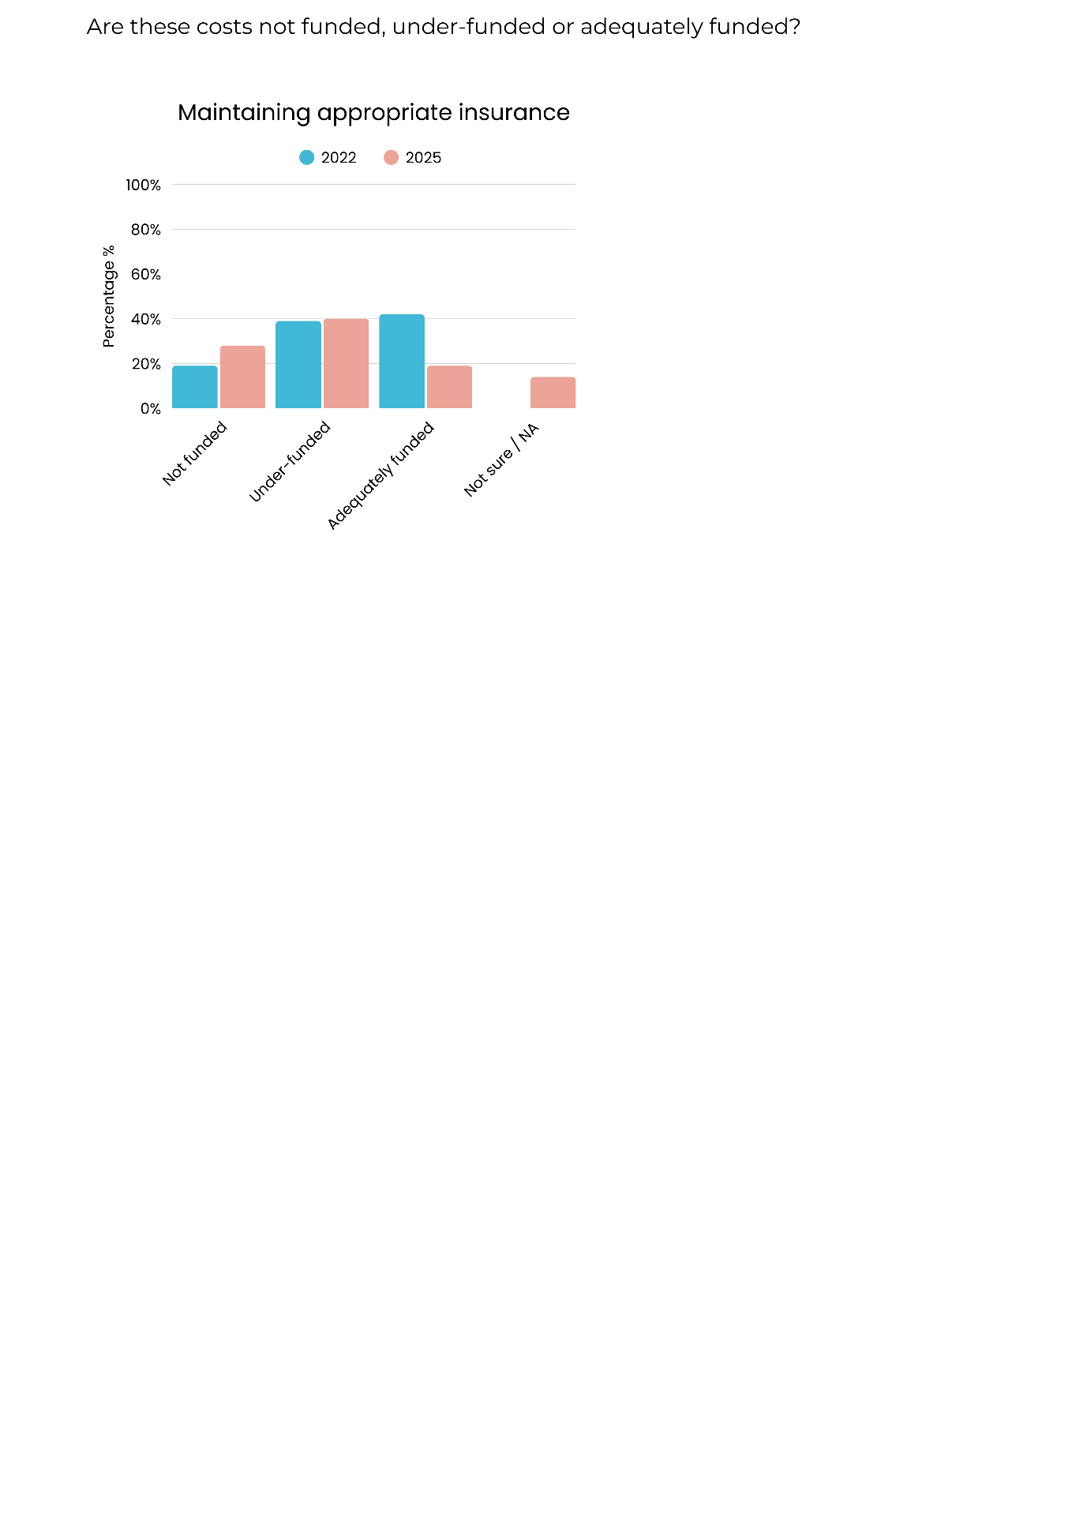
Organisations were asked whether ACT Government funding supports the costs of maintaining appropriate insurance. In 2025:
Figure 7b. Adequacy of funding to maintain appropriate insurance

- 40% of organisations reported they were under-funded to maintain appropriate insurance, compared to 39% in 2022
- 28% were not funded at all, compared to 19% in 2022
- 19% considered these costs adequately funded, declining from 42% in 2022
- 14% were unsure or said not applicable, increasing from 0% in 2022.
These findings show a decline in adequate funding for insurance, despite its essential role in managing risk and protecting both organisations and clients. The increase in organisations reporting no or insufficient funding highlights growing financial pressure associated with compliance and risk management, which could compromise organisational stability and sector capacity.

Main service focus area

4.1.1 Main focus of work
The scope of work across the ACT community sector is broad. In 2022 the sample reflected ageing and carer services, housing and homelessness, and financial/legal supports were among the most reported areas. In 2025, there was a shift in the sample towards mental health and youth services, as well as diversification into areas such as LGBTIQ+ support, multicultural services, and alcohol, tobacco and other drug services. It is unlikely that these apparent changes represent total employment across the sector, however, observation of these two years combined, demonstrate the diversity of the community sector.
The top 5 responses for main service focus area of work in 2025 included:
- Child and youth services (19%)
- Housing and homelessness (11%)
- Mental health services and supports (11%)
- Financial support (8%)
- Other (7%).
The top 5 main service focus areas of work in 2022 included:
- Ageing and carer (17%)
- Financial, legal and emergency supports (13%)
- Housing and homelessness (13%)
- Multiple services / other main service type (12%)
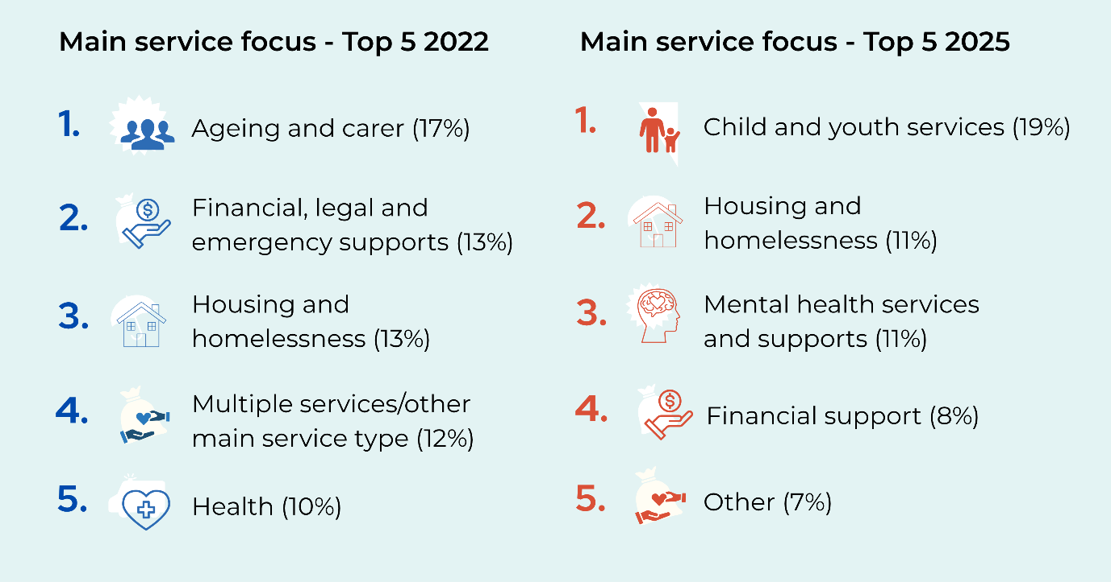
- Health (10%).

Beyond the top five in 2025, a wide range of service types were represented, reflecting the sector’s diversification. These include:
- Community health, health promotion and sexual health services (6%)
- Disability services (5%), alcohol, tobacco and other drug services (5%), and domestic and family violence and other family-related services (5%)
- Ageing services (4%)
- Legal services (3%), LGBTIQ+ support (3%), community development (3%), and early childhood education and care (3%)
- Aboriginal and Torres strait islander services (2%), migrant and multicultural services (2%), and employment, education and training (2%)
- Supports for carers (1%), emergency relief and food support (1%), and environment and animal welfare (1%).
Table 1c. Main service focus of work in 2025
Service type | Percentage %
Child and youth services | 19%
Mental health services and supports | 11%
Housing and homelessness services | 11%
Financial support services | 8%
Other services | 7%
Community health, health promotion, and sexual health services | 6%
Disability services | 5%
Alcohol, tobacco, and other drugs services | 5%
Domestic and family violence (DFV) and other family-related services | 5%
Ageing services | 4%
Legal services | 3%
LGBTIQ+ services | 3%
Community development services | 3%
Early childhood education and care (ECEC) | 3%
Aboriginal and Torres Strait Islander services | 2%
Migrant and multicultural services | 2%
Employment, education, and training services | 2%
Supports for carers | 1%
Emergency relief and food support | 1%
Environment and animal welfare | 1%
Hospital, hospice, palliative care services | 0%
International aid and development | 0%
Climate change, energy, and disasters | 0%
Note: respondents could only select one response to indicate their service’s main focus.
Numbers may not add up due to rounding.

In 2025, services involving climate change, palliative care, and international aid remained largely unrepresented as main service focus areas.
However, respondents noted that their organisations often provided support in these areas as part of broader service delivery, particularly in response to client needs or emerging community issues, even though these were not the organisation’s primary area of work.

Common themes from Respondents that selected “other” (7%) included:

- Peak body / sector coordination
- Advocacy and welfare support for specific groups
- Crisis and specialist support services
- Broad multi-service support (such as mental health, climate, care services, addictions, family, migrants, Aboriginal and Torres Strait Islander peoples, employment, accommodation, food, financial support)
- Administration and operations.

Staffing challenges and workforce capacity

5.1.6 Staff absenteeism
Figure 1d. Proportion of respondents indicating that their main service or program experienced staff absenteeism in 2022 and 2024

Staff absenteeism remained a challenge in 2024, though lower than during the height of the COVID-19 pandemic.
- In 2022, 64% of organisations reported staff absenteeism in their main service or program likely due to COVID-19. This decreased to 43% in 2024.
These findings suggest that while absenteeism remains a concern, the impact of COVID-19 on staff attendance has lessened over time.

Project endorsement
Endorsement of project as a Quality Assurance/Improvement (QAI) activity by the ACT Health Human Research Ethics Committee, Low Risk Sub-Committee.
This survey has been assessed by the ACT Health Human Research Ethics Committee, Low-Risk Sub-Committee as a quality assurance/improvement (QAI) activity with negligible risk to participants (2025.QAI.00043).

Participant information
Participant information sheet.
Participant information sheet

What is the State of the ACT Community Sector Survey?
The State of the ACT Community Sector Survey 2025 is a short survey based on the Australian Community Sector Survey, conducted by Australian Council of Social Service (ACOSS). Participating in this survey will help us map the ACT community sector and its needs. Taking this survey will help inform areas of advocacy to support the community sector.
All ACT community sector employees and organisations are encouraged to participate.
Who is conducting it?
The ACT Council of Social Service Inc. (ACTCOSS) represents not-for-profit community organisations and works tirelessly for social justice in the ACT. ACTCOSS is a not-for-profit peak body, working collaboratively with organisations and individuals to create a collective voice, advocating for positive social change, and justice and self-determination for Aboriginal and/or Torres Strait Islander peoples.
ACTCOSS also works closely with our colleagues in the nationwide COSS Network, made up of each of the state and territory Councils of Social Service (COSS) and the national body, the ACOSS.
What does participating involve?
The survey includes questions about your work, your experience working in the community sector, the level of need in the community sector and general demographic information.
Completing the survey will take approximately 5-10 minutes for community workers. For CEOs and senior managers, it will take approximately 15 minutes and there will be extra questions about funding, contracts, staffing, financials and viability.
Most questions are general in nature and can be skipped if you prefer not to answer the question. You may withdraw from the survey at any time.
The survey will close on Friday 7 March 2025.
How can I participate?
To participate in the survey, please see our website: https://actcoss.org.au/. The participant consent and privacy form, and project description can be found at: https://actcoss.org.au/
For any questions about the study or survey questions, please contact Leanne Bourke at leanne.bourke@actcoss.org.au or by phoning 02 6202 7200.
This survey has been assessed by the ACT Health Human Research Ethics Committee, Low-Risk Sub-Committee as a quality assurance/improvement (QAI) activity with negligible risk to participants (2025.QAI.00043).

Project description.
Project description
About the survey
The State of the ACT Community Sector Survey 2025 is a survey based on the Australian Community Sector Survey, conducted by Australian Council of Social Service (ACOSS).
ACT Council of Social Service Inc. (ACTCOSS) is a not-for-profit peak body for the community sector in the ACT, working collaboratively with organisations and individuals to create a collective voice, advocating for positive social change, including justice and self-determination for Aboriginal and/or Torres Strait Islander peoples.
The survey is open to all ACT Community Sector Workers, board members of volunteer-led organisations, CEOs and senior managers. The survey includes questions for community sector workers, CEOs and senior managers that ask about their experience of working in the community sector, opinions on training and funding needs, and general demographic questions. For CEOs and senior managers, there will be additional questions that ask about organisational recruitment, staffing, sustainability and financials.
ACTCOSS, as the peak body for ACT community services, is seeking to conduct this evaluation to help understand community service demand and identify the needs of community services within the ACT. This evaluation will help inform areas of policy and advocacy to support the sectors sustainability.
The results of the survey will be published in a ‘State of the Sector’ report. All recorded data will be reported in an aggregated way, ‘de-identified’ to ensure anonymity of individuals and organisations, unless otherwise specified by a participant/organisation (i.e. they wish to share their response). All data will be collected, handled, and stored in accordance with the ACTCOSS privacy policy and National ethical data collection, management and storage guidelines.
This survey has been assessed by the ACT Health Human Research Ethics Committee, Low-Risk Sub-Committee as a quality assurance/improvement (QAI) activity with negligible risk to participants (2025.QAI.00043).
For more information, please contact Leanne Bourke at leanne.bourke@actcoss.org.au or by phoning 02 6202 7200 or visit the ACTCOSS website at https://actcoss.org.au/

The survey will close on Friday 07 March 2025.

Participant consent and privacy form.
Participant consent and privacy form

About the survey
The survey includes questions about your work, your experience working in the community sector, the level of need in the community sector and general demographic information.
Completing the survey will take approximately 5-10 minutes for community workers. For CEOs and senior managers, it will take approximately 15 minutes and there will be extra questions about funding, contracts, staffing, financials and viability.
Storage and use of data
Responses will be stored securely and confidentially by ACTCOSS, in accordance with our privacy policy. When publishing, information will be provided in an aggregated way, so that neither you nor your organisation can be identified. Information may be made available for other research in deidentified form only.
Questions, support or feedback
For support, to provide feedback or to ask questions about the study or survey questions, please contact Leanne Bourke at leanne.bourke@actcoss.org.au or by phoning 02 6202 7200.
The survey questions are general in nature and are unlikely to cause harm or distress. However, if you find any content upsetting and would like support, please contact Lifeline (24 hours) on 13 11 14 or Beyond Blue on 1300 224 636.
Consent and participation
Participation in this survey will be through implied consent. Implied consent means that if you continue beyond the first page of the survey, that you have implied that you have read the participant information sheet, and the consent and privacy form, and you agree to your data being collected.

Participation in this study is voluntary, and you may withdraw from the survey at any time. Most questions are general in nature and can be skipped if you prefer not to answer. All answers will be de-identified for individuals and organisations. Following the survey, a report containing the results of the research will be made available on the ACTCOSS website.

To find out more, please read or download the Participant Information Sheet before proceeding.

Methodology

The State of the ACT Community Sector Survey 2025 was developed and conducted by the ACT Council of Social Service Inc. (ACTCOSS), drawing on the national framework established by the Australian Community Sector Survey conducted by the Australian Council of Social Service (ACOSS). The purpose of the ACT survey was to gather information from community sector workers, CEOs, senior managers, and board members of volunteer organisations to inform advocacy, policy development, and sector support strategies.

Survey Design and Content

The survey included a combination of closed and open-ended questions across four key areas: sector workforce overview; staffing and volunteers (including wellbeing and challenges); funding and sustainability; and service delivery and demand. Tailored question sets were provided for general community sector workers and for CEOs, senior managers, and board members of volunteer organisations, with the latter group receiving additional questions related to organisational sustainability, staffing, and financial management.

The survey instrument was hosted using Microsoft Forms and included a participant information sheet, privacy notice, and links to the ACTCOSS privacy policy. Participation was voluntary, anonymous, and conducted in accordance with ethical guidelines for the handling of data. Respondents provided implied consent by proceeding with the survey.

Survey Administration

The survey was open for a three-week period from February to March 2025 and was promoted through ACTCOSS networks, newsletters, and targeted communications. It was designed to take approximately 5–10 minutes for community workers and 10–15 minutes for CEOs, senior managers, and board members to complete.

Participants

A total of 129 individuals completed the survey. Of these, 46 respondents identified as CEOs, senior managers, or board members of volunteer organisations. All participants were based in the Australian Capital Territory (ACT) and represented a broad cross-section of community services, including areas such as housing and homelessness, disability, mental health, legal services, family support, multicultural services, and community development.
Data Management and Analysis

Survey data was collected through Microsoft Forms and downloaded for analysis in de-identified format. Responses were aggregated and analysed descriptively to identify trends, key issues, and sector needs. Qualitative comments were reviewed for thematic insights and presented anonymously when included in reporting.

All data was collected, stored, and managed in accordance with the ACTCOSS Privacy Policy and relevant national ethical guidelines for data collection, management, and storage. The findings will be reported in the State of the ACT Community Sector report and used to inform ACTCOSS's ongoing policy, advocacy, and sector development work.

02 6202 7200
ABN 81 818 839 988
Thank you
actcoss@actcoss.org.au
actcoss.org.au

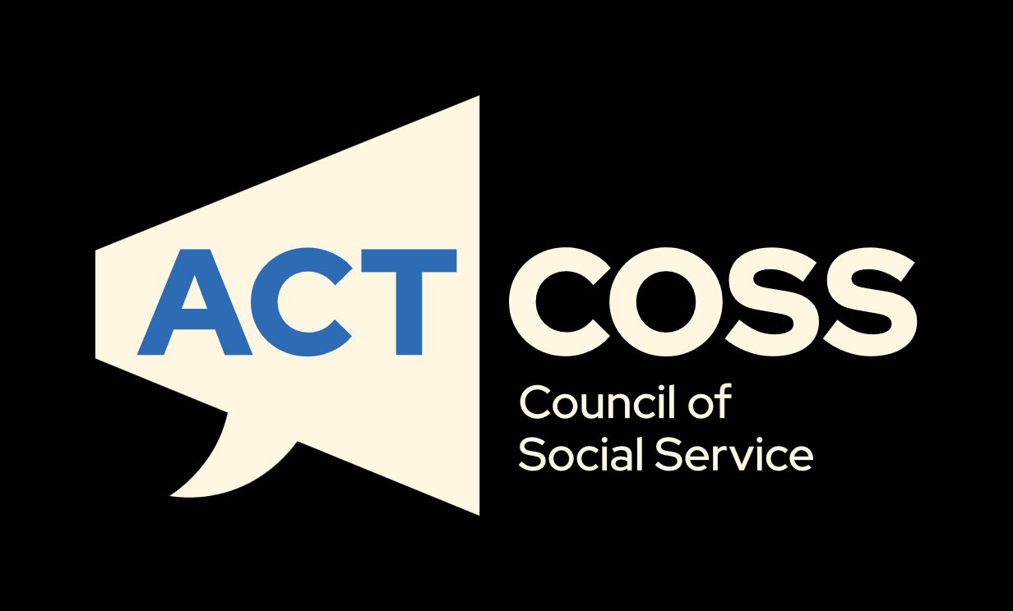
02 6202 7200
ABN 81 818 839 988
actcoss@actcoss.org.au
actcoss.org.au

ACT Government, Chief Minister, Treasury and Economic Development Directorate. (2025). Community Sector Budget Fact Sheet 2025–2026
Australian Capital Territory. (2025). State of the Service Report 2024-25.
Australian Capital Territory Government. (2024). Welcome to Commissioning
Australian Capital Territory Government. (2025). Community sector budget fact sheet 2025-26. Community sector budget fact sheet 2025 to 2026
Legislative Assembly for the Australian Capital Territory. 2009. Hansard. Page 782 Week 02
ACT Government. 2009. Budget paper 3: Budget overview. Table 2.1.1. https://www.treasury.act.gov.au/__data/assets/pdf_file/0006/1464882/04finpro.pdf
ACT Government. 2025. Strengthening Community Services, p1.
ACT Government. 2025. 2025-26 Budget Outlook. Table 3.5.1, p169.
Calculated using the Reserve Bank of Australia’s Inflation Calculator. Reserve Bank of Australia. 2024. Inflation Calculator. https://www.rba.gov.au/calculator/annualDecimal.html
Australian Bureau of Statistics. 2024. 3101.0 National, state and territory population; Table: Annual population change at 31 December 2024. https://www.abs.gov.au/statistics/people/population/national-state-and-territory-population/latest-release Calculated based on figures for December 2009 and December 2024.
Nationwide Super. (2025). Superannuation rates and thresholds.
Australian Capital Territory Government. (2025). Community sector budget fact sheet 2025-26.
Australian Capital Territory. (2025). State of the Service Report 2024-25.
Commonwealth of Australia. Australian Small Business Key Statistics and Analysis, 2012. AustralianSmallBusinessKeyStatisticsAndAnalysis.docx

