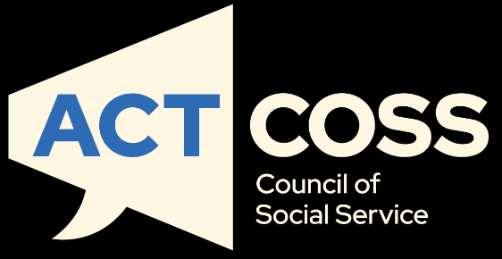
2026 Cost of Living Report
Taking stock of the 2020s: A decade of inflationary pain
actcoss@actcoss.org.au
actcoss.org.au
02 6202 7200
ABN 81 818 839 988
02 6202 7200
ABN 81 818 839 988
actcoss@actcoss.org.au
actcoss.org.au

About ACTCOSS
The ACT Council of Social Service Inc. (ACTCOSS) acknowledges Canberra has been built on the land of the Ngunnawal people. We pay respects to their Elders and recognise the strength and resilience of Aboriginal and/or Torres Strait Islander peoples. We celebrate Aboriginal and/or Torres Strait Islander cultures and ongoing contributions to the ACT community.
ACTCOSS advocates for social justice in the ACT and represents not-for-profit community organisations.
ACTCOSS is a member of the nationwide COSS Network, made up of each of the state and territory Councils and the national body, the Australian Council of Social Service (ACOSS).
ACTCOSS’s vision is for Canberra to be a just, safe and sustainable community in which everyone has the opportunity for self-determination and a fair share of resources and services.
The membership of the Council includes the majority of community-based service providers in the social welfare area, a range of community associations and networks, self-help and consumer groups and interested individuals.
ACTCOSS advises that this document may be publicly distributed, including by placing a copy on our website.
Contact Details
Phone 02 6202 7200
Address Weston Community Hub, 1/6 Gritten St, Weston ACT 2611
Email actcoss@actcoss.org.au
Web actcoss.org.au
CEO Dr Devin Bowles
Head of Policy Jenny Sandilands
Senior Policy Adviser Dr Jacob Priergaard
June 2026
© Copyright ACT Council of Social Service Incorporated
This publication is copyright, apart from use by those agencies for which it has been produced. Non-profit associations and groups have permission to reproduce parts of this publication as long as the original meaning is retained and proper credit is given to the ACT Council of Social Service Inc (ACTCOSS). All other individuals and Agencies seeking to reproduce material from this publication should obtain the permission of the CEO of ACTCOSS.
An ACT Government funded initiative.

Table of Contents
About ACTCOSS 2
Acronyms 4
Executive Summary 5
2026 ACT Cost of Living Report: At a Glance 6
Recommendations 7
Changes in prices of key goods and services: Consumer Price Index 8
Changes in income and the poverty gap 16
Tipping Point? The Fuel Shortage 23
Conclusion 25

Acronyms
ABS Australian Bureau of Statistics
ACOSS Australian Council of Social Service
ACT Australian Capital Territory
ACTCOSS ACT Council of Social Service Inc.
CPI Consumer Price Index
CRA Commonwealth Rent Assistance
LCI Living Cost Index
PBLCI Pensioner and beneficiary Living Cost Index
SLCI Selected Living Cost Indexes



Executive Summary
The last five years have pushed more Canberrans into poverty and financial precarity. The 2026 cost of living report is delivered in the shadow of a global fuel shortage. Without continued active government management, this could threaten the financial security of middle to low income Australians. As with every economic shock, these negative effects are felt most keenly by those in our community who have the least – people already on the margins for whom minor increases in costs may be a tipping point towards crisis.

In last year’s cost of living report, we highlighted that the period of high inflation that characterised the early 2020s was easing but we remained concerned about the long-term impact this period had for those in poverty. An easing of inflation means that costs are rising slower. It does not necessarily mean that costs are going down relative to wages or social security, nor does it mean that people are able to cope.

In the first part of this cost of living report we take stock of the 2020s to understand the pressures already faced by Canberrans in what has been a difficult decade to date. The data demonstrates how five years of increasing inflation of essential goods has been putting enormous strain on household budgets across the Territory.

The second part of the report considers the state of poverty in the ACT. We are fortunate that many Canberrans enjoy above-average wages and a high standard of living that provide some insulation from the pressures of rapidly rising costs. However, those on the lowest wages and those relying on social security are struggling to meet the essential needs of their households. Moreover, we see the downstream impacts of rising costs in the increasing number of people foregoing medical services, meals and struggling to pay energy bills to manage their finances.

The resilience of low income households is being further tested by the fuel shortage that drove up costs across the board and triggered multiple interest rate increases. At the time of writing this report, our members in the community sector are reporting a significant rise in financial strain among their clients. The community sector also seeing an unprecedented jump in the use of foodbanks in the ACT as people struggle to make ends meet.

Governments at both ACT and Commonwealth levels need to continue to actively manage the situation. An economy needs to work for its people, not the other way around.


Devin Bowles
ACTCOSS CEO

2026 ACT Cost of Living Report: At a Glance
Cost of living pressures have not eased for low income households and it could get worse

 | The cost of essential goods continue to rise  From 2020 to 2025, costs of essentials have skyrocketed:  - Automotive Fuel (+48.6 per cent)  - Education (+34.7 per cent)  - Medical and hospital services (+25.6 per cent)  - Utilities (+23.5 per cent)  - Food and beverages (+22.2 per cent)
 | Housing remains Canberra’s key cost of living issue  From 2020 to 2025, the cost of housing (including utilities) has increased by 26.3 per cent.  Anglicare’s 2026 Rental Affordability Snapshot found that out of the rental properties advertised in the ACT during their survey period, none were affordable for someone on JobSeeker. Only a single listing was affordable for a full-time minimum wage earner.  As of 31 March 2026, there were 3,551 applicants on the ACT housing waiting list – an increase of 362 compared to the previous year. The average wait time was 5 years for standard housing, 3 years for high needs and 5 months for priority.
 | Inadequate income support is trapping people in poverty  As of December 2025:  - A single person receiving Youth Allowance had a weekly income that was 42.6 per cent below the poverty line of $584 per week.  - A single person without children receiving JobSeeker had a weekly income that was 31.3 per cent below the poverty line of $584 per week.

To alleviate cost of living pressures in the ACT, ACTCOSS calls on the ACT Government to:
Ensure financial assistance is provided to those who need it most
- It is not clear that financial assistance is appropriately targeted nor sufficient to meet to the needs of people experiencing disadvantage in the ACT. ACTCOSS therefore recommends a refresh of the ACT Targeted Assistance Strategy in partnership with the Community Sector. The strategy has not been reviewed since its introduction in 2012.
Commit to ongoing funding for food relief in the ACT
- ACTCOSS recommends that the Government provide ongoing funding for the food relief sector and commit that all of this funding will go to directly to support the food relief sector including frontline service delivery.
Support low income households to pay their energy bills
- The eligibility and payment rate for the ACT Electricity, Gas and Water Rebate have not kept up with utility costs and need in the ACT. ACTCOSS recommends the eligibility is reviewed and the payment adjusted to ensure appropriate coverage that meets the needs of disadvantaged Canberrans.
Re-introduce a one-off payment for people on low incomes who face eviction during a period of financial hardship
- With rental affordability at an all time low, a safety net is essential to reduce avoidable evictions and the cascading consequences that homelessness produces.
To alleviate cost of living pressures in the ACT, ACTCOSS joins ACOSS and calls on the Commonwealth Government to:
Raise the Rate for Good
- The Federal Government should increase Jobseeker Payment, Youth Allowance and related income support payments to parity with pension payments as a matter of urgency. These payments must be indexed to wages as well as prices at least twice per year.
- In addition to the base rate increase, there should be supplementary payments paid to people with disability and illness and single parents that reflect the additional costs they face.

Recommendations

Changes in prices of key goods and services: Consumer Price Index
As in previous ACT Cost of Living Reports, this analysis draws primarily on Canberra’s Consumer Price Index (CPI) for the December quarter, tracking both short-term (12-month) and longer-term (five-year) price changes.

The timing for this year’s report, in some respects, presents an out-of-date measure because of how rapidly the context has been changing in the January and April 2026 quarters. In this situation, the value of the data in this report is best understood as providing a view of cost of living in the ACT preceding the current fuel supply shortage. As Figure 1 shows, from 2020 to 2025, the ACT experienced increases of 20 per cent or more in the cost of food, education, housing, transport and healthcare. These are not luxury items in a household budget and their collective growth is cause for concern.

Figure 1: Change in CPI for CPI Groups (including overall CPI), Canberra and Australia, December 2020 – December 2025 (%)

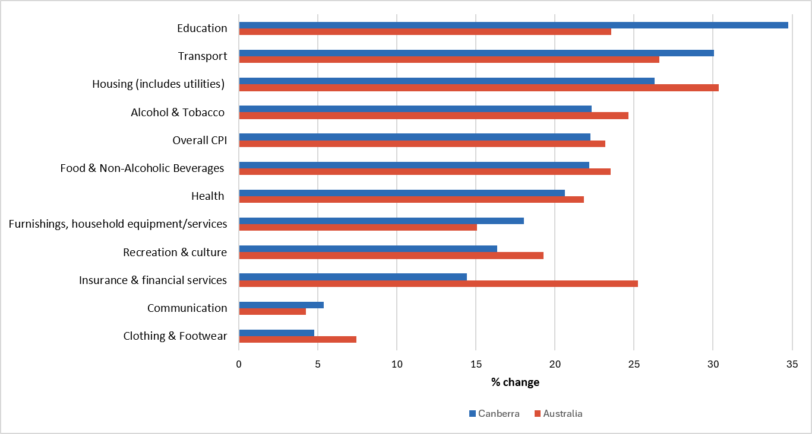
Source: ABS, ‘Table 11. CPI: Group, Sub-group and Expenditure Class, Percentage change from previous quarter by Capital City’ [time series spreadsheets], Consumer Price Index, Australia, September Quarter 2025, ABS, 2025; ABS, CPI: Group, Sub-group and Expenditure Class, Percentage change from previous quarter, December 2025, Canberra.

From December 2020 to December 2025, consistent with national trends, Canberrans experienced substantial increases in the cost of essential goods. As Figure 1 shows, the cost of education (+34.7 per cent), housing (including utilities) (+26.3 per cent) and transport (+30.1 per cent) continued the longer-term trend of rising at above the rate of inflation.

Canberra has experienced relatively lower inflation in many goods and services. However, the increases in actual terms in the ACT remain substantial compared to the incomes of those in the lowest quintile which have stagnated through the same period (e.g. minimum wage and social security).

Underlying the headline numbers are increases in some specific goods and services that are disproportionately driving increased costs for low income and vulnerable households. These are highlighted in Figure 2 and Figure 3. Key findings include:
- Education: The cost of education is rising across the board, but the magnitude of the growth is mainly because childcare has significantly increased in cost in the ACT (+34.7 per cent) compared to the national average (+12.8 per cent). It is also a concern that this increased cost has not necessarily manifested in better quality education, with educational outcomes measuring below national averages.
- Transport: The cost of transport has increased almost entirely because of a 48.6 per cent increase in automative fuel costs in the ACT from 2020 to 2025 – an increase that obviously predates the current fuel shortage issue. Meanwhile public transport increased in costs by just 0.5 per cent in the corresponding period, contributing hardly at all to increased costs.
- Housing (including utilities): Housing costs have increased through three contributing elements. First, the cost of new dwelling purchases has increased by 34.2 per cent, though this is lower than national average of 40.4 per cent. Second, property rates and charges have increased by 38.2 per cent, which is 8.5 per cent faster than the national average. This is due to policy decision to transition stamp duty taxation into the more efficient land tax. Finally, the cost of utilities has increased by 23.5 per cent.
- Health: Healthcare in the ACT has increased at just below the rate of CPI, but, critically, the largest increase has been in the cost of medical and hospital services (+25.6 per cent).

The figures are not all negative, with some notable positive takeaways. The cost of a number of essentials increased at rates well below inflation over the 5-year period. This included rents (+13.5 per cent), pharmaceutical products (+4.5 per cent), clothing (+4.8 per cent) and public transport (+0.5 per cent). Unfortunately, except for rent, most of these categories are not goods and services that are among the most expensive for household budgets. This might be partly attributable to the ACT Government’s nation-leading caps on rental increases, which came into effect in 2019. This means they are not sufficient to offset the increasing cost of so many different areas of life in the ACT.

Figure 2: Change in CPI for selected sub-groups and expenditure classes (including overall CPI), Canberra and Australia, December 2020 – December 2025 (%)
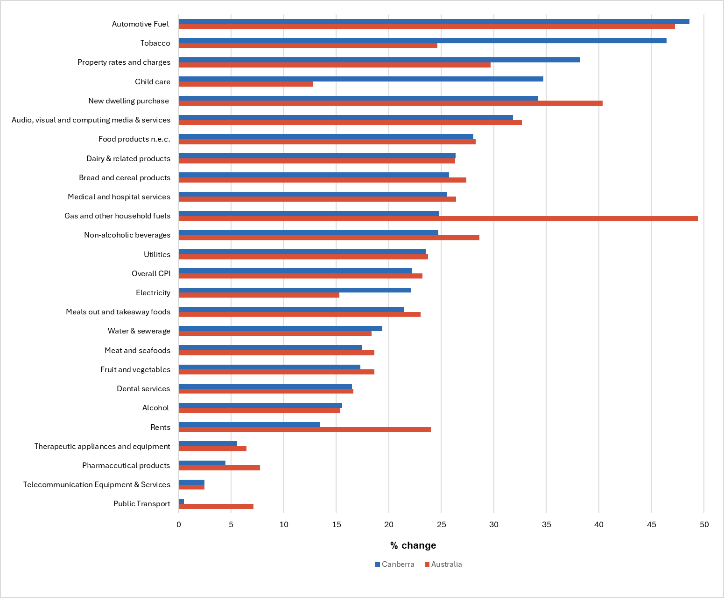

Source: ABS, ‘Table 11. CPI: Group, Sub-group and Expenditure Class, Percentage change from previous quarter by Capital City’ [time series spreadsheets], Consumer Price Index, Australia, September Quarter 2025, ABS, 2025; ABS, CPI: Group, Sub-group and Expenditure Class, Percentage change from previous quarter, December 2025, Canberra.

Households with young children are disproportionately impacted by increasing costs over the past five years and remain notably vulnerable to the fuel shortage issue. This is because a larger household is likely to spend more on food, medical services and utilities, and the costs of education and childcare are two of the most rapidly growing types of expenditure. It is unsurprising that single-parent households continue to be one of the strongest predictors of financial distress. Ongoing increases in costs across the board present parents with near-impossible trade-offs. Recent findings from OZHarvest demonstrate this challenge in their national data. Families are their most commonly supported group, making up 46 per cent of those accessing foodbank services.

In the long-term, these household cost pressures are a further risk to child development in the ACT, potentially exacerbating existing issues of increasing developmental vulnerability in the ACT. For example, child development is negatively impacted by poor nutrition that can result from difficulty accessing food and increased mental health challenges that can come from housing insecurity.

Figure 3: Changes in CPI sub-groups and expenditure classes with increases above the overall CPI, Canberra, December 2020 – December 2025 (%)

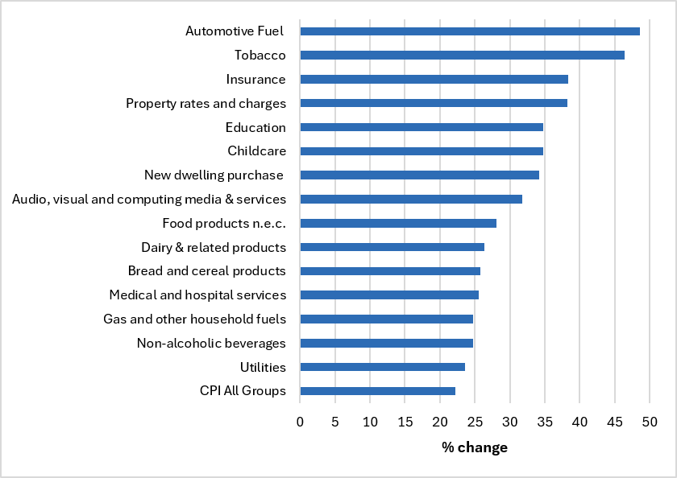
Source: ABS, ‘Table 11. CPI: Group, Sub-group and Expenditure Class, Percentage change from previous quarter by Capital City’ [time series spreadsheets], Consumer Price Index, Australia, September Quarter 2025, ABS, 2025; ABS, CPI: Group, Sub-group and Expenditure Class, Percentage change from previous quarter, December 2025, Canberra.

CASE STUDY: Budgeting cannot overcome inadequate income
Care has been supporting the Canberra community since 1983 and we believe in financial fairness for all. We are a charitable organisation that provides free and confidential support and assistance to people living on low to moderate incomes or who are experiencing financial difficulty. Our work spans across four programs: financial counselling and capability; consumer law; community loans; and community education.
Ella* is 37 years old and is a victim-survivor of family violence. She lives in a private rental with her 4-year-old daughter who has special needs. Ella's family do not live in Canberra.
Ella has an injury that prevents her from working. Her only income is from Parenting Payment Single, Family Tax Benefit A and B, and Commonwealth Rent Assistance. This limited income leaves Ella and her daughter in persistent financial stress that means they:
- Are at constant risk of homelessness: Ella's rent is more than her fortnightly income. At the moment she has financial support from family which covers half her rent but this may end at any time.
- Have no access to safe and reliable transport: Ella's car is in need of repairs that she cannot afford. She has to use public transport which limits her access to other support services and makes it very difficult to get her daughter to pre-school. Ella doesn't feel safe without her car.
- Often go without health services: many services and treatments have an out-of-pocket cost which they cannot afford.
- Skip meals: Ella often runs out of money for food. She tries to access support but this is difficult without a car.
- Cannot afford essential services: Ella is not able to pay for her electricity at the moment and is getting temporary hardship support from her phone provider. They cannot afford home internet.
Ella feels exhausted and overwhelmed and is very worried about the future for herself and her daughter. She has already accessed available grants but there just isn't enough money to pay for day-to-day essentials.
*Name changed for privacy

Cost of living from 2024 to 2025
Between December 2024 and December 2025, the ACT experienced an overall increase in CPI of 3.3 per cent, 0.5 per cent below the national average. However, despite a slowing rate of inflation, there were substantial jumps in the cost of a number of essential goods that suggest this number underrepresents the actual impact on households – especially those on low incomes. Table 1 shows there were above-CPI increases in the cost of utilities (+8.7 per cent), child care (+11.7 per cent), medical and hospital services (+5.5 per cent) and education (+6.1 per cent). This continues the longer trend in which aggregate CPI data continues to understate the actual impact on household budgets, and especially for households with young families.

Table 1: Change in CPI for key household expenditure areas, Canberra and Australia, Dec 2024 – Dec 2025 and Dec 2020 – Dec 2025

Cost of Living Area | Canberra CPI Change (%) Dec 24-Dec 25 | Australia CPI Change (%) Dec 24-Dec 25 | Canberra CPI Change (%) Dec 20-Dec 25 |  | Australia CPI Change (%) Dec 20-Dec 25
Food & Non-Alcoholic Beverages | 3.1 | 3.4 | 22.2 | 23.5
Bread and cereal products | 1.0 | 1.5 | 25.8 | 27.4
Meat and seafoods | 4.2 | 4.4 | 17.4 | 18.6
Dairy & related products | 3.1 | 2.9 | 26.3 | 26.3
Fruit and vegetables | 5.0 | 4.0 | 17.3 | 18.7
Food products n.e.c. | 2.9 | 3.2 | 28.0 | 28.3
Non-alcoholic beverages | 3.6 | 4.0 | 24.7 | 28.6
Meals out and takeaway foods | 2.7 | 3.5 | 21.5 | 23.0
Alcohol & Tobacco | 4.9 | 4.9 | 22.3 | 24.6
Alcohol | 2.8 | 1.8 | 15.6 | 15.4
Tobacco | 12.4 | 12.5 | 46.4 | 47.1
Clothing & Footwear | 1.6 | 3.4 | 4.8 | 7.4
Housing (includes utilities) | 3.6 | 5.5 | 26.3 | 30.4
Rents | 1.1 | 3.9 | 13.5 | 24.0
New dwelling purchase | 1.0 | 3.0 | 34.2 | 40.4
Property rates and charges | 7.6 | 6.2 | 38.2 | 29.7
Utilities | 8.7 | 14.2 | 23.5 | 23.8
Water & sewerage | 7.8 | 7.1 | 19.4 | 18.4
Electricity | 14.1 | 21.5 | 22.1 | 15.3
Gas and other household fuels | 1.4 | 5.8 | 24.8 | 49.4
Furnishings, household equipment/ services | 2.2 | 2.0 | 18.0 |  | 15.1
Child care | 11.7 | 11.2 | 34.7 | 12.8
Health | 4.1 | 3.6 | 20.6 | 21.8
Pharmaceutical products | -2.2 | -0.2 | 4.5 | 7.8
Therapeutic appliances and equipment | 1.1 | 2.9 | 5.6 | 6.4
Medical and hospital services | 5.5 | 4.3 | 25.6 | 26.4
Dental services | 2.8 | 3.2 | 16.5 | 16.7
Transport | 1.8 | 1.6 | 30.1 | 26.6
Automotive Fuel | -3.8 | -0.8 | 48.6 | 47.2
Public Transport | 3.4 | -0.6 | 0.5 | 7.1
Communication | 1.2 | 1.1 | 5.4 | 4.2
Telecommunication Equipment & Services | 0.8 | 0.8 | 2.5 | 2.5
Recreation & culture | 3.8 | 4.4 | 16.3 | 19.3
Audio, visual and computing equipment | -1.7 | -1.6 | -4.1 | -2.7
Audio, visual and computing media & services | 9.4 | 10.0 | 31.8 | 32.7
Education | 6.1 | 5.4 | 34.7 | 23.6
Insurance & financial services | 2.6 | 2.5 | 14.4 | 25.3
Insurance | 0.2 | 2.6 | 38.3 | 45.8
Overall CPI | 3.3 | 3.8 | 22.2 | 23.2

Source: ABS, ‘Table 11. CPI: Group, Sub-group and Expenditure Class, Annual percentage change, by Capital City’, Consumer Price Index, Australia, December 2025 and ‘Table 11. CPI: Group, Sub-group and Expenditure Class, Percentage change from previous quarter by Capital City’, Consumer Price Index, Australia, September Quarter 2025, ABS, 2025; ABS, CPI: Group, Sub-group and Expenditure Class, Percentage change from previous quarter, December 2025, Canberra, [time series spreadsheets].

Housing
Perhaps the most important indicator for cost-of-living is the capacity to rent or own a home. Stable, secure housing is fundamental to individual and community wellbeing.

Housing remains the single largest driver of cost-of-living pressures in the ACT. As Table 1 indicates, rental costs have been rising slower as a proportion in the ACT than the national average both over 2024-25 and in the previous five years. However, it is misleading to interpret this data as showing that rentals are affordable in the ACT because baseline costs were already high.

The 2026 Anglicare Rental Affordability Snapshot found ‘that rental affordability [in the ACT] has shifted from acute pressure to structural exclusion, leaving low income households with little realistic access to the private rental market.’ In their analysis, Anglicare found zero rental properties in the ACT were deemed affordable for anybody living on social security payments and only one (or 0.1 per cent of the market) affordable for a single person on a minimum wage. This suggests that declining growth in rental costs are occurring because the ACT is reaching an upper limit of affordability rather than because of improvements to supply of low cost rental properties. Those on the lowest incomes are either excluded from the private rental market, or experience severe financial stress if they are required to use it.

There remains a significant backlog for access to priority public housing in the ACT. The ACT Government prioritises public housing need based on urgency. The first tier is ‘priority’ where ‘urgent’ help is needed. The second tier is ‘high needs’ where ‘you might have one or more health or wellbeing needs’. The third tier is termed ‘standard’ where ‘the basic eligibility criteria for social housing’ is met. As at 31 March 2026, 3,551 Canberrans with approved applications were sitting on a waiting list for public housing, as noted in Table 2.

Table 2: Waiting times for public housing
Waiting list | Approved applications | Average waiting time (days)
Priority housing | 139 | 172 (5.6 months)
High needs housing | 1,932 | 1,173 (3.2 years)
Standard housing | 1,480 | 1,859 (5 years)
Source: ACT Government (2026) Waiting list for public housing. https://www.act.gov.au/housing-planning-and-property/public-housing/waiting-lists-for-public-housing.

The ACT Government has committed to building more social and affordable housing over the coming decade but it is unlikely to meet growing demand. However, the current levels are a serious concern – nobody should have to wait five years to secure a home in a moment of intense need. There remains an immediate issue for people on low incomes in the ACT to secure safe and accessible housing. For example, someone in the priority category is either homeless or will imminently be homeless but will on average experience more than five months wait for housing.

Changes in income and the poverty gap
Australia does not have an official poverty measure. While there are multiple ways that poverty can be defined and measured, the Commonwealth has repeatedly refused to establish an official measure. ACTCOSS draws on the poverty definition and measures used by the ACOSS/UNSW Poverty and Inequality partnership. The definition is as follows:

‘People are in poverty when their economic resources are inadequate to attain a socially acceptable living standard.’

This definition is a relative measure of poverty tied to standards of living in the particularly community. It is operationalised through an income-based measure of poverty. ACOSS/UNSW uses two poverty lines set at proportions of median income, with the first line at 50 per cent of median income and the second line at 60 per cent of median income. Total income is calculated after housing costs, as housing is usually the largest fixed cost for most household budgets. This means that families with lower housing costs (e.g. those who own their home outright) have a higher standard of living than those with the same income but who have higher housing costs.

In 2025, the ACOSS/UNSW national poverty line (50 per cent of median income after housing) was $584 a week for a single adult and $1226 a week for a couple with two children.

Those receiving social security payments continue to be well below the poverty line. With no substantial increases to social security payments in the past three Commonwealth budgets, beyond regular indexation, every payment remained at or below the poverty line. Figures 4 and 5 show the challenges for people receiving working age payments. As at December 2025:

- A single person without children on Jobseeker Payment had a weekly income that was $183 (31.3%) below the poverty line of $584.
- A single person on Youth Allowance (other) had a weekly income that was $249 (42.6%) below the poverty line of $584.

For those on pensions (e.g. Age or Disability Support) which are intended as long-term support payments, a single person is now $5 above the poverty line. This is because pensions are indexed to a combination of the CPI and Male Average Weekly Earnings, resulting in higher rates of indexation than working age payments that are purely indexed to CPI. Over the long-term, this has resulted in an increasing disparity of payment rates of pensions vis-à-vis allowance payments with the gap incrementally growing year-on-year.

Figure 4: Weekly income compared to poverty lines by income type, December 2025

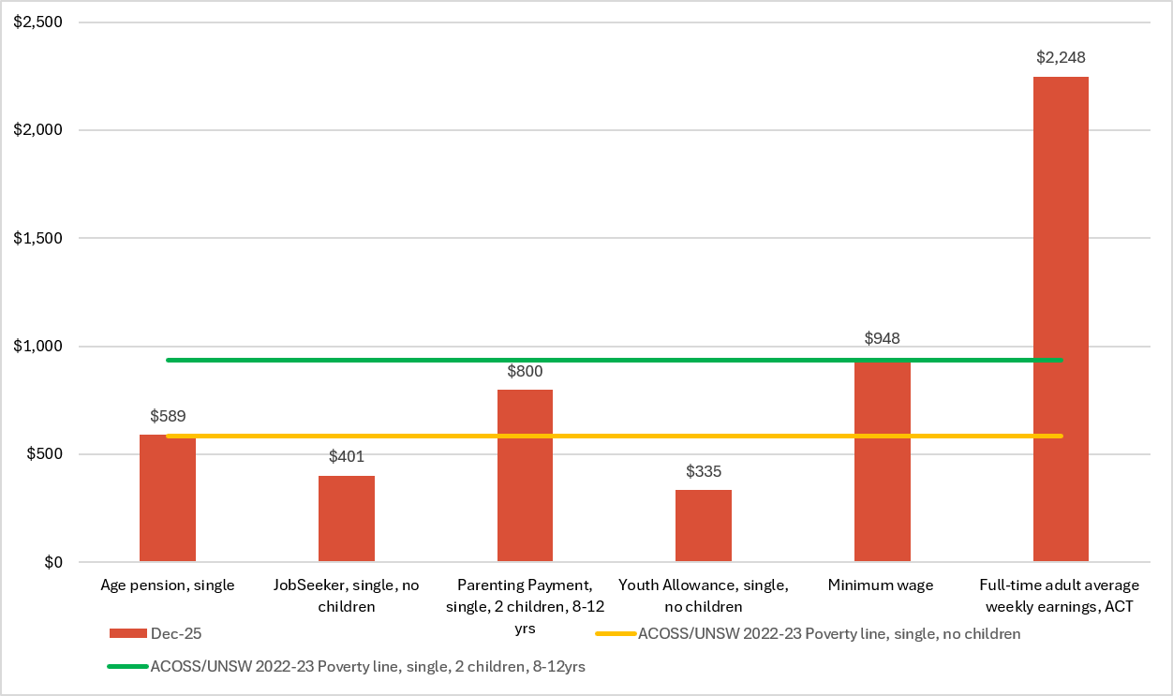
Source: Services Australia, A guide to Australian Government payments, Historical versions, 20 September to 31 December 2025, Services Australia, Canberra, 2025; P Davidson, B Bradbury & M Wong, Poverty in Australia 2023: who is affected?, Poverty and Inequality Partnership Report no. 20. Australian Council of Social Service and UNSW Sydney, 2023; Fair Work Commission, National Minimum Wage Orders, Fair Work Commission, Melbourne, 2025; ABS, Average Weekly Earnings, Australia, Nov 2024 & Nov 2025, ABS, Canberra, 2025.

CASE STUDY: The devastating impact of long-term financial stress
CONTENT WARNING: Suicide
Care has been supporting the Canberra community since 1983 and we believe in financial fairness for all.
Kobie* is 28 years old and has been unable to work for over two years because of severe mental health conditions. Kobie's only source of income is Jobseeker Payment and Commonwealth Rent Assistance. He struggles to engage in everyday life and feels unable to find and sustain employment. Kobie feels helpless and stuck.
Kobie is struggling financially. He pays over 80 per cent of his fortnightly income in rent. Kobe has been doing whatever he can to save money. He recently switched to mobile data only and is going without home internet, and he use to time his appointments for Fridays so he could get free public transport (which is no longer available).
Kobie has been seeking whatever financial assistance he can find to try to get by. For example, he previously accessed Rent Relief which provided some short term respite but that is no longer available. He has a financial hardship arrangement with his electricity provider. Kobie has also been relying on community organisations for support with food and medication – or is going without – and has applied for public housing but does not hold much hope of securing a place anytime soon.
In amongst the financial stress of surviving day-to-day, Kobie’s mental health continues to worsen. He has thoughts of suicide and self-harm and has been hospitalised after a suicide attempt. He has been unable to afford specialist mental health treatment and has limited access to free supports.

*Name changed for privacy

An increase in the minimum wage over the past 12 months sees the minimum wage remain above the 60 per cent poverty line and $364 per week above the lower poverty line. The average full-time adult weekly income in the ACT continues to be significantly above national averages. The gap between waged labour and those on social security is most starkly illustrated in Figure 5.

The story of poverty is one that reflects national conditions and policy decisions far more than those in the ACT. The Commonwealth Government remains unwilling to engage in serious reform of social security – especially around adequacy of payments, the failing employment services system or in the creation of an official poverty line. Payment rates have increased incrementally, mostly through existing indexation structures, but as Figure 5 highlights, these are insufficient to bring people out of poverty. To its credit, the Commonwealth Government has overseen improved conditions and wages for care workers and other low wage workers and this reflected in the data. However, it remains cautious about improving conditions and payment adequacy for people who are unemployed which has flow on impacts for service infrastructure at the territory level.

Figure 5: Weekly income poverty gap by income type, December 2024- December 2025
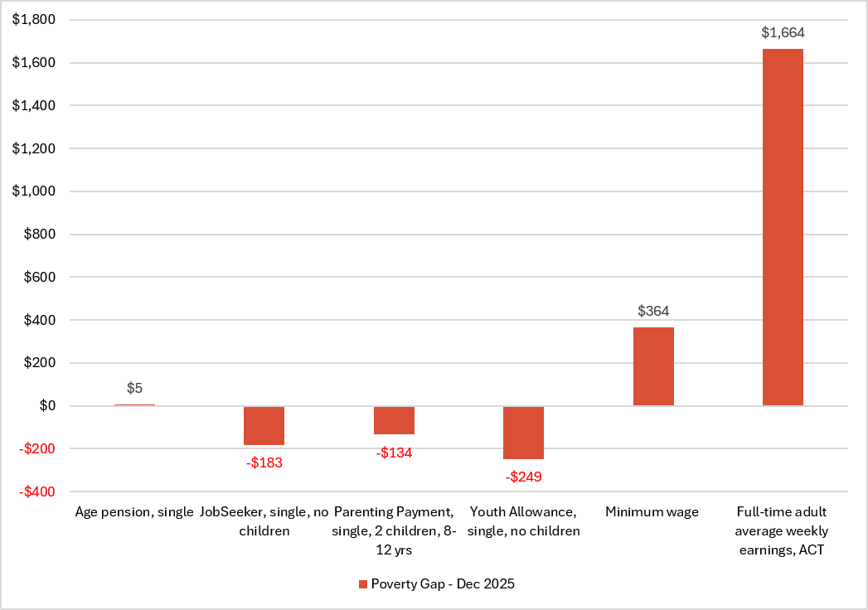
Source: Services Australia, A guide to Australian Government payments, Historical versions, 20 September to 31 December 2025, Services Australia, Canberra, 2025; P Davidson, B Bradbury & M Wong, Poverty in Australia 2023: who is affected?, Poverty and Inequality Partnership Report no. 20. Australian Council of Social Service and UNSW Sydney, 2023; Fair Work Commission, National Minimum Wage Orders, Fair Work Commission, Melbourne, 2025; ABS, Average Weekly Earnings, Australia, Nov 2024 & Nov 2025, ABS, Canberra, 2025.

For the ACT, and especially the community sector, the lack of Commonwealth action to increase the rate of social security payments means that there is more pressure on local community and Government services to step up and fill in the gaps that the Commonwealth is creating. The last five years have seen above-inflationary increases in the cost of essential goods. This combination of the gap in support for people in poverty combined with cost increases has created significant precarity for anyone reliant on social security.

A further concerning consequence of this situation is that the ACT community sector is coming under increasing strain as it attempts to support people whose basic needs are not being met. The sector is under growing pressure from increased demand, rising service complexity and the cumulative impact of long-term underfunding.

In considering policy responses, the most significant single action that could be taken is for the Commonwealth Government to dramatically increase social security payments. ACTCOSS supports the call of ACOSS for the Commonwealth to set a minimum payment rate for working-age payments at the current pension rate and move towards equalising pension and non-pension payments. The Government’s own Economic Inclusion Advisory Committee has also, yet again, called for the Commonwealth to act to increase the value of non-pension payments up to at least 90 per cent of pensions, and to reform Australia’s ‘harmful and punitive’ employment services system.

Turning attention to the ACT, ACTCOSS recommends the ACT Government fund a review of how it targets financial assistance. A review last occurred in 2012 associated with the establishment of the Targeted Assistance Strategy, but the structure of disadvantage in both the ACT and Australia more broadly has shifted substantially in the intervening years. The ACT Government no longer tracks the intersecting adequacy nor coverage of its financial assistance measures which are delivered through multiple Directorates. Given the extent of inflation in the cost of essential goods over the last decade, it is a necessary step for the ACT Government to review the adequacy and coverage of financial assistance provided to disadvantaged Canberrans.

In order to ensure everyone is able to meet basic needs for housing, food and energy ACTCOSS makes the following recommendations:

- Make sure financial assistance is provided to those who need it most – The strategy has not been reviewed since its introduction in 2012. After a half-decade of rapid inflation, combined with diminished adequacy of social security benefits, the distribution of need is not the same as it was in 2012. The strategy needs to be re-examined to make sure that it is appropriately targeted to the needs of disadvantaged Canberrans and is fit for the 2020s and beyond.

- Re-introduce a one-off payment for people on low incomes who face eviction during a period of financial hardship – While the ACT Government works to increase the supply of social and affordable housing, it will take time before any additional supply meaningfully changes the rental market. A cost of living safety net is essential to reduce avoidable evictions and the downstream costs to health, crisis accommodation and social services that accompany them.

- Make sure people can pay their energy bills – The eligibility and payment rate for the ACT Electricity, Gas and Water Rebate have not kept up with utility costs and need in the ACT. ACTCOSS recommends the Rebate is reviewed and the payment adjusted to ensure appropriate coverage that meets the needs of Canberrans experiencing disadvantage.

- Commit to ongoing funding for food relief in the ACT – In the 2025-26 ACT budget, the Government committed $1.5m in food relief over three years, expiring at the end of the 2027-28 financial year. This funding is desperately needed in the sector to ensure that those most in need do not go hungry. ACTCOSS recommends that the Government extend this funding of $500k per year by a further two years from 2028-29 to 2029-30 and, further, commit that all of this funding will go to directly to support the food relief sector including frontline service delivery.

Government must be creative and work closely with the community sector to maintain a robust safety net for those experiencing disadvantage. Given the magnitude of the present challenge around fuel and how it is likely to impact those in already in poverty, these reforms might provide at least a start to supporting people through the current instability.

Tipping Point? The Fuel Shortage
While there are not up-to-the-minute public data on the impact of fuel shortages, it is evident that cracks are starting to show in Australia’s social support systems. As the situation in the Middle East drags on there are impacts that will start to emerge. This concluding section considers potential contingencies over the coming months and where the Government might intervene to ensure a resilient system that is capable protecting those who most need support.

ACTCOSS acknowledges the work of both the Commonwealth and ACT Governments in this space. This includes securing fuel imports and other measures to return petrol prices to more normal levels. While efforts to date have significantly moderated fuel prices after a period of dramatic escalation, further policy intervention may be required for this to continue. Events in the Middle East cannot be predicted, but action on the part of the Commonwealth and ACT Governments could be critical in how future global fuel production changes affect Canberrans.

To date, the Commonwealth Government has been largely successful in securing fuel imports and returning fuel prices to their normal levels. If international events or domestic policy choices see Australian fuel prices escalate again, there will be significant economic consequences which will be experienced most painfully by those already doing it tough. If this occurs, significant economic intervention by governments will be required.

Many Canberrans were already struggling financially before the fuel shortage. In 2024, the University of Canberra’s ‘Living well in the ACT region’ reported the way people had changed their lives to manage living costs:
- 68.5 per cent had changed some of their food purchases to cheaper options,
- 51 per cent had reduced use of heating and cooling at home,
- 45.8 per cent had cancelled one or more social events, and
- 37.9 per cent had delayed seeking medical appointments.

While the cost of fuel most obviously impacts personal transportation, it also drives up food costs and has triggered the Reserve Bank to raise interest rates repeatedly driving cost increases across the economy. For those in the bottom two income quintiles ACTCOSS anticipates an increasing sacrifice of essential goods and services to try and get by. For those lucky enough to still have savings, those savings are likely to be drawn down, removing any buffer to a prolonged crisis or future unexpected costs.

More and more people were accessing community services for emergency support as they run out of alternatives. In a survey of ACTCOSS members conducted across April and May 2026 about the impact of fuel supply disruptions, 40 per cent of community service organisations surveyed reported more (30 per cent) or much more (10 per cent) demand for their services. While 75 per cent of community service organisations surveyed reported their clients were experiencing more (45 per cent) or much more (30 per cent) financial pressure than before fuel shortages began.

Most pressing are housing and food costs. Alongside existing high demand for social housing, food relief organisations are already turning people away due to a lack of sufficient supply to meet demand. Moreover, food relief organisations are reporting that 36 per cent of those accessing support are new faces, likely receiving food relief for the first time. Among those receiving support, the two most common reasons reported by clients are rising grocery prices (76 per cent) and housing affordability (74 per cent).

ACTCOSS appreciates the efforts of the Commonwealth and ACT Governments to minimise the Canberra impact of global fuel supply disruption. It looks forward to continuing to work with the ACT Government to ensure that people on low incomes are not disproportionately affected.

Conclusion
This report highlights how years of inflation and economic strain have left low-income households vulnerable to even minor economic setbacks, let alone the sustained pressure coming from rising fuel prices. Despite growth in the ACT economy, the costs of essential goods continue to climb at above inflationary levels. This has disproportionately impacted people who were already experiencing disadvantage.

Housing is a critical challenge, with rental affordability in the ACT falling further than last years previous record low, while public housing waitlists continue to climb. When combined with above-inflationary increases in the cost of utilities, food and fuel, it should surprise nobody that more and more people are drawing on community supports merely to get by. As we’ve highlighted in this report, the financial resilience of those in disadvantage has been sorely tested over a sustained period and more help is needed to make sure the current inflationary pressures are not a tipping point into poverty.

ACTCOSS urges the ACT Government to ensure targeted and adequate assistance to make sure that Canberrans doing it tough can cope. This means investing in social housing, reviewing financial assistance payments for utilities and housing costs, and appropriately funding the food relief sector.

The recommendations in this report show a path forward that builds long-term resilience and ensures no Canberran is left behind.


02 6202 7200
ABN 81 818 839 988
Thank you
actcoss@actcoss.org.au
actcoss.org.au

Data set not published online – December 2025 quarter CPI data was provided directly from the ABS as they transitioned from quarterly to monthly CPI reporting from October 2025.
ACT Government. (2025). Australian Early Development Census: 2024 Results for the ACT. https://www.act.gov.au/__data/assets/pdf_file/0020/3051335/AEDC-2024-Results-for-the-ACT.pdf.
Economic Inclusion Advisory Committee. (2026). 2026 Report to Government, 13.
OZHarvest. (2026). OZHarvest Frontline Report 2026: Food insecurity insights from local organisations providing food relief, 4.
Families ACT. (2025). Child First Forum Outcome Paper 2025: A Canberra where all children thrive. ACT; ACT Government. (2025). Australian Early Development Census: 2024 Results for the ACT. https://www.act.gov.au/__data/assets/pdf_file/0020/3051335/AEDC-2024-Results-for-the-ACT.pdf.
Anglicare NSW South/NSW West/ACT & St John’s Care. (2026). Rental Affordability Snapshot 2026: From pressure to permanence: Rental affordability, a structural challenge for low-income Australians, 5.
Ibid, 6.
ACT Government. (2026). Waiting lists for public housing. https://www.act.gov.au/housing-planning-and-property/public-housing/waiting-lists-for-public-housing
Davidson, P. (2025) Poverty & Inequality in Australia: Defining and measuring poverty. https://povertyandinequality.acoss.org.au/wp-content/uploads/2025/02/PIP-measuring-poverty-Dec2024-3.pdf.
ACOSS &UNSW. (2025). Poverty in Australia 2025: Overview.
Economic Inclusion Advisory Committee. (2026). 2026 Report to Government, 16-17.
Spies-Butcher, B. (2024). Social Policy. The Journal of Australian Political Economy 92:1, 75-85.
ACTCOSS. (2025). ACTCOSS ACT Budget Submission 20267-27, 18.
ACOSS. (2023). Addressing inadequacy of income support: briefing note. https://www.acoss.org.au/wp-content/uploads/2023/02/Addressing-inadequacy-of-income-support-2023-final.pdf.
Economic Inclusion Advisory Committee. (2026). 2026 Report to Government, 15.
Schirmer, J., Carroll, S. & Dale, M. (2025). Living well in the ACT region: Understanding the changing wellbeing of Canberrans, 2019-2024, 28.
OZHarvest. (2026). OZHarvest Frontline Report 2026: Food insecurity insights from local organisations providing food relief, 5.

